Supplementary Information

Selective growth of α-form zinc phthalocyanine nanowire crystals through flow rate control of physical vapor transport method

Youngkwan Yoon¹, Soyoung Kim¹, Hee Cheul Choi^{1*}

¹ Department of Chemistry, Pohang University of Science and Technology (POSTECH), 77 Cheongam-ro, Nam-gu, Pohang-si 37673, Korea

* E-mail: choihc@postech.edu

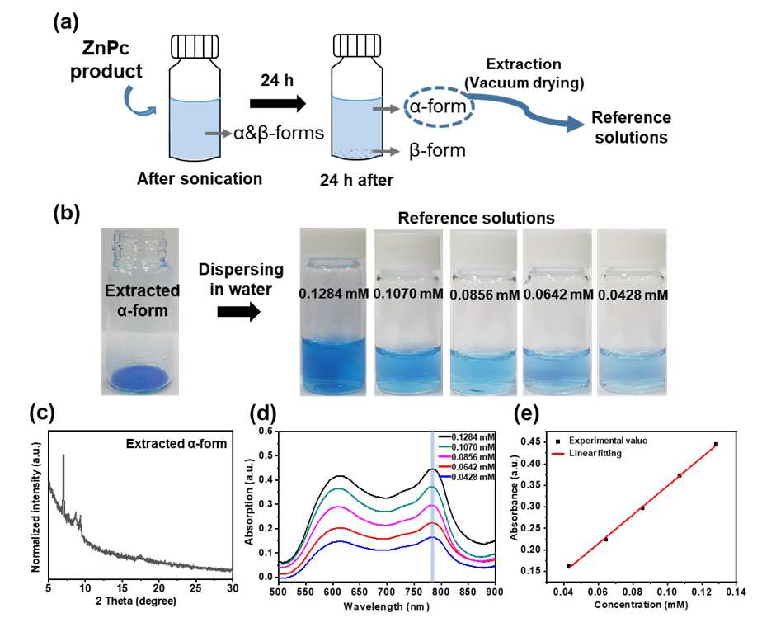
Figure S1. The quantitative analysis of α-form ZnPc NW solutions. (a) Experimental scheme for obtaining reference solutions of α-form ZnPc. ZnPc product dispersed in water by sonication for 40 min. After sitting for 24 hours, the upper part of the ZnPc NW solution which consists of α-form only was extracted by vacuum drying. The extracted α-form was redispersed in water and sequentially diluted to obtain reference solutions. (b) Photographs of extracted α-form ZnPc and reference solutions at various concentrations. (c) PXRD pattern of extracted α-form ZnPc. (d) UV-VIS spectra of the reference solutions. (e) Linear fitting between absorbance and concentration of reference solutions of α-form ZnPc.
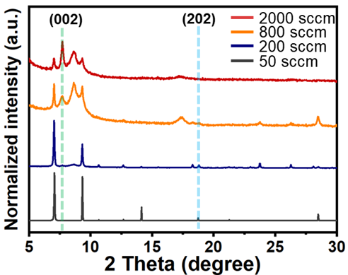
Figure S2. PXRD patterns plotted on linear scale of ZnPc NW crystals grown at different flow rates.
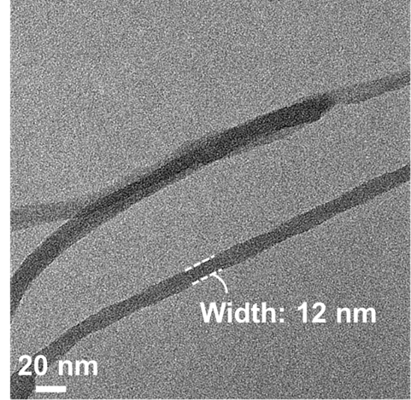
Figure S3. TEM image of the α-form ZnPc NWs with the thinnest width (12 nm) obtained at the flow rate of 2000 sccm

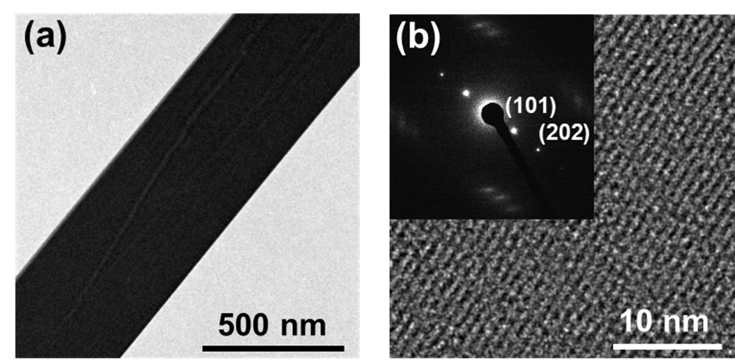
Figure S4. Crystal structure analysis of the β-form ZnPc NW crystal. (a) Low and (b) high magnification TEM images of the β-form ZnPc NW. The inset of Figure S2b is an ED pattern of the β-form ZnPc NW. The lattice distance of (202) plane in inset is 0.480 nm.

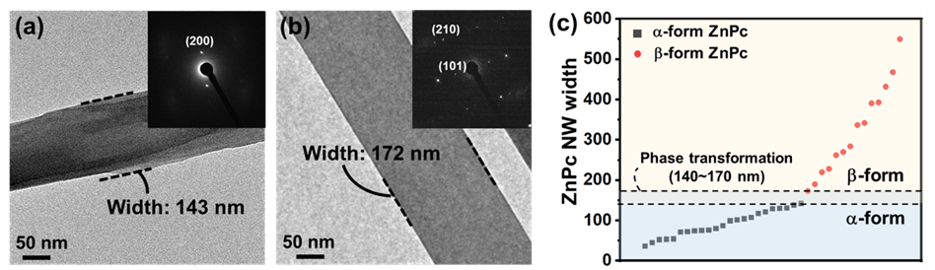
Figure S5. TEM images of (a) the largest width of α-form ZnPc NW and (b) the smallest width of β-form ZnPc NW. The insets are ED patterns of (a) α-form and (b) β-form ZnPc NWs, respectively. (c) Phase diagram of ZnPc NWs.

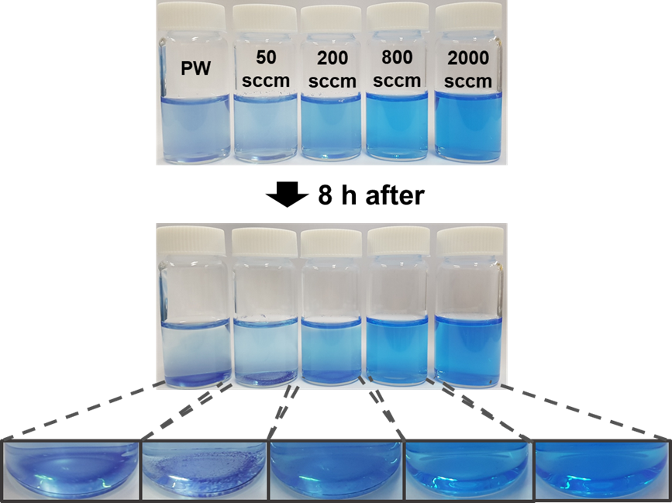
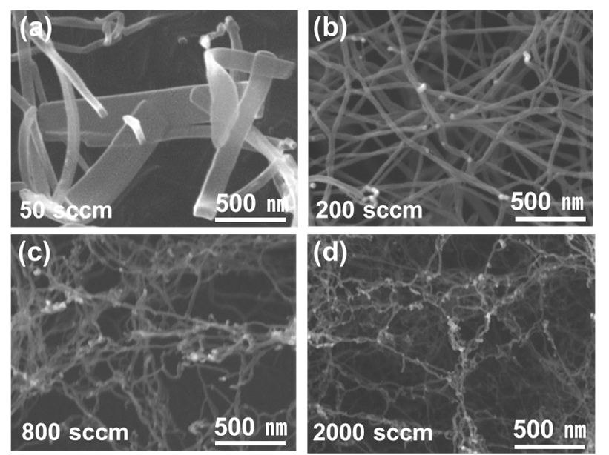
Figure S6. Morphologies of CuPc crystals grown at different flow rates. SEM images of CuPc crystals grown at various flow rates of carrier gas of (a) 50 sccm (b) 200 sccm (c) 800 sccm (d) 2000 sccm.
Figure S7. Photographs of CuPc crystals dispersed in water depending on the flow rate of carrier gas. The CuPc NWs grown at higher flow rate of carrier gas showed high water dispersibility without notable aggregation after dispersion in water for 8 hours.
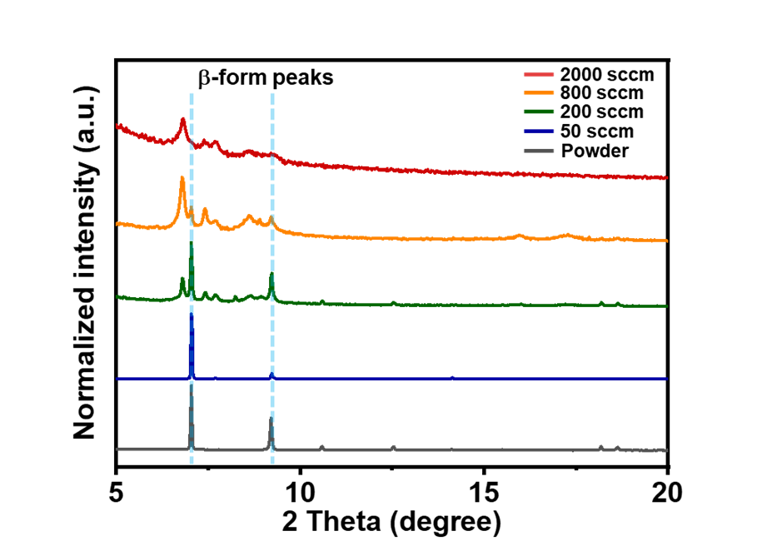
Figure S8. PXRD patterns of CuPc NW crystals grown at different flow rates. CuPc powder (grey) and crystals obtained at a relatively low flow rate (50 sccm, navy) showed identical diffraction patterns of reported β-form CuPc. By contrast, CuPc crystals obtained at a relatively high flow rate (2000 sccm, red) showed metastable form of CuPc.¹
References
(1) Zou, T.; Wang, X.; Ju, H.; Zhao, L.; Guo, T.; Wu, W.; Wang, H. Controllable Molecular Packing Motif and Overlap Type in Organic Nanomaterials for Advanced Optical Properties. Crystals 2018, 8, 22.

