Supporting Information
Nitrogen-enriched graphene framework with synergetic kinetics from a large-scale magnesiothermic conversion of CO₂ for high-power lithium-ion capacitors
Chen Li¹, Xiong Zhang^{1,2,6,*}, Kai Wang^{1,2,6}, Xianzhong Sun¹, Yanan Xu¹, Fangyuan Su^{4,6}, Cheng-Meng Chen^{4,6}, Fangyan Liu^{5,6}, Zhong-Shuai Wu^{5,6} and Yanwei Ma^{1,2,3,*}
¹ Institute of Electrical Engineering, Chinese Academy of Sciences, Beijing 100190, China
² School of Engineering Sciences, University of Chinese Academy of Sciences, Beijing 100049, China
³ School of Materials Science and Engineering, Zhengzhou University, Zhengzhou 450001, China
⁴ CAS Key Laboratory of Carbon Materials, Institute of Coal Chemistry, Chinese Academy of Sciences, Taiyuan 030001, China
⁵ State Key Laboratory of Catalysis, Dalian Institute of Chemical Physics, Chinese Academy of Sciences, Dalian 116023, China
⁶ Dalian National Laboratory for Clean Energy, Chinese Academy of Sciences, Dalian 116023, China

Corresponding Author
*X. Zhang. E-mail address: zhangxiong@mail.iee.ac.cn
*Y. Ma. E-mail address: ywma@mail.iee.ac.cn

Keywords: Nitrogen-enriched graphene, CO₂ conversion, lithium-ion capacitor, high power density

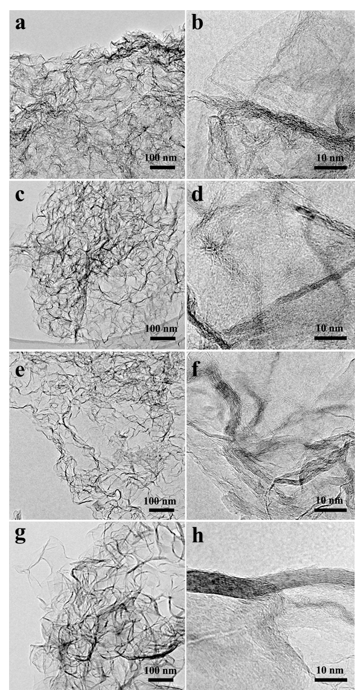
Figure S1 Morphological evolution of NGF materials fabricated with different amount of melamine. (a-b) NGF-0, (c-d) NGF-1, (e-f) NGF-2, (g-h) NGF-3.

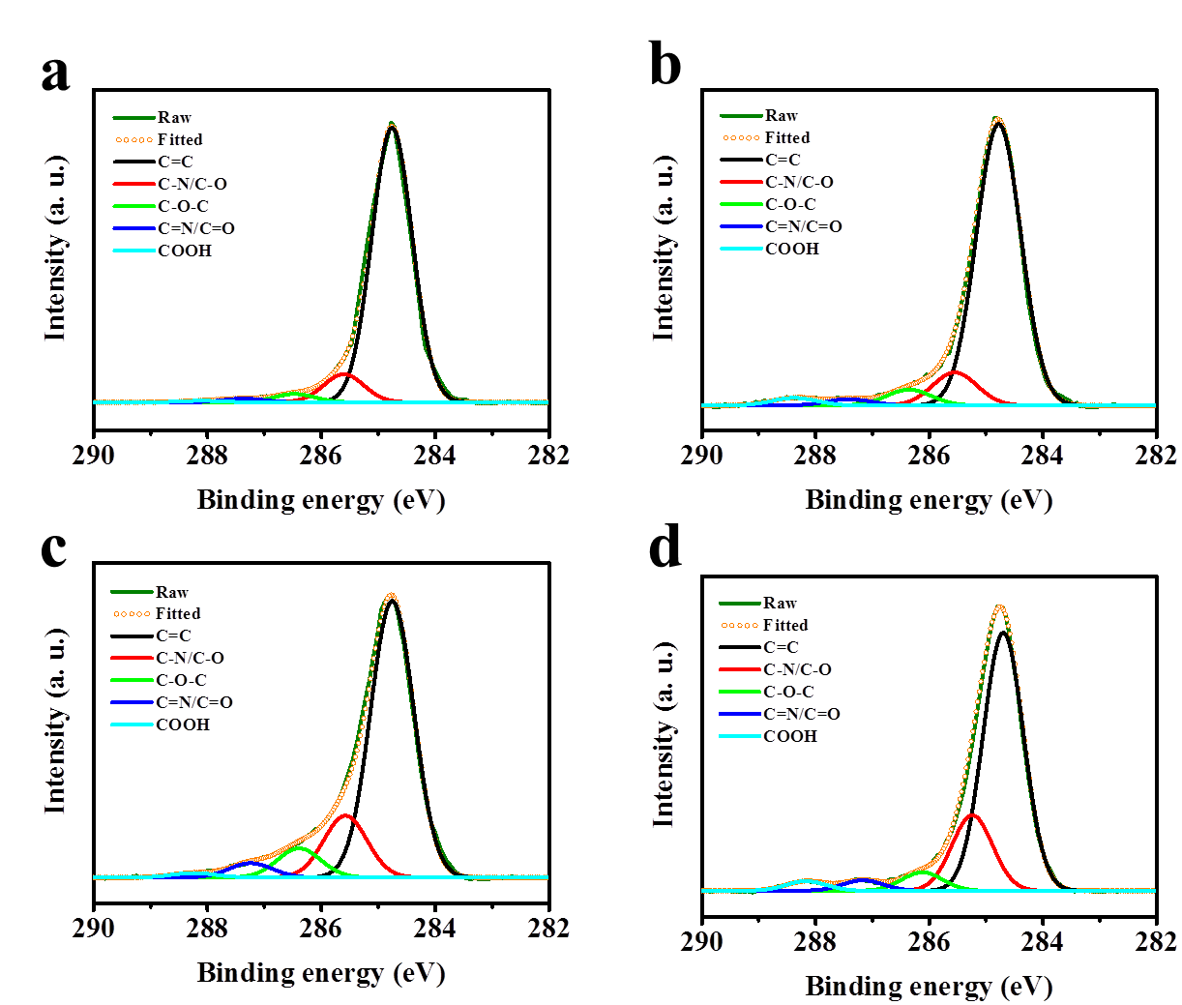
Fig. S2 Deconvoluted C 1s spectra of (a) NGF-0, (b) NGF-1 (c) NGF-2 and (d) NGF-3.

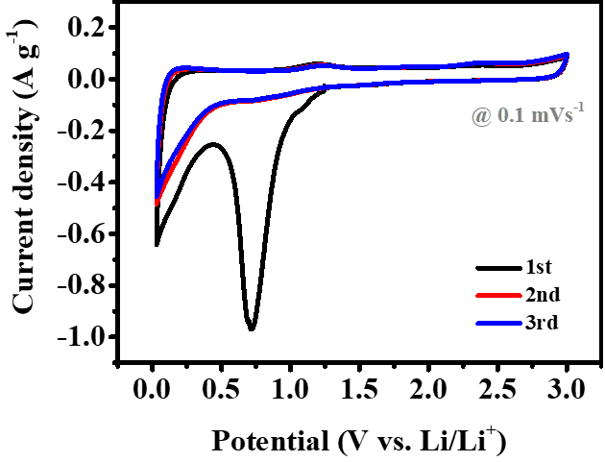
Fig. S3 The first three CV curves of NGF-2 at a scan rate of 0.1 mV s⁻¹. The first discharge curve shows a prominent reduction peak at around 0.7 V due to the consumption of Li⁺ ions and the formation of solid electrolyte interface (SEI) layers. Besides, the smaller reduction peak around 1.2 V is probably induced by the irreversible reactions between electrolyte and minimum surface functional groups of anode.

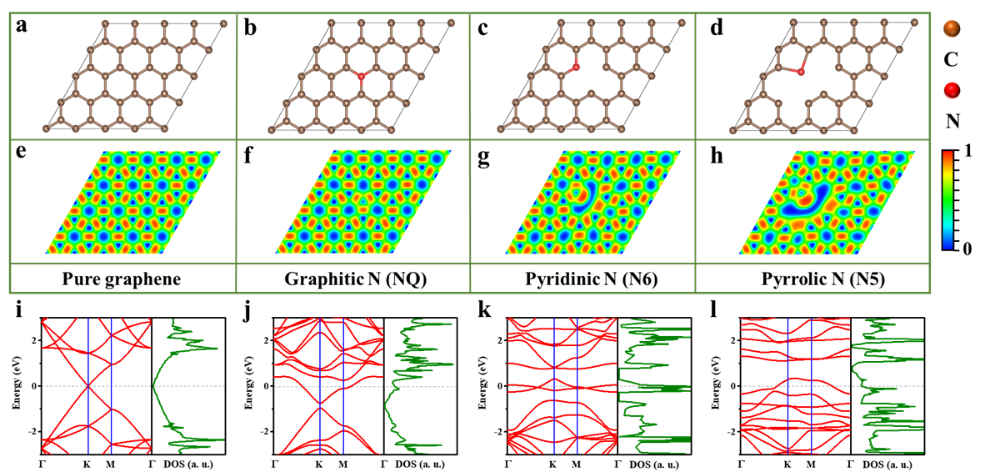
Fig. S4 (a-d) Optimized structure of pristine graphene and N-doped graphene with NQ, N6 and N5 configurations; (e-f) the corresponding electron localization function (ELF); (i-l) band structure and density of state (DOS) for NGFs.

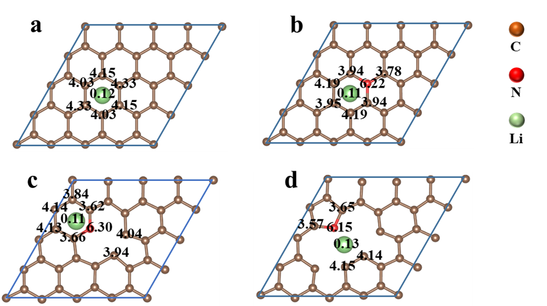
Fig. S5 Bader charge analysis of NGFs interacting with lithium ions.

Fig. S6 Comparison of the capacitive performance of various NGFs as cathode.

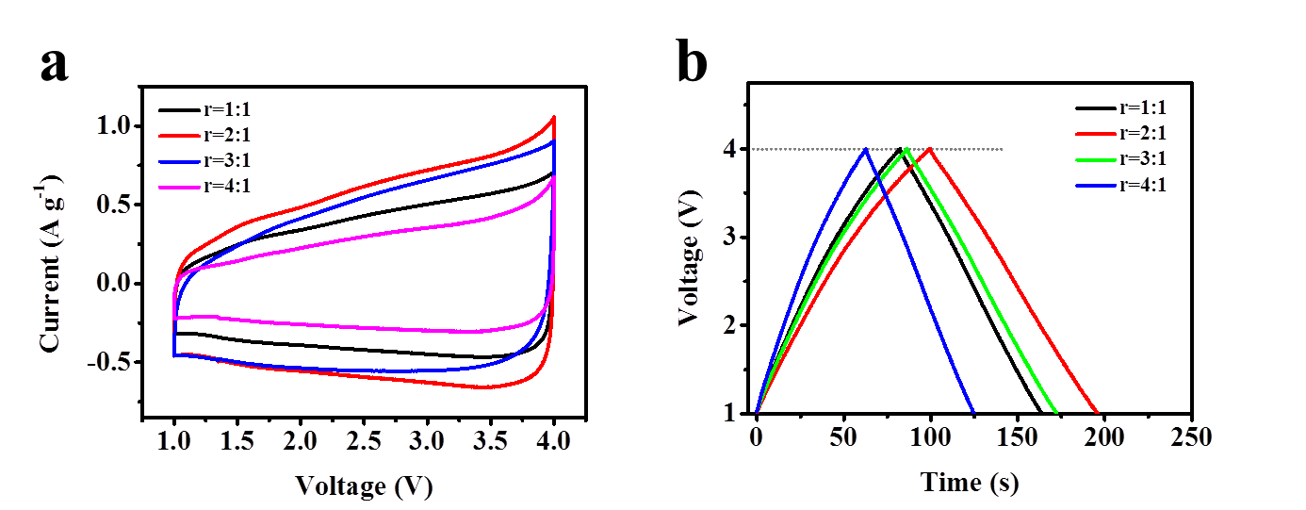
Fig. S7 (a) CV and (b) GCD curves of NGF-0//NGF-2 LIC with different mass ratio of cathode and anode (r_{c/a}) from 1:1 to 4:1.

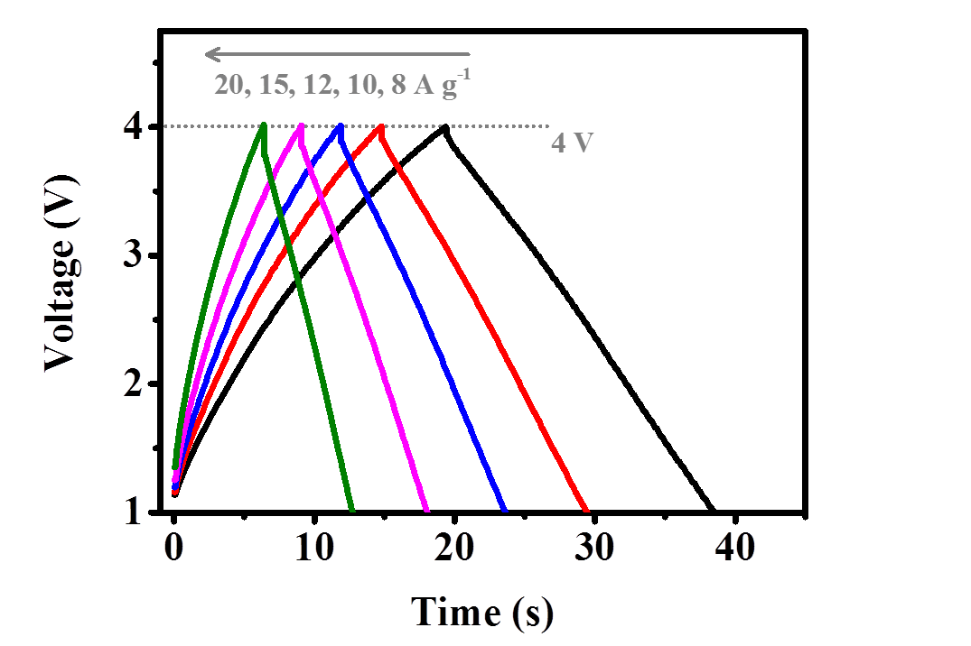
Fig. S8 GCD curves of NGF-0//NGF-2 at high current densities.

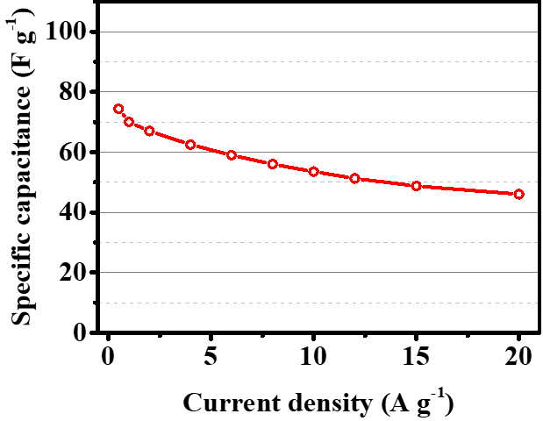
Fig. S9 Rate capability of NGF-0//NGF-2.

Table S1 Summarization of elemental composition of NGFs.
Sample | C | O | N | Total
NGF-0 | 98.8 | 1.2 | 0 | 100.0
NGF-1 | 97.3 | 1.4 | 1.3 | 100.0
NGF-2 | 96 | 1.6 | 2.4 | 100.0
NGF-3 | 93.8 | 1.5 | 4.7 | 100.0

Table S2 Summarization of the percentage of different N atoms in NGFs.
Sample | N-6 | N-5 | N-Q | N-X | Total
NGF-1 | 22.1 | 23.7 | 31.9 | 22.3 | 100.0
NGF-2 | 21.4 | 28.6 | 34.6 | 15.4 | 100.0
NGF-3 | 14.3 | 33.6 | 39.5 | 12.6 | 100.0

Table S3 Electrical conductivity of NGFs by four-probe method.
Sample | Electrical conductivity (S m⁻¹)
NGF-0 | 9547
NGF-1 | 9718
NGF-2 | 10524
NGF-3 | 9961

Table S4 Bader charge analysis results of NGFs.
 | Graphitic N (NQ) | Pyridinic N (N6) | Pyrrolic N (N5)
Li | 0.109659 | 0.112023 | 0.129983
N | 6.221313 | 6.299163 | 6.157969
C | 3.946442 | 3.664485 | 3.655461

Table S5 Electrochemical performances of NGF-0//NGF-2 LIC and other previously reported LIC.
LIC systems | E/Wh kg⁻¹ | P/kW kg⁻¹ | Ref.
NGF-0//NGF-2 (This work) | 147 @ 1.19 kW kg⁻¹ | 86 @ 48.9 kW kg⁻¹
MSP-20//Nb₂O₅/C | 63 @ 0.07 W kg⁻¹ | 5 @ 16.5 kW kg⁻¹ | ¹
N-doped carbon//TiC | 101 @ 0.45 W kg⁻¹ | 23 @ 67.5 kW kg⁻¹ | ²
Graphene//TiO₂ | 82 @ 0.57 W kg⁻¹ | 21 @ 19 kW kg⁻¹ | ³
Graphene//Li₄Ti₅O₁₂ | 95 @ 0.045 W kg⁻¹ | 32 @ 3 kW kg⁻¹ | ⁴
AC//Li₄Ti₅O₁₂ | 69 @ 0.5 W kg⁻¹ | 32 @ 3 kW kg⁻¹ | ⁵
MOF-based carbon//Li₄Ti₅O₁₂ | 65 @ 0.5 W kg⁻¹ | 9 @ 10 kW kg⁻¹ | ⁶
Porous carbon//Li₄Ti₅O₁₂ | 55 @ 0.5 W kg⁻¹ | 25 @ 5 kW kg⁻¹ | ⁷
AC//Graphdiyne | 112 @ 0.4 W kg⁻¹ | 95 @ 1 kW kg⁻¹ | ⁸
AC//TiO₂-B | 23 @ 0.15 W kg⁻¹ | 7.5 @ 2.8 kW kg⁻¹ | ⁹
AC//Li₃VO₄ | 136 @ 0.53 W kg⁻¹ | 24.4 @ 11 kW kg⁻¹ | ¹⁰
AC//V₂O₅/CNT | 40 @ 0.21 W kg⁻¹ | 7 @ 6.3 kW kg⁻¹ | ¹¹
AC//Li₄Ti₅O₁₂ | 110 @ 0.02 W kg⁻¹ | 30 @ 5 kW kg⁻¹ | ¹²
N-AC//MnO/G | 127 @ 0.125 W kg⁻¹ | 83 @ 25 kW kg⁻¹ | ¹³
AC//rGO | 106 @ 0.0840W kg⁻¹ | 85 @ 4.2 kW kg⁻¹ | ¹⁴
AC//LiNi_{0.5}Mn_{1.5}O₄ | 19 @ 0.12 W kg⁻¹ | 8 @ 3.5 kW kg⁻¹ | ¹⁵
Carbon sphere//Si/C | 128 @ 1.2 W kg⁻¹ | 89 @ 9.7 kW kg⁻¹ | ¹⁶
AC//Hard carbon | 93.4 @ 0.05 W kg⁻¹ | 20 @ 6 kW kg⁻¹ | ¹⁷
N-porous carbon//Graphite | 80 @ 0.15 W kg⁻¹ | 60 @ 32 kW kg⁻¹ | ¹⁸

Discussion on the relationship between type of nitrogen doping and electrical conductivity
Generally, the chemical bonding between N and C atoms can be divided into three categories: (i) pyrrolic N-5, (ii) pyridinic N-6 and (iii) graphitic N-Q/N-X. Specifically, N-5 represents the pyrrolic N which contributes two electrons to the conjugated system of the pentagonal ring while N-6 denotes the pyridinic N substituting a carbon atom in the C₆ ring and bonds with two sp² carbon atoms. N-Q is the graphitic N located inside the graphitic plane and bonded with three sp² carbon atoms, which is beneficial to the electro conductibility due to the significant change in electron-donor characteristics.
The invasion of N heteroatom into the perfect hexagonal carbon sheet of pristine graphene will inevitably cause structural and electronic distortions, leading to alterations of localized electronic state and charge transport in graphene materials. Depending on the doping configurations of N, new or improved properties may arise and be beneficial for particular applications. Although pyrrolic N-5 and pyridinic N-6 contribute electron density at N-doping sites, they introduce vacancy and defect to the honeycomb crystal lattice. Consequently, these two types of N, especially pyrrolic N-5 with larger steric hindrance, jeopardize the transport of electrons across the basal plane of graphene. However, for graphitic N with one quaternary nitrogen substituting one carbon atom, three valence electrons of N form three σ-bonds with the neighboring C atoms and one electron is engaged in a p bond formation. The fifth electron is partially involved in the π*-state of the conduction band. Moreover, the hexagonal crystal lattice of graphene lattice is well-maintained, meaning the steric hindrance on electron transport is minimized. Each graphitic N can contribute ~0.5 electron to the total π network of graphene lattice, resulting in an n-doping effect. In comparison, pyrrolic N form at the defects sites to impose p-doping effect by withdrawing electrons from the graphene sheet. Therefore, graphitic nitrogen is expected to efficiently improve electrical conductivity for N-doped graphene materials, while pyrrolic N tends to cause localized electron density at active sites.
In this study, we proved both experimentally and theoretically that NGF-2 with high graphitic N and low pyrrolic N could exhibit superior electrical conductivity than other samples. From the deconvoluted N 1s spectrum in XPS analysis (Fig. 2d), the ratio of pyrrolic, pyridinic and graphitic N can be calculated from the integrals of corresponding peaks, which shows NGF-2 has a high graphitic nitrogen content (N-Q and N-X) of 50 at. % and low pyrrolic N-5 content of 28.6 at. %. Compared with NGF-0, NGF-2 boast high graphitic N content. As to NGF-3, the content of graphitic N (42.1 at. %) is roughly the same with NGF-2, but the pyrrolic N (33.6 at. %) is much higher. As expected, the electrical conductivity by four-probe method of NGF-2 reaches 10524 S m⁻¹, higher than NGF-0 (9547 S m⁻¹), NGF-1 (9718 S m⁻¹) and NGF-3 (9961 S m⁻¹). More importantly, the electrical conductivity of NGF-2 shows 11% enhancement than NGF-0 without N-doping (9050 S m⁻¹), which firmly proves the effectiveness of N-doping by melamine in enhancing the electron transport capability of graphene materials via magnesiothermic combustion synthesis.
Various work has reported similar results with us that graphitic N tends to increase the electrical conductivity of graphene and pyridinic N usually causes electron deficiency to exert the opposite effect. For example, Wang et al. also used melamine as nitrogen source to prepare N-doped activated carbon sheets. Their results demonstrated that positively charged graphitic N-Q and N-X facilitated the electron transfer in the carbon skeleton to enhance the conductivity of carbon materials, while the pseudocapacitive interactions are mainly induced by negatively charged pyridinic N.¹⁹ Jeong et al.²⁰ elucidated different nitrogen-doped sites on graphene basal plane and concluded that graphitic N played a major role in improving electrical conductivity across basal planes. In another work on nitrogen-doped carbon for capacitive energy storage, Tong et al.²¹ maintained that the presence of graphitic N inserting into the carbon matrix and bonding three carbon atoms can effectively contribute to the conductivity of carbon materials. Chen et al.²² indicated that a higher ratio of graphitic N in the carbon sample contributes to the improvement of electrical conductivity and electron transfer. In a recent review on heteroatom doped graphene for energy storage, Kumar et al.²³ clearly stated that graphitic N tends to increase the electrical conductivity of graphene, which pyridinic N induces concentrated local electron density to generate pseudocapacitance. Based on the above analysis, it is reasonable to understand that NGF-2 with the highest ratio of graphitic N exhibits the highest electrical conductivity among the graphene samples.

Reference for supporting information
1 Lim, E. et al. Facile synthesis of nb2o5@carbon core-shell nanocrystals with controlled crystalline structure for high-power anodes in hybrid supercapacitors. ACS Nano. 9, 7497-7505 (2015)
2 Wang, H. W. et al. A high-energy lithium-ion capacitor by integration of a 3d interconnected titanium carbide nanoparticle chain anode with a pyridine-derived porous nitrogen-doped carbon cathode. Adv. Func. Mater. 26, 3082-3093 (2016)
3 Wang, H., Guan, C., Wang, X. & Fan, H. J. A high energy and power li-ion capacitor based on a tio2 nanobelt array anode and a graphene hydrogel cathode. Small. 11, 1470-1477 (2015)
4 Leng, K. et al. Graphene-based li-ion hybrid supercapacitors with ultrahigh performance. Nano Research. 6, 581-592 (2013)
5 Jain, A. et al. Activated carbons derived from coconut shells as high energy density cathode material for li-ion capacitors. Sci. Rep. 3, 3002 (2013)
6 Banerjee, A. et al. Mof-derived crumpled-sheet-assembled perforated carbon cuboids as highly effective cathode active materials for ultra-high energy density li-ion hybrid electrochemical capacitors (li-hecs). Nanoscale. 6, 4387-4394 (2014)
7 Puthusseri, D., Aravindan, V., Madhavi, S. & Ogale, S. Improving the energy density of li-ion capacitors using polymer-derived porous carbons as cathode. Electrochimica Acta. 130, 766-770 (2014)
8 Du, H. P. et al. Graphdiyne applied for lithium-ion capacitors displaying high power and energy densities. Nano Energy. 22, 615-622 (2016)
9 Aravindan, V., Shubha, N., Ling, W. C. & Madhavi, S. Constructing high energy density non-aqueous li-ion capacitors using monoclinic tio2-b nanorods as insertion host. J. Mater. Chem. A. 1, 6145-6151 (2013)
10 Shen, L. et al. Peapod-like li3 vo4 /n-doped carbon nanowires with pseudocapacitive properties as advanced materials for high-energy lithium-ion capacitors. Adv. Mater. 29, (2017)
11 Chen, Z. et al. High-performance supercapacitors based on intertwined cnt/v2o5 nanowire nanocomposites. Adv. Mater. 23, 791-795 (2011)
12 Choi, H. S., Im, J. H., Kim, T., Park, J. H. & Park, C. R. Advanced energy storage device: A hybrid batcap system consisting of battery-supercapacitor hybrid electrodes based on li4ti5o12-activated-carbon hybrid nanotubes. J. Mater. Chem. 22, 16986-16993 (2012)
13 Yang, M. et al. Fabrication of high-power li-ion hybrid supercapacitors by enhancing the exterior surface charge storage. Adv. Energy Mater. 5, 1500550 (2015)
14 Lee, J. H. et al. Functionalized graphene for high performance lithium ion capacitors. ChemSusChem. 5, 2328-2333 (2012)
15 Arun, N. et al. Nanostructured spinel lini0.5mn1.5o4 as new insertion anode for advanced li-ion capacitors with high power capability. Nano Energy. 12, 69-75 (2015)
16 Yi, R. et al. High-performance hybrid supercapacitor enabled by a high-rate si-based anode. Advanced Functional Materials. 24, 7433-7439 (2014)
17 Zhang, J., Liu, X. F., Wang, J., Shi, J. L. & Shi, Z. Q. Different types of pre-lithiated hard carbon as negative electrode material for lithium-ion capacitors. Electrochim. Acta. 187, 134-142 (2016)
18 Yu, X. et al. Ultrahigh-rate and high-density lithium-ion capacitors through hybriding nitrogen-enriched hierarchical porous carbon cathode with prelithiated microcrystalline graphite anode. Nano Energy. 15, 43-53 (2015)
19 Wang, Y. L. et al. A melamine-assisted chemical blowing synthesis of n-doped activated carbon sheets for supercapacitor application. J. Power Sources. 319, 262-270 (2016)
20 Jeong, H. M. et al. Nitrogen-doped graphene for high-performance ultracapacitors and the importance of nitrogen-doped sites at basal planes. Nano Lett. 11, 2472-2477 (2011)
21 Tong, Y.-X. et al. Nitrogen-doped hierarchical porous carbon derived from block copolymer for supercapacitor. Energy Storage Mater. 3, 140-148 (2016)
22 Yang, L., Chen, C., Xu, G. B. & Wei, X. L. Macroscopic three-dimensional tetrapod-separated graphene-like oxygenated n-doped carbon nanosheets architecture for use in supercapacitors. J. Mater. Chem. A. (2016)
23 Kumar, R. et al. Heteroatom doped graphene engineering for energy storage and conversion. Mater. Today. (2020)

