Lead-substituted barium hexaferrite for tunable terahertz optoelectronics
Alyabyeva L.N.¹, Prokhorov A.S.^{1,2}, Vinnik D.A.³, Anzin V.B.^{1,2}, Ahmed A.G.^{1,4}, Mikheykin A.⁵, Bednyakov P.⁶, Kadlec C. ⁶, Kadlec F.⁶, de Prado E.⁶, Prokleška J.⁷, Proschek P.⁷, Kamba S.⁶, Pronin A.V.⁸, Dressel M.^{1,8}, Abalmasov V.A.⁹, Dremov V.V.¹, Schmid S.¹⁰, Savinov M.⁶, Lunkenheimer P.¹⁰, Gorshunov B.P.¹
¹Moscow Institute of Physics and Technology, 141701, Dolgoprudny, Russia
²Prokhorov General Physics Institute of the Russian Academy of Sciences, 119991, Moscow, Russia
³South Ural State University, 454080 Chelyabinsk, Russia
⁴Department of Physics, Faculty of Science, Sohag University, Sohag University St., Sohag, Egypt
⁵Southern Federal University, 344006, Rostov-on-Don, Russia
⁶Institute of Physics of the Czech Academy of Sciences, Praha 8, 18221, Czech Republic
⁷Faculty of Mathematics and Physics, Charles University, 12116 Prague 2, Czech Republic
⁸1. Physikalisches Institut, Universität Stuttgart, D-70550, Stuttgart, Germany
⁹Institute of Automation and Electrometry SB RAS, 630090 Novosibirsk, Russia
¹⁰Experimental Physics V, Center for Electronic Correlations and Magnetism, University of Augsburg, 86159 Augsburg, Germany
^{a)}Corresponding author: aliabeva.ln@mipt.ru

Supplementary Information
SI1. Crystals growth and characterization
High-quality single crystals of lead substituted barium hexaferrite, Ba_{1-x}Pb_{x}Fe₁₂O₁₉ (x = 0.1 and 0.2) were grown using by the flux technique with a Pt rod and PbO flux. After the crystals were separated from the crystallized flux, they were shaped to crystal plates up to 8 mm in size; their composition and unit cell parameters were determined using Energy-dispersive X-ray spectroscopy, powder X-ray diffraction and scanning electron microscopy [2]. The chemical composition and calculated chemical formulas are presented in Table 1. The obtained powder X-ray diffraction patterns on the Ba_{0.9}Pb_{0.1}Fe₁₂O₁₉ and Ba_{0.8}Pb_{0.2}Fe₁₂O₁₉ samples together with the literature data from [1] presented in Figure SI1-1 confirm the single-phase character of the samples and their magnetoplumbite-type (or M-type hexaferrite) structure. The calculated cell parameters values are presented in Table 2. The doping-induced changes in the cell parameters for are in good agreement with the previously published data [2].

Table 1. Chemical composition and chemical formulas of the studied barium-lead hexaferrite crystals.
Elemental content, at.% |  |  | Calculated chemical formula
Fe | Pb | Ba | Calculated chemical formula
33.95 | 0.32 | 2.49 | Ba_{0.9}Pb_{0.1}Fe₁₂O₁₉
33.63 | 0.58 | 2.21 | Ba_{0.8}Pb_{0.2}Fe₁₂O₁₉

Table 2. Experimental and literature data on unit cell parameters of the M-type hexaferrite crystals.
Sample formula | a [Å] | c [Å] | V [Å³] | Ref.
BaFe₁₂O₁₉ | 5.893 | 23.194 | 697.5 | [3]
BaFe₁₂O₁₉ | 5.8928(3) | 23.201(3) | 698.74 | [1]
Ba_{0.9}Pb_{0.1}Fe₁₂O₁₉ | 5.8936(3) | 23.1753(16) | 697.14(5) | Current work
Ba_{0.8}Pb_{0.2}Fe₁₂O₁₉ | 5.8948(3) | 23.1780(8) | 697.51(4) | Current work
PbFe₁₂O₁₉ | 5.873 | 23.007 | 687.24 | [4]

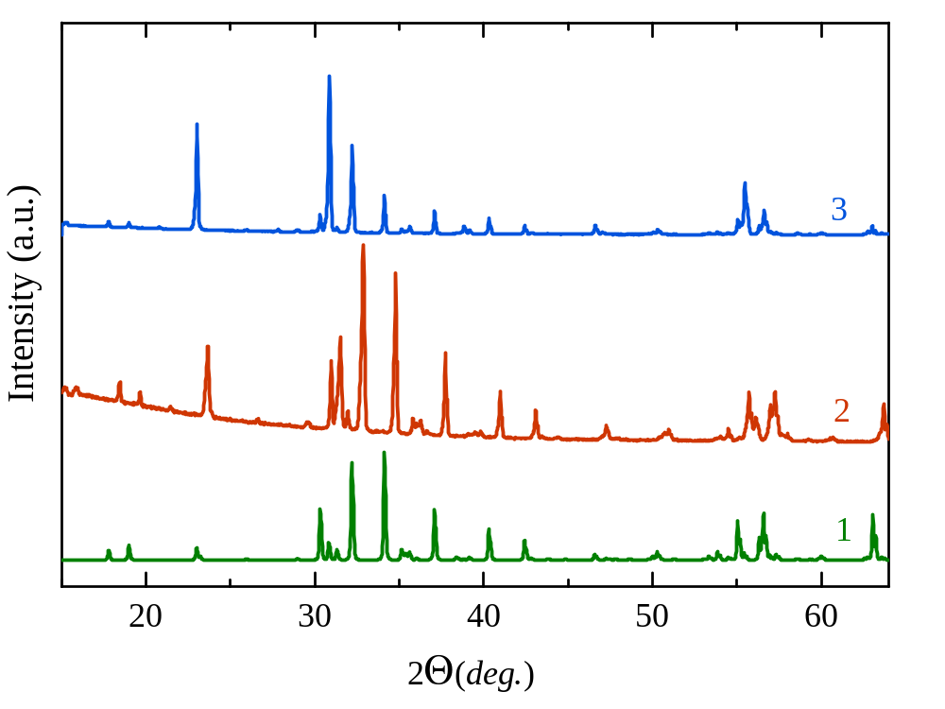
Figure SI1-1. Powder XRD patterns of studied Ba_{0.9}Pb_{0.1}Fe₁₂O₁₉ (2) and Ba_{0.8}Pb_{0.2}Fe₁₂O₁₉ (1) together with literature data on pristine BaFe₁₂O₁₉ from [1] (3). The patterns for different compounds are vertically shifted for reader’s convenience.

The orientation of the crystals prepared for optical measurements was checked using XRD mapping; the samples were shown to be well oriented with a tilting of the c-axis from the surface normal no larger than 1.29 deg.
XRD measurements for the verification of the orientation were performed using Co radiation in a Panalytical X’Pert PRO diffractometer with a parallel-beam geometry, with the beam generated by a parabolic graded multilayer mirror (Göbel mirror). In order to ensure the parallelism in the diffracted beam, a parallel-plate collimator was employed. The diffractometer has a built-in Eulerian cradle which allows for measuring different crystallographic planes by turning the sample. The notation used below is shown in Figure SI1-2.
Figure SI1-2c represents the situation when the unit cells are not well oriented. It is necessary to turn the sample an angle (offset) in order to set the correct orientation of the planes for the diffraction to be observed. This offset then yields the misorientation of the unit cells with respect to the surface of the sample. Figure SI1-1d shows the notation used for the axes and movements performed by the diffractometer. Here $ϕ$ is the sample azimuthal axis, $ω$ is an axis perpendicular to the diffraction plane, and $χ$ is the axis perpendicular to both $ϕ$ and $ω$. The accuracy of the measurements around those axes are 0.05° in $ϕ$, 0.005° in $ω$ and 0.05° in $χ$. In order to observe diffraction, the crystallographic planes must satisfy the Bragg's law given by Equation SI1-1 where d is the inter-plane distance, $θ$ is the Bragg angle, n the diffraction order and $λ$ the wavelength of the radiation. For a non distorted hexagonal system, the inter-plane distance can be calculated by Equation SI1-2 where h, k, l are the diffraction indices of the plane, and a, c denote the lattice parameters.
$$\begin{matrix}2dsinθ=nλ, & Eq.SI1-1\end{matrix}$$
$$\begin{matrix}\frac{1}{d^{2}}=\frac{4}{3}\left(\frac{h^{2}+k^{2}+kl}{a^{2}}\right)+\frac{l^{2}}{c^{2}}. & Eq.SI1-2\end{matrix}$$
We have calculated the misorientation of the unit cells and its lattice parameters for the sample Ba_{0.9}Pb_{0.1}Fe₁₂O₁₉. For calculating the misorientation, we measured a $χ/ω$ map for the diffraction 008 corresponding to (008) atomic planes. In such a map the angle $2θ$ was fixed. Then for several $χ$ angles the intensity of the diffraction as a function of $ω$ was acquired. For this diffraction $2θ=35.908$°, which was found using the 01-086-5547 PDF4 card for BaFe₁₂O₁₉ as a reference.

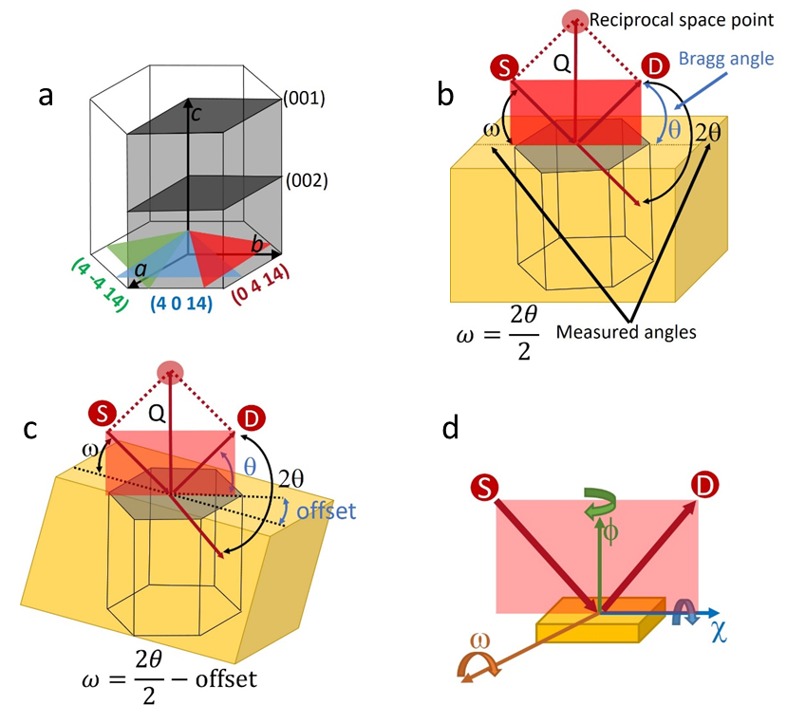
Figure SI1-2. (a) Hexagonal structure with the unit cell shaded. a, b and c are the lattice parameters; if the unit cell is not distorted, a=b. Several atomic c planes (001) and (002) are shown in dark gray. Three planes from the family {0 4 14} are depicted in green, blue and red. (b) Sketch of a sample (in yellow) in which the unit cell is well oriented. The source (S), the detector (D), the diffraction vector (Q), the reciprocal space point and the diffraction plane are shown in red. $ω$ is the angle between the incident beam and the surface of the sample, $θ$ is the angle between the diffracted beam and the crystallographic plane, and $2θ$ is the angle between the incident and the diffracted beams. (c) Sketch of a not well oriented sample. The offset is the angle between the surface of the sample and the face of the unit cell. (d) Sketch of the turns and axes of the diffractometer. $ϕ$ is the sample azimuthal axis, $ω$ is an axis perpendicular to the diffraction plane and $χ$ the axis perpendicular to both $ϕ$and $ω$.

The result is shown in Figure SI1-3, where the intensity of the peak is depicted on color contour lines as a function of χ and ω angles. The $χ$ angle at which the intensity of the peak is maximal is marked by the horizontal black line. The horizontal dashed red line represents the angle at which the sample is not tilted around $χ$. The difference between these two lines corresponds to the misorientation around the $χ$ axis.
As for the angle $ω$, the value at which the intensity is maximum is depicted by the vertical black line; the position at which the sample is not tilted aroud this axis ($ω=θ$) is outside of the range of the measurement. It is obvious that the situation illustrated in Figure SI1-2b is not satisfied since
$19.248=ω≠\frac{2θ}{2}=17.954→offset=1.294$ .
These measured tilts indicate that in order to orient the unit cell, it is necessary to tilt the sample by 0.56° around the χ axis and by 1.29° around the ω axis.
(deg)
(deg)

Figure SI1-3: $χ/ω$ map for the 008 diffraction peak, showing the intensity by color contour lines as a function of χ and ω angles. The solid black lines denote the position of the peak intensity maximum. The horizontal dotted line in red indicates the position in which the sample is not tilted around the $χ$ axis. The position in which the sample is not tilted around the ω axis is outside the range of the measurement.
A reciprocal space map (RSM) consists of a two-dimensional dependence of the intensity distribution around a given point in the reciprocal space (around the diffraction peak in the angular space) as a function of its coordinates q_{x} and q_{y}. The relations between the angles $2θ$ and $ω$ in the angular space and the coordinates q_{x} and q_{y} in the reciprocal space are shown in Figure SI1-4.

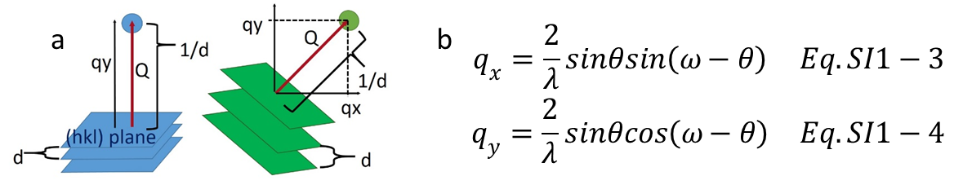
Figure SI1-4. (a) Sketch of the reciprocal space coordinates for two different set of planes and (b) equations relating the measurements in the angular and reciprocal spaces.

In order to find out whether the lattice is distorted, several measurements belonging to the same family of planes and performed at different $ϕ$ angles must been done. The multiplicity of the planes {0 4 14} is 12 but only 6 of their corresponding diffraction peaks are accessible to the measurement. We have calculated the lattice parameters through RSMs from the diffraction peaks 0 0 8, 0 0 20, and 6 maps (three of them are shown in FigureSI1-2a) from the family of planes $\left\{0414\right\}$. Two of those maps are presented in Figure SI1-5.

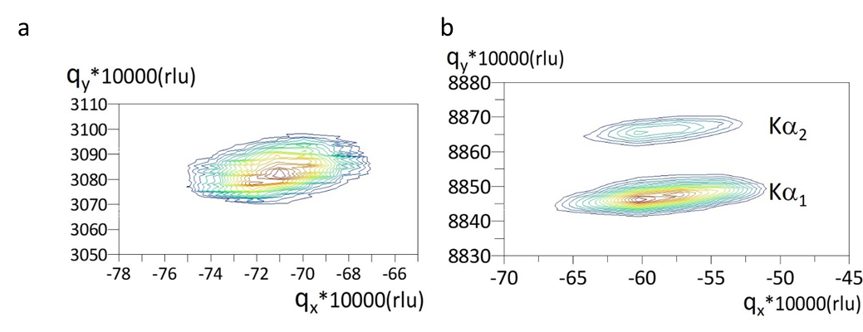
Figure SI1-5. RSMs for the diffraction peak (a) 008 and (b) 4 0 14. In (b), the bottom and top peaks belong to Ka₁ and Ka₂ spectral lines from the Co anode, respectively. rlu (reciprocal-lattice unit) = 2/$λ$ Å⁻¹.

Using Eqs. SI1-1 – SI1-4, we obtained the lattice parameters values as follows:
a=5.893 Å, b=5.894 Å, and c= 23.201 Å with an estimated uncertainty of ±0.005 Å.
Since, within the estimated error, a=b, we can conclude that the distortion amounts to $ε=\left(0.0\text{\%}±0.1\text{\%}\right).$

SI2. Structure and Infrared polar phonons
A convenient description of the magnetoplumbite structure relies on the concept of layered modules stacked along the hexagonal c axis. This concept is applied to a wide range of long-period hexagonal ferrites of natural and artificial origins [5-7]. In the case of M-type hexaferrites, the modules are formed by two fundamental types of blocks: the S – block with the formula [B₆O₈]²⁺ and the R-block with the formula [AB₆O₁₁]²⁻ where A=Ba, Sr, Pb and B=Fe. The S block has the structure of cubic spinel. The R layer consists of two kinds of columns, one being the trigonal bipyramidal element, and the other consisting of two stacked octahedral units. These columns are connected through equatorial edges of bipyramids and edges of shared facets. A framework of columns forms a set of cuboctahedral voids occupied by the divalent ions. Figure SI2-1 shows a segment of the magnetoplumbite type crystal structure built of the two basic blocks, R and S. These two blocks form the so-called M-block. The next in the sequence is the M block again that is turned by 180 degrees around the c axis. The asterisks in Figure SI2-1 indicate this block rotation. This stacking of two M-blocks rotated by 180 degrees relative to each other forms the unit cell of magnetoplumbite crystal structure.

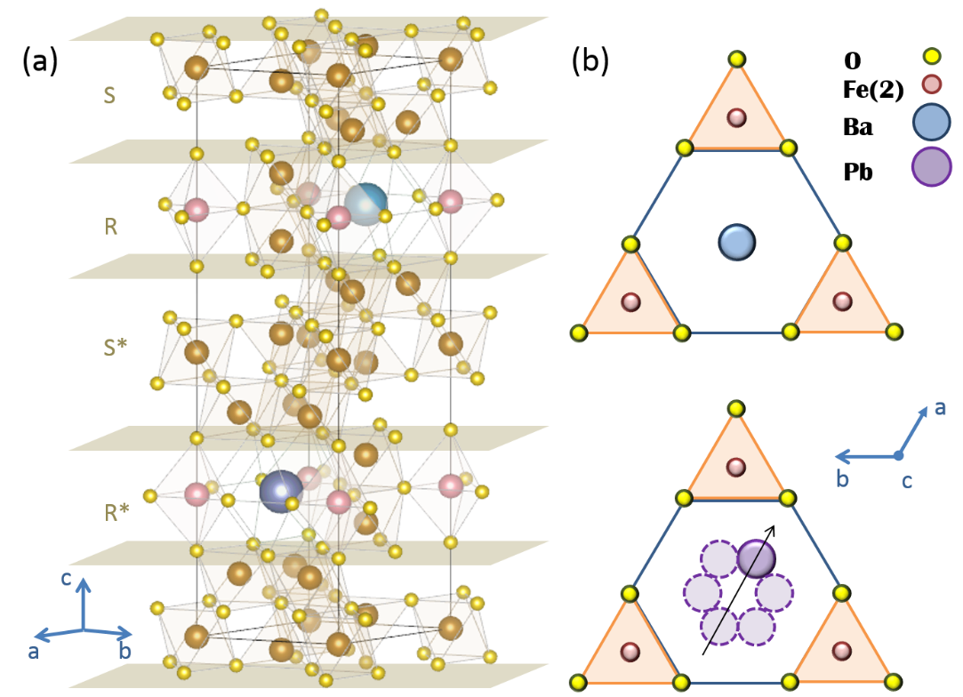
Figure SI2-1. Panel (a): stack of fundamental blocks that form the crystal structure of the M-type hexaferrite. The S and R blocks boundaries are indicated by yellow planes. The black lines indicate the unit cell of the crystal structure. Big balls correspond to large A²⁺ ions (for the compositions studied in this work, A²⁺ = Ba or Pb), middle-size balls indicate Fe ions (pink ones are iron ions, located in 2b positions, that surround the A²⁺ cuboctahedra), small bright-yellow balls are oxygen ions. Panel (b): schematic illustration of appearance of a dipole moment in the ab-plane. The Ba ion is located in the center of the polyhedron with all Ba-O bonds of equal length (top), while Pb is shifted towards one of the oxygen vertices (bottom), thus inducing a dipole moment (black arrow). The Pb ion can hop among six potential minima, which can be considered as a reorientation of the dipole moment around the c-axis.

Figure SI2-2 demonstrates room-temperature THz-IR spectra of reflection coefficient of Ba_{1-x}Pb_{x}Fe₁₂O₁₉ samples with x=0.1 and x=0.2 measured for polarization $E⊥c$. In the THz range the reflectivity was calculated from the complex dielectric permittivity spectra using the Fresnel expressions. The spectra above 1000 cm⁻¹ are smooth and contain few information; we used the flat phonon tails of reflectivity primarily to obtain the high-frequency values of dielectric permittivity. A set of excitations seen in the region 90-1000 cm⁻¹ are associated with polar lattice vibrations. Out of 17 E_{1u} phonon modes, predicted by the factor-group analysis (ref. [21] from the main text), we detected 14 lines for both compositions.
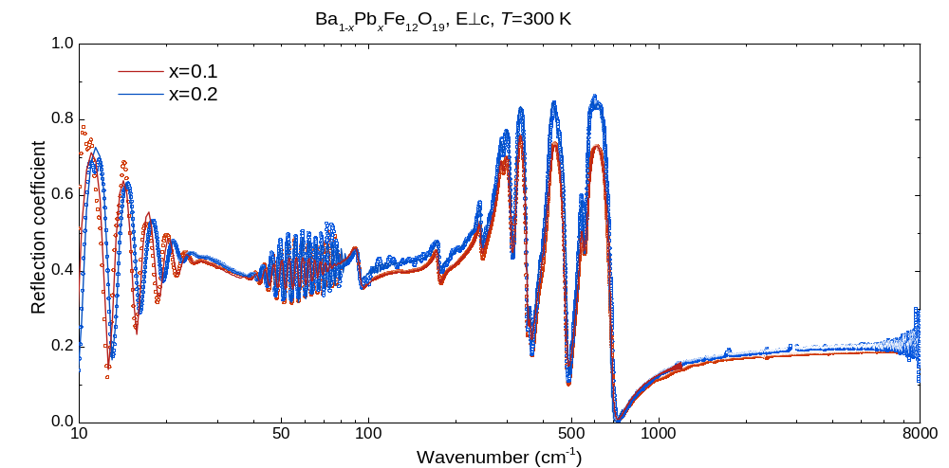
Figure SI2-2. Room-temperature spectra of reflection coefficient of Ba_{1-x}Pb_{x}Fe₁₂O₁₉ with x=0.1 (red) and x=0.2 (blue) measured for polarization $E⊥c$. Open dots are experimental data; solid lines correspond to modeling using Equation (1) from the main text to calculate the reflectivity spectra as described in the text. Spectra below ≈100 cm⁻¹ correspond to measured infrared data and to the reflectivity calculated from complex THz dielectric permittivity. Oscillations in the spectra below ≈20 cm⁻¹ and between 40 and 80 cm⁻¹ are due to interference of the radiation within the plane-parallel sample (Fabry-Perot effect).

SI3. Dielectric origin of the THz soft mode in Ba_{1-x}Pb_{x}Fe₁₂O₁₉
The magnetic or dielectric origin of the soft absorption line seen in the THz spectra can be identified according to the spectral shape of reflection coefficient spectrum. Two basic models used to describe the resonances are dielectric and magnetic Lorentzian lineshapes given, respectively, by equations: for the dielectric one,
$ε^{*}=ε´+iε"=$ $\frac{{}_{j}{}_{j}^{2}}{\left({}_{\dot{j}}^{2}-{}^{2}\right)+iγ_{j}}$ (SI3-1)
Here f_{j}=Δε_{j}ν_{j}² is the oscillator strength of the j-th resonance, Δε_{j} is its dielectric strength (dielectric contribution), ν_{j} represents the resonance frequency, γ_{j} is the damping factor; and for the magnetic one,
$µ^{*}=μ´+iµ"=$ $\frac{µ_{j}{}_{j}^{2}}{\left({}_{\dot{j}}^{2}-{}^{2}\right)+iγ_{j}}.$ (SI3-2)
Here μ´ and μ" are real and imaginary parts of complex magnetic susceptibility μ*=μ´+iμ", Δ$µ$_{j}ν_{j}² is the oscillator strength of the j-th resonance, Δ$µ$_{j} is its magnetic strength (magnetic contribution), ν_{j} represents the resonance frequency, and γ_{j} is the damping factor. With the above expressions, spectra of reflection R(ν) and transmission Tr(ν) coefficients of plane-parallel samples can be calculated using standard Fresnel expressions. It is known that unlike transmissivity, magnetic and dielectric resonances show up differently in the reflectivity R(ν) spectra [8]. This fact was used to determine the character of the THz soft mode seen in the terahertz spectra of Ba_{1-x}Pb_{x}Fe₁₂O₁₉ compounds. We modeled the room temperature transmissivity spectra of the soft mode for x=0.2 compound separately with dielectric and magnetic Lorentzians, Eqs. SI3-1, SI3-2, respectively. Having the obtained parameters, we reconstructed the reflection coefficient spectra for both cases. Utilizing the Fourier transform IR-spectrometer Bruker 113v equipped with a far-IR bolometer detector, we measured directly the reflection coefficient in the range 25-80 cm⁻¹. Three sets of data collected are shown in Figure SI3-1, clearly indicating a dielectric origin of the THz resonance.
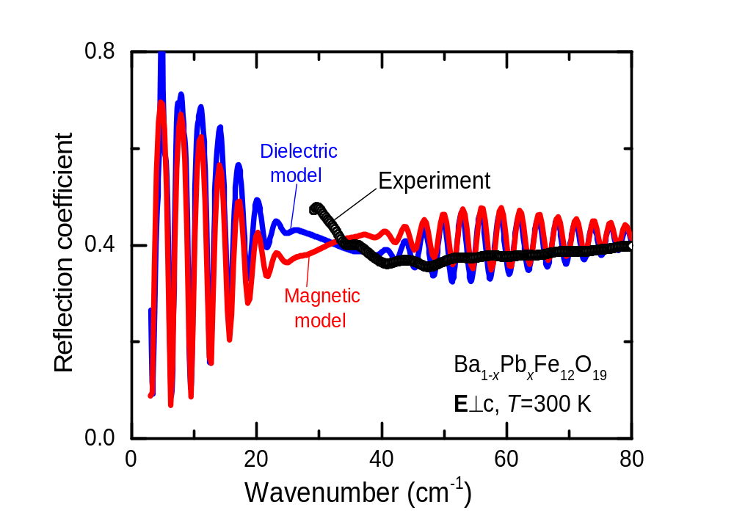
Figure SI3-1. Black dots show room-temperature spectrum of reflection coefficient of Ba_{1-x}Pb_{x}Fe₁₂O₁₉, x=0.2, crystal measured for polarization $E⊥c$. Solid lines correspond to results of least-square fitting of transmission coefficient spectrum, modeling the soft-mode resonance with a dielectric Lorentzian, Eq (SI3-1), (blue) and magnetic Lorentzian, Equation (SI3-2) (red).

SI4. Gigahertz peak in the spectra of Ba_{1-x}Pb_{x}Fe₁₂O₁₉, x=0.2

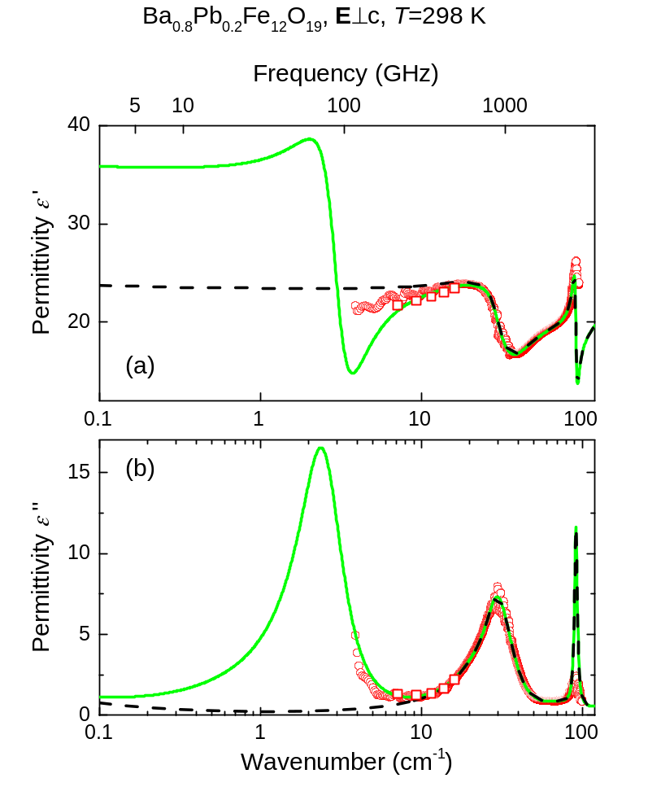
Figure SI4-1. Room temperature THz spectra of real (a) and imaginary (b) parts of complex dielectric permittivity of Ba_{1-x}Pb_{x}Fe₁₂O₁₉, x=0.2, for polarization $E⊥c$. Open squares represent the data obtained at frequencies of interference maxima in the transmission coefficient of the plane-parallel sample; this data provides an enhanced accuracy in the determination of dielectric parameters [9]. Full green lines show the results of a least-square fit that takes into account the dispersion in the experimental spectra below 20 cm⁻¹ and yields a radio-frequency real permittivity of ε’≈30-35 (Figure1 in main text); the fit evidences an excitation at ≈2 cm⁻¹. Dashed black lines correspond to a model without the spectral dispersion below 20 cm⁻¹, yielding a wrong value of the radio-frequency permittivity.
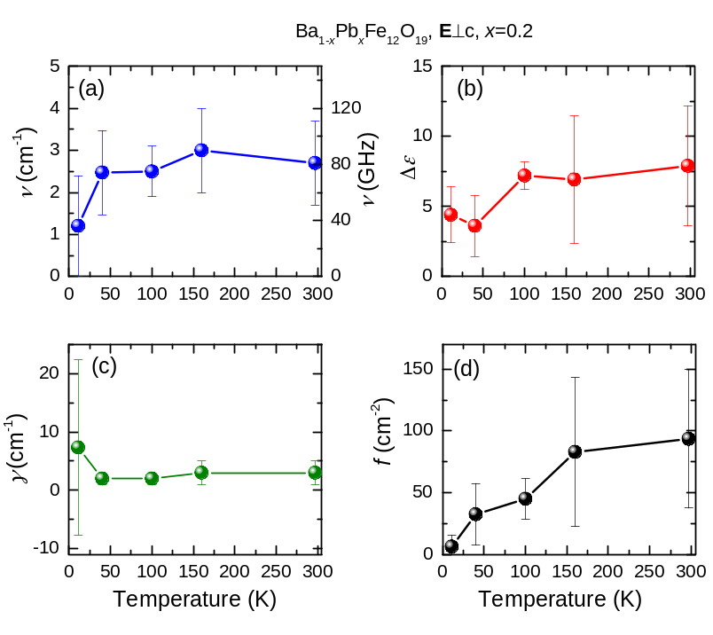
Figure SI4-2. Temperature dependences of parameters of the absorption peak detected near ≈2 cm⁻¹ (Figure SI4-1) in the spectra of Ba_{1-x}Pb_{x}Fe₁₂O₁₉, x=0.2, for polarization $E⊥c$: resonance frequency (a), dielectric strength (b), damping constant (c) and oscillator strength (d).

SI5. Molecular model of the THz soft mode
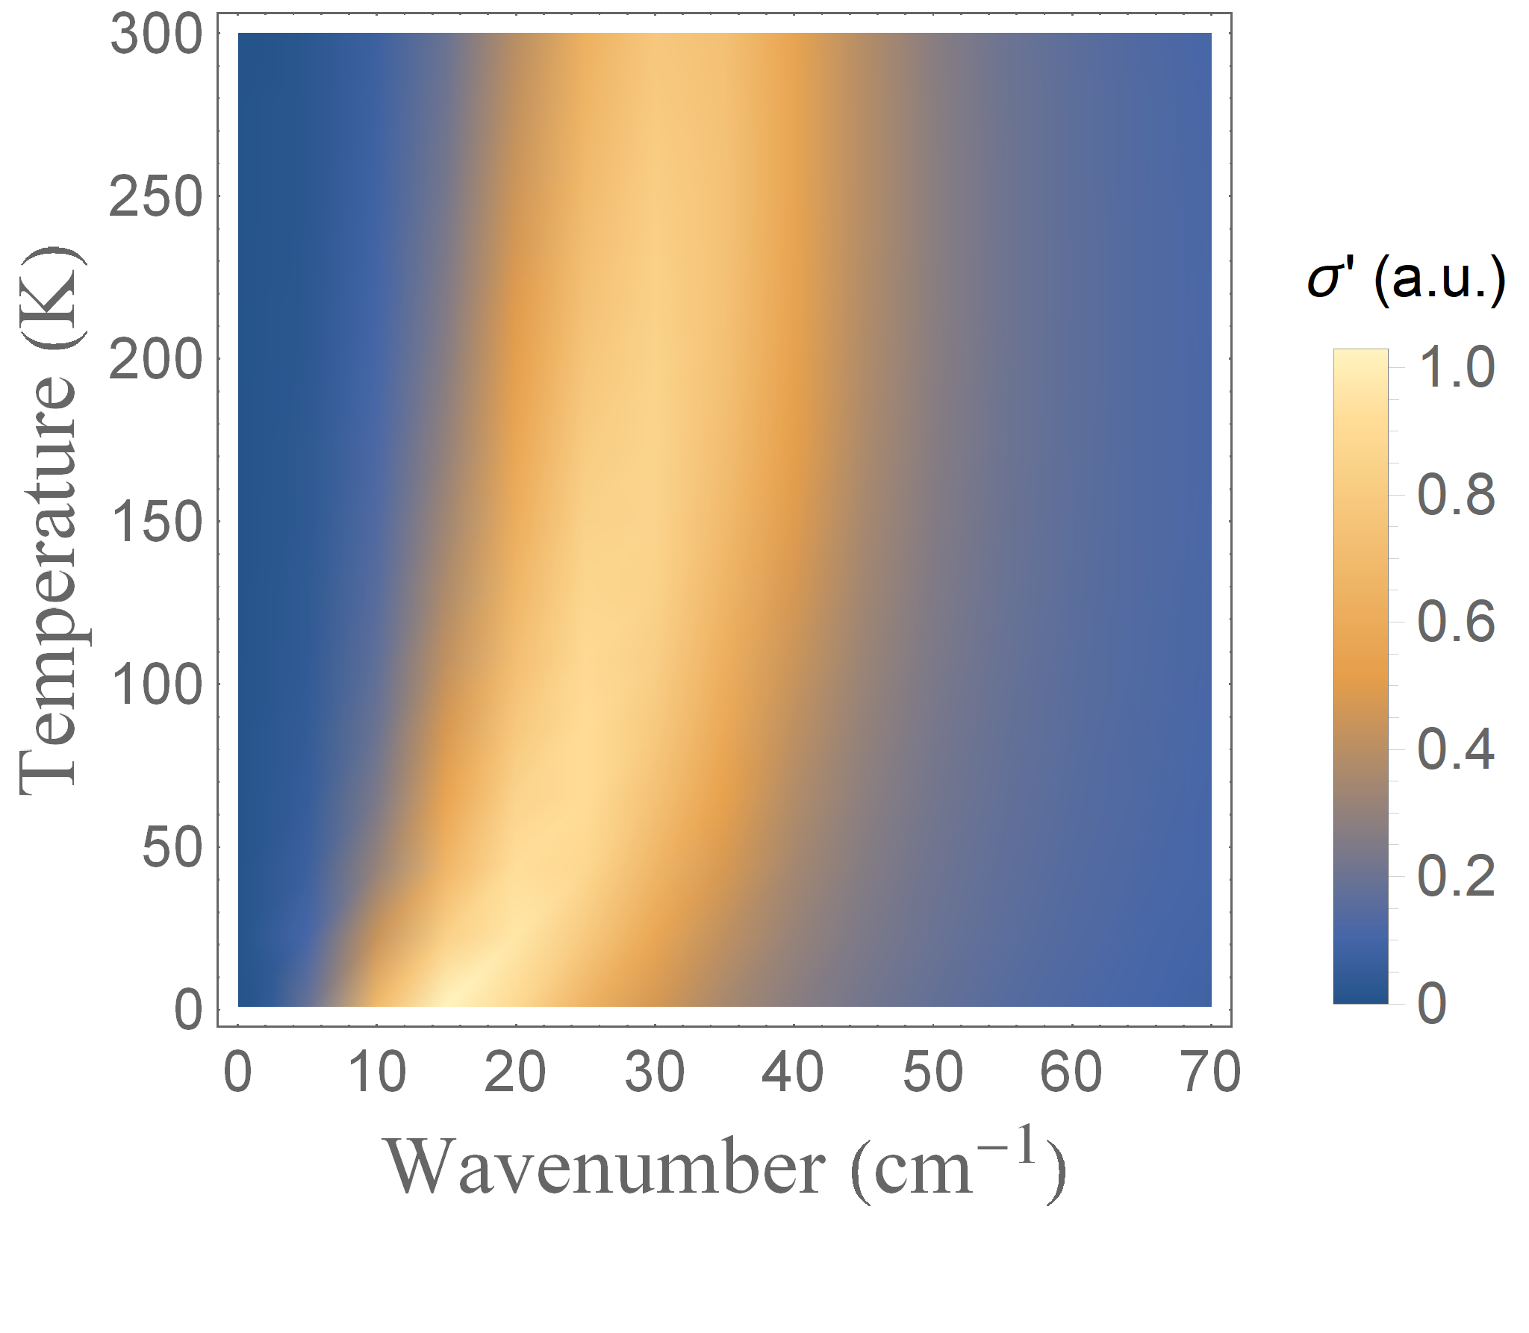

Figure SI5-1. Real part of the AC conductivity for Fe(2) ions in a quartic potential.

SI6. Relaxations in radio frequency range
Havriliak-Negami parameters of dielectric relaxation spectra of Ba_{1-x}Pb_{x}Fe₁₂O₁₉ crystals are provided in Figure SI6-1.
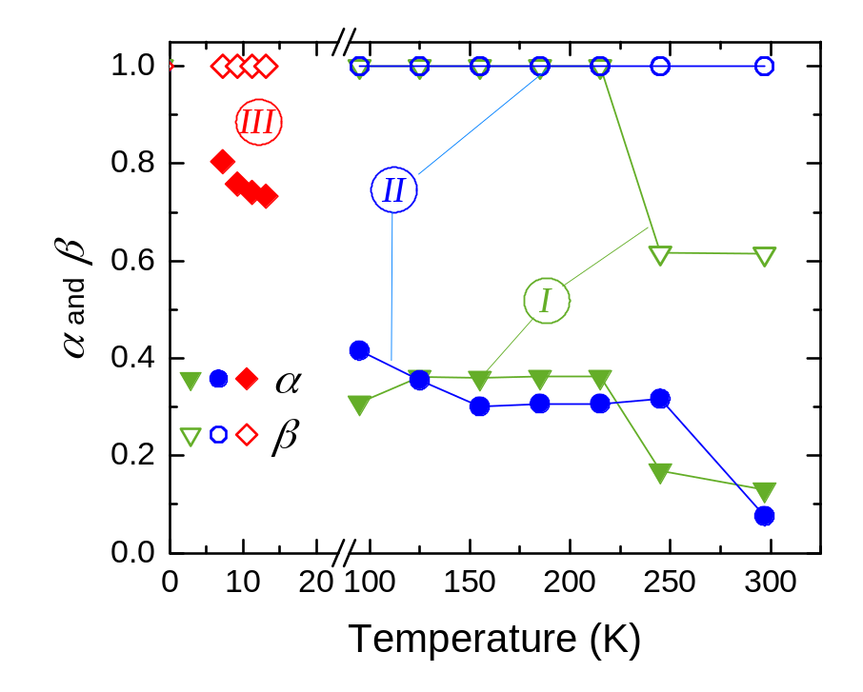
Figure SI6-1. Temperature dependences of parameters α (solid symbols) and β (open symbols) obtained by least-square fitting of radio-frequency dielectric spectra of real and imaginary parts of dielectric permittivity (Figure 1 in the main text) with the Havriliak-Negami expression (Eq. 4 in the main text). The Roman numerals in circles denote the three relaxational processes visible in the spectra (Figure 1 in the main text).
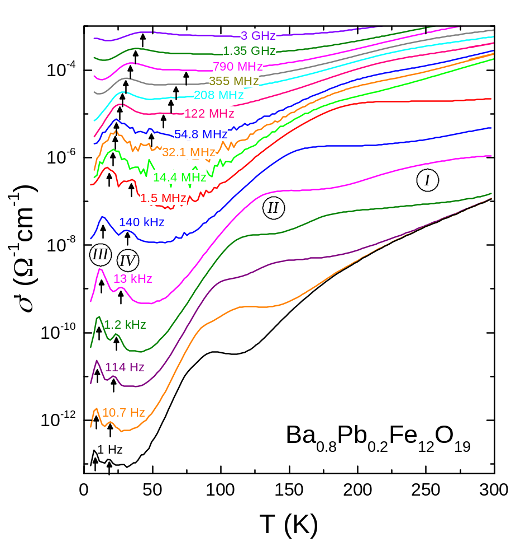
Figure SI6-2. Temperature dependence of the real part of the AC conductivity of Ba_{1-x}Pb_{x}Fe₁₂O₁₉ with x = 0.2, measured for polarization $E⊥c$. Results are shown for various frequencies between 1 Hz and 3 GHz. At frequencies above 100 MHz, the absolute values are of low precision (uncertainty of about a factor of two), whereas the relative temperature variation is of high significance, allowing for a meaningful estimate of the peak temperatures. Arrows indicate the positions of the two intrinsic low-temperature relaxation peaks used for estimates of their temperature-dependent relaxation times, shown by open symbols in Figure 3b. For the 13 kHz curve, the numbering of the four detected relaxational processes (non-intrinsic: I and II; intrinsic: III and IV) is indicated. The Roman numerals in circles denote the four relaxational processes visible in the spectra (Figs. 3 and 4 in main text).

SI7. Heat capacity of Ba_{1-x}Pb_{x}Fe₁₂O₁₉, x=0.1
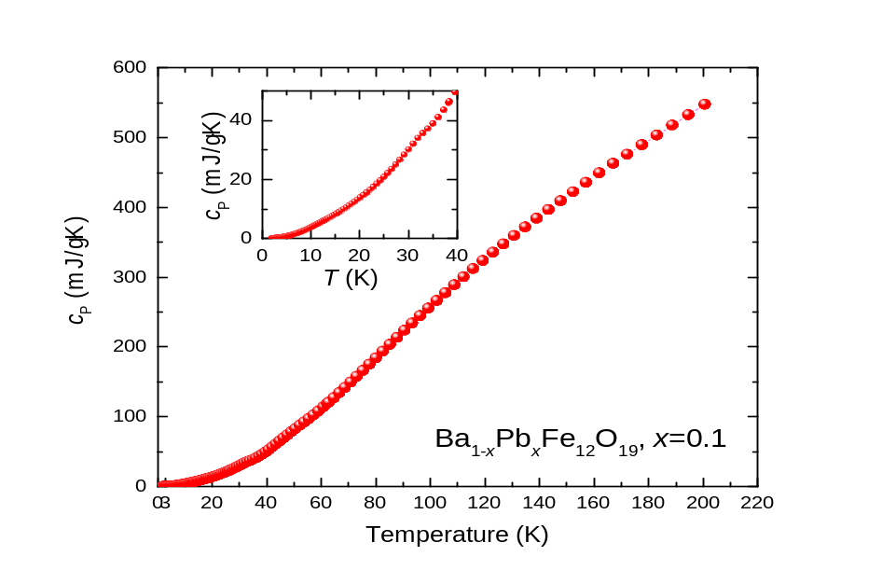
Figure SI7-1. Temperature dependence of heat capacity of the Ba_{1-x}Pb_{x}Fe₁₂O₁₉, x=0.1, single crystal. Inset shows c_{P}(T) behavior at low temperatures.

SI8. Magnetic/electric Force Microscopy
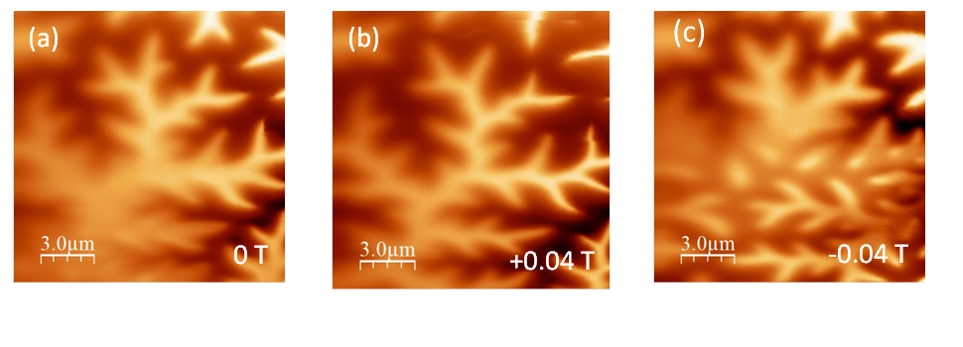
Figure SI8-1. MFM images of BaFe₁₂O₁₉ single crystal obtained at T=5 K under external magnetic field of 0 T (a), +0.04 T (b) and -0.04 T (c). In the mode of constant distance (lift=150nm) between the tip and the sample cleaved surface, the shift of the cantilever frequency under PLL control was measured. The observed change in contrast across the scanned field is associated with the unavoidable slope of the sample surface. Changes in the shapes of the domains caused by the external field are clearly visible. The crystallographic c-axis is perpendicular to the sample surface.

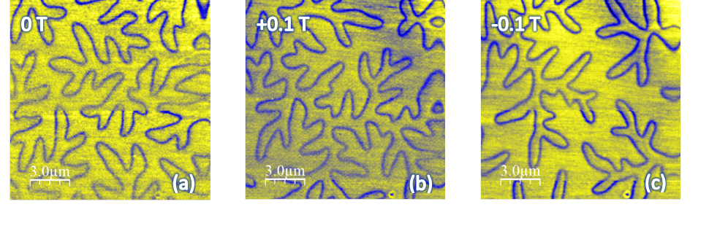
Figure SI8-2. EFM images of BaFe₁₂O₁₉ single crystal at T=5 K. The image was obtained by measuring the shift in resonance frequency of a nonmagnetic cantilever covered with PtIr film, in the mode of constant distance (lift=50 nm) between the tip and the cleaved sample surface. At the magnetic domains walls, there is an electric field gradient causing the resonance frequency shift. The observed domain walls change their positions and shapes depending on the applied external magnetic field of 0 T (a), 0.1 T (b) and -0.1 T (c). A defect visible at the bottom of the images can serve as a reference point for comparison. The crystallographic c-axis is perpendicular to the sample surface.
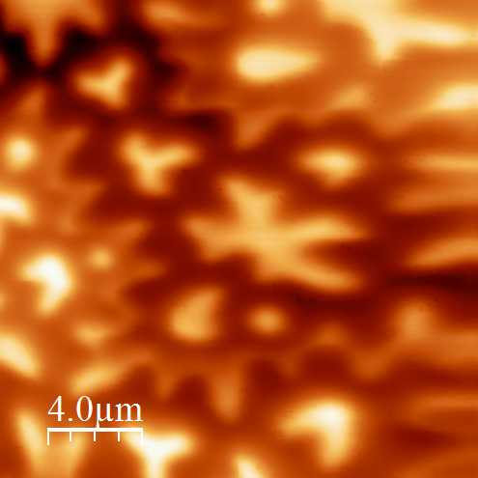
FigureSI8-3. MFM image of a Ba_{1-x}Pb_{x}Fe₁₂O₁₉ single crystal(x=0.2) at T=5 K in zero magnetic field. The emanated magnetic field repolarizes the MFM tip [10]. The phase map was obtained with a lift of 150 nm. The crystallographic c-axis is perpendicular to the sample surface.

SI9. Magnetic relaxation in the radio-frequency spectra of Ba_{1-x}Pb_{x}Fe₁₂O₁₉, x=0.1
In the spectra of complex magnetic susceptibility of single crystalline Ba_{0.9}Pb_{0.1}Fe₁₂O₁₉, at frequencies from 0.1 Hz to 1490 Hz, we detected a relaxational process; its characteristic frequency shifts with temperature, see FigureSI8-1. We note that this relaxation occurs within the same frequency region as the dielectric relaxations I and II observed in the spectra of dielectric permittivity, below 1 MHz, see Figure 3 in the main text. Both relaxations red-shift during cooling. We connect both relaxations with the domains dynamics similar to those observed in the compound with a higher concentration of lead, Ba_{0.3}Pb_{0.7}Fe₁₂O₁₉ [11]. The temperature-activated behavior of the corresponding relaxation time is presented in FigureSI9-2.
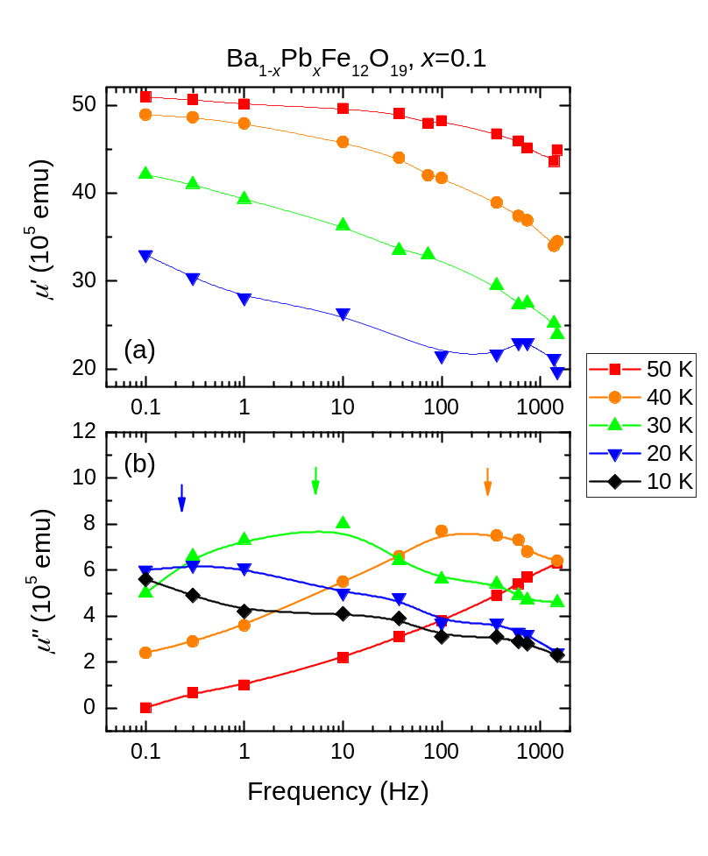
Figure SI9-1. Spectra of real μ´ (a) and imaginary μ´´ (b) parts of complex magnetic susceptibility μ*= μ´ + i μ´´ of Ba_{1-x}Pb_{x}Fe₁₂O₁₉, x=0.1, crystal measured at different temperatures for driving magnetic field H_{ac} || c. The magnetic resonance enters the useful frequency window at a temperature between 40 and 50 K, and it moves outside the window at about 10 K. Arrows indicate the positions of the magnetic absorption peaks.

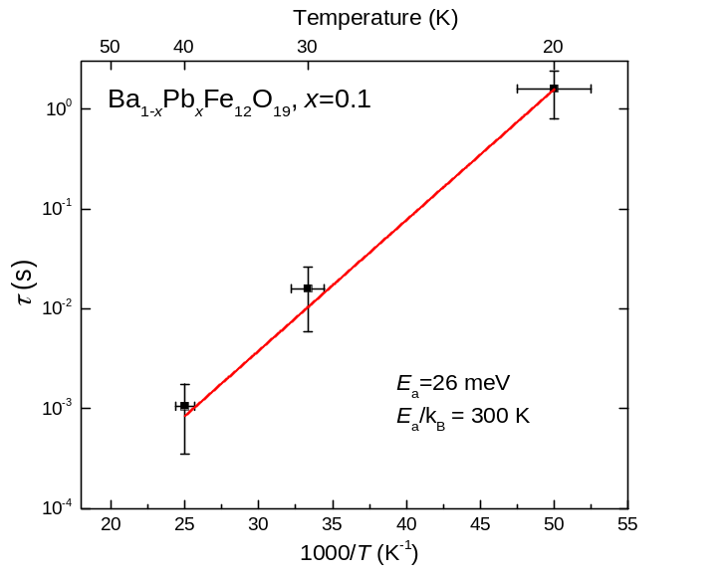
Figure SI19-2. Arrhenius plot of the magnetic relaxation time characteric of the relaxational band observed in spectra of magnetic susceptibibility for the Ba_{1-x}Pb_{x}Fe₁₂O₁₉, x=0.1, crystal for driving magnetic field H_{ac} || c (Figure SI9-1). Line shows activated behavior.

SI10. Ferromagnetic resonance in Ba_{1-x}Pb_{x}Fe₁₂O₁₉, x=0.1
We measured the reflectivity spectra in the frequency range where the THz soft mode is located (20-60 cm⁻¹), and the complex transmissivity at lower frequencies (4-30 cm⁻¹), under varying external magnetic fields (EMF) μ₀H_{EMF}=0-7 T where μ₀ is the vacuum permeability. In the transmissivity spectra we detected a shallow resonance that enters the measurement frequency window at H_{EMF}=3 T and shifts to higher frequencies with the increase of the EMF. The peak frequency of the resonance linearly depends on the field with the slope k=0.95±0.5 cm⁻¹/T. The field-dependent frequency can be expressed as [12]:
$ωg\frac{μ_{B}}{ħ}H_{EMF}$μ₀, (SI10-1)
where g is the g-factor. From the above expression for hexaferrite with g=2 [13] we obtained ν[cm⁻¹]~0.93 μ₀H_{EMF}(T) which is consistent with our observation (Figure SI10-1) . Extrapolation of ν(H_{EMF}) to H_{EMF}=0 gives the peak frequency of the FMR at zero field ν(H_{EMF}=0)=1.7±0.2 cm⁻¹ (51±6 GHz), a value typical of hexaferrites [14].
We can exclude the coupling between the THz soft excitation and the observed ferromagnetic resonance which would lead to a transfer of the soft mode intensity, since the oscillator strength Δµν² of the resonance is temperature independent, Figure SI4-2(d).

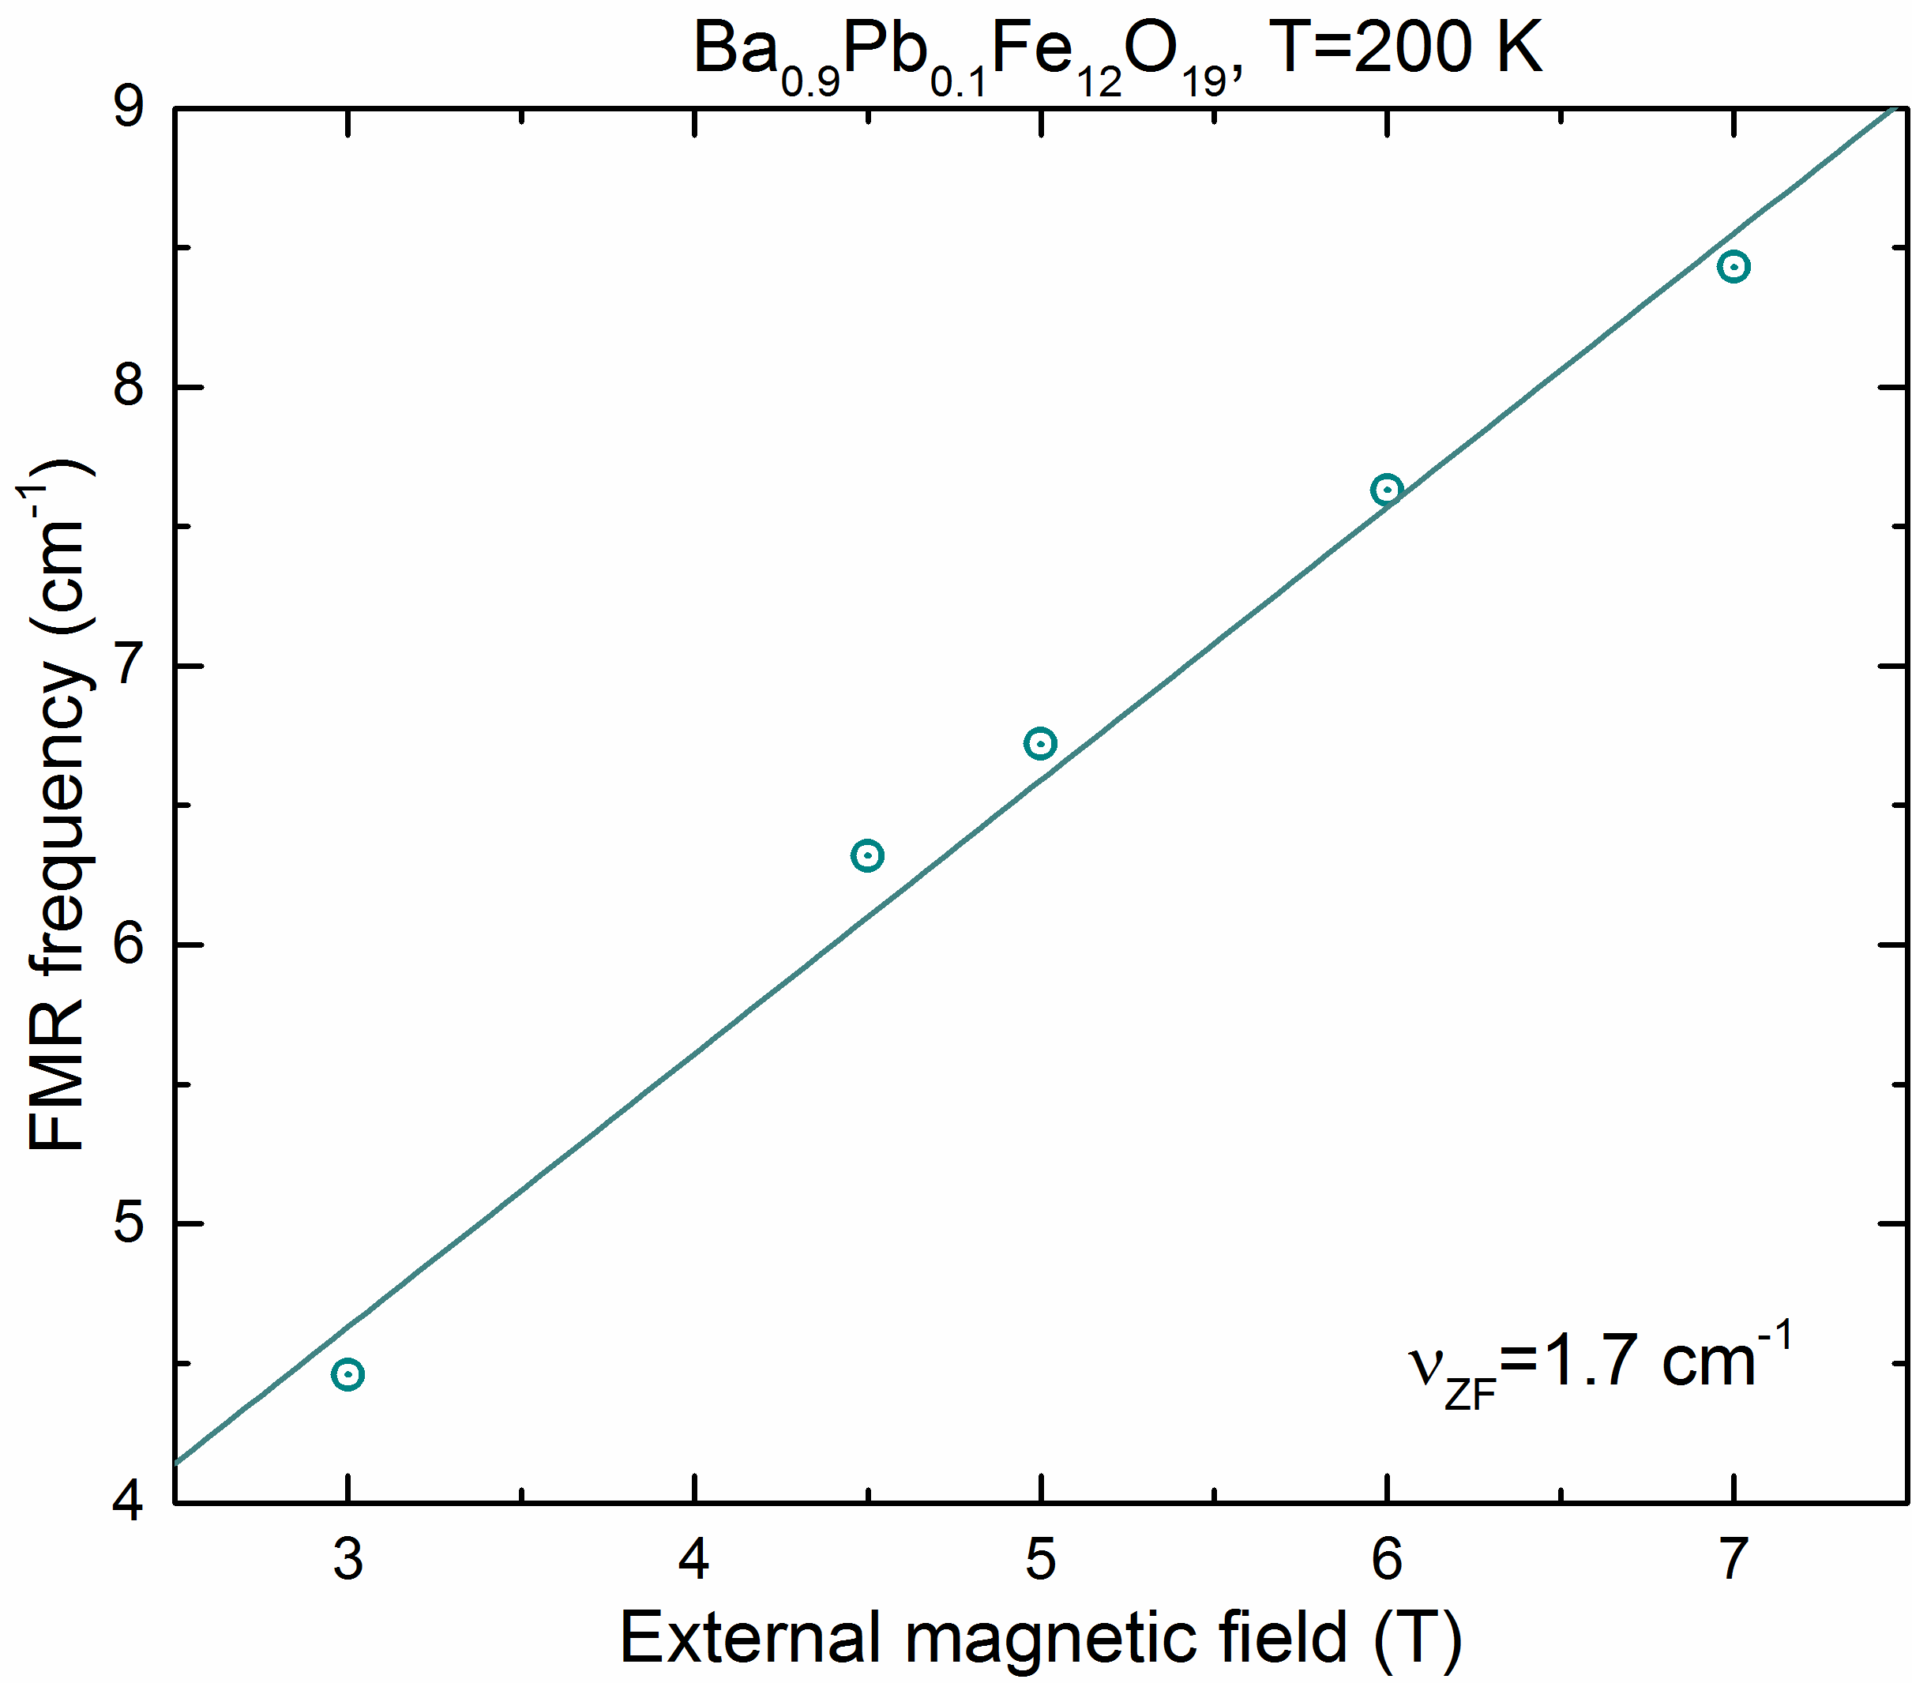
Figure SI10-1. Frequency position of the ferromagnetic resonance as a function of external magnetic field in Ba_{1-x}Pb_{x}Fe₁₂O₁₉ with x = 0.1 for polarization $E⊥c$. Dots are experimental data; line represents a linear approximation with Eq (SI10-1). Extrapolation of the model to the zero frequency gives the value of the FMR ν_{ZF}=1.7±0.2 cm⁻¹ or (51±6) GHz.
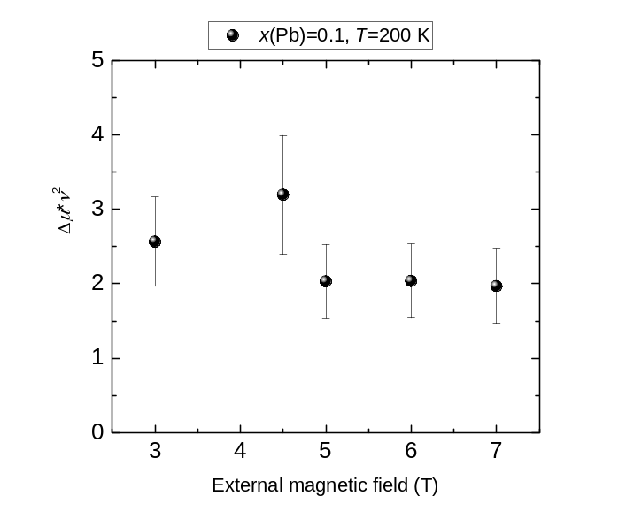
Figure SI10-2. Oscillator strength of the ferromagnetic resonance as a function of external magnetic field.

References
1. Kwon, S. J. A suggestion on the standard x-ray powder diffraction pattern of barium ferrite. Powder Diffr. 7, 212–214 (1992).
2. Vinnik, D. et al. Magnetic and Structural Properties of Barium Hexaferrite BaFe12O19 from Various Growth Techniques. Materials (Basel). 10, 578 (2017).
3. Townes, W. D., Fang, J. H. & Perrotta, A. J. The crystal structure and refinement of ferrimagnetic barium ferrite, BaFe 12 O 19. Zeitschrift für Krist. 125, 437–449 (1967).
4. Watanabe, K. Growth of minute barium ferrite single crystals from a Na2O-B2O3 flux system. J. Cryst. Growth 169, 509–518 (1996).
5. Pullar, R. C. Hexagonal ferrites: A review of the synthesis, properties and applications of hexaferrite ceramics. Prog. Mater. Sci. 57, 1191–1334 (2012).
6. Delacotte, C. et al. Structure determination and crystal chemistry of large repeat mixed-layer hexaferrites. IUCrJ 5, 681–698 (2018).
7. Kimura, T. Magnetoelectric Hexaferrites. Annu. Rev. Condens. Matter Phys. 3, 93–110 (2012).
8. Mukhin, A. A. et al. Submillimeter and far IR spectroscopy of magneto- and electrodipolar rare-earth modes in the orthoferrite TmFeO3. Phys. Lett. A 153, 499–504 (1991).
9. Gorshunov, B. et al. Terahertz BWO-spectrosopy. Int. J. Infrared Millimeter Waves 26, 1217–1240 (2005).
10. Neu, V., Vock, S., Sturm, T. & Schultz, L. Epitaxial hard magnetic SmCo 5 MFM tips – a new approach to advanced magnetic force microscopy imaging. Nanoscale 10, 16881–16886 (2018).
11. Alyabyeva, L. N. et al. Influence of chemical substitution on broadband dielectric response of barium-lead M-type hexaferrite. New J. Phys. 21, 063016 (2019).
12. Manuilov, S. A. & Grishin, A. M. Pulsed laser deposited films: Nature of magnetic anisotropy II Pulsed laser deposited Y 3 Fe 5 O 12 films: Nature of magnetic anisotropy II. J. Appl. Phys. J. Appl. Phys. J. Appl. Phys. J. Appl. Phys. Appl. Phys. Lett. (2010).
13. De Bitetto, D. J. Anisotropy Fields in Hexagonal Ferrimagnetic Oxides by Ferrimagnetic Resonance. J. Appl. Phys. 35, 3482–3487 (1964).
14. Labeyrie, M., Mage, J., Simonet, W., Desvignes, J. & Le Gall, H. FMR linewidth of barium hexaferrite at millimeter wavelengths. IEEE Trans. Magn. 20, 1224–1226 (1984).

