Supporting Information
Super-Assembled Compressible Carbon Frameworks Featuring Enriched Heteroatom Defect Sites for Flexible Zn-Air Batteries
Huaipeng Pang¹, Meng Wang¹, Peipei Sun¹, Wenshuai Zhang¹, Dan Wang¹, Runhao Zhang^{1,2}, Li Qiao¹, Weijie Wang¹, Meng Gao¹, Yong Li¹, Jiang Chen³, Kang Liang⁴, and Biao Kong^{2,5}
¹ National Supercomputer Research Center of Advanced Materials, Advanced Materials Institute, Qilu University of Technology (Shandong Academy of Sciences), Jinan 250014, P. R. China
² Department of Chemistry, Shanghai Key Lab of Molecular Catalysis and Innovative Materials iChEM, Fudan University, Shanghai 200433, P. R. China
³ ARC Research Hub for Computational Particle Technology, Monash University, Melbourne 3000, Australia
⁴ School of Chemical Engineering and Graduate School of Biomedical Engineering, The University of New South Wales, Sydney 2052, Australia
⁵ Yiwu Research Institute of Fudan University, Yiwu, Zhejiang 322000, P. R. China

Correspondence: Biao Kong (bkong@fudan.edu.cn) or Meng Wang (wangmeng@sdas.org)
These authors contributed equally: Huaipeng Pang, Meng Wang
Experimental Section
Fabrication of N, S co-carbon framework (N₁S₁@CF): According to our previous work, CNF suspensions were prepared by TEMPO-mediated oxidation and high-pressure homogenization. To prepare N₁S₁@CF, 0.15 g of CNT was dispersed in 6 mL of deionized water and stirred for 30 min, then 0.15 g of CNF suspension (1.0 wt.%, 14 g) was dispersed in 30 ml of deionized water and stirred for 30 min, and the CNT suspension was mixed with the CNF suspension and sonicated for one hour (mass ratio of CNT: CNF = 1:1). 0.1 g of dicyandiamide and 0.1 g of thiourea were dispersed into the mixed solution for 1 h to obtain a homogeneous precursor, which was then transferred to a polytetrafluoroethylene mold (50 mm × 10 mm × 10 mm) for subsequent directional freeze casting and drying. A homemade fast-freezing device consisting of a metal base and mold was designed. A plastic mold containing 5 ml of precursor solution is placed on the metal base and immersed in liquid nitrogen. Until the upper surface of the solution is frozen, freeze-drying is then performed to obtain N, S-doped CNT/CNF frameworks. The frameworks were annealed under N₂ atmosphere at a rate of 2°C min⁻¹ to 200°C for 2 h, and then pyrolyzed at a rate of 5°C min⁻¹ to 900°C for 2 h. Thus, N, S-doped carbon frameworks were prepared. As a comparison, N, S-doped CNT/CNF carbon frameworks with different ratios (N₁S₂@CF and N₂S₁@CF) were also prepared by the same process. The content of dicyandiamide and thiourea in N₁S₂@CF and N₂S₁@CF is 0.15:0.3 and 0.3:0.15, respectively.
Materials Characterization: SEM (S4800, Hitachi) was applied to characterize the morphology of the electrode materials. TEM measurements were performed on a Talos F200X. Raman spectra were collected from a Horiba JY iHR550 system with excitation wavelength at 633 nm. XRD (Bruker D8 ADVANCE) was used to study the crystallite characteristic of the catalysts. BET method and BJH model were recorded by SSA-4000 applied for specific surface and pore size distribution. Thermo Scientific K-Alpha spectrometer was used to perform XPS to characterize the chemical composition.
Electrocatalytic activity evaluation: Electrochemical tests were performed with a three-electrode configuration rotating electrode and a CHI 760E electrochemical workstation. For electrode preparation, 2 mg of catalyst was mixed in a solution containing 0.2 mL of Nafion and 0.8 mL of ethanol, then sonicated for 0.5 h, and then carefully dropped on rotating disk electrode (RDE, d =3 mm) and rotating ring disk electrode (RRDE, d=4 mm) upper surface. Specifically, a total of 20 μL of the slurry was carefully dropped on the surface of the RDE in several times. Similarly, a total of 37.5 μL of the slurry was dropped on the surface of the RRDE in several times, and stood for drying. CV, LSV, and long-cycle durability performance tests can be performed by electrochemical workstations. The electrolyte was bubbled with argon or oxygen was bubbled through the electrolyte for 30 minutes prior to testing. ORR was performed in 0.1 M KOH at 10 mV s⁻¹. The electron transfer number (n) for ORR is obtained from the K-L equation:
$\frac{1}{J}=\frac{1}{J_{L}}+\frac{1}{J_{K}}=\frac{1}{Bω\frac{1}{2}}+\frac{1}{JK}$ (1)
$B=0.62nFC_{O_{2}}D_{O_{2}}^{\frac{2}{3}}v^{-\frac{1}{6}}$ (2)
Where J is the current density, J_{L} represent the kinetic current density, and J_{K} is limiting diffusion current density, 𝜔 is the rotation speed. The Faraday constant is indicated as F (96485 C mol⁻¹). The concentration of O₂ is indicated as C₀ (1.2 × 10⁻⁶ M). The diffusion coefficient of O₂ is indicated as D₀ (1.9 ×10⁻⁵ cm² s⁻¹). The kinetic viscosity is indicated as ν (0.01 cm² s⁻¹).
The hydrogen peroxide yield (H₂O₂%) was calculated with the following equation:
$H_{2}O_{2}\%=200×\frac{\frac{I_{R}}{N}}{I_{D}+\frac{I_{R}}{N}}$ (3)
Meanwhile, n was calculated with the following equation:
$n=200×\frac{I_{D}}{I_{D}+\frac{I_{R}}{N}}$ (4)
Where I_{D} is the disk current, I_{R} is the ring current and N is the ring collection efficiency (N =0.424).
Assembly and Measurement of Aqueous Zn-Air Batteries: For the ZAB test, the battery was assembled of carbon cloth loaded with electrocatalyst as the air electrode, metal zinc sheet as the negative electrode, and 6.0 M KOH containing 0.2 M Zn (CH₃COO)₂ as the electrolyte. The electrocatalyst were dripped on the carbon cloth with a loading amount of 1.0 mg cm⁻². Then a liquid-box battery was assembled by the two electrode sheets with three different acrylic plates, and the middle volume was filled with electrolyte. The performance of the ZAB was carried out on the LAND CT2001ALAND BT 2000 system, such as: discharge under various current densities and constant current charge-discharge cycle tests. In addition, the polarization curve and electrochemical impedance curve were performed utilizing CHI 760E.
The specific capacity (C) was calculated according to the equation below:
$C=\frac{I×t}{m}$ (5)
where the I (mA cm⁻²) represent the current density and t (h) is the time and m (g cm⁻²) is the quality consumed Zn anode.
The power density (P) of the ZAB was calculated by:
$P=IV$ (6)
where I is the discharge current density and V is the voltage.
Assembly and Measurement of Flexible Solid-State Zn-Air Batteries: In a typical assembly of a flexible all-solid Zn-air battery (FZAB), a zinc sheet is used as the negative electrode and the gel polyvinyl alcohol electrolyte is attached to one side of the zinc sheet. The flexible N₁S₁@CF is used directly as the air electrode and is affixed to the other side of the gel electrolyte. Finally, a piece of pressed nickel foam is used as a casing and as a test lead for the cell test. Power and current density are calculated based on the area of the entire N₁S₁@CF catalyst sheet. The performance of the FZABs was carried out on the LAND CT2001ALAND BT 2000 system. The charge-discharge polarization was determined utilizing an electrochemical workstation (CHI 760E).
Gel polyvinyl alcohol electrolyte (GPE) synthesis: 3 g of polyvinyl alcohol (PVA) powder (MW = 1788) was dissolved in 24 mL of deionized water and then stirred continuously in a water bath at 90 °C for 1 h. 6 mL of KOH solution (3 g of solute) was then slowly added to the PVA solution and stirred continuously in a water bath at 90 °C for 0.5 h. Next, the mixture was poured into a glass Petri dish to make the gel electrolyte film was then refrigerated at -5 °C for 12 h and finally transferred to 3 °C for storage before use.
DFT calculations: All DFT calculations were performed using the VASP program. The DFT functional was utilized at the Perdew−Burke−Ernzerhof (PBE) level. The project-augmented wave (PAW) method was used to represent the core−valence electron interaction. The k-points were sampled using a 2*2*1 Monkhorst-Pack grid. The valence electronic states were expanded in plane-wave basis sets with energy cutoff at 500 eV. A Gaussian smearing of 0.05 eV was applied during the geometry optimization. The convergence criteria for the iteration in self-consistent field (SCF) was set at 10⁻⁵ eV, and the residual force for optimizing atom positions was less than 0.02 eV/Å.

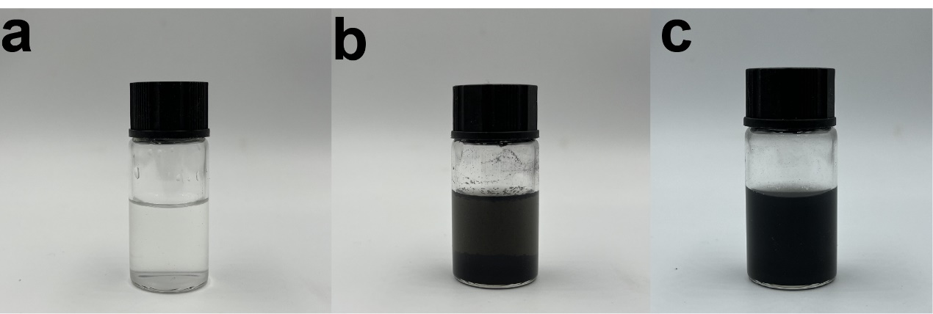
Fig. S1. Photographs of (a) CNF solution, (b) CNT solution, and (c) CNT/CNF mixed solution.

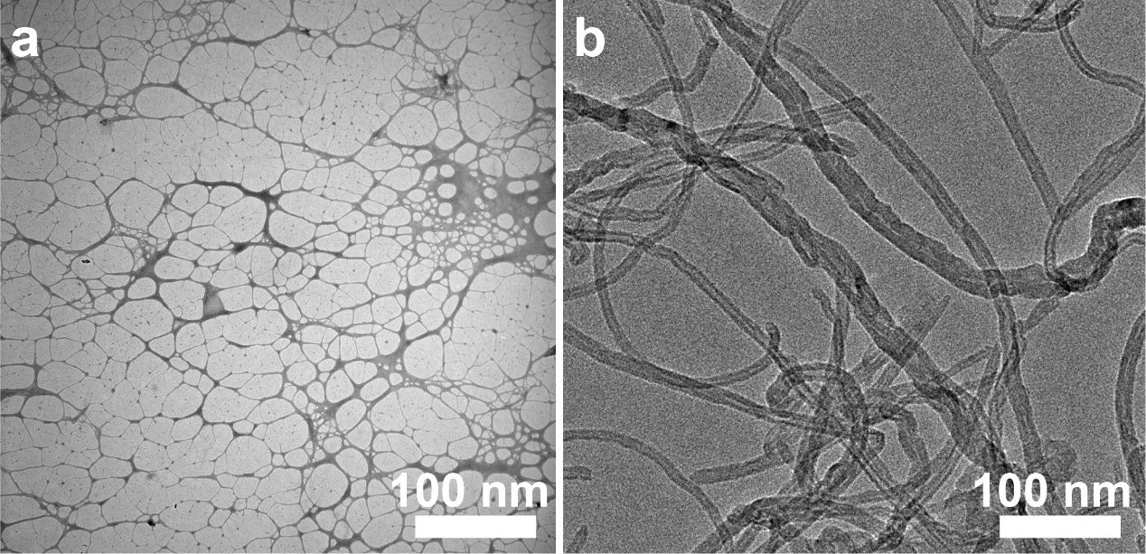
Fig. S2. TEM images of (a) CNF, and (b) CNT.

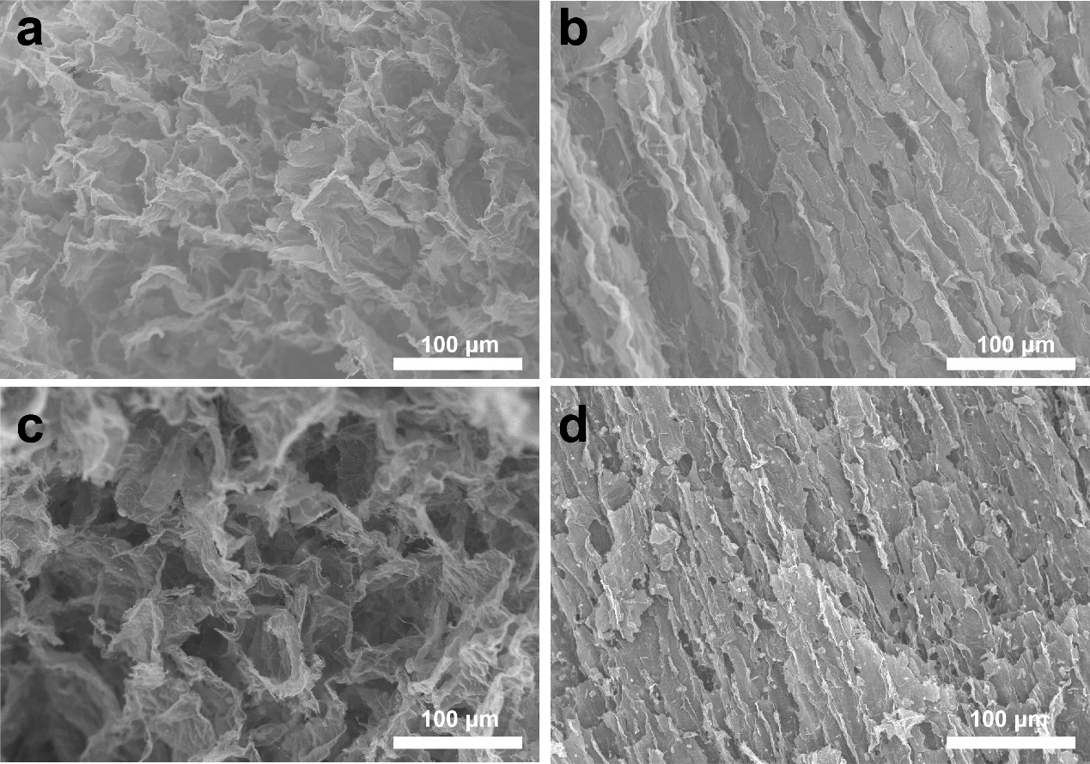
Fig. S3. (a-b) SEM images under different directions of N₁S₂@CF. (c-d) SEM images under different directions of N₂S₁@CF.

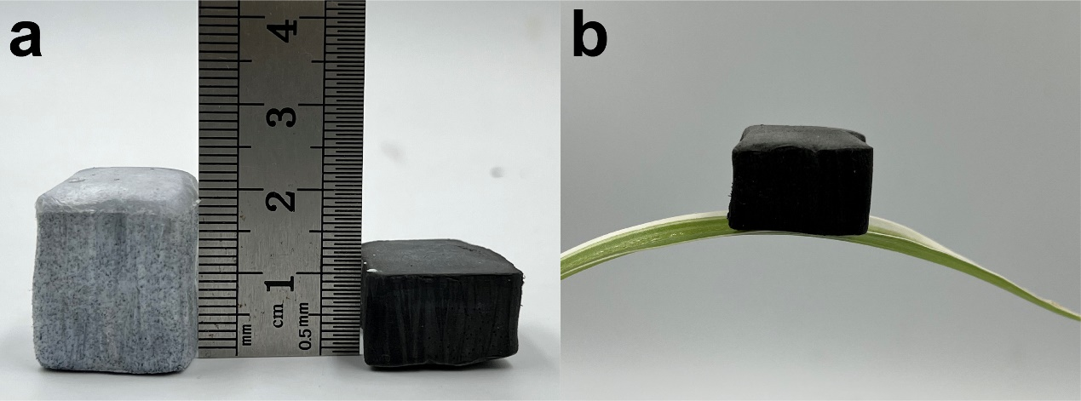
Fig. S4. (a) Comparison of frameworks before and after pyrolysis. (b) N₁S₁@CF stands stably on top of a leaf.

Fig. S5. (a) Stress-strain curves of N₁S₁@CF at different compressive strains. (b) Stress-strain curves of N₁S₁@CF at 50% compressive strain with 1, 10 and 100 cycles, respectively.

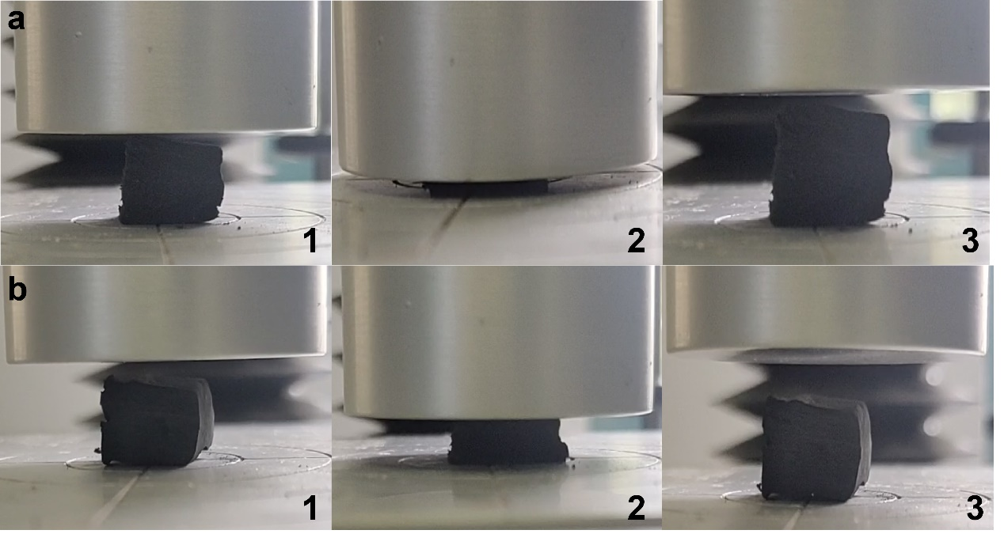
Fig. S6. (a) Photograph of N₁S₁@CF at 95% compressive strain. (b) Photograph of N₁S₁@CF at 50% compressive strain.

Fig. S7. XRD patterns of CF and N₁S₁@CF.

Fig. S8. Raman spectra of different samples, the relative I_{D}/I_{G} ratios are also listed.

Fig. S9. (a) Adsorption-desorption isotherms. (b) Pore size distributions curves.

Table S1. Specific surface area of the synthesized composite electrocatalyst.
Catalyst | SSA (m² g⁻¹)
N₁S₁@CF | 144.36
N₁S₂@CF | 95.561
N₂S₁@CF | 102.72

Table S2. Atomic percentage of each element in the N₁S₁@CF catalyst obtained by XPS.
Catalyst | C (ct %) | N (at %) | S (at %) | O (at %)
N₁S₁@CF | 86.65 | 4.47 | 3.15 | 5.73

Fig. S10. The configurations of N dopants of N₁S₁@CF.

Fig. S11. ORR polarization curves of the N₁S₁@CF after 100 cycles of compression at 50% strain.

Table S3. Summary of the catalytic activities of the reported composite electrocatalysts in 0.1 M KOH.
Catalyst | E_{onset} (V vs. RHE) | E_{1/2}(V vs. RHE) | I_{k} (mA cm⁻²)  Vs. RHE | Ref
N₁S₁@CF | 0.98 | 0.88 | 6.52 | This work
Pt/C | 0.98 | 0.85 | 6.2 | This work
Fe-N_{x}-C | 1.05 | 0.91 | 5.44 | ¹
N, S-WC | 0.98 | 0.86 | 5.31 | ²
CoNC-GF | 0.99 | 0.87 |  | ³
Co-N-CNF | 0.893 | 0.79 |  | ⁴
FeCoN_{x}-CN | 0.954 | 0.886 | 6.3 | ⁵
NiFe@N-CFs | 0.94 | 0.82 |  | ⁶
FeP/Fe₂O₃@ NPCF | 0.95 | 0.838 | 5.35 | ⁷
N/E-HPC-900 | 0.98 | 0.85 | 5.7 | ⁸
N-GCNT/FeCo | 1.03 | 0.92 | 5.4 | ⁹

Table S4. The fitting value of each element of the equivalent circuit in the electrochemical impedance diagram of N₁S₁@CF.
Samples | Rs  (Ω cm⁻²) | CPE-1  (Ω cm⁻²) | Rc  (Ω cm⁻²) | CPE-2  (Ω cm⁻²) | Rt  (Ω cm⁻²)
N₁S₁@CF | 8.36 | 0.189 | 11.98 | 0.086 | 109.7
N₁S₂@CF | 8.79 | 0.093 | 16.16 | 0.081 | 136.3
N₂S₁@CF | 8.96 | 0.138 | 18.26 | 0.053 | 210.3

Fig. S12.EIS of the N₁S₁@CF cathode.

Fig. S13. Voltage gap of (a) 50th h, (b) 101th h, (c) 231th h of the N₁S₁@CF based ZAB during charge-discharge.

References
1 Han, J., Meng, X., Lu, L., Bian, J., Li, Z. & Sun, C. Single‐Atom Fe‐Nx‐C as an Efficient Electrocatalyst for Zinc–Air Batteries. Adv. Functional Mater. 29, 1808872 (2019).
2 Tang, Z., Pei, Z., Wang, Z., Li, H., Zeng, J., Ruan, Z. et al. Highly anisotropic, multichannel wood carbon with optimized heteroatom doping for supercapacitor and oxygen reduction reaction. Carbon 130, 532-543 (2018).
3 Liu, S., Wang, M., Sun, X., Xu, N., Liu, J., Wang, Y. et al. Facilitated Oxygen Chemisorption in Heteroatom-Doped Carbon for Improved Oxygen Reaction Activity in All-Solid-State Zinc-Air Batteries. Adv. Mater. 30 (2018).
4 Wang, Q., Shang, L., Shi, R., Zhang, X., Zhao, Y., Waterhouse, G. I. N. et al. NiFe Layered Double Hydroxide Nanoparticles on Co,N-Codoped Carbon Nanoframes as Efficient Bifunctional Catalysts for Rechargeable Zinc-Air Batteries. Adv. Energy Mater. 7, 1700467 (2017).
5 Li, S., Cheng, C., Zhao, X., Schmidt, J. & Thomas, A. Active Salt/Silica-Templated 2D Mesoporous FeCo-Nx -Carbon as Bifunctional Oxygen Electrodes for Zinc-Air Batteries. Angew. Chem. Int. Ed. 57, 1856-1862 (2018).
6 Niu, Y., Teng, X., Gong, S. & Chen, Z. A bimetallic alloy anchored on biomass-derived porous N-doped carbon fibers as a self-supporting bifunctional oxygen electrocatalyst for flexible Zn–air batteries. J. Mater. Chem. A. 8, 13725-13734 (2020).
7 Wu, K., Zhang, L., Yuan, Y., Zhong, L., Chen, Z., Chi, X. et al. An Iron-Decorated Carbon Aerogel for Rechargeable Flow and Flexible Zn-Air Batteries. Adv. Mater. 32, e2002292 (2020).
8 Peng, X., Zhang, L., Chen, Z., Zhong, L., Zhao, D., Chi, X. et al. Hierarchically Porous Carbon Plates Derived from Wood as Bifunctional ORR/OER Electrodes. Adv. Mater. 31, e1900341 (2019).
9 Su, C.-Y., Cheng, H., Li, W., Liu, Z.-Q., Li, N., Hou, Z. et al. Atomic Modulation of FeCo-Nitrogen-Carbon Bifunctional Oxygen Electrodes for Rechargeable and Flexible All-Solid-State Zinc-Air Battery. Adv. Energy Mater. 7, 1602420 (2017).

