Supporting Information
Tough and biodegradable polyurethane-silica hybrids with rapid sol-gel transition for bone repair
Su Jeong Park^{1,2}, Seung Hyuk Im¹, Donghak Kim^{1,2}, DoYeun Park², Youngmee Jung^{2,3}, Hyung-seop Han², Soo Hyun Kim^{1,2,4}*, Justin J. Chung^{5,6,7}*
Figure S1. FTIR spectra of BPH0 (APTES functionalized polyurethane, black), PCL-diol (red), HDI (blue), and APTES (Green).

Figure S2. Rheology measurements of PCL-diol and hydrolyzed TEOS mixture (30 wt.% silica ratio) for 1 hours of mixing.

Figure S3. DSC curves for BPHs

Figure S4. Representative uniaxial stress/strain curves of the 0, 10, 20, 30 40 wt. % silica hybrids (Sample size diameter: 11 mm, Thickness: 6.25 mm).

Figure S5. Schematic illustration of (A) the shape memory property test of (i) non-porous BPH30 and (ii) porous BPHS30, (B) the shape memory mechanism of the hybrid scaffolds: (i) hybrid scaffold transformed into a temporary shape by a mechanical force above the melting temperature (at 60 °C), (ii) fixated into the temporary shape by crystallization at RT, (iii) recovered to the permanent shape by an external trigger (temperature above the melting temperature), (iv) DSC curve of BPHS30 before heating and after cooling, and (C) BPHS self-fitting into an irregular bone defect.
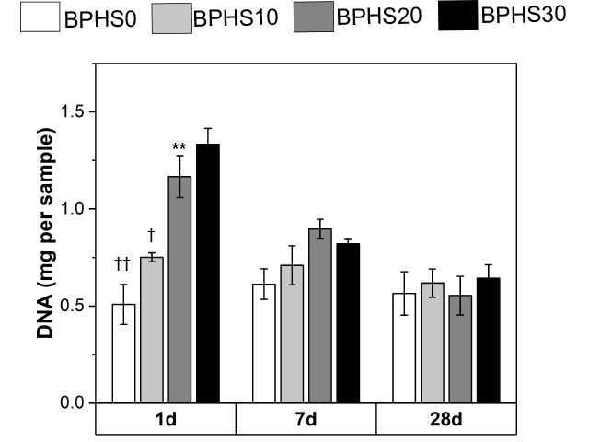
Figure S6. DNA quantification of MC3T3-E1 cells attached on the hybrid scaffolds (*p < 0.05, † p < 0.05, and ††p < 0.01 compared with 30 wt. % silica hybrid on day 1, n=3).

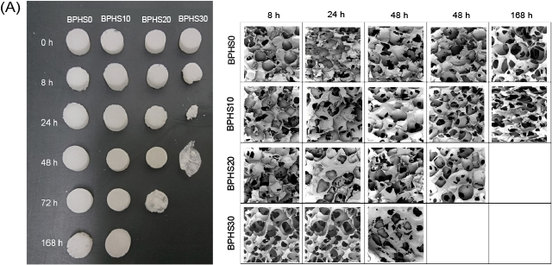
Figure S7. Accelerated degradation test on hybrid scaffolds. Samples were immersed in 1M NaOH at 25 ℃ for 0, 8, 24, 48, 72 and 168 h. Samples and SEM images of the degraded hybrid scaffold samples after accelerated degradation test.

Figure S8. Representative stress-strain curve of BPHS30 after 2 and 4 weeks of immersion in PBS.

Table S1. Mechanical properties of BPHS30 after 2 and 4 weeks of immersion in PBS (n=3).
 | 2 weeks |  | 4 weeks
 | Young’s modulus (KPa) | Ultimate strength (KPa) | Young’s modulus (KPa) | Ultimate strength (KPa)
BPHS30 | 980 ± 266.30 | 575.12 ± 128.51 | 666.67 ± 300.2 | 362.06 ± 76.60
Standard deviations are derived from the average values.

