Supplementary materials

Figure S1. XRD theta-2 theta scan of the SD state

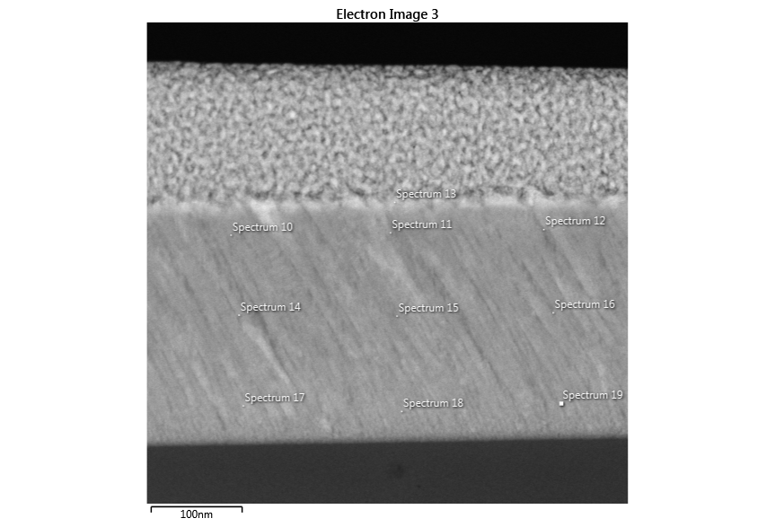
Figure S2. The cross-sectional image of the SD state
Table S1. The EDS analysis in the SD state
Statistics (At %) | Al | Cr | Fe | Co | Ni
Max | 9.39 | 20.15 | 19.54 | 23.73 | 37.09
Min | 6.11 | 14.46 | 17.32 | 20.89 | 32.08
Average | 7.88 | 17.01 | 18.54 | 21.63 | 34.95
Standard Deviation | 1.18 | 1.77 | 0.69 | 0.90 | 1.49
Table S2. The elemental EDS statistics in the SD state

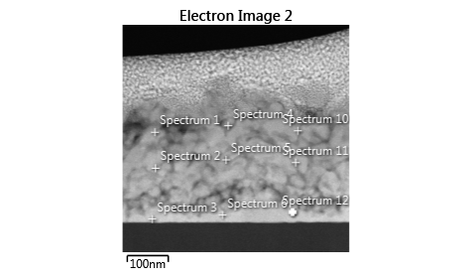
Figure S3. The cross-sectional image of the ASD state
Result type (at%)
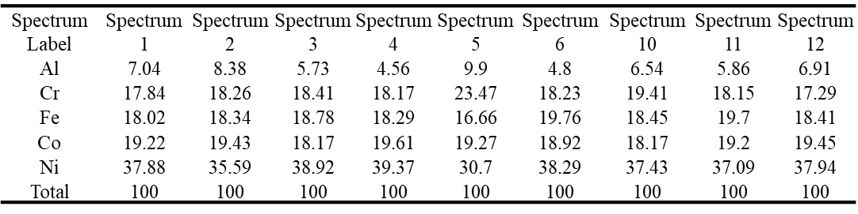
Table S3. The EDS analysis in the ASD state
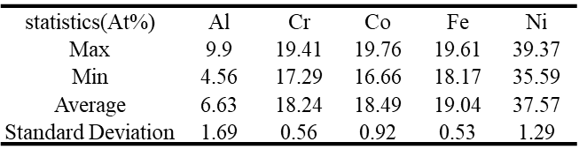
Table S4. The elemental EDS statistics in ASD states

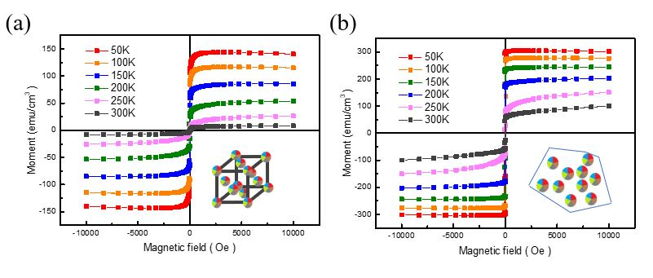 Figure S4. Temperature-dependent of hysteresis loop for (a) ASD and (b) SD states

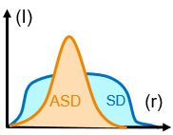
Figure S5. Schematic of the probable atomic distribution of the two states

Figure S6. The FFT results of the SD state and the distance of the first near neighbor diffraction ring.

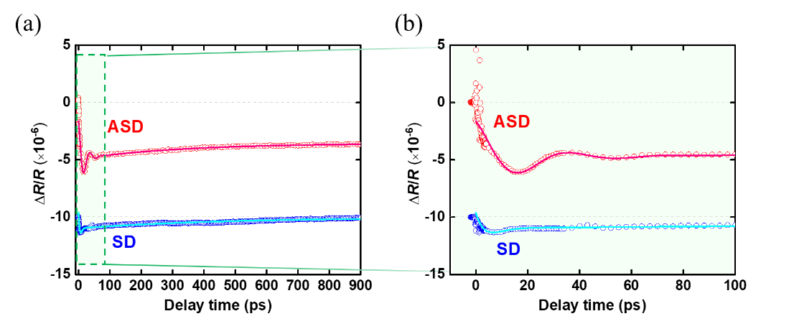
Figure S7. Ultrafast dynamics spectra for the ASD and SD states. (a) After pumping by a laser pulse with a wavelength of 800 nm, the transient reflectivity changes (ΔR/R) were measured by a laser pulse with a wavelength of 800 nm. (b) Zoomed in on the dashed-square area in (a). Solid lines are the fitting curves, including one exponential decay function and one damped oscillation function.

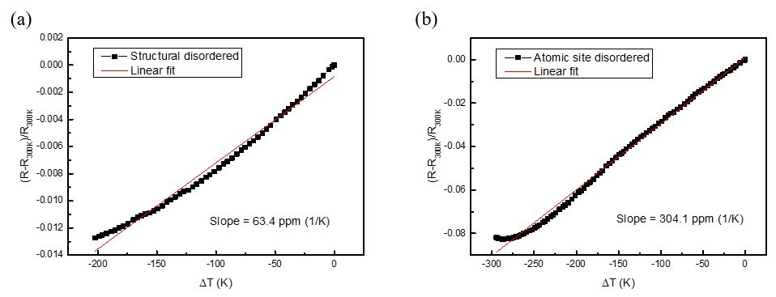
Figure S8. TCR of the SD and ASD states, respectively.

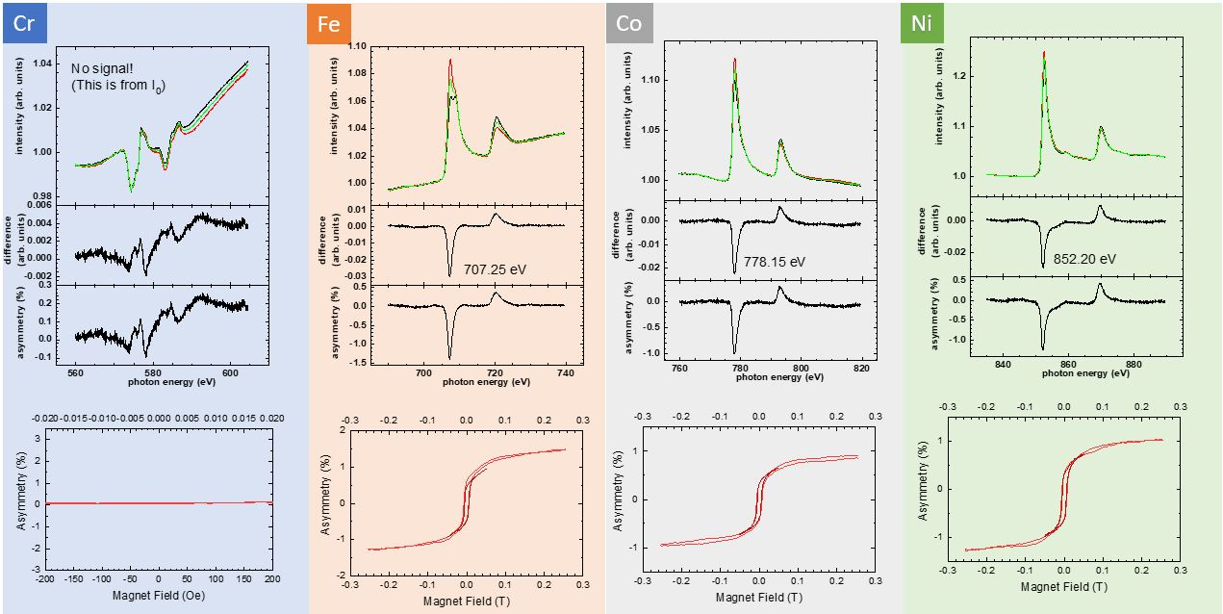
Figure S9. XAS and XMCD for each magnetic element in an atomic site disordered system in TEY mode.
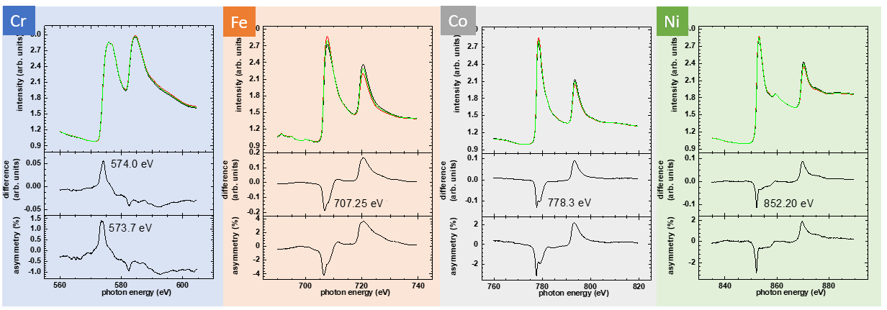
Figure S10. XAS and XMCD for each magnetic element in an atomic site disordered system in LY mode.

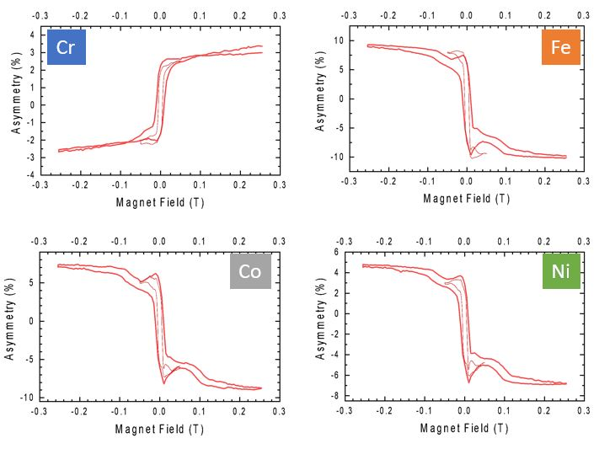
Figure S11. Hysteresis loop of the luminescence signals in the ASD state

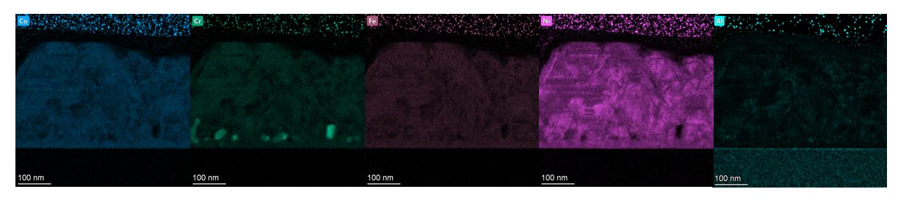
Figure S12. EDS mapping of the ASD state system
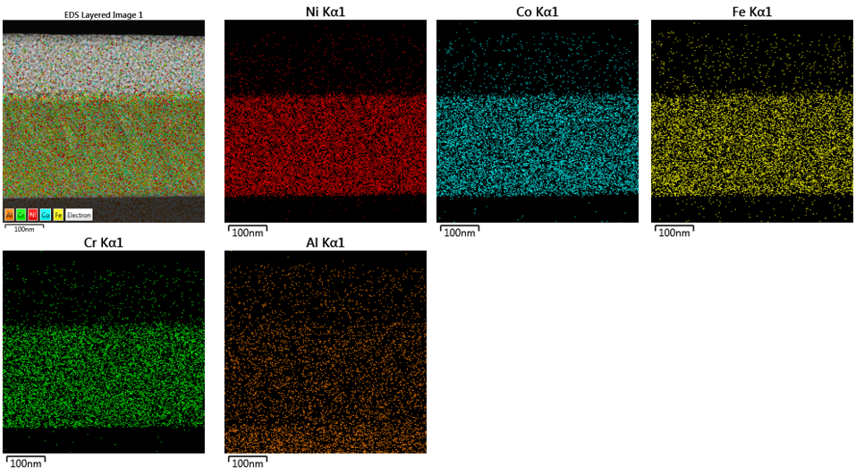
Figure S13. The EDS maps of the SD state.

Figure S14. The thickness-dependent M-T curves

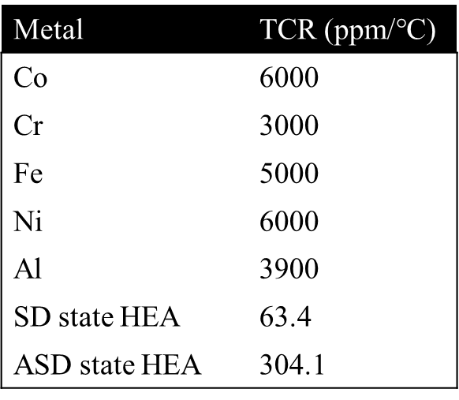
Table S5. The TCR value of single elements and HEAs

