Supplementary information for the manuscript:
High tolerance of the superconducting current to the large grain boundary angles in potassium-doped BaFe₂As₂

The fabrication of [010]-tilt (roof-type) AGB of (Ba,K)Fe₂As₂ and its transport property
To see the impact of the weak-link features on another type of grain boundaries, we also performed the film growth for the [010]-tilt (roof type) bi-crystal MgO substrate having θ_{GB} = 8°. As shown in FIG. S1(a), [001] axis of each domain in the [010]-tilt bi-crystal substrate is inclined by θ_{GB}/2 against the normal vector of the surface. Therefore, the substrate has two 004 peaks with an 8°-difference from each other (FIG. S1(b)). On the other hand, the Ba122:K grown on this substrate shows 002 peaks with ~7°-difference (FIG. S1(c)), indicating that the film was grown so as to slightly reduce the grain boundary angles as schematically sketched in FIG. S1(d). Thus, we conducted the out-of-plane x-ray diffraction scan with the offset angle of 3.5° and observed the 00l-related peaks as plotted in FIG. S1(e). Note that several impurity peaks were also observed.
After structural analysis, we fabricated the inter- and the intra-GB bridges on the film using the aforementioned process and examined the transport measurements. Both inter- and intra-GB show zero resistivity at 20 K under the self-field, as shown in FIG. S1(f, g). However, the superconducting transition was broadened as compared to the [001]-tilt specimens (FIG. 2), which is presumably due to the presence of impurity phases. The E−J characteristic of the inter-GB bridge shows rather low J_{c}s as compared to the [001]-tilt AGBs.

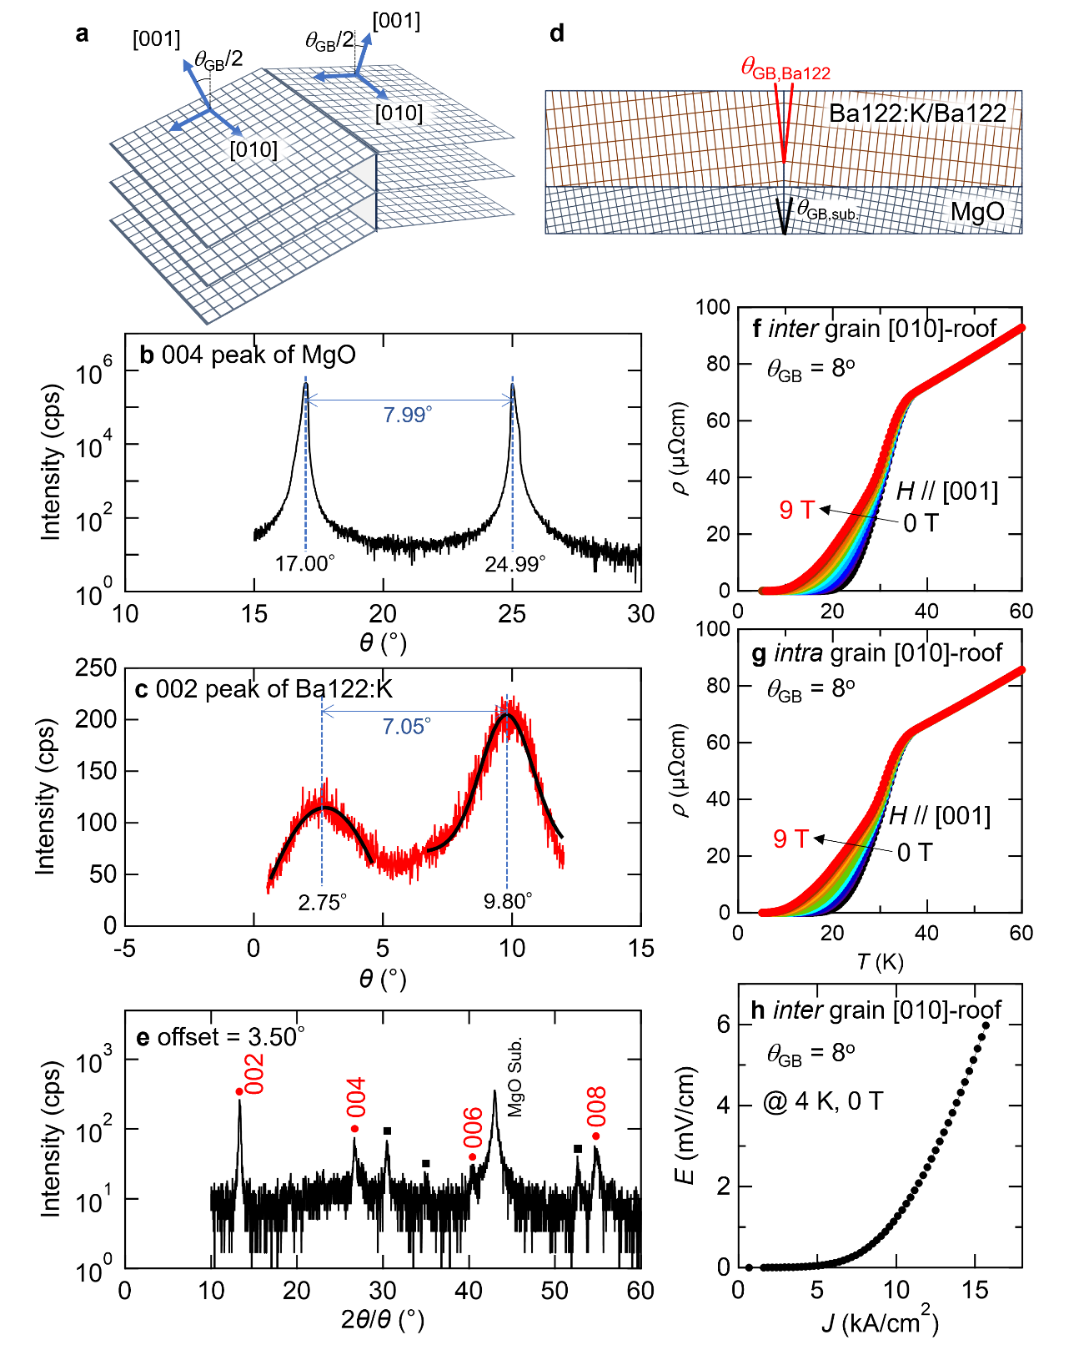
FIG. S1 The structural analysis and the evaluation of transport properties for the Ba122:K/Ba122 film grown on [010]-tilt (roof type) MgO bi-crystal substrate having θ_{GB} = 8°.
(a) The schematic image of [010]-tilt (roof type) bi-crystal substrate. (b) The out-of-plane 004 peak of MgO and (c) the out-of-plane 002 peak of Ba122:K. (d) The schematic image of the θ_{GB} configuration of the Ba122:K film. (e) The out-of-plane x-ray diffraction spectrum with an offset angle of 3.5°. The temperature dependence of the resistivity for (f) the inter-GB bridge and (g) the intra-GB bridge measured in the range of 0 to 9 T with an increment of 1 T. The applied field was parallel to the c-axis. (h) The electric field E − the current density J characteristic for the inter-GB bridge taken at 4 K under the self-field. The estimated critical current density was less than 1 kA/cm².

The E–J characteristics for the other bridges
We prepared the several bridges on each film and tried to perform the experiments for these bridges. However, most of bridges were broken at the early stage of the E – J measurements. The frequent occurrence of the breakdown accident may be mainly due to the application of large current during the measurements. Considering the high J_{c} performance of Ba122:K, the bridge with small width is suitable to keep the actual critical current lower. However, the feasible condition of the bridge fabrication using the laser cutting system only allowed the width to be wider than ~80 μm. Thus, the large current application to the bridges was required to evaluate the critical value, leading to the increase of the accidental breakdown of the bridges during the V – I measurements.
For the θ_{GB} = 6° specimen, we were able to perform the E-J characteristics for another bridge (inter-GB#2), as shown in FIG. S2. The self-field J_{c} at 12 K was 1.93 MA/cm², which is comparable to that of the bridge on θ_{GB} = 6° film shown in FIG. 3 (inter-GB#1). The temperature dependence of J_{c} (shown in FIG. S2(b)) also shows similar behavior as the inter-GB#1. The data for inter-GB#2 taken at self-field are plotted in FIG. 4(a, b).
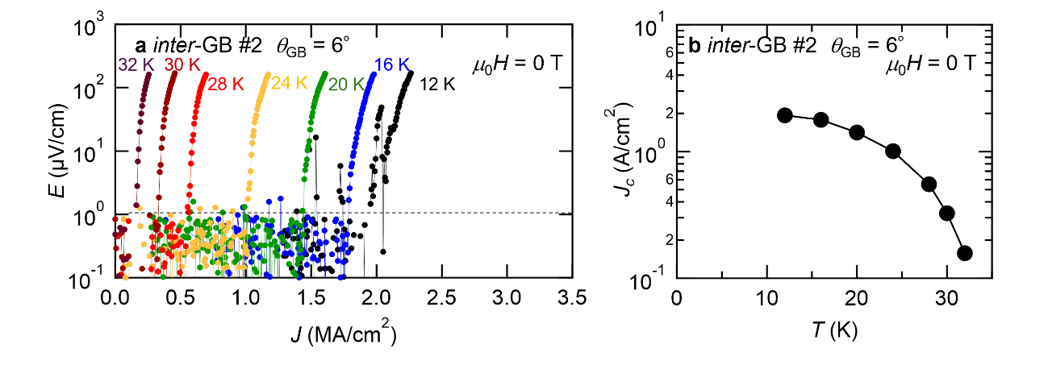
FIG. S2 (a) The electric field E – current density J curves of another inter-GB bridge ($θ_{GB}$=6º) measured in the self-field. (b) The temperature dependence of the critical current density J_{c} estimated from (a).

The estimation of the doping level difference and its effect on the J_{c} ratio
The bulk Ba122:K samples show the elongation of c-axis with increasing the K doping as showing in FIG. S3(a). Assuming that our film is fully relaxed, the estimated potassium content of each film is 0.303 (θ_{GB} = 6°), 0.307 (13°) and 0.336 (24°). According to Ref. 30, the ratio of inter-grain J_{c} to intra-grain J_{c} depends on the doping level (FIG. S3(b)). Based on the estimation shown in FIG. S3(b), the J_{c} ratio for θ_{GB} = 6° and 24° are estimated as ~0.052 (θ_{GB} = 6°) and ~0.065 (θ_{GB} = 24°). This indicates that the J_{c} ratio of the 24° specimen with the same doping level as the 6° specimen may show the about 20% lower value (corresponding to ~0.052/0.065).
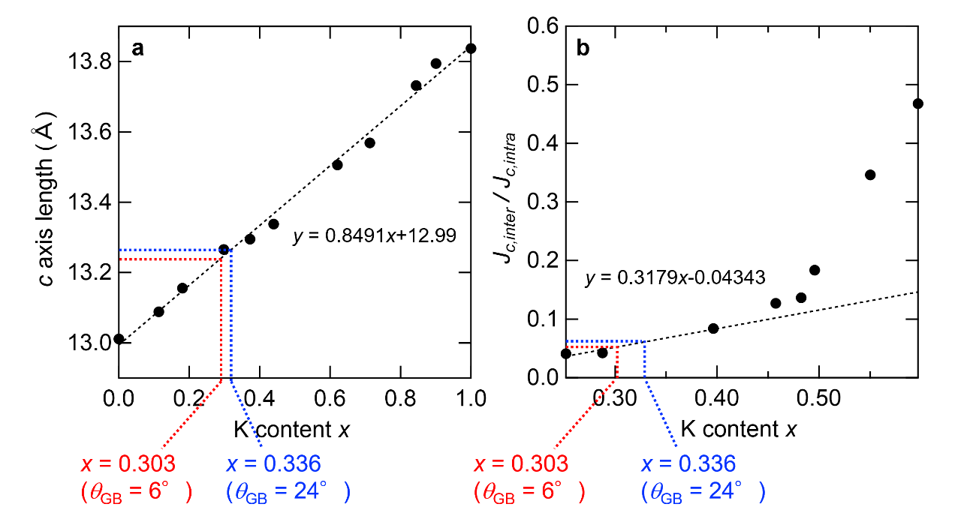FIG. S3 (a) The c-axis length as a function of potassium content x in (Ba_{1-x}K_{x})Fe₂As₂ (Ba122:K). The data is taken from Ref. 36. As can be seen, the almost perfect Vegard’s law is realized in the entire x. (b) The J_{c} ratio (J_{c,inter}/J_{c,intra}) of the Ba122:K polycrystalline samples as a function of potassium content x . The data is taken from Ref. 30.

The difference of J_{c}s among intra-GBs bridges with θ_{GB} = 6º
The respective intra-grain J_{c} for θ_{GB} = 6º, 13º and 24º are ~2 MA/cm², ~3 MA/cm² and ~6 MA/cm². There is indeed a three times difference of J_{c} between the 6º and 24º specimens. The difference among the intra-GB bridges is probably due to uncontrollable factors occurring during the film growth. For example, compositional variations and/or creation of point defects inevitably happen even though the films were prepared under the same growth conditions. In the case that these imperfect parts are contained in the bridge area, the transport property would vary. This difference potentially affects the J_{c} ratio (inter-J_{c}/intra-J_{c}), which is plotted in FIG. 4(b). To roughly estimate the possible variation range of J_{c} ratio, we divided the inter-J_{c}s of each θ_{GB} specimen by the intra-J_{c} value of 6º (the smallest intra-GB J_{c}) and the intra-J_{c} value of 24º (the largest intra-GB J_{c}), and plotted as dashed lines in FIG. S4. These data are expected to indicate an at-most and at-least J_{c} ratio, respectively. As shown in FIG. S4(a), the θ_{GB} dependence of the J_{c} ratio at 12 K possibly ranges within about a half order of J_{c} ratio. With increasing the temperature, the range width of J_{c} ratio seems to be reduced [FIG. S4 (b,c)]. Although the range of J_{c} ratio at 12 K is rather broad, we consider that the overall tendency is still maintained; a considerable reduction of J_{c} was found at 13°, followed by one order of magnitude decaying at 24°, suggesting that the angle θ_{GB} dependence of J_{c} ratio is similar to that of the other IBSs.
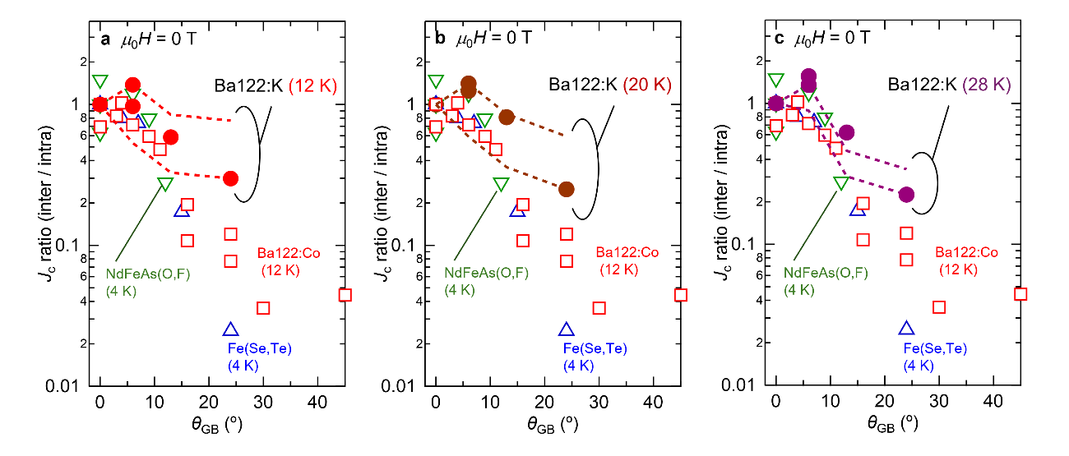
FIG. S4 (a) The J_{c} ratio of the inter-GB bridge to the intra-GB bridge as functions of θ_{GB} taken at 12 K. For the comparison, the other IBSs data are also plotted taken from Ref. 22, 23, 25. The dashed lines represent the J_{c} ratio calculated by dividing the inter-GB J_{c}s by the intra-GB J_{c} value of 6º (the smallest intra-GB J_{c}) and the intra-GB J_{c} value of 24º (the largest intra-GB J_{c}) for the guidance of the possible variation range of the θ_{GB} dependence of the J_{c} ratio. The same estimations for (b) 20 K and (c) 28 K data are also plotted.

