Supporting Information

Burst Plasma Preparation of Metallic Nanoparticles on Carbon Fabrics for Anti-bacteria and Electrocatalytic Applications
Guiyin Xu^{1,2,6}, Zheyi Meng^{1,6}, Yunteng Cao³, Zixu Tao⁴, Qing-Jie Li², Myles Stapelberg², Bing Han⁵, Rui Gao², Qipeng Yu², Meng Gu⁵, Benedetto Marelli³, Hailiang Wang*⁴, Meifang Zhu*¹, Ju Li*²
¹State Key Laboratory for Modification of Chemical Fibers and Polymer Materials, College of Materials Science and Engineering, Donghua University, Shanghai 201620, China
²Department of Materials Science and Engineering, and Department of Nuclear Science and Engineering, Massachusetts Institute of Technology, Cambridge, MA 02139, USA
³Department of Civil and Environmental Engineering, Massachusetts Institute of Technology, Cambridge, MA 02139, USA
⁴Department of Chemistry and Energy Sciences Institute, Yale University, West Haven, CT 06516, USA
⁵Department of Materials Science and Engineering, Southern University of Science and Technology, Shenzhen 518055, China
⁶Both authors contributed equally to this work

Fitting procedure
The fitting procedure is based on the black-body radiation equation. First, based on Whitaker and Hayes’s modified Z-score, all the emission data points with an outlier detection method were removed. Then, the adjusted spectrum data was fitted by the black-body radiation equation with Scipy. optimize. curve_fit function. The standard black-body radiation equation was multiplied by a scaling factor A to match the scale of experimentally measured intensity values. Finally, the fitted temperature is ~3500 K, with a R² value of 0.983, which suggests quite good fitting.

Figure S1. Schematic illustration of carbon ignited microwave plasma in nitrogen.

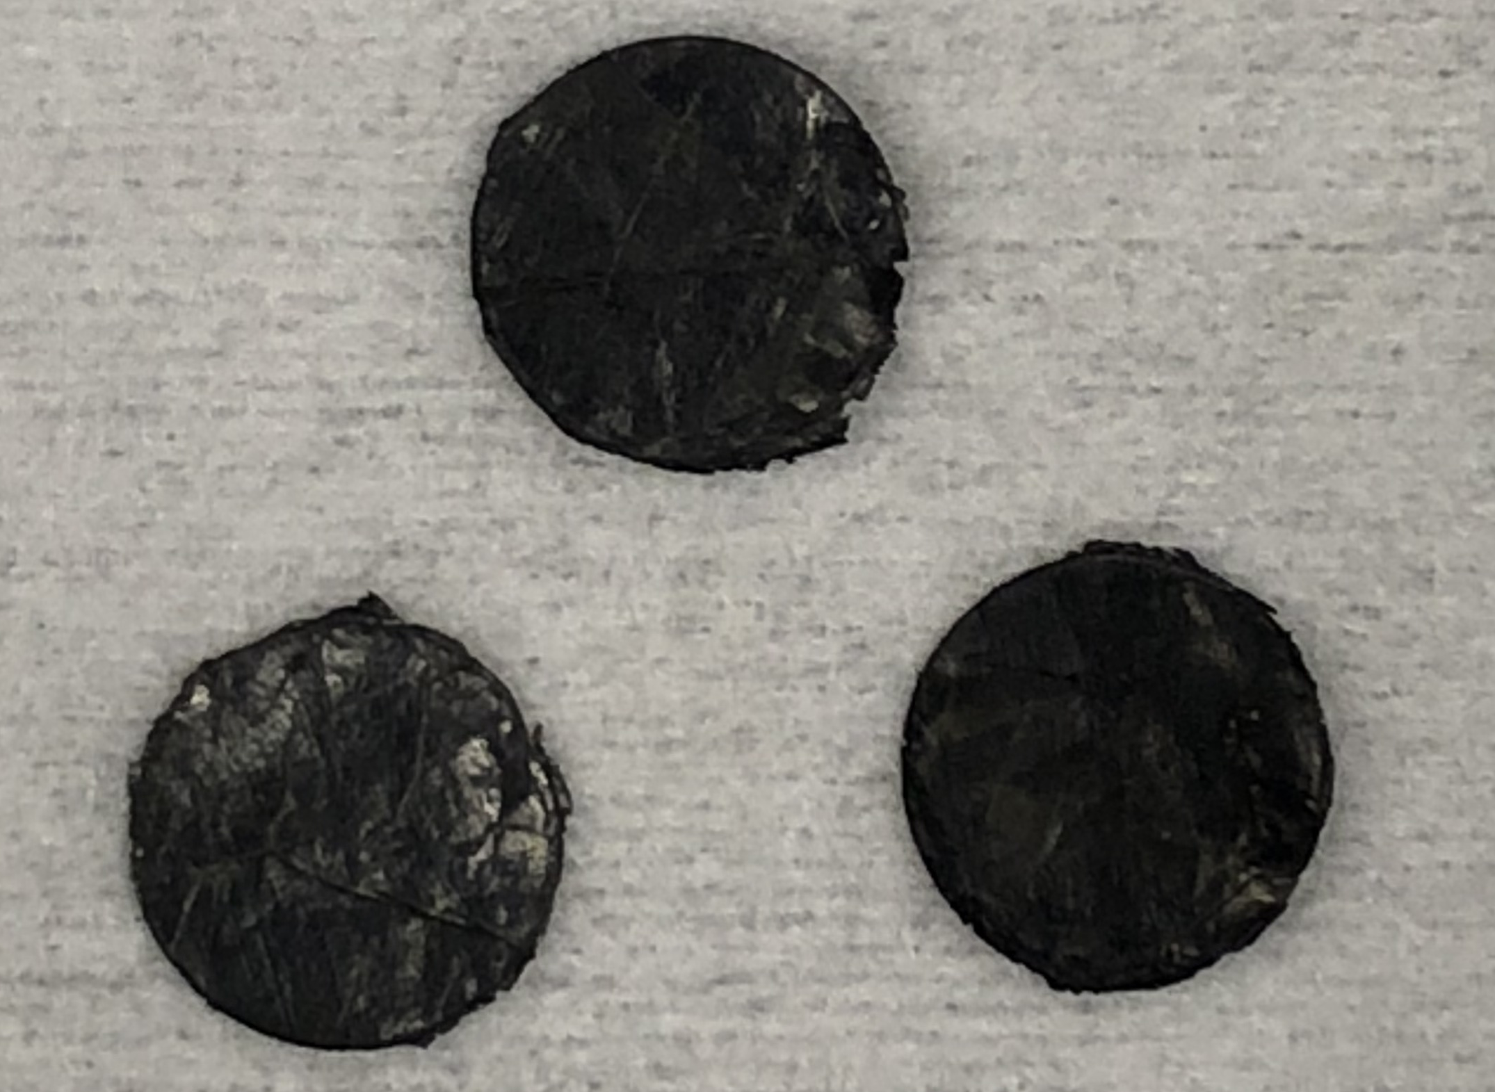
Figure S2. Digital image of carbon nanotube paper (CNTP).
Carbon nanotube paper could ignite argon plasma (Video S2).

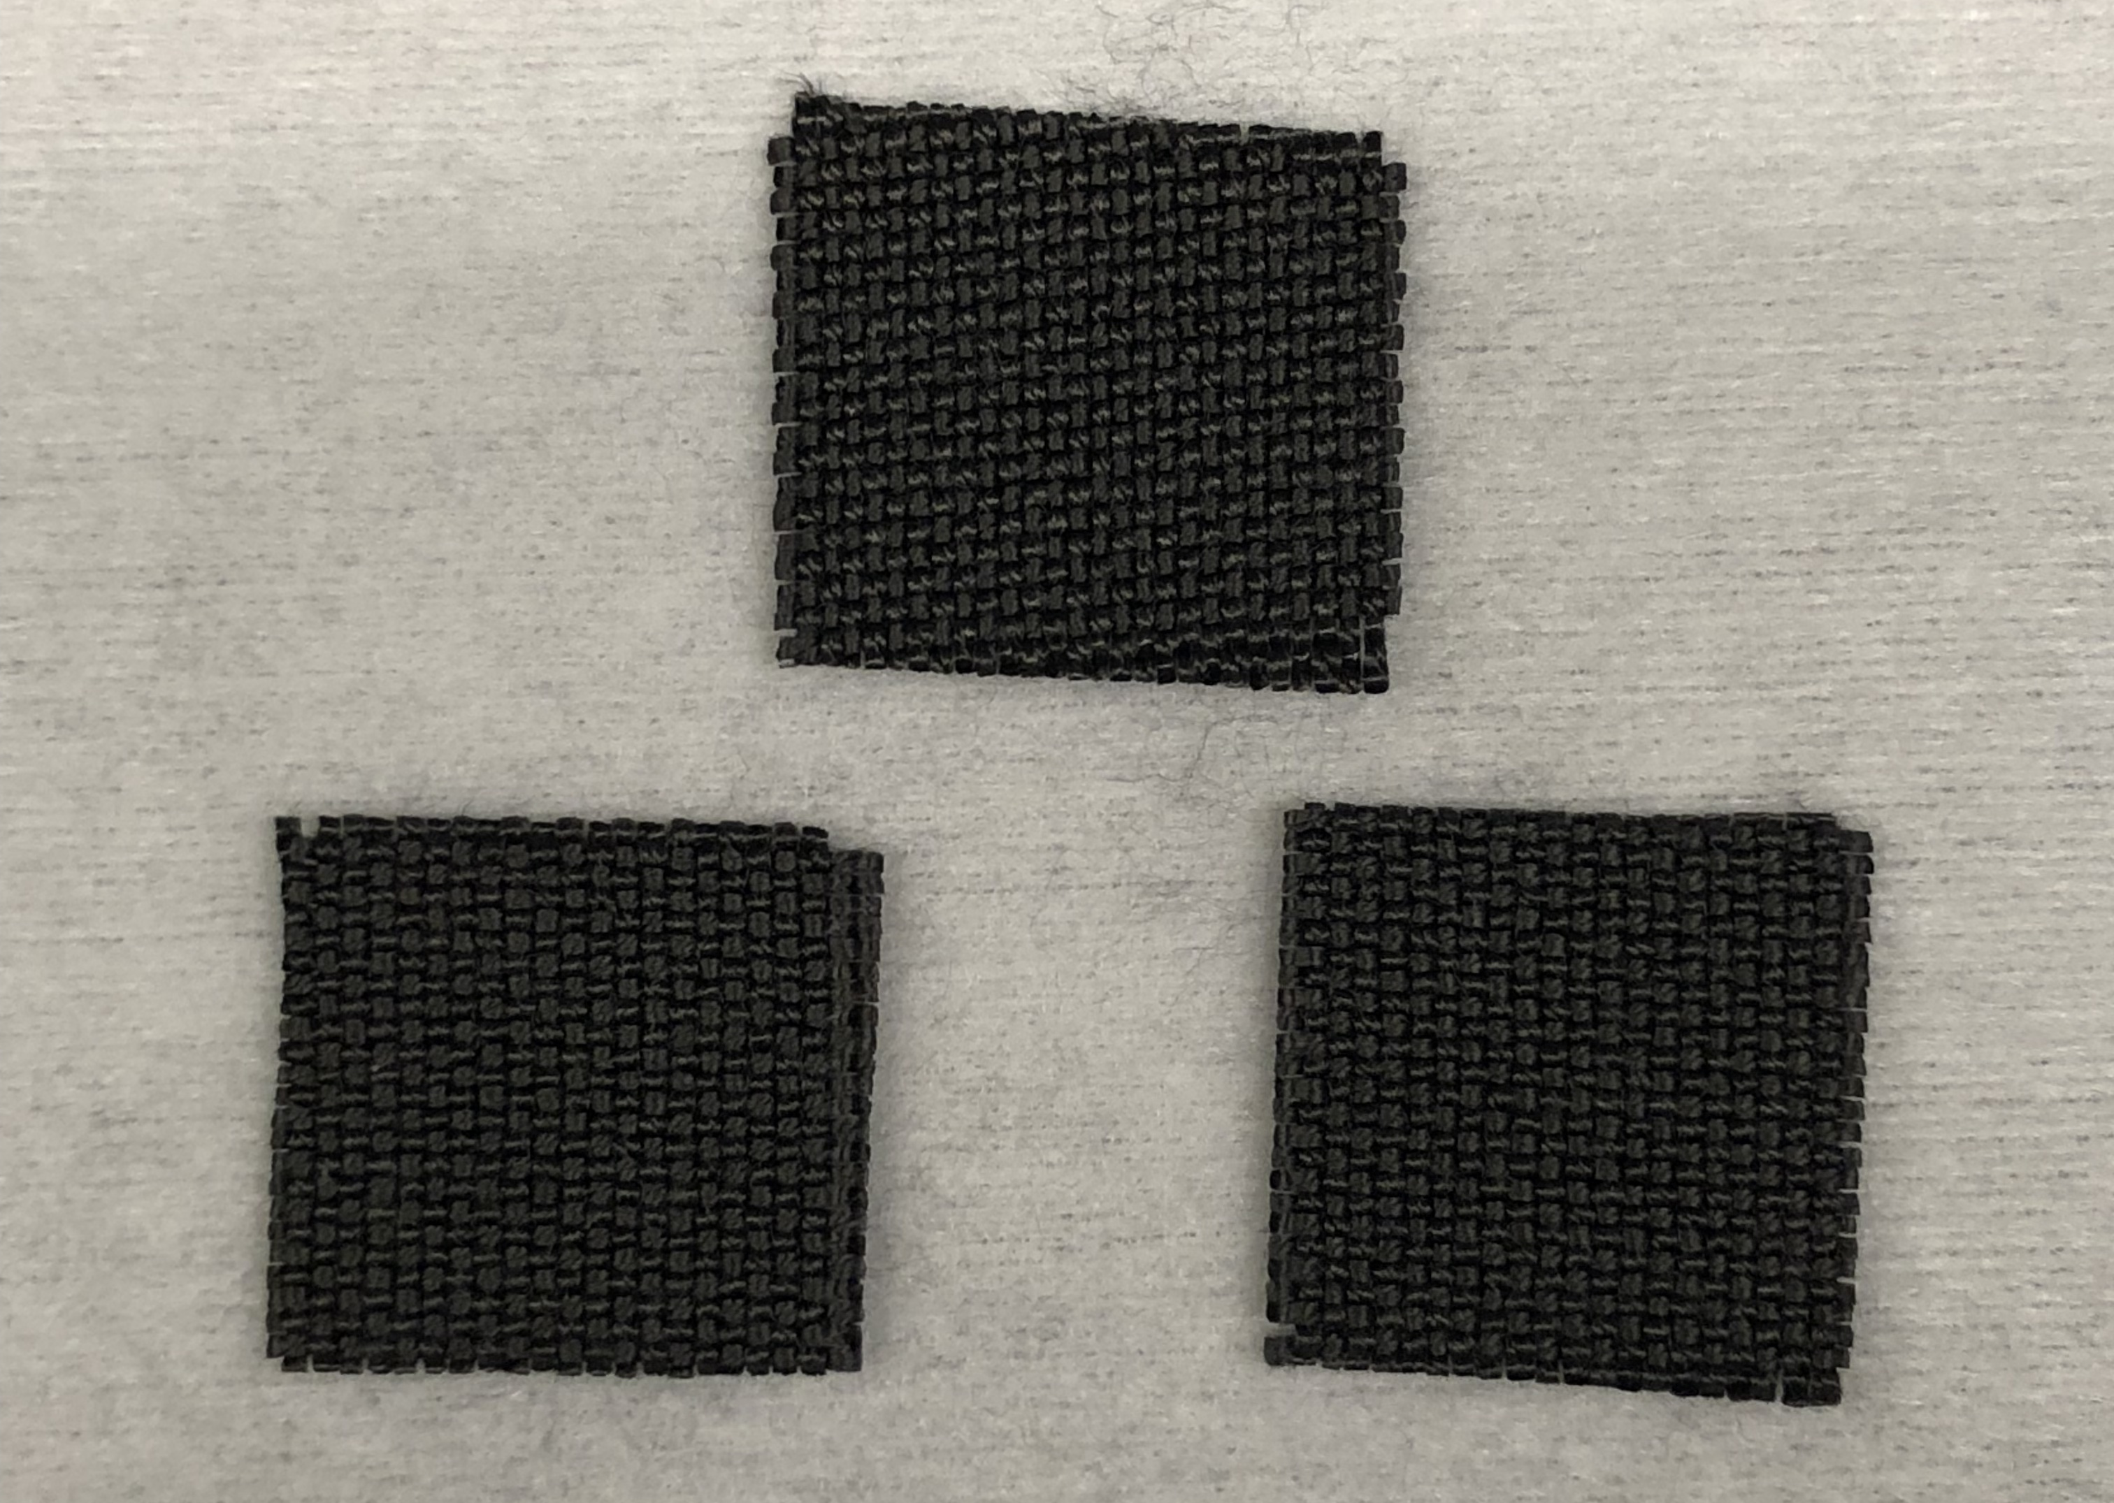
Figure S3. Digital image of carbon cloth.
Carbon cloth could ignite argon plasma (Video S3).

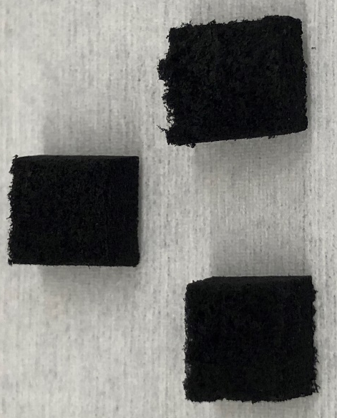
Figure S4. Digital image of carbon nanotube foam.
Carbon nanotube foam could ignite argon plasma (Video S4).

Figure S5. Enlarged section of the in-situ spectrum of carbon nanotube paper exposed to argon and microwave irradiation.

Figure S6. The emission spectrum of Ar plasma based on the CCSD/6-311+g (3d, p) method in Gaussian program at 3500 K.

Figure S7. Electrical conductivity of nitrogen and argon plasma at different temperature.

Figure S8. Thermal conductivity of nitrogen and argon plasma at different temperature.

Figure S9. Mass Density of nitrogen and argon plasma at different temperature.
The argon plasma has a higher mass density of 0.137275 kg m⁻³ compared to 0.096280973 kg m⁻³ of nitrogen plasma at different temperature.

Figure S10. Specific heat capacity of nitrogen and argon plasma at different temperature.
The argon plasma has a lower specific heat capacity of 520.328 J (kg K)⁻¹ compared to 1353.000545 J (kg K)⁻¹ of nitrogen plasma at different temperature.

Figure S11. Viscosity of nitrogen and argon plasma at different temperature.
The argon plasma has a higher viscosity of 0.000126643 kg (m·s)⁻¹ compared to 9.99371E-05 kg (m·s)⁻¹ of nitrogen plasma at different temperature.

Figure S12. Enthalpy of nitrogen and argon plasma at different temperature.
Enthalpy of argon and nitrogen plasma is 1.821 MJ and -28.322 MJ at different temperature, respectively.

Figure S13. Entropy of nitrogen and argon plasma at different temperature.
The argon plasma has a lower entropy of 5.158 kJ K ⁻¹ compared to 20.188 kJ K ⁻¹ of nitrogen plasma at different temperature.

Figure S14. (A) The initial configuration for Ab initio molecular dynamics (MD) simulation. The supercell contains two intact AgNO₃ molecules and one carbon nanotube (CNT). (B) Dissociation of AgNO₃ molecules and oxidization of CNT at T = 3500 K. The CNT is oxidized by adsorption of O atoms from AgNO₃ molecules, meanwhile reducing AgNO₃ molecules to NO, NO₂ and Ag atoms.

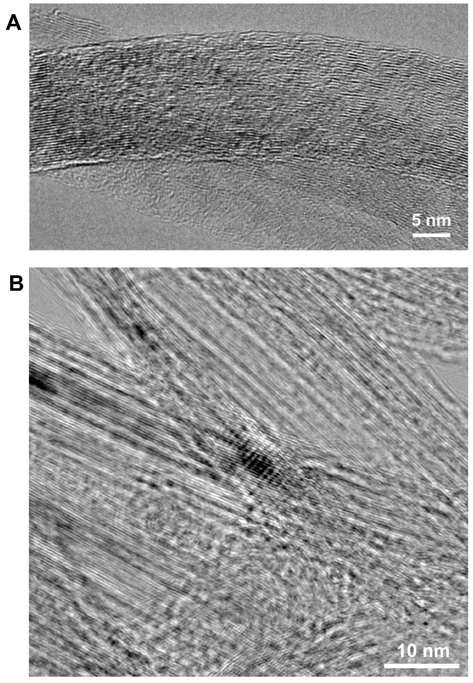
Figure S15. Transmission electron microscopy (TEM) images of CNTP.

Figure S16. XPS (A) Full spectrum (B) C, (C) Au and (D) Ag spectrums of CNTP.

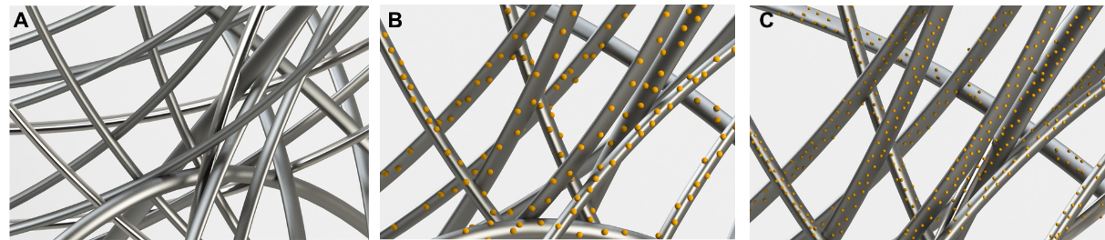
Figure S17. Diagrams of (A) CNTP, (B) metal salt-CNTP, and (C) metal-CNTP.

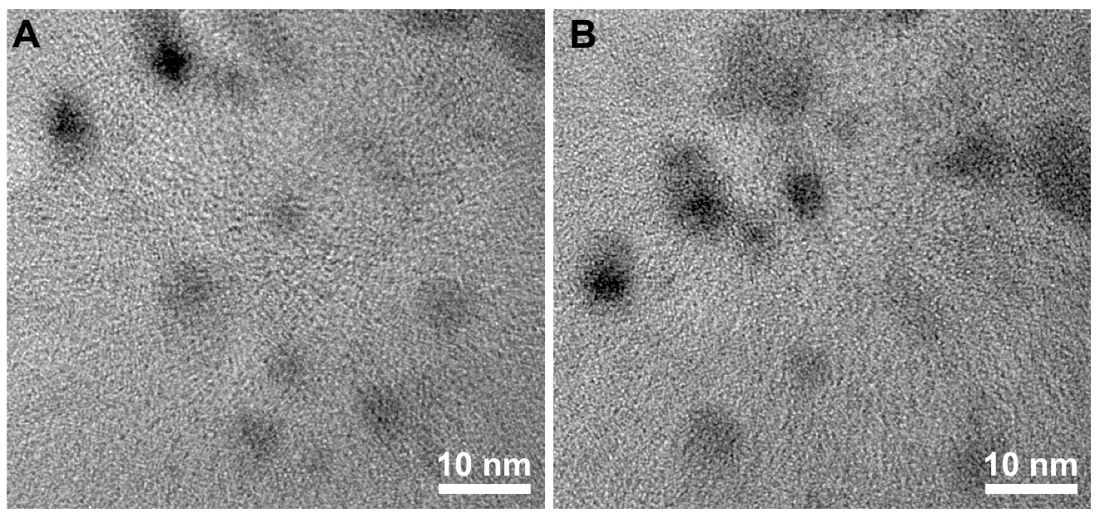
Figure S18. Transmission electron microscopy (TEM) images of Ag/CNTP.

Figure S19. Particle size distribution of Ag NPs on CNTP.
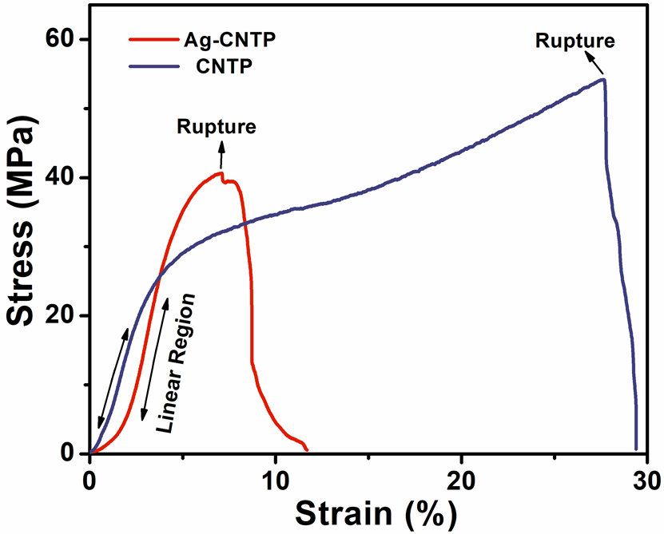
Figure S20. Stress‐strain curves of CNTP and Ag-CNTP.

Figure S21. The optimized geometry of isolated oxygen atom.

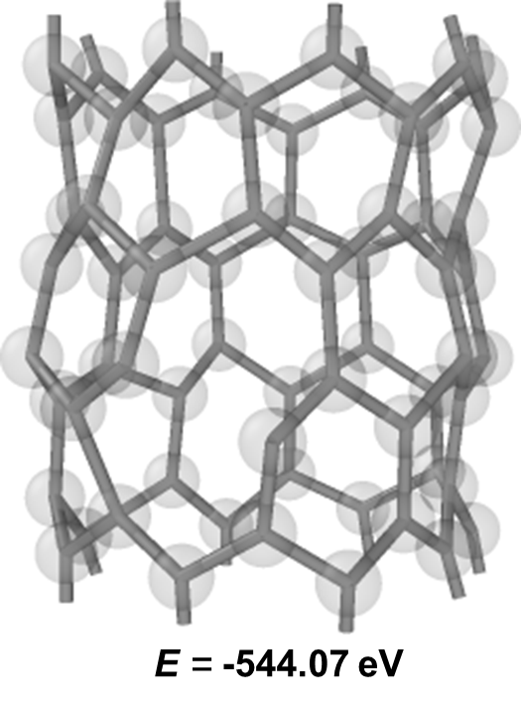
Figure S22. The optimized geometry of CNTP.

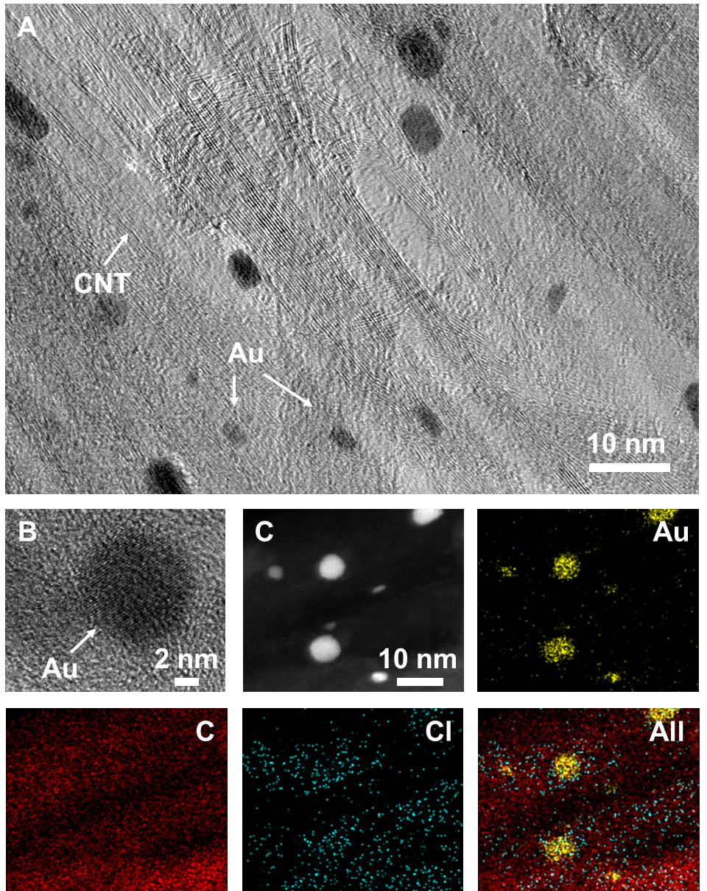
Figure S23. (A) TEM and (B) HRTEM images of Au-CNTP. (C) STEM image of Au-CNTP and the corresponding elemental mapping images for gold, carbon, chlorine, and their mixture.

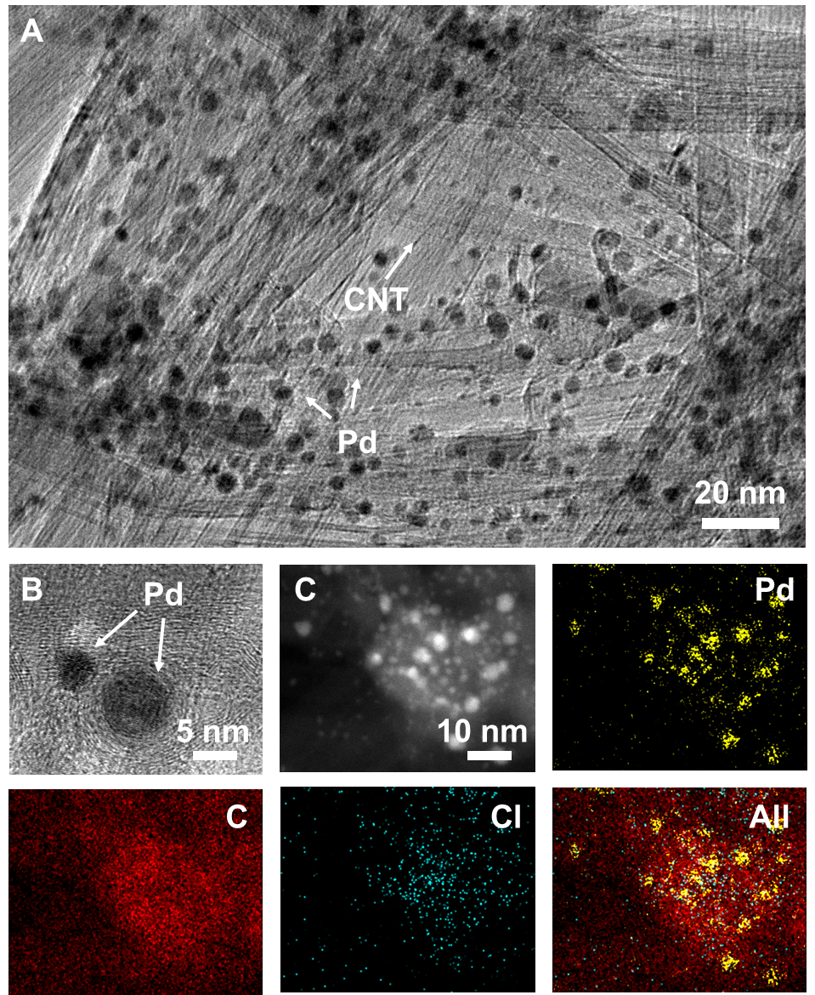
Figure S24. (A) TEM and (B) HRTEM images of Pd-CNTP. (C) STEM image of Pd-CNTP and the corresponding elemental mapping images for palladium, carbon, chlorine, and their mixture.

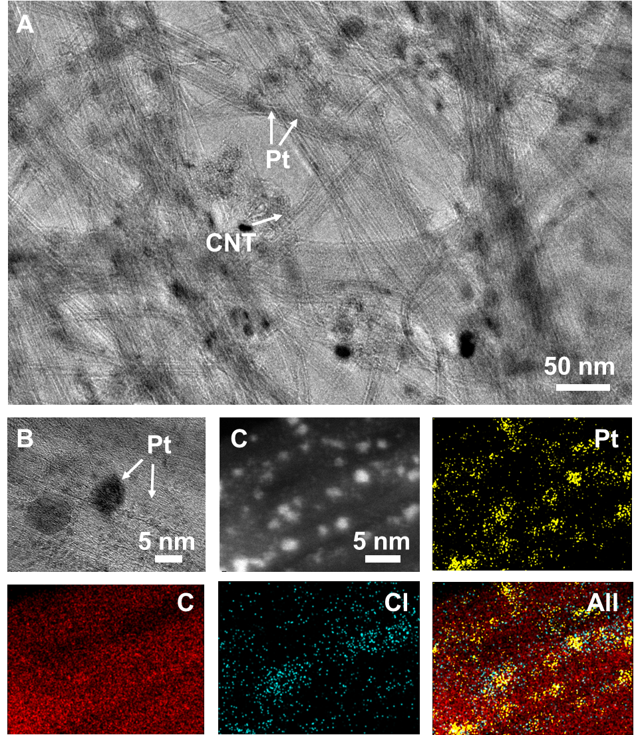
Figure S25. (A) TEM and (B) HRTEM images of Pt-CNTP. (C) STEM image of Pt-CNTP and the corresponding elemental mapping images for platinum, carbon, chlorine, and their mixture.

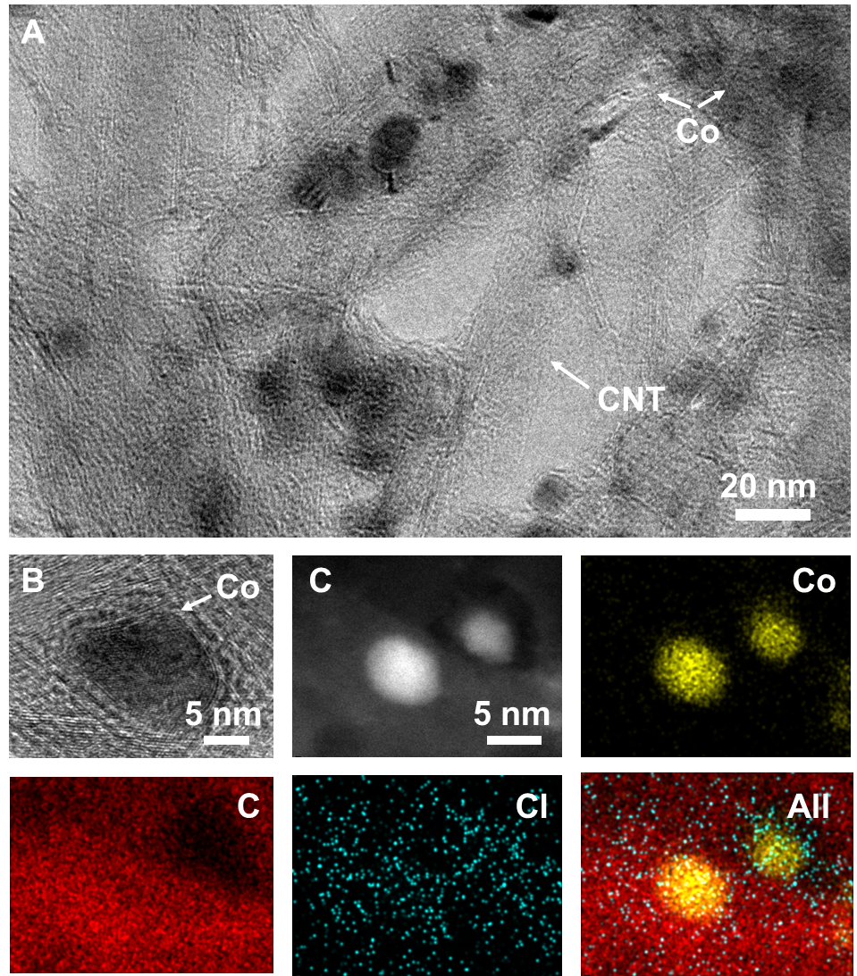
Figure S26. (A) TEM and (B) HRTEM images of Co-CNTP. (C) STEM image of Co-CNTP and the corresponding elemental mapping images for cobalt, carbon, chlorine, and their mixture.

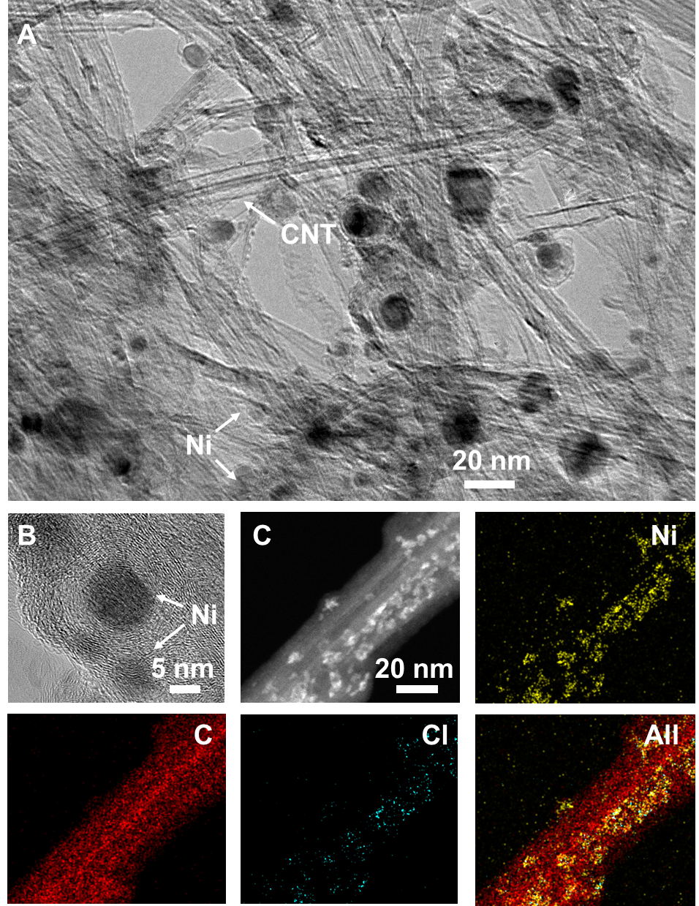
Figure S27. (A) TEM and (B) HRTEM images of Ni-CNTP. (C) STEM image of Ni-CNTP and the corresponding elemental mapping images for nickel, carbon, chlorine, and their mixture.

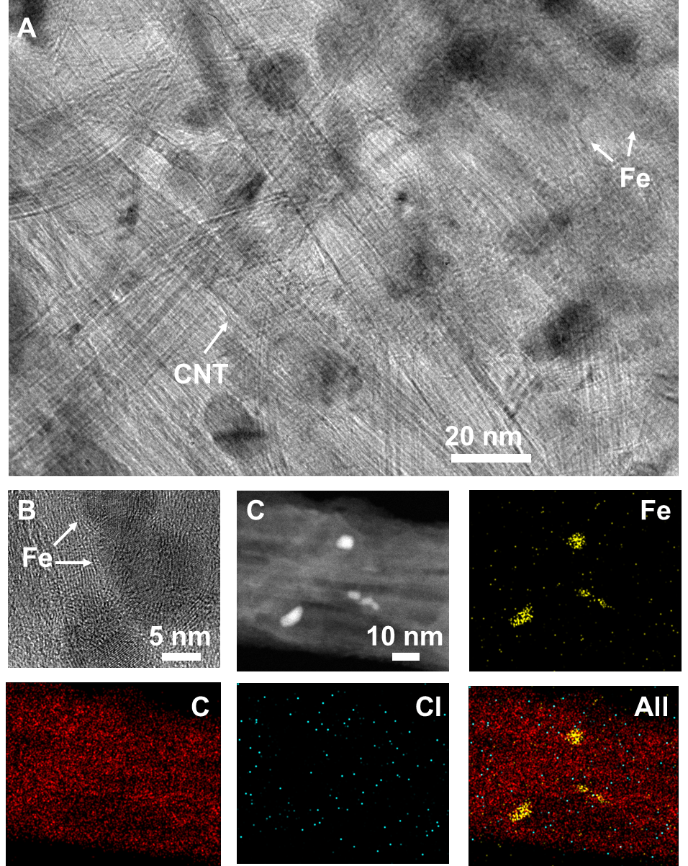
Figure S28. (A) TEM and (B) HRTEM images of Fe-CNTP. (C) STEM image of Fe-CNTP and the corresponding elemental mapping images for iron, carbon, chlorine, and their mixture.

Figure S29. On-line gas chromatography (GC) quantification for electrocatalytic CO₂ reduction products. (A) FID spectrum which is used to quantify CO and CH₄ among gas products. (B) TCD spectrum which is used to quantify H₂ among gas products.

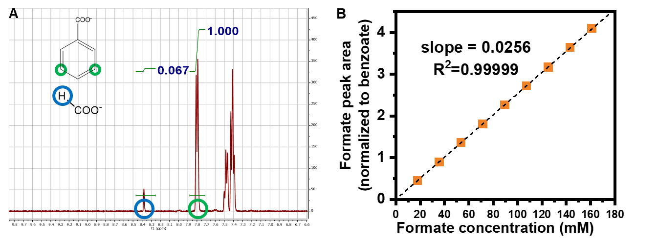
Figure S30. (A) ¹H-NMR spectrum for quantifying formate product after performing CO₂ reduction electrolysis. A known concentration of benzoate was used as the internal standard. (B) Calibration curve of quantifying formate by comparing its ¹H-NMR peak area vs that of benzoate.

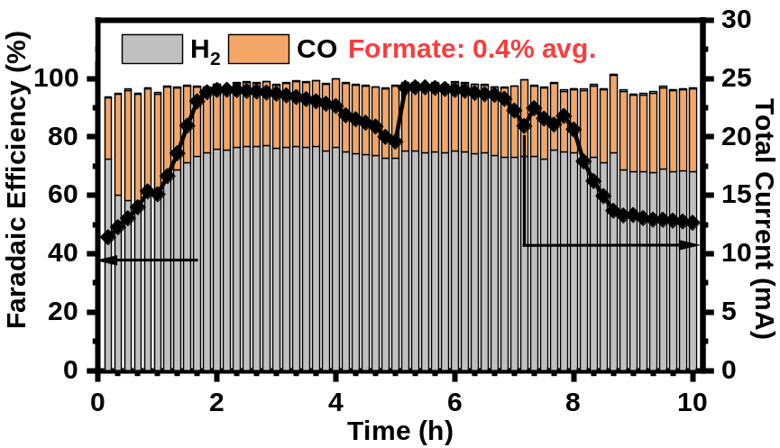
Figure S31. 10 h stability test for CO₂ reduction catalyzed by Ag-CNTP at -1.0 V. The average formate Faradaic efficiency was quantified after the electrolysis.

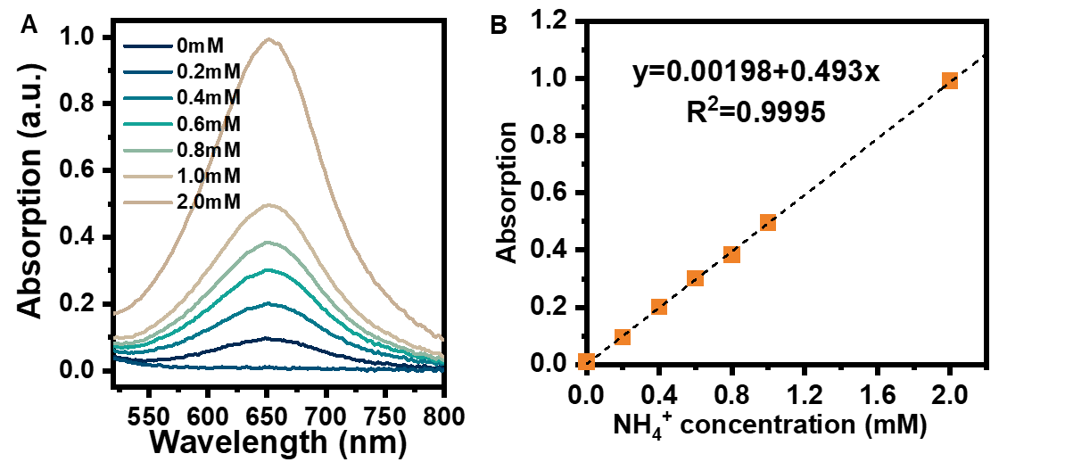
Figure S32. (A) UV-Vis spectra of the NH₄⁺ standard solutions treated with colorimetric method. (B) Calibration curve of quantifying NH₄⁺ after performing NO₂⁻ reduction electrolysis.

Figure S33. Antibacterial activity of Ag-CNTP vs. time compared to CNTP without Ag nanoparticles as control.

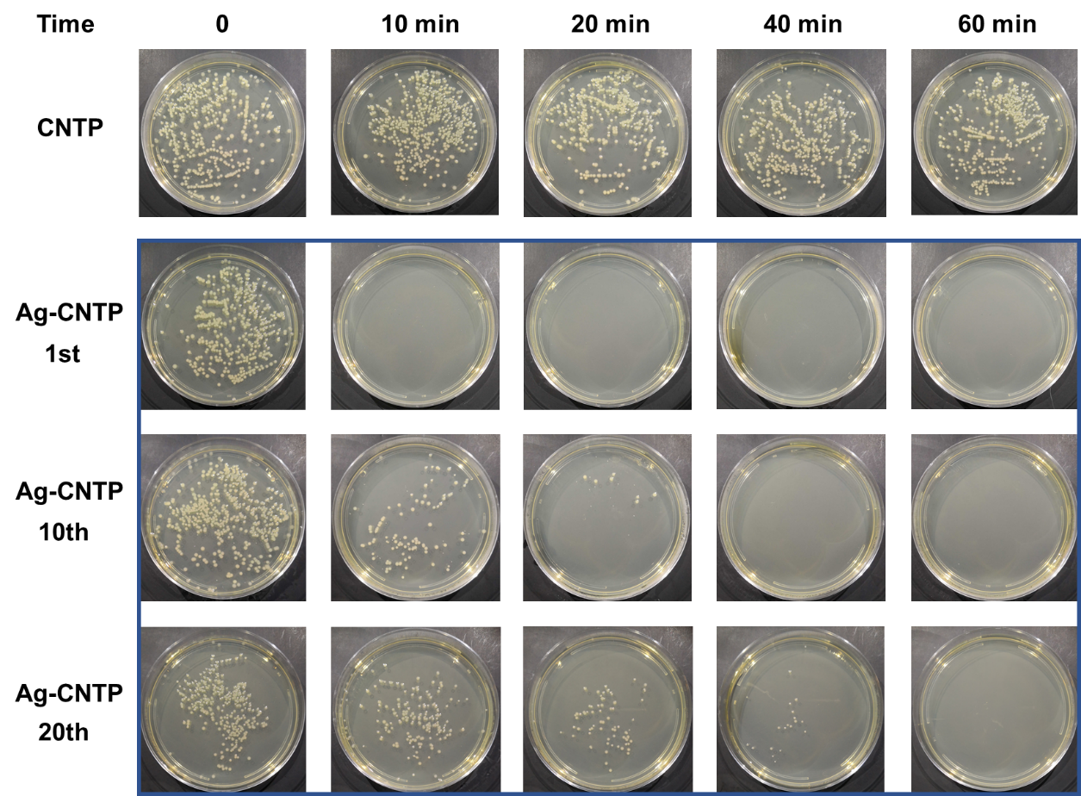
Figure S34. Digital images of the growth of E. coli on plates at different times after CNTP and Ag-CNTP treatment.

Figure S35. Antimicrobial efficacy of Ag-CNTP when used repeatedly.

Table S1. Young’s modulus of CNTP and Ag-CNTP.
Sample | Young’s Modulus  (MPa) | Failure Strain  (%) | Breaking Strength  (MPa)
CNTP | 794 ± 134 | 27.37 ± 8.72 | 50.81 ± 9.23
Ag-CNTP | 1298 ± 141 | 6.26 ± 1.4 | 39.44 ± 2.07

