Supporting Information

Mussel-Inspired Thermo-Switchable Underwater Adhesive based on a Janus Hydrogel

Hiroya Abe^{1,2}*, Daichi Yoshihara¹, Soichiro Tottori¹, Matsuhiko Nishizawa^{1,3}

1.
Graduate School of Engineering, Tohoku University,
6-6-01 Aramaki-aza Aoba, Aoba-ku, Sendai, 980-8579, Japan
2.
Frontier Research Institute for Interdisciplinary Sciences (FRIS), Tohoku University,
6-3 Aramaki-aza Aoba, Aoba-ku, Sendai, Miyagi, 980-8578, Japan
3.
Graduate School of Biomedical Engineering, Tohoku University,
6-6-04 Aramaki-aza Aoba, Aoba-ku, Sendai, 980-8579, Japan

*Corresponding author: Hiroya Abe
E-mail: H. A.: hiroya.abe.c4@tohoku.ac.jp,

Keywords: mussel adhesion, polydopamine, underwater adhesion, biomimetics, hydrogel

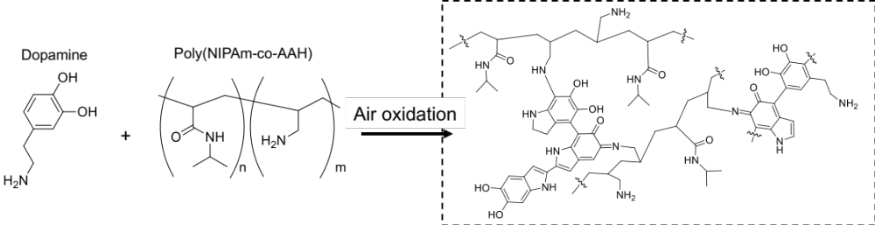
Scheme S1. Reaction scheme and possible chemical structure of the air-oxidation and crosslinking reactions for hydrogel synthesis.

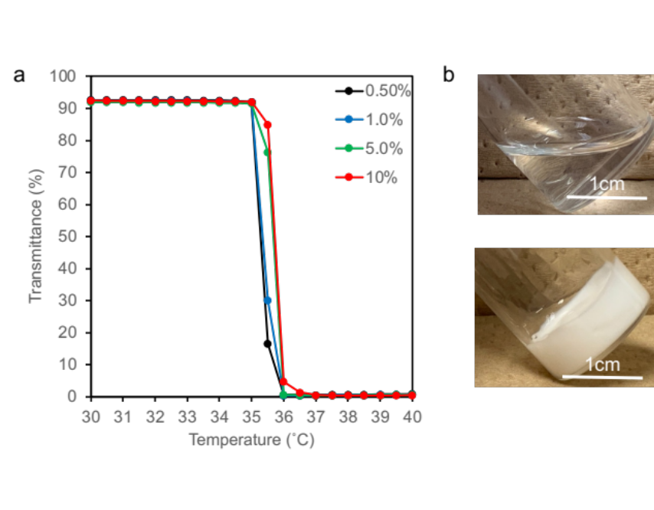
Figure S1. Thermoresponsivity of the amine-containing polymers. a) Transparency of the polymer solution (50 g L⁻¹) with temperature. The polymers were prepared with different concentrations of allylamine. b) Images of the polymer solution (50 g L⁻¹) with 1% allylamine at room temperature (top) and 40 ℃ (bottom).

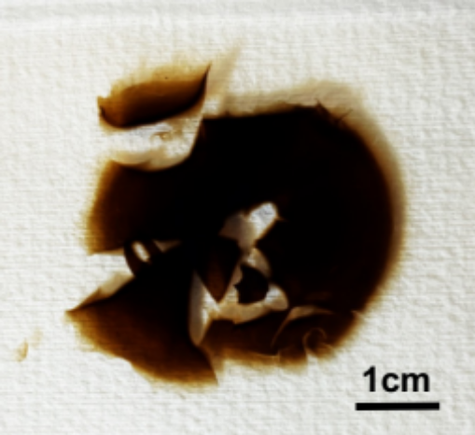
Figure S2. Image of the TSA hydrogel prepared without “Step i.”

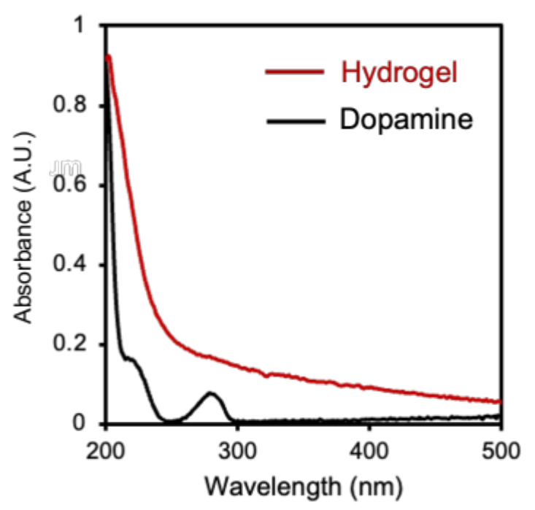
Figure S3. UV-Vis spectrum of the TSA hydrogel (red) and dopamine (black).
The obtained hydrogel exhibited broad absorbance at 200 nm (red line), which was attributed to the absorbance peaks of catechol and its conjugated oligomers.^{[S1]} In addition, the absorbance of dopamine (black line) disappeared from the hydrogel, indicating that the hydrogel did not contain monomeric dopamine.

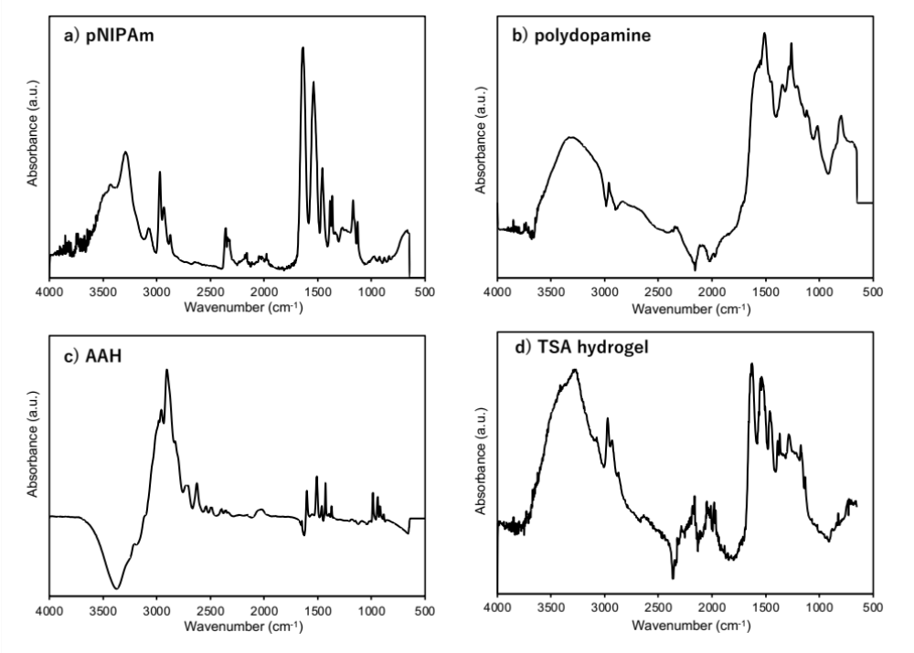
Figure S4. FT-IR spectra of (a) pNIPAm, (b) polydopamine, (c) AAH, and (d) TSA hydrogel.
Fourier-transform infrared (FT-IR) spectroscopy was used to characterize the chemical structure of the hydrogel (Figure S4). Characteristic signals were observed at 1619, 1513, and 1468 cm⁻¹, corresponding to the stretching vibrations of the aromatic ring ν(C–C)/ν(C=C).^{[S2]} These characterizations indicated that the hydrogel comprised oligomers and polymers of dopamine. In addition, several characteristic peaks of PNIPAm were observed in the spectrum of the hydrogel at 1300–1700 cm⁻¹, confirming that the hydrogel comprised PNIPAm.

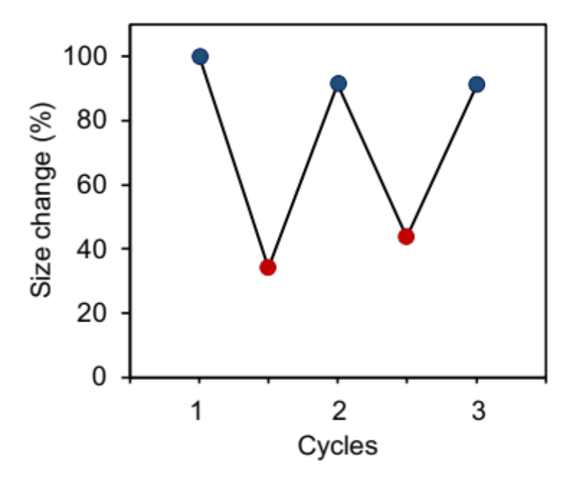
Figure S5. Repeatability of the swelling and shrinking cycles by changing the temperature.

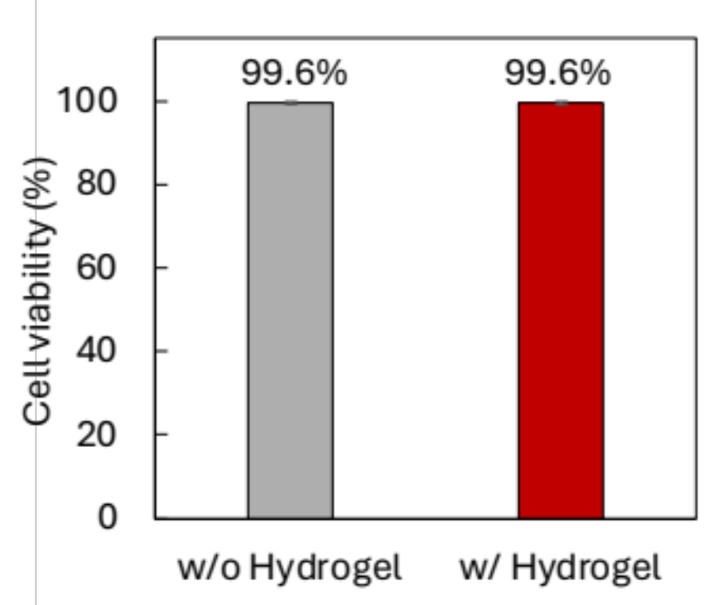
Figure S6. Cell viability test of the cell culture without the TSA hydrogel (gray, control) and with the TSA hydrogel.

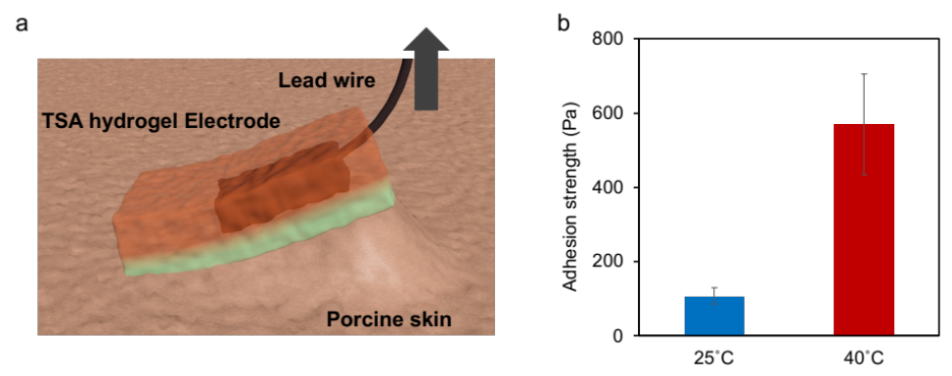
Figure S7. a) Schematic image of the adhesion of the carbon electrode-embedded hydrogel, and b) its adhesion strength at different temperatures.

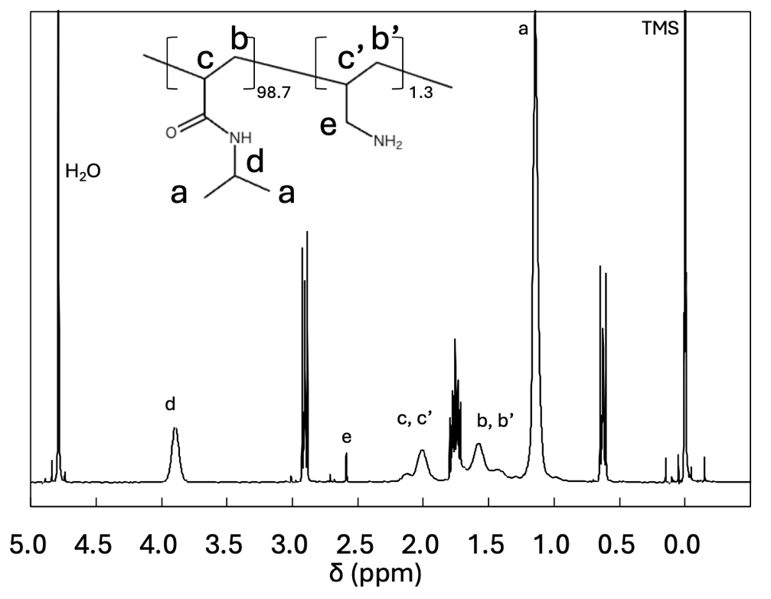
Figure S8. The ¹H NMR of 1% amine-containing polymer (P(NIPAm-ran-AAH)) was performed in the D₂O. The peaks assigned to NIPAm and AAH were observed, and the amount of AAH in the copolymer was calculated from the ratio of 2e/d, yielding a value of 1.3%. This ratio of AAH in the copolymer was reasonable for AAH added to the monomer solution.

References in supporting information.
S1. M. Kohri, K. Yanagimoto, A. Kawamura, K. Hamada, Y. Imai, T. Watanabe, T. Ono, T. Taniguchi, K. Kishikawa, ACS Appl. Mater. Interfaces 2018, 10, 7640.
S2. I. M. Dugandžić, D. J. Jovanović, L. T. Mančić, N. Zheng, S. P. Ahrenkiel, O. B. Milošević, Z. V. Šaponjić, J. M. Nedeljković, J. Nanoparticle Res. 2012, 14, 1157.

Table S1. Comparison of temperature-responsive adhesives
Type | Transition temperature | Conditions | Substrate | Adhesion strength at high temperature | Adhesion strength at low temperature | Gap of adhesion strength* | Mechanism | Ref. (in Main text)
Hydrogels | ~ 35 ℃ | Underwater | Glass | 134.3 kPa | 0.093 kPa | 1444 | Catechol | This work
Hydrogels | ~ 35 ℃ | Underwater | Ti | 128 kPa | 0.080 kPa | 1600 | Catechol | This work
Hydrogels | ~ 35 ℃ | Underwater | Al | 128.3 kPa | 0.25 kPa | 513 | Catechol | This work
Hydrogels | ~ 35 ℃ | Underwater | PTFE | 85.67 kPa | 0.16 kPa | 535 | Catechol | This work
Hydrogels | ~ 35 ℃ | Dry | Wood, Ti, Fe, Al, Glass, Si, PET | 0.13 kPa | 31.25 kPa | ~ 1/240 | Microscale and mesoscale contact coupling changes | ^{[57]}  Nat. Commun. 2022
Polymer coating | ~ 35 ℃ | Underwater | Al, Si, Ti, PTFE, Glass | 4370 mJ m⁻² | 182 mJ m⁻² | ~ 20 | Catechol with β-cyclodextrin | ^{[9]}  Nat. Commun. 2017
Polymer coating | ~ 34 ℃ | Underwater | Al, Si, PP, PS, PET, PTFE, PI, Glass | 8.1 kPa | 1.8 kPa | 4.5 | Catechol | ^{[61]}  Adv. Mater. 2018
Hydrogel | From 28 to 22 ℃ | Dry | PE, Al, Steel, PTFE, Glass, PP, Rubber | 37.4 kPa | 6.8 kPa | 5.5 | Phase transition | ^{[42]}  Small 2021
Polymer coating | ~ 70 ℃ | Underwater | Quartz, glass, Al, PMMA, silicone, SiC, PTFE, steel, rubber | 225 kPa | 447 kPa | ~ 1/2 | Crosslinked polymer networks of anthracene | ^{[59]}  Mater. Horiz. 2020
Hydrogels | ~ 35 ℃ | Underwater | PP, Biological tissues, metal, rubber, Teflon, Glass | 38 kPa | 11 kPa | 3.5 | Catechol | ^{[43]}  Nanomicro Lett. 2022
* Gap in adhesion strength was calculated by dividing the adhesion strength at high temperatures by that at low temperature.

