Injectable Thixotropic Hydrogel Composed of Elastin-Like Polypeptide and Oxidized Dextran for Anastomotic Support

Yuki Aoyama,¹ Yuta Nakano,² Takahiro Shinozuka,³ Kotaro Aoki,³ Kazumasa Suzuki,¹ Chikara Ohtsuki,¹ Mitsuro Kanda,^{3,*} Ayae Sugawara-Narutaki^{4,*}

¹Department of Materials Chemistry, Graduate School of Engineering, Nagoya University, Furo-cho, Chikusa-ku, Nagoya 464-8603, Japan
²Department of Oral and Maxillofacial Surgical Oncology, Graduate School of Medical and Dental Sciences, Institute of Science Tokyo, Yushima, Bunkyo-ku, Tokyo 113-0034, Japan
³Department of Gastroenterological Surgery, Graduate School of Medicine, Nagoya University, Tsurumai-cho, Showa-ku, Nagoya 466-8550, Japan
⁴Laboratory for Biomaterials and Bioengineering, Institute of Integrated Research, Institute of Science Tokyo, Kanda-Surugadai, Chiyoda-ku, Tokyo 101-0062, Japan

*Mitsuro Kanda: +81-52-744-2233, kanda.mitsuro.v5@f.mail.nagoya-u.ac.jp
*Ayae Sugawara-Narutaki: +81-3-5280-8006, narutaki.ayae@tmd.ac.jp

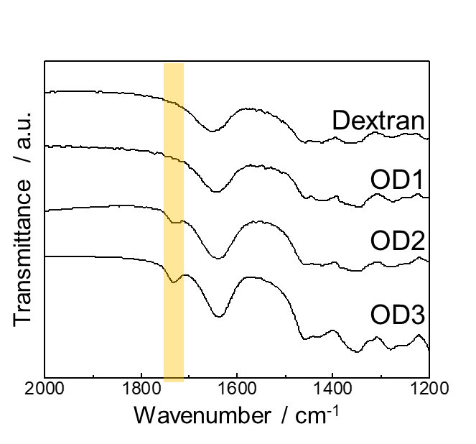

Figure S1. FT-IR spectra of dextran, OD1, OD2, and OD3. Although it was not clearly observed in OD1, a peak around 1730 cm⁻¹, attributable to the C=O stretching vibration of the aldehyde group, appeared in both OD2 and OD3.

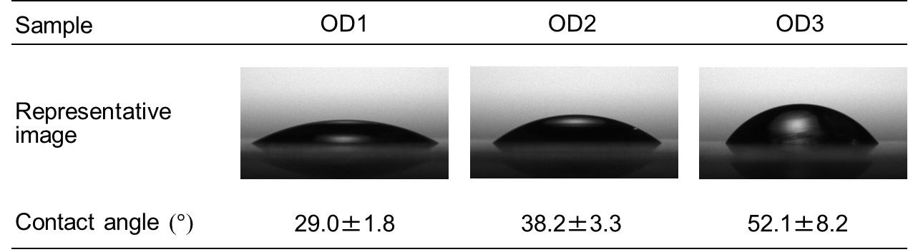

Figure S2. Water contact angles on OD1, OD2, and OD3 surfaces. Ten microliters of each OD solution (150 mg/mL in 100 mg/mL sucrose aq.) was spin-coated onto a borosilicate cover glass at 3,000 rpm for 30 s using a spin coater (MS-B100, Mikasa, Japan) and air-dried overnight. Water contact angles were measured by the sessile drop method using a contact angle meter (DMo-602, Kyowa, Japan). A 5-µL droplet of ultrapure water was gently placed on the surface, and the static contact angle was recorded 1 s after deposition. Nine measurements were performed for each sample, and the mean ± SD is reported.

Supplementary Movie S1. Detachment of the GPG-KR/OD3 hydrogel from the tissue of mouse specimen No. 1 after one week in vivo.
This movie shows that the hydrogel injected into the mouse Douglas fossa was retained for a week. The hydrogel showed relatively firm adhesion to the surrounding tissues, and stretching of the gel was observed when it was grasped with forceps. The hydrogel was elastic and did not liquefy even when deformed with forceps.

Supplementary Movie S2. Detachment of the GPG-KR/OD3 hydrogel from the tissue of mouse specimen No. 2 after one week in vivo.
This movie shows that the hydrogel injected into the mouse Douglas fossa was retained for a week. The adhesion was comparatively weak, allowing the hydrogel to be removed easily with forceps. The hydrogel exhibited elastic behavior and did not flow when manipulated with forceps.

