Supporting Information for
Solvent-Engineered MoS₂–Perovskite Heterostructures Enabling Defect Passivation and Enhanced Charge Transport
Mohammed Misbah Uddin,^{1,2,6} Md Fahim Al Fattah,^{3,6} Alexander Schleusener,⁴ Wisnu Tantyo Hadmojo,^{1,2} Asif Abdullah Khan,³ Fadi Dawaymeh,^{1,2} Mirko Prato,⁵ Roman Krahne,⁴ Dayan Ban,³ Marwa Abd-Ellah,^{1,2}* Ahmed L. Abdelhady^{1,2}*
¹Department of Chemistry, Khalifa University of Science and Technology, Abu Dhabi, 127788, UAE
²Center for Catalysis and Separation (CeCaS), Khalifa University of Science and Technology, Abu Dhabi, 127788, UAE
³Department of Electrical and Computer Engineering, Waterloo Institute for Nanotechnology, University of Waterloo, Waterloo, ON N2L 3G1, Canada
⁴Optoelectronics Group, Istituto Italiano di Tecnologia, Via Morego 30, Genova, 16163, Italy
⁵Materials Characterization Facility, Istituto Italiano di Tecnologia, Via Morego 30, Genova 16163, Italy
⁶These authors contributed equally.
*Corresponding authors: A.L.A.: ahmed.abdelhady@ku.ac.ae and M.A.: marwa.abdellah@ku.ac.ae

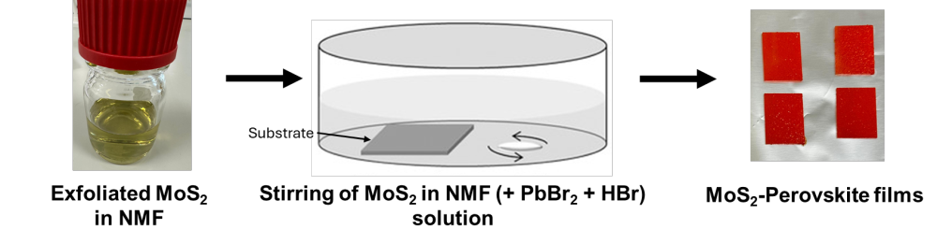
Figure S1: Schematic representation of the fabrication process of the MoS₂-perovskite microcrystalline films.

Figure S2: Absorbance spectrum of the stock solution prepared for crystallization of MoS₂-MAPbBr₃ heterostructures (inset: picture of the stock solution).
Figure S3: Photoluminescence emission spectra (excited at 419 nm) of the stock solution prepared for crystallization of MoS₂-MAPbBr₃ heterostructures.

XPS figures
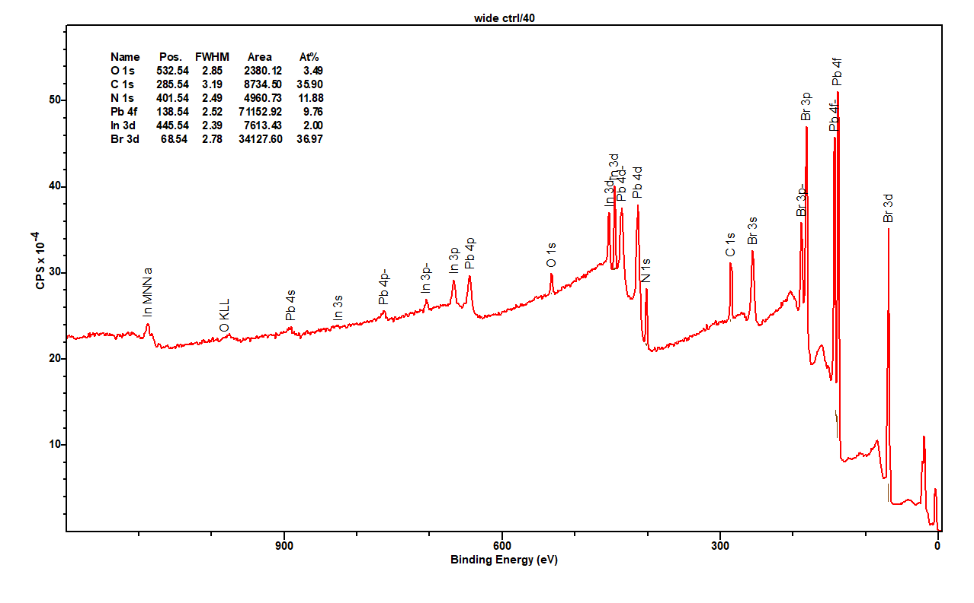
Figure S4: XPS survey scan of control MAPbBr₃ powders. The sample was pressed onto a high-purity indium substrate, as evidenced by the presence of In XPS peaks in the spectrum.
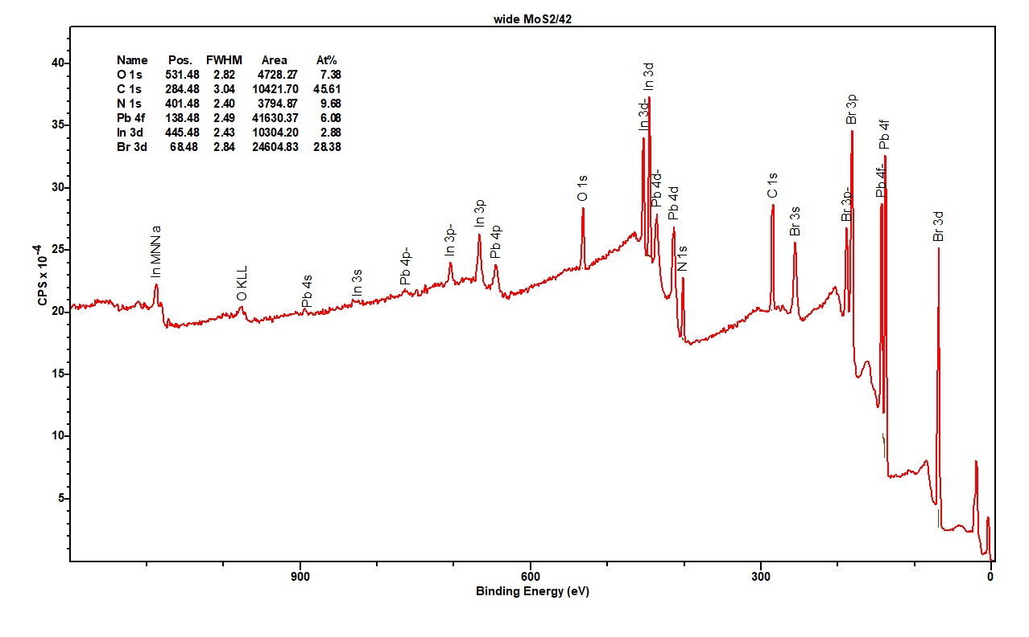
Figure S5: XPS survey scan of MoS₂-MAPbBr₃ powders. Also in this case, indium was used as substrate.
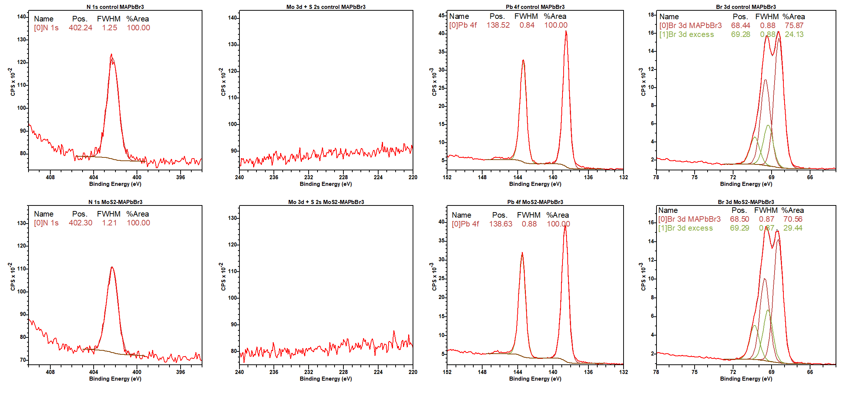
Figure S6: High-resolution XPS spectra of control MAPbBr₃ (top) and MoS₂-MAPbBr₃ (bottom) powders.
Table S1: Ratios of Br, N and Pb in control and MoS₂-MAPbBr₃ samples
Sample | Br 3d r % | N 1s r % | Pb 4f r % | Br/Pb | N/Pb | N:Pb:Br
Control MAPbBr₃ | 59.9 | 24.0 | 16.2 | 3.7 | 1.5 | 1.5:1:3.7
MoS₂-MAPbBr₃ | 63.7 | 19.0 | 17.3 | 3.7 | 1.1 | 1.1:1:3.7

Table S2: Results of the PL decay fitting with the sum of two exponential functions, as well as the intensity-averaged lifetime.
Sample | $τ_{1}$ / ns | A₁ | $τ_{2}$ / ns | A₂ | Intensity averaged lifetime / ns
control_PSK_glass_1 | 49.9 | 0.06 | 822.3 | 0.94 | 819.3
control_PSK_glass_2 | 16.9 | 0.04 | 1047.1 | 0.96 | 1046.4
MoS2_PSK_glass_1 | 29.5 | 0.1 | 569 | 0.9 | 566.0
MoS2_PSK_glass_2 | 23.3 | 0.16 | 509.1 | 0.84 | 505.0

The time-resolved PL decay curves were fitted using a biexponential function of the form:
$$I\left(t\right)=A_{1}e^{-t/τ_{1}}+A_{2}e^{-t/τ_{2}}$$
where $τ_{1}$and $τ_{2}$ are the fast and slow decay components, and $A_{1}$ and $A_{2}$ are their respective amplitudes. The intensity-averaged lifetime was calculated according to:
$τ_{avg}=\frac{A_{1}τ_{1}^{2}+A_{2}τ_{2}^{2}}{A_{1}τ_{1}+A_{2}τ_{2}}$.
The first (fast) component shows a relatively low contribution to the overall PL decay, while the second (slow) component dominates the emission dynamics. Both lifetime components become shorter in the MAPbBr₃/MoS₂ heterostructure, while the relative amplitudes remain nearly unchanged. According to previous reports on metal halide perovskites, the fast component $τ_{1}$ is typically attributed to radiative recombination of free excitons or free carriers, whereas the slower component $τ_{2}$ originates from delayed recombination involving shallow trap states.^{1,2} In the case of single crystals, these two components are often further distinguished as surface-related (fast) and bulk-related (slow) recombination processes.^{3,4} Although a detailed discussion of the individual recombination pathways is beyond the scope of this work, the simultaneous shortening of both components and consequently of the intensity-averaged lifetime in the heterostructure indicates the presence of an additional non-radiative decay channel. This is further corroborated by the decrease in PL intensity reported in Figure 2d. We therefore attribute this new channel to the interfacial electron transfer from MAPbBr₃ to MoS₂.
Table S3: Summarized Hall effect measurement comparison of MAPbBr₃ and MoS₂-MAPbBr₃ microcrystalline films.
Sample | Hall voltage | Current | Magnetic Field | Type | Mobility | Carrier concentration
 | V (V) | I (A) | B (T) |  | µ (cm²V⁻¹s⁻¹) | n (cm⁻³)
MAPbBr₃ | 0.036 | 4×10⁻⁸ | 1 | P | 150 | 0.8×10⁹
MoS₂-MAPbBr₃ | -0.001 | 4×10⁻⁸ | 1 | N | 346 | 1.9×10¹²

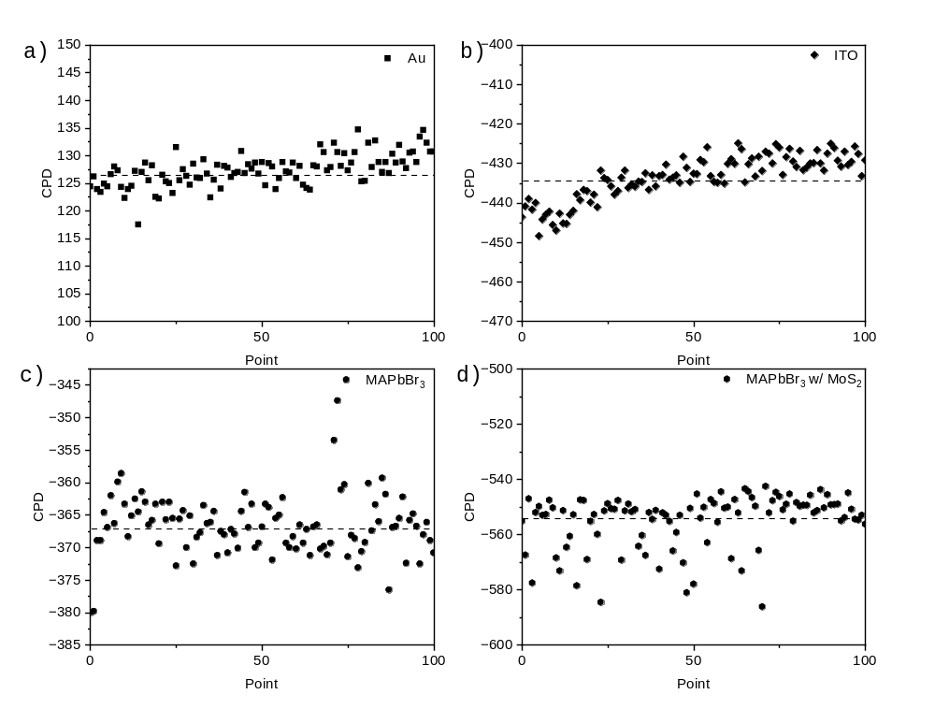
Figure S7: Contact potential difference (CPD) of a) Au, b) ITO, c) MAPbBr₃ (control), and d) MoS₂-MAPbBr₃.
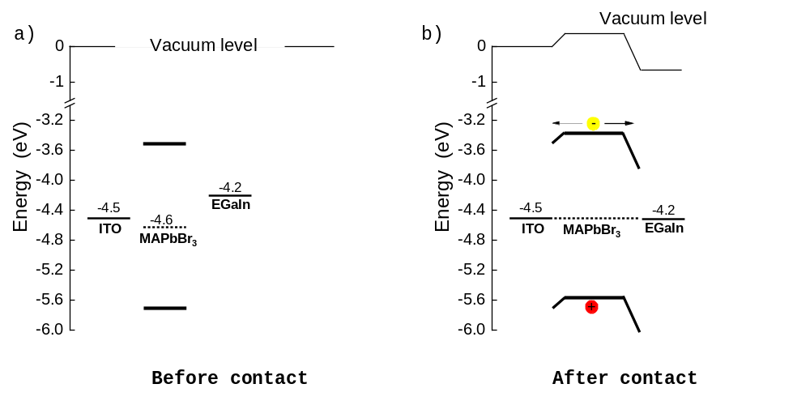
Figure S8: Band alignment of device based on ITO/MAPbBr₃ (control)/EGaIn (a) before and (b) after contact. The presence of hole barrier on both interfaces of MAPbBr₃ suggest it exhibit unipolar electron only transport.
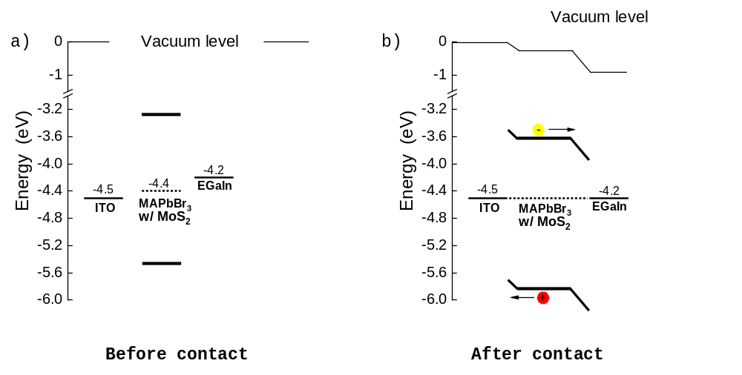
Figure S9: Band alignment of device based on ITO/MoS₂-MAPbBr₃/EGaIn (a) before and (b) after contact. Upshifted WF of MoS₂-MAPbBr₃ facilitates electron transport to EGaIn and hole transport to ITO.

Table S4: A comparison table of device performance, including the control, the hybrid, and previously reported state-of-the-art photodetectors.
Perovskite material | Device structure | Trap density (cm⁻³) | Detectivity (Jones) | R (A/W) | Rise/fall time (ms/ms) | Ref.
MAPbBr₃ | lateral | 2×10¹¹ | 10¹³ | 4,000 | 0.025/0.025 | ⁵
MAPbBr₃ | lateral | -- | -- | 2.2 | -- | ⁶
FAPbI₃ | lateral | 7.5×10¹¹ | -- | 300 | -- | ⁷
FAPbBr₃ | lateral | 6.9×10¹¹ | 10¹⁴ | 4000 | 0.67/0.75 | ⁸
MAPbCl₃ | lateral | -- | 10¹² | 18 | 1/1 | ⁹
CsPbBr₃ | lateral | 4.5×10¹² | 10¹³ | 6×10⁴ | 0.5/1.6 | ¹⁰
CsPbBr₃ | Vertical | 2.8×10¹² | 4.8×10¹² | 0.172 | 0.14/0.12 | ¹¹
CsPbBr₃ | Vertical | -- | 10¹⁴ | 150–300 | 100/20 | ¹²
Cs₂AgBiBr₆ | Vertical | -- | 1.72×10¹¹ | 1.58 | -- | ¹³
CsPbBr₃ NCs/monolayer MoS₂ | lateral | -- | 3.38×10¹¹ | 640 | 92 | ¹⁴
MAPbI₃BP/MoS₂ | lateral | -- | 1.3×10¹² | 11 | 0.15/0.24 | ¹⁵
(PEA)₂SnI₄/few-layer MoS₂ | lateral | -- | 8.09×10⁹ | 1100 | 34/38 | ¹⁶
MoS₂/MAPbI₃ | vertical | -- | -- | 68.11 | 205/206 | ¹⁷
MoS₂/MAPbI₃ | lateral | -- | -- | 28 | 356/204 | ¹⁷
MoS₂ few-layer/Cs₂CuBr₄ | lateral | -- | 1.6×10¹¹ | 0.137 | ∼32/∼79 | ¹⁸
MoS₂/MAPbI₃ | lateral | -- | 4.28×10¹³ | 1.08× 10⁴ | <45 | ¹⁹
MAPbI₃/MoS₂  heterostructure | lateral | -- | 10¹⁸ | 1.2 | 0.178/0.212 | ²⁰
MoS₂-MAPbBr₃ | Vertical | 5.72×10¹⁰ | 2×10¹¹ | 2.2 | 48/20 | This work

Table S5: Mean and Standard deviation for performance-determining parameters of multiple MoS₂-MAPbBr₃ devices at constant optical power and fixed bias.
Device No. | Average thickness (µm) | Rise (ms) | Decay (ms) | R (A/W) | EQE(%) | D*(Jones)
1 | 170 ± 30 | 42.6 ± 2.1 | 21.7 ± 3.9 | 2.1 ± 0.10 | 541.5 ± 10.6 | 3.1×10¹¹ ± 6.10×10⁹
2 | 170 ± 30 | 44.7 ± 1.2 | 19.7 ± 2.1 | 2.0 ± 0.20 | 508.6 ± 36.9 | 2.9×10¹¹ ± 2.10×10¹⁰
3 | 170 ± 30 | 41.0 ± 2.7 | 22.3 ± 4.1 | 2.1 ± 0.10 | 525.5 ± 11.9 | 3.0×10¹¹ ± 6.89×10⁹
4 | 170 ± 30 | 41.0 ± 1.0 | 22.7 ± 3.2 | 2.2 ± 0.01 | 562.2 ± 1.10 | 3.3×10¹¹ ± 6.93×10⁹

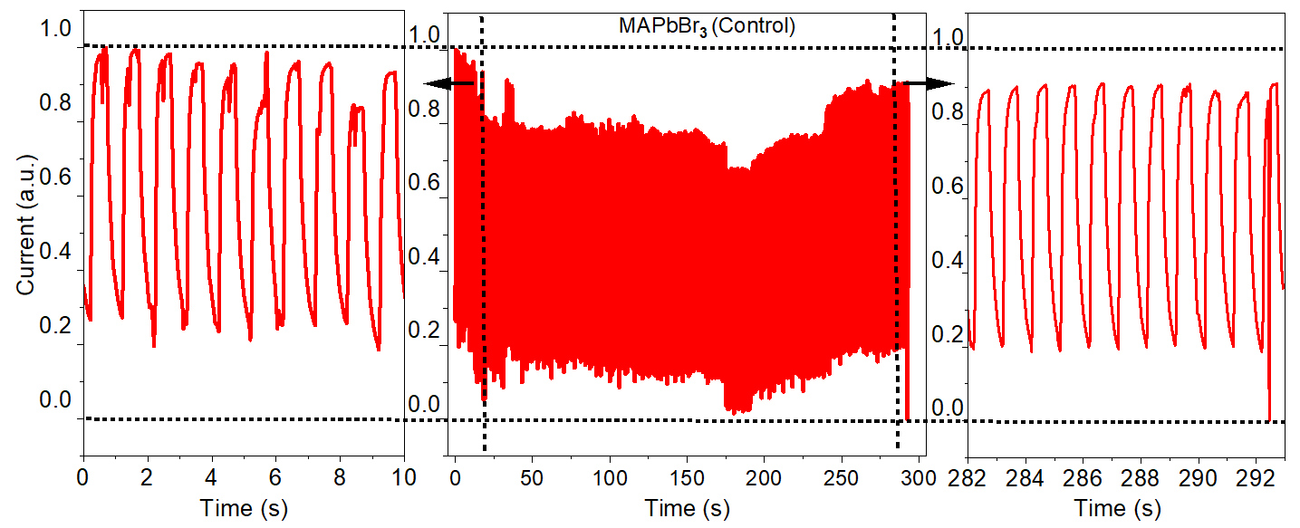References
Figure S10: Operational stability of the MAPbBr₃ (control) photodetector.

(1) de Quilettes, D. W.; Vorpahl, S. M.; Stranks, S. D.; Nagaoka, H.; Eperon, G. E.; Ziffer, M. E.; Snaith, H. J.; Ginger, D. S. Impact of Microstructure on Local Carrier Lifetime in Perovskite Solar Cells. Science 2015, 348 (6235), 683–686. https://doi.org/10.1126/science.aaa5333.
(2) Droseros, N.; Longo, G.; Brauer, J. C.; Sessolo, M.; Bolink, H. J.; Banerji, N. Origin of the Enhanced Photoluminescence Quantum Yield in MAPbBr3 Perovskite with Reduced Crystal Size. ACS Energy Lett. 2018, 3 (6), 1458–1466. https://doi.org/10.1021/acsenergylett.8b00475.
(3) Shi, D.; Adinolfi, V.; Comin, R.; Yuan, M.; Alarousu, E.; Buin, A.; Chen, Y.; Hoogland, S.; Rothenberger, A.; Katsiev, K.; Losovyj, Y.; Zhang, X.; Dowben, P. A.; Mohammed, O. F.; Sargent, E. H.; Bakr, O. M. Low Trap-State Density and Long Carrier Diffusion in Organolead Trihalide Perovskite Single Crystals. Science 2015, 347 (6221), 519–522. https://doi.org/10.1126/science.aaa2725.
(4) Zhumekenov, A. A.; Saidaminov, M. I.; Haque, M. A.; Alarousu, E.; Sarmah, S. P.; Murali, B.; Dursun, I.; Miao, X.-H.; Abdelhady, A. L.; Wu, T.; Mohammed, O. F.; Bakr, O. M. Formamidinium Lead Halide Perovskite Crystals with Unprecedented Long Carrier Dynamics and Diffusion Length. ACS Energy Lett. 2016, 1 (1), 32–37. https://doi.org/10.1021/acsenergylett.6b00002.
(5) Saidaminov, M. I.; Adinolfi, V.; Comin, R.; Abdelhady, A. L.; Peng, W.; Dursun, I.; Yuan, M.; Hoogland, S.; Sargent, E. H.; Bakr, O. M. Planar-Integrated Single-Crystalline Perovskite Photodetectors. Nat Commun 2015, 6 (1), 8724. https://doi.org/10.1038/ncomms9724.
(6) Yang, B.; Chen, J.; Shi, Q.; Wang, Z.; Gerhard, M.; Dobrovolsky, A.; Scheblykin, I. G.; Karki, K. J.; Han, K.; Pullerits, T. High Resolution Mapping of Two-Photon Excited Photocurrent in Perovskite Microplate Photodetector. J. Phys. Chem. Lett. 2018, 9 (17), 5017–5022. https://doi.org/10.1021/acs.jpclett.8b02250.
(7) Wu, G.; Zhou, J.; Meng, R.; Xue, B.; Zhou, H.; Tang, Z.; Zhang, Y. Air-Stable Formamidinium/Methylammonium Mixed Lead Iodide Perovskite Integral Microcrystals with Low Trap Density and High Photo-Responsivity. Phys. Chem. Chem. Phys. 2019, 21 (6), 3106–3113. https://doi.org/10.1039/C8CP07271J.
(8) Zhang, F.; Yang, B.; Zheng, K.; Yang, S.; Li, Y.; Deng, W.; He, R. Formamidinium Lead Bromide (FAPbBr3) Perovskite Microcrystals for Sensitive and Fast Photodetectors. Nano-Micro Lett. 2018, 10 (3), 43. https://doi.org/10.1007/s40820-018-0196-2.
(9) Adinolfi, V.; Ouellette, O.; Saidaminov, M. I.; Walters, G.; Abdelhady, A. L.; Bakr, O. M.; Sargent, E. H. Fast and Sensitive Solution-Processed Visible-Blind Perovskite UV Photodetectors. Advanced Materials 2016, 28 (33), 7264–7268. https://doi.org/10.1002/adma.201601196.
(10) Yang, B.; Zhang, F.; Chen, J.; Yang, S.; Xia, X.; Pullerits, T.; Deng, W.; Han, K. Ultrasensitive and Fast All-Inorganic Perovskite-Based Photodetector via Fast Carrier Diffusion. Advanced Materials 2017, 29 (40), 1703758. https://doi.org/10.1002/adma.201703758.
(11) Zhou, H.; Zeng, J.; Song, Z.; Grice, C. R.; Chen, C.; Song, Z.; Zhao, D.; Wang, H.; Yan, Y. Self-Powered All-Inorganic Perovskite Microcrystal Photodetectors with High Detectivity. J. Phys. Chem. Lett. 2018, 9 (8), 2043–2048. https://doi.org/10.1021/acs.jpclett.8b00700.
(12) Abiedh, K.; Dhanabalan, B.; Kutkan, S.; Lauciello, S.; Pasquale, L.; Toma, A.; Salerno, M.; Arciniegas, M. P.; Hassen, F.; Krahne, R. Surface-Dependent Properties and Tunable Photodetection of CsPbBr3 Microcrystals Grown on Functional Substrates. Advanced Optical Materials 2022, 10 (3), 2101807. https://doi.org/10.1002/adom.202101807.
(13) Hossain, M.; Sheikh, M. S.; Rao, K. D. M. Hot-Spin Casting Synthesis of Freestanding Cs2AgBiBr6 Double Perovskite Facet-Oriented Microcrystals for Efficient Photodetectors. Advanced Materials Interfaces 2021, 8 (18), 2100570. https://doi.org/10.1002/admi.202100570.
(14) Zhang, L.; Shen, S.; Li, M.; Li, L.; Zhang, J.; Fan, L.; Cheng, F.; Li, C.; Zhu, M.; Kang, Z.; Su, J.; Zhai, T.; Gao, Y. Strategies for Air-Stable and Tunable Monolayer MoS2-Based Hybrid Photodetectors with High Performance by Regulating the Fully Inorganic Trihalide Perovskite Nanocrystals. Advanced Optical Materials 2019, 7 (11), 1801744. https://doi.org/10.1002/adom.201801744.
(15) Wang, L.; Zou, X.; Lin, J.; Jiang, J.; Liu, Y.; Liu, X.; Zhao, X.; Liu, Y. F.; Ho, J. C.; Liao, L. Perovskite/Black Phosphorus/MoS2 Photogate Reversed Photodiodes with Ultrahigh Light On/Off Ratio and Fast Response. ACS Nano 2019, 13 (4), 4804–4813. https://doi.org/10.1021/acsnano.9b01713.
(16) Fang, C.; Wang, H.; Shen, Z.; Shen, H.; Wang, S.; Ma, J.; Wang, J.; Luo, H.; Li, D. High-Performance Photodetectors Based on Lead-Free 2D Ruddlesden–Popper Perovskite/MoS2 Heterostructures. ACS Appl. Mater. Interfaces 2019, 11 (8), 8419–8427. https://doi.org/10.1021/acsami.8b20538.
(17) Bai, F.; Qi, J.; Li, F.; Fang, Y.; Han, W.; Wu, H.; Zhang, Y. A High-Performance Self-Powered Photodetector Based on Monolayer MoS2/Perovskite Heterostructures. Advanced Materials Interfaces 2018, 5 (6), 1701275. https://doi.org/10.1002/admi.201701275.
(18) Pramanik, M.; Bera, A.; Karmakar, S.; Sinha, P.; Singha, A.; Das, K. High-Performance Broadband Self-Driven Photodetector Based on MoS2/Cs2CuBr4 Heterojunction. ACS Appl. Mater. Interfaces 2024, 16 (29), 38260–38268. https://doi.org/10.1021/acsami.4c06966.
(19) Peng, Z.-Y.; Xu, J.-L.; Zhang, J.-Y.; Gao, X.; Wang, S.-D. Solution-Processed High-Performance Hybrid Photodetectors Enhanced by Perovskite/MoS2 Bulk Heterojunction. Advanced Materials Interfaces 2018, 5 (18), 1800505. https://doi.org/10.1002/admi.201800505.
(20) Song, J.; Li, T.; Li, W.; Xiao, Z.; Chen, B.; Li, D.; Ducharme, S.; Lu, Y.; Huang, J.; Zia, R.; Hong, X. Enabling Fast Photoresponse in Hybrid Perovskite/MoS2 Photodetectors by Separating Local Photocharge Generation and Recombination. Nano Lett. 2024, 24 (45), 14307–14314. https://doi.org/10.1021/acs.nanolett.4c03950.

