Nucleation effects of high molecular weight polymer additives on low molecular weight gels

Symone L. M. Alexander^{a,b} and LaShanda T. J. Korley^{b,c}*

ªDepartment of Macromolecular Science and Engineering, Case Western Reserve University
Cleveland, Ohio 44106-7202, United States
^{b}Department of Materials Science and Engineering, University of Delaware
Newark, DE 19716, United States
^{c}Department of Chemical and Biomolecular Engineering, University of Delaware
Newark, DE 19716, United States

SUPPLEMENTAL INFORMATION

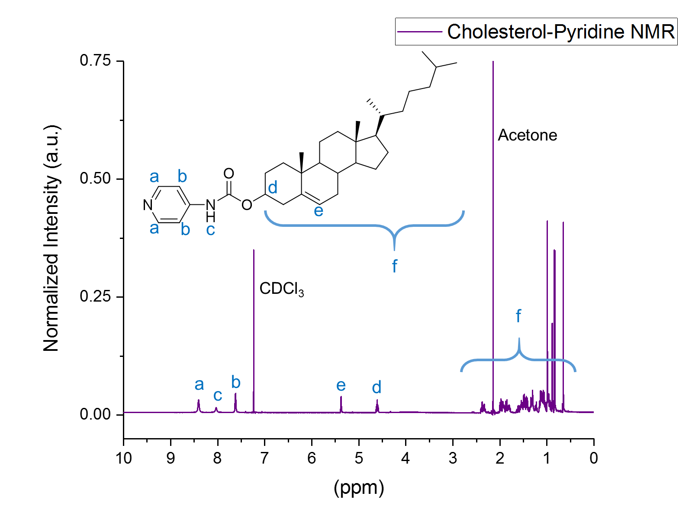
Figure S1: ¹H-NMR spectrum and peak identification of cholesterol-pyridine gelator
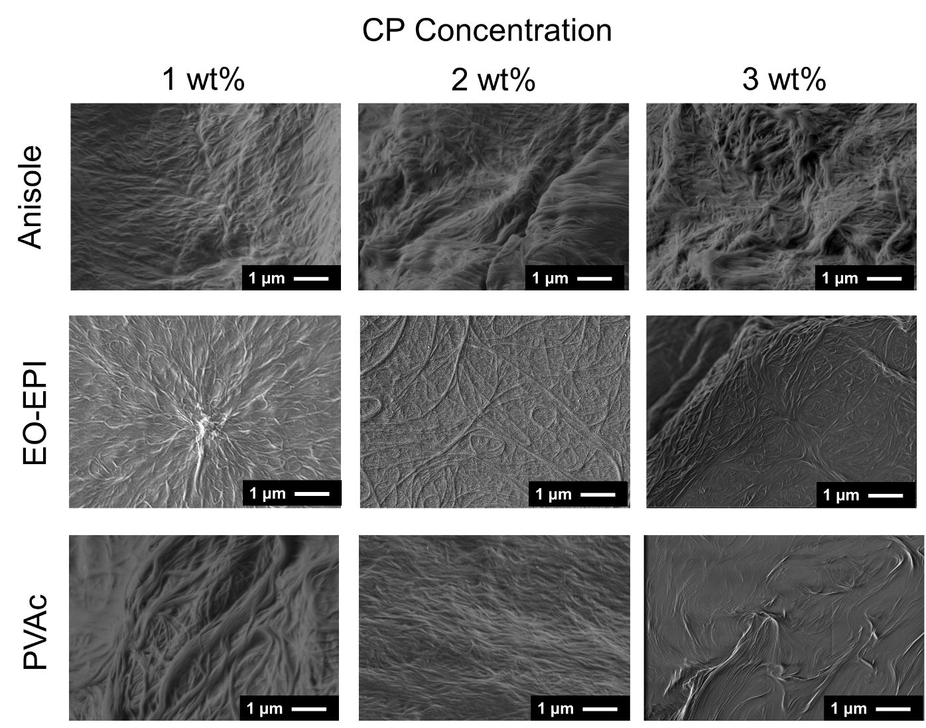
Figure S2: Scanning electron microscopy of neat CP, E-CP, and P-CP gels and the fiber structural evolution as a function of CP concentration.

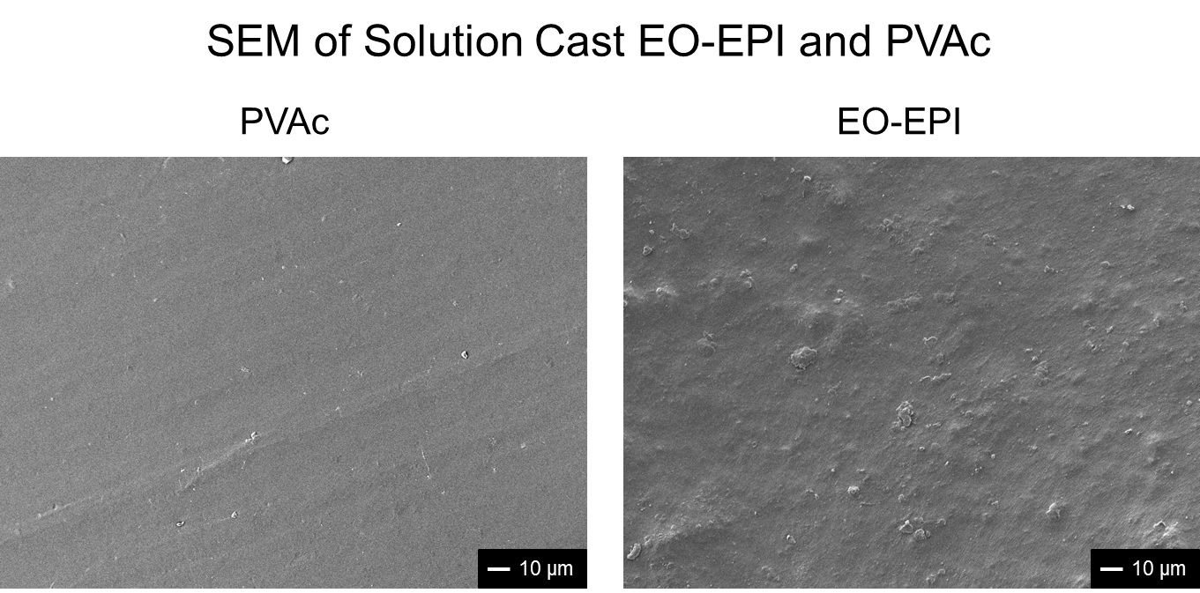
Figure S3: Scanning electron microscopy of solution cast EO-EPI and PVAc.
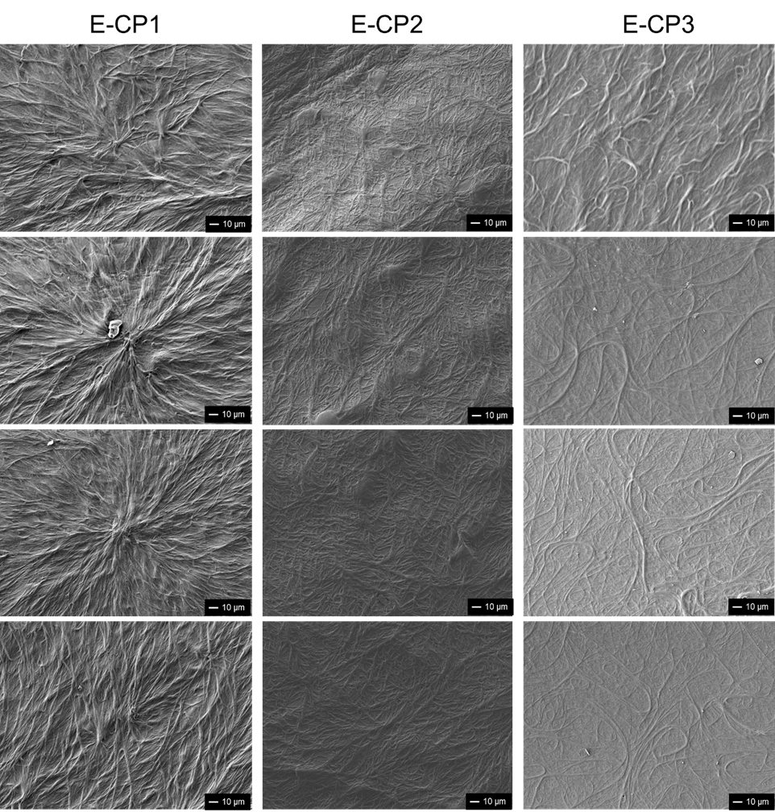
Figure S4: Wide field SEM of E-CP gels exemplifying the persistence of network structures throughout the gels.
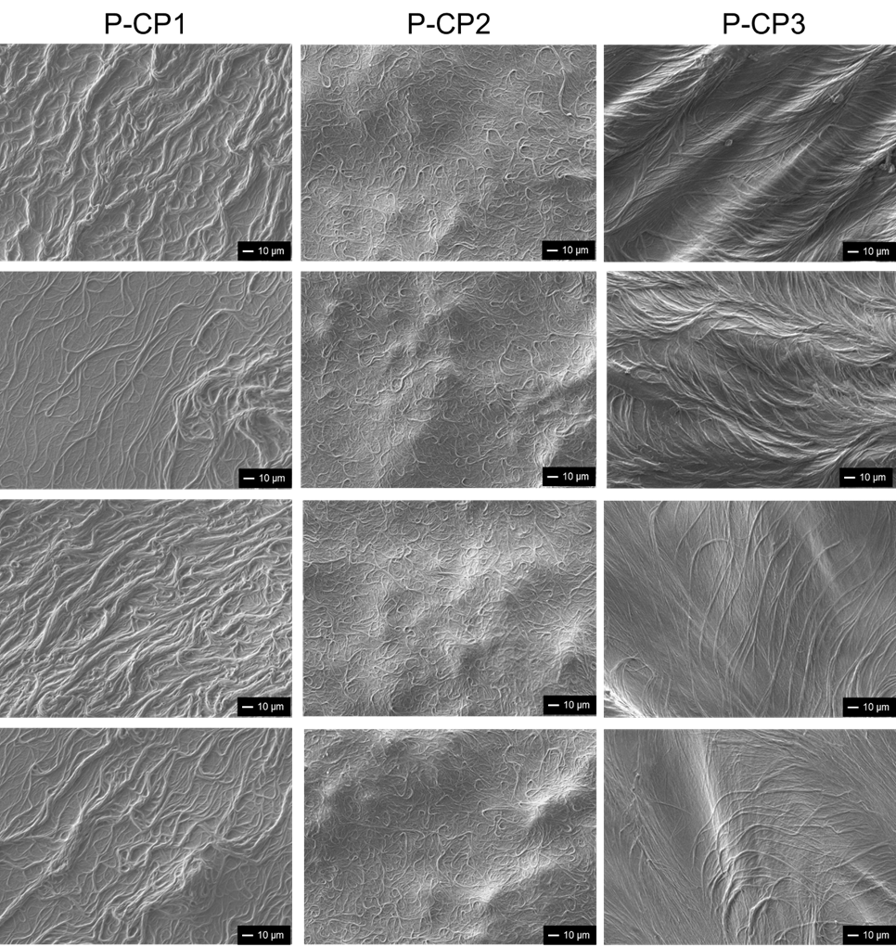
Figure S5: Wide field SEM of P-CP gels exemplifying the persistence of network structures throughout the gels.

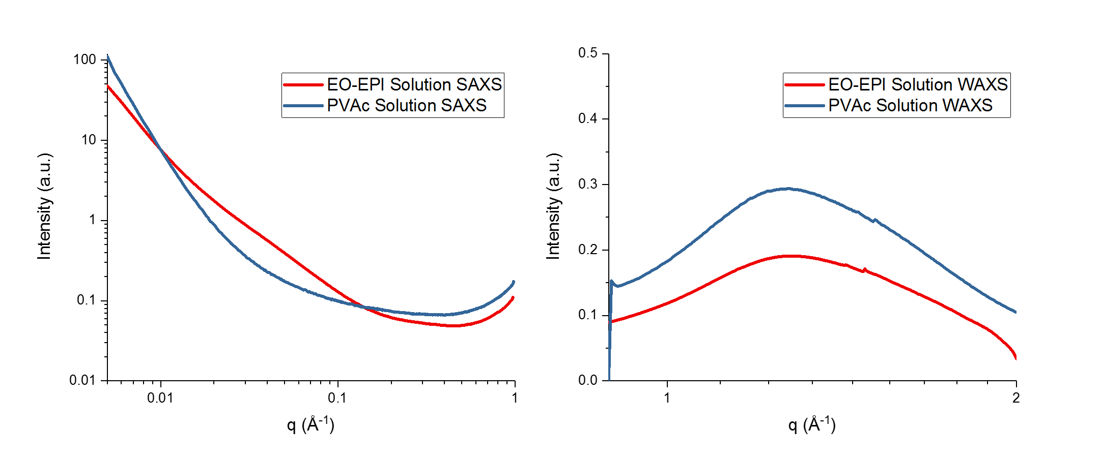
Figure S6: 1-D SAXS and WAXS of polymer solutions. The solutions do not display scattering peaks, signifying that any structural order observed is due to the CP gel network.

Figure S7: Fitting of anisole-CP SAXS data with SasView lamellar model
Figure S8: Fitting of E-CP SAXS data with SasView lamellar and cylindrical models
Figure S9: Fitting of P-CP SAXS data with SasView cylindrical models

