Supplementary materials for

Molecular-Weight and Cooling-Rate Dependence of Thermodynamics of Polymer in Molecular Dynamics Simulation

Yao-Chun Wang¹, Jun-Fu Zhang², Min-Hsueh Chiu², Jia-Han Li², Chia-Yung Jui³, Te-Hsun Yang², Wen-Jay Lee* ³

¹ Daxin Materials Corporation, No.15, Keyuan 1st Rd., Central Taiwan Science Park, Taichung City, Taiwan (R.O.C.)
² Department of Engineering Science and Ocean Engineering College of Engineering, National Taiwan University, No. 1, Sec. 4, Roosevelt Rd., Taipei 10617, Taiwan (R.O.C.)
³ National Center for High-performance Computing, No.22, Keyuan Rd., Central Taiwan Science Park, Taichung City, Taiwan (R.O.C.)

*Corresponding author: wjlee@nchc.narl.org.tw
- (b) (c)

(d) (e) (f)

(g) (h) (i)

(i)
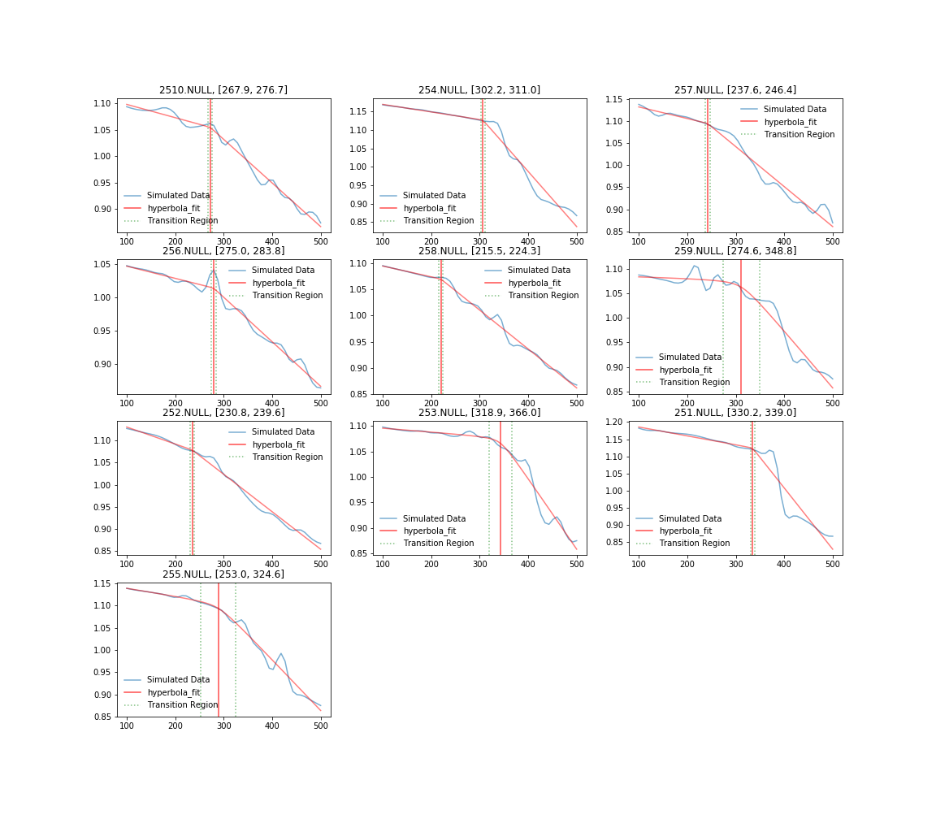
Fig. S1 Density as a function of temperature for single PEO system with molecular weight of 1,124g/mol per chain.
(a) (b) (c)

(d) (e) (f)

(g) (h) (i)

(i)
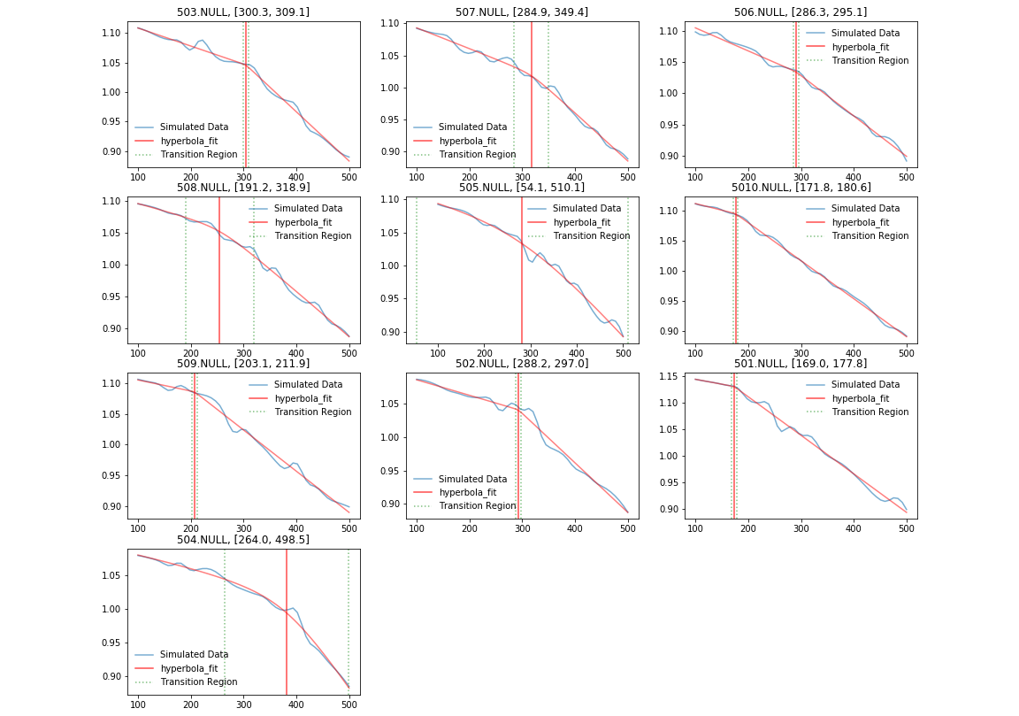
Fig. S2 Density as a function of temperature for single PEO system with molecular weight of 2,248g/mol per chain.
(a) (b) (c)

(d) (e) (f)

(g) (h) (i)

(i)
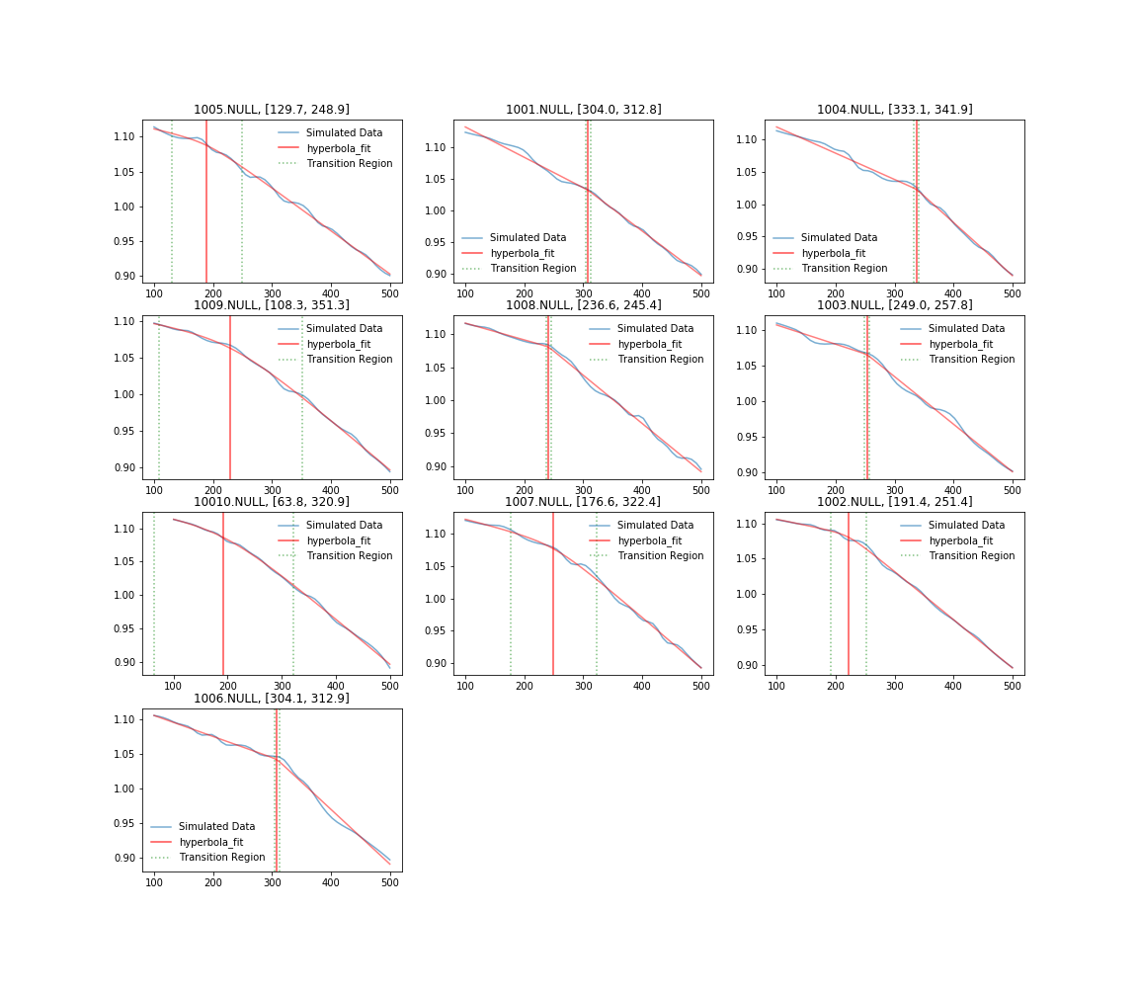Fig. S3 Density as a function of temperature for single PEO system with molecular weight of 4,496g/mol per chain.
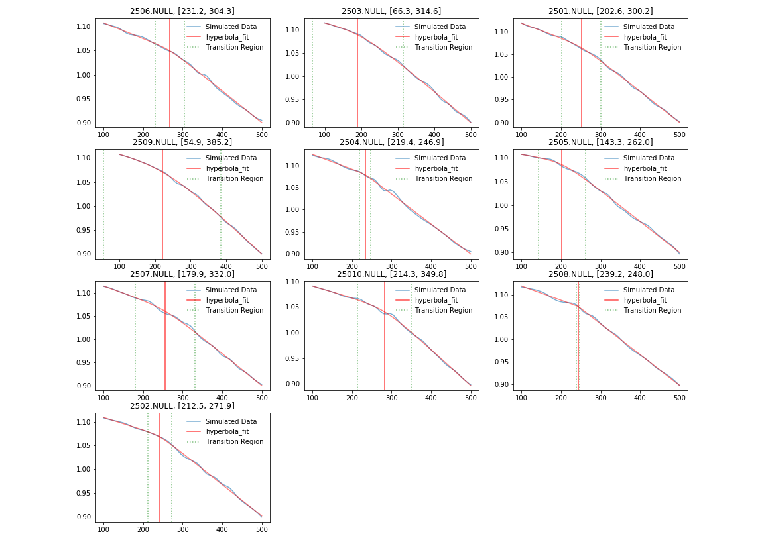
(a) (b) (c)

(d) (e) (f)

(g) (h) (i)

(i)
Fig. S4 Density as a function of temperature for single PEO system with molecular weight of 11,240g/mol per chain.

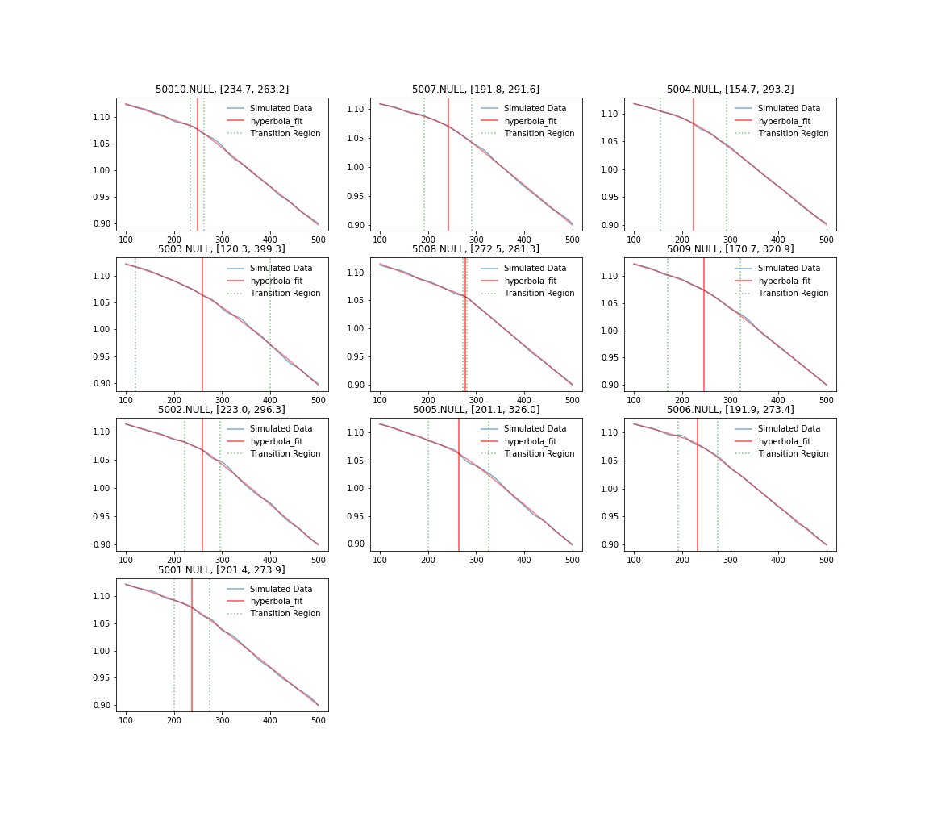
(a) (b) (c)

(d) (e) (f)

(g) (h) (i)

(i)
Fig. S5 Density as a function of temperature for single PEO system with molecular weight of 22,480g/mol per chain.
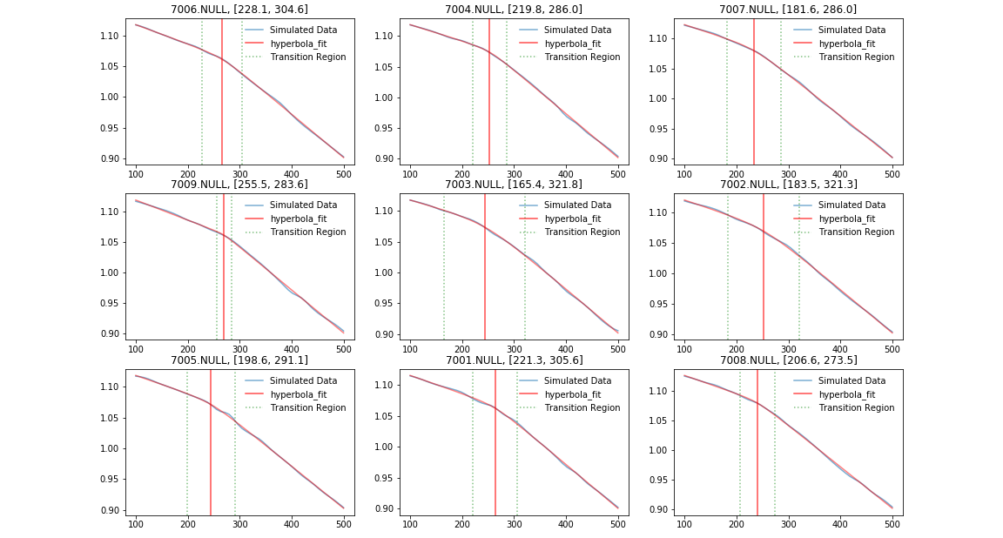
(a) (b) (c)

(d) (e) (f)

(g) (h) (i)

(i)
Fig. S6 Density as a function of temperature for single PEO system with molecular weight of 31,472g/mol per chain.
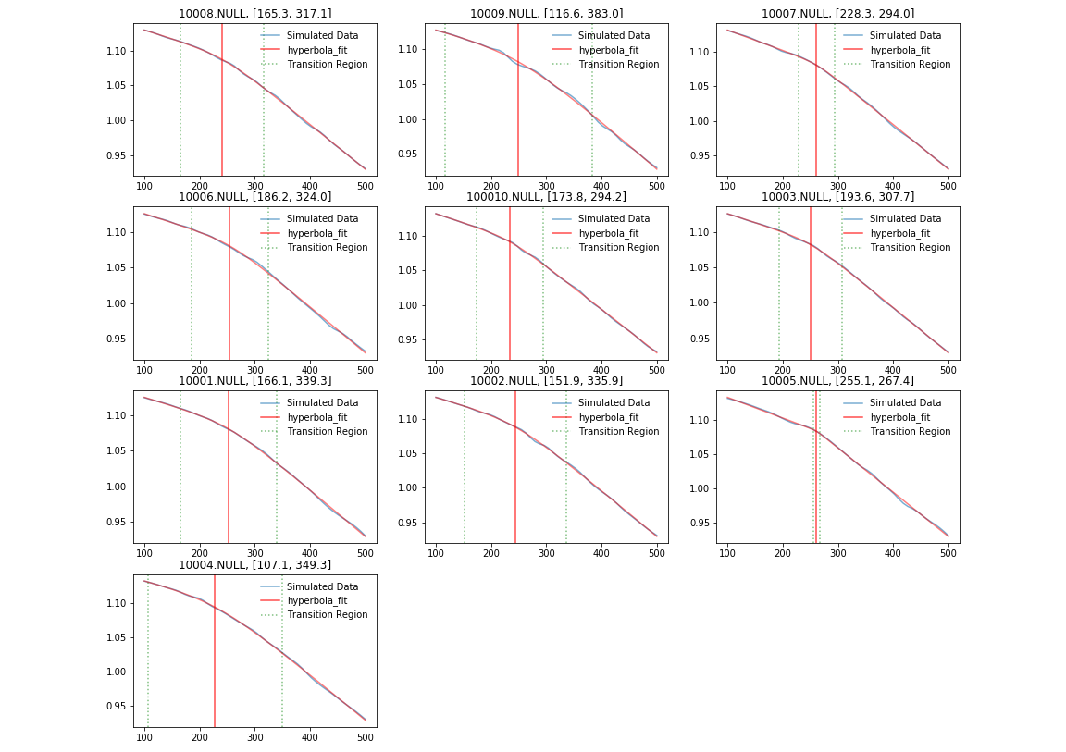
(a) (b) (c)

(d) (e) (f)

(g) (h) (i)

(i)

Fig. S7 Density as a function of temperature for single PEO system with molecular weight of 44,960g/mol per chain.

