Support Information

Intermediates of tris(pentafluorophenyl)borane and dimethyl carbonate pave the way for deeper organosiloxane depolymerization reaction

Iryna Protsak,*ª Volodymyr Gun’ko,ª Yevhenii Morozov,^{b} Ian M. Henderson^{c}, Dong Zhang^{d}, Zhang Yinjun,^{e}
Volodymyr Turovª

ª Chuiko Institute of Surface Chemistry of NASU, Kyiv 03164, Ukraine
^{b} Institute for Information Recording of NASU, Kyiv 03113, Ukraine
^{c} Biophagy, Inc., Albuquerque, NM, 87110, USA
^{d} Department of Chemical & Biomolecular Engineering, University of Akron, Akron, Ohio 44325, USA
^{e} College of Biotechnology and Bioengineering, Zhejiang University of Technology,
Hangzhou, Zhejiang Province, 310014, China

Keywords: siloxane bond cleavage, tris(pentafluorophenyl)borane, dimethyl carbonate, quantum chemical calculations

Experimental Procedures
Materials
Commercial poly(dimethylsiloxane) (code name: PDMS linear, –CH₃ terminated, linear, average value of the polymerisation degree n ≈ 100) was purchased from Aladdin Reagents, China. Tert-butanol (TBA) containing ≥ 99.0 wt. % of C₄H₁₀O; dimethyl carbonate containing ≥ 99.0 wt. % of C₃H₆O₃ and deuterated chloroform (CDCl₃) containing ≥ 99.0 wt. % were purchased from Aladdin Reagents, China. Tris(pentafluorophenyl)borane containing ≥ 97 wt. % of B(C₆F₅)₃ was purchased from Aladdin Reagents, China. All materials were used as received.

Materials characterization

NMR spectroscopy
¹H NMR spectra were recorded on a Bruker AVANCE III 500 MHz spectrometer (Bruker, Germany) at resonance frequency of 500.13 MHz. All the spectra were collected with an acquisition time of 2 sec. A total of 16 scans were accumulated for all ¹H spectra. Chemical shifts (δ) are reported in ppm and were referenced internally relative to deuterated chloroform (δ_{H} = 7.26 ppm). ¹H-NMR (500 MHz, 25 °C, CDCl₃): 0.22 to -0.05, (m, -Si(CH₃)₂-); 1.28 (d, (CH₃)₂SiCH₂-); 3.79 (s, -SiOCH₃); 3.75 (q, -SiOCH₂CH₃).

GPC studies of PDMS depolymerisation
The relative average molecular weight (M_{n}) of depolymerised PDMS was determined with a Waters 1515 gel permeation chromatographer (GPC) equipped with a refractive index detector (RI), using HR1, HR3, and HR4 columns with the molecular weight range of 0.1–500 kDa calibrated with polystyrene standards. A series of polystyrenes were used as the standards with THF as the eluent at a flow rate of 1.0 mL min⁻¹. Standard deviation for PDMS is determined to be ±0.562 kDa.

Depolymerisation of poly(dimethylsiloxane) monitored by ¹H NMR spectroscopy and GPC
The PDMS depolymerisation reaction was carried out at different temperatures as 25, 50, 75, 100, and 125 ºC; using different concentrations of B(C₆F₅)₃ ((7.2 mg) 0.014 mmol, (46 mg) 0.09 mmol, (56 mg) 0.11 mmol, (36 mg) 0.07 mmol, and (76 mg) 0.15 mmol); and various concentrations of DMC (12 mmol (1 ml), 71 mmol (6 ml), 107 mmol (9 ml) and 285 mmol (24 ml)). In the typical depolymerisation process, a round bottom flask equipped with a reflux condenser was charged with TBA (1 ml, 0.01 mmol), DMC (1 ml, 12 mmol) and PDMS (1 ml) and stirred thoroughly for 2 h at 25 °C in oil bath and also at various temperatures as mentioned above. In case of using B(C₆F₅)₃, the all reactions were performed under inert atmosphere to avoid possible reaction of B(C₆F₅)₃ with air and moisture. After a depolymerisation reaction, the volatile unreacted products were removed using a rotary evaporator at 40-50 °C for 15-30 min. The resulting depolymerised PDMS solutions were analysed using GPC and ¹H NMR spectroscopy method (Figures S1-S5).
Quantum chemical calculations
Density functional theory (DFT with ωB97X−D/cc−pVDZ) method was used with the Gaussian 09 [1] and GAMESS (version 2019 R2) [2] program suits to calculate the geometry, energetic and other characteristics of PDMS (7 units), DMC, B(C₆F₅)₃, their complexes and reaction products. The interaction energy was calculated using counterpoise (considering BSSE) corrections. The solvation effects were considered using the SMD method [3, 4] with 2-butanol as a solvent. Visualisation of the calculated structures was carried out using ChemCraft [5] and Avogadro 2 [6] program suits.

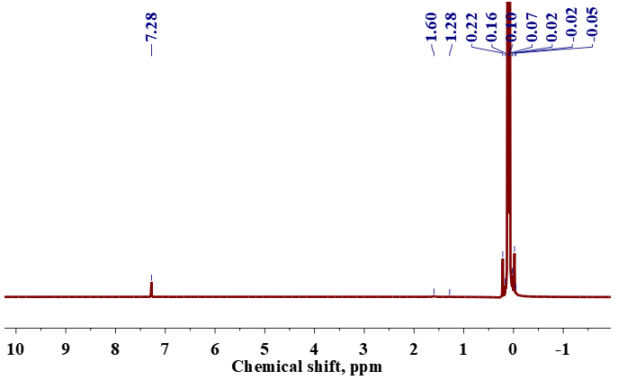
Figure S1. ¹H NMR spectrum (500 MHz, 25 °C) of neat PDMS–100.

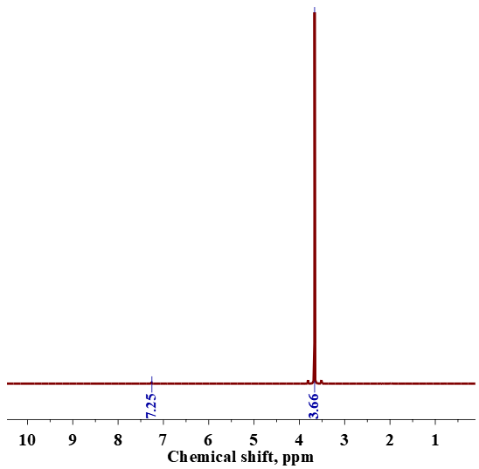
Figure S2. ¹H NMR spectrum (500 MHz, 25ºC) of neat DMC.

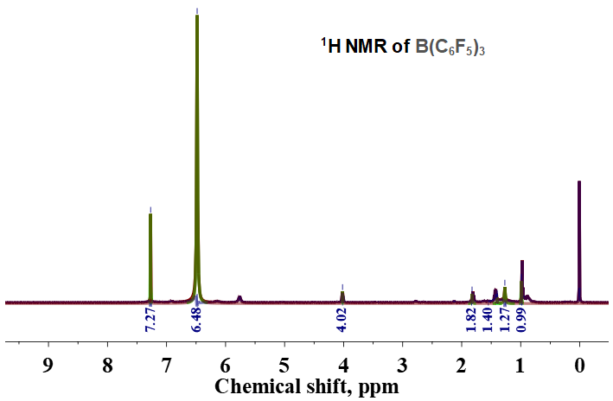
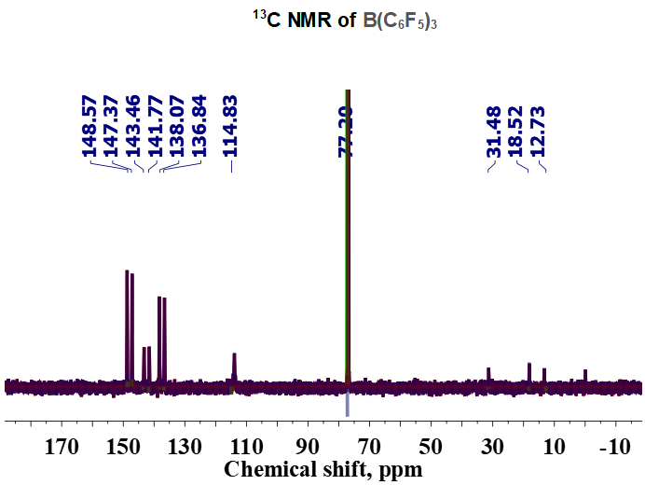
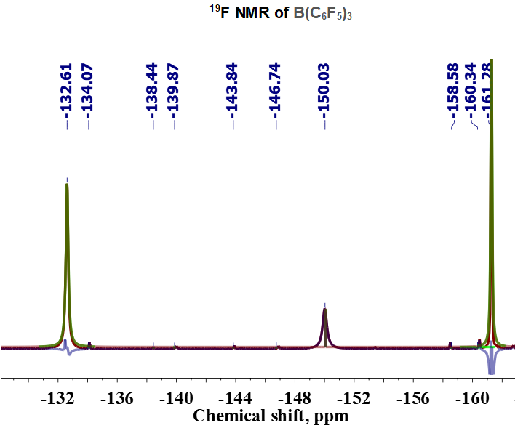
Figure S3. ¹H NMR, ¹³C NMR, ¹⁹F NMR spectrum of neat B(C₆F₅)₃.
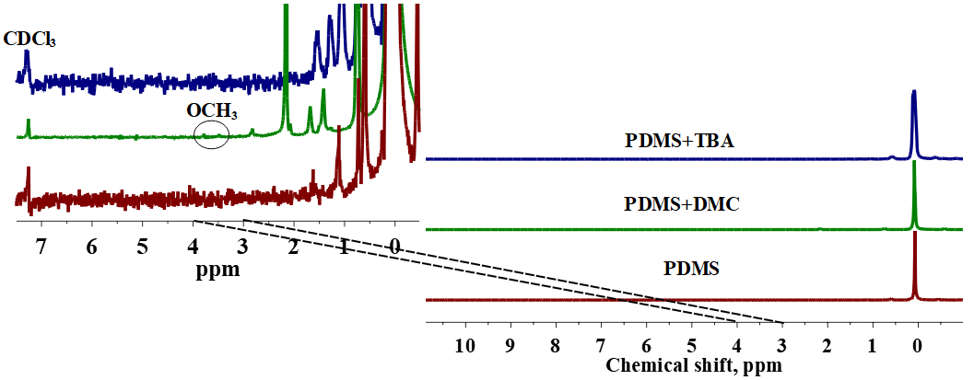
Figure S4. ¹H NMR spectra (500 MHz, 25 °C) of neat PDMS, PDMS (1 ml) depolymerised in DMC alone (1 ml, 12 mmol) and PDMS depolymerised in TBA alone (1 ml, 0.01 mmol); the insert shows the alkoxy group signals of depolymerised PDMS.

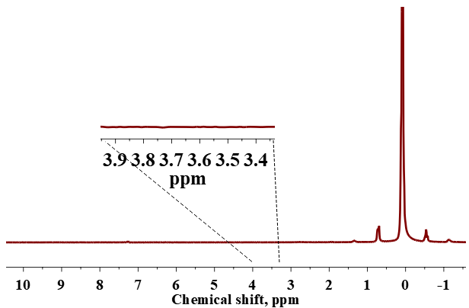
Figure S5. ¹H NMR spectra (500 MHz, 25 °C, CDCl₃) of PDMS depolymerised with B(C₆F₅)₃ alone at 25 °C for 2 h; insert shows absence of the alkoxy group signal of depolymerised PDMS.

Theoretical model
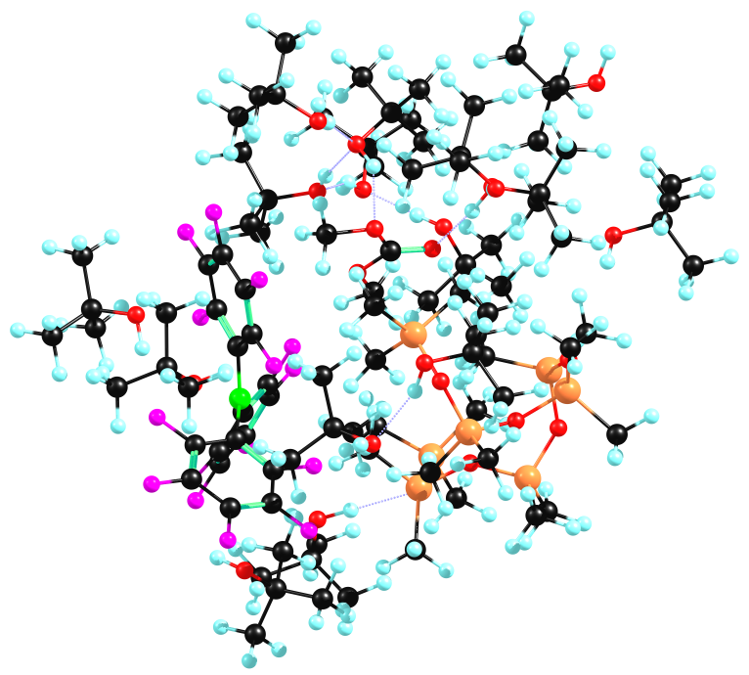
Figure S6. PDMS (7 units), DMC and B(C₆F₅)₃ interacting with 15 molecules of tert-butanol (ωB97X−D/cc−pVDZ method, E_{t} = −9172.78179832 a.u., complexation energy E_{c} = −372.8 kJ/mol (−24.9 kJ/mol per a TBA molecule) taking into account interactions of TBA with PDMS, DMC, and B(C₆F₅)₃ and between reactants, and E_{c} = −315.8 kJ/mol (−21.1 kJ/mol per a TBA molecule) for interactions of TBA with PDMS, DMC, and B(C₆F₅)₃).

Table S1. Results of calculations with the SMD/ωB97X−D/cc−pVDZ method (GAMESS 2019 R2) and 2-butanol as a solvent.
DMC
Parameter | Value^{[a]}
Internal energy in gas = <PSI(0)| H(0) |PSI(0)> | −343.4951432618 a.u.
Internal energy in solvent = <PSI| H(0) |PSI> | −343.4918731080 a.u.
Delta internal energy = <D-PSI| H(0) |D-PSI> | 0.0032701538 a.u.
Total energy in solvent = <PSI| H(0)+V/2 |PSI> | −343.5114324080 a.u.
Electrostatic interaction <PSI| V/2 |PSI> | −0.0195593000 a.u.
CDS (non-electrostatic) interaction | 0.0054290450 a.u.
Total free energy in solvent, G_{s} | −343.5060033630 a.u.
Delta internal energy | 2.05 kcal/mol
Electrostatic interaction | −12.27 kcal/mol
CDS interaction | 3.41 kcal/mol
Free energy of solvation | −6.81 kcal/mol
Free energy of solvation, ΔG_{s} | −4.92 kcal/mol (1 atm standard state)

B(C₆F₅)₃
Parameter | Value
Internal energy in gas = <PSI(0)| H(0) |PSI(0)> | −2207.7654717988 a.u.
Internal energy in solvent = <PSI| H(0) |PSI> | −2207.7648582208 a.u.
Delta internal energy = <D-PSI| H(0) |D-PSI> | 0.0006135780 a.u.
Total energy in solvent = <PSI| H(0)+V/2 |PSI> | −2207.7725567735 a.u.
Electrostatic interaction <PSI| V/2 |PSI> | −0.0076985527 a.u.
CDS (non-electrostatic) interaction | 0.0074754297 a.u.
Total free energy in solvent, G_{s} | −2207.7650813439 a.u.
Delta internal energy | 0.39 kcal/mol
Electrostatic interaction | −4.83 kcal/mol
CDS interaction | 4.69 kcal/mol
Free energy of solvation | 0.25 kcal/mol
Free energy of solvation, ΔG_{s} | 2.14 kcal/mol (1 atm standard state)

PDMS (7 units)
Parameter | Value
Internal energy in gas = <PSI(0)| H(0) |PSI(0)> | −3116.9619790828 a.u.
Internal energy in solvent = <PSI| H(0) |PSI> | −3116.9613684749 a.u.
Delta internal energy = <D-PSI| H(0) |D-PSI> | 0.0006106079 a.u.
Total energy in solvent = <PSI| H(0)+V/2 |PSI> | −3116.9708297254 a.u.
Electrostatic interaction <PSI| V/2 |PSI> | −0.0094612505 a.u.
CDS (non-electrostatic) interaction | 0.0056261537 a.u.
Total free energy in solvent, G_{s} | −3116.9652035717 a.u.
Delta internal energy | 0.38 kcal/mol
Electrostatic interaction | −5.94 kcal/mol
CDS interaction | 3.53 kcal/mol
Free energy of solvation | −2.02 kcal/mol
Free energy of solvation, ΔG_{s} | −0.13 kcal/mol (1 atm standard state)

Products (CO₂, B(C₆F₅)₃ and PDMS cleaved into two fragments with OCH₃ end-groups)
Parameter | Value
Internal energy in gas = <PSI(0)| H(0) |PSI(0)> | −5668.2819834299 a.u.
Internal energy in solvent = <PSI| H(0) |PSI> | −5668.2808357555 a.u.
Delta internal energy = <D-PSI| H(0) |D-PSI> | 0.0011476744 a.u.
Total energy in solvent = <PSI| H(0)+V/2 |PSI> | −5668.2963855403 a.u.
Electrostatic interaction <PSI| V/2 |PSI> | −0.0155497848 a.u.
CDS (non-electrostatic) interaction | 0.0116522969 a.u.
Total free energy in solvent, G_{s} | −5668.2847332434 a.u.
Delta internal energy | 0.72 kcal/mol
Electrostatic interaction | −9.76 kcal/mol
CDS interaction | 7.31 kcal/mol
Free energy of solvation | −1.73 kcal/mol
Free energy of solvation, ΔG_{s} | 0.17 kcal/mol

Complex of B(C₆F₅)₃ with DMC
Parameter | Value
Internal energy in gas = <PSI(0)| H(0) |PSI(0)> | −2551.2936248471 a.u.
Internal energy in solvent = <PSI| H(0) |PSI> | −2551.2902076259 a.u.
Delta internal energy = <D-PSI| H(0) |D-PSI> | 0.0034172212 a.u.
Total energy in solvent = <PSI| H(0)+V/2 |PSI> | −2551.3192133681 a.u.
Electrostatic interaction <PSI| V/2 |PSI> | −0.0290057423 a.u.
CDS (non-electrostatic) interaction | 0.0098021637 a.u.
Total free energy in solvent, G_{s} | −2551.3094112045 a.u.
Delta internal energy | 2.14 kcal/mol
Electrostatic interaction | −18.20 kcal/mol
CDS interaction | 6.15 kcal/mol
Free energy of solvation | −9.91 kcal/mol
Free energy of solvation, ΔG_{s} | −8.01 kcal/mol (1 atm standard state)

Complex of B(C₆F₅)₃/DMC with PDMS
Parameter | Value
Internal energy in gas = <PSI(0)| H(0) |PSI(0)> | −5668.3089552524 a.u.
Internal energy in solvent = <PSI| H(0) |PSI> | −5668.3063663722 a.u.
Delta internal energy = <D-PSI| H(0) |D-PSI> | 0.0025888802 a.u.
Total energy in solvent = <PSI| H(0)+V/2 |PSI> | −5668.3311254342 a.u.
Electrostatic interaction <PSI| V/2 |PSI> | −0.0247590620 a.u.
CDS (non-electrostatic) interaction | 0.0125103771 a.u.
Total free energy in solvent, G_{s} | −5668.3186150570 a.u.
Delta internal energy | 1.62 kcal/mol
Electrostatic interaction | −15.54 kcal/mol
CDS interaction | 7.85 kcal/mol
Free energy of solvation | −6.06 kcal/mol
Free energy of solvation, ΔG_{s} | −4.17 kcal/mol (1 atm standard state)

^{[a]} 1 a.u. = 2625.49962 kJ/mol, 1 kcal/mol = 4.184 kJ/mol
Note that the dielectric constant of tert-butanol (used as a solvent in the experiments) is lower (10.9) than that of 2-butanol (15.8) used in the SMD calculations (2-butanol is used because the SMD parameters for tert-butanol are absent in the Gaussian and GAMESS program suits). Therefore, contribution of the electrostatic interactions in the total free energy in the solvent could be slightly overestimated, but the opposite results could be for CDS contribution. However, these effects are small for the difference values for the reactants or complexes and products.
G_{s,products} - G_{s,DMC} - G_{s,PDMS} - G_{s,B(C6F5)3} = −127.2 kJ/mol
G_{s,products} - G_{s,DMC/B(C6F5)3} - G_{s,PDMS} = −26.6 kJ/mol
G_{s,products} - G_{s,DMC/B(C6F5)3+PDMS} = 89.0 kJ/mol

References
[1] M. J. Frisch et al., Gaussian 09, Revision D.01, Gaussian, Inc., Wallingford CT, 2013.
[2] M. W. Schmidt et al., General atomic and molecular electronic structure system, J. Comput. Chem. 1993, 14, 1347-1363.
[3] A. V. Marenich, C. J. Cramer, D. G.Truhlar, Universal Solvation Model Based on Solute Electron Density and on a Continuum Model of the Solvent Defined by the Bulk Dielectric Constant and Atomic Surface Tensions, J. Phys. Chem. B 2009, 113, 6378-6396.
[4] A. V. Marenich, C. J. Cramer, D. G.Truhlar, Performance of SM6, SM8, and SMD on the SAMPL1 Test Set for the Prediction of Small-Molecule Solvation Free Energies, J. Phys. Chem. B 2009, 113, 4538-4543.
[5] G. A. Zhurko and D. A. Zhurko, Chemcraft (version 1.8, build b562a), 2019, http://www.chemcraftprog.com.
[6] M. D. Hanwell, D. E. Curtis, D. C. Lonie, T. Vandermeersch, E. Zurek, G. R. Hutchison, Avogadro: an advanced semantic chemical editor, visualization, and analysis platform, J. Chem. Inf. 2012, 4, 1-17.

