Supporting Information
Comparison of the microtubules stabilized with anti-cancer drugs cevipabulin and paclitaxel
Syeda Rubaiya Nasrin¹, Tsukasa Ishihara², Arif Md. Rashedul Kabir¹, Akihiko Konagaya³, Kazuki Sada^{1,4}, and Akira Kakugo*^{1,4}

¹ Faculty of Science, Hokkaido University, Sapporo 060-0810, Hokkaido, Japan.
² Biomedical Research Institute, National Institute of Advanced Industrial Science and Technology (AIST), Tsukuba, Ibaraki, 305-8566, Japan.
³ Department of Computational Intelligence and Systems Science, Tokyo Institute of Technology, Yokohama, 226-8502, Japan.
⁴ Graduate School of Chemical Sciences and Engineering, Hokkaido University, Sapporo 060-0810, Hokkaido, Japan.

*Corresponding author
E-mail: kakugo@sci.hokudai.ac.jp
Tel/Fax: +81-11-706-3474
S1. Scheme. Synthesis of Cevipabulin-R
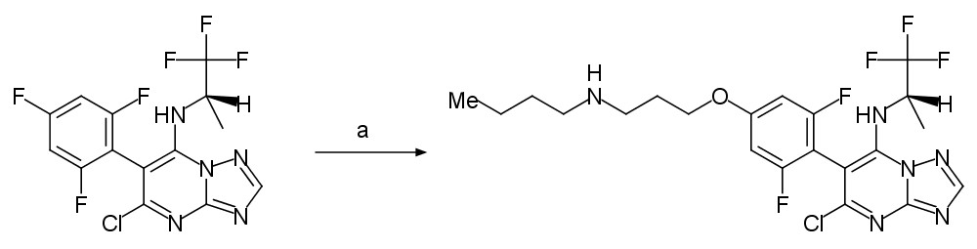
Cevipabulin-R

(a) 3-(Butylamino)propan-1-ol, NaH, DMF, 60 °C

S2. 1H-NMR of Cevipabulin-R

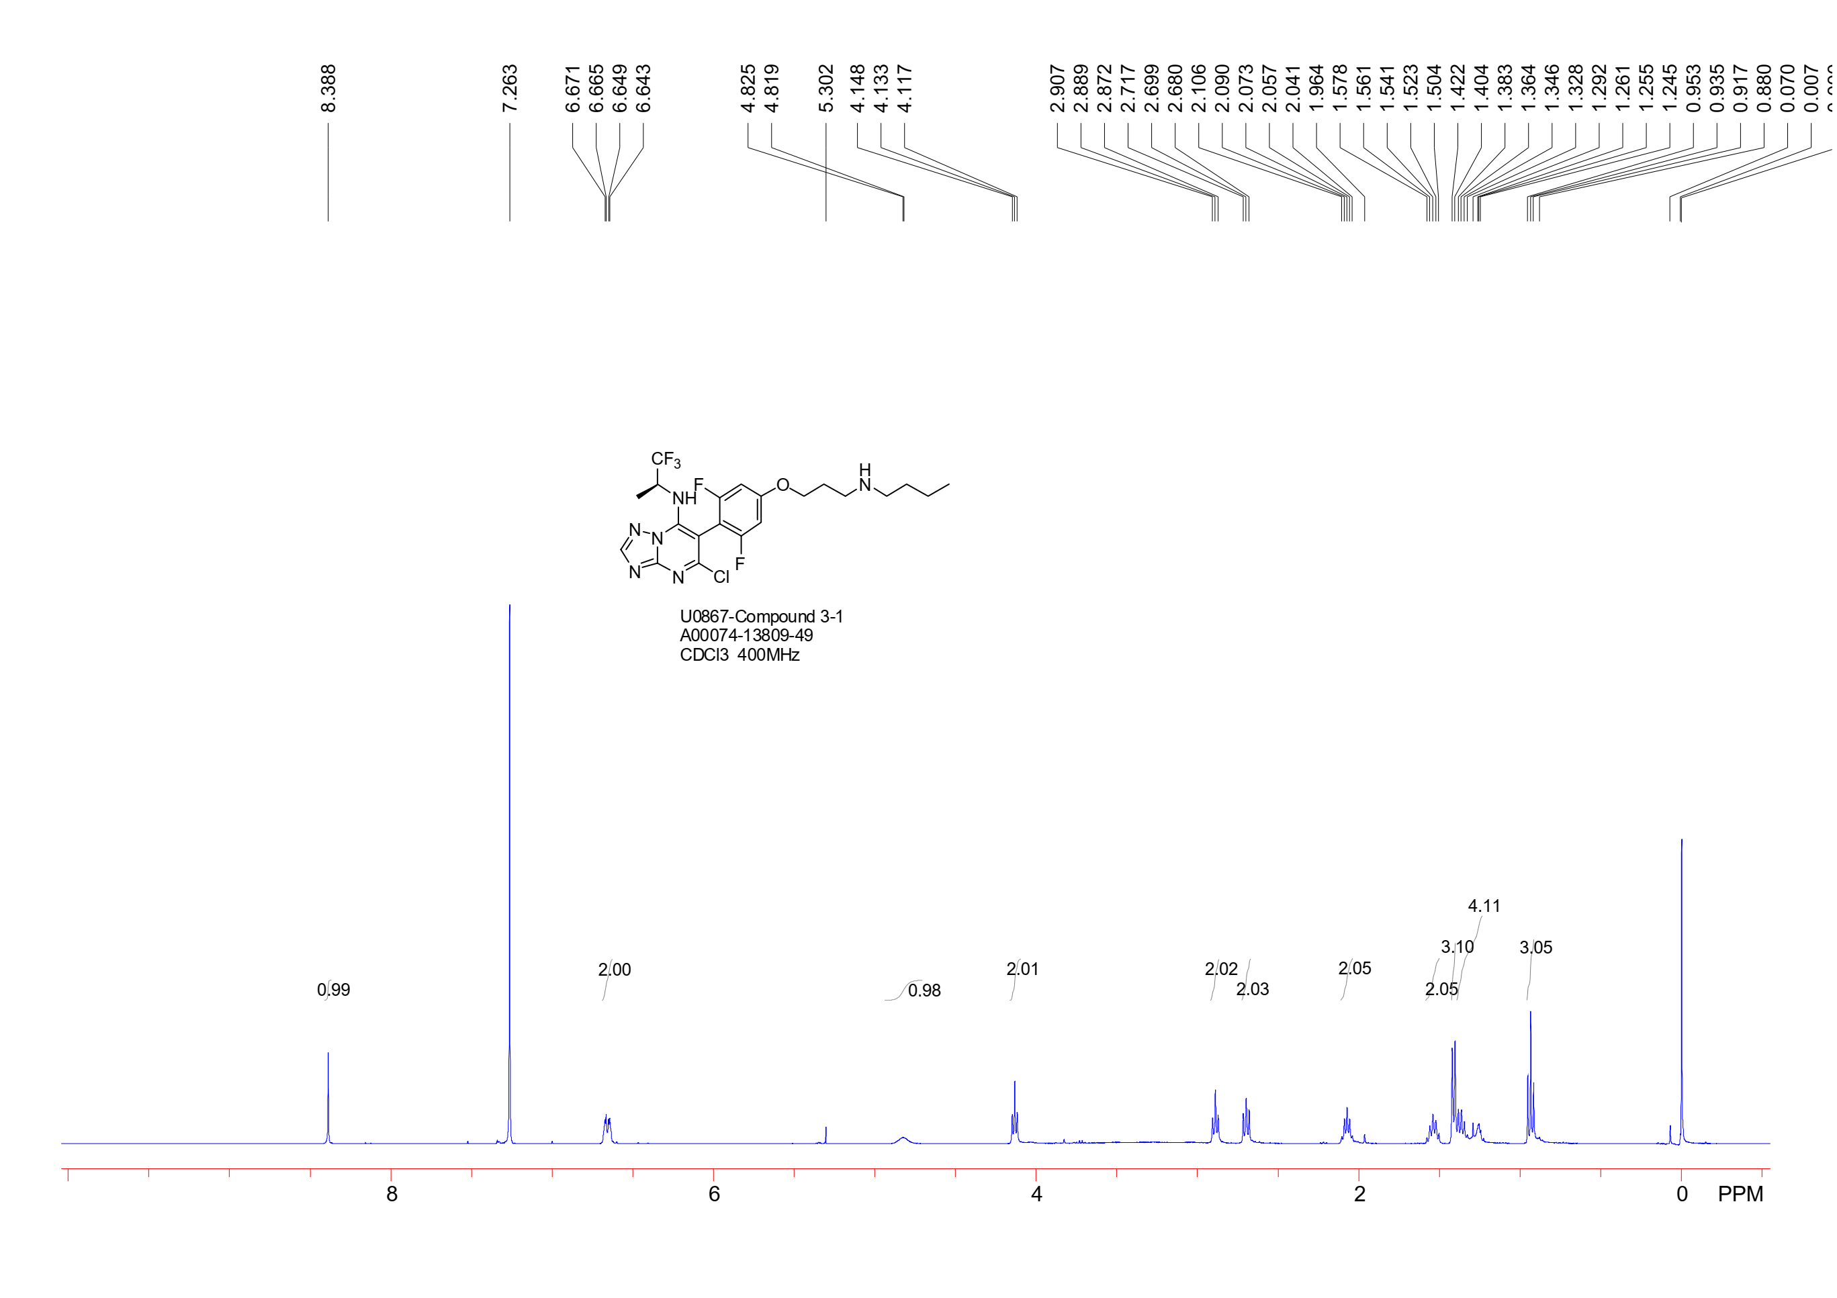
SUPPORTING FIGURES
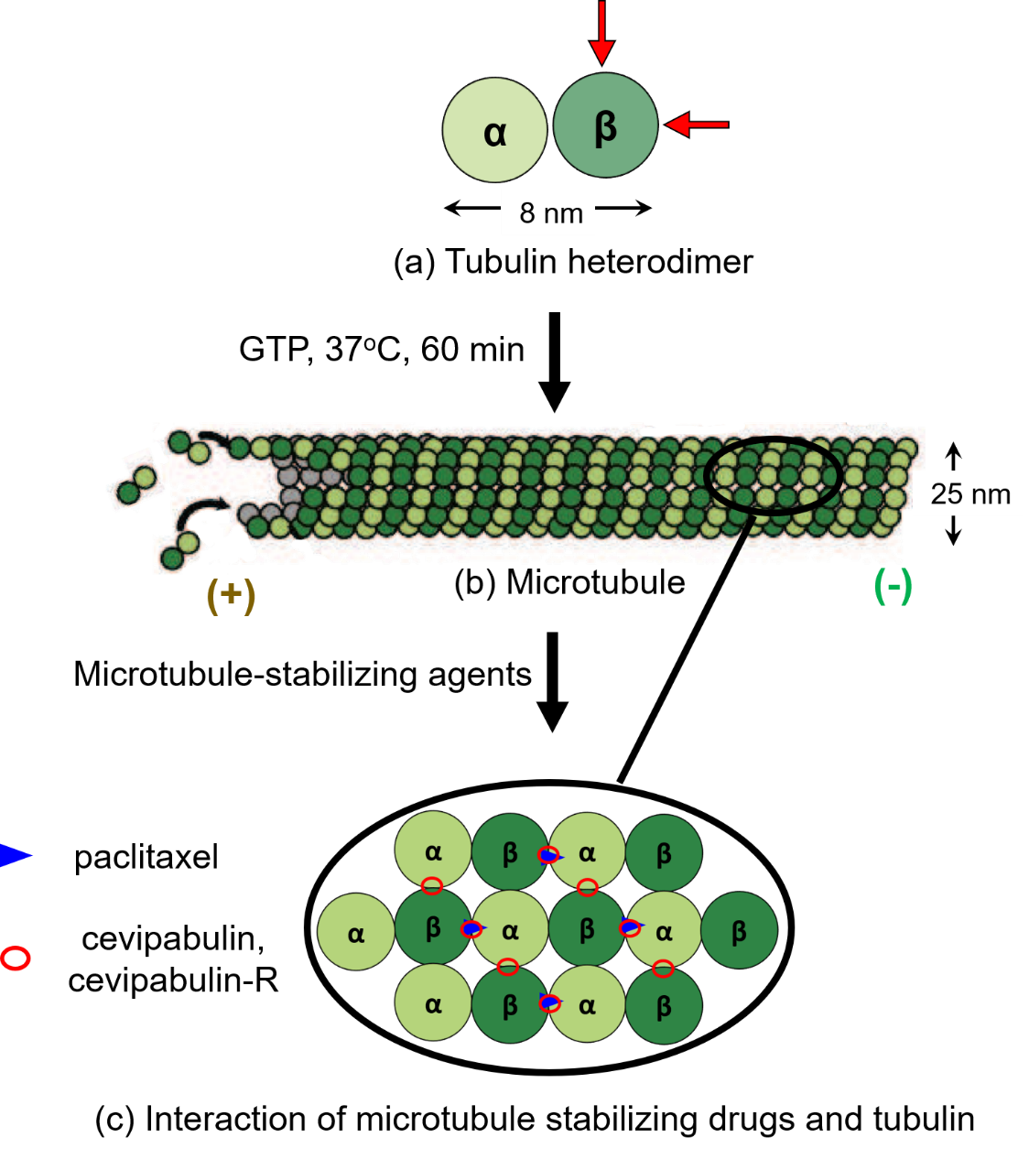
Figure S1. The tubulin heterodimer (a) consists of α-tubulin and β-tubulin. These are globular proteins, each having a diameter of 4nm. The vertical and horizontal red arrows indicate the positions of the vinca alkaloid domain and the taxoid site of the β-tubulin, respectively. In vitro, in the given experimental condition, the tubulin heterodimers assemble themselves in the presence of GTP to form the cylindrical microtubule (b) structure. The outer diameter of the microtubule is maintained to be 25 nm. The microtubule structure is dynamic, i.e., it may be depolymerized into tubulins. Therefore, to stabilize its structure in vitro, microtubule-stabilizing agents, here, paclitaxel, cevipabulin, and cevipabulin-R are added (c). Paclitaxel binds to the taxoid site of the β-tubulin and facilitates the inter-dimer interactions to stabilize the microtubule structure. Cevipabulin and cevipabulin-R bind to both the taxoid site and the vinca alkaloid domain of β-tubulin of microtubules ²⁰.
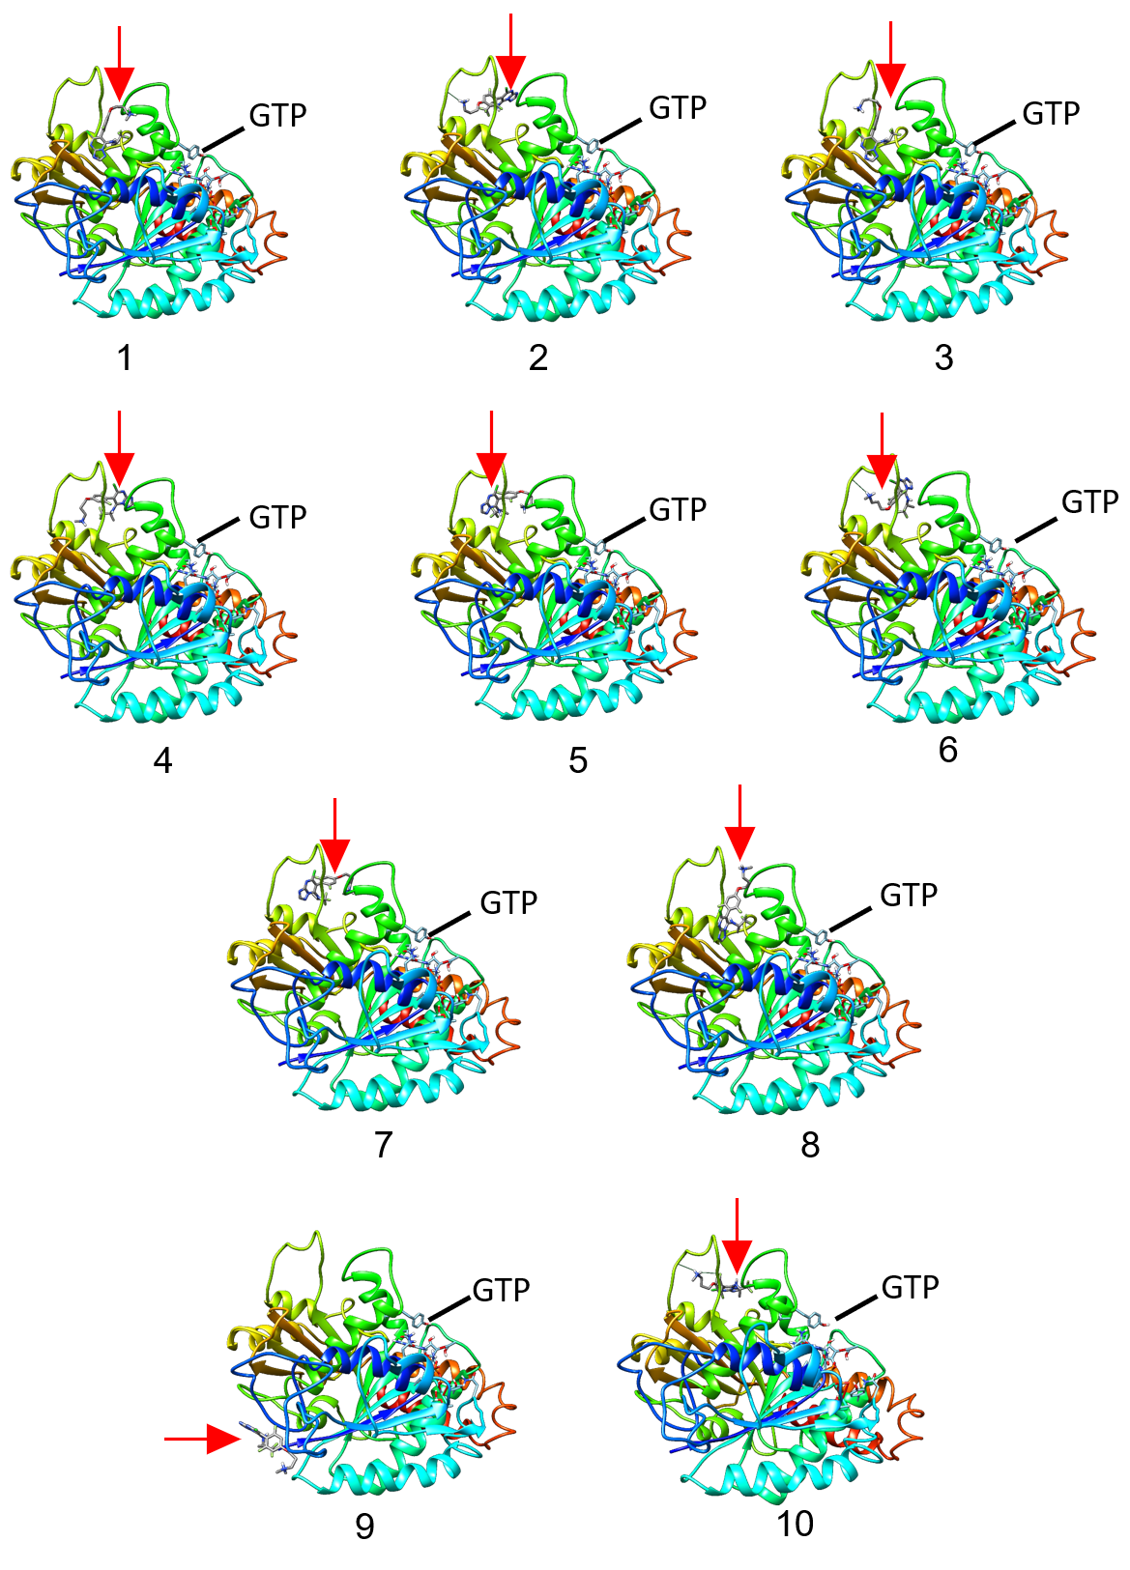
Figure S2. 10 energetically most favorable complexes of β-tubulin and cevipabulin molecule. The position of the docked cevipabulin molecule in the protein is indicated by the red arrows. The paclitaxel binding sites (taxoid sites) are indicated by the vertical arrows and the vinca alkaloid domains are indicated by the horizontal arrows. The GTP bound to the β-tubulin monomers are also indicated in each complex.
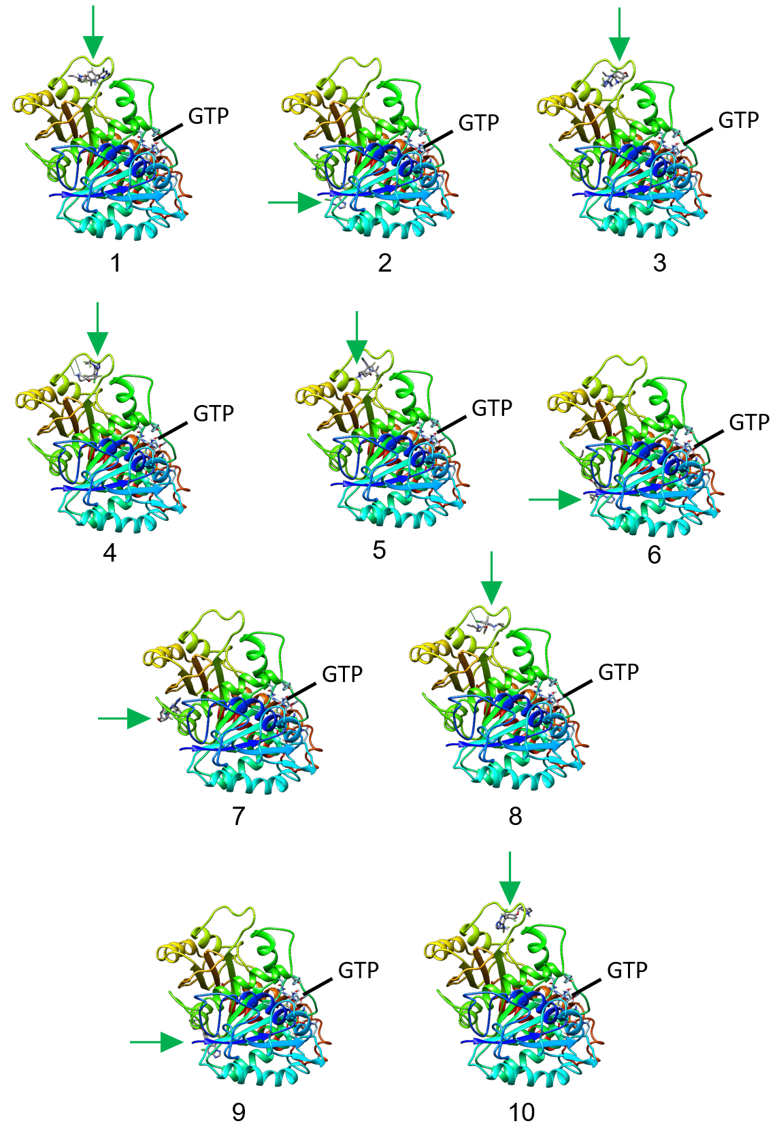
Figure S3. 10 energetically most favorable complexes of β-tubulin and cevipabulin-R molecule. The position of the docked cevipabulin-R molecule in the protein is indicated by the green arrows. The paclitaxel binding sites (taxoid sites) are indicated by the vertical arrows and the vinca alkaloid domains are indicated by the horizontal arrows. The GTP bound to the β-tubulin monomers are also indicated in each complex.

