Supporting information for
Rapid and highly efficient recombination of crosslinking points in hydrogels generated via the template polymerization of dynamic covalent three-dimensional nanoparticle crosslinkers
Mahmoud H. Othman^{1,2}, Yoshihiro Ito^{1,3}, Jun Akimoto¹
¹Emergent Bioengineering Materials Research Team, RIKEN Center for Emergent Matter Science, 2-1 Hirosawa, Wako, Saitama 351-0198, Japan
²Department of Pharmaceutics and Pharmaceutical Technology, Faculty of Pharmacy, Al-Azhar University, Assiut 71524, Egypt
³Nano Medical Engineering Laboratory, RIKEN Cluster for Pioneering Research, 2-1 Hirosawa, Wako, Saitama 351-0198, Japan

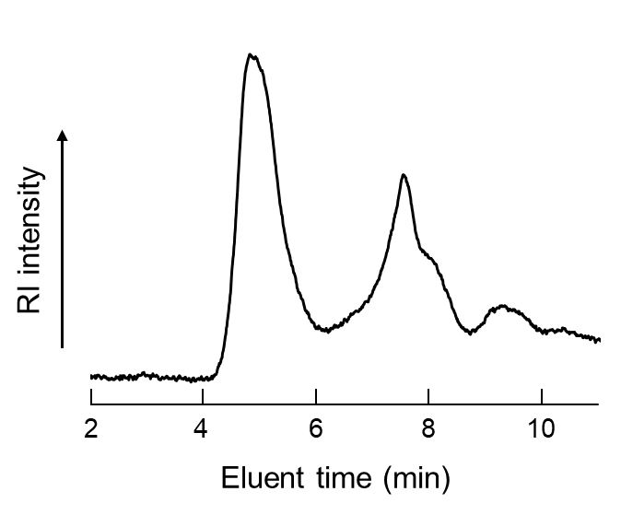
Supplementary Figures
Fig. S1 Results of gel permeation chromatography (GPC) of PTHMAAm (GPC system (JASCO, Tokyo) with α-M column (Tosoh, Tokyo, Japan)) at 25 °C using water as an eluent with a flow rate of 1.0 mL/min.

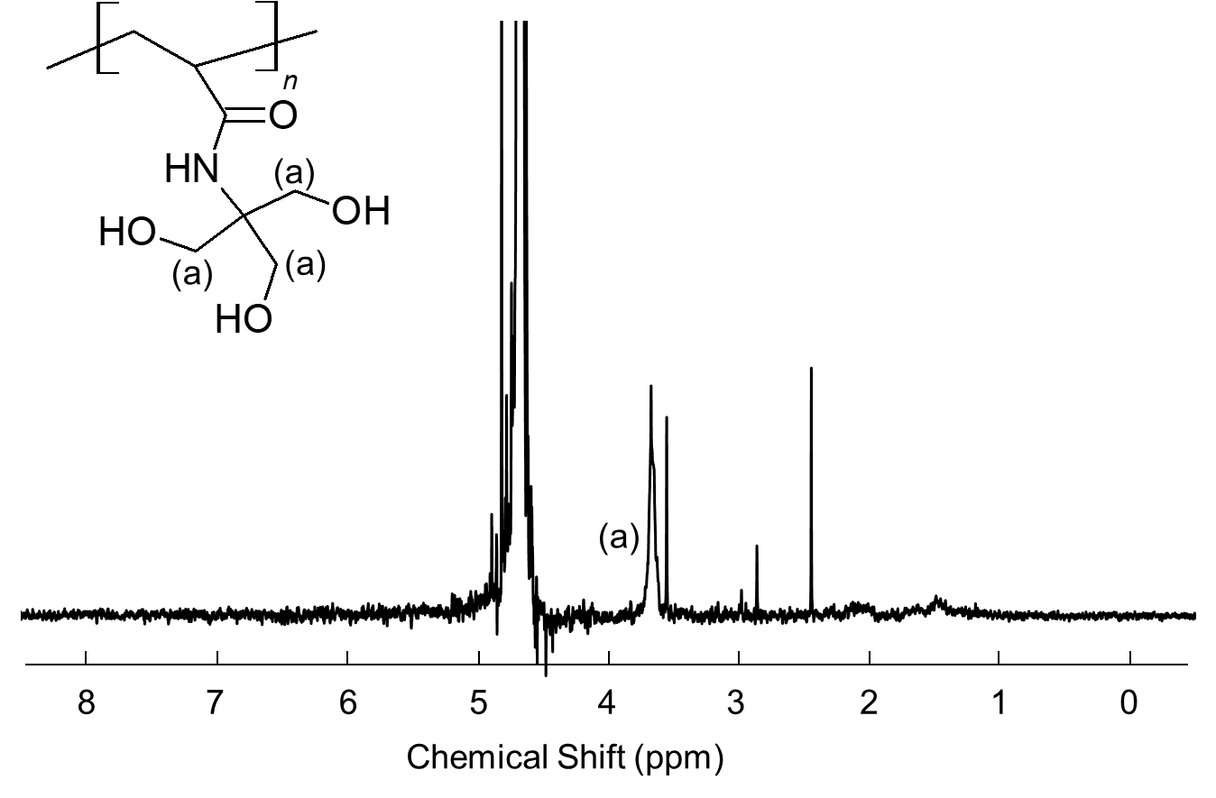
Fig. S2 ¹H NMR spectra (JNM-ECZ400R, 400 MHz, JEOL, Tokyo, Japan) of PTHMAAm (solvent: D₂O).

Fig. S3 Changes in G′ and G″ compared to those of original (A) MixGel(NP) and (B) TempGel(NP) under temperature cycles of 25 and 50 °C.
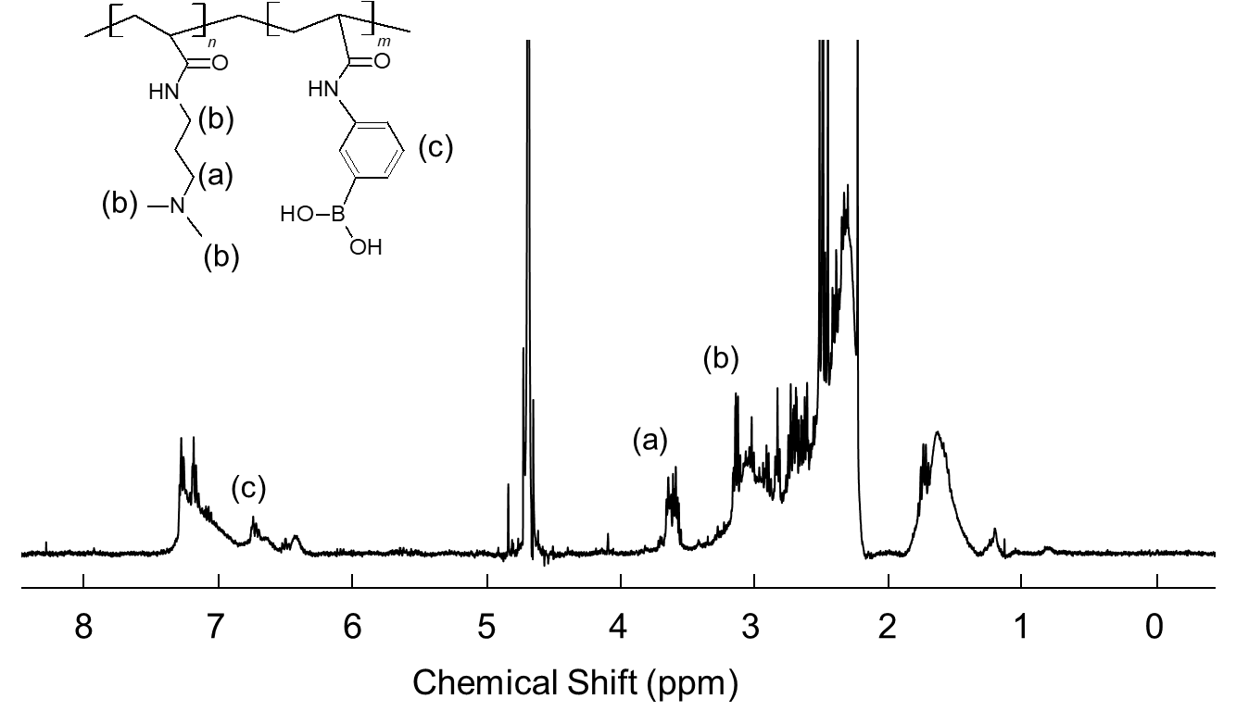
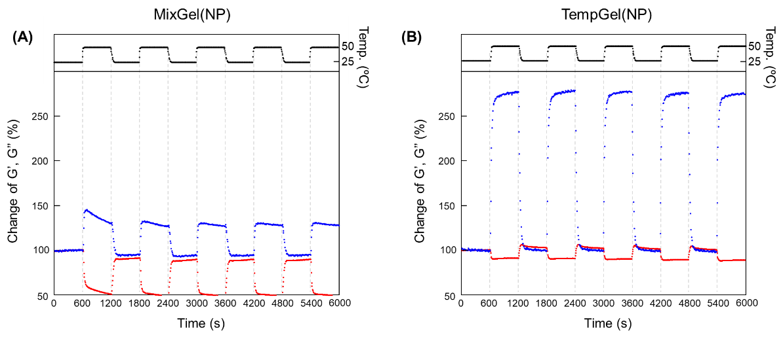
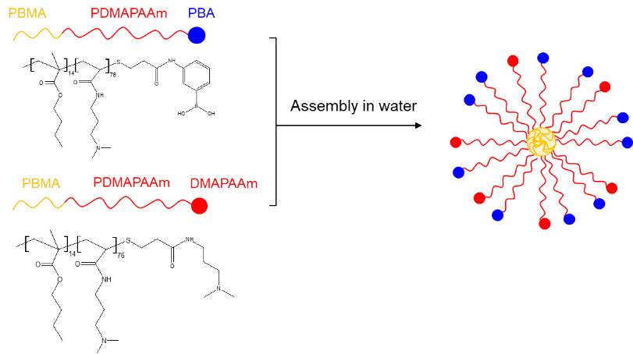
Fig. S4 ¹H NMR spectra of P(APBA-co-DMAAm) (LN) (solvent: D₂O).
Fig. S5 Schematic illustration of the preparation of PBA-NPs by mixing PBA-b-PDMAPAAm-PBA and PBA-b-PDMAPAAm-DMAPAAm.

Supplementary Table
Table S1 Hydrodynamic diameters of the heterogeneous surface of PBA-NPsª
Surface PBA functionality (wt%) | Diameter (nm)
100 | 51.9 ± 41.6
75 | 53.9 ± 25.3
50 | 57.9 ± 37.1
25 | 59.2 ± 33.1
12.5 | 54.9 ± 28.2
ª Measured using a dynamic light scattering instrument (ELSZ-2PL, Otsuka Electronics, Osaka, Japan).

