New anti-fungal compounds 1PB1 and 45R from Streptomyces chrestomyceticus ADP4 target exo-β-1,3-glucanase and ergosterol biosynthesis in Candida albicans

Jyoti Shukla and Ashok K. Dubey*
Department of Biological Sciences and Engineering, Netaji Subhas University of Technology, Dwarka, New Delhi - 110078, India

Fig S1: GC-MS chromatogram of extracted sterol from untreated C. albicans cells (i) and from the cells treated with 1PB1 (ii), 45R (iii), and Flc (iv), to identify the key sterol intermediated: 1, Squalene; 2, Ergosterol; 3, Lanosterol; 4, 4-Methylcholesta-8,24-dien-3-ol, 3.β,4.α,5.α); 5, Zymosterol; 6, Ergosta-5,7,9(11),22-tetraen-3-ol, (3.β).
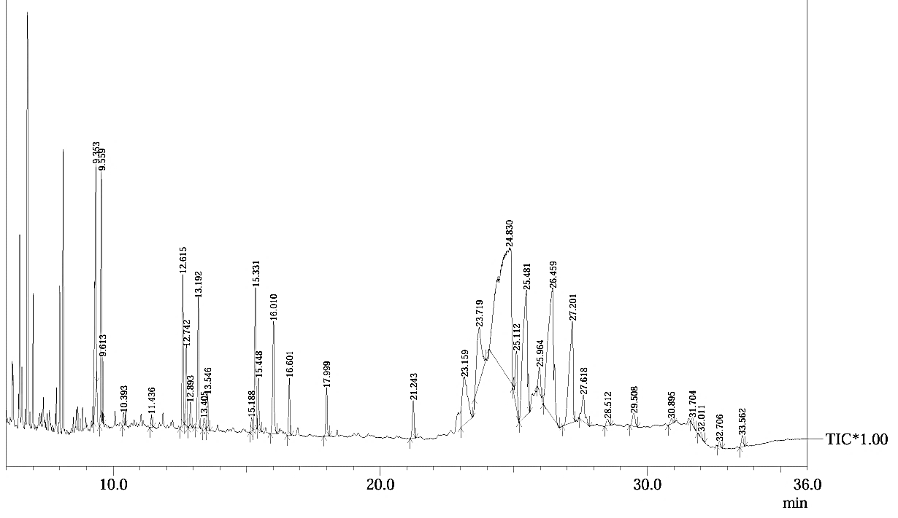
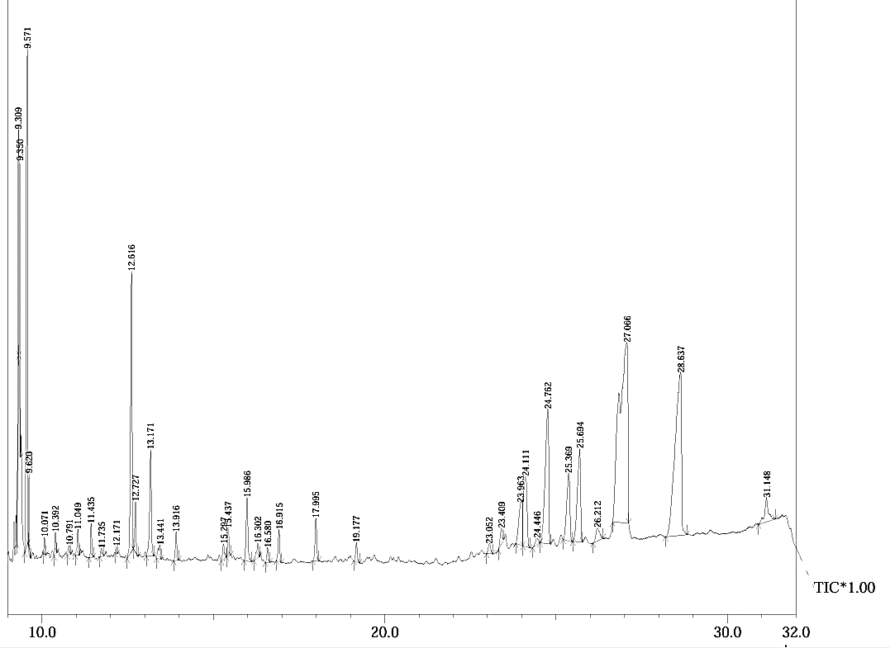
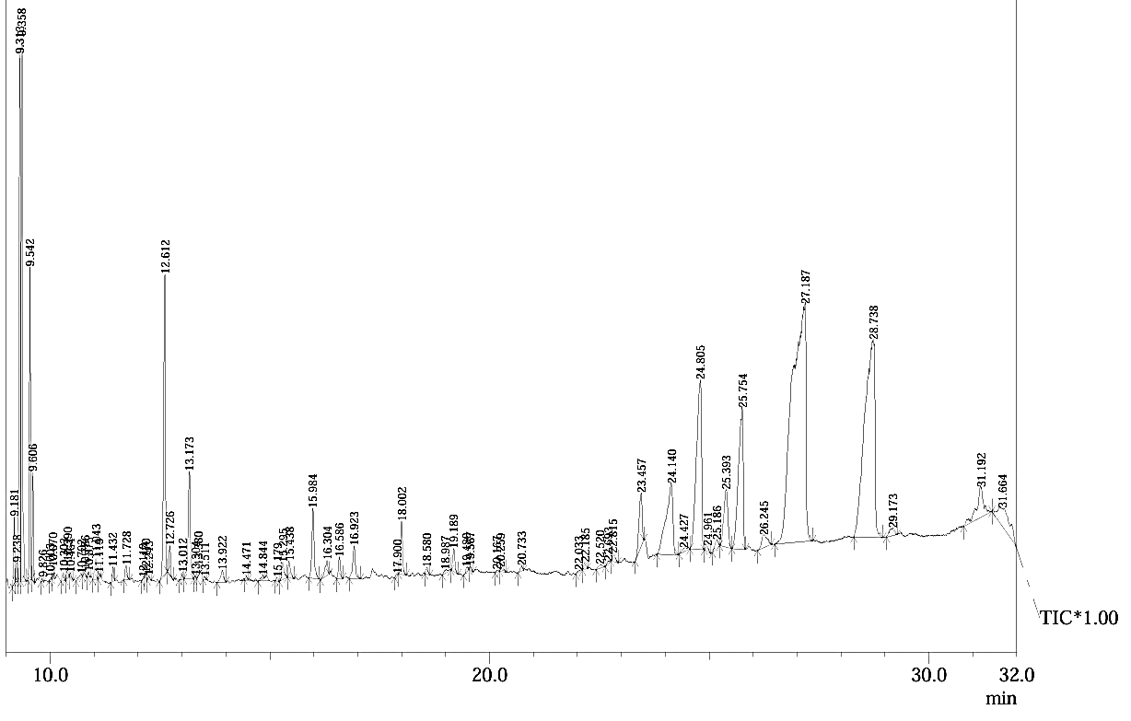
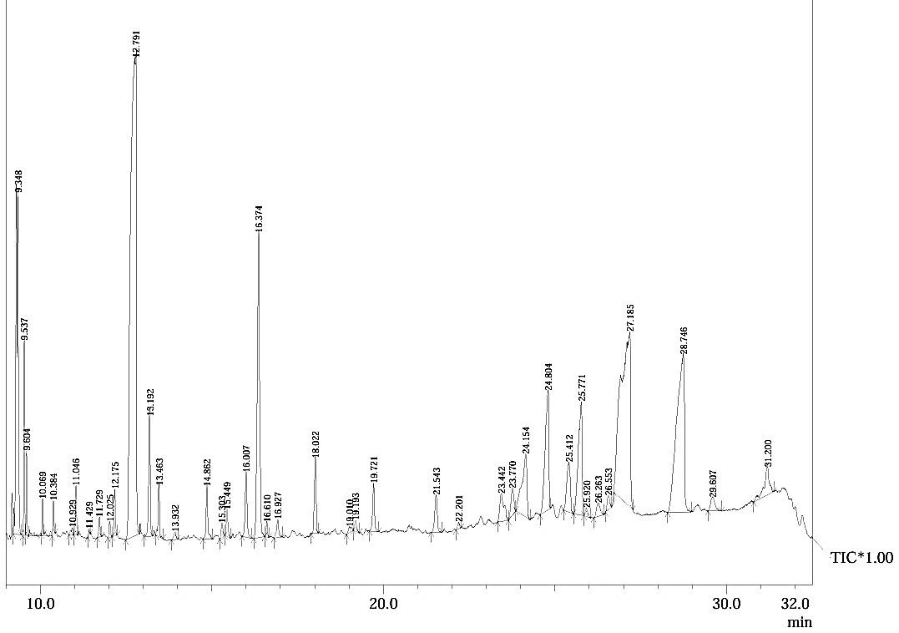
1
2
3
4
6
5
1
2
3
4
6
1
2
3
6
1
2
3
4
6
(i)
(ii)
(iii)
(iv)

Table S1: List of amino acids in the active site pocket of proteins obtained from CASTp Web server

Target protein | Chain | Active site amino acids
CYP51 | A | Gln20, Tyr22, Tyr118, Thr122, Phe131, Tyr132, Arg179, Asp180, Ser181, Lys182, Asn183, Arg185, Asn187, Glu188, Met197, Val198, Pro201, Glu202, Ile205, Phe206, Arg218, Leu221, Asp222, Thr223, Ala226, Tyr227, Tyr229, Ser230, Leu232, Asp233, Phe233, Lys234, Ile261, Tyr265,Gly303, Ile304,Gly307, Thr311, Met313, Gln316, His317, Ala320, Ala321,Leu 376, Val510, Leu512, His534, His535
Exo-β-1,3-glucanase | A | GLU27, Pro28, Tyr 29, Arg92, His135, Phe144, Asp145, Asn146, Arg150, Asn191, Glu192, His226, Asp227, Phe229, Gln230, Val231, Phe232, His 252, His253, His254, Tyr255, Gln256, val257, Phe258, Glu262, Arg292, Trp303, Leu304, Asn305, Gly306, Arg309, Arg312, Tyr317, Trp363, Trp373

