The Effects of Low-Fat, High-Carbohydrate Diets vs. Low-Carbohydrate, High-Fat Diets on Weight, Blood Pressure, Serum Liquids and Blood Glucose: A Systematic Review and Meta-analysis
Qing Yang^{1*}, Xinyue Lang^{1,2*}, Wei Li^{1,2#}, Yan Liang^{1#}
- Fuwai Hospital, Chinese Academy of Medical Sciences & Peking Union Medical College, Beijing 100037, China
- Medical Research & Biometrics Center, National Center for Cardiovascular Diseases, Chinese Academy of Medical Sciences, Beijing 102300, China
*These authors contributed to the work equally and should be regarded as co-first authors.

Supplemental Table 2
Supplemental Figure 7
Figure and Table Legends 10
Search strategy 11

Supplemental Table
Table S1. Assessment of risk of bias of the studies included in the meta-analysis
 | Selection bias | Selection bias | Performance bias | Detection bias | Attrition bias | Reporting bias | Other Bias | Overall^{b} | Overall risk of bias^{c}
Study | Random sequence  generation | Allocation  concealment | Blinding of participants  and personnel | Blinding of outcome  assessment | Incomplete  outcome data | Selective  reporting |  | Overall^{b} | Overall risk of bias^{c}
Aude, 2004 | 1ª | 1 | 1 | 2 | 2 | 2 | 2 | 10 | unclear
Bradley, 2009 | 2 | 2 | 2 | 2 | 2 | 2 | 2 | 14 | low
Brink, 2009 | 1 | 2 | 1 | 2 | 2 | 2 | 2 | 12 | unclear
Fleming, 2002 | 1 | 1 | 1 | 2 | 2 | 1 | 2 | 9 | unclear
Hu, 2015 | 1 | 2 | 1 | 2 | 2 | 2 | 1 | 10 | unclear
Meckling, 2004 | 2 | 2 | 0 | 1 | 1 | 2 | 1 | 9 | high
Petrisko, 2020 | 2 | 2 | 2 | 2 | 2 | 2 | 2 | 14 | low
Ruth, 2013 | 2 | 2 | 2 | 2 | 2 | 2 | 2 | 14 | low
Tay, 2008 | 1 | 2 | 1 | 2 | 2 | 2 | 2 | 12 | unclear
Ulz, 2013 | 2 | 2 | 2 | 2 | 2 | 2 | 2 | 14 | low
Yancy, 2010 | 0 | 2 | 0 | 2 | 2 | 2 | 0 | 8 | high
ª Low risk is awarded as 2, unclear risk as 1, and high risk as 0;
^{b} Sum scores were calculated.
^{c} Low risk of bias for all studies is awarded as low, unclear risk of bias for one or more studies as unclear, and high risk of bias for one or more studies as high.

Table S2. The results of sensitivity analyses (omitting one study each time)
Study Omitted | SMD | Lower of 95% CI | Upper of 95% CI | p-value | I²
ΔWeight change
Petrisko,2020 | -1.05 | -2.16 | 0.07 | 0.07 | 96.23%
Hu,2015 | -0.55 | -0.91 | -0.19 | 0.003 | 59.79%
Yancy,2010 | -1.08 | -2.32 | 0.16 | 0.09 | 96.05%
Bradley,2009 | -1.16 | -2.24 | -0.08 | 0.04 | 96.10%
Tay,2008 | -1.14 | -2.30 | 0.03 | 0.06 | 95.82%
Meckling,2004 | -1.18 | -2.26 | -0.09 | 0.03 | 96.00%
Aude,2004 | -0.95 | -2.09 | 0.18 | 0.10 | 96.20%
Combined | -1.01 | -1.99 | -0.04 | 0.04 | 95.49%
ΔLean mass
Petrisko,2020 | -0.96 | -2.15 | 0.23 | 0.11 | 93.07%
Ruth,2013 | -0.91 | -2.19 | 0.36 | 0.16 | 93.17%
Brink,2009 | -0.39 | -0.70 | -0.08 | 0.01 | 0.00%
Bradley,2009 | -1.04 | -2.16 | 0.09 | 0.07 | 92.74%
Aude,2004 | -1.06 | -2.21 | 0.09 | 0.07 | 91.57%
Combined | -0.87 | -1.82 | 0.08 | 0.07 | 90.94%
ΔFat mass
Petrisko,2020 | -0.34 | -1.10 | 0.41 | 0.37 | 85.08%
Ruth,2013 | -0.30 | -1.12 | 0.53 | 0.48 | 85.73%
Brink,2009 | 0.04 | -0.26 | 0.35 | 0.79 | 0.00%
Bradley,2009 | -0.31 | -1.06 | 0.44 | 0.41 | 85.85%
Aude,2004 | -0.38 | -1.12 | 0.37 | 0.32 | 82.67%
Combined | -0.26 | -0.89 | 0.36 | 0.41 | 81.64%
ΔSBP
Ruth,2013 | -0.36 | -1.38 | 0.66 | 0.49 | 94.50%
Yancy,2010 | -0.09 | -0.51 | 0.33 | 0.68 | 63.26%
Brink,2009 | -0.60 | -1.53 | 0.33 | 0.20 | 92.94%
Bradley,2009 | -0.52 | -1.48 | 0.43 | 0.29 | 94.44%
Tay,2008 | -0.51 | -1.56 | 0.55 | 0.35 | 94.13%
Meckling,2004 | -0.56 | -1.51 | 0.40 | 0.25 | 94.24%
Combined | -0.44 | -1.28 | 0.40 | 0.30 | 93.24%
ΔDBP
Ruth,2013 | -0.29 | -1.61 | 1.02 | 0.66 | 96.51%
Yancy,2010 | 0.08 | -0.51 | 0.68 | 0.79 | 81.71%
Brink,2009 | -0.65 | -1.76 | 0.46 | 0.25 | 94.89%
Bradley,2009 | -0.48 | -1.71 | -0.75 | 0.45 | 96.48%
Tay,2008 | -0.46 | -1.82 | 0.89 | 0.50 | 96.29%
Meckling,2004 | -0.42 | -1.68 | 0.85 | 0.52 | 96.54%
Combined | -0.37 | -1.45 | 0.71 | 0.50 | 95.70%
ΔTG
Petrisko,2020 | -0.60 | -0.97 | -0.23 | 0.002 | 62.10%
Ruth,2013 | 0.08 | -0.73 | 0.88 | 0.85 | 90.79%
Yancy,2010 | -0.03 | -0.99 | 0.93 | 0.95 | 92.12%
Brink,2009 | -0.01 | -0.90 | 0.89 | 0.99 | 91.98%
Bradley,2009 | 0.06 | -0.74 | 0.85 | 0.89 | 91.62%
Meckling,2004 | -0.13 | -0.97 | 0.70 | 0.75 | 91.94%
Aude,2004 | -0.10 | -0.98 | 0.78 | 0.82 | 92.00%
Combined | -0.12 | -0.85 | 0.61 | 0.74 | 90.56%
ΔTC
Petrisko,2020 | 0.77 | 0.35 | 1.19 | 0.0003 | 75.96%
Ruth,2013 | 0.69 | 0.18 | 1.20 | 0.008 | 82.63%
Yancy,2010 | 0.60 | 0.05 | 1.15 | 0.03 | 82.98%
Brink,2009 | 0.52 | 0.05 | 0.98 | 0.03 | 78.93%
Bradley,2009 | 0.63 | 0.14 | 1.13 | 0.01 | 83.75%
Tay,2008 | 0.64 | 0.09 | 1.18 | 0.02 | 83.75%
Meckling,2004 | 0.47 | 0.06 | 0.88 | 0.02 | 76.57%
Aude,2004 | 0.71 | 0.23 | 1.20 | 0.004 | 81.29%
Combined | 0.63 | 0.18 | 1.08 | 0.006 | 81.05%
ΔLDL-Cholesterol
Petrisko,2020 | 0.78 | 0.23 | 1.33 | 0.006 | 86.07%
Ruth,2013 | 0.65 | -0.01 | 1.31 | 0.05 | 89.62%
Yancy,2010 | 0.40 | -0.09 | 0.90 | 0.11 | 79.73%
Brink,2009 | 0.60 | -0.09 | 1.29 | 0.09 | 90.17%
Bradley,2009 | 0.67 | 0.04 | 1.30 | 0.04 | 89.70%
Tay,2008 | 0.55 | -0.15 | 1.25 | 0.12 | 90.14%
Meckling,2004 | 0.43 | -0.17 | 1.03 | 0.16 | 88.74%
Aude,2004 | 0.66 | 0.01 | 1.31 | 0.05 | 89.31%
Combined | 0.59 | 0.01 | 1.18 | 0.05 | 88.60%
ΔHDL-Cholesterol
Petrisko,2020 | 0.81 | 0.38 | 1.23 | 0.0002 | 76.89%
Ruth,2013 | 0.67 | 0.33 | 1.01 | 0.0001 | 61.85%
Yancy,2010 | 0.93 | 0.53 | 1.34 | <0.0001 | 67.84%
Brink,2009 | 0.86 | 0.40 | 1.32 | 0.00028 | 77.71%
Bradley,2009 | 0.81 | 0.39 | 1.23 | 0.0002 | 77.23%
Tay,2008 | 0.90 | 0.43 | 1.36 | 0.0002 | 76.98%
Meckling,2004 | 0.70 | 0.34 | 1.06 | 0.0001 | 68.08%
Aude,2004 | 0.90 | 0.46 | 1.34 | <0.0001 | 76.80%
Combined | 0.82 | 0.43 | 1.21 | <0.0001 | 74.00%
ΔGlucose
Petrisko,2020 | -0.14 | -0.59 | 0.30 | 0.53 | 73.41%
Yancy,2010 | 0.03 | -0.22 | 0.28 | 0.84 | 0.00%
Brink,2009 | -0.17 | -0.63 | 0.29 | 0.47 | 71.25%
Bradley,2009 | -0.20 | -0.61 | 0.22 | 0.35 | 70.89%
Tay,2008 | -0.17 | -0.64 | 0.30 | 0.48 | 70.22%
Meckling,2004 | -0.19 | -0.62 | 0.24 | 0.39 | 71.34%
Combined | -0.15 | -0.53 | 0.24 | 0.45 | 67.16%
Abbreviations: SMD, Standardized Mean Differences; 95% CI, 95% Confidence Interval; SBP, Systolic Blood Pressure; DBP, Diastolic Blood Pressure; TG, Triglycerides; TC, total cholesterol.

Supplemental Figure

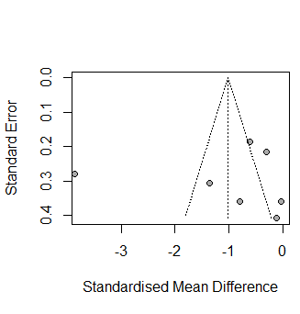
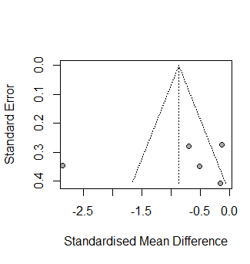
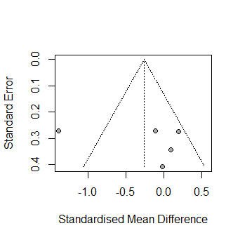
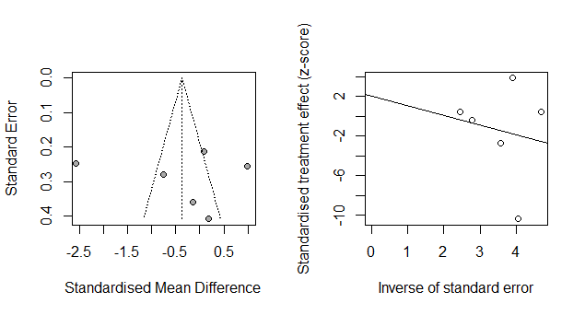
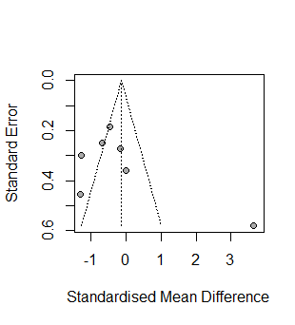
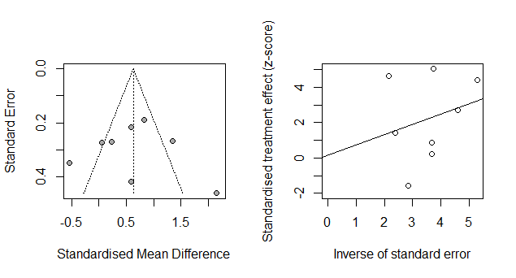
A. ΔWeight
B. ΔLean Mass
C. ΔFat Mass
D. ΔSBP
E. ΔDBP
F. ΔTG

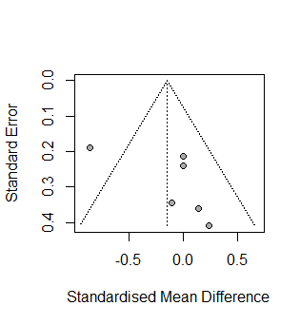
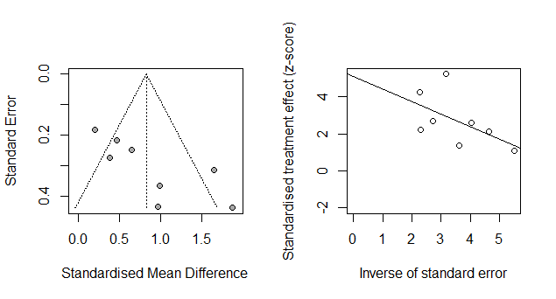
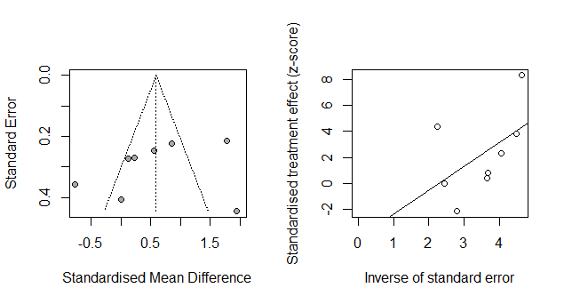
J. ΔGlucose
I. ΔHDL-Cholesterol
G. ΔTC
H. ΔLDL-Cholesterol

Figure S1. Funnel plots for publication bias on body weight, blood pressure, serum liquids and blood glucose. A. Δweight (7 studies); B. Δlean mass (5 studies); C. Δfat mass (5 studies); D. ΔSBP (6 studies); E. ΔDBP (6 studies); F. ΔTG (7 studies); G. ΔTC (8 studies); H. LDL-cholesterol (8 studies) I. HDL-cholesterol (8 studies); J. Glucose (6 studies). The plots are standardized mean differences from individual studies (horizontal axis) against the standard error of the mean difference (vertical axis). The solid vertical line represents the summary estimate of the standardized mean difference, derived using random-effect meta-analysis. Abbreviations: SBP, Systolic Blood Pressure; DBP, Diastolic Blood Pressure; TG, Triglycerides; TC, total cholesterol.

Figure and Table Legends
Figure S1. Funnel plots for publication bias on body weight, blood pressure, serum liquids and blood glucose.
- Δweight (7 studies); B. Δlean mass (5 studies); C. Δfat mass (5 studies); D. ΔSBP (6 studies); E.
ΔDBP (6 studies); F. ΔTG (7 studies); G. ΔTC (8 studies); H. LDL-cholesterol (8 studies) I. HDL-cholesterol (8 studies); J. Glucose (6 studies). The plots are standardized mean differences from individual studies (horizontal axis) against the standard error of the mean difference (vertical axis). The solid vertical line represents the summary estimate of the standardized mean difference, derived using random-effect meta-analysis. Abbreviations: SBP, Systolic Blood Pressure; DBP, Diastolic Blood Pressure; TG, Triglycerides; TC, total cholesterol.
Table S1. Assessment of risk of bias of the studies included in the meta-analysis
ª Low risk is awarded as 2, unclear risk as 1, and high risk as 0;
^{b} Sum scores were calculated.
^{c} Low risk of bias for all studies is awarded as low, unclear risk of bias for one or more studies as unclear, and high risk of bias for one or more studies as high.
Table S2. The results of sensitivity analyses (omitting one study each time)
Abbreviations: SMD, Standardized Mean Differences; 95% CI, 95% Confidence Interval; SBP, Systolic Blood Pressure; DBP, Diastolic Blood Pressure; TG, Triglycerides; TC, total cholesterol.

Search strategy

Ovid MEDLINE
- Diet, Carbohydrate-Restricted/
- low carbohydrate$.tw,kw.
- (carbohydrate$ adj2 restrict$).tw,kw.
- (carbohydrate$ adj2 reduc$).tw,kw.
- high fat.tw,kw.
- Ketogenic Diet/
- (ketogenic and diet$).tw,kw.
- (atkins and diet$).tw,kw.
- 1 or 2 or 3 or 4 or 5 or 6 or 7 or 8
- Diet, Fat-Restricted/
- (fat adj2 restrict$).tw,kw.
- (fat adj2 reduc$).tw,kw.
- high carbohydrate$.tw,kw.
- whole grain$.tw,kw.
- (cereal and diet$).tw,kw.
- 10 or 11 or 12 or 13 or 14 or 15
- 9 and 16
- exp Cardiovascular Diseases/
- (cardi* or vascular* or heart or coronary).tw,kw.
- 18 or 19
- 17 and 20
- "randomized controlled trial".pt.
- (random$ or placebo$ or single blind$ or double blind$ or triple blind$).ti,ab.
- (retraction of publication or retracted publication).pt.
- or/22-24
- (animals not humans).sh.
- ((comment or editorial or meta-analysis or practice-guideline or review or letter or journal correspondence) not "randomized controlled trial").pt.
- (random sampl$ or random digit$ or random effect$ or random survey or random regression).ti,ab. not "randomized controlled trial".pt.
- 25 not (26 or 27 or 28)
- exp cohort analysis/
- exp longitudinal study/
- exp prospective study/
- exp follow up/
- cohort$.tw.
- or/29-34
- 21 and (29 or 35)

Embase
- low carbohydrate diet/
- low carbohydrate$.tw,kw.
- (carbohydrate$ adj2 restrict$).tw,kw.
- (carbohydrate$ adj2 reduc$).tw,kw.
- high fat.tw,kw.
- Ketogenic Diet/
- (ketogenic and diet$).tw,kw.
- (atkins and diet$).tw,kw.
- 1 or 2 or 3 or 4 or 5 or 6 or 7 or 8
- low fat diet/
- (fat adj2 restrict$).tw,kw.
- (fat adj2 reduc$).tw,kw.
- high carbohydrate$.tw,kw.
- whole grain$.tw,kw.
- (cereal and diet$).tw,kw.
- 10 or 11 or 12 or 13 or 14 or 15
- 9 and 16
- exp Cardiovascular Diseases/
- (cardi* or vascular* or heart or coronary).tw,kw.
- 18 or 19
- 17 and 20
- (random$ or placebo$ or single blind$ or double blind$ or triple blind$).ti,ab.
- RETRACTED ARTICLE/
- or/22-23
- (animal$ not human$).sh,hw.
- (book or conference paper or editorial or letter or review).pt. not exp randomized controlled trial/
- (random sampl$ or random digit$ or random effect$ or random survey or random regression).ti,ab. not exp randomized controlled trial/
- 24 not (25 or 26 or 27)
- exp cohort analysis/
- exp longitudinal study/
- exp prospective study/
- exp follow up/
- cohort$.tw.
- exp case control study/
- (case$ and control$).tw.
- or/29-35
- 28 and (28 or 36)

Web of Science
#1 TS= ((“low carbohydrate*” OR ketogenic OR atkins OR "high fat" OR ((restrict* OR reduc*) AND carbohydrate*)) AND diet*)
#2 TS= ((“low fat” OR "high carbohydrate*" OR “whole grain*” OR cereal OR ((restrict* OR reduc*) AND fat)) AND diet*)
#3 #1 AND #2
#4 TS= (cardi* OR vascular* OR heart OR coronary)
#5 TS= (“risk factor” OR “relative risk” OR “hazard ratio” OR “odds ratio” OR “risk difference” OR “incidence ratio” OR “rate difference” OR exposure)
#6 TS= (animal* NOT human*)
#7 #3 AND #4 AND #5 NOT #6

Cochrane Library
- MeSH descriptor: [Diet, Carbohydrate-Restricted]
- "low carbohydrate*":ti,ab,kw
- carbohydrate* near/2 restrict*:ti,ab,kw
- carbohydrate* near/2 reduc*:ti,ab,kw
- "high fat":ti,ab,kw
- (ketogenic and diet*):ti,ab,kw
- (atkins and diet*):ti,ab,kw
- #1 or #2 or #3 or #4 or #5 or #6 or #7
- MeSH descriptor: [Diet, Fat-Restricted]
- fat near/2 restrict*:ti,ab,kw
- fat near/2 reduc*:ti,ab,kw
- "high carbohydrate*":ti,ab,kw
- “whole grain*”:ti,ab,kw
- (cereal and diet*):ti,ab,kw
- #9 or #10 or #11 or #12 or #13 or #14
- #8 and #15
- MeSH descriptor: [Cardiovascular Diseases]
- (cardi* or vascular* or heart or coronary ):ti,ab,kw
- #17 or #18
- #16 and #19

