Supplementary Files

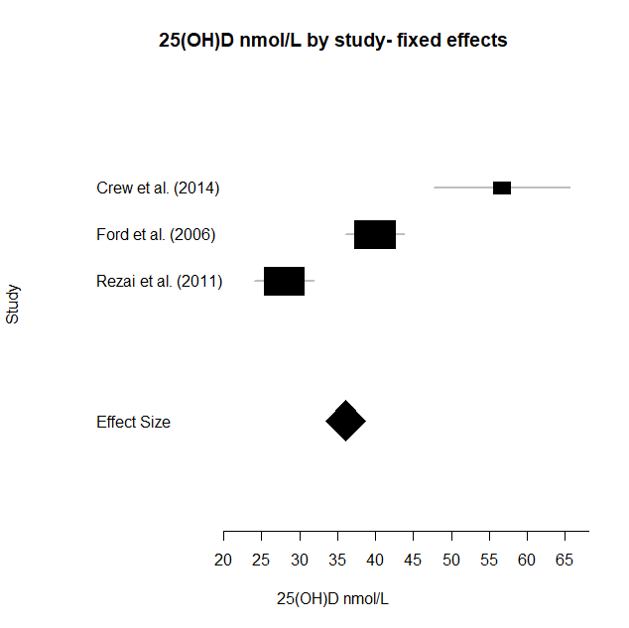

A B
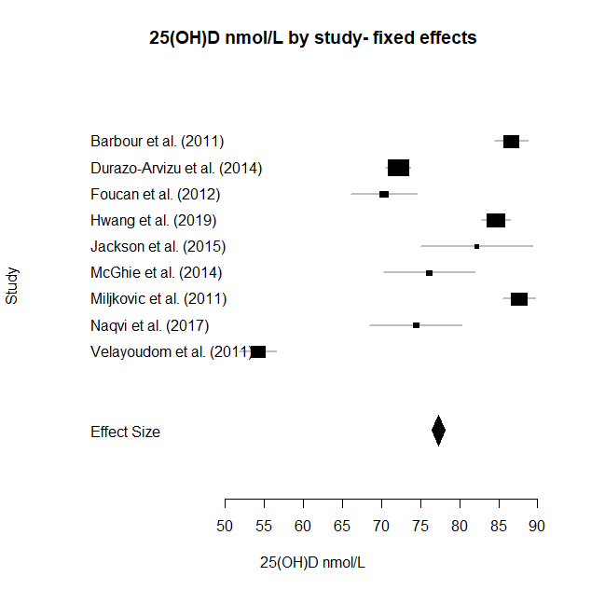

C

Figure 1: Fixed effects meta-analyses of 25(OH)D concentration of the African-Caribbean population. A. All countries: Summary effect= 73.5nmol/L, 95% CI (72.7, 74.3) (n=2974 participants) B. High latitudes: Summary effect=36nmol/L, 95% CI (33.4, 38.7) (n=213 participants) C. Low latitudes Summary effect=77.3nmol/L, 95% CI (76.5, 78.1) (n=2761 participants). Estimated heterogeneity for all analyses was p<0.001.

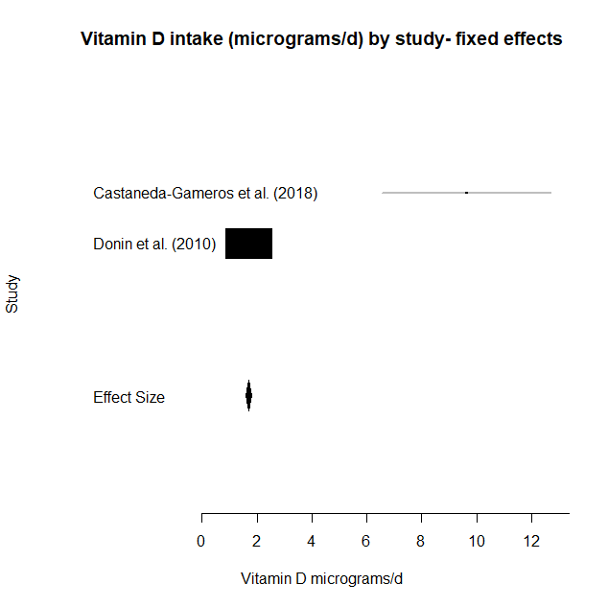

A B
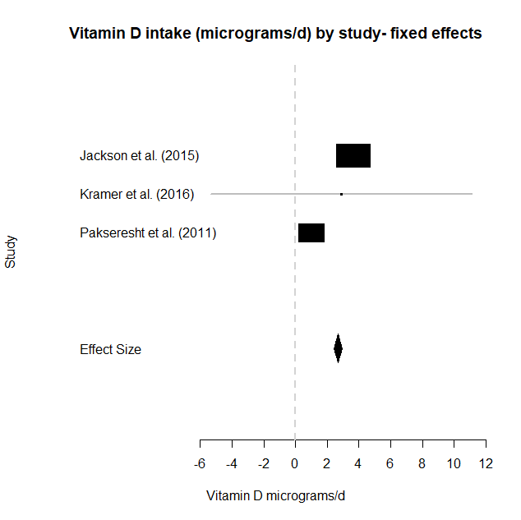

C

Figure 2: Fixed effects meta-analyses of vitamin D intake (µg/day) of the African-Caribbean population: A. All countries: Summary effect= 1.84µg/day, 95% CI (1.75, 1.93) (n=1363 participants).
B. High latitudes: Summary effect=1.71µg/day, 95% CI (1.61, 1.81) (n=581 participants). C. Low latitudes: Summary effect=2.68µg/day, 95% CI (2.43,2.93) (n=782 participants). Estimated heterogeneity for all analyses was p<0.001.

Table 1: Database Searches

Database | Search Terms
PUBMED, Web of Science and Scopus | (Vitamin D intake OR dietary vitamin D OR vitamin D supplement OR vitamin D consumption OR Vitamin D status OR vitamin D level OR 25(OH)D OR 25-hydroxy*) AND (African-Caribbean OR afro-Caribbean OR African OR Caribbean)
Database | Search Results
PUBMED | 810 papers
Web of Science | 1207 papers
Scopus | 187 papers
The search was conducted in October 2019. Unless otherwise stated, search terms were free text terms. Only human papers and papers written in the English language were considered.

Table 2: Recommended Vitamin D cut-off ranges and sources of these values for biomarkers and diet across different latitudes included in the review

Vitamin D status | 25(OH)D concentration (nmol/L) | Reference | Reasoning
Deficiency | <25 | Scientific Advisory Committee on Nutrition (SACN)(22) | Increased risk of poor musculoskeletal health below this level  Note: not a clinical threshold diagnosis
Insufficiency | >25-50 | Institute of Medicine (IOM)(28) | Inadequate for bone health and general health in healthy populations
Sufficiency | >50 | IOM(28) | Adequate for bone health and general health in healthy populations
Note: 1nmol/L = 0.4ng/mL. To convert nmol/L to ng/ml, divide by 2.50

Table 3: Recommended vitamin D intakes across different latitudes included in the review
Country | Recommended intake (µg/day) |  | Reference | Reasoning
United Kingdom | 0 months-4 years | 8.5-10 | Scientific Advisory Committee on Nutrition (SACN) (22) | Recommended nutrient intake (RNI): The average amount needed by 97.5% of the population to maintain a serum 25(OH)D concentration ≥ 25 nmol/L when UVB sunshine exposure is minimal  Note: 0 months-4 years is a ‘safe intake’ due to insufficient data to set an RNI
United Kingdom | >4 years | 10 | Scientific Advisory Committee on Nutrition (SACN) (22)
Caribbean | 0-3 years | 10 | Caribbean Food and Nutrition Institute (29) | Recommended dietary allowance. Allowance of vitamin D is low due to abundance of sunshine seen in Caribbean countries. A gradual transition to a lower intake with age.
Caribbean | 4-6 years | 5 | Caribbean Food and Nutrition Institute (29)
Caribbean | >7 years | 2.5 | Caribbean Food and Nutrition Institute (29)

Table 4: Reasoning for excluding papers from review

Stage of Screening | Number of papers screened against inclusion criteria | Reason for exclusion | Number of papers excluded at this stage
Screening of titles and abstracts | 1507 | Ethnicity of population (African, South African, East African, Finnish, Saudi, Japanese, Chinese, Asian, Spanish, Indian), Hispanic (black and non-black), animal studies, plant studies, did not measure vitamin D as an outcome, review (SLR, narrative), food (e.g. content of vitamin D in milk) | 1260 papers were excluded at this stage.
Screening of full texts | 247 | Incorrect Population (Puerto Rican/Hispanic/Latino/other: 15, Black/African American/non-Hispanic black: 158, African/African ancestry: 18, Caribbean: 6), Population included African Caribbean, however various degrees of African heritage were not analysed separately: 7,  Ethnicity not a variable or not measured against vitamin D status: 7, did not measure vitamin D as an outcome: 4, Non English: 1, Reviews, case reports, book chapters or conference abstracts: 12 | 228 papers were excluded at this stage
Inclusion in systematic review | The remaining 19 studies that fit the inclusion criteria were included in this review.
Table 5: Included studies in the systematic review and meta-analysis
Systematic review: n=19 papers
 | Low latitudes | High latitudes | Total
25(OH)D | n= 10  Barbour et al. 2011  Chiang et al. 2017  Durazo-Arvizu et al. 2014  Foucan et al. 2012  Hwang et al. 2019  Jackson et al. 2015  McGhie et al. 2014  Miljkovic et al. 2011  Naqvi et al. 2017  Velayoudom-Cephise et al. 2011 | n=4  Crew et al. 2014  Ford et al. 2006  Patel et al. 2013  Rezai et al. 2011 | 14
Dietary intake | n=3  Jackson et al. 2015  Kramer et al. 2016  Pakseresht et al. 2011 | n=3  Castaneda-Gameros et al. 2018  Donin et al. 2010  Rees et al. 2005 | 6
 |  |  | 20 (includes Jackson et al. 2015 twice in both dietary intake and 25(OH)D)
Meta-analysis: n =16 papers
25(OH)D | n=9  Barbour et al. 2011  Durazo-Arvizu et al. 2014  Foucan et al. 2012  Hwang et al. 2019  Jackson et al. 2015  McGhie et al. 2014  Miljkovic et al. 2011  Naqvi et al. 2017  Velayoudom-Cephise et al. 2011 | n=3  Crew et al. 2014  Ford et al. 2006  Rezai et al. 2011 | 12
Dietary intake | n=3  Jackson et al. 2015  Kramer et al. 2016  Pakseresht et al. 2011 | n=2  Castaneda-Gameros et al. 2018  Donin et al. 2010 | 5
 |  |  | 17 (includes Jackson et al. 2015 twice in both dietary intake and 25(OH)D)

Table 6: Newcastle Ottawa Scale quality analysis table of case control study (30)
Reference | Selection |  |  |  | Comparability | Exposure |  |  | Total Score
Reference | Is the case definition adequate | Representativeness of the cases | Selection of controls | Definition of controls | Comparability of cases and controls on the basis of the design or analysis | Ascertainment of exposure | Same method of ascertainment for cases and controls | Non-Response rate
Jackson et al. (2015) |  |  |  |  |  |  |  |  | 7
Note: Selection category (maximum score of 4). Comparability category (maximum score of 2). Exposure category (maximum score of 3). Total maximum score of 9 (30).
Thresholds for converting the Newcastle-Ottawa scales (good, fair, and poor):
Good quality: 3 or 4 stars in selection domain AND 1 or 2 stars in comparability domain AND 2 or 3 stars in outcome/exposure domain
Fair quality: 2 stars in selection domain AND 1 or 2 stars in comparability domain AND 2 or 3 stars in outcome/exposure domain
Poor quality: 0 or 1 star in selection domain OR 0 stars in comparability domain OR 0 or 1 stars in outcome/exposure domain

Table 7: Adapted Newcastle Ottawa Scale quality analysis table of cross-sectional and cohort studies (30-32)
Reference | Selection |  |  |  | Comparability | Outcome |  | Total Score
Reference | Representativeness of the sample | Sample size | Non-respondents | Ascertainment of the exposure (risk factor) | Confounding controlled for | Assessment of outcome | Statistical test
Barbour et al. (2011) |  |  |  |  |  |  |  | 7
Castaned-Gameros et al (2018) |  |  |  |  |  |  |  | 5
Chiang et al. (2017) |  |  |  |  |  |  |  | 6
Crew et al. (2014) |  |  |  |  |  |  |  | 6
Donin et al. (2010) |  |  |  |  |  |  |  | 5
Durazo-Arvizu et al. (2014) |  |  |  |  |  |  |  | 5
Ford et al. (2006) |  |  |  |  |  |  |  | 5
Foucan et al. (2012) |  |  |  |  |  |  |  | 7
Hwang et al. (2019) |  |  |  |  |  |  |  | 8
Kramer et al. (2016) |  |  |  |  |  |  |  | 6
McGhie et al. (2014) |  |  |  |  |  |  |  | 7
Miljkovic et al. (2011) |  |  |  |  |  |  |  | 7
Naqvi et al. (2017) |  |  |  |  |  |  |  | 7
Pakseresht et al. (2011) |  |  |  |  |  |  |  | 7
Patel et al. (2013) |  |  |  |  |  |  |  | 8
Rees et al. (2005) |  |  |  |  |  |  |  | 6
Rezai et al. (2011) |  |  |  |  |  |  |  | 7
Velayoudom-Cephise et al. (2011) |  |  |  |  |  |  |  | 7
Note: Selection category (maximum score of 5). Comparability category (maximum score of 2). Exposure category (maximum score of 3). Total maximum score of 10 (30, 31).
Thresholds for converting the Newcastle-Ottawa scales (good, fair, and poor):
Good quality: 3 or 4 stars in selection domain AND 1 or 2 stars in comparability domain AND 2 or 3 stars in outcome/exposure domain
Fair quality: 2 stars in selection domain AND 1 or 2 stars in comparability domain AND 2 or 3 stars in outcome/exposure domain
Poor quality: 0 or 1 star in selection domain OR 0 stars in comparability domain OR 0 or 1 stars in outcome/exposure domain

Table 8: Sensitivity analysis table for 25(OH)D concentration and vitamin D dietary intake (random effects model)

Without author | Random effect size | P
Barbour et al. (2011) | 71.3 95%CI (70.4, 72.2) | <0.001
Crew et al. (2014) | 73.6 95% CI (72.8, 74.4) | <0.001
Durazo-Arvizu et al. (2014) | 73.9 95% CI (73, 74.8) | <0.001
Ford et al. (2006) | 75 95% CI (74.2, 75.8) | <0.001
Foucan et al. (2012) | 73.6 95% CI (72.8, 74.4 | <0.001
Hwang et al. (2019) | 70.9 95% CI (70.1, 71.8) | <0.001
Jackson et al. (2015) | 73.3 95% CI (72.5, 74.2) | <0.001
McGhie et al. (2014) | 73.4 95% CI (72.6, 74.2) | <0.001
Miljkovic et al. (2011) | 71.1 95% CI (70.2, 72) | <0.001
Naqvi et al. (2017) | 73.4 95% CI (72.6, 74.2) | <0.001
Rezai et al. (2011) | 74.4 95% CI (74.6, 76.2) | <0.001
Velayoudom-Cephise et al. (2011) | 72.4 95% CI (71.5, 73.2) | <0.001
Castaneda-Gameros et al. 2018) | 1.85 95% CI (1.74, 1.92) | <0.001
Donin et al. (2010) | 2.73 95% CI (2.48, 2.98) | <0.001
Jackson et al. (2015) | 1.67 95% CI (1.57, 1.77) | <0.001
Kramer et al. (2016) | 1.84 95% CI (1.75, 1.93) | <0.001
Pakseresht et al. (2011) | 1.88 95% CI (1.79, 1.98) | <0.001

