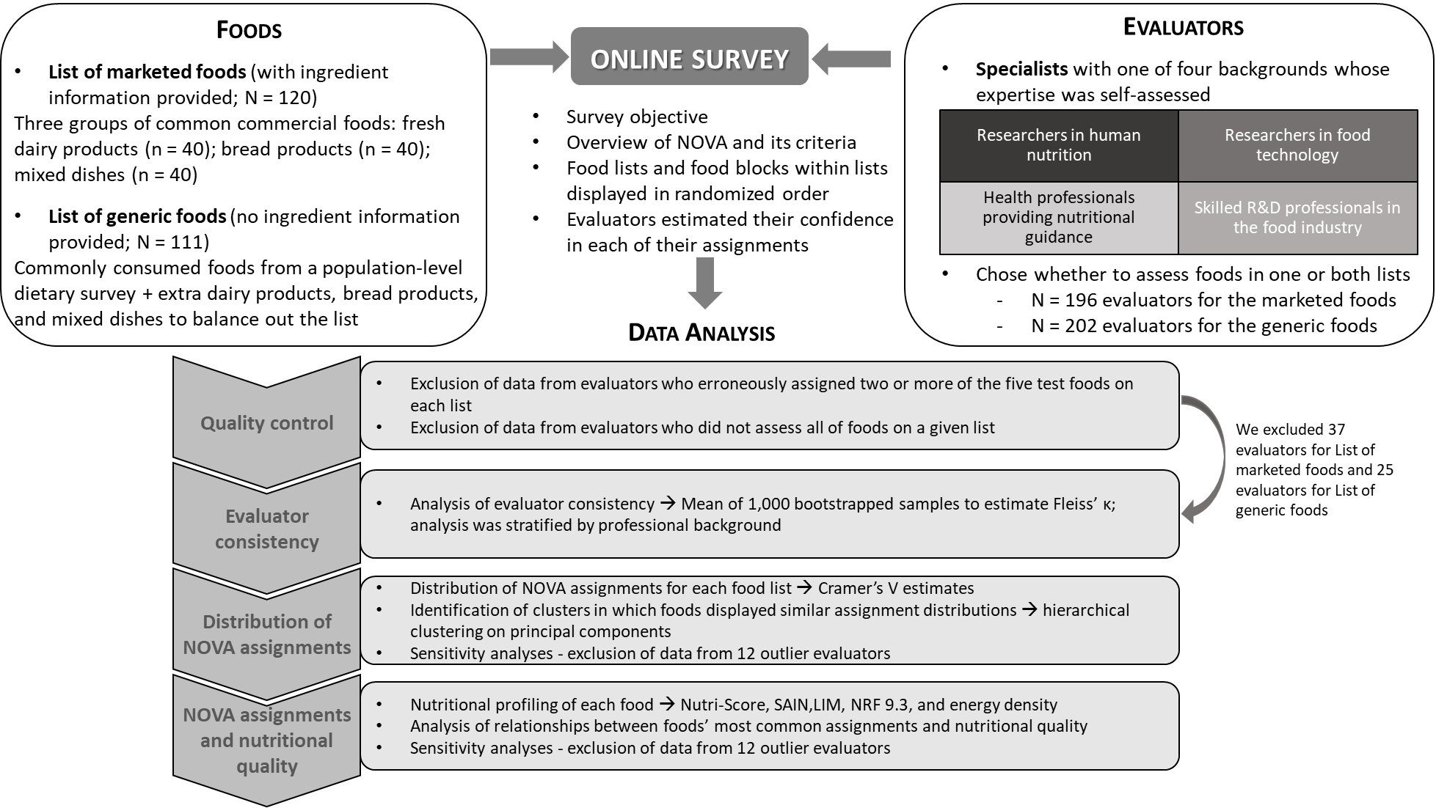
Supplementary Figure 1: Schematic of the study’s experimental design. Abbreviations: NRF, Nutrient Rich Food Index.

