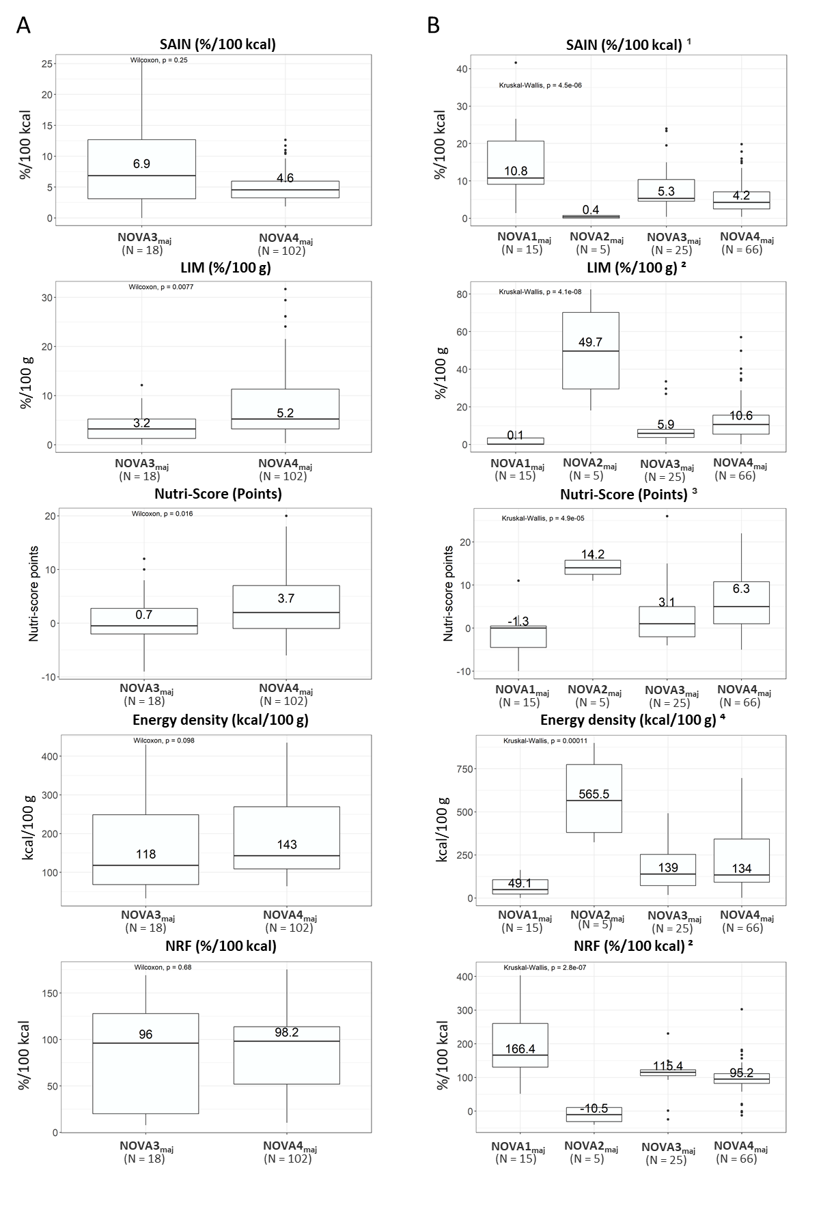
Supplementary Figure 2. Different nutritional profiles of the foods based on the NOVA group to which they were most commonly assigned (NOVA_{maj}). Higher SAIN and NRF 9.3 values indicate higher nutritional quality; higher LIM, Nutri-Score, and energy density values indicate lower nutritional quality. (A) Marketed foods (List with ingredient information provided). (B) Generic foods (no ingredient information provided). N indicates the number of foods in each NOVA_{maj}.

¹Results for all the paired comparisons were significantly different, except for the comparison between NOVA3_{maj} and NOVA4_{maj} (p = 0.055 for SAIN, p = 0.52 for energy density)
²Results for all the paired comparisons were significantly different
³Results for all the paired comparisons were significantly different, except between NOVA1_{maj} and NOVA3_{maj} (p = 0.077)

