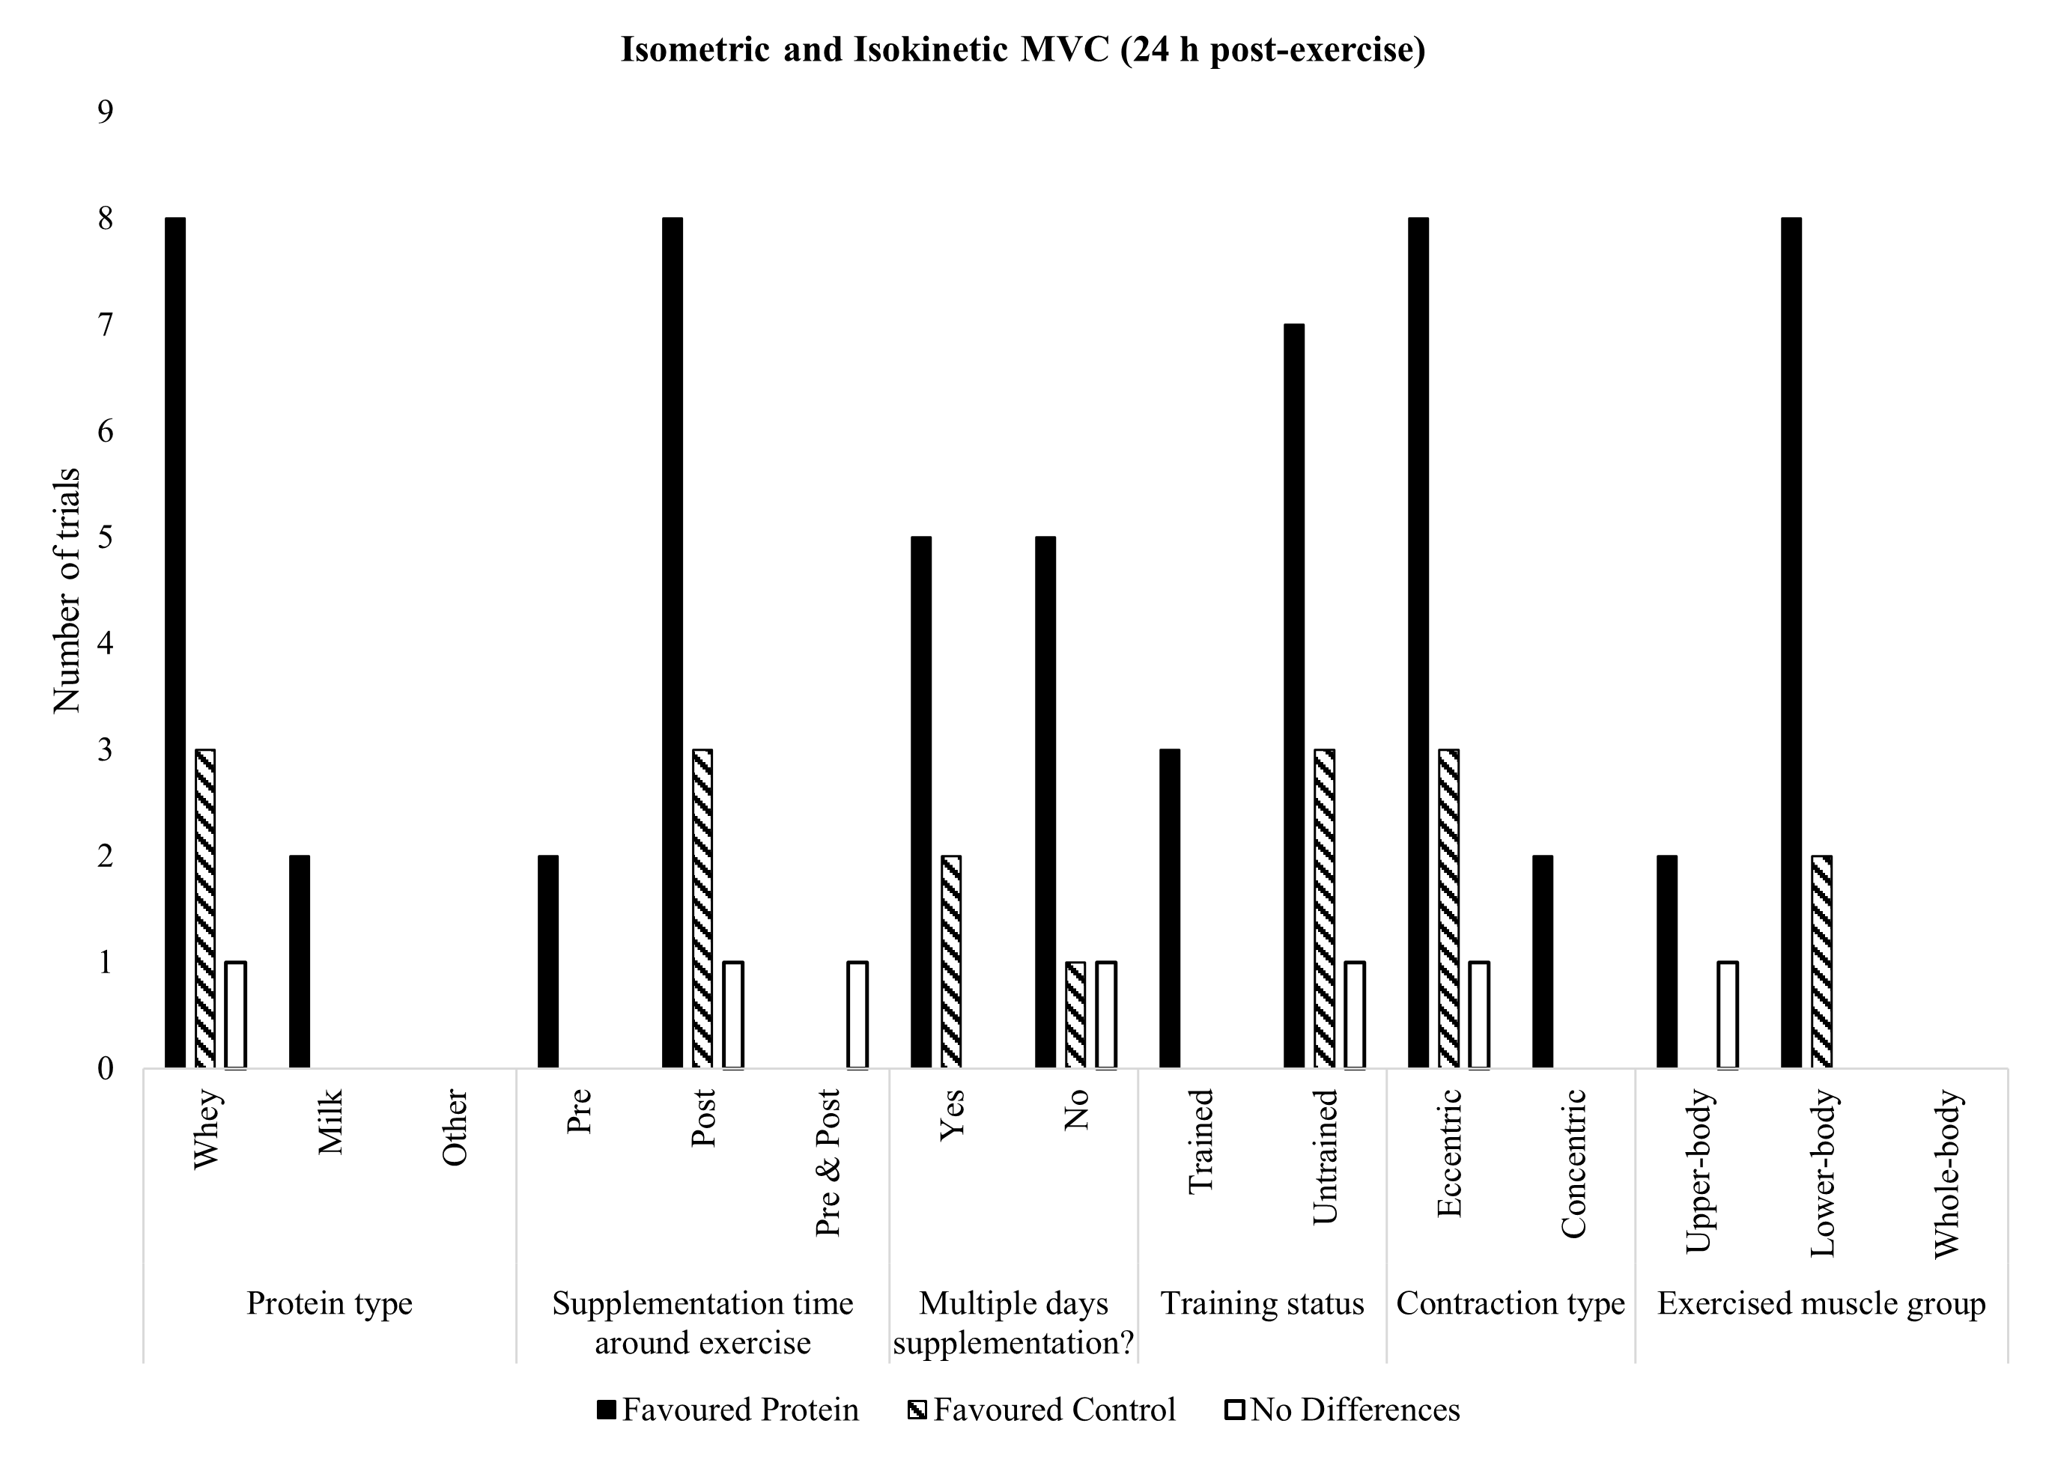
a

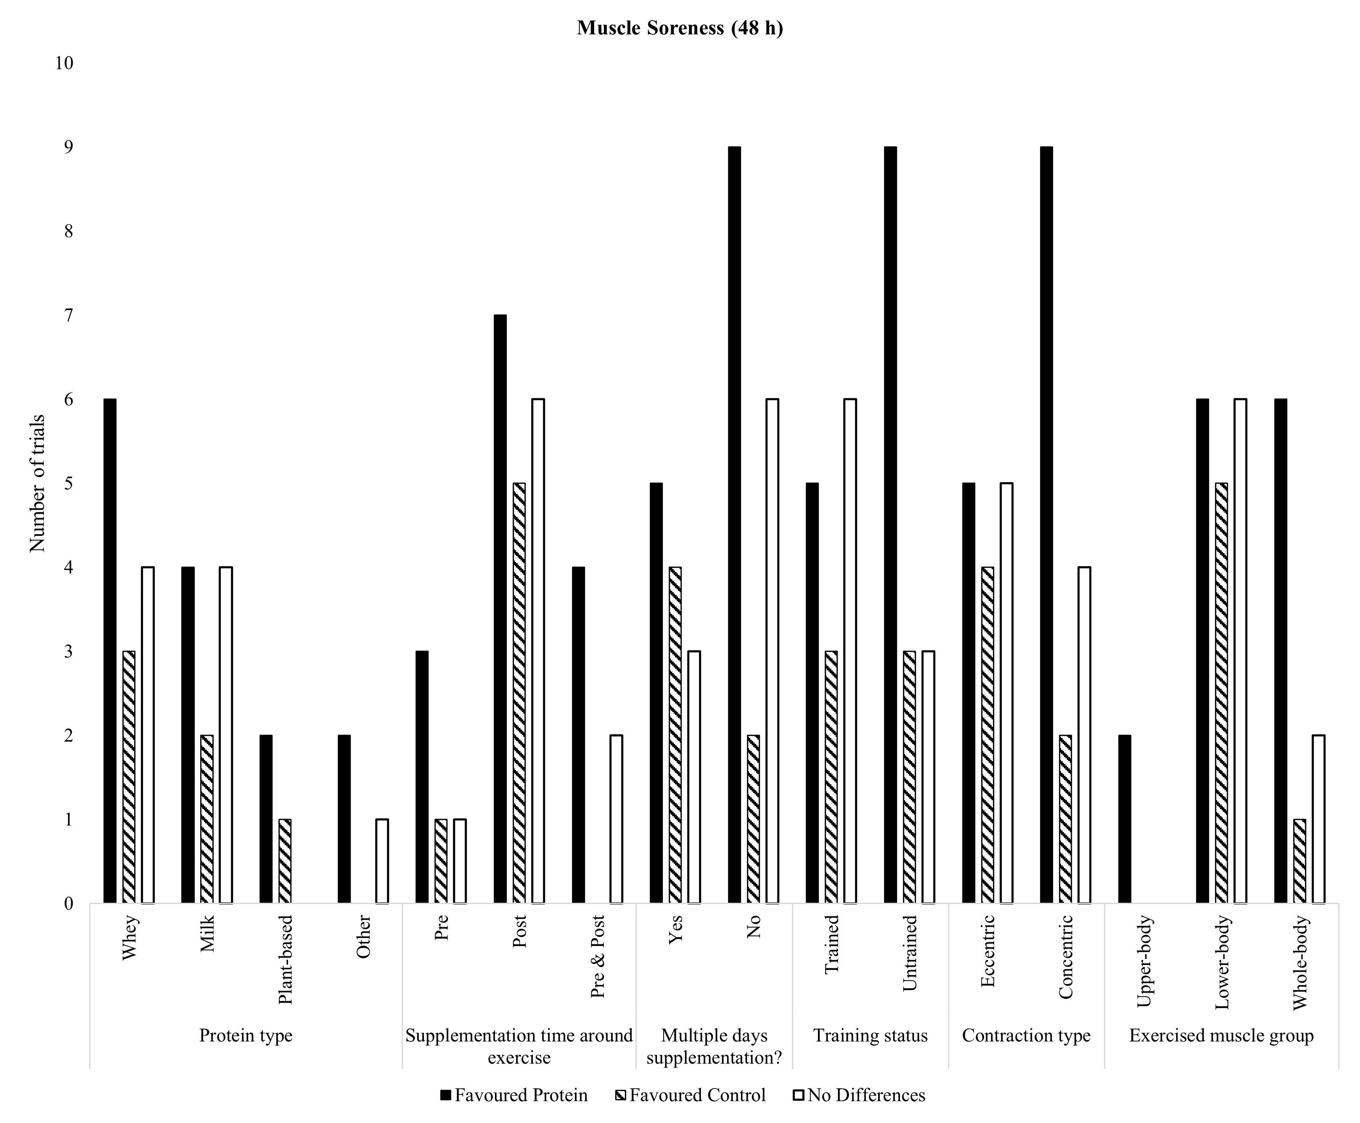
b

Figure S.1 Frequency of trials reporting a favourable effect of protein or control supplementation on a. isometric and isokinetic maximal voluntary contraction at 24 h post-exercise categorised by study variables and b. muscle soreness at 48 h post-exercise categorised by study variables

