Risk factors for inpatient mortality among children with severe acute malnutrition in Zimbabwe and Zambia

HOPE-SAM study team
Beatrice Amadi³, Ellen Besa³, Claire D Bourke², Mutsa Bwakura-Dangarembizi^{1,4}, Bernard Chasekwa¹, Pamela Chakara¹, Leah Chidamba¹, Theodore Chidawanyika¹, Tafadzwa Chidhanguro¹, Kapula Chifunda³, Esther Chilala³, Lovemore Chingaoma¹, Miyoba Chipunza³, Nivea Chulu³, Adlight Dandadzi¹, Tenzeni Dumba³, Cherlynn Dumbura¹, Washington Dune¹, Temwaninge Gondwe³, Margaret Govha¹, Karen Gwanzura¹, Jean H Humphrey^{1,5}, Tomola Kaingu³, Chanda Kapoma³, Sarudzai Kasaru³, Lydia Kazhila³, Paul Kelly^{2,3}, Lucy Macwani³, Florence D Majo¹, Idah Mapurisa¹, Patience Mashayanembwa¹, Faithful Masimba¹, Stephen Moyo¹, Eddington Mpofu¹, Mary Mpundu³, Edith Mukusho³, Johnson Mushonga¹, Kuda Mutasa¹, Agatha Muyenga³, Sophreen Mwaba³, Simutanyi Mwakamui³, Mpala Mwanza³, Benjamin Mwapenya¹, Kusum J Nathoo⁴, Gwendolyn Nayame³, Deophine Ngosa³, Sibongile Nkiwane¹, Robert Ntozini¹, Penias Nyamwino¹, Evelyn Nyendwa³, Dennis Phiri³, Phillipa Rambanepasi¹, Andrew J Prendergast^{1,2}, Ruairi Robertson², Sandra Rukobo¹, Thompson Runodamoto¹, Virginia Sauramba¹, Shepherd Seremwe¹, Pururudzai Simango¹, Jonathan P Sturgeon^{1,2}, Jonathan R Swann⁶, Andreck Tembo³, Dalitso Tembo³, Blessing Tsenesa¹, Jonathan CK Wells⁷, Kanekwa Zyambo³, and Khozya Zyambo³.

¹Zvitambo Institute for Maternal and Child Health Research, 16 Lauchlan Avenue, Harare, Zimbabwe.
²Centre for Genomics and Child Health, Blizard Institute, Queen Mary University of London, 4 Newark Street London, E1 2AT, UK
³Tropical Gastroenterology and Nutrition Group, University of Zambia, Lusaka, Zambia
⁴Faculty of Medicine and Health Sciences, University of Zimbabwe, Harare, Zimbabwe
⁵Department of International Health, Johns Hopkins Bloomberg School of Public Health, 615 North Wolfe Street, Baltimore, MD 21205, USA
⁶Faculty of Medicine, Department of Metabolism, Digestion and Reproduction, Imperial College, London, UK
⁷Population, Policy & Practice Dept. UCL GOS Institute of Child Health, University College London, UK

Supplemental Figure 1: Conceptual framework of signs, symptoms, and systems plausibly associated with mortality
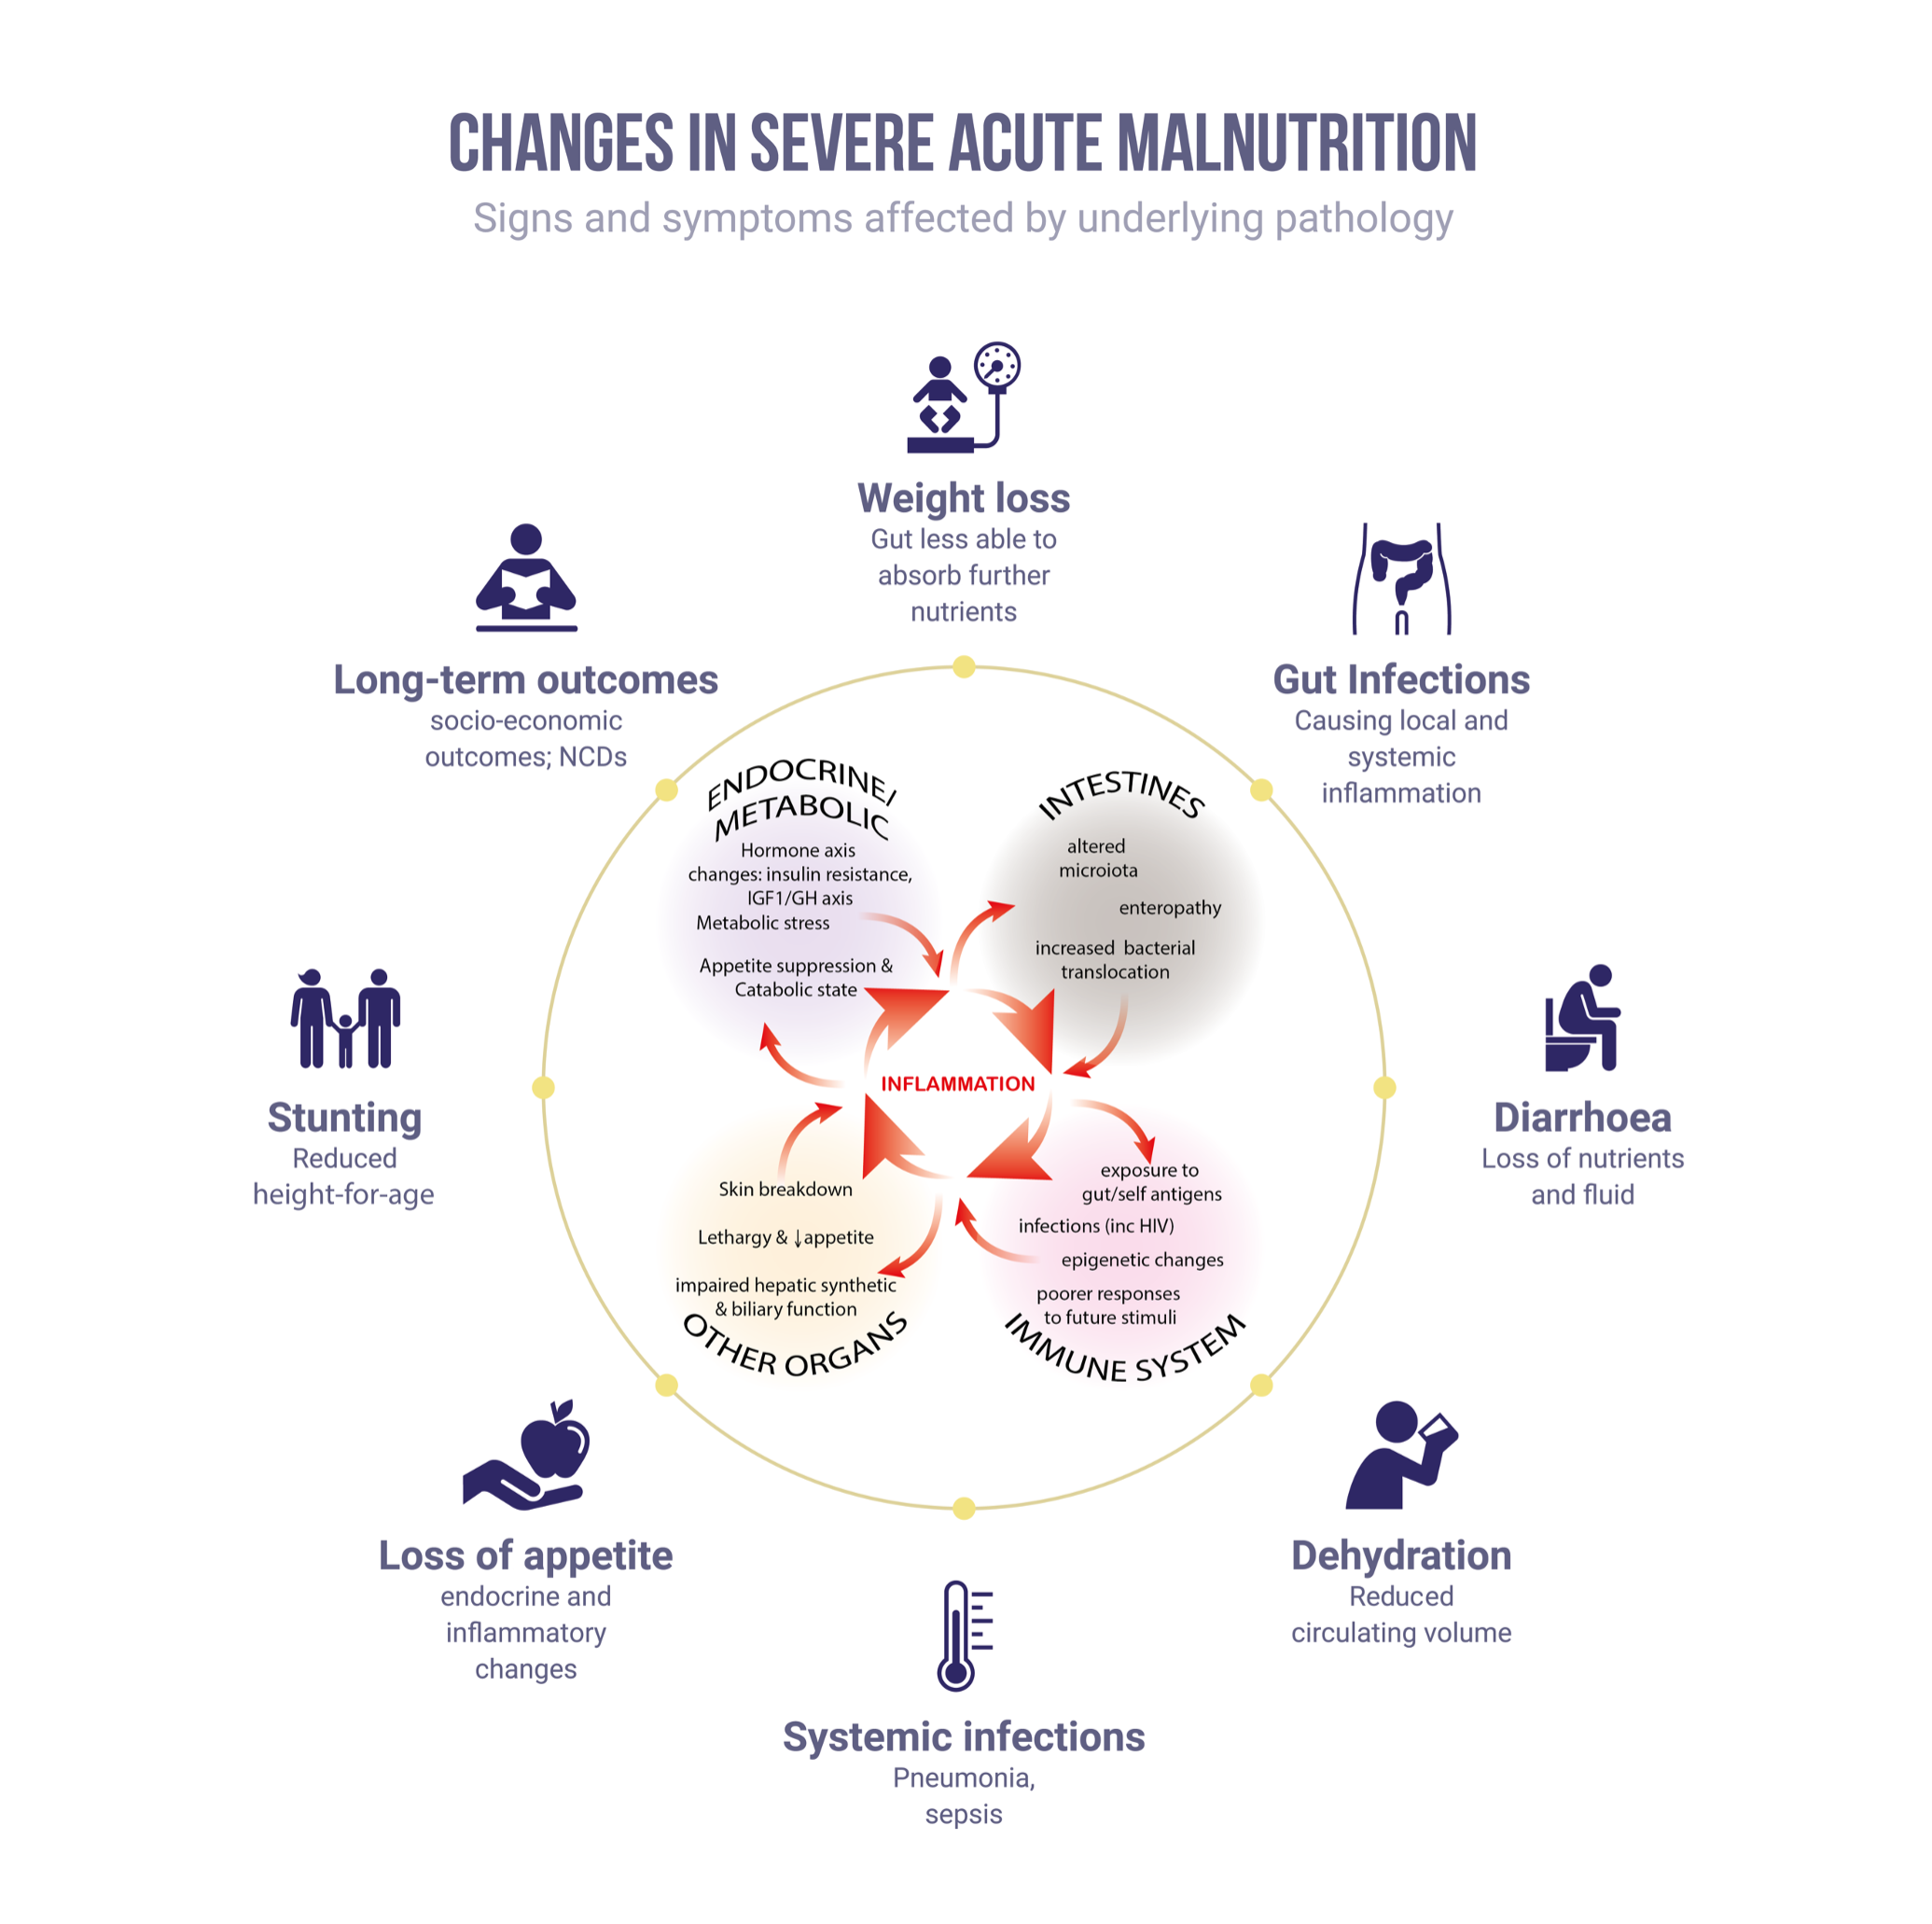

 | Form 4: Admission Details
 | Full form: https://osf.io/29uaw/files/osfstorage/5b55f22fc86a8c0012458241
Identification | Participant ID (PID)
Identification | Sex
Identification | Date of birth
Identification | Age
Identification | Date of initial assessment in hospital
Identification | Time of initial assessment in hospital
Identification | Are you the main person who cares for the child each day?
Identification | What is your relationship to the child?
Identification | Where is the mother?
Identification | How long has your child been unwell with this current illness?
Identification | Who did you seek help from prior to hospitalization?
Identification | Has the child already been admitted to hospital during this current episode of illness?
Current History | In the last 2 weeks:
Current History | Fever/hot body?
Current History | Cold hands and feet?
Current History | Night sweats?
Current History | Cough?
Current History | Fast or difficult breathing?
Current History | Diarrhoea? (3 or more loose or watery stools in 24 hours)
Current History | If yes, how many days of diarrhoea has your child had in a row?
Current History | How long ago did this diarrhoea problem first begin?
Current History | Last 24h? Or in the last 2 weeks?
Current History | Blood in the stools?
Current History | Vomiting?
Current History | Poor or reduced appetite?
Current History | Weight loss (or poor weight gain)?
Current History | Swelling of any part of their body?
Current History | Convulsions / fits?
Current History | Drowsy or difficult to wake?
Current History | Has your child experienced any other symptoms during this illness?
Current History | Other problem?
Medication | Has your child taken any medications or nutritional supplements in the past two weeks?
Medication | Has he/she taken any antibiotics in the past 2 weeks? [+which]
Medication | Has he/she taken any TB medications in the past 2 weeks? [+which]
Medication | Has he/she taken any antiretroviral (anti-HIV) medicines in the past 2 weeks? [which]
Medication | Has he/she taken any nutritional supplements in the past 2 weeks?
Medication | Has he/she taken any other medication in the past 2 weeks?
Past medical History | What sort of delivery did this child have?
Past medical History | Was this child born premature (early)?
Past medical History | What was the weight of this child at birth?
Past medical History | What was the length of this child at birth?
Past medical History | Has your child had any of these medical conditions now or in the past?
Past medical History | Is this child currently being breastfed?
Past medical History | How old was the child when he/she stopped breastfeeding?
Past medical History | Why did you stop breastfeeding?
Past medical History | Is this child currently receiving solid foods?
Past medical History | At what age did he/she first have solid foods?
Past medical History | Has this child ever been admitted to hospital and received therapeutic milk (e.g. F75) before this episode?
Past medical History | How many times has your child been admitted to hospital and received therapeutic milk (not including this episode)
Past medical History | Has this child ever been treated for malnutrition in the community?
Past medical History | How many episodes of malnutrition have been treated in the community (not including this episode)?
Past medical History | Has your child ever had persistent diarrhoea (loose stools for at least 14 days in a row)?
HIV history | What was your last HIV test result?
HIV history | When was that test?
HIV history | Was the mother HIV positive during pregnancy, delivery or breastfeeding of this child?
HIV history | Is the mother currently taking ARV's?
HIV history | When were these ARVs started?
HIV history | What is the HIV status of the child?
HIV history | Was the child diagnosed with HIV prior to this hospital admission?
HIV history | Is the child currently taking cotrimoxazole?
HIV history | Is the child currently taking ARV's?
HIV history | When were these ARV's started?
HIV history | Which drugs is the child taking?
Anthropometry | Weight
Anthropometry | Length
Anthropometry | MUAC
Anthropometry | Head circumference
Anthropometry | Oedema

Supplemental Table 1: Summary of the questions asked in the admission case report form, Form 4
This is a brief summary. For the full questions, including the coding for each question please see the full form available from: https://osf.io/29uaw/files/osfstorage/5b55f22fc86a8c0012458241
 | Form 5 (Baseline)
 | Full form: https://osf.io/29uaw/files/osfstorage/5b55f22c69e43a0010d458b9
Family | Is the child’s mother alive?
Family | Is the child’s father alive?
Family | How many people live in the child’s homestead/household?
Family | How many of these are children below 5 years of age?
Family | What is your marital status?
Family | How old are you?
Family | What is your highest completed grade of education?
Family | How do you earn a living?
Family | What is your husband/partner’s highest completed grade of education?
Family | How does your husband/partner earn a living?
Family | What is the total income of your household per month?
Family | Where do you live the majority of the time?
Family | Is there a toilet or latrine of any type at the homestead/household?
Family | What kind of toilet/latrine is it?
Family | How many households share this toilet facility?
Family | Where do you get water from?
Family | Do you treat your drinking water?
Family | Where do you cook?
Family | What methods do you use to cook?
Family | Does your household have any electricity from the mains (e.g. ZESA/ZESCO? )
Family | Do you receive any food aid from the government or other organizations?
Family | What food aid items have you received in the past 12 months?

Supplemental Table 2: Summary of the questions asked in the admission case report form, Form 5
This is a brief summary. For the full questions, including the coding for each question please see the full form available from: https://osf.io/29uaw/files/osfstorage/5b55f22c69e43a0010d458b9

 | Form 7 (clinical)
 | Full form: https://osf.io/29uaw/files/osfstorage/5b55f235c86a8c00114543a6
 | Full problem list
 | Includes dehydration, shock, hypothermia, fever, poor appetite, hypoglycaemia, eye signs, heart failure, oedema, diarrhoea, vomiting, respiratory distress, cough, sepsis, meningitis, measles in past 3 months, malaria, ear discharge, HIV infected, HIV exposed, TB, dermatosis, skin infection, oral thrush, cannula site infection, UTI, abnormal electrolytes, cerebral palsy, seizures, other
 | Observations
 | Examination - including general, adjuncts, cardiovascular, respiratory, gastroenterology, neurology and other
Resuscitation | What signs of shock did the child have in the past 24 hours?
Resuscitation | Did the child receive any intravenous fluids for shock in the past 24 hours?
Resuscitation | What intravenous fluids did the child receive for shock?
Resuscitation | What was the total volume of intravenous infusions given in past 24 hours?
Resuscitation | Did the child receive a blood transfusion for anaemia/pallor in the past 24 hours?
Resuscitation | What type of blood transfusion?
Resuscitation | What was the total volume of blood given in the past 24 hours?
Resuscitation | What oral/nasogastric fluids did the child receive in the past 24 hours (apart from F75/F100 feeds)
Resuscitation | Did the child receive any ACTIVE rewarming in the past 24 hours?
 | Medications
 | Clinical Tests

Supplemental Table 3: Summary of the questions asked in the clinical case report form, Form 7
This is a brief summary. For the full questions, including the coding for each question please see the full form available from: https://osf.io/29uaw/files/osfstorage/5b55f235c86a8c00114543a6

Missing Variables | Freq. | Percent of total | Cumulative total | Number of deaths in this group
Anthropometry | 0 | 0% | 0% | -
Clinical only | 59 | 7.92% | 7.92% | 7/59
Birthweight only | 51 | 6.85% | 14.77% | 5/51
Toilet type only | 4 | 0.54% | 15.31% | 0/4
Birthweight and toilet type | 2 | 0.27% | 15.58% | 0/2
Clinical and birthweight | 4 | 0.54% | 16.12% | 1/4
Clinical, birthweight, and toilet type | 1 | 0.13% | 16.25% | 1/1
None [all present] | 624 | 83.76% | 100% | 56/675
Total | 745 | 100 |  | 70/745
Variables Removed before multivariable analysis due to missingness
Electrolytes | 540 | 80.32%
Heart rate | 167 | 22.42%

Supplementary Table 4: Missingness of the data for the multivariable model

Variable | Obs | Mean % inclusion | Std. Dev
Age category | 7,450 | 93% | 0.251394
Gender | 7,450 | 27% | 0.444579
Site | 7,450 | 70% | 0.459393
WHZ | 7,450 | 35% | 0.475868
MUAC | 7,450 | 60% | 0.490418
HAZ | 7,450 | 23% | 0.422359
Oedema | 7,450 | 61% | 0.486652
Shock | 7,450 | 99% | 0.099835
Hypothermia | 7,450 | 56% | 0.496814
Fever | 7,450 | 19% | 0.391102
Diarrhoea | 7,450 | 71% | 0.454811
Cough | 7,450 | 27% | 0.445882
Oral thrush | 7,450 | 35% | 0.478515
Poor appetite | 7,450 | 35% | 0.476128
Respiratory Distress | 7,450 | 28% | 0.448766
Pneumonia | 7,450 | 57% | 0.494869
Dermatosis | 7,450 | 33% | 0.47194
Sepsis | 7,450 | 75% | 0.433158
TB | 7,450 | 37% | 0.482819
HIV | 7,450 | 19% | 0.395008
preterm | 7,450 | 33% | 0.470703
Prior SAM admission | 7,450 | 31% | 0.463265
Cerebral Palsy | 7,450 | 9% | 0.2884
HEU | 7,450 | 26% | 0.438517
Birth weight | 7,450 | 52% | 0.499715
Premature cessation of breastfeeding | 7,450 | 19% | 0.395424
Residence | 7,450 | 19% | 0.38884
Toilet type | 7,450 | 76% | 0.425962
More than 1 other child >5y | 7,450 | 23% | 0.423037
Maternal HIV status | 7,450 | 36% | 0.481302

Supplementary Table 5: Results of the bootstrap validation of the variable selection for the final multivariable model

