Appendix 4: Leave-One-Out Sensitivity Analyses for Pain, Physical Function, and Weight Outcomes.
Leave-One-Out Sensitivity Analyses for Pain.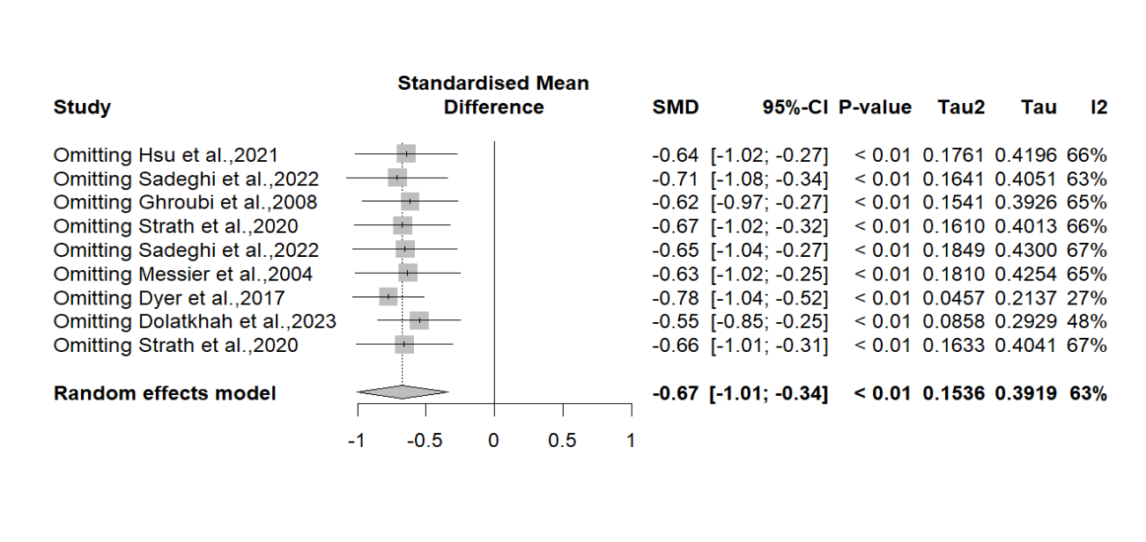
Leave-One-Out Sensitivity Analyses for Physical Function. 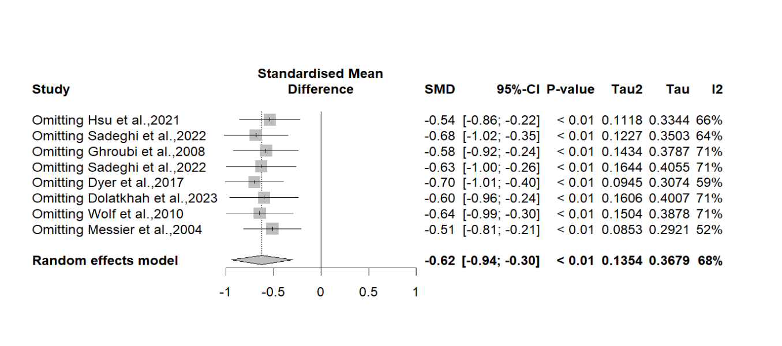
Leave-One-Out Sensitivity Analyses for Weight.