Supplemental Table 1: Example menus for portfolio and control dietary patterns

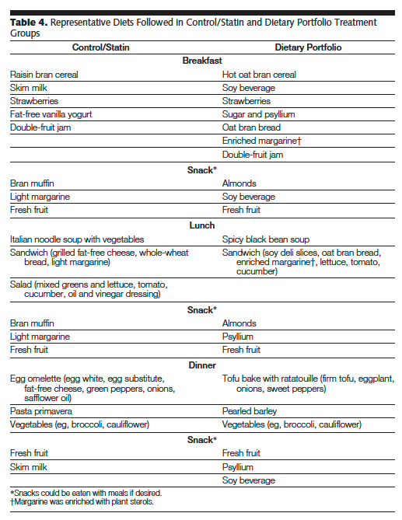

Supplemental Table 2: Mean intake of baseline diets of the participants in each study

 | Study one (n=34, cross-over design) |  |  | Study two (n=25, parallel design)
 | Portfolio | Control | Statin | Portfolio | Control
Energy, kcal/day | 1829 | 1903 | 1766 | 2020 | 1818
Total protein, %E | 17.8 | 18.0 | 18.0 | 18.1 | 17.8
Vegetable protein, %E | 8.1 | 7.8 | 8.5 | 8.0 | 8.3
Available CHO, %E | 49.4 | 53.9 | 50.3 | 50.0 | 51.6
Fiber, g/d | 28 | 30 | 29 | 33 | 30
Total fat, %E | 30.3 | 26.1 | 30.3 | 27.0 | 25.0
Saturated fat, %E | 8.1 | 7.0 | 7.6 | 7.4 | 6.1
Monounsaturated fat, %E | 13.1 | 10.9 | 13.6 | 10.5 | 10.6
Polyunsaturated fat, %E | 6.6 | 5.7 | 6.4 | 6.4 | 6.0
Cholesterol, mg/d | 161 | 190 | 142 | 167 | 154
Alcohol, g/d | 8.0 | 6.0 | 3.0 | 3.0 | 5.3
Clinical portfolio diet score (cPDS), 0-20 points | 3.4 | 3.9 | 3.7 | 3.0 | 2.8
Plant protein, 0-5 points | 0.8 | 0.9 | 0.9 | 0.9 | 0.8
Almonds, 0-5 points | 1.3 | 1.6 | 1.5 | 0.9 | 1.2
Viscous fiber, 0-5 points | 1.1 | 1.2 | 1.1 | 0.9 | 0.8
Phytosterols, 0-5 points | 0.2 | 0.2 | 0.2 | 0.3 | 0.0
The values represent foods consumed at baseline determined via 7-day diet records completed by the study participants. The cPDS represents overall adherence to the portfolio diet, and for the individual components: 1 plant protein point = 10g of legume protein, 1 almond point = 9g of almonds, 1 viscous fiber point = 4g viscous fiber, 1 phytosterol point = 400mg from supplements and fortified foods.

Supplemental Figure 1: Significant metabolites that changed with the control diet intervention from baseline in study one

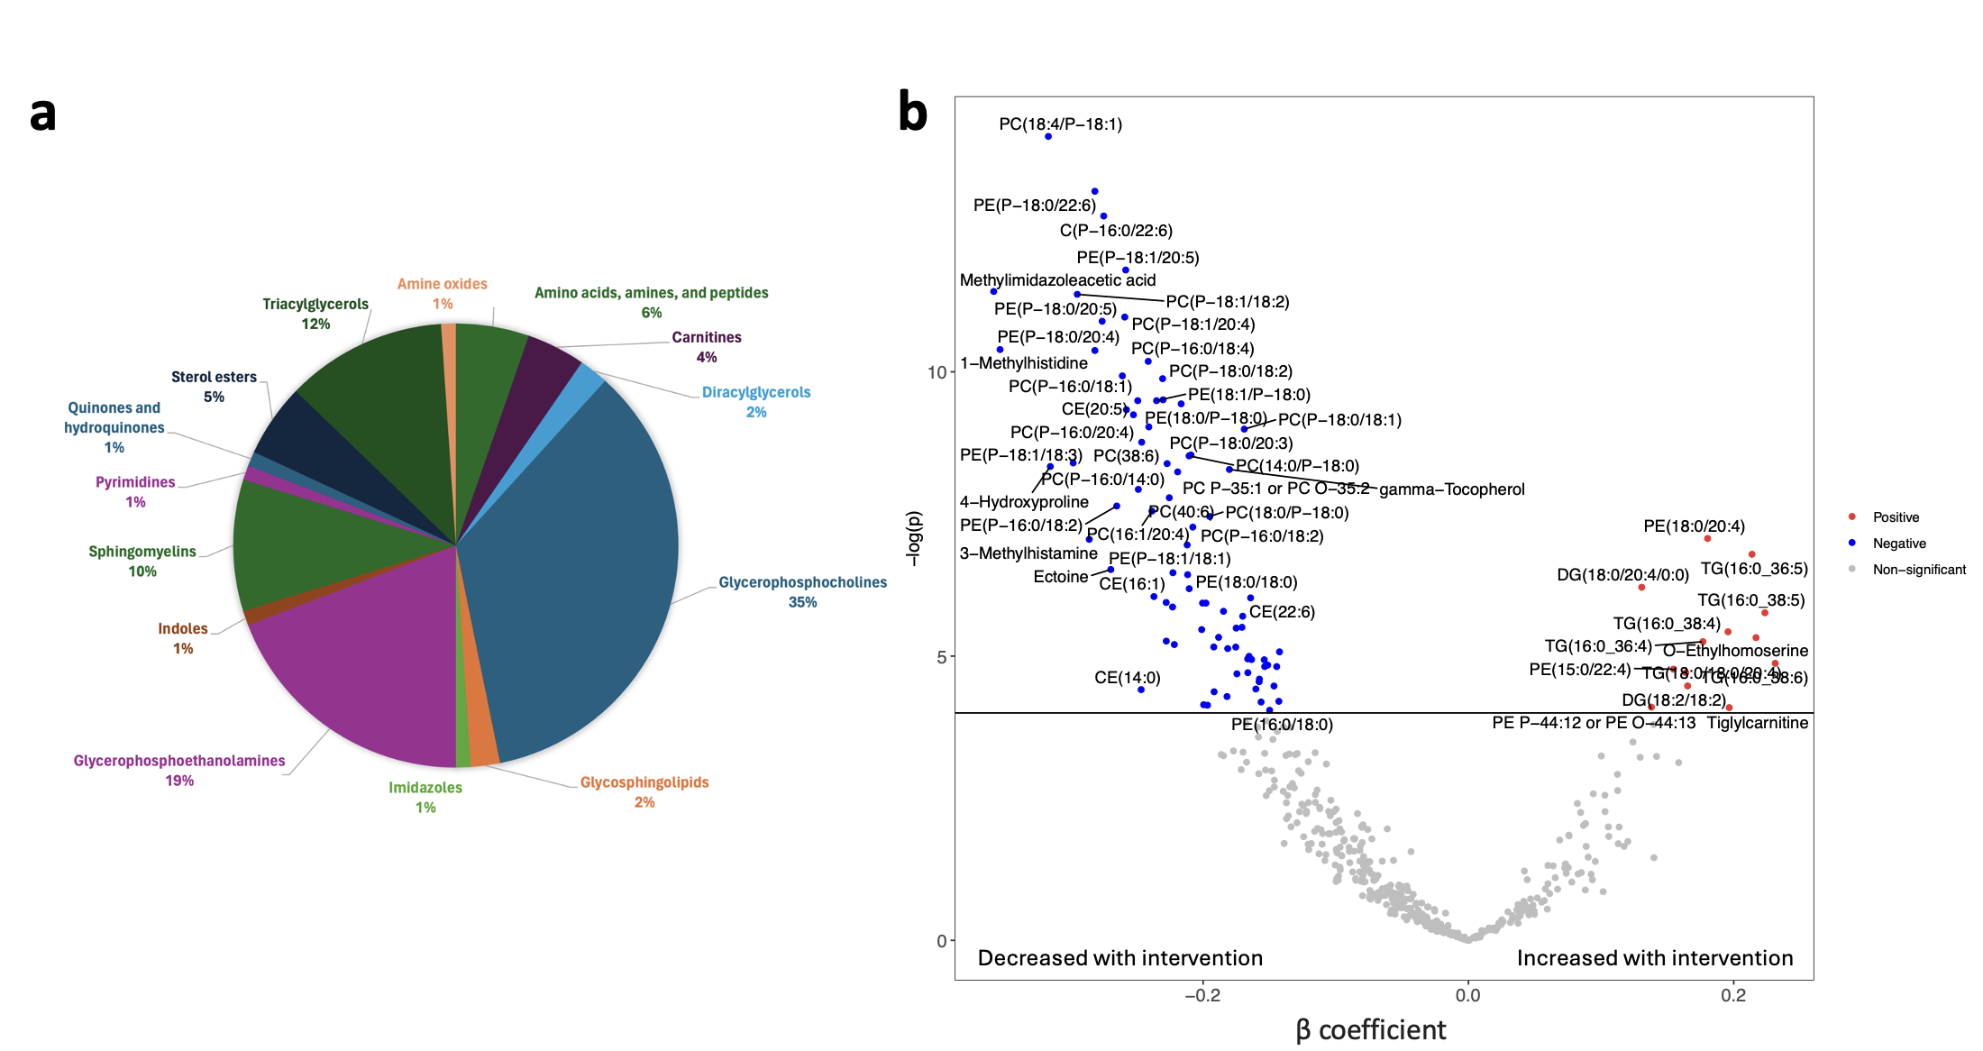
(a) Metabolite classes of the 94 metabolites significantly changed after the control diet intervention from a total of 496 metabolites assessed. (b) Volcano plot of mean difference in plasma metabolites over 4 weeks after consumption of the control diet from baseline. Significant metabolites were estimated from 34 participants via linear mixed models and included a Bonferroni adjustment for multiple testing (p<0.0001). The models (per 1-SD increment in each metabolite) incorporated participant-specific intercepts as a random effect and the fixed effects were diet, time (week), and the interaction between time and diet (diet x week), adjusted for phase. See Supplemental Table 4 for full list of significant metabolites.

Supplemental Figure 2: Significant metabolites that changed with the statin plus control diet intervention from baseline in study one

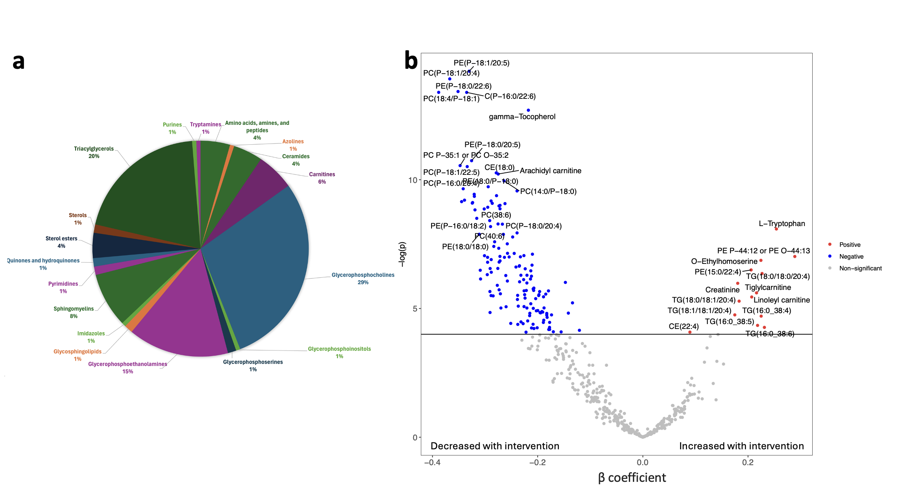
(a) Metabolite classes of the 159 metabolites significantly changed after the statin plus control diet intervention from a total of 496 metabolites assessed. (b) Volcano plot of mean difference in plasma metabolites over 4 weeks after consumption of the statin plus control diet from baseline. Significant metabolites were estimated from 34 participants via linear mixed models and included a Bonferroni adjustment for multiple testing (p<0.0001). The models (per 1-SD increment in each metabolite) incorporated participant-specific intercepts as a random effect and the fixed effects were diet, time (week), and the interaction between time and diet (diet x week), adjusted for phase. See Supplemental Table 5 for full list of the significant metabolites.
Supplemental Figure 3: Significant metabolites that changed with the control diet intervention from baseline in study two

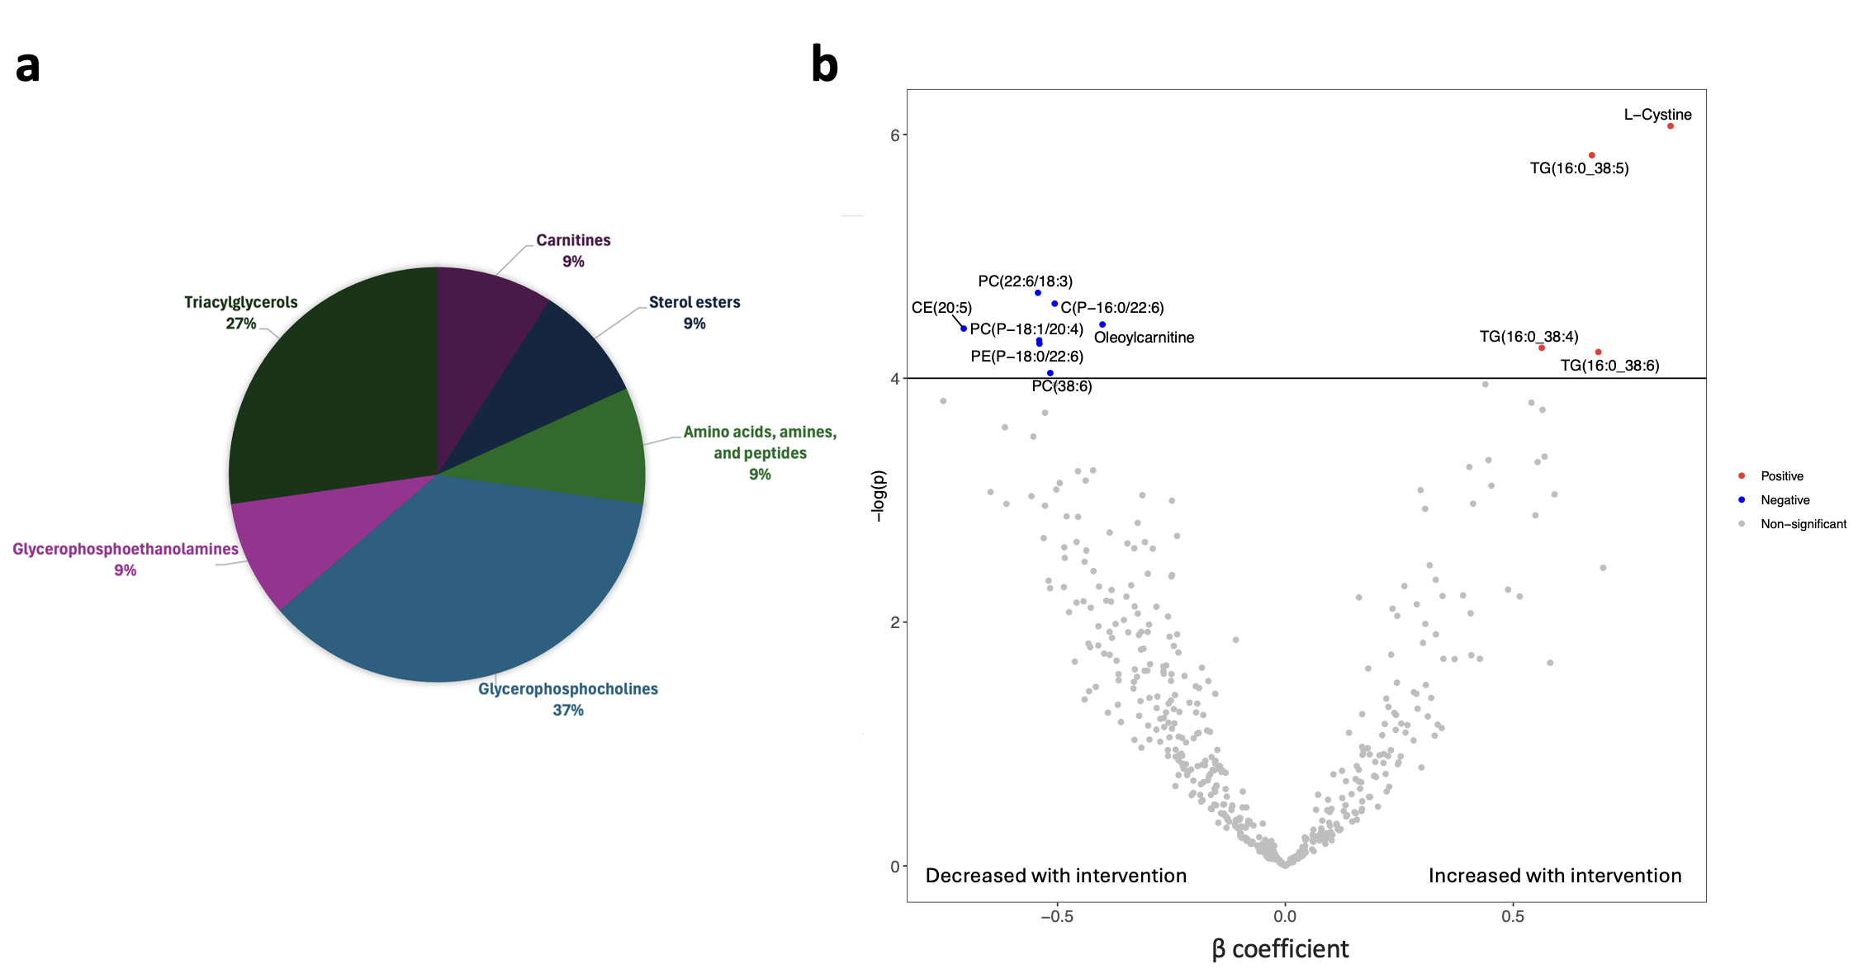
(a) Metabolite classes of the 11 metabolites significantly changed after the control diet intervention from a total of 496 metabolites assessed. (b) Volcano plot of mean difference in plasma metabolites over 4 weeks after consumption of the control diet from baseline. Significant metabolites were estimated from 25 participants via linear mixed models and included a Bonferroni adjustment for multiple testing (p<0.0001). The models (per 1-SD increment in each metabolite) incorporated participant-specific intercepts as a random effect and the fixed effects were diet, time (week), and the interaction between time and diet (diet x week). See Supplemental Table 7 for full list of significant metabolites.

