Supplementary material
Text 1. Assessment of covariates
Demographic data (age, sex, ethnicity, Townsend deprivation index, education), lifestyle factors (smoking status, sleep duration, physical activity),^{1,2} and health indicators (other autoimmune diseases,³ genetic predisposition of rheumatoid arthritis (RA)⁴) were collected at baseline. Townsend deprivation index measured material deprivation based on unemployment, car ownership, home ownership, and household overcrowding, with higher scores representing greater deprivation.⁵ Physical activity was assessed using the International Physical Activity Questionnaire (IPAQ, short forms). Physical activity was classified as high, moderate, or low level according to the IPAQ scoring protocol.⁶ Hypertension was defined based on blood pressure (≥140/90mmHg) or self-reported intake of antihypertensive medication. Diabetes was defined based on measurements of hemoglobin A1c (HbA1c, ≥6.5%) or self-reported intake of antidiabetic medication. Other autoimmune diseases were defined as having at least one of the following diseases: psoriasis (ICD-10: L40), multiple sclerosis (ICD-10: G35), systemic lupus erythematosus (ICD-10: M32) and inflammatory bowel disease (ICD-10: K50, K51),³ as determined by self-report, hospital and primary care records. We measured genetic predisposition to RA using the polygenic risk score (PRS) of RA calculated by Thompson et al. for each UKB participant. The per-participant PRS score was calculated as the sum of the effect size multiplied by the number of risk alleles. Details of the algorithm can be found elsewhere.⁷ Rheumatoid factor (RF) was measured at baseline using immunoturbidimetry on a Beckman Coulter AU5800 and level >14 IU/mL was considered RF-positive.⁸

Reference
1. Nguyen Y, Salliot C, Gelot A, et al. Mediterranean Diet and Risk of Rheumatoid Arthritis: Findings From the French E3N-EPIC Cohort Study. Arthritis & Rheumatology 2021; 73(1): 69-77.
2. Hu Y, Costenbader KH, Gao X, Hu FB, Karlson EW, Lu B. Mediterranean Diet and Incidence of Rheumatoid Arthritis in Women. Arthritis Care & Research 2015; 67(5): 597-606.
3. Mazzucca CB, Scotti L, Cappellano G, Barone-Adesi F, Chiocchetti A. Nutrition and Rheumatoid Arthritis Onset: A Prospective Analysis Using the UK Biobank. Nutrients 2022; 14(8).
4. Johansson K, Askling J, Alfredsson L, Di Giuseppe D, on behalf of the Esg. Mediterranean diet and risk of rheumatoid arthritis: a population-based case-control study. Arthritis Research & Therapy 2018; 20(1): 175.
5. Adams J, Ryan V, White M. How accurate are Townsend Deprivation Scores as predictors of self-reported health? A comparison with individual level data. J Public Health (Oxf) 2005; 27(1): 101-6.
6. IPAQ scoring protocol. 2005. https://sites.google.com/site/theipaq/scoring-protocol (accessed 10-02 2022).
7. Thompson DJ, Wells D, Selzam S, et al. UK Biobank release and systematic evaluation of optimised polygenic risk scores for 53 diseases and quantitative traits. medRxiv 2022: 2022.06.16.22276246.
8. Stanciu I, Anderson J, Siebert S, Mackay D, Lyall DM. Associations of rheumatoid arthritis and rheumatoid factor with mental health, sleep and cognition characteristics in the UK Biobank. Sci Rep 2022; 12(1): 19844.

Figures

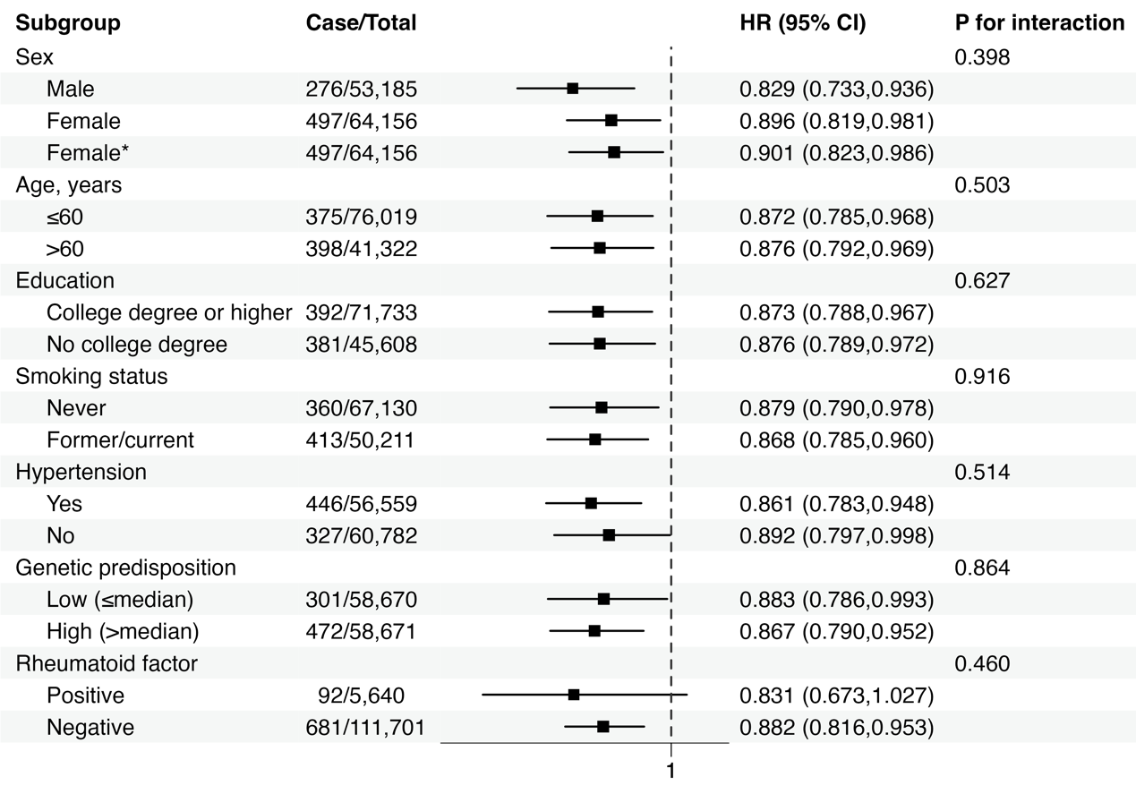
Figure S1. Forest plot for subgroup analysis of associations between MEDI-LITE score (per SD) and the risk of rheumatoid arthritis. Models were adjusted for age, sex, ethnicity, Townsend Deprivation index, education, energy intake, physical activity, sleep duration, smoking, genetic predisposition, history of other autoimmune diseases, hypertension, and diabetes. *Model additionally adjusted for menarche age, menopause status, parous, use of oral contraceptive, and use of hormone replacement therapy.

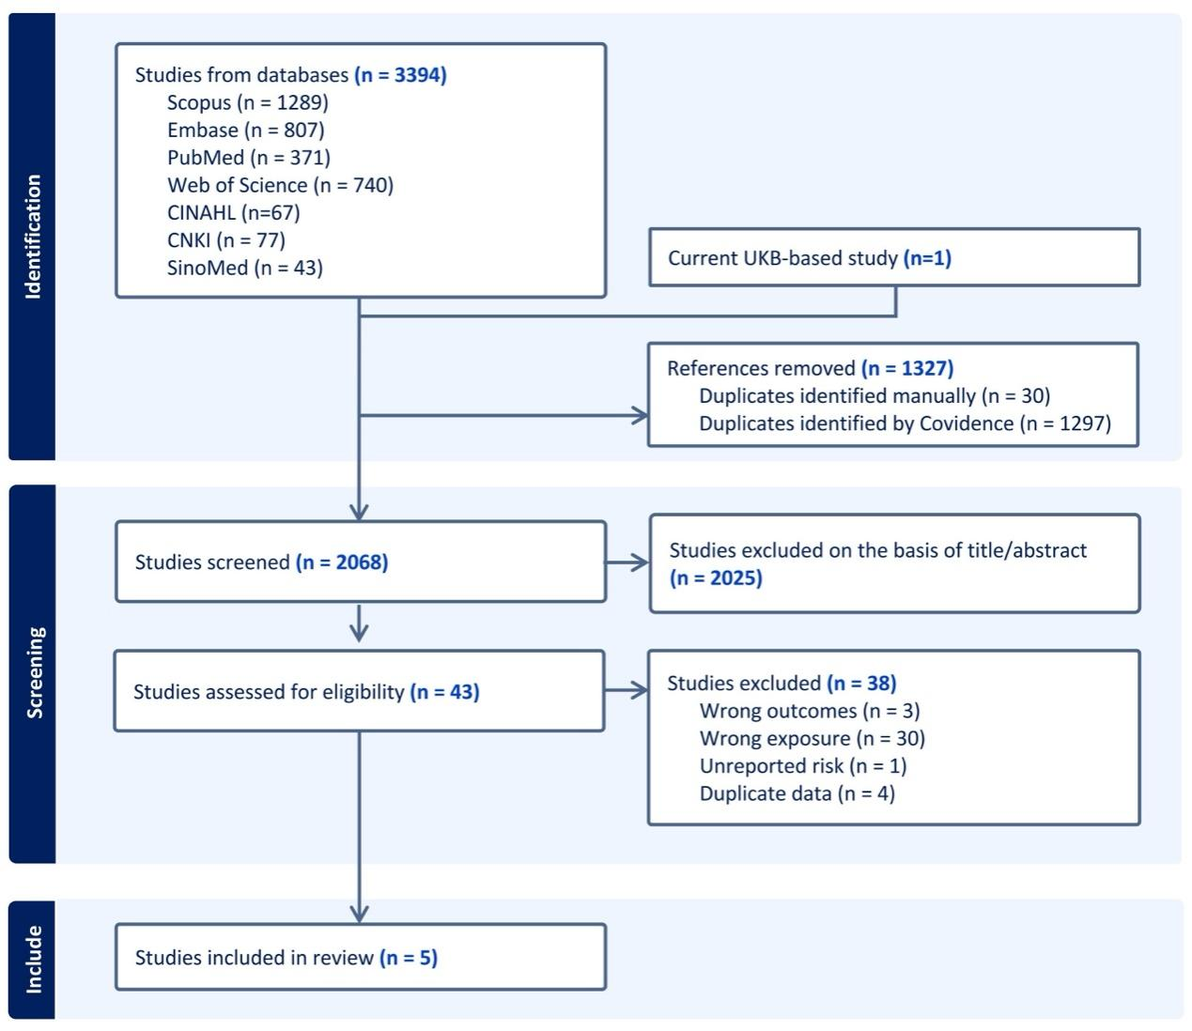
Figure S2. PRISMA flow diagram of the study selection process in systematic review

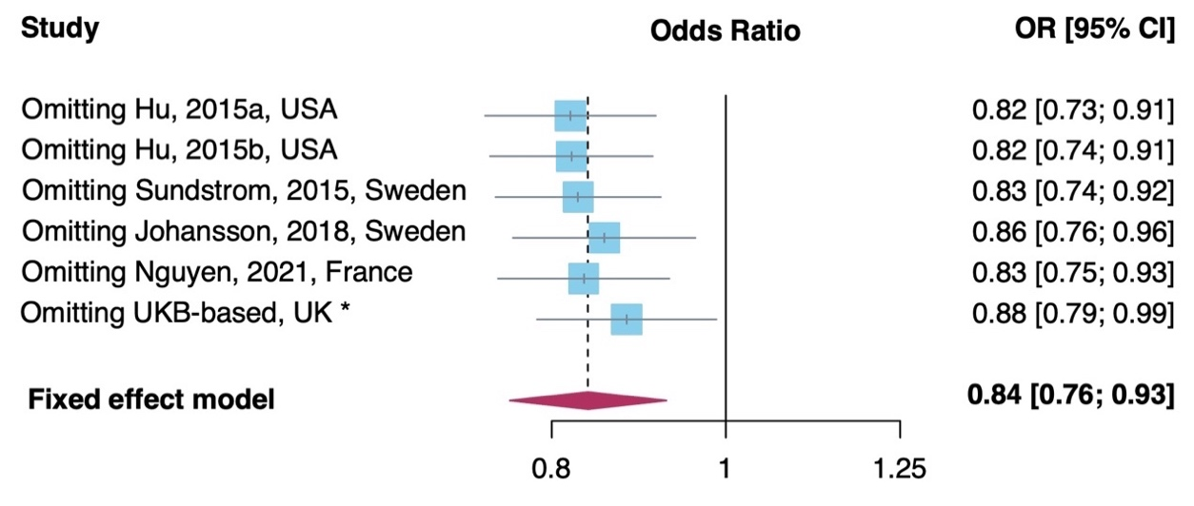
Figure S3. Sensitivity analysis of the meta-analysis. *the current cohort study.

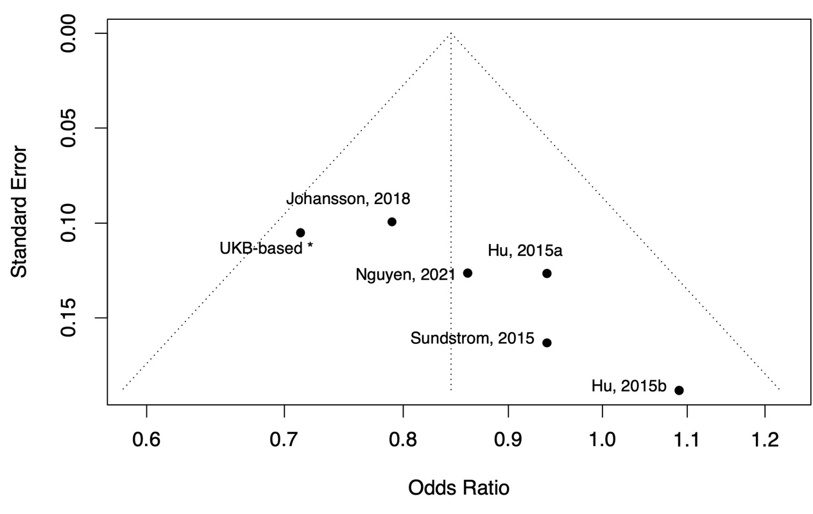
Figure S4. Funnel plot of the included studies. *the current cohort study.

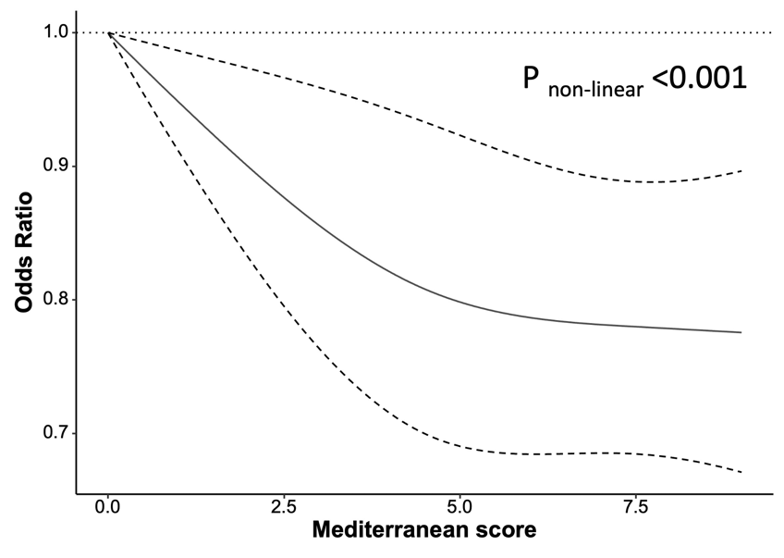
Figure S5. Pooled dose-response risk relationship between adherence score and the risk of RA

Tables
Table S1. Cut-off points for individual components of the Mediterranean diet as established by Sofi et al.ª
Component | 0 points | 1 point | 2 points
Fruits  1 portion: 150 g | < 1 portion/day | 1 – 1.5 portion/day | > 1.5 portion/day
Vegetables  1 portion: 100 g | < 1 portion /day | 1 – 2.5 portion /day | > 2.5 portion /day
Legumes  1 portion: 70 g | < 1 portion /week | 1 – 2 portion /week | > 2 portion /week
Cereals  1 portion: 130 g | < 1 portion /day | 1 – 1.5 portion /day | > 1.5 portion /day
Fish  1 portion: 100 g | < 1 portion /week | 1 – 2.5 portion /week | > 2.5 portion /week
Olive oil | Occasional use | Frequent use | Regular use
Alcohol  1 Alcohol Unit (AU): 12g | > 2 AU/day | < 1 AU/day | 1-2 AU/day
Meat and meat products  1 portion: 80 g | > 1.5 portion /day | 1 – 1.5 portion /day | < 1 portion /day
Dairy products  1 portion: 180 g | > 1.5 portion /day | 1 – 1.5 portion /day | < 1 portion /day
ª Sofi F, Macchi C, Abbate R, Gensini GF, Casini A. Mediterranean diet and health status: an updated meta-analysis and a proposal for a literature-based adherence score. Public Health Nutrition 2014; 17(12): 2769-82.

Table S2. Search strategy for systematic review and meta-analysis
Database |  | Search Terms
PubMed
 | #1 | "rheumatoid arthritis"[Title/Abstract] OR "arthritis, rheumatoid"[MeSH Terms]
 | #2 | ("Mediterranean"[Title/Abstract] AND ("diet*"[Title/Abstract] OR "eating"[Title/Abstract] OR "food"[Title/Abstract] OR "style"[Title/Abstract] OR "pattern*"[Title/Abstract])) OR (("diet*"[Title/Abstract] OR "eating"[Title/Abstract] OR "food"[Title/Abstract]) AND ("pattern*"[Title/Abstract] OR "style"[Title/Abstract] OR "quality"[Title/Abstract])) OR "diet, mediterranean"[MeSH Terms]
 | Combine | #1 AND #2
Embase
 | #1 | rheumatoid arthritis.ab,ti. or rheumatoid arthritis/
 | #2 | Mediterranean diet/ or ((Mediterranean and (diet* or eating or food or style or pattern*)) or ((Diet* or eating or food) and (pattern* or style or quality))).ab,ti.
 | Combine | #1 AND #2
CINAHL Ultimate
 | #1 | (MH "Arthritis, Rheumatoid") OR (AB rheumatoid arthritis) OR (TI rheumatoid arthritis)
 | #2 | (MH "Mediterranean Diet")
 | #3 | AB (Mediterranean AND (diet* OR eating OR food OR style OR pattern*)) OR ((Diet* OR eating OR food) AND (pattern* OR style OR quality))
 | #4 | TI (Mediterranean AND (diet* OR eating OR food OR style OR pattern*)) OR ((Diet* OR eating OR food) AND (pattern* OR style OR quality))
 | Combine | #1 AND (#2 OR #3 OR #4)
Web of science
 | #1 | TS=(rheumatoid arthritis OR arthritis, rheumatoid)
 | #2 | TS=((Mediterranean AND (diet* OR eating OR food OR style OR pattern*)) OR ((Diet* OR eating OR food) AND (pattern* OR style OR quality)) OR diet, mediterranean)
 | Combine | #1 AND #2
Scopus
 | #1 | TITLE-ABS-KEY ( "rheumatoid arthritis" OR "arthritis, rheumatoid" )
 | #2 | TITLE-ABS-KEY ( ( "mediterranean" AND ( "diet*" OR "eating" OR "food" OR "style" OR "pattern*" ) ) OR ( ( "diet*" OR "eating" OR "food" ) AND ( "pattern*" OR "style" OR "quality" ) ) OR "diet, mediterranean" )
 | Combine | #1 AND #2
CNKI
 | #1 | (TKA=('Mediterranean' * ('diet' + 'food' + 'pattern' + 'style')) OR TKA=(('diet' + 'food') * ('pattern' + ' style' + 'quality'))) AND TKA='rheumatoid arthritis'
SinoMed
 | #1 | "rheumatoid arthritis"[Common field]
 | #2 | (("diet"[Common field] OR "food"[Common field]) AND( "pattern"[Common field] OR "style"[Common field] OR "quality"[Common field])) OR ("Mediterranean"[Common field] AND ( "diet"[Common field] OR "food"[Common field] OR "pattern" [Common field] OR "style"[Common field]))
 | Combine | #1 AND #2

Table S3. Hazard ratios for the associations between MEDI-LITE score components and risk of rheumatoid arthritis
Component of MEDI-LITE score ª | Case/Total | Model1  HR (95% CI) | Model2  HR (95% CI) | Model3  HR (95% CI)
Fruit
0 points | 263/44184 | ref. | ref. | ref.
1 point | 181/25247 | 1.206 (0.998,1.457) | 1.063 (0.879,1.285) | 1.135 (0.936,1.376)
2 points | 329/47910 | 1.154 (0.982,1.358) | 0.958 (0.813,1.129) | 1.039 (0.873,1.236)
Vegetables
0 points | 218/34882 | ref. | ref. | ref.
1 point | 360/55292 | 1.044 (0.882,1.235) | 0.915 (0.773,1.085) | 0.985 (0.828,1.172)
2 points | 195/27167 | 1.146 (0.945,1.391) | 0.947 (0.778,1.152) | 1.041 (0.844,1.283)
Legumes
0 points | 553/80686 | ref. | ref. | ref.
1 point | 41/8491 | 0.771 (0.594,1.000) | 0.733 (0.564,0.951) | 0.760 (0.585,0.987)
2 points | 179/28164 | 0.984 (0.848,1.142) | 0.941 (0.811,1.093) | 0.952 (0.819,1.107)
Cereals
0 points | 211/27054 | ref. | ref. | ref.
1 point | 223/32134 | 0.892 (0.739,1.077) | 0.928 (0.769,1.121) | 0.965 (0.797,1.169)
2 points | 339/58153 | 0.747 (0.629,0.887) | 0.830 (0.698,0.987) | 0.891 (0.742,1.071)
Fish
0 points | 366/50174 | ref. | ref. | ref.
1 point | 127/21342 | 0.841 (0.687,1.029) | 0.785 (0.641,0.961) | 0.844 (0.688,1.035)
2 points | 280/44925 | 0.872 (0.746,1.018) | 0.808 (0.691,0.945) | 0.887 (0.753,1.044)
Olive oil
0 points | 350/46203 | ref. | ref. | ref.
1 point | 323/53190 | 0.805 (0.692,0.936) | 0.803 (0.690,0.934) | 0.866 (0.742,1.011)
2 points | 100/17948 | 0.728 (0.583,0.909) | 0.712 (0.570,0.889) | 0.775 (0.616,0.975)
Alcohol
0 points | 201/33229 | ref. | ref. | ref.
1 point | 442/59632 | 1.228 (1.039,1.451) | 1.127 (0.950,1.336) | 1.165 (0.970,1.399)
2 points | 130/24480 | 0.876 (0.703,1.093) | 0.812 (0.650,1.014) | 0.860 (0.686,1.078)
Meat and meat products
0 points | 241/35042 | ref. | ref. | ref.
1 point | 224/31491 | 1.040 (0.867,1.248) | 0.937 (0.781,1.125) | 0.976 (0.810,1.176)
2 points | 308/50808 | 0.881 (0.745,1.043) | 0.791 (0.668,0.938) | 0.840 (0.700,1.008)
Dairy products
0 points | 371/52455 | ref. | ref. | ref.
1 point | 212/31969 | 0.938 (0.793,1.111) | 0.981 (0.829,1.161) | 0.955 (0.804,1.134)
2 points | 190/32917 | 0.815 (0.684,0.971) | 0.882 (0.740,1.051) | 0.837 (0.698,1.004)
ª The cut-off value of each component was provided in Appendix Table S1
Bold indicates statistically significant values;
Model 1, crude model; Model 2, adjusted for age and sex; Model 3, adjusted for age, sex, ethnicity, Townsend Deprivation index, education, energy intake, physical activity, smoking, sleep duration time, genetic predisposition, history of other autoimmune diseases, hypertension, diabetes, and other MEDI-LITE score components.

Table S4. Hazard ratios for the associations between MEDI-LITE score and risk of rheumatoid arthritis (sensitivity analyses)
 | Quartiles of MEDI-LITE score |  |  |  | p for trend | Continuous MEDI-LITEscore  (per 1-SD increment)
 | Q1 | Q2 | Q3 | Q4 | p for trend | HR (95% CI) | p
Sensitivity analysis 1
Case/Total | 87/23374 | 116/28397 | 89/30477 | 92/34704
Model 1 | ref. | 1.098 (0.832,1.450) | 0.783 (0.583,1.052) | 0.711 (0.530,0.953) | 0.007 | 0.846 (0.765,0.936) | 0.001
Model 2 | ref. | 1.026 (0.777,1.355) | 0.696 (0.517,0.936) | 0.602 (0.448,0.809) | <0.001 | 0.792 (0.715,0.878) | <0.001
Model 3 | ref. | 1.062 (0.804,1.404) | 0.738 (0.548,0.994) | 0.654 (0.484,0.882) | 0.001 | 0.817 (0.737,0.906) | <0.001
Model 4 | ref. | 1.065 (0.806,1.407) | 0.746 (0.554,1.005) | 0.664 (0.492,0.895) | 0.002 | 0.822 (0.741,0.912) | <0.001
Sensitivity analysis 2
Case/Total | 172/23459 | 196/28477 | 187/30575 | 198/34810
Model 1 | ref. | 0.940 (0.766,1.154) | 0.834 (0.678,1.026) | 0.776 (0.633,0.952) | 0.010 | 0.902 (0.840,0.969) | 0.005
Model 2 | ref. | 0.878 (0.715,1.078) | 0.740 (0.601,0.911) | 0.656 (0.534,0.806) | <0.001 | 0.845 (0.786,0.909) | <0.001
Model 3 | ref. | 0.906 (0.738,1.113) | 0.782 (0.634,0.964) | 0.709 (0.575,0.874) | 0.001 | 0.870 (0.808,0.937) | <0.001
Model 4 | ref. | 0.908 (0.739,1.115) | 0.788 (0.639,0.971) | 0.717 (0.582,0.883) | 0.001 | 0.874 (0.812,0.941) | <0.001
Sensitivity analysis 3
Case/Total | 90/12922 | 122/17287 | 120/19697 | 129/23127
Model 1 | ref. | 1.012 (0.771,1.329) | 0.870 (0.662,1.144) | 0.796 (0.609,1.043) | 0.056 | 0.897 (0.819,0.983) | 0.020
Model 2 | ref. | 0.949 (0.722,1.246) | 0.773 (0.587,1.017) | 0.674 (0.513,0.884) | 0.002 | 0.842 (0.767,0.924) | <0.001
Model 2^{c} | ref. | 0.984 (0.749,1.293) | 0.817 (0.620,1.076) | 0.726 (0.551,0.955) | 0.010 | 0.865 (0.787,0.951) | 0.003
Model 4 | ref. | 0.981 (0.747,1.289) | 0.818 (0.621,1.078) | 0.732 (0.556,0.964) | 0.013 | 0.869 (0.790,0.955) | 0.003
Sensitivity analysis 4
Case/Total | 192/24968 | 213/30198 | 214/32519 | 223/36774
Model 1 | ref. | 0.919 (0.756,1.117) | 0.856 (0.704,1.040) | 0.788 (0.650,0.957) | 0.013 | 0.911 (0.851,0.974) | 0.007
Model 2 | ref. | 0.859 (0.707,1.045) | 0.762 (0.627,0.927) | 0.670 (0.551,0.814) | <0.001 | 0.855 (0.798,0.916) | <0.001
Model 3 | ref. | 0.888 (0.730,1.080) | 0.806 (0.662,0.982) | 0.727 (0.597,0.886) | 0.001 | 0.882 (0.822,0.946) | <0.001
Model 4 | ref. | 0.890 (0.732,1.083) | 0.814 (0.669,0.992) | 0.737 (0.605,0.898) | 0.002 | 0.887 (0.827,0.951) | 0.001
Sensitivity analysis 5
Case/Total | 158/22541 | 181/27443 | 175/29528 | 190/33644
Model 1 | ref. | 0.943 (0.762,1.167) | 0.846 (0.682,1.049) | 0.807 (0.653,0.996) | 0.034 | 0.918 (0.853,0.989) | 0.023
Model 2 | ref. | 0.877 (0.708,1.086) | 0.747 (0.602,0.928) | 0.676 (0.546,0.837) | <0.001 | 0.858 (0.795,0.925) | <0.001
Model 3 | ref. | 0.904 (0.730,1.120) | 0.788 (0.634,0.979) | 0.728 (0.587,0.904) | 0.003 | 0.882 (0.817,0.952) | 0.001
Model 4.1 | ref. | 0.902 (0.728,1.117) | 0.791 (0.637,0.983) | 0.731 (0.589,0.907) | 0.003 | 0.884 (0.819,0.955) | 0.002
Bold indicates statistically significant values; SD, standard deviation;
Sensitivity analysis 1, incident RA was defined based on at least two separate records;
Sensitivity analysis 2, exclude RA cases determined by self-report only;
Sensitivity analysis 3, among participants who completed at least three occasions dietary assessments;
Sensitivity analysis 4, combined results of 20 imputation datasets;
Sensitivity analysis 5, exclude participants with other autoimmune diseases;
Model 1, crude model; Model 2, adjusted for age and sex; Model 3, adjusted covariates in Model 2 + ethnicity, Townsend Deprivation index, education, energy intake, physical activity, smoking, and sleep duration; Model 4, adjusted covariates in Model 3+history of other autoimmune disease, hypertension, diabetes, and genetic predisposition; Model 4.1, adjusted covariates in Model 3+history of hypertension, diabetes, and genetic predisposition.

Table S5. Quality assessment of case-control studies
 | Selection |  |  |  | Comparability |  | Exposure |  |  | NOS | AHRQ
Case-control studies | Case definition | Representativeness of the cases | Selection of Controls | Definition of Controls | Study controls for age, sex, and smoking | Study controls for any additional factor | Ascertainment of exposure | Same method of ascertainment for cases and controls | Non-Response rate
Sundström, 2015 | 0 | 1 | 1 | 1 | 1 | 1 | 0 | 1 | 1 | 7 | Good
Johansson, 2018 | 1 | 1 | 1 | 0 | 1 | 1 | 0 | 1 | 1 | 7 | Good

Table S6. Quality assessment of cohort studies
 | Selection |  |  |  | Comparability |  | Outcome |  |  | NOS | AHRQ
Case-control studies | Representativeness of the exposed cohort | Selection of the non-exposed cohort | Ascertainment of exposure | Outcome of interest was not present at start of study | Study controls for age, sex, and smoking | Study controls for any additional factor | Assessment of outcome | Follow-up ≥ 5 years) | Adequacy of follow up of cohort
Hu, 2015a | 0 | 1 | 0 | 1 | 1 | 1 | 1 | 1 | 1 | 7 | Fair
Hu, 2015b | 0 | 1 | 0 | 1 | 1 | 1 | 1 | 1 | 1 | 7 | Fair
Nguyen, 2021 | 1 | 1 | 0 | 1 | 1 | 1 | 0 | 1 | 1 | 7 | Good
UKB-based, 2023 | 1 | 1 | 0 | 1 | 1 | 1 | 1 | 1 | 1 | 8 | Good

Table S7. Subgroup analysis of the Mediterranean diet and the risk of RA for meta-analysis
Subgroup | No. of studies | Pooled OR (95% CI) | Subgroup differences
Design |  |  | 0.863
Cohort | 4 | 0.843 (0.744,0.956)
Case-control | 2 | 0.828 (0.701,0.978)
No. of Cases |  |  | 0.148
>500 | 3 | 0.795 (0.703,0.899)
≤500 | 3 | 0.930 (0.782,1.106)
Study quality |  |  | 0.079
Fair | 2 | 0.984 (0.801,1.210)
Good | 4 | 0.797 (0.711,0.894)
Sex* |  |  | 0.002
Female | 5 | 0.896 (0.797,1.008)
Male | 2 | 0.576 (0.445,0.746)
*data were obtained from studies that reported results stratified by sex or that included females only

