Table of Contents

- SUPPLEMENTARY FIGURE 1. Consumption patterns and diet score in DMAS.
- SUPPLEMENTARY FIGURE 2. Relationship between diet score and parameter 𝑟.

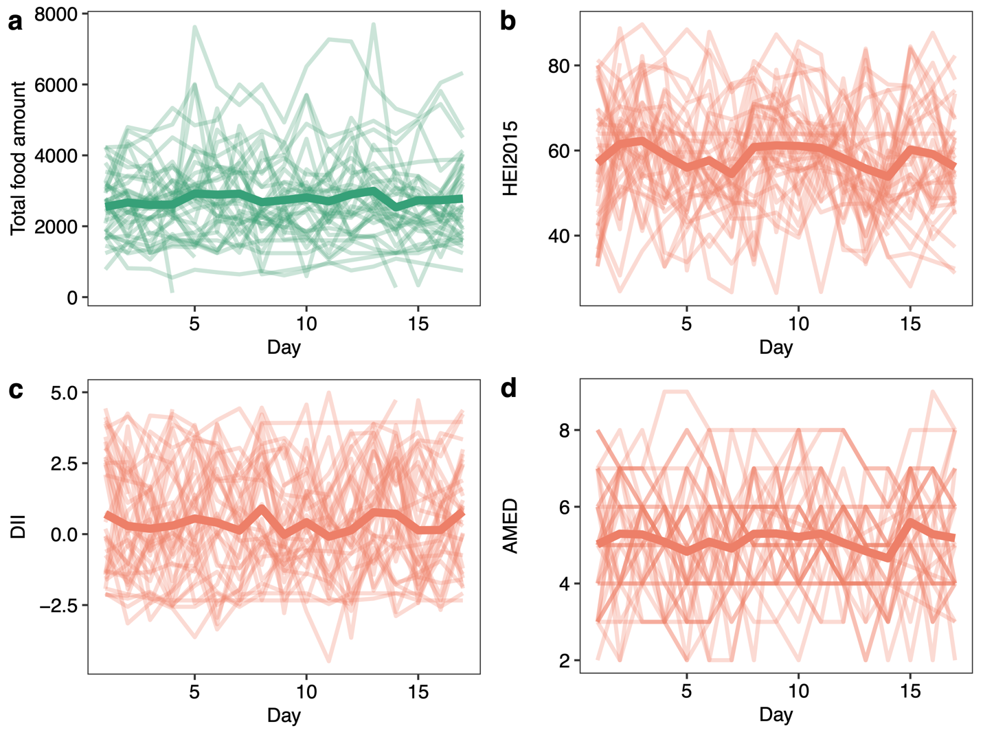
SUPPLEMENTARY FIGURE 1: Consumption patterns and diet score in DMAS. a, Total food grams of each subject across 17 days. A thin line represents a subject, and the thick line represents the mean of all 30 subjects. b-d, HEI2015 (b), DII (c), and AMED (d) of each subject across 17 days. A thin line represents a subject, and the thick line represents the mean of all 30 subjects.

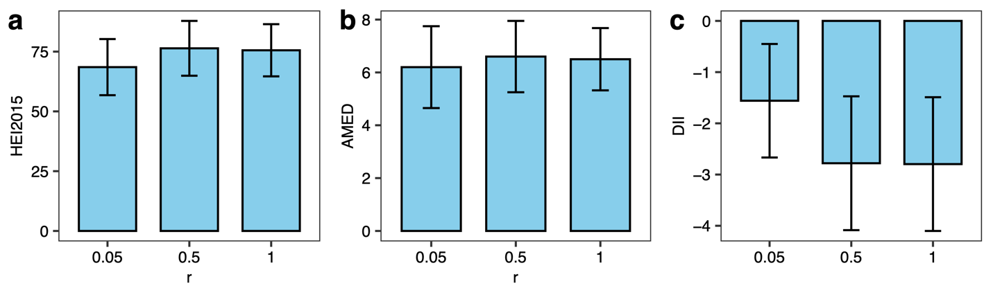
SUPPLEMENTARY FIGURE 2: Relationship between diet score and parameter 𝑟. Each bar represents the mean diet score, and the error bar indicates the standard deviation for HEI-2015 (a), AMED (b), and DII (c) among 10 randomly selected subjects in the DMAS cohort.

