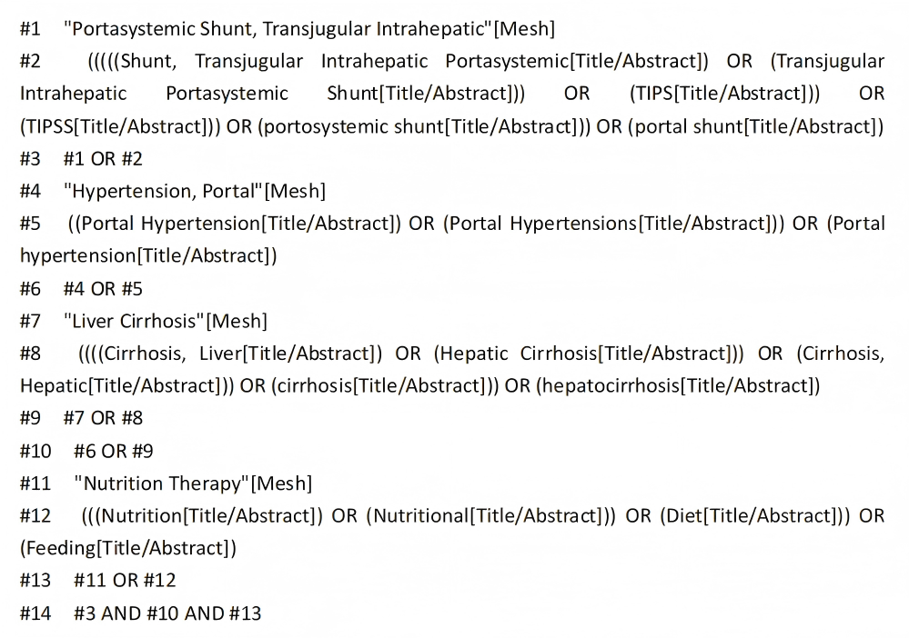
Fig 1. PubMed search strategy.

Supplementary Table 1. Quality evaluation of guidelines (n =6).
Guidelines | Standardized scores in various domains (%) |  |  |  |  |  | ≥60% | ≤30% | Quality grade
Guidelines | Scope and purpose | Stakeholder involvement | Rigour | Clarity | Applica  -bility | Indepen  -dence
Gerbes et al. [30] | 94.44 | 94.44 | 75 | 94.44 | 87.5 | 91.67 | 6 | 0 | A
Bischoff et al. [31] | 94.44 | 88.89 | 72.92 | 88.89 | 70.83 | 83.33 | 6 | 0 | A
European Association for the Study of the Liver [32] | 94.44 | 66.67 | 68.75 | 94.44 | 62.5 | 83.33 | 6 | 0 | A
Tripathi et al. [33] | 88.89 | 83.33 | 64.58 | 88.89 | 70.83 | 91.67 | 6 | 0 | A
Larrue et al. [7] | 77.78 | 61.11 | 72.92 | 77.78 | 70.83 | 83.33 | 6 | 0 | A
Chinese College of Interventionalists [8] | 88.89 | 77.78 | 72.92 | 88.89 | 70.83 | 91.67 | 6 | 0 | A

Supplementary Table 2. Quality evaluation of systematic reviews (n = 1).
Systematic Reviews | Q1 | Q2 | Q3 | Q4 | Q5 | Q6 | Q7 | Q8 | Q9 | Q10 | Q11
Giri et al. [34] | Yes | Yes | Yes | Yes | Yes | Yes | Yes | Yes | No | Yes | Yes
Note: Q1: Is the review question clearly and explicitly stated? Q2: Were the inclusion criteria appropriate for the review question? Q3: Was the search strategy appropriate? Q4: Were the sources and resources used to search for studies adequate? Q5: Were the criteria for appraising studies appropriate? Q6: Was critical appraisal conducted by two or more reviewers independently? Q7: Were there methods to minimize errors in data extraction? Q8: Were the methods used to combine studies appropriate? Q9: Was the likelihood of publication bias assessed? Q10: Were recommendations for policy and/or practice supported by the reported data? Q11: Were the specific directives for new research appropriate?

Supplementary Table 3. Quality evaluation of expert consensus (n = 6).
Expert consensus | Q1 | Q2 | Q3 | Q4 | Q5 | Q6
Lai et al. [35] | Yes | Yes | Yes | Yes | Yes | Yes
de Franchis et al. [4] | Yes | Yes | Yes | Yes | Yes | Yes
Mandorfer et al. [36] | Yes | Yes | Yes | Yes | Yes | Yes
Chinese Society of Gastroenterology (CSG) [37] | Yes | Yes | Yes | Yes | Yes | Yes
Nursing Group, Radiology Society of Chinese Medical Association [38] | Yes | Yes | Yes | Yes | Yes | Yes
Intervention Physician Branch of Chinese Medical Doctor Association [9] | Yes | Yes | Yes | Yes | Yes | Yes
Note: Q1: Is the source of the opinion clearly identified? Q2: Does the source of opinion have standing in the field of expertise? Q3: Are the interests of the relevant population the central focus of the opinion? Q4: Does the opinion demonstrate a logically defended argument to support the conclusions drawn? Q5: Is there reference to the extant literature? Q6: Is any incongruence with the literature/sources logically defended?

Supplementary Table 4. Quality evaluation of evidence summaries (n = 2).
Evidence summaries | Q1 | Q2 | Q3 | Q4 | Q5 | Q6 | Q7 | Q8 | Q9 | Q10
Zhang [39] | Yes | Not completely | Yes | Yes | Yes | Yes | Yes | Yes | Yes | Yes
Pang et al.[40] | Yes | Yes | Yes | Yes | Yes | Yes | Yes | Not completely | Yes | Yes
Note: Q1: Is the summary specific in scope and application? Q2: Is the authorship of the summary transparent? Q3: Are the reviewer(s)/editor(s) of the summary transparent? Q4: Are the search methods transparent and comprehensive? Q5: Is the evidence graded and is the system transparent and translatable? Q6: Are the recommendations clear? Q7: Are the recommendations appropriately cited? Q8: Are the recommendations current? Q9: Is the summary free of possible bias? Q10: Can this summary be applied to your patient(s)?

