Dietary one-carbon metabolism nutrients and risk of MASLD progression: a prospective cohort study

Lijun Shen¹*, Kai Wang^{2,3}*, Renjie Li*⁴, Yafang Li⁵, Yunchong Guo¹, Fangping Li⁶, Jinqiu Yuan^{2,3}, Zhen Yang⁷#, Bin Xia^{2,3}#, Xiahong Lin^{1,8}#

- Department of Endocrinology, The Seventh Affiliated Hospital of Sun Yat-sen University, Shenzhen, China.
- Department of Epidemiology and Biostatistics, Clinical Big Data Research Center, The Seventh Affiliated Hospital, Sun Yat-sen University, Shenzhen, China.
- Chinese Health Risk Management Collaboration (CHRIMAC), Shenzhen, China.
- Department of Ultrasound, The Seventh Affiliated Hospital, Sun Yat-sen University, Shenzhen, China.
- Health Technology Evaluation Center, Evidence-based Social Science Research Center, School of Public Health, Lanzhou University, Lanzhou, China.
- Department of Endocrinology, The Chinese University of Hong Kong, Shenzhen Hospital, Shenzhen, China.
- Department of Clinical Nutrition, The Seventh Affiliated Hospital of Sun Yat-sen University, Shenzhen, China.
- Department of Geriatric, The Seventh Affiliated Hospital of Sun Yat-sen University, Shenzhen, China.

* These authors contribute equally to this work and shared the first authorship.
# Co-corresponding authors.
Dr. Xiahong Lin, Department of Endocrinology, Department of Geriatric, The Seventh Affiliated Hospital of Sun Yat-sen University, Shenzhen, China. E-mail: linxh67@mail.sysu.edu.cn

Supplemental appendix

Table S1. Criteria for liver-related events.
Table S2. Sensitivity analyses of association between OCM and LRE incidence and mortality.
Table S3. E-value for point estimates and the upper bound of the 95% confidence intervals of the hazard ratios.
Figure S1. Flow chart of participant inclusion and exclusion.
Figure S2. The spearman’s rank correlations between 9 components of OCM.
Figure S3. Subgroup analyses of dietary methionine and LRE in MASLD.
Figure S4. Subgroup analyses of dietary folate and LRE in MASLD.
Figure S5. Subgroup analyses of dietary vitamin B2 and LRE in MASLD.
Figure S6. Subgroup analyses of dietary vitamin B6 and LRE in MASLD.
Figure S7. Subgroup analyses of dietary vitamin B12 and LRE in MASLD.
Figure S8. Subgroup analyses of dietary methionine and mortality in MASLD.
Figure S9. Subgroup analyses of dietary folate and mortality in MASLD.
Figure S10. Subgroup analyses of dietary vitamin B2 and mortality in MASLD.
Figure S11. Subgroup analyses of dietary vitamin B6 and mortality in MASLD.
Figure S12. Subgroup analyses of dietary vitamin B12 and mortality in MASLD.

Table S1. Criteria for liver-related events.
ICD-10 | Description
K72.11, K72.90, K72.91 | Hepatic encephalopathy
K76.7 | Hepatorenal syndrome
K76.81 | Hepatopulmonary syndrome
K65.2 | Spontaneous bacterial peritonitis
I85.0 | Variceal bleed
R18.8 + at least one code for cirrhosis / decompensation | Ascites
C22.0 | Hepatocellular carcinoma

Table S2. Sensitivity analyses of association between OCM and LRE incidence and mortality in population with MASLD.
Group | Case/  Person-years | Model1 HR (95% CI) | Mode2 HR  (95% CI) | Case/  Person-years | Model1 HR (95% CI) | Mode2 HR  (95% CI)
LRE |  |  |  | Death
Methionine
Low | 72/152160 | 1 | 1 | 942/152410 | 1 | 1
Moderate | 138/309374 | 0.90 (0.67, 1.19) | 0.89 (0.66, 1.20) | 1660/309802 | 0.83 (0.76, 0.89) | 0.85 (0.78, 0.92)
High | 57/154748 | 0.72 (0.51, 1.02) | 0.72 (0.50, 1.04) | 869/154948 | 0.85 (0.77, 0.93) | 0.88 (0.81, 0.97)
P trend |  | 0.07 | 0.11 |  | <0.001 | 0.01
HR for Per SD |  | 0.89 (0.78, 1.01) | 0.88 (0.77, 1.00) |  | 0.94 (0.91, 0.98) | 0.96 (0.92, 0.99)
Folate
Low | 78/153008 | 1 | 1 | 874/153268 | 1 | 1
Moderate | 131/309020 | 0.77 (0.58, 1.02) | 0.78 (0.58, 1.04) | 1731/309423 | 0.90 (0.83, 0.97) | 0.93 (0.86, 1.01)
High | 58/154253 | 0.69 (0.49, 0.97) | 0.71 (0.49, 1.01) | 866/154470 | 0.92 (0.84, 1.01) | 0.96 (0.88, 1.06)
P trend |  | 0.17 | 0.3 |  | 0.24 | 0.57
HR for Per SD |  | 0.91 (0.80, 1.04) | 0.91 (0.79, 1.04) |  | 0.98 (0.95, 1.01) | 0.99 (0.96, 1.03)
Vitamin B2
Low | 68/152091 | 1 | 1 | 900/152304 | 1 | 1
Moderate | 138/309516 | 0.92 (0.69, 1.23) | 0.91 (0.67, 1.23) | 1708/309946 | 0.85 (0.78, 0.92) | 0.88 (0.81, 0.95)
High | 61/154674 | 0.80 (0.56, 1.13) | 0.80 (0.55, 1.16) | 863/154910 | 0.84 (0.77, 0.93) | 0.89 (0.81, 0.97)
P trend |  | 0.16 | 0.27 |  | 0.01 | 0.1
HR for Per SD |  | 0.91 (0.81, 1.04) | 0.90 (0.79, 1.04) |  | 0.95 (0.92, 0.99) | 0.97 (0.94, 1.00)
Vitamin B6
Low | 80/152368 | 1 | 1 | 918/152604 | 1 | 1
Moderate | 131/309363 | 0.77 (0.58, 1.01) | 0.78 (0.59, 1.04) | 1689/309820 | 0.85 (0.79, 0.92) | 0.88 (0.82, 0.96)
High | 56/154550 | 0.65 (0.46, 0.91) | 0.65 (0.46, 0.94) | 864/154736 | 0.86 (0.78, 0.94) | 0.90 (0.82, 0.99)
P trend |  | 0.03 | 0.06 |  | 0.01 | 0.09
HR for Per SD |  | 0.86 (0.76, 0.98) | 0.85 (0.75, 0.98) |  | 0.96 (0.92, 0.99) | 0.97 (0.94, 1.00)
Vitamin B12
Low | 75/152985 | 1 | 1 | 882/153232 | 1 | 1
Moderate | 135/308567 | 0.83 (0.62, 1.10) | 0.85 (0.64, 1.13) | 1744/308990 | 0.90 (0.83, 0.98) | 0.93 (0.86, 1.01)
High | 57/154729 | 0.67 (0.48, 0.95) | 0.69 (0.48, 0.98) | 845/154938 | 0.84 (0.76, 0.92) | 0.88 (0.80, 0.97)
P trend |  | 0.12 | 0.21 |  | 0.01 | 0.08
HR for Per SD |  | 0.90 (0.79, 1.03) | 0.90 (0.79, 1.03) |  | 0.96 (0.92, 0.99) | 0.97 (0.94, 1.00)
Nutrients intake levels were divided into 3 groups: low (quartile 1), moderate (quartiles 2-3), and high (quartile 4).
*P < 0.05, **P < 0.01, ***P < 0.001.
Model1 was crude Cox regression model stratified by sex, age and total energy intake.
Model2 was multivariable adjusted for demographic characteristics (ethnicity, education attainment, IMD and BMI), lifestyle factors (smoking status, physical activity and daily sleeping time), chronic comorbidities (hypertension, diabetes, coronary heart disease and chronic obstructive pulmonary disease), antidiabetic medication use (sulfonylureas, glitazones, metformin, insulin), and laboratory data (total cholesterol, LDL, HDL, Triglycerides, fasting glucose, and hsC-reactive protein).
Note: we excluded participants who had died or diagnosed with CHD, diabetes, and CKD during the first 2 years of follow-up.
Abbreviations: MASLD, metabolic dysfunction-associated steatotic liver disease; LRE, liver-related events; HR, hazard ratio; CI, confidence interval; SD, standard deviation.

Table S3. E-value for point estimates and the upper bound of the 95% CIs of the HRs.
 | Case/  Person-years | Model 1 | Mode 2 | Case/  Person-years | Model 1 | Mode 2
LRE |  |  |  | Death
Methionine
Low | 72/152160 | 1 | 1 | 942/152410 | 1 | 1
Moderate | 138/309374 | 1.564 (NA, 1.000) | 1.462 (NA, 1.000) | 1660/309802 | 1.773 (NA, 1.530) | 1.667 (NA, 1.429)
High | 57/154748 | 2.167 (NA, 1.111) | 2.000 (NA, 1.000) | 869/154948 | 1.737 (NA, 1.462) | 1.598 (NA, 1.324)
HR per SD |  | 1.530 (NA, 1.111) | 1.462 (NA, 1.000) |  | 1.360 (NA, 1.250) | 1.288 (NA, 1.165)
Folate
Low | 78/153008 | 1 | 1 | 874/153268 | 1 | 1
Moderate | 131/309020 | 1.960 (NA, 1.000) | 1.883 (NA, 1.000) | 1731/309423 | 1.530 (NA, 1.288) | 1.394 (NA, 1.111)
High | 58/154253 | 2.302 (NA, 1.288) | 2.124 (NA, 1.000) | 866/154470 | 1.462 (NA, 1.111) | 1.324 (NA, 1.000)
HR per SD |  | 1.429 (NA, 1.000) | 1.360 (NA, 1.000) |  | 1.209 (NA, 1.000) | 1.165 (NA, 1.000)
Vitamin B2
Low | 68/152091 | 1 | 1 | 900/152304 | 1 | 1
Moderate | 138/309516 | 1.598 (NA, 1.000) | 1.530 (NA, 1.000) | 1708/309946 | 1.702 (NA, 1.462) | 1.598 (NA, 1.360)
High | 61/154674 | 2.040 (NA, 1.000) | 1.883 (NA, 1.000) | 863/154910 | 1.737 (NA, 1.462) | 1.598 (NA, 1.288)
HR per SD |  | 1.462 (NA, 1.000) | 1.429 (NA, 1.000) |  | 1.324 (NA, 1.165) | 1.250 (NA, 1.000)
Vitamin B6
Low | 80/152368 | 1 | 1 | 918/152604 | 1 | 1
Moderate | 131/309363 | 1.960 (NA, 1.000) | 1.846 (NA, 1.000) | 1689/309820 | 1.667 (NA, 1.429) | 1.564 (NA, 1.324)
High | 56/154550 | 2.553 (NA, 1.564) | 2.399 (NA, 1.394) | 864/154736 | 1.702 (NA, 1.429) | 1.564 (NA, 1.250)
HR per SD |  | 1.598 (NA, 1.209) | 1.564 (NA, 1.111) |  | 1.324 (NA, 1.165) | 1.250 (NA, 1.111)
Vitamin B12
Low | 75/152985 | 1 | 1 | 882/153232 | 1 | 1
Moderate | 135/308567 | 1.702 (NA, 1.000) | 1.598 (NA, 1.000) | 1744/308990 | 1.462 (NA, 1.209) | 1.360 (NA, 1.000)
High | 57/154729 | 2.350 (NA, 1.324) | 2.124 (NA, 1.000) | 845/154938 | 1.702 (NA, 1.429) | 1.564 (NA, 1.250)
HR per SD |  | 1.360 (NA, 1.000) | 1.288 (NA, 1.000) |  | 1.288 (NA, 1.165) | 1.250 (NA, 1.000)
Nutrients intake levels were divided into 3 groups: low (quartile 1), moderate (quartiles 2-3), and high (quartile 4).
*P < 0.05, **P < 0.01, ***P < 0.001.
Model1 was crude Cox regression model stratified by sex, age and total energy intake.
Model2 was multivariable adjusted for demographic characteristics (ethnicity, education attainment, IMD and BMI), lifestyle factors (smoking status, physical activity and daily sleeping time), chronic comorbidities (hypertension, diabetes, coronary heart disease and chronic obstructive pulmonary disease), antidiabetic medication use (sulfonylureas, glitazones, metformin, insulin), and laboratory data (total cholesterol, LDL, HDL, Triglycerides, fasting glucose, and hsC-reactive protein). Note: we excluded participants who had died or diagnosed with CHD, diabetes, and CKD during the first 2 years of follow-up.
Abbreviations: LRE, liver-related events; HR, hazard ratio; CI, confidence interval; SD, standard deviation.

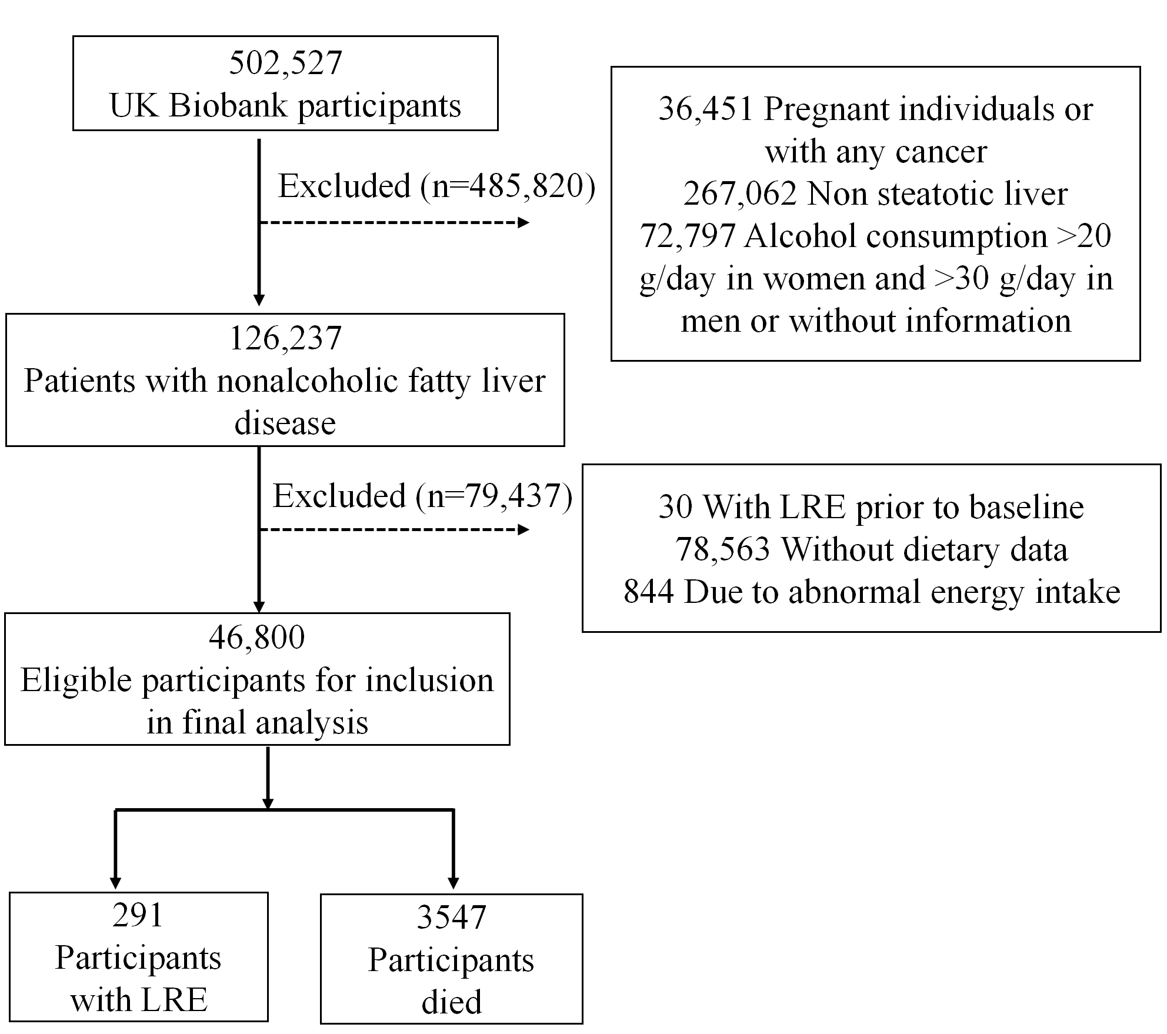
Figure S1. Flowchart of participants inclusion and exclusion from the UK Biobank.

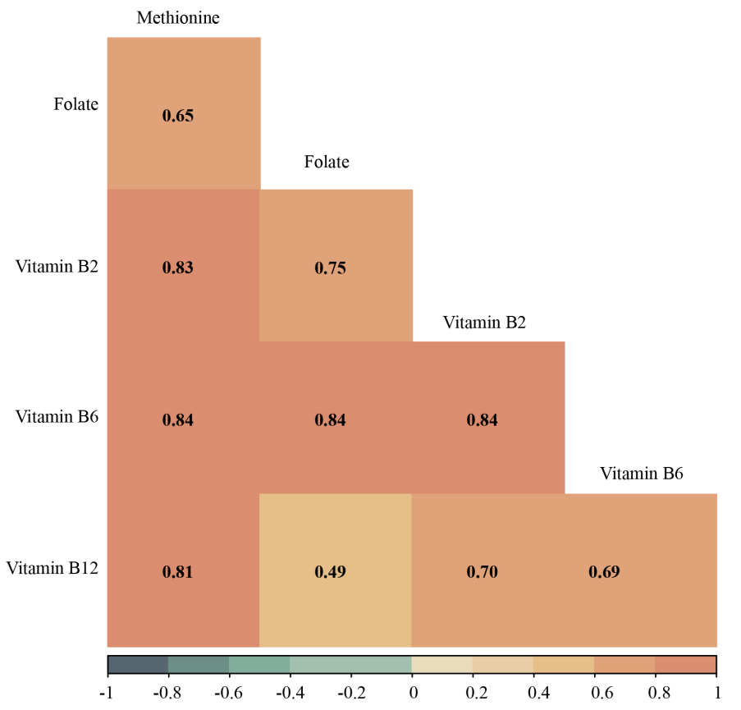
Figure S2. The spearman’s rank correlations between 5 components of OCM nutrients.

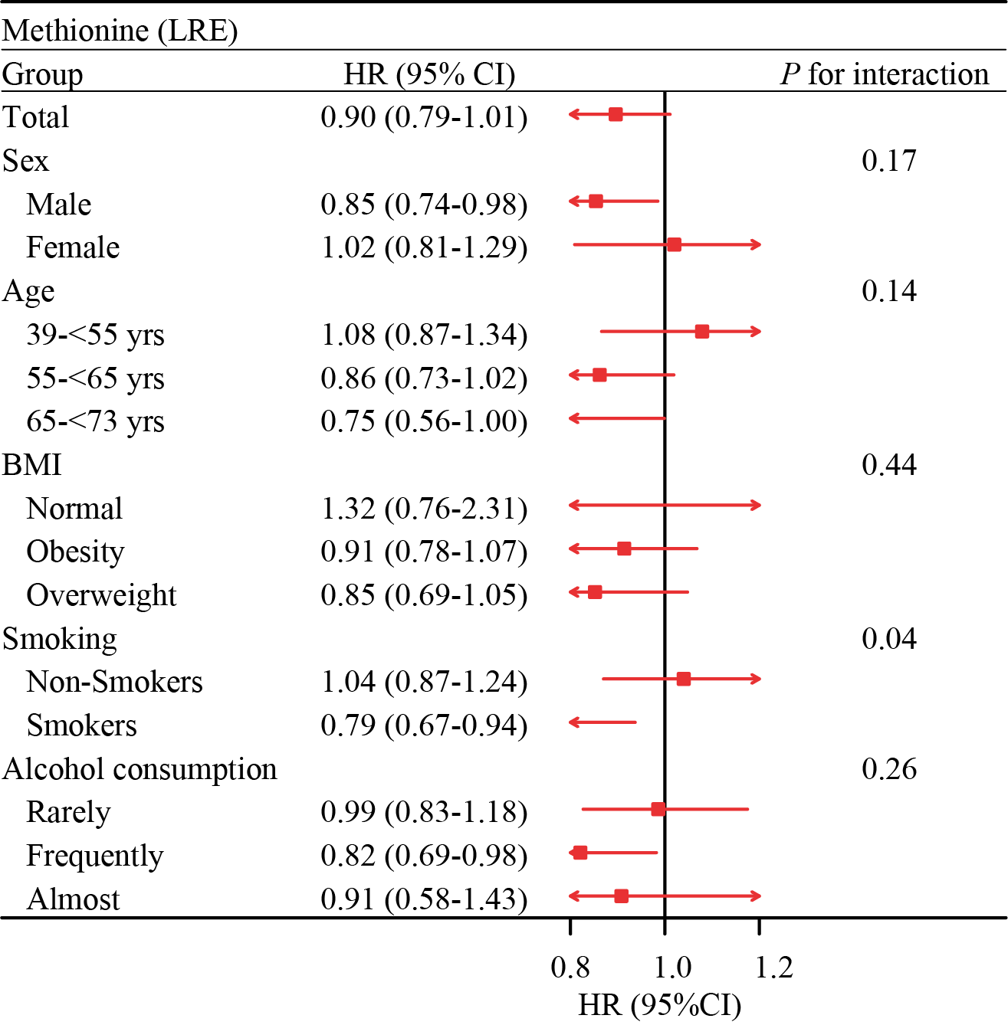
Figure S3. Subgroup analyses of dietary methionine and LRE in MASLD
Abbreviations: LRE, liver-related events; HR, hazard ratio; CI, confidence interval; BMI, body mass index. Rarely: 1-3 times a month, Special occasions only or never. Frequently: 1-4 times a week. Almost: Daily or almost daily.

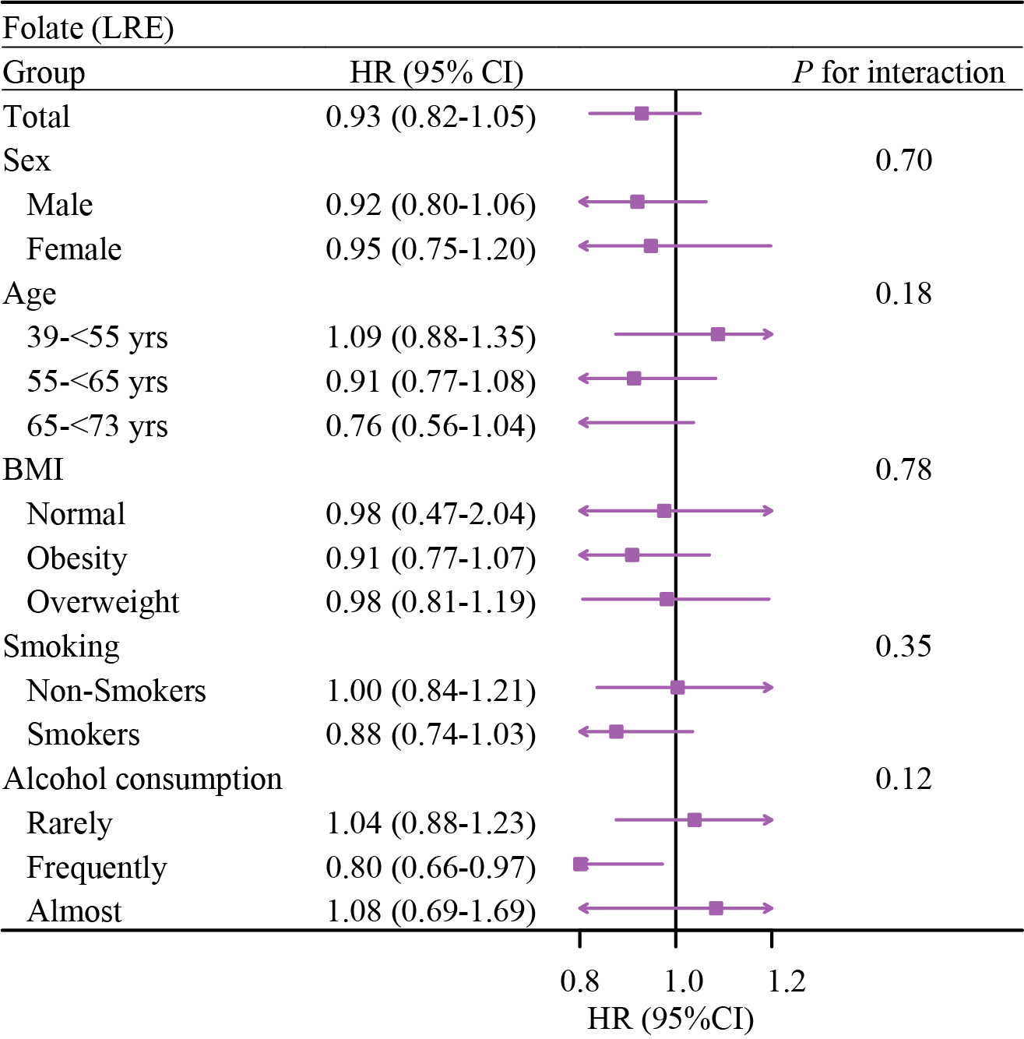
Figure S4. Subgroup analyses of dietary folate and LRE in MASLD
Abbreviations: LRE, liver-related events; HR, hazard ratio; CI, confidence interval; BMI, body mass index. Rarely: 1-3 times a month, Special occasions only or never. Frequently: 1-4 times a week. Almost: Daily or almost daily.

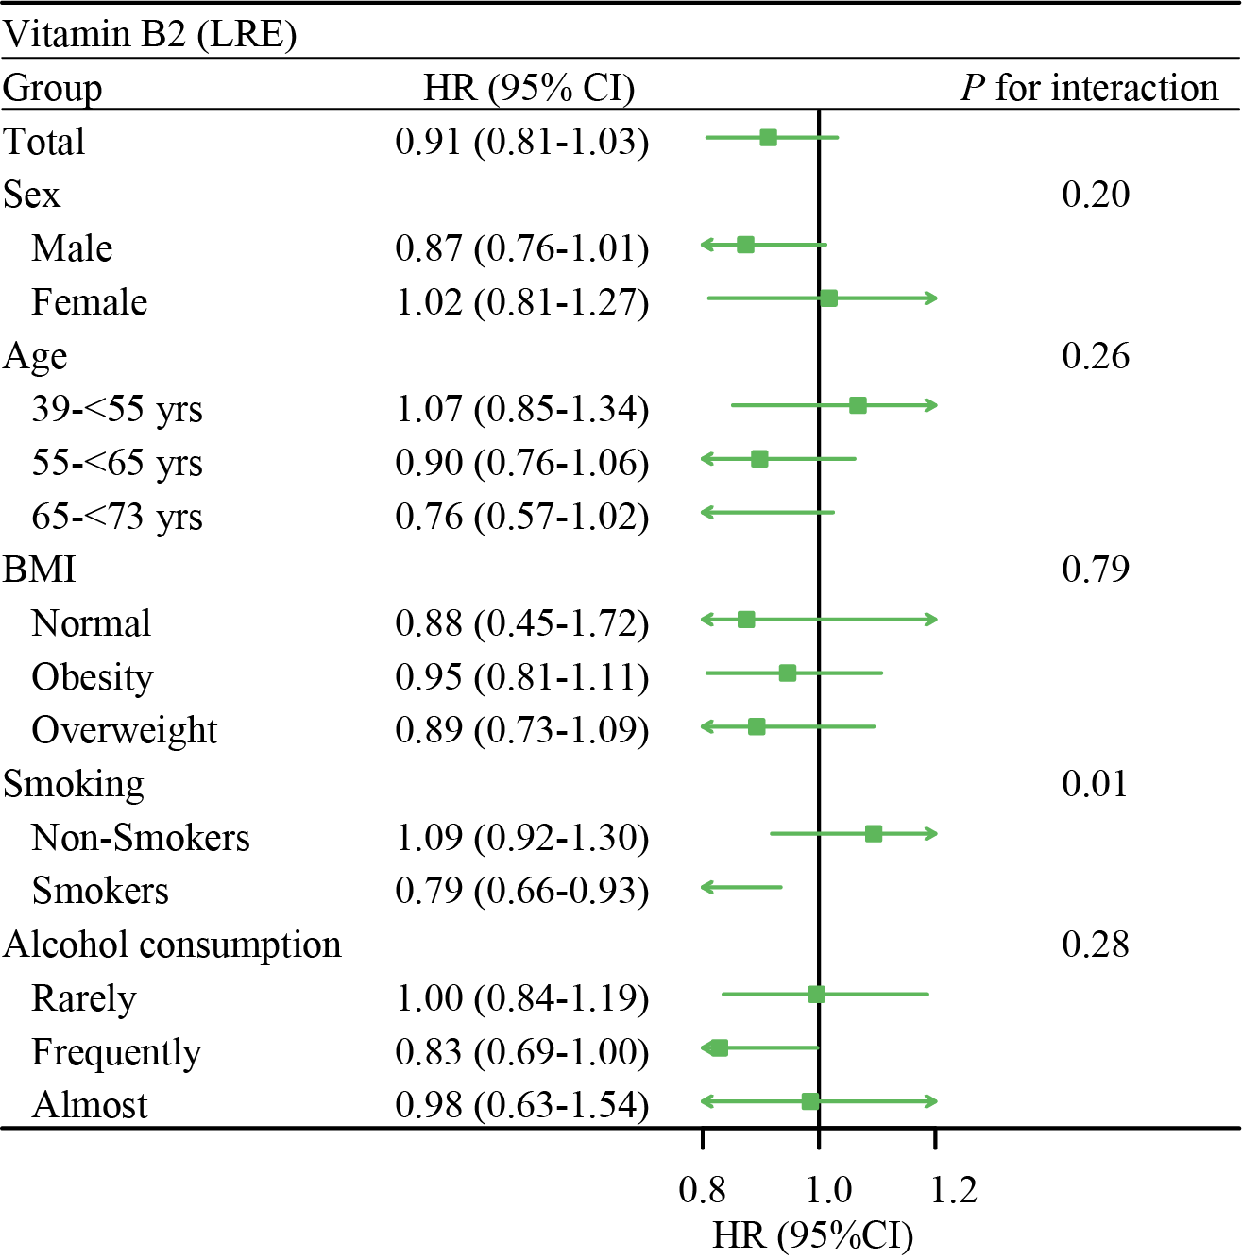
Figure S5. Subgroup analyses of dietary vitamin B2 and LRE in MASLD
Abbreviations: LRE, liver-related events; HR, hazard ratio; CI, confidence interval; BMI, body mass index. Rarely: 1-3 times a month, Special occasions only or never. Frequently: 1-4 times a week. Almost: Daily or almost daily.

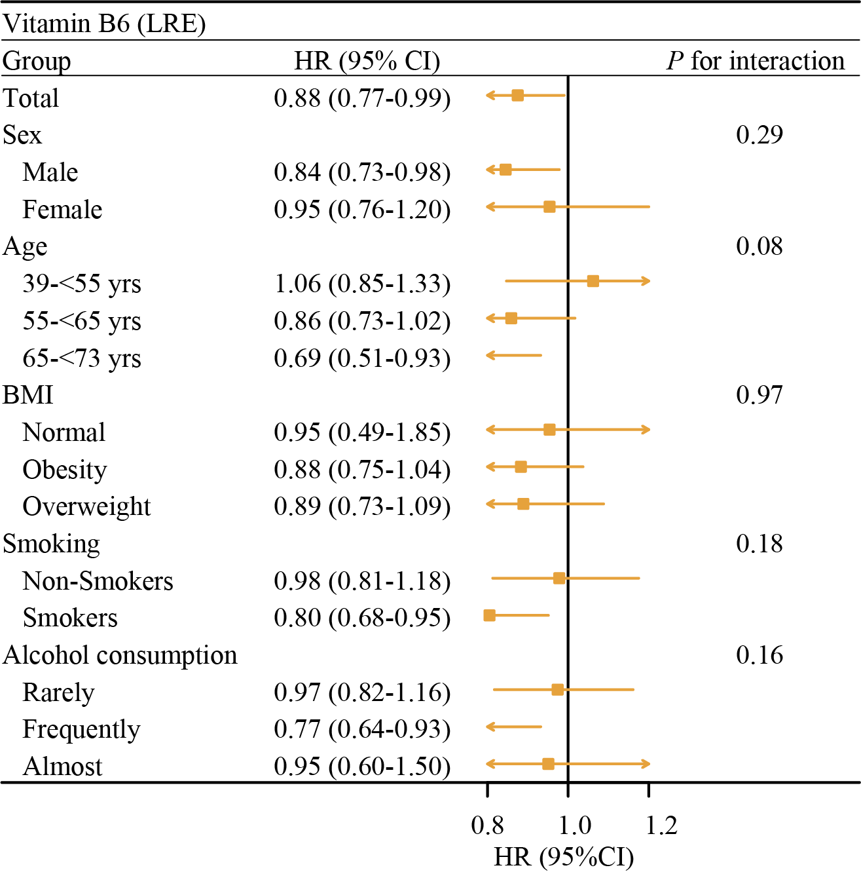
Figure S6. Subgroup analyses of dietary vitamin B6 and LRE in MASLD
Abbreviations: LRE, liver-related events; HR, hazard ratio; CI, confidence interval; BMI, body mass index. Rarely: 1-3 times a month, Special occasions only or never. Frequently: 1-4 times a week. Almost: Daily or almost daily.

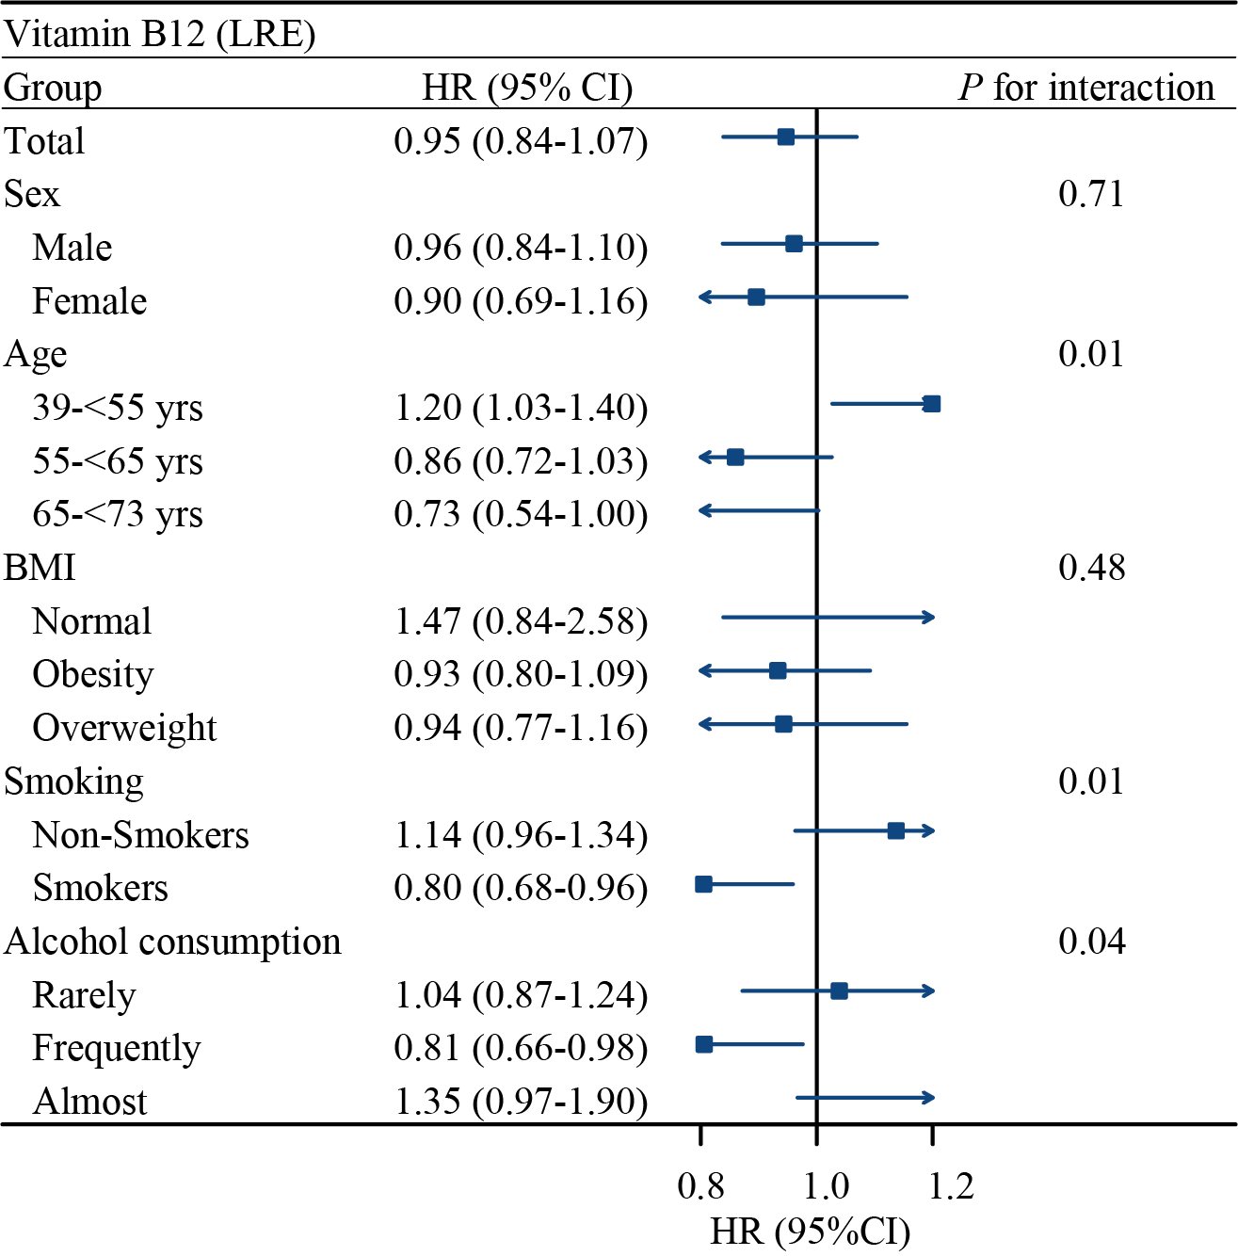
Figure S7. Subgroup analyses of dietary vitamin B12 and LRE in MASLD
Abbreviations: LRE, liver-related events; HR, hazard ratio; CI, confidence interval; BMI, body mass index. Rarely: 1-3 times a month, Special occasions only or never. Frequently: 1-4 times a week. Almost: Daily or almost daily.

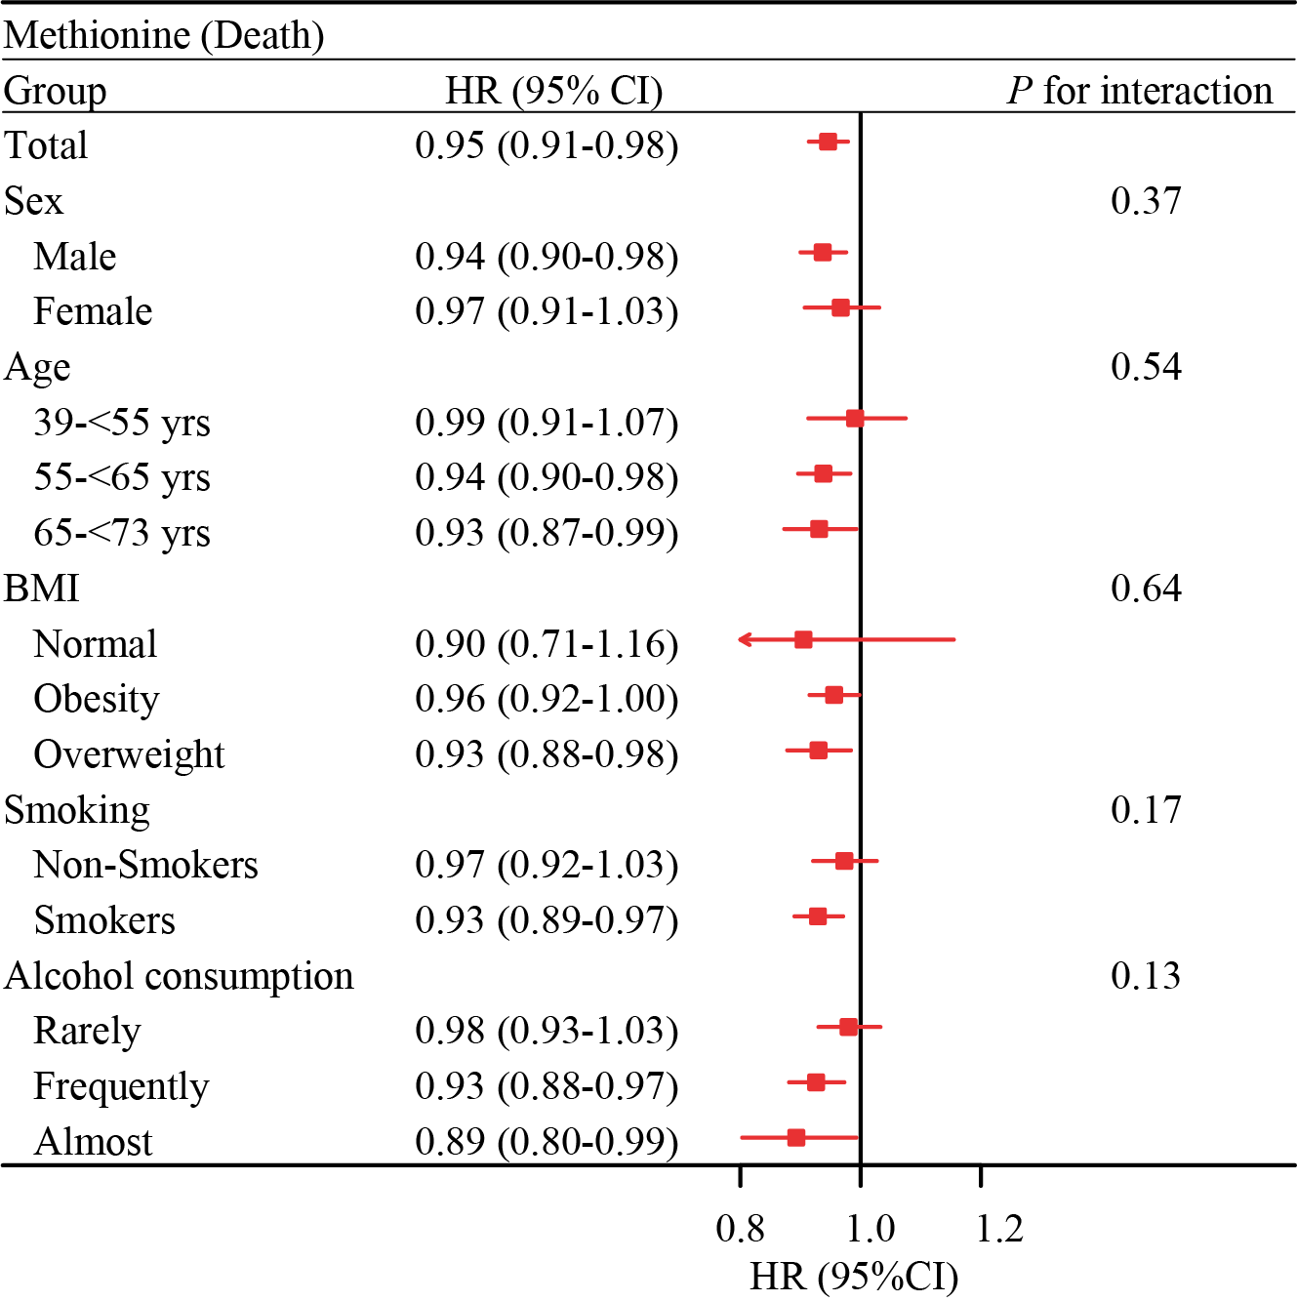
Figure S8. Subgroup analyses of dietary methionine and mortality in MASLD
Abbreviations: LRE, liver-related events; HR, hazard ratio; CI, confidence interval; BMI, body mass index. Rarely: 1-3 times a month, Special occasions only or never. Frequently: 1-4 times a week. Almost: Daily or almost daily.
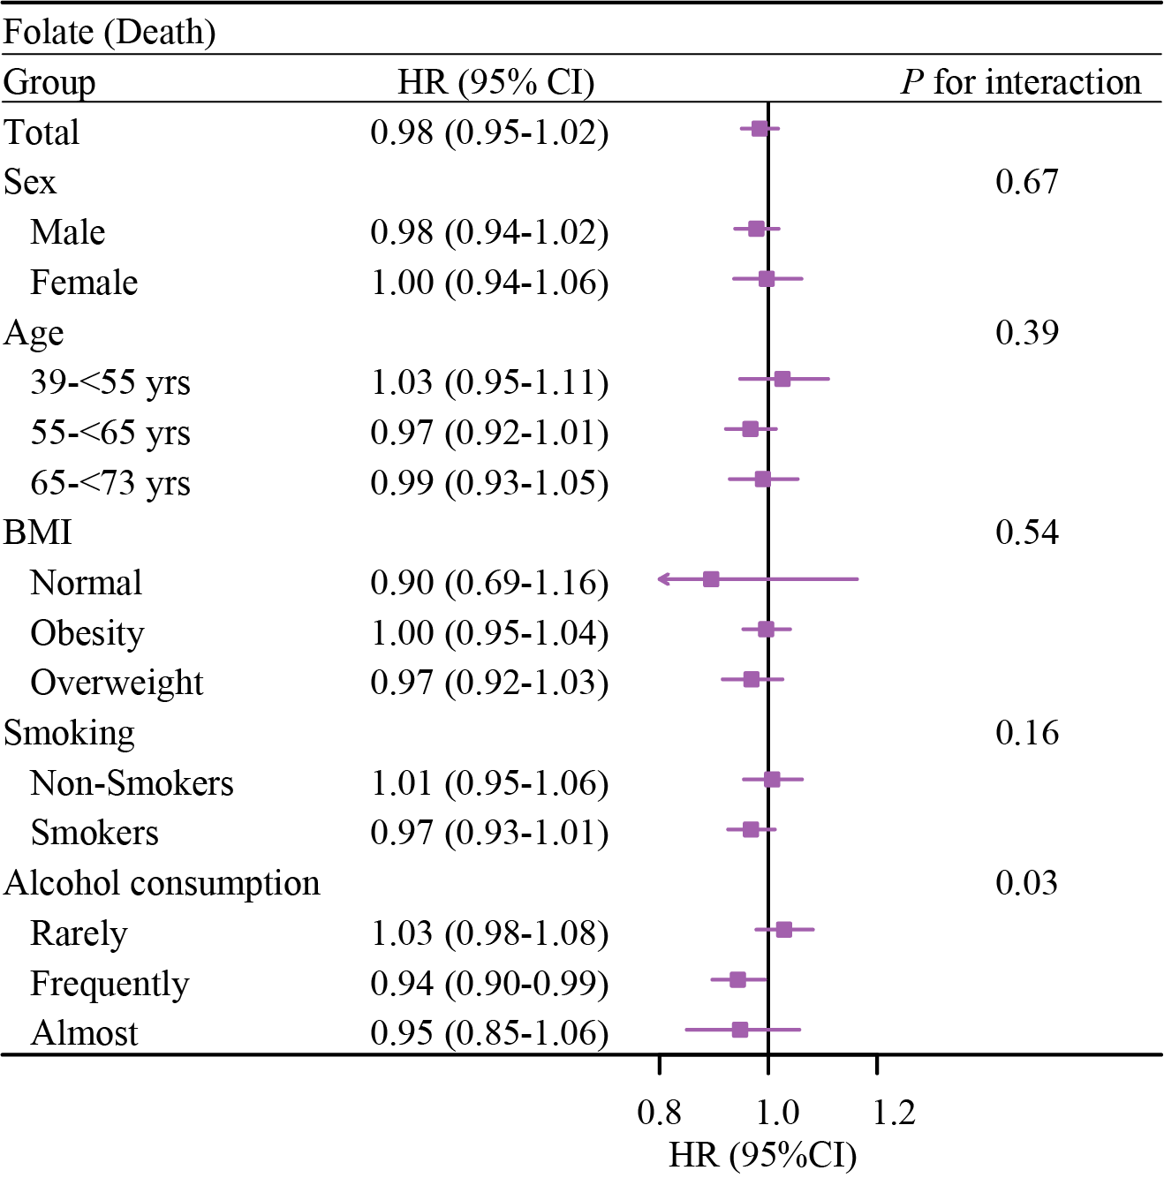
Figure S9. Subgroup analyses of dietary folate and mortality in MASLD
Abbreviations: LRE, liver-related events; HR, hazard ratio; CI, confidence interval; BMI, body mass index. Rarely: 1-3 times a month, Special occasions only or never. Frequently: 1-4 times a week. Almost: Daily or almost daily.

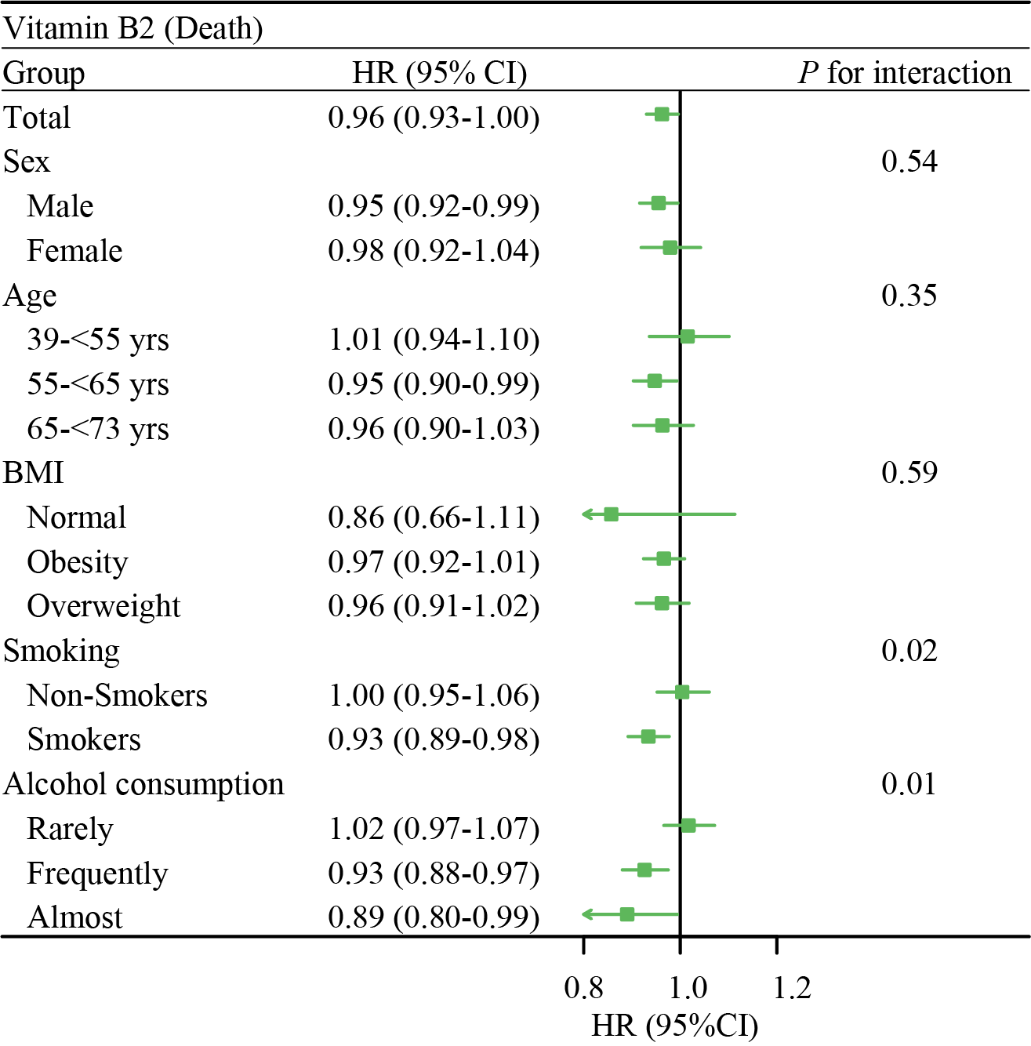
Figure S10. Subgroup analyses of dietary vitamin B2 and mortality in MASLD
Abbreviations: LRE, liver-related events; HR, hazard ratio; CI, confidence interval; BMI, body mass index. Rarely: 1-3 times a month, Special occasions only or never. Frequently: 1-4 times a week. Almost: Daily or almost daily.
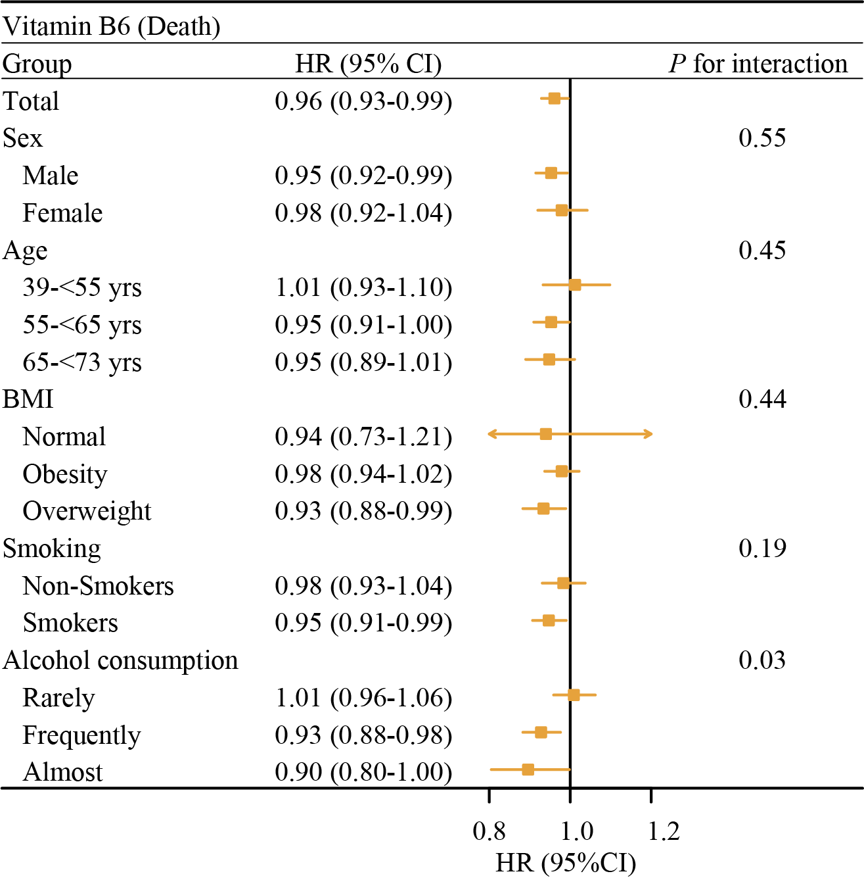
Figure S11. Subgroup analyses of dietary vitamin B6 and mortality in MASLD
Abbreviations: LRE, liver-related events; HR, hazard ratio; CI, confidence interval; BMI, body mass index. Rarely: 1-3 times a month, Special occasions only or never. Frequently: 1-4 times a week. Almost: Daily or almost daily.

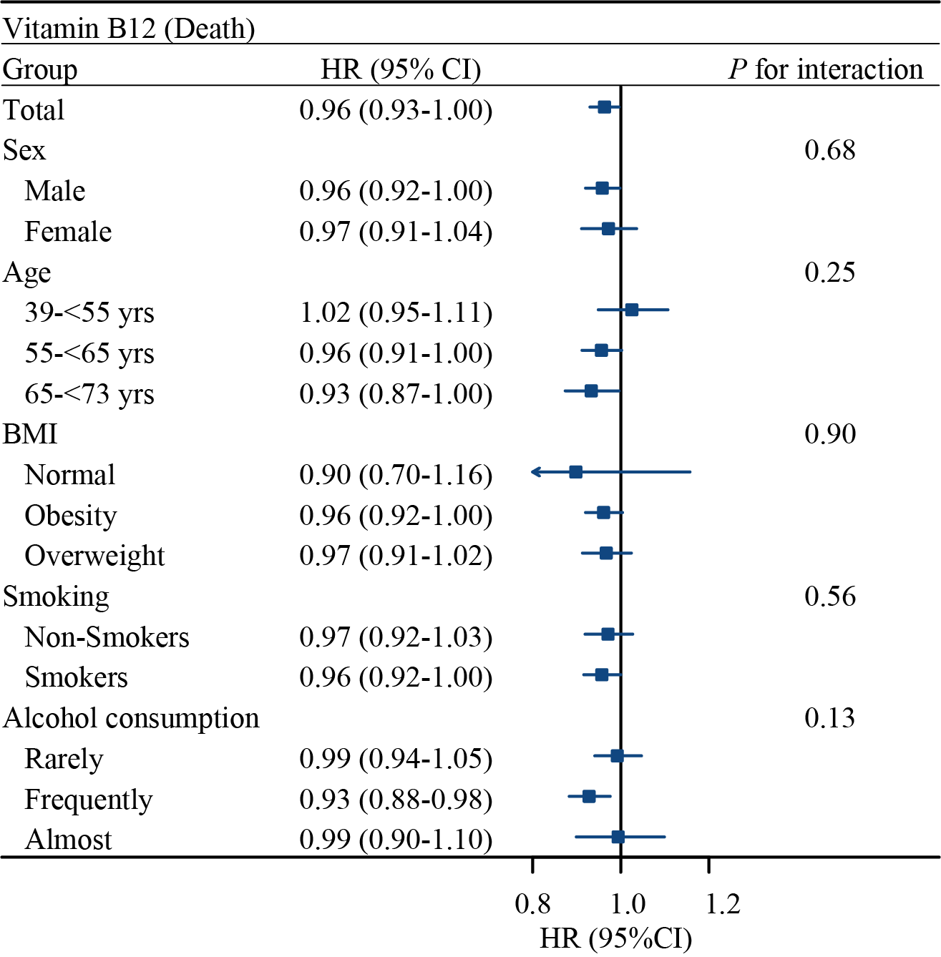
Figure S12. Subgroup analyses of dietary vitamin B12 and mortality in MASLD
Abbreviations: LRE, liver-related events; HR, hazard ratio; CI, confidence interval; BMI, body mass index. Rarely: 1-3 times a month, Special occasions only or never. Frequently: 1-4 times a week. Almost: Daily or almost daily.

