Supplemental Data

Diphthamide-Deficiency Syndrome: A Novel Human Developmental Disorder and Ribosomopathy
Harmen Hawer^{1*}, Bryce A. Mendelsohn^{2,6*}, Klaus Mayer³, Ann Kung², Amit Malhotra², Sari Tuupanen⁴, Jennifer Schleit⁵, Ulrich Brinkmann^{3,6}, Raffael Schaffrath¹
¹ Fachgebiet Mikrobiologie, Institut für Biologie, Universität Kassel, Hessen, Kassel, D-34132, Germany.
²Kaiser Permanente Oakland Medical Center, CA, Oakland, 94611, USA.
³Roche Pharma Research & Early Development, Large Molecule Research, Roche Innovation Center Munich, Bavaria, Penzberg, D-82377, Germany.
⁴Blueprint Genetics Oy, Keilaranta 16 A-B 02150 Espoo, Finland ⁵Blueprint Genetics, WA, Seattle, 98121, USA.
⁶ Correspondence: Bryce.A.Mendelsohn@kp.org, ulrich.brinkmann@roche.com
* These authors contributed equally to this work

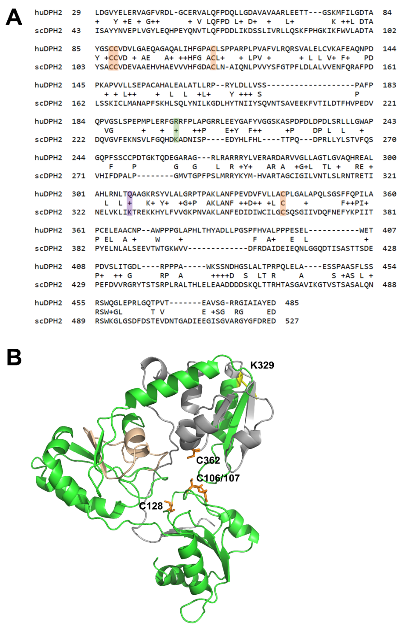
Fig. S1 Sequence alignment and structure analysis of Saccharomyces cerevisiae Dph2 to visualize locations of mutations that correspond to c.922C>T (p.(Gln308*)) and c.601C>T (p.(Arg201Cys)) variants in the human counterpart (huDPH2). A. Amino acid sequence alignment of human DPH2 and yeast Dph2. Orange: conserved cysteine residues. Green: Position of R201 and K239 in human and yeast DPH2, respectively. Violet: Position that marks the location of the truncating variant in the patient (c.922C>T (p.(Gln308*)) as well as the assigned yeast position (K329*). Alignment was calculated with protein BLAST and standard algorithm parameters using human DPH2 as query and S. cerevisiae Dph2 as subject. Analysis revealed a 93 % query cover. B. Structural model of yeast Dph2. The model shown derives from alignment with the template structure of Dhp2 from Pyrococcus (PDB:3LZD, (1)). Orange: Structure alignments identify cysteines at positions 106/107 and 362 to be homologous to two of the cysteines (C59 and C287) that bind the [4Fe-4S] cluster in Pyrococcus Dph2. An additional cysteine is located at position 128. The truncation mutation (K329*) corresponding to the one found in the patient c.922C>T (p.(Gln308*)) is highlighted in yellow. The region containing K239 is highlighted in wheat.

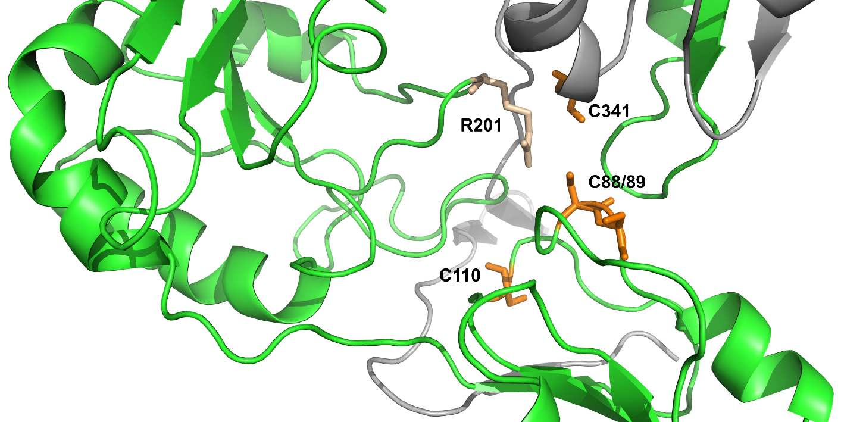

Fig. S2 Structural model of human DPH2 showing the c.601C>T (p.(Arg201Cys)) variant places an additional cysteine in close proximity to the active center. Orange: Cysteines at positions 88/89, 110 and 341. Point mutated residue found in the patient (R201) highlighted in wheat. Grey: Region that is predicted to be absent in the c.922C>T (p.(Gln308*)) truncation variant. The additional cysteine introduced by c.601C>T (p.(Arg201Cys)) in human DPH2 may affect functionality because it either destabilizes the catalytic center and the overall structural integrity of the protein, or impairs the binding of the iron sulfur cluster co-factor and interferes with the electron transfer cascade essential for the catalytic activity of the DPH1-DPH2 heterodimer.

References
1. Zhang Y, Zhu X, Torelli AT, Lee M, Dzikovski B, Koralewski RM, et al. Diphthamide biosynthesis requires an organic radical generated by an iron-sulphur enzyme. Nature. 2010;465(7300):891-6.

