Supplementary Data

Exome sequencing reveals broad genetic heterogeneity for neuromuscular disorders in consanguineous Pakistani Families.
Tooba Aleem^{1, 2}, Maliha Rashid¹, Naeem Ahmad¹, Muhammad Farrukh Asif¹, Muhammad Tariq¹, Naveed Altaf Malik¹, James A. Poulter².

¹National Institute for Biotechnology & Genetic Engineering College Pakistan Institute of Engineering & Applied Sciences (NIBGE-C, PIEAS) Jhang Road, Faisalabad
²Division of Molecular Medicine, Leeds Institute of Medical Research, University of Leeds, Leeds, UK

Supplementary Table 1: Sequences of primers used to confirm and segregate candidate variants.
Supplementary Table 2: Clinical summary of affected individuals across all families in this study.
Supplementary Table 3: List of variants remaining after filtering (Family A)
Supplementary Table 4: List of variants remaining after filtering (Family B)
Supplementary Table 5: List of variants remaining after filtering (Family C)
Supplementary Table 6: List of variants remaining after filtering (Family D)
Supplementary Table 7: List of variants remaining after filtering (Family E)
Supplementary Figure 1: Map showing the location of five families sampled from different region of Pakistan
Supplementary Figure 2: Ideograms showing regions of homozygosity shared between affected individuals with exome data for each Family

Supplementary Table 1: Sequences of primers used to confirm and segregate candidate variants.

Family | Gene | Forward Primer (5’-3’) | Reverse Primer (5’-3’)
A | MMP2 | GTACAGCCTGTTCCTCGTGG | AGCTCCTGAATGCCCTTGAT
B | POMT1 | GCCCTTGTCTGTTCTGCCAG | AGTCATCACTTCTCAGCGC
C | SPEN | AATGAACCAGGCACCATCCC | GTCTCCGCTCATAACGTCCT
C | NPHP4 | GCCCATGTCCTCTTTGTGTG | TTTGTCCTGGGAAGCAGAGA
D | ARL13B | CATGTTCAGCAATCTCGGGG | CGCACTCGTTCAGCTCTTTC
E | SPG11 | CAAATCTTCTTTATTTCCCC | GAAAAAAGCCTTTGGGTTAC

Supplementary Table 2: Clinical summary of affected individuals across all families described in this study.
 |  | 143:2 | 143:3 | 143:1 | 30:1 | 30:2 | 26:1 | 26:2 | 25:1 | 25:2 | 50:3 | 50:3
 | Age (years) at examination | 6 | 10 | 8 | 5 | 2.5 | 22 | 11 | 15 | 11 | 18 | 21
 | Disease Onset | Unknown | Unknown | Unknown | Congenital | Congenital | Congenital | Congenital | Progressive | Progressive | Progressive | Progressive
 | Gender | Male | Female | Male | Male | Male | Male | Female | Male | Male | Female | Male
 | Facial  Dimorphism | + | + | + | - | - | + | + | - | - | + | +
 | Developmental milestone | Achieved on Time | Achieved on Time | Achieved on Time | Delayed | Delayed | Delayed | Delayed | Delayed | Delayed | Delayed | Delayed
 | Muscles contracture | + | + | + | + | + | + | + | - | - | - | -
 | Muscle degeneration | + | + | + | - | - | + | + | - | - | - | -
Intellectual disability |  | - | - | - | - | - | + | + | - | - | + | +
Self-care/ self-feed |  | + | - | + | + | + | - | - | - | - | + | +
Skeletal |  | Hammer toes | Hammer toes | Hammer toes &  Scoliosis | OFC 47.1cm | - | - | - | - | - | - | -
Gait |  | Abnormal gait | Abnormal gait | Abnormal gait
Movement |  | Ambulation difficulty | Ambulation difficulty | Ambulation difficulty | Walking with support | Walking with support | On buttocks | On buttocks | Sitting and walking delayed | Sitting and walking delayed | Sitting and walking  Delayed | Sitting and walking Delayed
Epilepsy |  | - | - | - | - | - | Fits, since 7 days old |  | Fit (with foaming) | every 2⁻3 days  (Stopped with medication)
Cardiac and Respiratory |  | Mild pulmonary stenosis  VSD (Heart) | Respiratory infections | Respiratory infections | - | - | - | - | Blood transfusion (9 bottles in past year) | Blood transfusion (4 bottles in past year) | - | -
Speech |  | Present | Present | Present | Present | Present | Absent | Absent | Delayed | Delayed | Present | Present
Other |  |  |  |  | C-section | C-section | Aggressive |  | High blood creatinine | High blood creatinine

Supplementary Table 3: List of variants remaining after filtering (Family A)
Chromosome | Position | rs ID | Ref seq | Alt seq | Gene | HGVS | Individual  143:2 | Individual  143:3 | PolyPhen2 | CADD Score (v1.7) | Variant consequence | Variant Class | gnomADe SAS Allele Frequency | clinVar Clinical Significance | ACGM Classification
Chr1 | 11711942 | rs143337024 | G | A | DRAXIN | NM_198545.4 c.734G>A,  p.(Gly245Asp) | A/A | A/A | Benign  (0.213) | 17.35 | Missense | SNV | 0.00323
Chr1 | 56696099 | rs369893630 | C | T | PRKAA2 | NM_006252.4 c.728C>T,  p.(Thr243Ile) | T/T | T/T | Benign (0.122) | 23.8 | Missense | SNV | 0.005977
Chr1 | 12775917 | rs766228967 | G | C | PRAMEF12 | NM_001080830.5  :c.662G>C:p.Arg221Thr | C/C | C/C | Benign  (0.001) | 0.001 | Missense | SNV | 0.0001391
Chr16 | 55491906 | rs794727916 | AG | A | MMP2 | NM_004530.6 c.1287del,  p.(Asn430ThrfsTer68) | A/A | A/A | N/A | 33.0 | Frameshift | DEL | 0.003266 | Pathogenic | Pathogenic
Chr18 | 54372468 | rs371851488 | C | A | C18orf54 | NM_001288980.2 c.1329C>A,  p.(Ser443Arg) | A/A | A/A | Benign (0.084) | 16.79 | Missense | SNV | 0.0006143

Supplementary Table 4: List of variants remaining after filtering (Family B)
Chromosome | Position | rs ID | Ref seq | Alt seq | Gene | HGVS | Individual  30:1 | Individual  30:2 | PolyPhen2 | CADD Score (v1.7) | Variant consequence | Variant Class | gnomADe SAS Allele Frequency | ClinVar Clinical Significance | ACGM Class
Chr 4 | 989984 | rs558586992 | C | T | SLC26A1 | NM_022042.4 c.955G>A, p.(Val319Met) | T/T | T/T | Probably Damaging (0.993) | 26 | Missense | SNV | 0.001016
Chr 9 | 130885027 | rs756505258 | A | G | ABL1 | NM_005157.6  c.2737A>G,  p.(Lys913Glu) | G/G | G/G | Benign (0.166) | 23.5 | Missense | SNV | 0.001927
Chr 9 | 131519485 | N/A | A | G | POMT1 | NM_001077365.2  c.1583A>G,  p.(Gln528Arg) | G/G | G/G | Probably Damaging (0.981) | 32 | Missense | SNV | 0.006699 | No clinical data available | Variant of uncertain significance
Chr 14 | 37796343 | rs559025860 | A | G | TTC6 | NM_001310135.5 c.3841A>G,  p.(Ile1281Val) | G/G | G/G | Possibly Damaging (0.753) | 24.4 | Missense | SNV | 4.347e-05
Chr 15 | 39807118 | N/A | G | A | GPR176 | NM_007223.3  c.313C>T,  p.(Pro105Ser) | A/A | A/A | Benign  (0.35) | 23.3 | Missense | SNV | 0.0002289

Supplementary Table 5: List of variants remaining after filtering (Family C)
Chromosome | Position | rs ID | Ref seq | Alt seq | Gene | HGVS | Individual 25:1 | Individual 25:2 | PolyPhen2 | CADD score (v1.7) | Variant Consequence | Variant class | gnomAD  SAS_AF | clinVar Clinical Significance | ACGM Class
Chr 1 | 973588 | rs147671258 | C | T | PLEKHN1 | NM_032129.3 c.1382C>T,  p.(Thr461Ile) | T/T | T/T | Probably Damaging (0.999) | 24.3 | Missense | SNV | 0.0008828
Chr1 | 1641711 | rs1462211439 | CTCCTCT | C | CDK11B | NM_033486.3 c.954_959del,  p.(Glu322_Glu323del) | C/C | C/C | N/A | 15.02 | Inframe Deletion | Deletion | 0.005285
Chr 1 | 5969232 | rs1557860870 | GGT | G | NPHP4 | NM_015102.5 c.305_306del,  p.(Asn102ThrfsTer13) | G/G | G/G |  | 27 | Frameshift | Deletion | 0.00003875 | No clinical data available | Likely Pathogenic
Chr 1 | 15873082 | rs769694476 | GTCCCCC | G | SPEN | NM_015001.3 c.351_356del,  p.(Pro119_Pro120del) | G/G | G/G |  | 22 | Inframe Deletion | Deletion | 0.0001307 | No clinical data available | Variant of uncertain significance
Chr 8 | 37844879 | rs780832243 | G | A | BRF2 | NM_018310.4 c.871C>T,  p.(Arg291Trp) | A/A | A/A | Possibly Damaging  (0.715) | 27.3 | Missense | SNV | 0.0007186
Chr 9 | 35841614 | rs1025949651 | C | T | TMEM8B | NM_001042590.4 c.1129C>T,  p.(Arg377Cys) | T/T | T/T | Benign  (0.093) | 25.7 | Missense | SNV | N/A
Chr X | 50086427 | rs781967363 | C | T | CLCN5 | NM_001127898.4 c.1114C>T,  p.(Arg372Cys) | T/T | T/T | Possibly Damaging (0.852) | 29.6 | Missense | SNV | 0.0005787

Supplementary Table 6: List of variants remaining after filtering (Family D)
Chromosome | Position | rs ID | Ref seq | Alt seq | Gene | HGVS | Individual 26:1 | Individual 26:2 | PolyPhen2 | CADD score (v1.7) | Variant Consequence | Variant class | gnomADe SAS Allele Frequency | clinVar Clinical Significance | ACGM Class
Chr 3 | 89449280 | rs73139269 | T | A | EPHA3 | NM_005233.6 c.2402T>A,  p.(Phe801Tyr) | A/A | A/A | Probably Damaging (0.977) | 29.3 | Missense | SNV | 0.003038
Chr 3 | 94036664 | rs764109067 | G | A | ARL13B | NM_001174150.2 c.599G>A,  p.(Arg200His) | A/A | A/A | Probably Damaging (0.977) | 33 | Missense | SNV | N/A | Pathogenic | Pathogenic
Chr 3 | 102468969 | rs533482871 | A | G | ZPLD1 | NM_001329788.2 c.767A>G,  p.(Asp256Gly) | G/G | G/G | Benign (0.007) | 22.2 | Missense | SNV | 0.001757

Supplementary Table 7: List of variants remaining after filtering (Family E)
Chromosome | Position | rs ID | Ref seq | Alt seq | Gene | HGVS | Individual 50:3 | Individual 50:5 | PolyPhen2 | CADD score (v1.7) | Variant Consequence | Variant class | gnomADe SAS  Allele Frequency | clinVar Clinical Significance | ACGM Class
Chr 2 | 90005607 | G | G | A | IGKV2D-24 | c.338G>A,  p.(Cys113Tyr) | A/A | A/A | Possibly Damaging (0.878) | 19.62 | Missense | SNV | 0.005681
Chr 15 | 25716813 | G | G | T | ATP10A | NM_024490.4  c.1693C>A,  p.(Leu565Met) | T/T | T/T | Probably Damaging (0.956) | 23.2 | Missense | SNV | 0.00006676
Chr 15 | 44566247 | CAG | CAG | C | SPG11 | NM_025137.4  c.6811_6812del,  p.(Leu2271AspfsTer68) | C/C | C/C |  | 34 | Frameshift | Deletion | N/A | Pathogenic | Pathogenic
Chr 19 | 812946 | T | T | C | PLPPR3 | NM_001270366.2  c.1781A>G,  p.(His594Arg) | C/C | C/C | Benign (0) | 17.84 | Missense | SNV | 0.0003015
Che X | 151700692 | C | C | T | PRRG3 | NM_001372163.1  c.355C>T,  p.(Arg119Trp) | T/T | T/T | Probably Damaging (0.98) | 27.5 | Missense | SNV | 0.0008473

Supplementary Figure 1: Map showing the location of five families sampled from different region of Pakistan

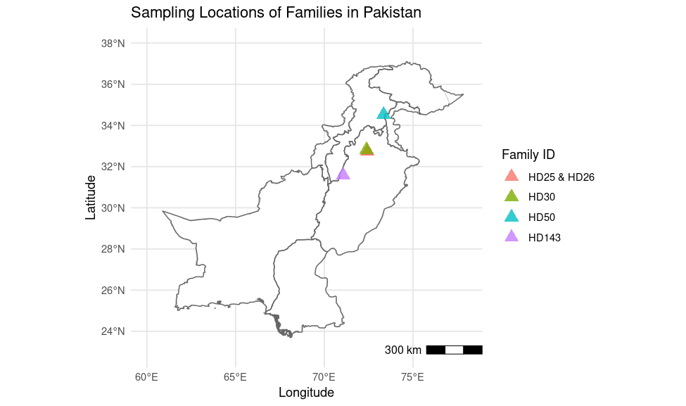
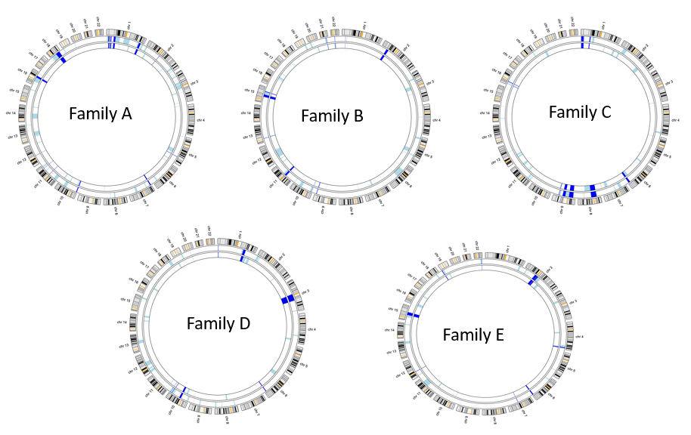
Supplementary Figure 2: Ideograms showing regions of homozygosity shared between affected individuals with exome data for each Family

