SUPPLEMENTARY MATERIAL
Supplementary Figure 1. Heatmap of g.27134T>G-cn (silent carrier haplotype variant) against SMN1-cn. Unfiltered results, “None” indicates not enough statistical evidence to confirm a value for the represented category.
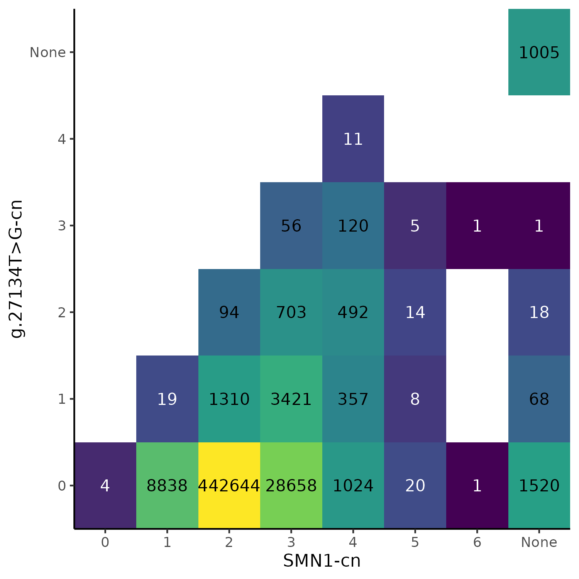

Supplementary Figure 2. Proportion of c.840C for each sample in Expansion Hunter against SMNCopyNumberCaller.
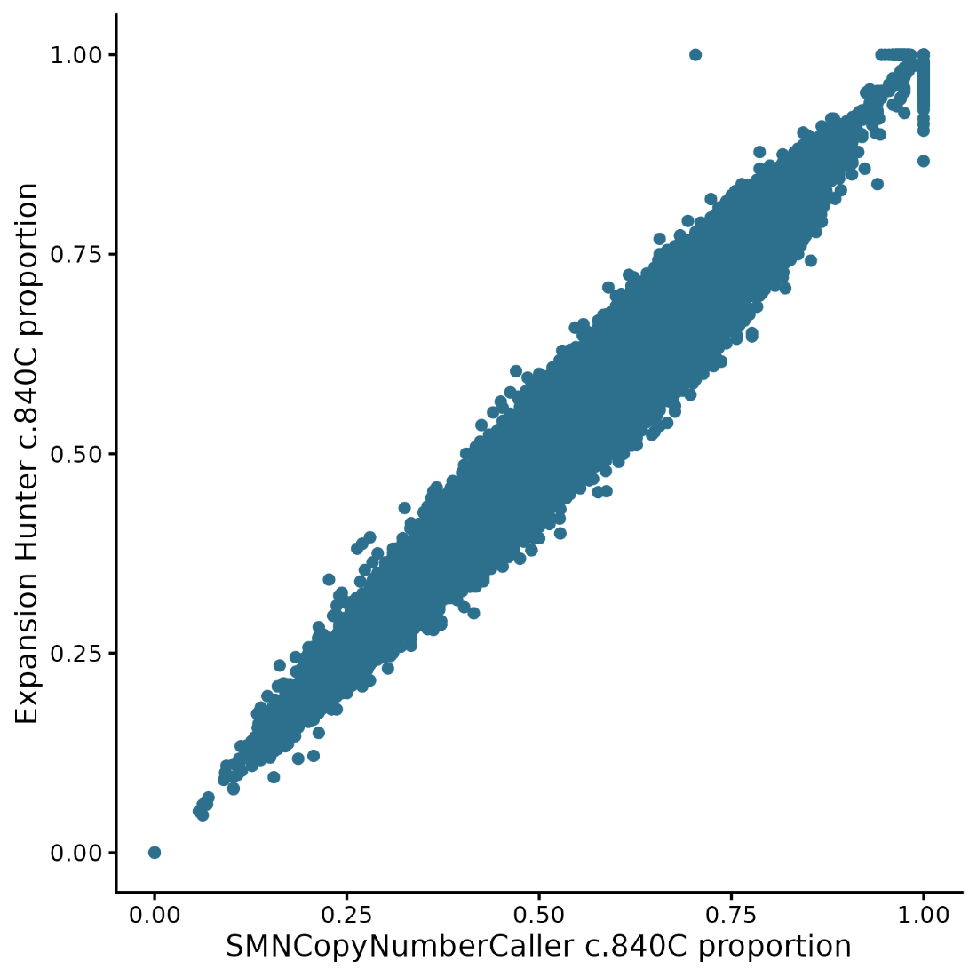

Supplementary Figure 3. Forest plots of SMN1/2-cn dosage PheWAS results of selected phenotypes. ‘*’ mark Bonferroni corrected significant results.
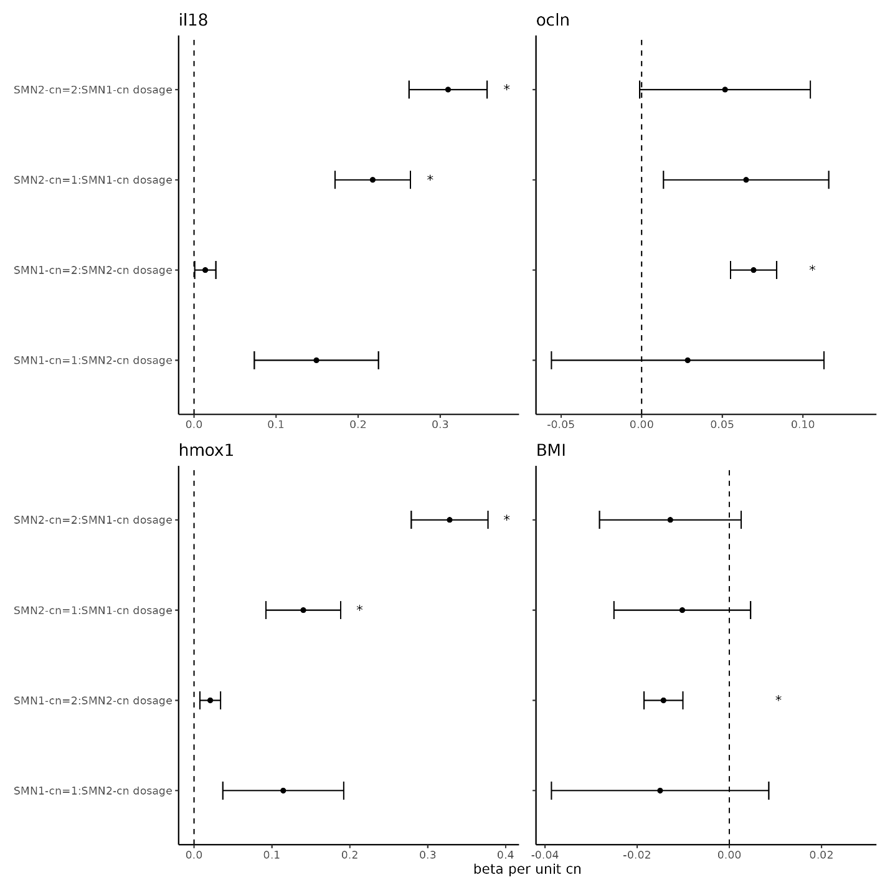

Notes on Supplementary Tables
Supplementary Table 1: Curated list of SMA related phenotypes in UK Biobank where an association with carrier status may be observed.
Supplementary Table 2: Significant results identified in dosage PheWAS.
Supplementary Table 3: Significant results identified in genotype PheWAS.

