Supplementary Material for Jezkova et al. Reanalysis of genomic data doubles the diagnostic yield for Welsh patients recruited to the UK 100,000 Genomes Project.

Supplementary Table 1. 100,000 Genomes Project (100KGP) Wales proband demographics and disease categories.
Proband - no. (%) | 100KGP Wales (n=154) | 100KGP Pilot (n=2183) | P*
Sex
Male | 85 (55) | 1138 (52) | 0.5045
Female | 69 (45) | 1045 (48)
Age group of proband
Paediatric (<18 years) | 104 (68) | 571 (26) | < 0.0001
Adult (18+ years) | 50 (32) | 1612 (74)
Family structure
Singleton | 9 (6) | 881 (40) | < 0.0001
Family Duo | 13 (8) | 343 (16) | 0.0144
Family Trio | 119 (77) | 797 (37) | < 0.0001
Other | 13 (8) | 162 (7) | 0.6339
Ancestry/ethnicity
European / White British or White other | 137 (89) | 1931 (88) | 1
African / Black or Black British | 1 (<1) | 50 (2) | 0.2544
Asian (any) / Asian or Asian British | 8 (5) | 171 (8) | 0.2742
Mixed | 7 (5) | 26 (1) | 0.0047
Not determined / other | 1 (<1) | 5 (<1) | 0.336
Disease Category**
Cardiovascular disorder | 11 (7) | 147 (7) | 0.8676
Ciliopathy | 1 (<1) | 69 (3) | 0.0855
Dermatologic disorder | 0 (0) | 38 (2) | 0.1741
Dysmorphic or congenital abnormality | 8 (5) | 20 (<1) | 0.0003
Endocrine disorder | 1 (<1) | 87 (4) | 0.0276
Gastroenterologic disorder | 1 (<1) | 32 (1) | 0.7211
Growth disorder | 0 (<1) | 3 (<1) | 1
Hematologic or immunologic disorder | 0 (<1) | 5 (<1) | 1
Hematologic disorder | 0 (<1) | 7 (<1) | 1
Hearing or ear disorder | 3 (2) | 35 (2) | 0.7361
Metabolic disorder | 4 (3) | 93 (4) | 0.4058
Intellectual disability | 66 (43) | 130 (6) | <0.0001
Neurologic or neurodev. disorder† | 32 (21) | 521 (24) | 0.4329
Ophthalmologic disorder | 11 (7) | 348 (16) | 0.0024
Renal and urinary tract disorder | 3 (2) | 176 (8) | 0.0026
Respiratory disorder | 0 (0) | 2 (<1) | 1
Rheumatologic disorder | 2 (1) | 48 (2) | 0.7701
Skeletal disorder | 2 (1) | 62 (3) | 0.4374
Tumor syndrome | 4 (3) | 293 (13) | <0.0001
Other | 13 (8) | 67 (3) | 0.0018

* Fisher's exact test, two-tailed P value – numbers of probands with/without disease category compared between cohorts. 100KGP Pilot data derived from [1]
** Some 100KGP Wales participants were recruited under two or three disease categories. The disease category column therefore adds to more than 154.
† Neurologic and neurodevelopmental symptoms excluded intellectual disability.

Supplementary Table 2. Family structures recruited to 100KGP Wales.

Family structure | Number of families recruited
Singleton (proband and no relatives) | 9
Family duo (proband and mother) | 12
Family duo (proband and father) | 1
Family trio (proband and both parents) | 119
Family quad (proband, parents and affected sibling) | 5
Proband, sibling and mother | 2
Proband, 2 siblings and mother | 2
Proband and sibling | 1
Proband and 2 siblings | 1
Proband, mother and grandmother | 1
Proband, mother, grandfather and uncle | 1

Supplementary Table 4. Secondary findings in 100KGP Wales participants.

Genomic location (GRCh38) | DNA transcript (gene) | Protein | Classification | ClinVar Accession | Notes
Chr19:g.11120122G>A | NM_000527.5(LDLR): c.1876G>A | p.(Glu626Lys) | Cold VUS | VCV000183127.38 | Conflicting classifications of pathogenicity in ClinVar
Chr10:g.43119548G>A | NM_020975.6(RET): c.2410G>A | p.(Val804Met) | Pathogenic | VCV000037102.120 | No relevant family history, neck ultrasound subsequent to diagnosis found irregular thyroid nodule. Total thyroidectomy and lateral neck dissection performed. Medullary thyroid carcinoma confirmed (pT1a)
Chr13:g.32371043del | NM_000059.4(BRCA2): c.8575del | p.(Gln2859LysfsTer4) | Pathogenic | VCV000038169.69 | Family history of breast cancer, normal screening to date.
Chr2:g.47803484_47803485del | NM_000179.3(MSH6): c.3238_3239del | p.(Leu1080ValfsTer12) | Pathogenic | VCV000218060.37 | No relevant family history, normal screening to date
Chr2:g.47799447_47799468del | NM_000179.3(MSH6): c.1465_1486del | p.(Pro489ValfsTer14) | Pathogenic |  | Family history of pancreatic cancer, normal screening to date

Supplementary Methods

RNA extraction for RNA-seq
Total RNA was extracted from cultured fibroblasts using the RNAEasy Plus Mini Kit (Qiagen) following the manufacturer's protocol with minor modifications. Fibroblasts were cultured in 25 cm² flasks until 80% confluent. Cells were lysed with Buffer RLT supplemented with β-mercaptoethanol. Lysates were homogenized using QIAshredder columns and genomic DNA was removed using gDNA Eliminator spin columns. RNA was purified using RNeasy spin columns and eluted in 50 μL of RNase-free water. RNA quantity and quality were assessed using NanoDrop spectrophotometry and TapeStation analysis, respectively. High-integrity RNA was defined as having an RNA Integrity Number (RIN) ≥ 7.0.

Library Preparation and Sequencing
RNA-seq libraries were prepared using the Illumina Stranded Total RNA Prep, ligation with RiboZero Plus kit (Illumina, cat. no. 20040529) and IDT for Illumina RNA UD Indexes Set A (Illumina, cat. no. 20040553). Input RNA was 100 ng for all samples. Paired-end sequencing was performed on an Illumina NovaSeq 6000 with a read length of 150 bp.

Bioinformatics Analysis
Raw reads were quality-trimmed using TrimGalore! with a Phred score cutoff of 20 and hard-trimming of the first 5' base pair. Filtered reads were aligned to the GRCh38 reference genome using both HISAT2 and STAR aligners. SAMtools was used to convert, sort, and index alignments. Differential gene expression analysis was performed using edgeR on read counts obtained from featureCounts, with multimapped reads split across regions. Differential exon usage was analysed using DEXSeq. For both analyses, significance was determined using an adjusted p-value < 0.05. Aberrant expression and splicing were detected using the Detection of RNA Outliers Pipeline (DROP) [2]. Three replicates of the test subject were compared with a reference panel. The reference panel comprised external count data from 492 fibroblast samples sequenced by GTEx [3] and provided by DROP, combined with RNA-seq data from six skin fibroblast samples sequenced locally in the same batch as the test subject (21 replicates in total, six of a commercially validated fibroblast control (Gibco C-013-5C) and three replicates each from five individuals unrelated to the test subject). Analyses were performed using both HISAT2 and STAR alignments, with phenotype-specific human phenotype ontology (HPO) terms included to focus the analysis. OUTRIDER was used to detect aberrant gene expression outliers [4].

NHS diagnostic pipeline used for 2025 reanalysis
Variant call format (VCF) files for 144 families were available on the Genomics England (GEL) Interpretation Portal. The VCF files contained single nucleotide variants (SNV), structural variants (SV) and copy-number variants (CNV).

The VCFs were produced by Platypus (for SNV) [5], Manta (for SV) [6] and Canvas [7] (for CNV). In-house processing scripts were used to annotate and filter the VCFs. Variants were annotated with Variant Effect Predictor [8], ClinVar [9], gnomAD [10] and Slivar [11]. Variants were ranked by Exomiser score and only variants on the Mendeliome panel (v.1.1687, 5103 disease genes from PanelApp Australia [12,13]) were kept. Variant filtering criteria applied to single nucleotide variants (SNVs) were: sequencing depth > 15 reads in proband; GQ score > 20; gnomAD popmax < 0.01; and a predicted protein coding consequence. The top three Exomiser ranked variants and any variants annotated as pathogenic or likely pathogenic in ClinVar were kept regardless of other filtering criteria.

For SV and CNV, the following criteria were applied: CNV length > 5kb and Manta call length > 25 bp and < 150kb. For small SVs the same consequence filter as SNVs was applied. For large SV, only those with the consequence transcript ablation and transcript amplification were kept. For parent-offspring trios and duos with unaffected parents, variant inheritance filters were applied: autosomal recessive, X-linked recessive, de novo, uniparental isodisomy, mitochondrial or compound heterozygous variants. These filters were not applied if a parent was affected. The analysis was adapted for families with other structures. Quads (two affected probands and two parents) were analysed as two trios. In families with multiple affected individuals, only variants shared by all affected individuals were retained.

For the 2025 reanalysis, AWMGS clinical scientists performed variant interpretation and classification of variants as per American College of Medical Genetics and Genomics (ACMG) [14] and UK ACGS 2024 guidelines (v1.2) [15].

GATAD2B AbSplice methods
As described in Wagner et al. [16], AbSplice scores were computed for all possible SNVs within a 100bp window from all splice sites related to developmentally regulated splicing events annotated in the Supplementary files from Mazin et al. [17]. Scores were computed for 7 tissues (brain, cerebellum, heart, liver, kidney, ovary, testis) and 15 developmental stages spanning embryogenesis to the adult with the earliest recorded stage being 4 weeks post conception. SNVs were filtered for AbSplice scores that were greater at an early developmental stage (up to toddler age) compared to the adult prediction. These variants were termed ‘developmental AbSplice variants’.

AbSplice data were imported into the National Genomics Research Library (NGRL) [18] with the liftover tool used to convert all coordinates to GRCh38 format. We queried the NGRL’s 100KGP v.18 de novo variant data to identify variants aligned to GRCh38 that passed the 100KGP ‘stringent’ filters, in consenting probands for whom neither parent was recorded as ‘affected’ (681,471 variants, 9,659 families). These variants were subset to those which corresponded to a developmental AbSplice variant (144 variants, 143 participants). Variants were further filtered to retain only those in ‘green’ or ‘amber’ MANE v1.0 transcripts, with a dominant, or dual mode of inheritance as defined by PanelApp, in virtual gene panels applied to each participant during the initial NGRL interpretation pipeline (19 variants/participants, Supplementary Table 5).

Eleven families for whom the diagnostic case had already been recorded as ‘solved’ were identified using the 100KGP ‘exit questionnaire’ table. In 10 of these cases the diagnostic variant corresponded with the variant identified in our data and was annotated as a positive control. Nine participants without an existing diagnosis were identified. We obtained all HPO terms for each individual from the 100KGP phenotype table and triaged all variants using mode of inheritance, and phenotypic information from DECIPHER [19], HPOJax and by querying RNA-seq data within the NGRL where available. Six variants were excluded as poor candidates in these individuals, three others were prioritised as candidate causal variants, two of which were already under investigation by the recruiting Genomic Laboratory Hub. The final variant (chr1_153813851_G/A) in GATAD2B was reported to the clinical team.
​​
Supplementary References
1. 100,000 Genomes Project Pilot Investigators, Smedley D, Smith KR, Martin A, Thomas EA, McDonagh EM, et al. 100,000 Genomes Pilot on Rare-Disease Diagnosis in Health Care - Preliminary Report. N Engl J Med. 2021; 385:1868–1880.
2. Yépez VA, Mertes C, Müller MF, Klaproth-Andrade D, Wachutka L, Frésard L, et al. Detection of aberrant gene expression events in RNA sequencing data. Nat Protoc. 2021; 16:1276–1296.
3. GTEx Consortium, Laboratory, Data Analysis &Coordinating Center (LDACC)—Analysis Working Group, Statistical Methods groups—Analysis Working Group, Enhancing GTEx (eGTEx) groups, NIH Common Fund, NIH/NCI, et al. Genetic effects on gene expression across human tissues. Nature. 2017; 550:204–213.
4. Brechtmann F, Mertes C, Matusevičiūtė A, Yépez VA, Avsec Ž, Herzog M, et al. OUTRIDER: A Statistical Method for Detecting Aberrantly Expressed Genes in RNA Sequencing Data. Am J Hum Genet. 2018; 103:907–917.
5. Rimmer A, Phan H, Mathieson I, Iqbal Z, Twigg SRF, WGS500 Consortium, et al. Integrating mapping-, assembly- and haplotype-based approaches for calling variants in clinical sequencing applications. Nat Genet. 2014; 46:912–918.
6. Chen X, Schulz-Trieglaff O, Shaw R, Barnes B, Schlesinger F, Källberg M, et al. Manta: rapid detection of structural variants and indels for germline and cancer sequencing applications. Bioinformatics. 2016; 32:1220–1222.
7. Roller E, Ivakhno S, Lee S, Royce T, Tanner S. Canvas: versatile and scalable detection of copy number variants. Bioinformatics. 2016; 32:2375–2377.
8. McLaren W, Gil L, Hunt SE, Riat HS, Ritchie GRS, Thormann A, et al. The Ensembl Variant Effect Predictor. Genome Biol. 2016; 17:122.
9. Landrum MJ, Lee JM, Benson M, Brown GR, Chao C, Chitipiralla S, et al. ClinVar: improving access to variant interpretations and supporting evidence. Nucleic Acids Res. 2018; 46:D1062–D1067.
10. Chen S, Francioli LC, Goodrich JK, Collins RL, Kanai M, Wang Q, et al. A genomic mutational constraint map using variation in 76,156 human genomes. Nature. 2024; 625:92–100.
11. Pedersen BS, Brown JM, Dashnow H, Wallace AD, Velinder M, Tristani-Firouzi M, et al. Effective variant filtering and expected candidate variant yield in studies of rare human disease. NPJ Genom Med. 2021; 6:60.
12. DiStefano MT, Goehringer S, Babb L, Alkuraya FS, Amberger J, Amin M, et al. The Gene Curation Coalition: A global effort to harmonize gene-disease evidence resources. Genet Med. 2022; 24:1732–1742.
13. Mendeliome (Version 1.3028). https://panelapp-aus.org/panels/137/ (accessed 8 Sept 2025).
14. Richards S, Aziz N, Bale S, Bick D, Das S, Gastier-Foster J, et al. Standards and guidelines for the interpretation of sequence variants: a joint consensus recommendation of the American College of Medical Genetics and Genomics and the Association for Molecular Pathology. Genet Med. 2015; 17:405–424.
15. Durkie M, Cassidy E-J, Berry I, Owens M, Turnbull C, Taylor RW, et al. ACGS Best Practice Guidelines for Variant Classification in Rare Disease 2024. . 2024. https://www.acgs.uk.com/media/12533/_media_12533_uk-practice-guidelines-for-variant-classification-v12-2024.pdf (accessed 8 Nov 2026).
16. Wagner N, Neverov AM, Martin-Geary AC, Londhe S, Schröder C, Yépez VA, et al. Aberrant splicing prediction during human organ development. . 2025. https://doi.org/10.1101/2025.07.16.665183 (accessed 14 Nov 2025).
17. Mazin PV, Khaitovich P, Cardoso-Moreira M, Kaessmann H. Alternative splicing during mammalian organ development. Nat Genet. 2021; 53:925–934.
18. Genomics England. National Genomic Research Library. . 2024. https://doi.org/10.6084/m9.figshare.4530893 (accessed 11 Feb 2026).
19. DECIPHER v11.36: Mapping the clinical genome. https://www.deciphergenomics.org/ (accessed 22 Jan 2026).

Supplementary Table 5. Nineteen developmental AbSplice variants identified in NGRL participants.
Variant | Max early | Max all GTEx | AbSplice conf | Feature | Gene symbol | Notes
chr1_153813851_G/A | 0.017 | 0.003 | LOW | ENST00000368655 | GATAD2B | Individual P3, this paper
chr4_157341338_A/G | 0.013 | 0.01 | LOW | ENST00000264426 | GRIA2 | Under investigation at GLH
chr1_224431591_T/C | 0.286 | 0.244 | HIGH | ENST00000414423 | WDR26 | Under investigation at GLH
chr7_44220825_C/T | 0.385 | 0.314 | HIGH | ENST00000395749 | CAMK2B | Var identified as causal
chr16_3751725_C/T | 0.359 | 0.359 | HIGH | ENST00000262367 | CREBBP | Var identified as causal
chr17_50188150_C/T | 0.279 | 0.279 | HIGH | ENST00000225964 | COL1A1 | Var identified as causal
chr12_115972238_T/G | 0.25 | 0.25 | HIGH | ENST00000281928 | MED13L | Var identified as causal
chr16_89288528_C/T | 0.091 | 0.091 | MEDIUM | ENST00000301030 | ANKRD11 | Var identified as causal
chr4_1803931_C/G | 0.07 | 0.07 | MEDIUM | ENST00000440486 | FGFR3 | Var identified as causal
chr2_229805784_C/A | 0.017 | 0.017 | LOW | ENST00000675903 | TRIP12 | Var identified as causal
chr16_2093043_A/C | 0.016 | 0.016 | LOW | ENST00000262304 | PKD1 | Var identified as causal
chr5_177238305_G/A | 0.012 | 0.011 | LOW | ENST00000439151 | NSD1 | Var identified as causal
chr1_244860483_A/C | 0.29 | 0.244 | HIGH | ENST00000640218 | HNRNPU | var identified as contributor
chr20_61978936_C/T | 0.009 | 0.024 | LOW | ENST00000252996 | TAF4 | No splicing errors in RNA
chr14_105391205_A/G | 0.362 | 0.309 | HIGH | ENST00000447393 | PACS2 | Does not fit disease mechanism
chr12_32740064_G/C | 0.017 | 0.017 | LOW | ENST00000549701, ENST00000553257 | DNM1L | Solved (other variant), Not good candidate‚ rejected
chr17_7910419_G/A | 0.426 | 0.219 | HIGH | ENST00000330494 | CHD3 | Does not fit disease mechanism
chr10_103071837_C/T | 0.18 | 0.18 | MEDIUM | ENST00000369878 | CNNM2 | GLH assessed as VUS
chr3_9454120_A/G | 0.118 | 0.118 | MEDIUM | ENST00000402198 | SETD5 | Uncertain significance on canonical transcript, not a strong candidate

Variants were triaged and split into four groups; variants considered poor diagnostic candidates (red), diagnostic variants (green), and potential novel diagnoses (purple). ‘Max early’ is the maximum AbSplice score for a variant across all 7 tissues with available developmental data (brain, cerebellum, heart, liver, kidney, ovary, testis) and all developmental timepoints up to toddler age. ‘Max all GTEx’ is the maximum AbSplice score for a variant across all adult tissues and sub-regions available in the GTEx dataset. AbSplice conf(idence) level represents how likely a variant is to cause aberrant splicing. The tiers are High (score > 0.2), Medium (score 0.05 to 0.2) or Low (score 0.01 to 0.05). GLH, Genomic Laboratory Hub; VUS, variant of uncertain significance; Var, variant.

Detailed case reports

Participant P1
This male individual is the only child of unrelated white British parents. There was no significant family history. The mother of P1 was aware of frequent foetal hiccups during the pregnancy. There was spotting of blood throughout pregnancy and threatened preterm labour from 21 weeks gestation. Individual P1 was born by spontaneous vaginal delivery at 34 weeks gestation. Birth weight was 2.68 kg (+1.3 SD). Individual P1 had poor feeding in the neonatal period. He was floppy and cyanosed on the postnatal ward. Blood lactate was 3 mmol/L (reference range 0.3-1.3). He required continuous positive airway pressure for 24 hours after delivery and spent 3-4 days in the Special Care Baby Unit (SCBU). On day 6, he was noted to be floppy again with lethargy and poor feeding. Sepsis was suspected but blood and CSF cultures did not reveal any growth. CSF glucose was 2.1 mmol/L. Blood glucose was 4.2 mmol/L. He was readmitted to SCBU and had 2 weeks of nasogastric (NG) feeds before discharge home.

At 6 weeks of age, individual P1 began having colic-like episodes associated with screaming, going blue, then sleeping. He was diagnosed with reflux and lactose intolerance and given special formula milk. At 24 weeks of age (18 weeks corrected) individual P1 was noted to have a seizure during a routine appointment. He appeared vacant with eyelid flickering and had generalised clonic movements for 3 minutes. He slept after the event. Individual P1 was commenced on phenobarbitone. CSF lactate was 2.21 (reference range 1.11-2.78 mmol/L). CSF Glucose was 2.3 mmol/L. Blood lactate was 4.0 mmol/L (reference range 0.3-1.3 mmol/L). Creatine kinase, plasma amino acids, transferrin isoforms, very long chain fatty acids, ammonia, biotinidase, acylcarnitine and urine organic acids were all normal. MRI brain scan demonstrated delayed myelination.

At 8 months of age, individual P1 was vocalising. He was able to roll from his back to his front. He had a hyperpigmented macule on the left arm and hypopigmented region on his right thigh. He made poor eye contact and had frequent movements that looked like an asymmetrical tonic neck reflex with extensor posturing. Eye movements were normal and facial movements were symmetrical. Head control was poor. Limb power was normal. Reflexes were present. Tone in his legs was slightly increased in the left compared to the right. Individual P1 had seizures with eyelid flickering and jerking of all four limbs which lasted 2-3 minutes. EEG at 9 months of age found slowing predominantly in the posterior regions and maximal in the right hemisphere.

Individual P1 had persistently raised blood lactate measurements in infancy (ranging from 2.1 mmol/L to 4.5 mmol/L, reference range 0.3 to 1.3 mmol/L). Subsequent plasma lactate levels (collected from 4 to 12 years of age, often in outpatient settings) were 1.5 to 2 mmol/L (reference range 0.5 to 2.2 mmol/L). At 9 and 11 years of age, he had arterial blood gas lactates of 3.6 and 2.9 mmol/L respectively (reference range 0.5-1.6). These were associated with acute illness (e.g. after 10 tonic-clonic seizures over 60 minutes).

At 2 years of age, individual P1 had developmental delay and visual inattention. His seizures were relatively controlled on levetiracetam and valproate. He was having infrequent vacant episodes and noise induced startles. His weight was 11.0 kg (-1.2 SD), length 83.9 cm (-0.9 SD) and occipitofrontal circumference (OFC) 46.2 cm (-3.1 SD). He had axial hypotonia with increased limb tone particularly of the left leg. Repeat MRI at 2 years of age showed myelination had progressed. MR spectroscopy found a lactate peak with a modestly elevated lactate. At 3 years of age, he used his right hand more than his left and was noted to have some choreoathetoid movements.

At 5 years of age, individual P1 was making slow developmental progress with no regression. He could commando crawl and his hand use was improving. He had variable tone and frequent startles. He had problems with swallowing and was recurrently chesty. He had bilateral hip subluxation. At 6 years of age, he had dystonia with tight muscles around the hip joints and over the knees. He had no dysmorphic features. His testes were difficult to palpate. His medication included sodium valproate, levetiracetam, azithromycin, baclofen and lactulose.

At 7 years of age, individual P1 was eating well and taking fluids orally. He used eye gaze to communicate. He was having 2-3 absences per day. He had lower limb hypertonia with a dislocating left hip. His leg muscles were treated with botulinum toxin. He also had some Botox of his saliva glands, but this was not effective. A muscle biopsy was performed. Respiratory chain enzyme studies found normal complex I activity (ratio 0.161, reference range 0.104-0.268) and reduced complex IV activity (ratio 0.008, reference range 0.014-0.034). Complex II+III activity was also borderline low (ratio 0.041, reference range 0.040-0.204). However, muscle ubiquinone was in the normal range, 401 pmol/mg (reference range 140 - 580). Nerve conduction studies at 8 years of age found evidence of sensory axonal dysfunction. Sensory responses were hard to identify, with absent sural and radial sensory action potentials and low amplitude median sensory responses despite high quantities of current. Motor responses and electromyography were normal.

At 9 years of age, individual P1 was vocalising and seemed to enjoy social interaction. He had restricted movement of the lower limbs with good function of his upper limbs. He had bilateral proximal femoral varus osteotomy and left sided Dega osteotomy and flexor tendon release of the toes. At 11 years of age he had difficulty feeding, poor weight gain (20 kg, -4.1 SD) and recurrent upper respiratory tract infections. Video fluoroscopy showed aspiration of thickened fluids and an unsafe swallow. He was commenced on NG and then nasojejunal feeding. He had bilateral orchidopexy for undescended testes. He was confirmed to have scoliosis. A gastrostomy was fitted at 12 years of age. His weight was 35.2 kg (-1.5 SD) at 13 years of age.

At 14 years of age, blood ubiquinone level was toward the bottom of the control range (result 48 pmol/mg, normal range 37-133). A trial of Coenzyme Q₁₀ treatment (300mg twice per day) did not show clinical benefit and was discontinued. Echocardiograph showed a structurally and functionally normal heart with no cardiomyopathy. At 15 years of age, individual P1 had a T3 to L5 posterior scoliosis correction which helped with discomfort and his breathing.

Participant P1 is now 16 years of age. His weight is 35.7 kg (-3.7 SD) and height 150cm (-3.2 SD). He is non-verbal but vocalises. He cannot sit independently. He communicates with eye gaze. He is mainly gastrostomy fed with a blended diet. He is able to swallow small amounts of pureed food. He continues to have vacant episodes and generalised tonic-clonic seizures. He also has dystonic episodes (head turning to the right and stiffening of the body). Botox injections to the upper limbs have helped his stiffness and dystonic posturing. His medication included levetiracetam, sodium valproate, baclofen, lansoprazole, azithromycin, hyoscine patches and sodium picosulphate.

Individual P1’s genetic investigations have included a routine karyotype, array comparative genomic hybridization (CGH), single gene testing of CDKL5, MECP2 and SLC9A6, common POLG mutations, common mitochondrial mutations (m.3243A>G, m.8344A>G, m.8993T>C/G) and the common ARX expansion. The results were all normal. Review of data from 100KGP found P1 had compound heterozygous COQ4 missense variants NM_016035.5, c.205A>G, p.(Met69Val) and c.211G>A, p.(Ala71Thr).

Participant P2
This male individual is the second child of unrelated white British parents. He has two brothers who are well. A maternal aunt had physical and mental disability from birth. There was no other significant family history. The pregnancy with P2 was uneventful. Antenatal scans were normal. He was born at term by spontaneous vaginal delivery. Microcephaly was noted at the newborn baby check. His birth OFC was 30.5 cm (-3.7 SD) and birth weight 2.98 kg (-1.2 SD). He went home after two days of observation. Urine testing for cytomegalovirus was negative and there was no evidence of maternal amnioacidopathy. Cranial ultrasound scan, skull x-ray and MRI head were normal. Neonatal hearing testing failed in one ear.

Individual P2 sat at 6 months of age. Eye examination at 6.5 months of age found high levels of hypermetropia. At 8.5 months of age, he was able to crawl and stand for a few seconds holding furniture. He babbled, was interested in toys and had good eye contact. On examination, he was not dysmorphic other than the microcephaly. His OFC was 37 cm (-7.5 SD), length 71.5 cm (+0.5 SD), and weight 7.03 kg (-2.2 SD). His fontanelles were completely closed. He was alert and very active. No abnormal movements were noted. The rest of his systemic examination was normal. Audiology testing at 9 months of age found a right middle ear effusion with responses outside the normal range, but no significant hearing loss.

At 13 months of age, individual P2 was cruising furniture and stand momentarily. He was still using a palmer grasp. He could use monosyllables but no specific words. He was sociable and interactive. His neurological examination was normal with no evidence of increased tone. His OFC was 38.3 cm (-8.3 SD), length 72.5 cm (-2.4 SD) and weight 7.6 kg (-3.4 SD). At 15 months of age, he was able to crawl, pull to standing and walking independently. At 19 months of age, individual P2 had a Schedule of Growing Skills II assessment which showed global delay, particularly affecting his speech and language, cognitive and visual skills. His gross motor skills were better. He had a normal gait, could get up to sit on a chair, and crawl upstairs. At 2 years of age, he had a pincer grip. He was putting 2 words together, naming family members and understood simple commands. He had bilateral conductive hearing loss and was wearing hearing aids. He had behavioural issues, pinching and smacking himself and biting other people.

Individual P2 began having vacant episodes associated with eye rolling, one arm shaking and facial twitching/grimacing. These lasted under 3 minutes. EEG was normal. MRI brain scan at 2.5 years of age found a 4 cm heterogenous, partially solid and partially cystic mass in the right posterior frontal and parietal lobes. The spinal cord was normal. He was diagnosed with a supratentorial primitive neuroectodermal tumour (PNET). A gastrostomy and Hickman line were fitted. The PNET was surgically excised and individual P2 was treated with five cycles of Head Start II type chemotherapy (high dose thiotepa, carboplatin and etoposide). Cisplatin was discontinued after three courses due to poor hearing. He was diagnosed with high tone sensorineural hearing loss bilaterally and impaired tympanic conduction of the right ear. The chemotherapy was followed by autologous hematopoietic stem cell transplant (HSCT). The HSCT was complicated by significant veno-occlusive disease. At 3 years of age, he had resection of residual tumour tissue. Echocardiography was normal. The gastrostomy was removed at 3.5 years of age.

At 4 years of age, individual P2 had delayed receptive and expressive language. His speech was difficult to understand. He received speech and language therapy. He had poor concentration and attention. He was supported 1:1 at school. Melatonin was commenced to help his sleeping. He had bilateral middle ear effusions and had grommets inserted bilaterally. At 4.5 years of age his understanding of instructions was poor. His speech was still limited but he was putting 2-3 words together more frequently and his vocabulary was increasing. He attended a special needs school. He was still biting and pinching others. School staff were struggling to cope with his behaviour. He had bilateral cochlear implants at 5 years of age. He had high levels of hypermetropia and astigmatism in both eyes, corrected with glasses. Dilated fundoscopy was normal.

At 5 years of age, individual P2 continued to have challenging behaviour at home and at school. He was affectionate towards his family with good eye contact. He liked routines. He had aggressive outbursts and tantrums. He needed to be supervised at all times due to safety issues. He continued to have speech and language delay and was introduced to signing.
On examination, his OFC was 41.2 cm (-7.7 SD), height 102.6 cm (-1.5 SD) and weight 15.35 kg (-1.7 SD). Individual P2 was diagnosed with autism spectrum disorder at 8 years of age. At 9 years of age, he had right esotropia with amblyopia treated with occlusion therapy. There was good optic nerve function with full Ishihara colour vision in both eyes. He was found to have a 2 cm non-tender bony lump on the medial edge of the left scapula. X-ray confirmed it was an osteochondroma (benign exostosis). Individual P2 was diagnosed with attention deficit hyperactivity disorder (ADHD) at 9.5 years of age.

Individual P2 continued to have challenging behaviours (meltdowns, biting, hitting) and poor sleep. A range of medications were tried to treat the ADHD (lisdexamfetamine, methylphenidate, atomoxetine) but either did not help or exacerbated symptoms. He required constant 1:1 support in school. He was able to communicate with Makaton. At 12.5 years of age his OFC was 45 cm (-6.3 SD), height 136 cm (-2.0 SD) and weight 35.4 kg (-0.8 SD). Individual P2 is now 14 years of age. His behaviour remains challenging. Significant weight gain occurred after starting risperidone and he is now around the 91st centile for weight (+1.3 SD). His height continues to track around the 2nd centile (-2 SD). He is starting to show some signs of puberty with some hair in the axilla and pubic regions but no significant growth of his genitalia.

Individual P2’s genetic investigations have included routine karyotype (no evidence of premature chromosome condensation in 100 cells from a lymphocyte culture), array CGH, single gene testing of ASPM, a 63 gene chromosome instability/breakage disorders panel and trio exome sequencing as part of the Deciphering Developmental Disorders study (DECIPHER 306931). Review of data from 100KGP found compound heterozygous variants in NCAPD2. The variants were a canonical splice site variant (NM_014865.4, c.1954+1G>A) and a splice region variant (c.3019G>A, p.(Gly1007Ser)).

Participant P3
This female individual is the child of unrelated white British parents. She has three older paternal half-siblings who are well. Her father had a reported squint. There was no other family history of note. The pregnancy with P3 was uneventful. Antenatal scans were normal. She was born at 42 weeks gestation following induction through forceps delivery. She was well after birth and had a weight of 3.69 kg (50th centile). There were parental concerns regarding the development of individual P3 from 6 months of age as she was not achieving milestones.

Individual P3 was assessed by orthoptics at 16 months due to the family history of squint and was found to have a right head tilt with normal visual acuities and normal eye movements. The head tilt resolved by 22 months of age. At 24 months of age, individual P3 presented with an episode of vomiting, reduced oral intake and a febrile seizure. She was found to be hypoglycaemic (blood glucose 2.3 mmol/L) with urine dipstick showing protein and ketones. She received a dextrose bolus and maintenance intravenous dextrose infusion until her blood glucose levels stabilised. Blood pressure measurement was within the normal range. Blood gas, electrolyte profile, cortisol, ammonia, lactate, acylcarnitines and urine organic acids were normal. Her weight was 11.8 kg (50-75th centile; +0.179 SD) and OFC 50 cm (91-98th centile; +1.99 SD). Over the next 24 hours the vomiting resolved, and the intravenous fluids were titrated down as oral intake was tolerated, and glycaemia remained stable.

Individual P3 presented again at 3 years 9 months of age due to ongoing parental concerns regarding her development. She walked at 2 years of age and had limited speech, using 5 to 6 words and singing noises, she communicated mainly with her body language and showed more understanding than she was able to express; however, this was variable. She was able to follow 1 to 2 key word instructions. She also had poor attention and concentration. She had longstanding drooling, teeth grinding and constipation. Individual P3 was found to have oral sensory defensiveness as she was not willing to put food in her mouth or finger feed herself, accepting food from a spoon only which she could do herself. She was described as not having sense of danger while being sociable and happy. On examination, P3 had poor balance and coordination, with a wide-based gait, hand posturing, reduced muscle tone and generalised hyperreflexia. In addition, she was noted to have hypermobile joints. Hearing assessment was normal.

At 4 years 3 months of age, individual P3 had an OFC of 53 cm (>91st centile; +1.44 SD), her height was 98 cm (9th centile; -1.31 SD) and weight 15.5 kg (12th centile; -1.182 SD). She had distinctive features including hypertelorism, straight eyebrows, deep-set eyes, low set posteriorly rotated left ear, broad nasal tip, wide mouth with down slanting corners and tented upper lip vermillion and fifth digit clinodactyly bilaterally in hands and feet. She had hypermobile joints with poor arches and an unsteady, wide based gait. She had autistic behaviour with flapping when excited. MRI scan of her brain at 4 years 7 months old was normal.

Individual P3 presented again at age 11 years of age with episodes of vacant staring, upwards gaze lasting a few seconds, sometimes associated with flickering of the eyelids, while unresponsive. These episodes occurred at least 3 to 5 a day. The episodes were more evident when P3 was tired, usually in the morning. Individual P3 was clinically diagnosed with absence seizures. At 12 years old individual P3 had a sleep electroencephalogram (EEG) which was not very successful despite melatonin, obtaining less than a minute of sleep with most of the record performed while participant P3 was awake/drowsy. The background was symmetrical, with right frontal sharp waves and spikes noted infrequently. Features favoured a focal onset epilepsy. Repeat EEG at 15 years old demonstrated an abnormal record with several interictal generalised and focal epileptiform discharges (right and left – frontal) which were accentuated during sleep. Findings were suggestive of a lowered seizure threshold with generalised and focal features. She has a working diagnosis of absence epilepsy, likely juvenile and was prescribed lamotrigine.

Individual P3 was last assessed at 15 years 9 months of age. Her weight was 59 kg (68th centile; +0.46 SD), height 155 cm (9th centile; -1.3 SD), and OFC 60 cm (>99.6th centile; +3.45 SD). She was mobile with an unsteady gate. She could reach, grab and transfer objects. She could pinch but struggled with fine motor skills. She had limited speech, still using around 6 words, and not using sentences. She ate and drinks well. Individual P3 attended a special school with additional support.

Individual P3’s genetic investigations have included routine karyotype, array CGH, SNRPN methylation analysis, and trio clinical exome sequencing (TruSight One Expanded sequencing panel). A de novo GATAD2B intronic variant (NM_020699.4: c.1217-399C>T) was detected through analysis of AbSplice scores for SNVs near splice sites related to developmentally regulated splicing events as described above.
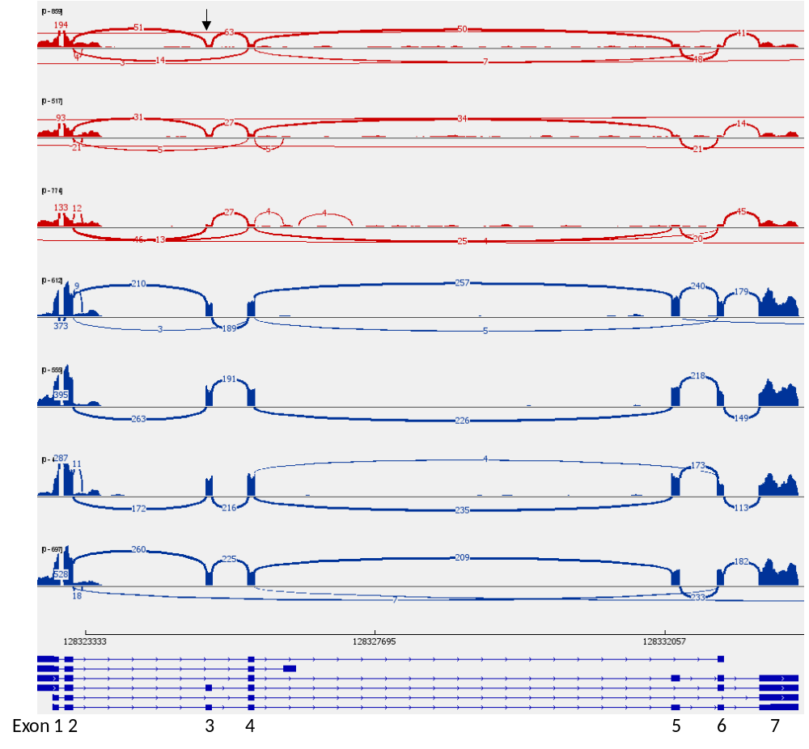
Supplementary Fig. 1. COQ4 RNA-seq data. A Sashimi plot of fibroblast-derived RNA-seq data from individual P1 (red, top three replicates) and control (blue, bottom four replicates). The COQ4 c.205A>G/c.211G>A variants are located at the 5’ end of exon 3 (arrow). For clarity, minimum junction coverage has been set to 3 (junctions with 2 or less reads are not visible). Transcripts of COQ4 with exons annotated are shown below. Genomic coordinates are GRCh38. In P1, COQ4 transcripts are significantly reduced (~40-60 reads with exon 3 compared with ~200 in controls). In addition, the proportion of transcripts skipping exon 3 in P1 is ~25% (compared with ~1% in the controls).
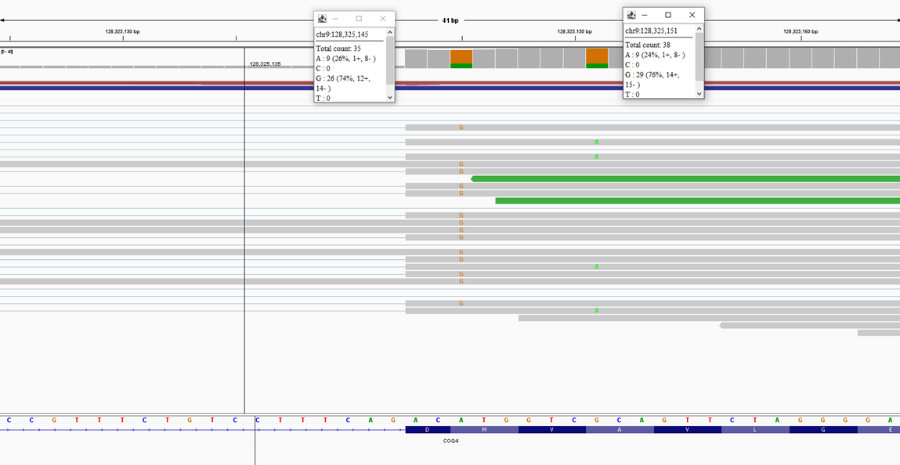
Supplementary Fig. 2. Integrative Genomics Viewer plot of the RNA-seq data from individual P1. The COQ4 c.205A>G and c.211G>A variants are present in a trans arrangement. The G alleles of both variants are seen in around 75% of transcripts indicating slightly more of the c.205A>G, p.(Met69Val) allele is present.

Supplementary Table 6. Primers used for PCR of cDNA.
Primer | Primer sequence | Location
COQ4 2F | cgctatactcgcaccacct | Exon 2 (NM_016035.5)
COQ4 i2F | tatcctgtaggaaacaaaggc | Intron 2
COQ4 4R | tggagcttgcccaggtcg | Exon 4
NCAPD2 13F | cgcatctatcaactgcttgc | Exon 13 (NM_014865.4)
NCAPD2 17R | agattctgaatcaaagcctgg | Exon 17
NCAPD2 21F | gagaaccagtcaggaggac | Exon 21
NCAPD2 25R | tgaacagaagacgaagctgg | Exon 25
GATAD2B 6F | ttcttgcctagtgcagccaa | Exon 6 (NM_020699.4)
GATAD2B 7R | gaggtcatacactgctcaca | Exon 7
GATAD2B pseudoF | tgtcattgacagccaaggctg | Exon 6 / pseudoexon
GATAD2B 8R | atgtctcatgatggtctcttg | Exon 8

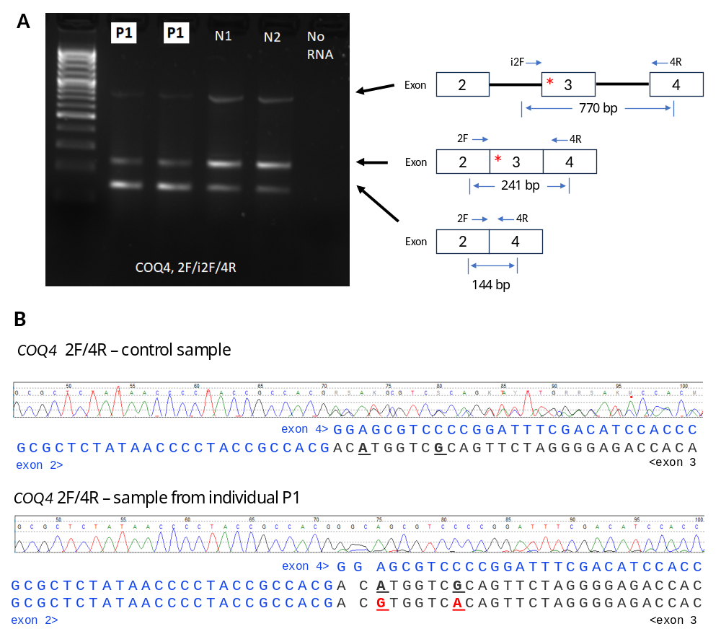
Supplementary Fig. 3. RNA analysis of COQ4 c.205A>G/c.211G>A. A Gel electrophoresis of a 100 bp DNA ladder and PCR products from participant P1 blood-derived cDNA, control samples (N) and no RNA. Exon models (based on NM_016035.5) of expected products are shown on the right. Both variants are located at the 5’ end of exon 3 (red asterisk). The i2F primer is located in intron 2. The i2F/4R primers work on residual genomic DNA to produce a product of 770 bp (top). The 2F/4R primers (located in exons 2 and 4 respectively) have an expected product size of 241 bp (middle). Exon 3 is 97 bp in size. Therefore, a product missing exon 3 (bottom) will be 144 bp in size. The 770 bp band from genomic DNA is stronger in the controls. There is no evidence of either variant causing intron retention. Transcripts with and without exon 3 are present in P1 and the controls. However, P1 has a weaker 241 bp band (transcript with exon 3) and a stronger 144 bp band (transcript skipping exon 3). B Sanger sequencing chromatograms from a control sample (top) show a mixture of transcripts with and without exon 3. In contrast, the sequence from P1 (bottom) is almost exclusively from transcripts lacking exon 3. When exon 3 is skipped the predicted protein consequence is an out-of-frame deletion

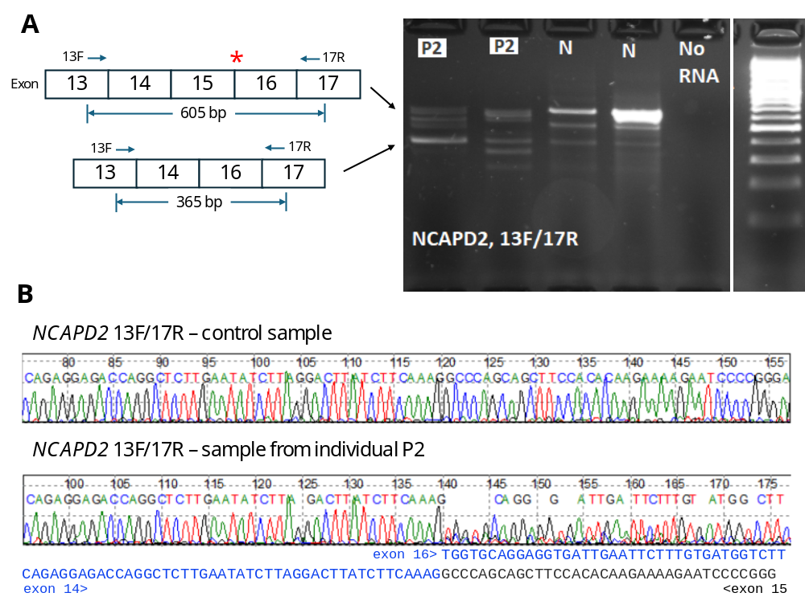

Supplementary Fig. 4. RNA analysis of NCAPD2 c.1954+1G>A. A Gel electrophoresis of PCR products from participant P2 blood-derived cDNA, control samples (N), no RNA and a 100 bp DNA ladder. Exon models (based on NM_014865.4) of expected products and location of primers are shown on the left. The c.1954+1G>A variant is located at the 5’ end of intron 15 (red asterisk). The 13F/17R primers (located in exons 13 and 17 respectively) have an expected product size (top) of 605 bp. Exon 15 is 240 bp in size. Therefore, a product missing exon 15 will be 365 bp in size (bottom). Individual P2 has some full-length product but has a bright band at 365 bp in size. B Sanger sequencing chromatograms from a control sample (top) and demonstrating skipping of exon 15 in individual P2 (bottom). The predicted protein consequence is an in-frame deletion of 80 codons: r.1715_1954del, p.(Gly572_Thr651del).

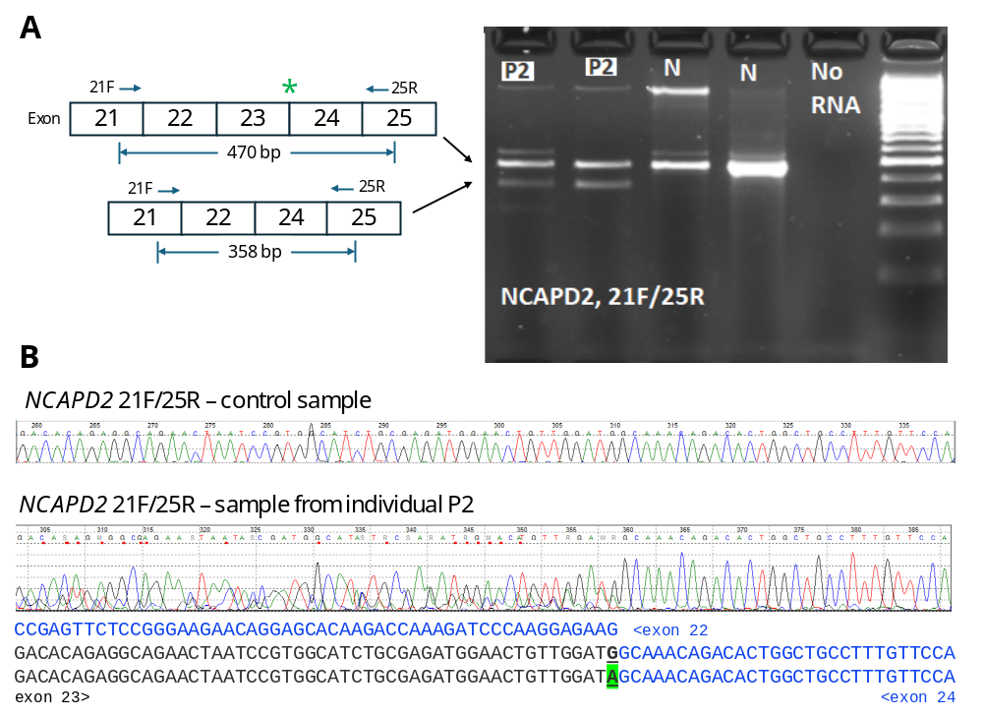

Supplementary Fig. 5. RNA analysis of NCAPD2 c.3019G>A. A Gel electrophoresis of PCR products from participant P2 blood-derived cDNA, control samples (N), no RNA and a 100 bp DNA ladder. Exon models (based on NM_014865.4) of expected products and location of primers are shown on the left. The c.3019G>A variant is located at the 3’ edge of exon 23 (green asterisk). The 21F/25R primers (located in exons 21 and 25 respectively) have an expected product size (top) of 470 bp. Exon 23 is 112 bp in size. Therefore, a product missing exon 23 will be 358 bp in size (bottom). Individual P2 has some full-length product but also produces a smaller product at 358 bp. B Sanger sequencing chromatograms from a control sample (top) and demonstrating skipping of exon 23 in individual P2 (bottom). The r.3019a allele (green peak, green highlight) can be seen in a significant proportion of reads. The skipping of exon 3 is ‘leaky’ and is only happening to some strands with r.3019a. When exon 23 is skipped the predicted protein consequence is an out-of-frame deletion: r.2908_3019del, p.(Asn970AlafsTer40). When exon 23 is not skipped the predicted protein consequence is a missense variant p.(Gly1007Ser).

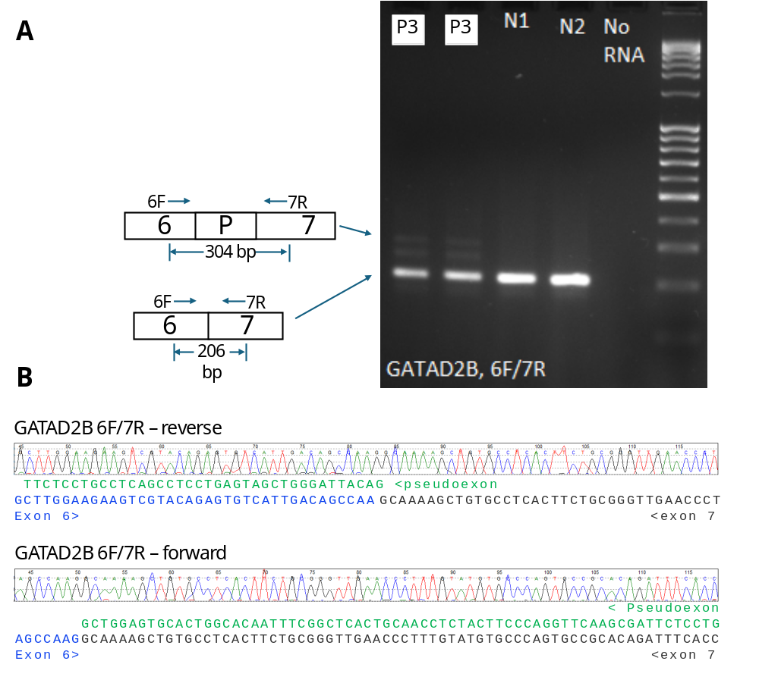

Supplementary Fig. 6. RNA analysis of GATAD2B c.1217-399C>T. A Gel electrophoresis of PCR products from participant P3 blood-derived cDNA, control samples (N1/2), no RNA and a 100 bp DNA ladder. Exon models (based on NM_020699.4) of expected products, pseudoexon (P) and location of primers are shown on the left. The 6F/7R primers (located in exons 6 and 7 respectively) have an expected product size (bottom) of 206 bp. The pseudoexon is 98 bp in size. Therefore, a product with the pseudoexon insertion (top) is 304 bp. Individual P3 produces some transcripts with the pseudoexon. There is an additional intermediate band which is likely heteroduplex formed between the wild-type and pseudoexon alleles. B Sanger sequencing chromatograms from reverse and forward directions. The mutant allele is low level but the small additional peaks on the chromatogram match the expected pseudoexon sequence (more obvious in reverse direction).

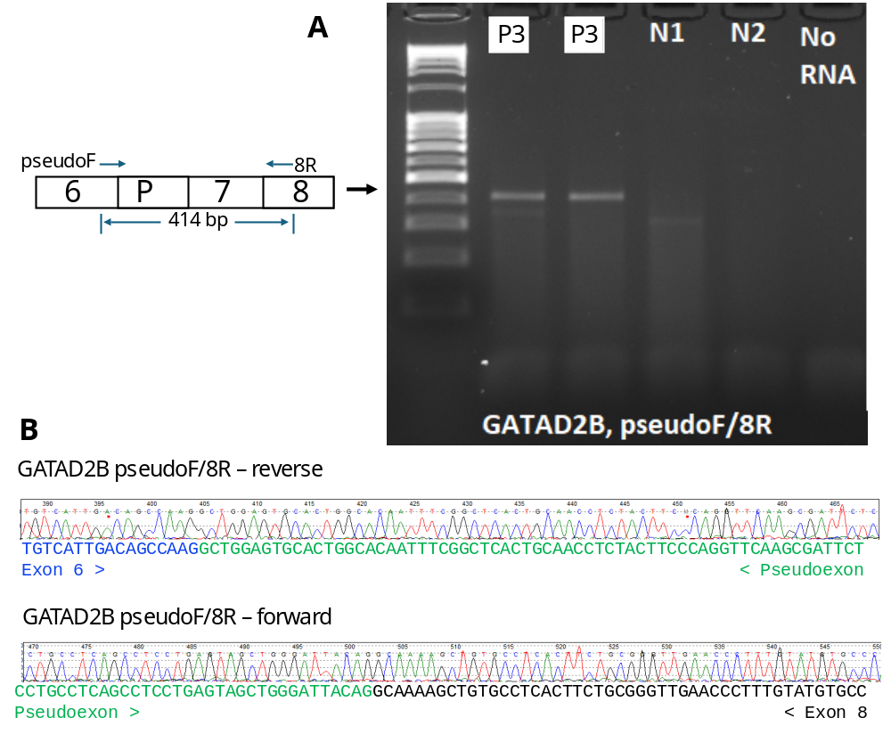

Supplementary Fig. 7. RNA analysis of the GATAD2B pseudoexon. A Gel electrophoresis of PCR products from a 100 bp DNA ladder, participant P3 blood-derived cDNA, control samples (N1/2), and no RNA. An exon model (based on NM_020699.4) of the expected product including pseudoexon (P) and location of primers is shown on the left. The pseudoexonF primer (designed to span the junction between exon 6 and the pseudoexon) and 8R primer (located in exon 8) have an expected product size of 414 bp. Individual P3 has the expected 414 bp PCR product specific to the pseudoexon. B Sanger sequencing chromatograms from reverse and forward directions. Exon 6 ends with CAA G and exon 7 begins with GC AAA. In contrast, the pseudoexon begins with GC TGG. Therefore, codon 407 is AAA (Lys) in the wildtype but changed to TGG (Trp) in the mutant allele. The predicted protein consequence is an out-of-frame insertion: r.1216_1217ins1217-498_1217-401, p.(Lys407TrpfsTer28)

