Supplementary Material

Online Appendix

This online appendix provides additional methodological details to support the main manuscript (Figure A1, Tables A1 and A2). It also provides additional results that will be of interest to the reader (Tables A3 to A5)

Figure A1. Comparison of Pathway for direct referral of people who are screen positive for R1M1 to HES and to digital surveillance
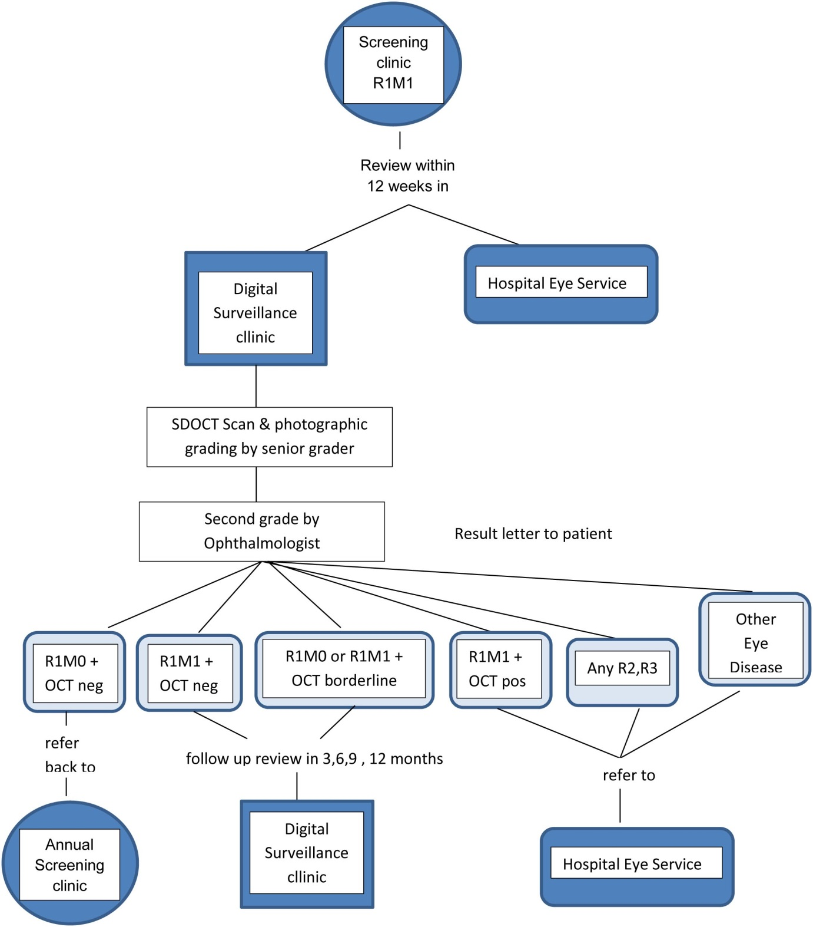

Table A1. OCT grading criteria for diabetic maculopathy in OCT surveillance
OCT Positive Criteria
OCT positive is defined as the following abnormalities affecting the central 1mm macular subfield:
- The presence of subretinal fluid, diffuse retinal thickening or parafoveal intra-retinal cysts with a change in foveal or ILM contour
- Retinal thickness in the foveal central subfield ≥ 300 µm due to diabetic maculopathy
- An area of retinal thickening of greater than 1 disc area the edge of which is within 1 disc diameter of the central fovea
- The presence of intraretinal cystoid spaces without a change in foveal contour in the central subfield associated with a drop in VA to 6/18 or worse unless there is a clear reason why the vision is reduced e.g. dry AMD or known amblyopia.
OCT Borderline Criteria
OCT borderline is defined as:
- The presence of intraretinal cystoid spaces, or subretinal fluid, in the ‘macular area’, without any change in the ILM contour and a VA better than or equal 6/12
OCT Negative Criteria
OCT negative is defined as:
- the absence of signs of OCT positive or borderline criteria.
Other Eye Disease
Different criteria were used in the presence of epiretinal membrane or vitreomacular traction.
Adequacy of OCT Grading
Adequate is defined as
- Artifacts are not present and signal strength appears optimal for interpretation of the image set.
or
- artifacts are present and/or signal strength is reduced, but there is still sufficient intensity to distinguish major interfaces across the entire dataset.
Inadequate is defined as
- Severe artifacts are present (e.g. “impossible” deviations in retinal contour) or the signal strength is reduced across the image set to the extent that major interfaces cannot be clearly identified.

Table A2. Model inputs: Unit costs and probabilities
Resource use/costs (2015/16) | Mean | Distribution | Source
SDOCT surveillance clinic appointment | £53 | Fixed | Reeves 2016¹⁵
Consultant-led Ophthalmology first appointment in HES* | £134 | Fixed | NHS Reference costs 2015/16 and Reeves 2016
Consultant-led Ophthalmology follow up appointment in HES* | £111 | Fixed | NHS Reference costs 2015/16 and Reeves 2016
Annual cost of laser treatment | £1,134 | Fixed | Scanlon 2015
Annual cost of injection treatment | £814 | Fixed | Scanlon 2015
Proportion of treatment that was injection | 39% | Beta(7,11) | This study
Visits by SDOCT surveillance frequency
Every 3 months | 2.00 | Normal(2.00,0.58) | This study
Every 6 months | 1.95 | Normal(1.95,0.03) | This study
Every 9 months | 1.59 | Normal(1.59,0.05) | This study
Every 12 months | 1.05 | Normal(1.05,0.02) | This study
Probabilities
Other eye at screening
R0-R1M0 | 81% | Residual | This study
R1M1 | 18% | Beta(140,626) | This study
R2-R3 | 1% | Beta(4,762) | This study
Uptake rate | 95% | Beta(727,39) | This study
Referral outcome following SDOCT grading | Table A3 | Bootstrap | This study
SDOCT surveillance intervals | Table A4 |  | This study
Other eye R0-R1M0 at screening
R0M0 at SDOCT grading | 11% | Beta(65,503) | This study
R1M0 at SDOCT grading | 34% | Beta(194,374) | This study
R1M1 at SDOCT grading | 53% | Residual | This study
R2/3MX at SDOCT grading | 1% | Beta(7,561) | This study
Other eye R1M1 at screening
R0M0 at SDOCT grading | 6% | Beta(8,122) | This study
R1M0 at SDOCT grading | 35% | Beta(46,84) | This study
R1M1 at SDOCT grading | 58% | Residual | This study
R2/3MX at SDOCT grading | 0% | Fixed | This study
Other eye R2/3MX at screening
R0M0 at SDOCT grading | 0% | Fixed | This study
R1M0 at SDOCT grading | 0% | Fixed | This study
R1M1 at SDOCT grading | 100% | Fixed | This study
R2/3MX at SDOCT grading | 0% | Fixed | This study
Other eye R0-R1M0 at screening and R0M0 at SDCOT grading
OCT negative | 82% | Residual | This study
OCT borderline | 9% | Beta(6,59) | This study
OCT positive | 9% | Beta(6,59) | This study
Other eye R0-R1M0 at screening and R1M0 at SDCOT grading
OCT negative | 80% | Residual | This study
OCT borderline | 13% | Beta(25,169) | This study
OCT positive | 7% | Beta(13,181) | This study
Other eye R0-R1M0 at screening and R1M1 at SDCOT grading
OCT negative | 57% | Residual | This study
OCT borderline | 25% | Beta(77,225) | This study
OCT positive | 18% | Beta(54,248) | This study
Other eye R0-R1M0 at screening and R2/3MX at SDCOT grading
OCT negative | 57% | Residual | This study
OCT borderline | 29% | Beta(2,7) | This study
OCT positive | 14% | Fixed | This study
Other eye R1M1 at screening and R0M0 at SDCOT grading
OCT negative | 100% | Fixed | This study
OCT borderline | 0% | Fixed | This study
OCT positive | 0% | Fixed | This study
Other eye R1M1 at screening and R1M0 at SDCOT grading
OCT negative | 80% | Residual | This study
OCT borderline | 13% | Beta(6,40) | This study
OCT positive | 7% | Beta(3,43) | This study
Other eye R1M1 at screening and R1M1 at SDCOT grading
OCT negative | 59% | Residual | This study
OCT borderline | 24% | Beta(18,58) | This study
OCT positive | 17% | Beta(13,63) | This study
*includes SDOCT equipment costs of £24 per appointment

Table A3. Multinomial regression to assess the predictors of referral outcome following SDOCT grading
 | Coefficient | SE | 95% CI
Continued surveillance in an SDOCT clinic
SDOCT positive | 1.07 | 1.10 | -1.09 to 3.24
SDOCT grading of R0M0 | -5.91 | 1.03 | -7.93 to -3.88
SDOCT grading of R1M0 | -5.34 | 1.01 | -7.32 to -3.35
Screen grading of other eye of R0/1 | -1.37 | 0.41 | -2.18 to -0.56
Constant | 6.90 | 1.08 | 4.79 to 9.01
Refer to HES
SDOCT positive | 5.60 | 1.09 | 3.47 to 7.74
SDOCT grading of R0M0 | -6.47 | 1.22 | -8.87 to -4.07
SDOCT grading of R1M0 | -5.55 | 1.07 | -7.64 to -3.45
Screen grading of other eye of R0/1 | -1.99 | 0.53 | -3.03 to -0.94
Constant | 4.89 | 1.12 | 2.70 to 7.08

Table A4. Ordered logistic regression to assess the predictors of SDOCT surveillance intervals
 | Coefficient | SE | 95% CI
SDOCT result
Positive | Reference case
Negative | 2.66 | 0.28 | 2.10 to 3.21
SDOCT grading
R1M1 | Reference case
R0M0 | 2.16 | 0.48 | 1.22 to 3.11
R1M0 | 1.44 | 0.25 | 0.96 to 1.93
Screening grading of other eye
R0/1 | 0.62 | 0.24 | 0.14 to 1.10
Cut between <3- and 6-month surveillance | -2.82 | 0.51 | -3.83 to -1.82
Cut between 6- and 9-month surveillance | 2.66 | 0.35 | 1.98 to 3.34
Cut between 9- and 12-month surveillance | 3.63 | 0.37 | 2.90 to 4.36

Table A5. Logistic regression to assess the predictors of treatment if incident R1M1 at screening
 | Coefficient | SE | 95% CI
SDOCT result positive | 3.57 | 0.65 | 2.30 to 4.84
Constant | -5.19 | 0.58 | -6.3 to -4.06

