Supplementary materials for: Halioua-Haubold et al Potential Quality of Life Benefits of Choroideremia Gene Therapy: Findings from a Lifetime Decision Model

Expanded methods
Choroideremia Progression Measures: Retinal Area & Visual Acuity
In choroideremia, visual acuity is preserved until late in the disease and often drops suddenly when retinal loss encroaches on the fovea. A Kaplan-Meier survival analysis has been used to detect the risk of vision dropping at each age.¹ This analysis was amended with low visual acuity being defined as vision below 20/40, which equates to low vision as defined by the National Institutes of Health National Eye Institute (NEI).²
Gene Therapy Assumptions
The gene therapy was modelled on the published data from the University of Oxford choroideremia AAV-2 gene therapy program assessing REP1 (AAV.REP1), and Spark Therapeutics’ AAV gene therapy for RPE65-mediated retinitis pigmentosa. AAV.REP1 has now been taken over by NightStar Therapeutics Inc. and is soon entering Phase III clinical trials after successfully completing Phase I/II in 2017.³ These were chosen due to the availability of published data and detailed knowledge of the functional effects of this disease in a large cohort of patients attending the clinic in Oxford – crucial for the development of an accurate model for a therapy which is not market authorized. Luxturna, while indicated for a different disease and therefore carrying a different gene product, uses a highly similar mechanism of action as AAV.REP1 (same vector, same promoter and same polyA signal) and has the advantage of having recently being market approved, and therefore was used to supplement unavailable data from AAV.REP1.
Additionally, it was assumed the gene therapy would be given to both eyes, and therefore the gene therapy effectively has two chances of being successful. It was assumed the gene therapy could only fail at point of administration, and that there was no lifetime risk of resumed retina degeneration should the treatment succeed initially.
Health States and Utility Values
The authors defined five health state categories: “healthy”, “hindered”, “functionally blind”, “blind”, and “death” (Figure 1). Each health state defines the impact of choroideremia on the patient, based on the combined effect of remaining retinal area and visual acuity. The assigning of qualitative severity states to the quantitative data on retinal structure and function was necessary to associate health utility values with the stage of the disease. (Table S1)
Transition Probabilities Between Health States
Transition probabilities were defined in the model as either set point estimates or an equation dependent on the age of the patient using user-defined variables (Tables 3, S1 – S4). A cycle of the model represented one year of the patient’s life, and within this year patients had a certain probability of remaining in their current health state, progressing to a worse health state, or dying. The model followed patients from point of treatment decision till death.
Transition probabilities for retinal area and visual acuity loss due to choroideremia were calculated from a 2016 anatomical study of retinal area in choroideremia and a 2017 functional assessment of visual acuity in choroideremia patients.⁴¹
Death risk per year was age-dependent, therapy-independent, and calculated using United States Census Data, which stratifies population counts by age and gender.²⁹
Non-Choroideremia-Associated Visual Function Loss
In this model, successful gene therapy was assumed to wholly prevent the further loss of retinal area and visual acuity. However, treated and untreated patients could still develop non-choroideremia-associated visual impairment or blindness for causes including glaucoma, injury,
and diabetic retinopathy. The probability of non-choroideremia visual impairment or blindness was calculated using United States National Eye Institute Data on the prevalence of low vision and blindness by age group in the United States.²
Inherited retinal degenerations (IRDs) are a significant cause of non-choroideremia-associated visual impairment and blindness: 2% of visual impairment and 2.8% of blindness certifications in the United Kingdom’s NHS are caused by inherited retinal disease and it disproportionately affects younger people, thereby having an even greater impact on years of blindness.³⁰ It was assumed that patients in both the treated and untreated cohorts would have their genome sequenced to confirm a CHM mutation, and as such would not be candidates for gene therapy should they carry another hereditary retinal disorder such as RPE65 IRD. Additionally, including inherited retinal degenerations, albeit small, would double-count the risk of the modelled patients developing choroideremia-associated visual function loss. The prevalence of visual impairment and blindness used to calculate the risk of non-choroideremia-associated visual function loss was
therefore adjusted downwards using the aforementioned percentages to correct for this.
Patient Groups
As there is currently no treatment for choroideremia, candidates for a new gene therapy will have various levels of retinal area and visual acuity loss. To model the possible spectrum of patients who could receive the gene therapy, three patient scenarios were modelled: a 20-year-old patient with greater than 80% remaining retinal area and no visual acuity loss (early-stage); a 45-year-old patient with between 50% and 80% remaining retinal area and no visual acuity loss (mid-stage); and a 60-year old patient with between 50% and 80% remaining retinal area who also has visual acuity loss (late-stage). These patients were chosen with expert clinical opinion and the understanding that choroideremia degeneration progresses with age, and that visual acuity loss is largely experienced once the retinal area loss infringes on the fovea.
Supplemental Patient Group
Preliminary AAV.REP1 clinical data has suggested that the gene therapy may not only halt retinal degeneration, but also improve visual acuity in patients where this has decreased due to choroideremia disease progression.³¹ The cited publication reports the results of AAV.REP1 treatment in a heterogeneous choroideremia population of six. Two of the treated patients that may be categorized as late-stage as used herein had improved visual acuity without changes in their retinal area after gene therapy treatment.
Discounting
The authors have chosen not to discount the health outcomes in the primary model since costs are not incorporated into this model. Nevertheless, as benefits are ultimately accrued over a long period of time, a sensitivity analysis was conducted applying a discount rate of 1.5% and results are reported accordingly.

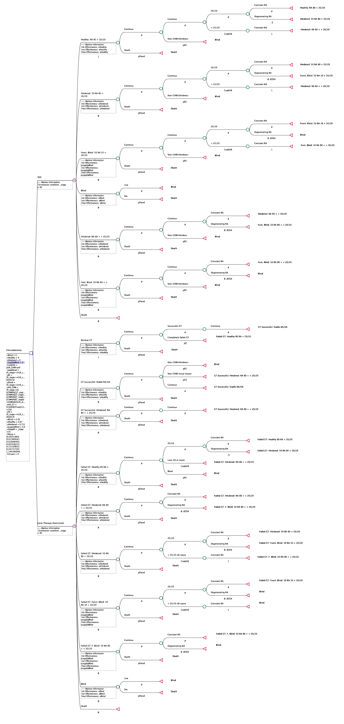
eFigure 1. Early Stage cohort Markov model
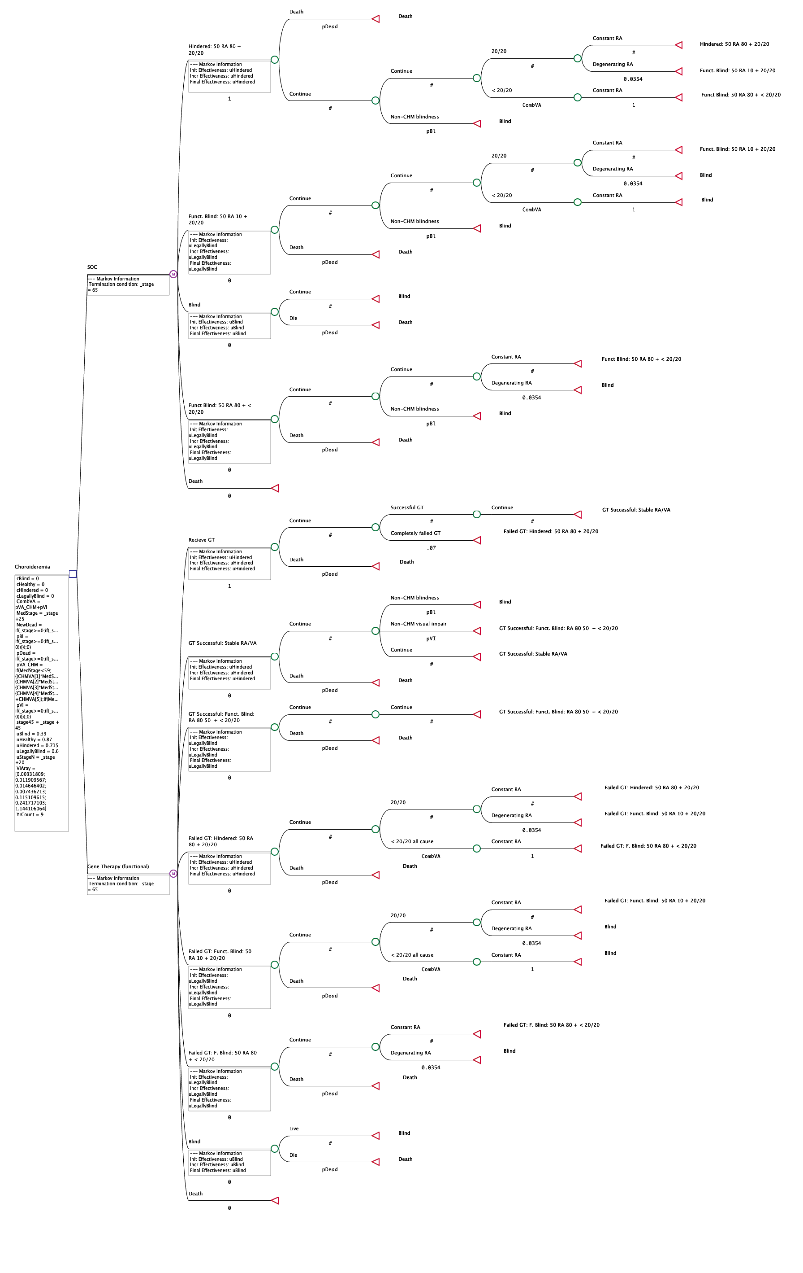
eFigure 2. Mid-Stage Cohort Markov Model

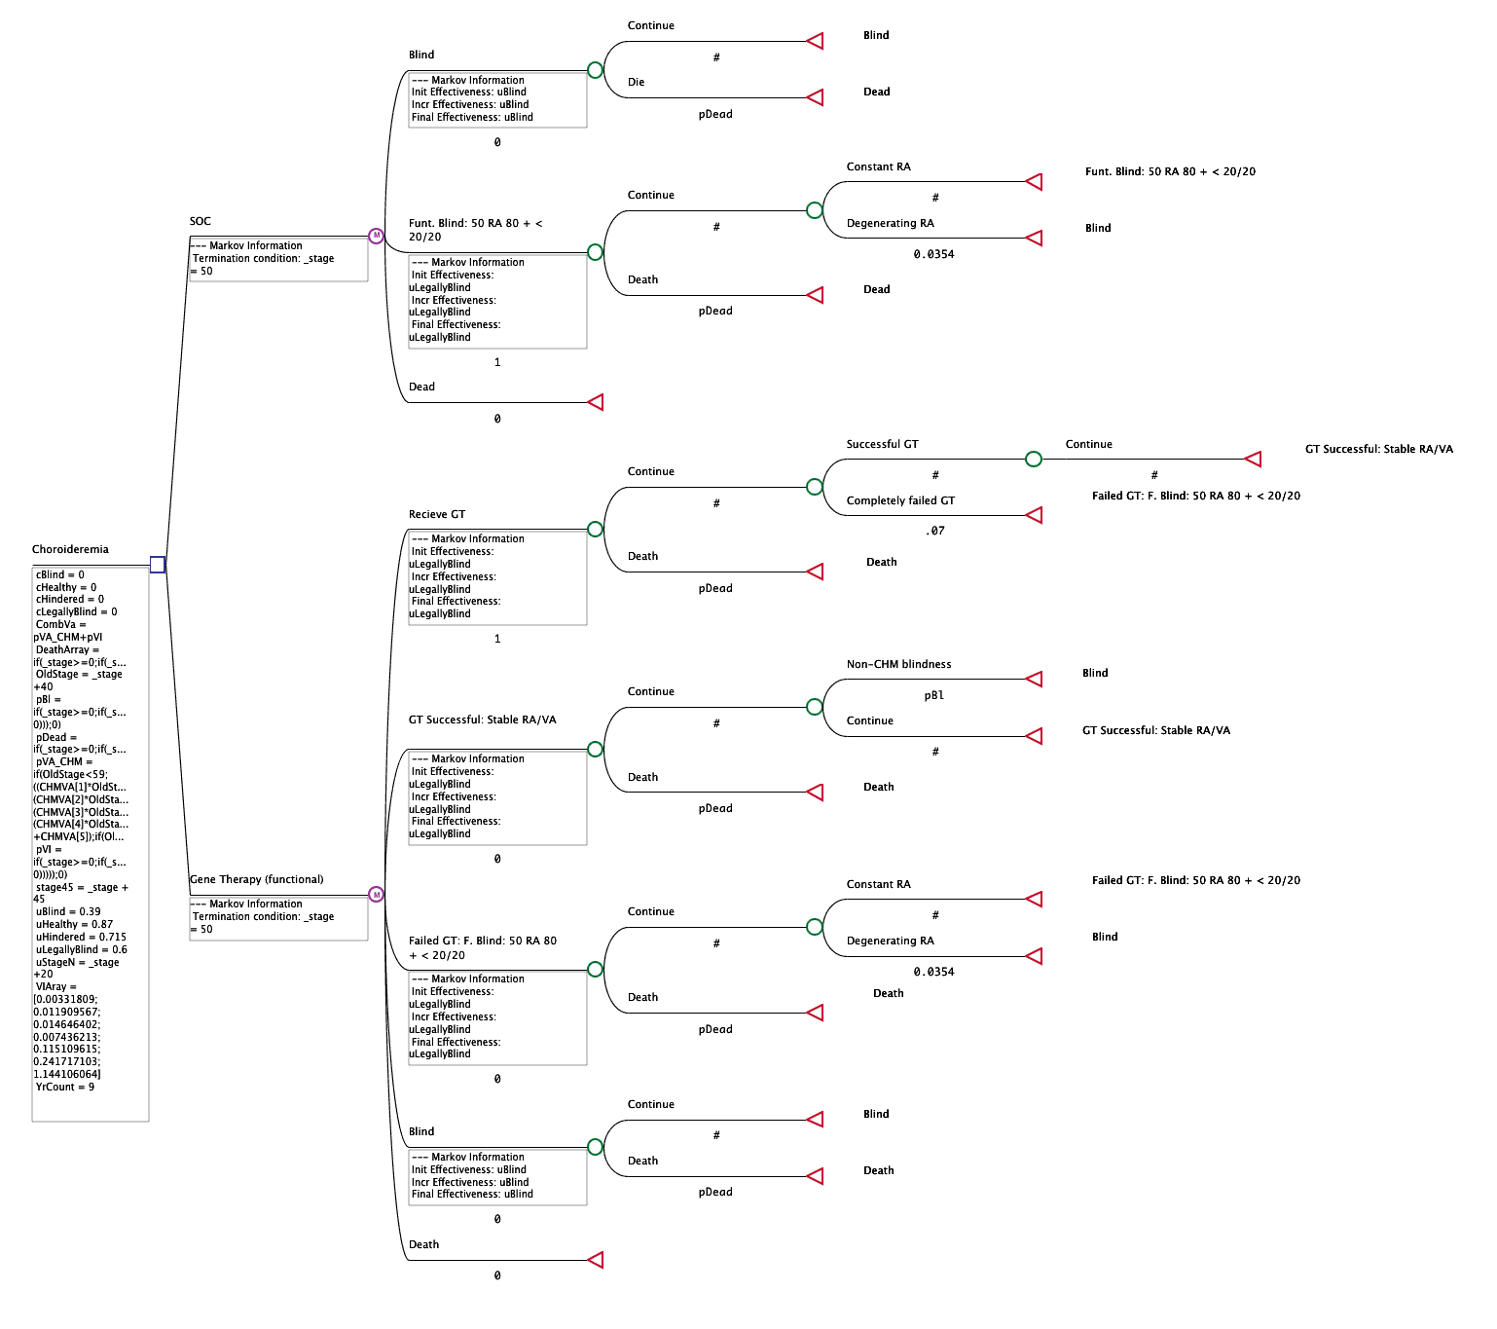
eFigure 3. Late-stage Cohort Markov model

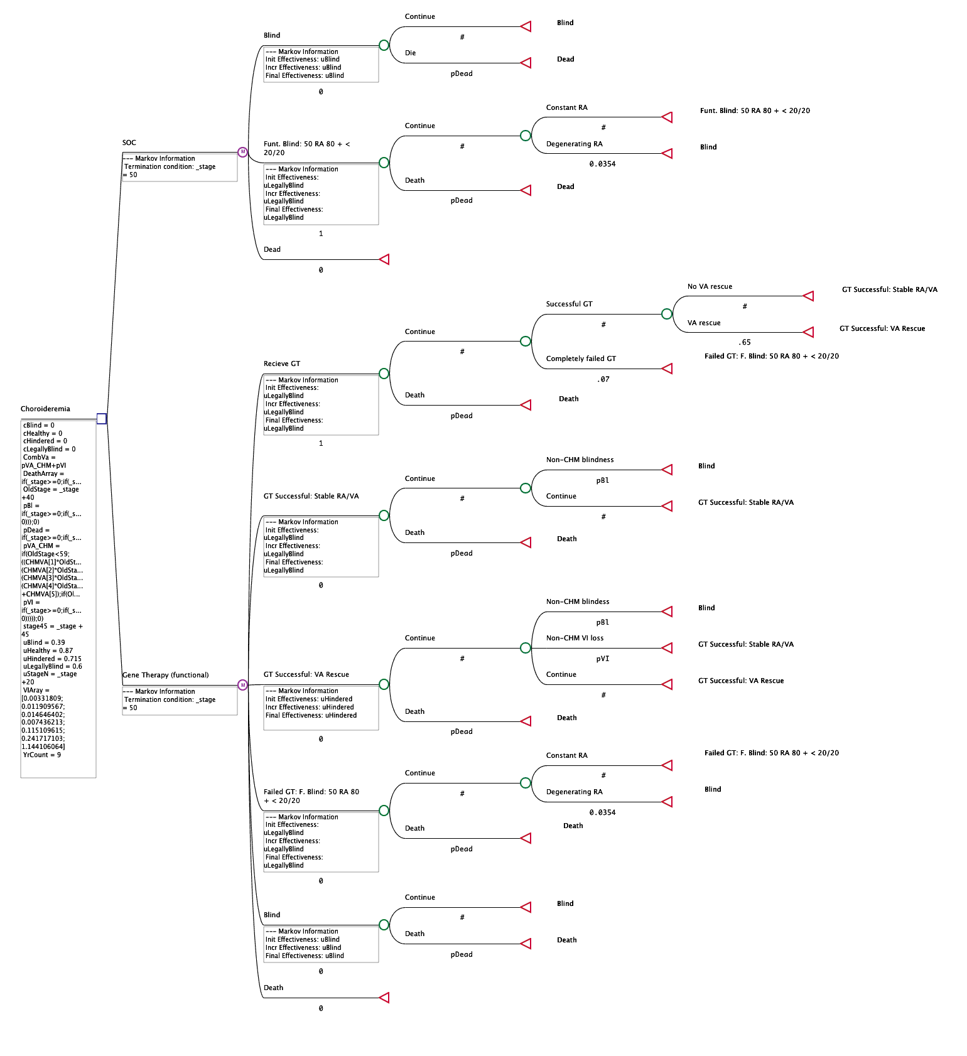

eFigure 4. Late Responders Supplemental Cohort Model

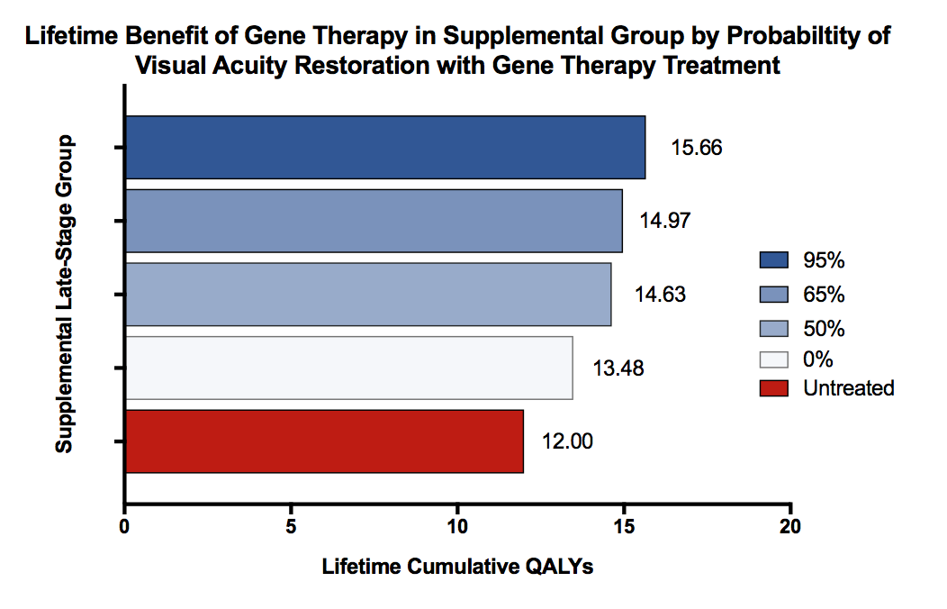

eFigure 5. Lifetime Benefit of Gene Therapy in Supplemental Group of Late Responders

Health State | Healthy |  | Hindered |  |  | Functionally Blind |  |  | Blind
Definition | RA > 80% & normal VA |  | RA > 80% and low VA OR  80% > RA > 50% & normal VA |  |  | 80% > RA > 50% & low VA OR 50% > RA > 10% & normal VA |  |  | 50% > RA > 10% & low VA OR RA < 10% & normal or low VA
Utility Value | 0.87 QALY/year |  | 0.715 QALY/year |  |  | 0.6 QALY/year |  |  | 0.39 QALY/year
 | Age-based Transition Probabilities (out of 1)
 | 20-29 years | 30-39 years |  | 40-49 years | 50-59 years |  | 60-69 years | 70-79 years |  | 80-110 years
Non-CHM Visual Impairment | 3.318*10⁻⁵ | 1.200*10⁻⁴ |  | 1.499*10⁻⁴ | 8.081*10⁻⁵ |  | 1.160*10⁻³ | 2.453*10⁻³ |  | 1.153*10⁻²
Non-CHM Blindness | 4.300*10⁻⁵ | 9.260*10⁻⁵ |  | 1.186*10⁻⁴ | 4.818*10⁻⁵ |  | 1.519*10⁻⁴ | 3.448*10⁻⁴ |  | 2.651*10⁻³
 | State-based Transition Probabilities (out of 1)
CHM Retinal Area Degeneration | 80% < RA to 80% > RA > 50% |  |  | 80% > RA > 50% to 50% > RA > 10% |  |  |  | 50% > RA > 10% to RA > 10%
 | 0.5 |  |  | 0.0354 |  |  |  | 0.0354
 | Equation-based Transition Probabilities
Death | If cycle # < 79; see graph below for plot of values (see S.3.i for exact values)  If cycle # ≥ 79; = (4.739*10⁻¹⁰)x⁵ – (3.100*10⁻⁸)x⁴ – (2.567*10⁻⁷)x³ + (5.345*10⁻⁵)x² – (8.209*10⁻⁴)x + 0.00322
CHM Visual Acuity Loss | If cycle # < 59; = (-1.0374e-7)x⁴ + (5.428e-6)x³ + (2.224e-4)x² + (-9.174e-4)x + 0.04618 (black)  If cycle # ≤ 75; = 0.7 (dark blue)  If cycle # < 75; = 0.85 (dark blue)
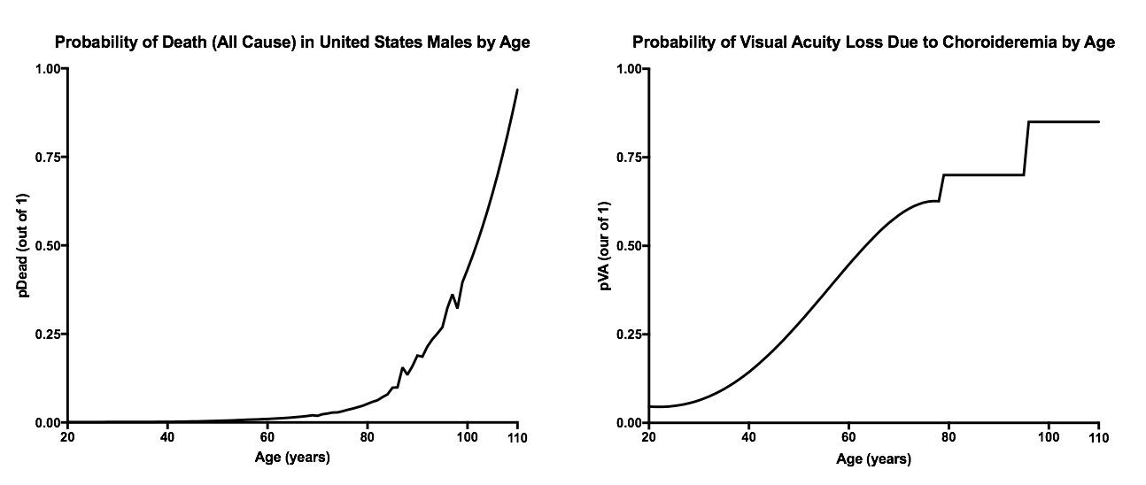
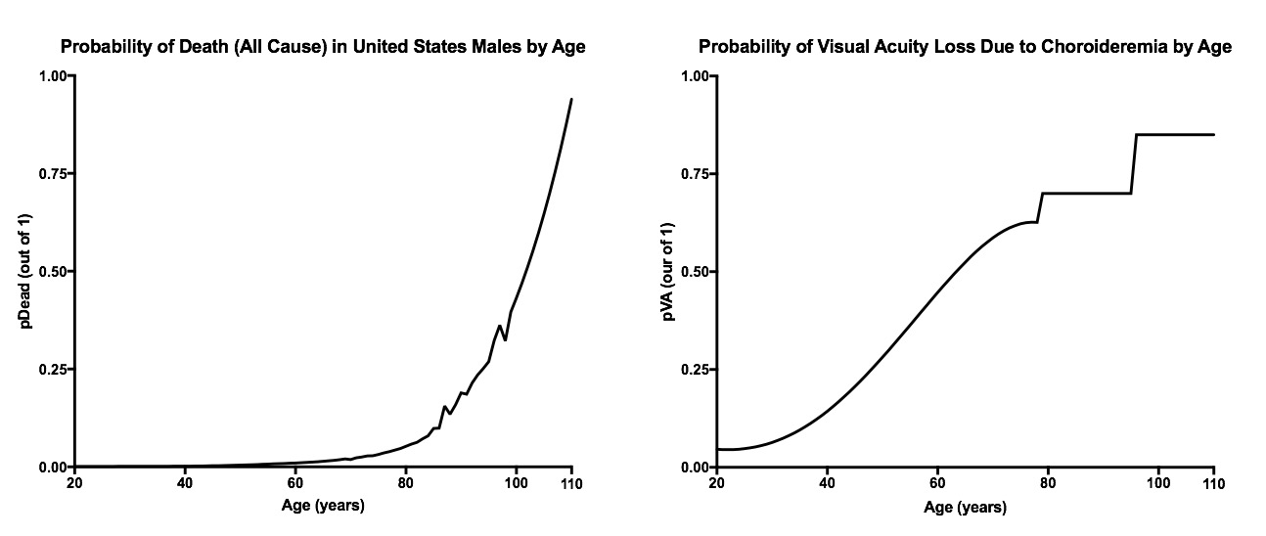

eTable 1. Input parameters of the model

pBl | Chance of patient developing blindness NOT due to choroideremia
pVA_CHM | Chance of a patient with choroideremia losing visual acuity due
pVI | Chance of a patient losing visual acuity NOT due to choroideremia
pDead | Chance of patient death
CombVA | Combined risk of visual acuity loss from both choroideremia and non-choroideremia causes
uHealthy | Health utility value for “healthy” health state
uHindered | Health utility value for “hindered” health state
uLegallyBlind | Health utility value for “functionally blind” health state
uBlind | Health utility value for “blind” health state
uStageN | Conversion of cycle number to patient age in years for early-stage
MedStage | Conversion of mid-stage model cycle number to early-stage cycle number scale
OldStage | Conversion of late-stage model cycle number to early-stage cycle number scale

eTable 2. Model Variables with Definitions

pDead Early-stage
if(_stage>=0;if(_stage<=1;DTbl[1];if(_stage=2;DTbl[2];if(_stage=3;DTbl[3];if(_stage=4;DTbl[4];if(_stage=5;DTbl[5];if(_stage=6;DTbl[6];if(_stage=7;DTbl[7];if(_stage=8;DTbl[8];if(_stage=9;DTbl[9];if(_stage=10;DTbl[10];if(_stage=11;DTbl[11];if(_stage=12;DTbl[12];if(_stage=13;DTbl[13];if(_stage=14;DTbl[14];if(_stage=15;DTbl[15];if(_stage=16;DTbl[16];if(_stage=17;DTbl[17];if(_stage=18;DTbl[18];if(_stage=19;DTbl[19];if(_stage=20;DTbl[20];if(_stage=21;DTbl[21];if(_stage=22;DTbl[22];if(_stage=23;DTbl[23];if(_stage=24;DTbl[24];if(_stage=25;DTbl[25];if(_stage=26;DTbl[26];if(_stage=27;DTbl[27];if(_stage=28;DTbl[28];if(_stage=29;DTbl[29];if(_stage=30;DTbl[30];if(_stage=31;DTbl[31];if(_stage=32;DTbl[32];if(_stage=33;DTbl[33];if(_stage=34;DTbl[34];if(_stage=35;DTbl[35];if(_stage=36;DTbl[36];if(_stage=37;DTbl[37];if(_stage=38;DTbl[38];if(_stage=39;DTbl[39];if(_stage=40;DTbl[40];if(_stage=41;DTbl[41];if(_stage=42;DTbl[42];if(_stage=43;DTbl[43];if(_stage=44;DTbl[44];if(_stage=45;DTbl[45];if(_stage=46;DTbl[46];if(_stage=47;DTbl[47];if(_stage=48;DTbl[48];if(_stage=49;DTbl[49];if(_stage=50;DTbl[50];if(_stage=51;DTbl[51];if(_stage=52;DTbl[52];if(_stage=53;DTbl[53];if(_stage=54;DTbl[54];if(_stage=55;DTbl[55];if(_stage=56;DTbl[56];if(_stage=57;DTbl[57];if(_stage=58;DTbl[58];if(_stage=59;DTbl[59];if(_stage=60;DTbl[60];if(_stage=61;DTbl[61];if(_stage=62;DTbl[62];if(_stage=63;DTbl[63];if(_stage=64;DTbl[64];if(_stage=65;DTbl[65];if(_stage=66;DTbl[66];if(_stage=67;DTbl[67];if(_stage=68;DTbl[68];if(_stage=69;DTbl[69];if(_stage=70;DTbl[70];if(_stage=71;DTbl[71];if(_stage=72;DTbl[72];if(_stage=73;DTbl[73];if(_stage=74;DTbl[74];if(_stage=75;DTbl[75];if(_stage=76;DTbl[76];if(_stage=77;DTbl[77];if(_stage=78;DTbl[78];if(_stage>=79; 0.000000000473978041100*_stage^5-0.000000031002169940000*_stage^4-0.000000256776852400000*_stage^3+0.000053453014590000000*_stage^2-0.000820971310800000000*_stage + 0.003223164424000000000;0)))))))))))))))))))))))))))))))))))))))))))))))))))))))))))))))))))))))))))))));0)
pDead Mid-stage
if(_stage>=0;if(_stage<=1;DTbl[1];if(_stage=2;DTbl[2];if(_stage=3;DTbl[3];if(_stage=4;DTbl[4];if(_stage=5;DTbl[5];if(_stage=6;DTbl[6];if(_stage=7;DTbl[7];if(_stage=8;DTbl[8];if(_stage=9;DTbl[9];if(_stage=10;DTbl[10];if(_stage=11;DTbl[11];if(_stage=12;DTbl[12];if(_stage=13;DTbl[13];if(_stage=14;DTbl[14];if(_stage=15;DTbl[15];if(_stage=16;DTbl[16];if(_stage=17;DTbl[17];if(_stage=18;DTbl[18];if(_stage=19;DTbl[19];if(_stage=20;DTbl[20];if(_stage=21;DTbl[21];if(_stage=22;DTbl[22];if(_stage=23;DTbl[23];if(_stage=24;DTbl[24];if(_stage=25;DTbl[25];if(_stage=26;DTbl[26];if(_stage=27;DTbl[27];if(_stage=28;DTbl[28];if(_stage=29;DTbl[29];if(_stage=30;DTbl[30];if(_stage=31;DTbl[31];if(_stage=32;DTbl[32];if(_stage=33;DTbl[33];if(_stage=34;DTbl[34];if(_stage=35;DTbl[35];if(_stage=36;DTbl[36];if(_stage=37;DTbl[37];if(_stage=38;DTbl[38];if(_stage=39;DTbl[39];if(_stage=40;DTbl[40];if(_stage=41;DTbl[41];if(_stage=42;DTbl[42];if(_stage=43;DTbl[43];if(_stage=44;DTbl[44];if(_stage=45;DTbl[45];if(_stage=46;DTbl[46];if(_stage=47;DTbl[47];if(_stage=48;DTbl[48];if(_stage=49;DTbl[49];if(_stage=50;DTbl[50];if(_stage=51;DTbl[51];if(_stage=52;DTbl[52];if(_stage=53;DTbl[53];if(_stage=54;DTbl[54];if(_stage=55;DTbl[55];if(_stage=56;DTbl[56];if(_stage=57;DTbl[57];if(_stage=58;DTbl[58];if(_stage=59;DTbl[59];if(_stage=60;DTbl[60];if(_stage=61;DTbl[61];if(_stage=62;DTbl[62];if(_stage=63;DTbl[63];if(_stage=64;DTbl[64];if(_stage=65;DTbl[65];0)))))))))))))))))))))))))))))))))))))))))))))))))))))))))))))))));0)
pDead Late-stage
if(_stage>=0;if(_stage<=1;DTbl[1];if(_stage=2;DTbl[2];if(_stage=3;DTbl[3];if(_stage=4;DTbl[4];if(_stage=5;DTbl[5];if(_stage=6;DTbl[6];if(_stage=7;DTbl[7];if(_stage=8;DTbl[8];if(_stage=9;DTbl[9];if(_stage=10;DTbl[10];if(_stage=11;DTbl[11];if(_stage=12;DTbl[12];if(_stage=13;DTbl[13];if(_stage=14;DTbl[14];if(_stage=15;DTbl[15];if(_stage=16;DTbl[16];if(_stage=17;DTbl[17];if(_stage=18;DTbl[18];if(_stage=19;DTbl[19];if(_stage=20;DTbl[20];if(_stage=21;DTbl[21];if(_stage=22;DTbl[22];if(_stage=23;DTbl[23];if(_stage=24;DTbl[24];if(_stage=25;DTbl[25];if(_stage=26;DTbl[26];if(_stage=27;DTbl[27];if(_stage=28;DTbl[28];if(_stage=29;DTbl[29];if(_stage=30;DTbl[30];if(_stage=31;DTbl[31];if(_stage=32;DTbl[32];if(_stage=33;DTbl[33];if(_stage=34;DTbl[34];if(_stage=35;DTbl[35];if(_stage=36;DTbl[36];if(_stage=37;DTbl[37];if(_stage=38;DTbl[38];if(_stage=39;DTbl[39];if(_stage=40;DTbl[40];if(_stage=41;DTbl[41];if(_stage=42;DTbl[42];if(_stage=43;DTbl[43];if(_stage=44;DTbl[44];if(_stage=45;DTbl[45];if(_stage=46;DTbl[46];if(_stage=47;DTbl[47];if(_stage=48;DTbl[48];if(_stage=49;DTbl[49];if(_stage=50;DTbl[50];0))))))))))))))))))))))))))))))))))))))))))))))))));0)
pVA_CHM Early-stage
if(_stage<59;((CHMVA[1]*_stage^4)+(CHMVA[2]*_stage^3)+(CHMVA[3]*_stage^2)+(CHMVA[4]*_stage)+CHMVA[5]);if(_stage<=75;0.7;0.85))
pVA_CHM Mid-stage
if(MedStage<59;((CHMVA[1]*MedStage^4)+(CHMVA[2]*MedStage^3)+(CHMVA[3]*MedStage^2)+(CHMVA[4]*MedStage)+CHMVA[5]);if(MedStage<=75;0.7;0.85))
pVA_CHM Late-stage
if(OldStage<59;((CHMVA[1]*OldStage^4)+(CHMVA[2]*OldStage^3)+(CHMVA[3]*OldStage^2)+(CHMVA[4]*OldStage)+CHMVA[5]);if(OldStage<=75;0.7;0.85))
pVI Early-stage
if(_stage>=0;if(_stage<=9;VITbl[1];if(_stage<=19;VITbl[2];if(_stage<=29;VITbl[3];if(_stage<=39;VITbl[4];if(_stage<49;VITbl[5];if(_stage<=59;VITbl[6];if(_stage<=90;VITbl[7];0)))))));0)
pVI Mid-stage
if(_stage>=0;if(_stage<=4;VITbl[1];if(_stage<=14;VITbl[2];if(_stage<=24;VITbl[3];if(_stage<=34;VITbl[4];if(_stage<65;VITbl[5];0)))));0)
pVI Late-stage
if(_stage>=0;if(_stage<=4;VITbl[1];if(_stage<=14;VITbl[2];if(_stage<=24;VITbl[3];if(_stage<=34;VITbl[4];if(_stage<65;VITbl[5];0)))));0)
pBl Early-stage
if(_stage>=0;if(_stage<=9;BlindTbl[1];if(_stage<=19;BlindTbl[2];if(_stage<=29;BlindTbl[3];if(_stage<=39;BlindTbl[4];if(_stage<49;BlindTbl[5];if(_stage<=59;BlindTbl[6];if(_stage<=90;BlindTbl[7];0)))))));0)
pBl Mid-stage
if(_stage>=0;if(_stage<=4;BlindTbl[1];if(_stage<=14;BlindTbl[2];if(_stage<=24;BlindTbl[3];if(_stage<=34;BlindTbl[4];if(_stage<=65;BlindTbl[5];0)))));0)
pBl Late-stage
if(_stage>=0;if(_stage<=9;BlindTbl[1];if(_stage<=19;BlindTbl[2];if(_stage<=60;BlindTbl[3];0)));0)

CombVA | pVA_CHM+pVI
_stage | = cycle count
uStageN | _stage + 20
MedStage | _stage + 25
OldStage | _stage + 40

eTable 3. Tree Age Pro Model Variable Definitions

DTbl Early-stage
Index | Value | Index | Value
1.0 | 0.001011053 | 40.0 | 0.009982858
2.0 | 0.001081902 | 41.0 | 0.010829288
3.0 | 0.001130725 | 42.0 | 0.011366471
4.0 | 0.001177227 | 43.0 | 0.012205895
5.0 | 0.001192603 | 44.0 | 0.01311356
6.0 | 0.001204095 | 45.0 | 0.014167817
7.0 | 0.001203962 | 46.0 | 0.015410675
8.0 | 0.001220225 | 47.0 | 0.016625315
9.0 | 0.001243065 | 48.0 | 0.018190381
10.0 | 0.001275754 | 49.0 | 0.020188924
11.0 | 0.001293479 | 50.0 | 0.018649091
12.0 | 0.001301509 | 51.0 | 0.023201932
13.0 | 0.001360092 | 52.0 | 0.025138095
14.0 | 0.001391065 | 53.0 | 0.028082428
15.0 | 0.001429969 | 54.0 | 0.028385137
16.0 | 0.001517068 | 55.0 | 0.031760718
17.0 | 0.001522384 | 56.0 | 0.035531533
18.0 | 0.001626516 | 57.0 | 0.039051267
19.0 | 0.001733618 | 58.0 | 0.043159087
20.0 | 0.001826207 | 59.0 | 0.04683313
21.0 | 0.002013154 | 60.0 | 0.052630745
22.0 | 0.002102256 | 61.0 | 0.058179138
23.0 | 0.002335173 | 62.0 | 0.062704643
24.0 | 0.002615333 | 63.0 | 0.071812409
25.0 | 0.002881326 | 64.0 | 0.079258324
26.0 | 0.003114582 | 65.0 | 0.098399432
27.0 | 0.003315167 | 66.0 | 0.099114008
28.0 | 0.00371224 | 67.0 | 0.155596891
29.0 | 0.004137048 | 68.0 | 0.134466516
30.0 | 0.00459842 | 69.0 | 0.158953277
31.0 | 0.005143391 | 70.0 | 0.188989221
32.0 | 0.005505479 | 71.0 | 0.185780348
33.0 | 0.005949554 | 72.0 | 0.214365224
34.0 | 0.006483491 | 73.0 | 0.235065983
35.0 | 0.007095244 | 74.0 | 0.251017401
36.0 | 0.007679032 | 75.0 | 0.268985685
37.0 | 0.008100391 | 76.0 | 0.323439352
38.0 | 0.008837535 | 77.0 | 0.362362216
39.0 | 0.00944848 | 78.0 | 0.321808815

DTbl Mid-stage
Index | Value | Index | Value
1.0 | 0.003114582 | 34.0 | 0.04683313
2.0 | 0.003315167 | 35.0 | 0.052630745
3.0 | 0.00371224 | 36.0 | 0.058179138
4.0 | 0.004137048 | 37.0 | 0.062704643
5.0 | 0.00459842 | 38.0 | 0.071812409
6.0 | 0.005143391 | 39.0 | 0.079258324
7.0 | 0.005505479 | 40.0 | 0.098399432
8.0 | 0.005949554 | 41.0 | 0.099114008
9.0 | 0.006483491 | 42.0 | 0.155596891
10.0 | 0.007095244 | 43.0 | 0.134466516
11.0 | 0.007679032 | 44.0 | 0.158953277
12.0 | 0.008100391 | 45.0 | 0.188989221
13.0 | 0.008837535 | 46.0 | 0.185780348
14.0 | 0.00944848 | 47.0 | 0.214365224
15.0 | 0.009982858 | 48.0 | 0.235065983
16.0 | 0.010829288 | 49.0 | 0.251017401
17.0 | 0.011366471 | 50.0 | 0.268985685
18.0 | 0.012205895 | 51.0 | 0.323439352
19.0 | 0.01311356 | 52.0 | 0.362362216
20.0 | 0.014167817 | 53.0 | 0.321808815
21.0 | 0.015410675 | 54.0 | 0.396285826
22.0 | 0.016625315 | 55.0 | 0.431457369
23.0 | 0.018190381 | 56.0 | 0.46908545
24.0 | 0.020188924 | 57.0 | 0.50929293
25.0 | 0.018649091 | 58.0 | 0.552206532
26.0 | 0.023201932 | 59.0 | 0.597956899
27.0 | 0.025138095 | 60.0 | 0.64667865
28.0 | 0.028082428 | 61.0 | 0.698510439
29.0 | 0.028385137 | 62.0 | 0.75359501
30.0 | 0.031760718 | 63.0 | 0.812079254
31.0 | 0.035531533 | 64.0 | 0.874114267
32.0 | 0.039051267 | 65.0 | 0.939855404
33.0 | 0.043159087

DTbl Late-stage
Index | Value | Index | Value
1.0 | 0.010829288 | 26.0 | 0.099114008
2.0 | 0.011366471 | 27.0 | 0.155596891
3.0 | 0.012205895 | 28.0 | 0.134466516
4.0 | 0.01311356 | 29.0 | 0.158953277
5.0 | 0.014167817 | 30.0 | 0.188989221
6.0 | 0.015410675 | 31.0 | 0.185780348
7.0 | 0.016625315 | 32.0 | 0.214365224
8.0 | 0.018190381 | 33.0 | 0.235065983
9.0 | 0.020188924 | 34.0 | 0.251017401
10.0 | 0.018649091 | 35.0 | 0.268985685
11.0 | 0.023201932 | 36.0 | 0.323439352
12.0 | 0.025138095 | 37.0 | 0.362362216
13.0 | 0.028082428 | 38.0 | 0.321808815
14.0 | 0.028385137 | 39.0 | 0.396285826
15.0 | 0.031760718 | 40.0 | 0.431457369
16.0 | 0.035531533 | 41.0 | 0.46908545
17.0 | 0.039051267 | 42.0 | 0.50929293
18.0 | 0.043159087 | 43.0 | 0.552206532
19.0 | 0.04683313 | 44.0 | 0.597956899
20.0 | 0.052630745 | 45.0 | 0.64667865
21.0 | 0.058179138 | 46.0 | 0.698510439
22.0 | 0.062704643 | 47.0 | 0.75359501
23.0 | 0.071812409 | 48.0 | 0.812079254
24.0 | 0.079258324 | 49.0 | 0.874114267
25.0 | 0.098399432 | 50.0 | 0.939855404

CHMVA (all)
Index | Value
1.0 | -1.03741936E-7
2.0 | 5.428130776E-6
3.0 | 2.224012258E-4
4.0 | -9.173510698E-4
5.0 | 0.04618941932

VITbl Early-stage
Index | Value 1
1.0 | 3.3180902781E-5
2.0 | 1.200489542255E-4
3.0 | 1.498838190209E-4
4.0 | 8.0809190861E-5
5.0 | 0.00115951162904
6.0 | 0.0024533798718562
7.0 | 0.0115358007479491

VITbl Mid- and late-stage
Index | Value
1.0 | 1.498838190209E-4
2.0 | 8.0809190861E-5
3.0 | 0.00115951162904
4.0 | 0.0024533798718562
5.0 | 0.0115358007479491

BlindTbl Early-stage
Index | Value
1.0 | 4.30043509311E-5
2.0 | 9.25977549295E-5
3.0 | 1.18620993624E-4
4.0 | 4.81809829672E-5
5.0 | 1.518884417653E-4
6.0 | 3.448454902214E-4
7.0 | 0.0026506435307779

BlindTbl Mid-stage
Index | Value
1.0 | 1.186209936241E-4
2.0 | 4.81809829672E-5
3.0 | 1.518884417653E-4
4.0 | 3.448454902214E-4
5.0 | 0.002650643530778

BlindTbl Late-stage
Index | Value
1.0 | 1.518884417653E-4
2.0 | 3.448454902214E-4
3.0 | 0.0026506435307779

eTable 4. Reference Tables for Tree Age Pro Model Variable Definitions

Discount Rate | Early Stage | Mid Stage | Late Stage
0% | 14.30 QALYs | 6.22 QALYs | 1.48 QALYs
1.5% | 8.65 QALYs | 4.46 QALYs | 1.14 QALYs
3.0% | 5.66 QALYs | 3.31 QALYs | 0.9 QALYs

eTable 5. Discount Rate Sensitivity Analyses

 |  | Net benefit of gene therapy over untreated
Patient Cohort | Health Utility Value Varied | Base | Low (-15%) | High (+15%)
Early Stage | Healthy (0.7395, 1.00) | 14.33 QALYs | 7.52 QALYs | 21.06 QALYs
Early Stage | Hindered (0.6078, 0.8223) | 14.33 QALYs | 16.75 QALYs | 11.85 QALYs
Early Stage | Funct. Blind (0.51, 0.69) | 14.33 QALYs | 15.68 QALYs | 12.93 QALYs
Early Stage | Blind (0.3315, 0.448) | 14.33 QALYs | 15.11 QALYs | 13.50 QALYs
Mid Stage | Healthy (0.7395, 1.00) | 6.22 QALYs | 6.22 QALYs | 6.22 QALYs
Mid Stage | Hindered (0.6078, 0.8223) | 6.22 QALYs | 3.14 QALYs | 9.30 QALYs
Mid Stage | Funct. Blind (0.51, 0.69) | 6.22 QALYs | 7.56 QALYs | 4.88 QALYs
Mid Stage | Blind (0.3315, 0.448) | 6.22 QALYs | 7.03 QALYs | 5.42 QALYs
Late Stage | Healthy (0.7395, 1.00) | 1.48 QALYs | 1.48 QALYs | 1.48 QALYs
Late Stage | Hindered (0.6078, 0.8223) | 1.48 QALYs | 1.48 QALYs | 1.48 QALYs
Late Stage | Funct. Blind (0.51, 0.69) | 1.48 QALYs | 1.90 QALYs | 1.07 QALYs
Late Stage | Blind (0.3315, 0.448) | 1.48 QALYs | 0.85 QALYs | 2.12 QALYs

eTable 6. Sensitivity Analysis of Health Utility Values. Health utility values were varied independently ± 15% of base model value.

Net benefit of gene therapy over untreated
Patient Cohort | Base | Low (-15%) | High (+15%)
Early Stage | 14.33 QALYs | 12.16 QALYs | 16.43 QALYs
Mid Stage | 6.22 QALYs | 5.29 QALYs | 7.17 QALYs
Late Stage | 1.48 QALYs | 1.26 QALYs | 1.71 QALYs

eTable 7. Sensitivity Analysis of Health Utility Values. Health utility values were simultaneously varied +15% or -15%.

Patient Cohort | Gene Therapy Treatment Success Probability
Patient Cohort | Utilized (93%) | 100% | 88.5% | 83.5%
Early-stage | 14.30 QALYs | 15.67 QALYs | 13.42 QALYs | 12.45 QALYs
Mid-stage | 6.22 QALYs | 6.67 QALYs | 5.93 QALYs | 5.61 QALYs
Late-stage | 1.48 QALYs | 1.59 QALYs | 1.42 QALYs | 1.34 QALYs
Late-responders* | 2.97 QALYs | 3.19 QALYs | 2.83 QALYs | 2.68 QALYs

eTable 8. Sensitivity Analysis of Gene Therapy Success Rate. Values are the QALY gain due to gene therapy (gene therapy lifetime QALY minus untreated lifetime QALY). *late-responder with a 65% probability of visual acuity rescue.

References for Supplemental Methods

1. Jolly JK, Xue K, Edwards TL, Groppe M, MacLaren RE. Characterizing the Natural History of Visual Function in Choroideremia Using Microperimetry and Multimodal Retinal Imaging. Invest Ophthalmol Vis Sci. 2017;58(12):5575-5583. doi:10.1167/iovs.17-22486
2. Low Vision Tables | National Eye Institute. https://www.nei.nih.gov/eyedata/lowvision/tables. Accessed November 2, 2017.
3. MacLaren RE, Groppe M, Barnard AR, et al. Retinal gene therapy in patients with choroideremia: initial findings from a phase 1/2 clinical trial. The Lancet. 2014;383(9923):1129-1137. doi:10.1016/S0140-6736(13)62117-0
4. Jolly JK, Edwards TL, Moules J, Groppe M, Downes SM, MacLaren RE. A Qualitative and Quantitative Assessment of Fundus Autofluorescence Patterns in Patients With ChoroideremiaQuantification of Autofluorescence in Choroideremia. Invest Ophthalmol Vis Sci. 2016;57(10):4498-4503. doi:10.1167/iovs.15-18362
5. US Census Bureau. Population and Housing Unit Estimates. /popest. Accessed December 31, 2017.
6. Bunce C, Wormald R. Leading causes of certification for blindness and partial sight in England & Wales. BMC Public Health. 2006;6:58. doi:10.1186/1471-2458-6-58
7. Edwards T, Jolly JK, Groppe M, et al. Visual Acuity after Retinal Gene Therapy for Choroideremia. N Engl J Med. 2016;374(20):1995-1996. doi:10.1056/NEJMc1509501

