- Case details

Patient local hospital number: ________________
Month and year of birth: ____________________
Patient Sex: Male Female
White | Asian or Asian British | Black or Black British | Chinese | Mixed Race | Other ethnic group
British  Irish  Other (please specify) | Indian  Pakistani  Bangladeshi  Other (please specify) | Caribbean  African  Other (please specify) | Chinese  Other (please specify) | (please specify)  ____________ | Other (please specify)

Here are some questions about the diagnosis of hydroxychloroquine toxicity in this patient

- What was the date of confirmation of the diagnosis of hydroxychloroquine retinopathy?

(Short case definition: macular dysfunction due to hydroxychloroquine toxicity confirmed on one investigation out of: automated visual field, OCT, autofluorescence or electrodiagnostics). For full case definition see Page 3 of this document.

___________/__________/__________ [DD/MM/YYYY]

3. Does the patient have any relevant ocular co-morbidities?

☐ Cataract
☐ Diabetic maculopathy
☐ Glaucoma
☐ Age related macular degeneration
☐ Choroidal neovascularisation
☐ Macular oedema associated with vein occlusion
☐ Other, please specify:

1.______________________________ 2.______________________________ 3._____________________________

☐ Don’t know

Next, we have some questions about indications and symptoms:

4. What is the patient’s primary treatment indication for hydroxychloroquine?

☐ Systemic Lupus Erythematosus
☐ Rheumatoid Arthritis
☐ Other disorder (including dermatological). Please specify: ______________________________
☐ Don’t know

5. At diagnosis, what symptoms did the patient have?

☐ Scotoma
☐ Reduced visual acuity
☐ Deficit in colour vision
☐ Other: please specify __________________________________
☐ Don’t know
☐ Patient was asymptomatic

Next are some questions about the abnormalities on investigation of the patient

6. Vision at diagnosis

 | RIGHT EYE | LEFT EYE
Best corrected visual acuity
(Snellen or LogMAR)

Visual field Mean Deviation
(in decibels (dB))

Please circle visual field protocol:

10-2 / 24-2 / 30-2 / not done

7. What investigations were used to diagnose hydroxychloroquine retinopathy in this patient? Please tick a column for each investigation result in this case.

Investigation | Normal | Abnormal | Not needed | Not available
Fundoscopy
Humphrey visual field
Fundus autofluorescence
Spectral domain OCT
Electrodiagnostic testing: ERG
Electrodiagnostic testing:
Multifocal ERG

8. Was the external limiting membrane disrupted on SD-OCT imaging at diagnosis?

☐ Yes
☐ No

9. What distribution of hydroxychloroquine retinopathy existed in this patient?
Please select A, B or C

A | B | C
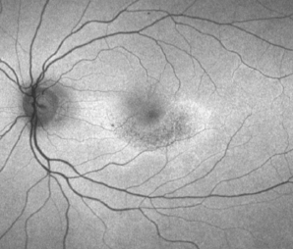 | 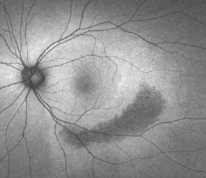 | 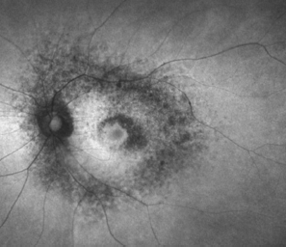
Paracentral disease | Pericentral disease | Mixed: paracentral and pericentral disease
retinal changes within a disc  diameter of the foveal centre | retinal changes > 1 disc diameter  away from the foveal centre | Paracentral AND pericentral  distribution of disease

10. How long had this patient been taking hydroxychloroquine for?

__________ years _________months

☐ Don’t know

11. What was the daily dose of hydroxychloroquine when the diagnosis was made?

__________ milligrams per day

☐ Don’t know

12. Did this patient have known renal impairment?

☐ Yes
☐ No
☐ Don’t know

13. Did this patient take tamoxifen in the past or at the time of diagnosis?

☐ Tamoxifen taken previously
☐ Tamoxifen taken at the time of diagnosis of hydroxychloroquine retinopathy
If known, what was the duration of tamoxifen use: __________years
☐ No history of tamoxifen use
☐ Don’t know
14. How was this patient with hydroxychloroquine retinopathy managed at diagnosis?

☐ Hydroxychloroquine treatment was stopped
☐ Hydroxychloroquine dose was reduced: the new dose was ________mg per day
☐ Hydroxychloroquine was continued at the same dose
☐ Don’t know

15. If hydroxychloroquine was continued, please specify the reason for this:

☐ Don’t know

16. Was this patient referred to your ophthalmology department from another ophthalmology department?

☐ Yes. Please specify hospital referred from:________________________________
☐ No
☐ Don’t know

Thank you for taking the time to complete this questionnaire.

Please return questionnaire to: Mr Imran Yusuf, Specialist Registrar in Ophthalmology, Oxford Eye Hospital, West Wing, John Radcliffe Hospital, Oxford, OX3 9DU.

Incomplete questionnaires should also be returned if outstanding clinical details cannot be identified.

