Appendix 1. PRISMA (Preferred Reporting Items for Systematic Reviews and Meta-Analyses) Study Selection Flow Diagram
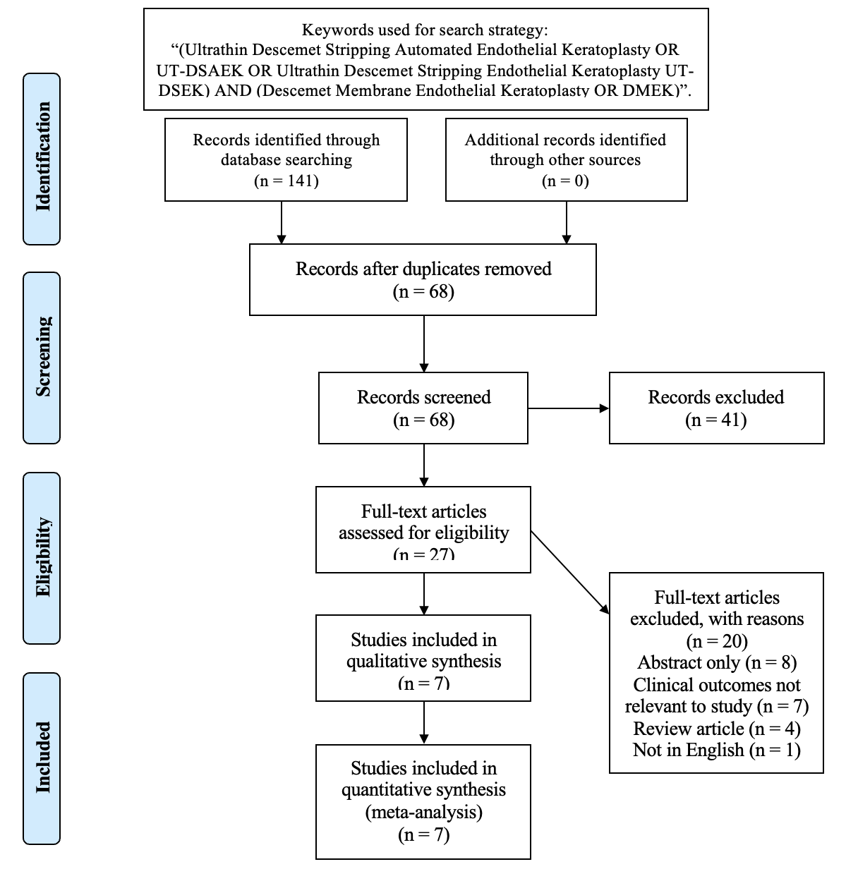
Appendix 2. Total Complications
Complication | UT-DSAEK | DMEK
Re-Bubbling | 11 | 31
Glaucoma / Raised IOP | 15 | 14
Graft Failure | 1 | 2
Graft Rejection | 2 | 1
Re-Transplantation | 0 | 3
Retinal Tear | 0 | 1
Cystoid Macular Edema | 0 | 1
Posterior Synechiae | 0 | 1
Donor Preparation Failure | 1 | 1
Other | 3 | 4

Appendix 3. Newcastle-Ottawa Scale (NOS) for assessing methodological quality of evidence (MQOE) in cohort studies
Study | Selection |  |  |  | Comparability | Outcome |  |  | NOS score
 | A | B | C | D | E | F | G | H
Mencucci, 2020 | * | * | * | * | ** |  | * | * | 8
Romano, 2020 | * | * | * | * |  |  | * | * | 6
Torras-Sanvicens, 2021 | * | * | * | * | * |  | * | * | 7
Tourabaly, 2019 | * | * | * | * | * |  | * | * | 7
A, Representativeness of the exposed cohort; B, Selection of the non-exposed cohort; C, Ascertainment of exposure; D, Demonstration that outcome of interest was not present at start of study; E, Comparability of cohorts on the basis of the design or analysis controlled for confounders; F, Assessment of outcome; G, Was follow-up long enough for outcomes to occur; H, Adequacy of follow-up of cohorts. * represents 1 point (max 2 points for E)

Appendix 4. Cochrane Collaboration risk of bias tool for assessing MQOE in randomised controlled trials
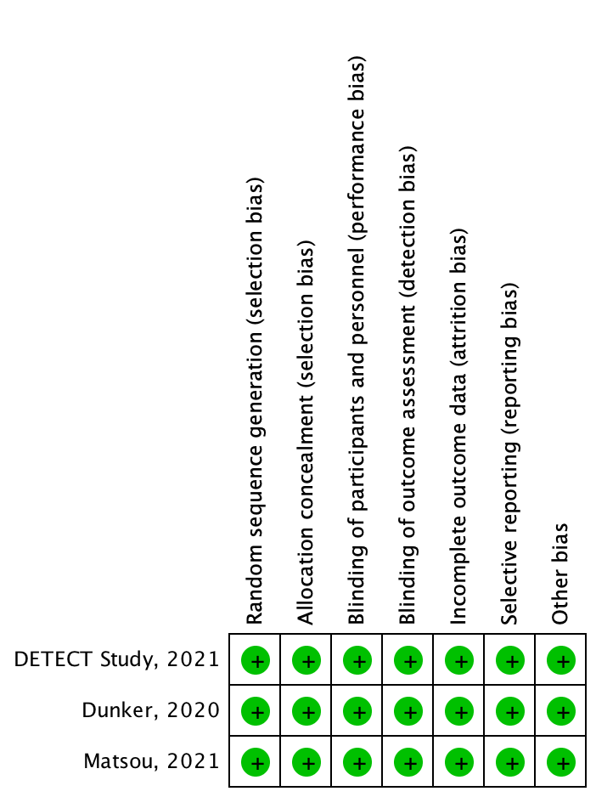

UT-DSAEK versus DMEK
Patients or population: Patients with corneal endothelial disease
Intervention 1: Ultrathin descemet stripping automated endothelial keratoplasty (UT-DSAEK)
Intervention 2: Descemet membrane endothelial keratoplasty (DMEK)
Outcomes | Illustrative comparative risks |  | Relative effect  (95% CI) | No. of eyes  (studies) | Quality of the evidence  (GRADE)
Outcomes | UT-DSAEK | DMEK | Relative effect  (95% CI) | No. of eyes  (studies) | Quality of the evidence  (GRADE)
BCVA (LogMAR)  1 year follow-up | 0.14 | 0.07 | MD: 0.07  (0.04 – 0.10) | 362  (7) | ⊕⊕⊕⊕  high
Endothelial Cell Density (cells/mm²)  1 year follow-up | 1,541 | 1,605 | MD: -63.57  (-296.7 – 169.5) | 216  (5) | ⊕⊕⊝⊝  low
Total Complications  1 year follow-up | 33 | 59 | RR: 0.57  (0.36 – 0.9) | 236  (5) | ⊕⊕⊕⊝ moderate
Rates of Re-Bubbling  1 year follow-up | 11 | 31 | RR: 0.40  (0.22 – 0.73) | 236  (5) | ⊕⊕⊕⊕  high
The corresponding risk (and its 95% confidence interval) is based on the assumed risk in the comparison group and the relative effect of the intervention (and its 95% CI). CI: Confidence interval; MD: Mean Difference; RR: Risk Ratio
GRADE Working Group grades of evidence
High quality: Further research is very unlikely to change our confidence in the estimate of effect
Moderate quality: Further research is likely to have an important impact on our confidence in the estimate of effect and may change the estimate
Low quality: Further research is very likely to have an important impact on our confidence in the estimate of effect and is likely to change the estimate
Very low quality: We are very uncertain about the estimate.
Appendix 5. Summary of Findings

