Supplementary materials for:

A Phase III study comparing preservative-free latanoprost eye drop emulsion with preserved latanoprost in open-angle glaucoma or ocular hypertension
Christophe Baudouin, Ingeborg Stalmans, Rupert Bourne, Jose Manuel Larrosa, Stefanie Schmickler, Aleksey Seleznev and Francesco Oddone, on behalf of the Phase III study group

Supplementary Statistical Information
Analysis of the primary efficacy endpoint was performed on the FAS population using a MMRM model on observed cases collected up to Week 12 [1]. No imputation of missing data was required. A separate MMRM model was used for IOP at each timepoint. The model included treatment, visit, treatment-by-visit interaction as fixed effects, baseline IOP at the respective timepoint and country as covariates. Within-subject errors will be modelled using an unstructured (UN) covariance matrix. Where the UN model failed to converge, the first-order auto-regression model and the variance components model were fitted sequentially until the convergence criteria are met.
A similar MMRM to primary endpoint analysis was performed mean diurnal IOP in period 1. The model included treatment, visit, and treatment-by-visit interaction as fixed effects, baseline diurnal IOP and country as covariates. Estimates of treatment effects were based on the least square means (LS mean). The LS mean, difference of the LS mean between two groups, and the corresponding 95% CI was provided at each visit.
For the binary endpoints, number of patients who achieved the criteria, response rate (%), risk difference and the corresponding 95% confidence interval, and p-value (Chi-squared test) were provided.
Reference
1. Laird NM, Ware JH. Random-Effects Models for Longitudinal Data. Biometrics 1982;38:963–74.

Supplementary Table 1. TFBUT, conjunctival hyperaemia and slit lamp examination in the efficacy analysis
Endpoint | Analysis visit | Statistics (Scores) | Preservative-free latanoprost eye drop emulsion (n=192) | Preserved latanoprost (n=192)
TFBUT | Baseline | n | 123 | 136
TFBUT | Baseline | Mean (SD) | 5.88 (2.71) | 6.14 (2.67)
TFBUT | Week 4 | n | 121 | 134
TFBUT | Week 4 | Mean (SD) | 6.49 (2.92) | 6.94 (3.42)
TFBUT | Week 12 | n | 119 | 134
TFBUT | Week 12 | Mean (SD) | 6.67 (3.14) | 7.03 (3.59)
Conjunctival hyperaemia score | Baseline | n | 191 | 191
Conjunctival hyperaemia score | Baseline | Mean (SD) | 1.38 (0.58) | 1.42 (0.63)
Conjunctival hyperaemia score | Week 4 | n | 189 | 189
Conjunctival hyperaemia score | Week 4 | Mean (SD) | 1.38 (0.59) | 1.46 (0.66)
Conjunctival hyperaemia score | Week 12 | n | 190 | 193
Conjunctival hyperaemia score | Week 12 | Mean (SD) | 1.34 (0.55) | 1.42 (0.66)
Slit lamp examination

Meibomian glands | Baseline | n | 192 | 192
Meibomian glands | Baseline | Mean (SD) | 0.4 (0.65) | 0.4 (0.66)
Meibomian glands | Week 4 | n | 189 | 189
Meibomian glands | Week 4 | Mean (SD) | 0.4 (0.65) | 0.3 (0.60)
Meibomian glands | Week 12 | n | 188 | 190
Meibomian glands | Week 12 | Mean (SD) | 0.4 (0.60) | 0.3 (0.59)
Conjunctiva chemosis | Baseline | n | 192 | 192
Conjunctiva chemosis | Baseline | Mean (SD) | 0.1 (0.34) | 0.2 (0.40)
Conjunctiva chemosis | Week 4 | n | 189 | 189
Conjunctiva chemosis | Week 4 | Mean (SD) | 0.1 (0.25) | 0.1 (0.37)
Conjunctiva chemosis | Week 12 | n | 188 | 190
Conjunctiva chemosis | Week 12 | Mean (SD) | 0.0 (0.21) | 0.1 (0.24)
Lid and lid margin erythema | Baseline | n | 192 | 192
Lid and lid margin erythema | Baseline | Mean (SD) | 0.3 (0.55) | 0.4 (0.58)
Lid and lid margin erythema | Week 4 | n | 189 | 189
Lid and lid margin erythema | Week 4 | Mean (SD) | 0.3 (0.53) | 0.3 (0.52)
Lid and lid margin erythema | Week 12 | n | 188 | 190
Lid and lid margin erythema | Week 12 | Mean (SD) | 0.3 (0.51) | 0.3 (0.48)
Tear film debris | Baseline | n | 192 | 192
Tear film debris | Baseline | Mean (SD) | 0.2 (0.48) | 0.2 (0.47)
Tear film debris | Week 4 | n | 189 | 189
Tear film debris | Week 4 | Mean (SD) | 0.2 (0.40) | 0.2 (0.45)
Tear film debris | Week 12 | n | 188 | 190
Tear film debris | Week 12 | Mean (SD) | 0.2 (0.41) | 0.1 (0.35)
SD, standard deviation; TFBUT, tear-film breakup time.

Supplementary Figure 1. Study design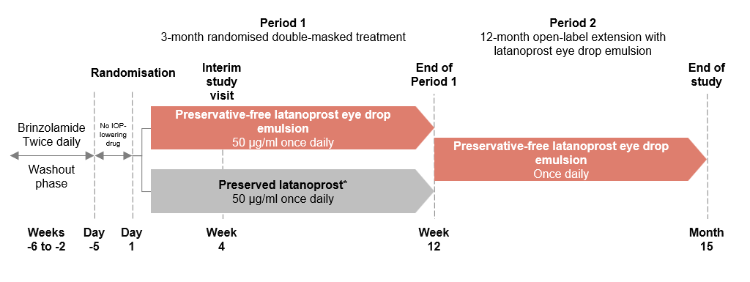

*Preserved latanoprost was requested as a study reference drug by the European Medicines Agency.
IOP, intraocular pressure.

Supplementary Figure 2. Patient disposition
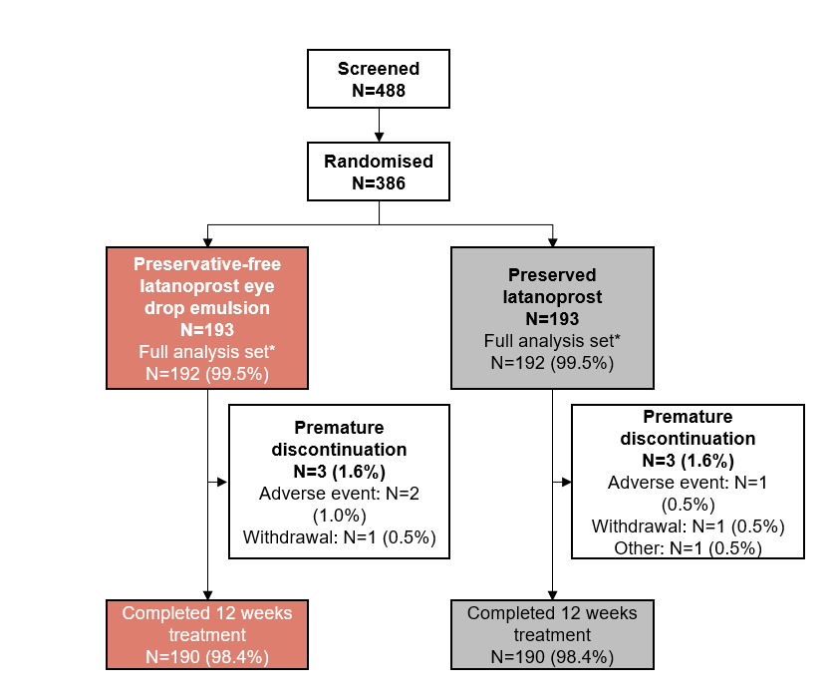*All randomised patients received at least one dose of study medication and were included in the safety population (N=386, 193 in each treatment arm); 384 patients (192 in each treatment arm) had at least one post-baseline IOP measurement at both peak and trough times and were included in the full analysis set evaluated for efficacy.
IOP, intraocular pressure.

Supplementary Figure 3. Baseline CFS and OSD average symptom score
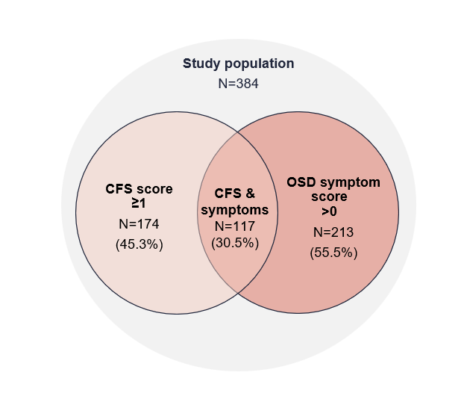CFS, corneal fluorescein staining; OSD, ocular surface disease.

Supplementary Figure 4. Patients with IOP response at Week 12 (A) peak and (B) trough in the efficacy population
A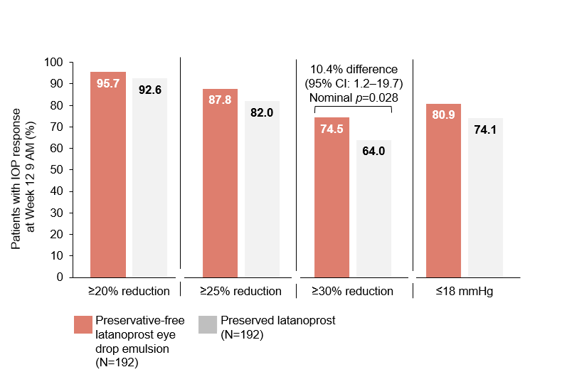

B
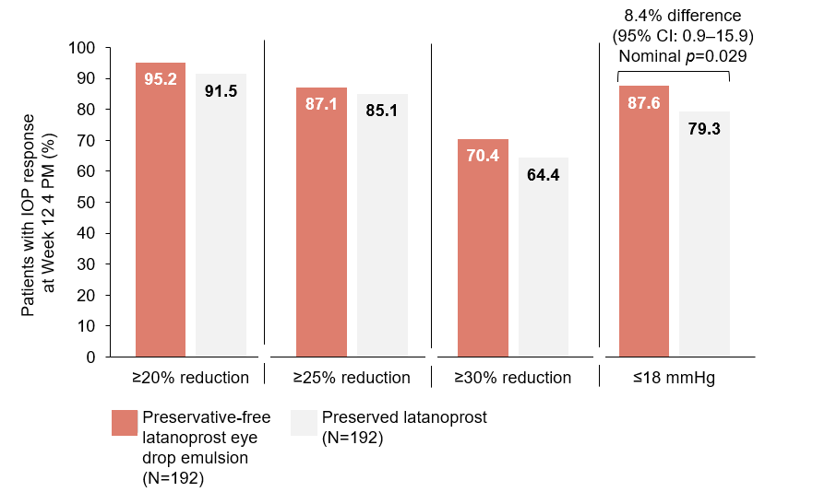
CI, confidence interval; IOP, intraocular pressure.
Supplementary Figure 5. Patient Global Rating of Treatment after 12 weeks in the efficacy analysis