Supplemental Information

Sensitization of ON bipolar cells with ambient light activatable Multi-characteristic opsin rescues vision in mice

Subrata Batabyal, Sivakumar Gajjeraman, Sanjay Pradhan, Sulagna Bhattacharya, Weldon Wright, Samarendra Mohanty*

Nanoscope Technologies LLC,
Bedford, TX 76022, USA.

* Correspondence should be addressed to S.M (smohanty@nanoscopetech.com)
Address: 1312 Brown Trail, Bedford TX 76022
Phone: 949-439-7923, Fax: 817-719-2962

Center
 | Before | 4-5 Weeks | 8 Weeks
AAV | NA | NA | NA
1E8 vg/eye | No Difference | ** | No Difference
1E9 vg/eye | No Difference | ** | NA
1E10 vg/eye | No Difference | ** | **, #
**p<0.01 between AAV and others, #p<0.05 between 1E8 vg/eye vs. 1E10 vg/eye

Side
AAV | NA | NA | NA
1E8 vg/eye | No Difference | ** | No Difference
1E9 vg/eye | No Difference | ** | NA
1E10 vg/eye | No Difference | ** | **, ##
**p<0.01 between AAV and others, ##p<0.01 between 1E8 vg/eye vs. 1E10 vg/eye

Table S1. One-way ANOVA with Tukey post hoc analysis of vMCO1 dose dependent improvement in behavior of rd10 mice in radial water maze assay.

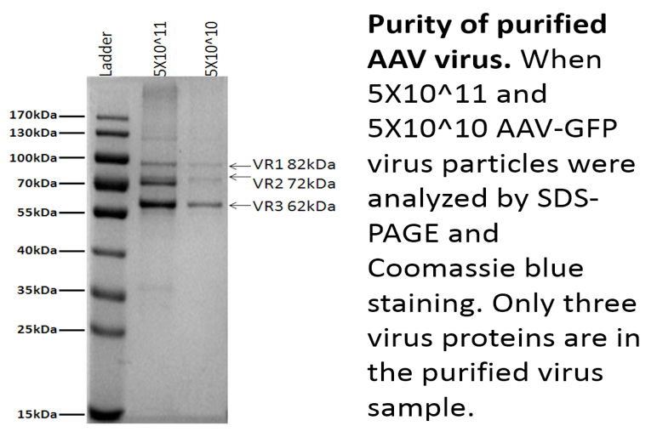
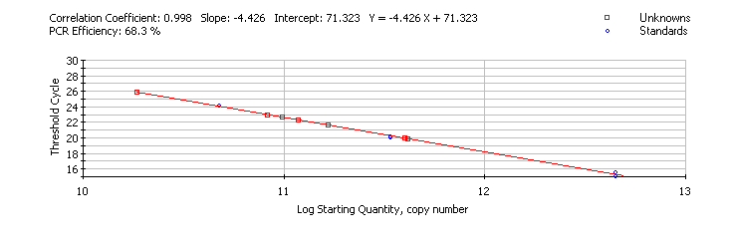
B
A

Fig. S1. Characterization of vMCO1. (A) PCR base line subtracted curve fit data for vMCO1; (B) SDS-PAGE and Coomassie blue staining-based analysis of two different concentrations of vMCO1.

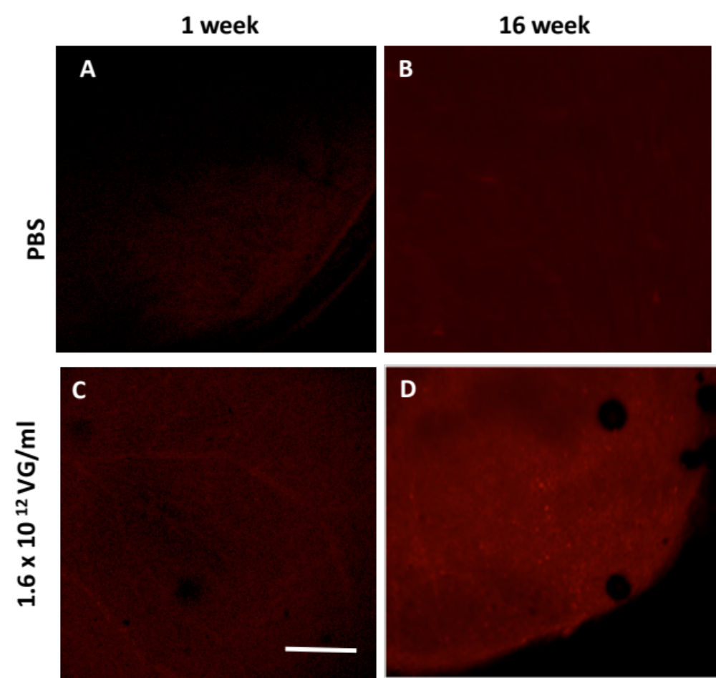

Fig. S2. Expression of vMCO1-mCherry in retina of rd10 mice at different time points. Low magnification (4X) representative confocal fluorescence image of rd10 mice retina with intravitreal injection of 1x PBS (top) and vMCO1 at 1.0 x 10¹⁰ vg (bottom). Scale bar: 200 μm.

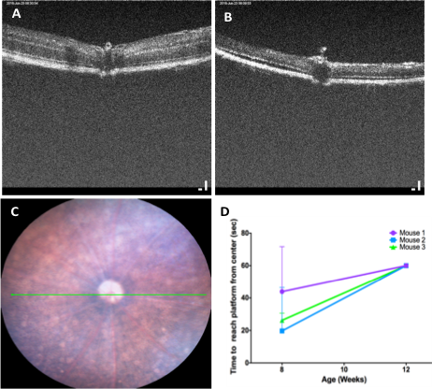

Fig. S3. Progressive retinal degeneration leads to behavioral deterioration of rd10 mice. OCT image of mouse retina: (A) 12 weeks old wild type, (B) age-matched rd10. (C) Representative fundus image of a rd10 mouse. The green line represents the OCT scan in B. (D) Time to reach platform (with white LED light directed towards center of maze) from center of the water maze as a function of age of rd10 mice. N=3; Average ± S.D. Mice not finding platform within experimental cut-off time (60 sec) were picked up to avoid tiring them.

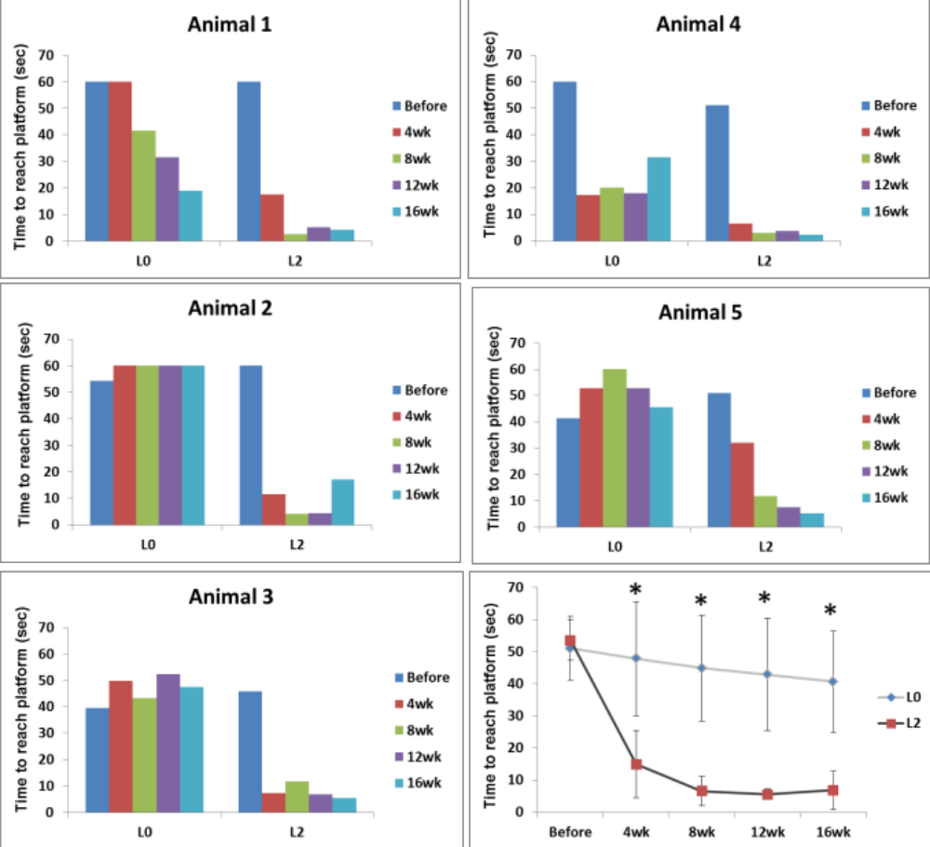

Fig. S4. Light-intensity dependence of improvement in rd10 mice behavior in radial water maze. Comparison of time to reach platform from center of the maze between two different light intensities as a function of post-injection (vMCO-1, 1.0x10¹⁰ vg/eye) period. Average ± S.D. *P < 0.01. L₀= 0.5 µW/mm²; L₂= 7 µW/mm². Bright ambient level is ~ 10 µW/mm².

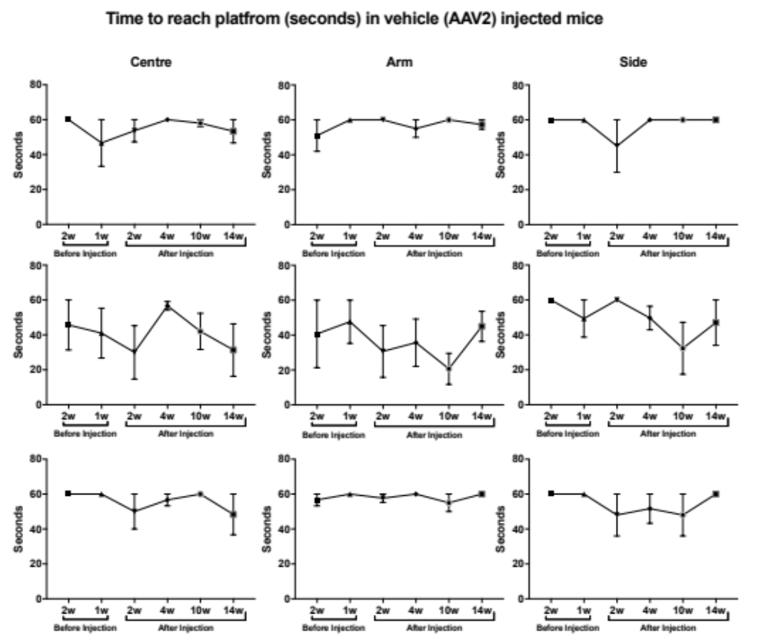

Fig. S5. Control longitudinal study of visually guided behavior in rd10 mice injected with vehicle (AAV2). Time to reach platform from center with light intensity: 7 µW/mm² (top panel), arm (middle panel) and side (bottom panel) of the maze (light intensity: 2 µW/mm²) as a function of pre, and post-injection of AAV2 vehicle. N=3; Average ± S.D.

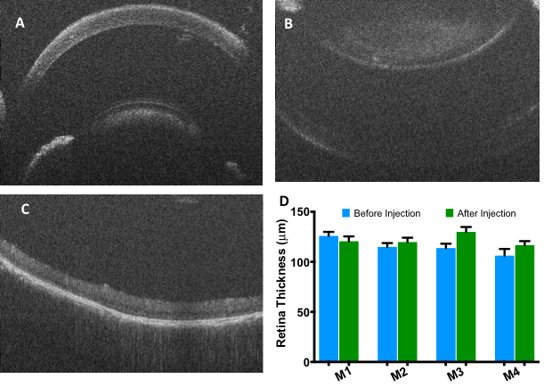
Fig. S6. Monitoring vMCO-1 injection related damage to eye. Representative OCT image of rd10 mice (A) cornea and lens (and iris) and (B) retina before vMCO-1 injection. (C) OCT image of retina of same animal after vMCO1 injection. (D) Comparison of retinal thickness before and within 1 week after injection. N=4 mice, n=10/ mice. Average + SD. No statistically significant difference between before and after injection thickness.

