Supplementary Figures:
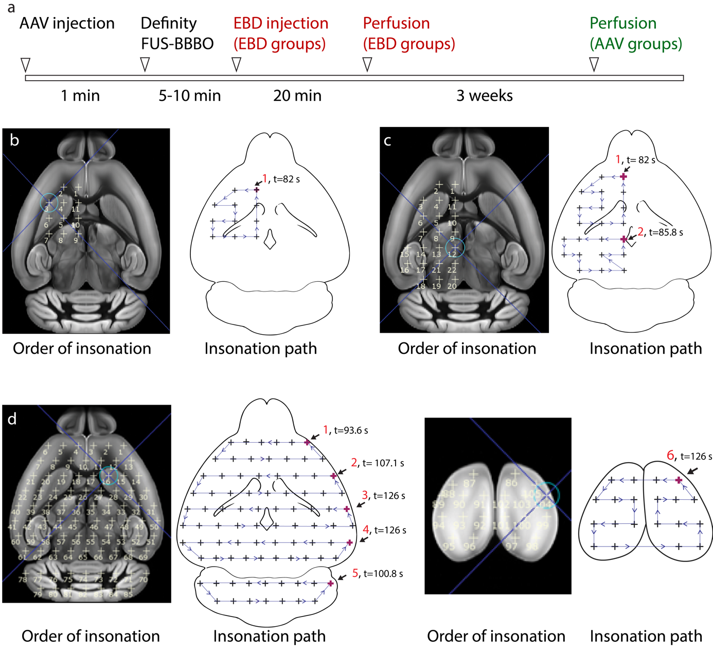
Supplementary Fig. 1: Targeting strategy for gene delivery. a) The timecourse of the typical FUS procedures. b) Site numbers with transducer movement and groups are shown on the axial images of the brain for group A, c) group B, and d) group C. Images with black background (left side of each panel; ‘Order of insonation’) indicate the sites of insonation, and the numbers indicate order in which these insonations were applied. The purple bolded crosses on the images on the right side of the panels (‘Insonation path’) indicate the initial site of insonation. The path and direction of the transducer’s movement are indicated on the thin blue lines connecting the insonation sites. The movement of the transducer from the initial position was observed for each sonication and timed. In group A (targeting 11 sites) the duration was 82 seconds. In group B (22 sites targeting) two sonications were performed. The first sonication lasted 82 seconds, while the second one lasted 85.8 seconds. Group C required six sonications to target 105 sites in the brain. The durations for these sonications were as follows: 93.6 seconds, 107.1 seconds, 126 seconds, 126 seconds, 100.8 seconds, and 126 seconds, respectively. The red numbers before the time of insonation indicate the individual Definity injections (1 for 11-site targeting, 2 for 22-site targeting, and 6 for 105-site targeting).

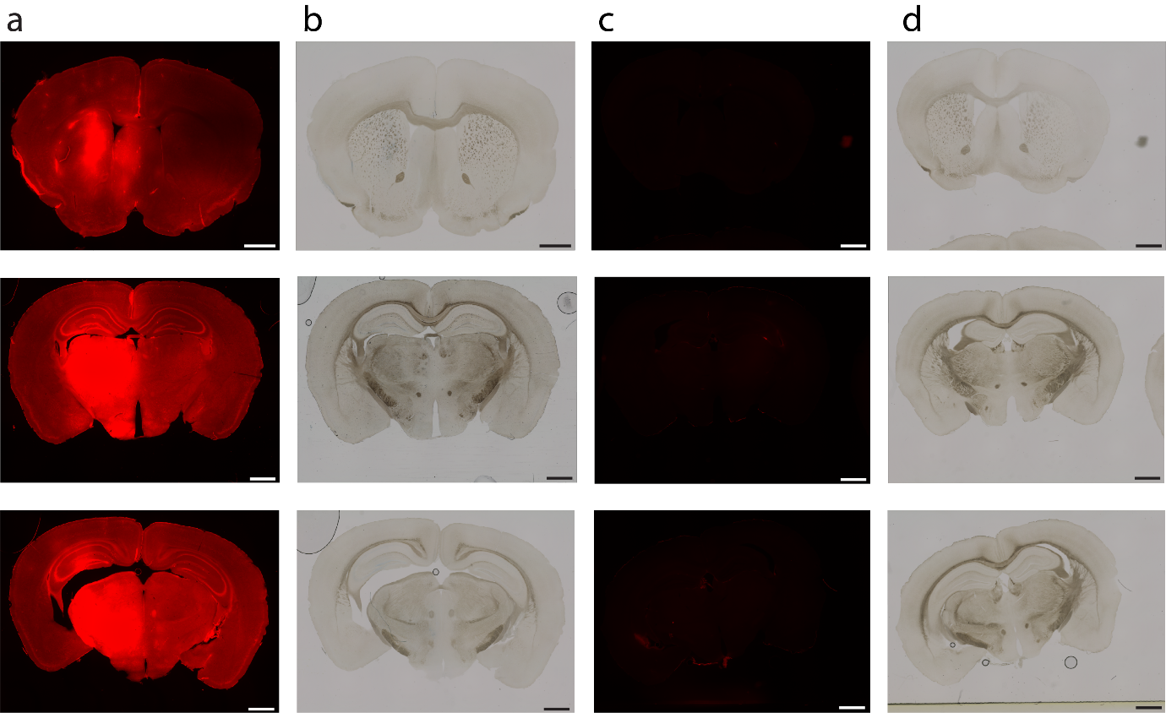
Supplementary Fig. 2: Evaluation of FUS-BBBO with Microbubble and without Microbubble injection . Two Groups of mice (N=4) were tested , with left side 22 sites targeting. Random brain section of a) EBD flourecence and b) bright field image of represented mouse with Microbubble injection and random brain section of c) EBD fluorescence and d) bright field image of represented mouse without microbubble injection are show no EBD extravasation. We have observed no apparent tissue damage in either of the groups. Scale bars are 1000 microns.
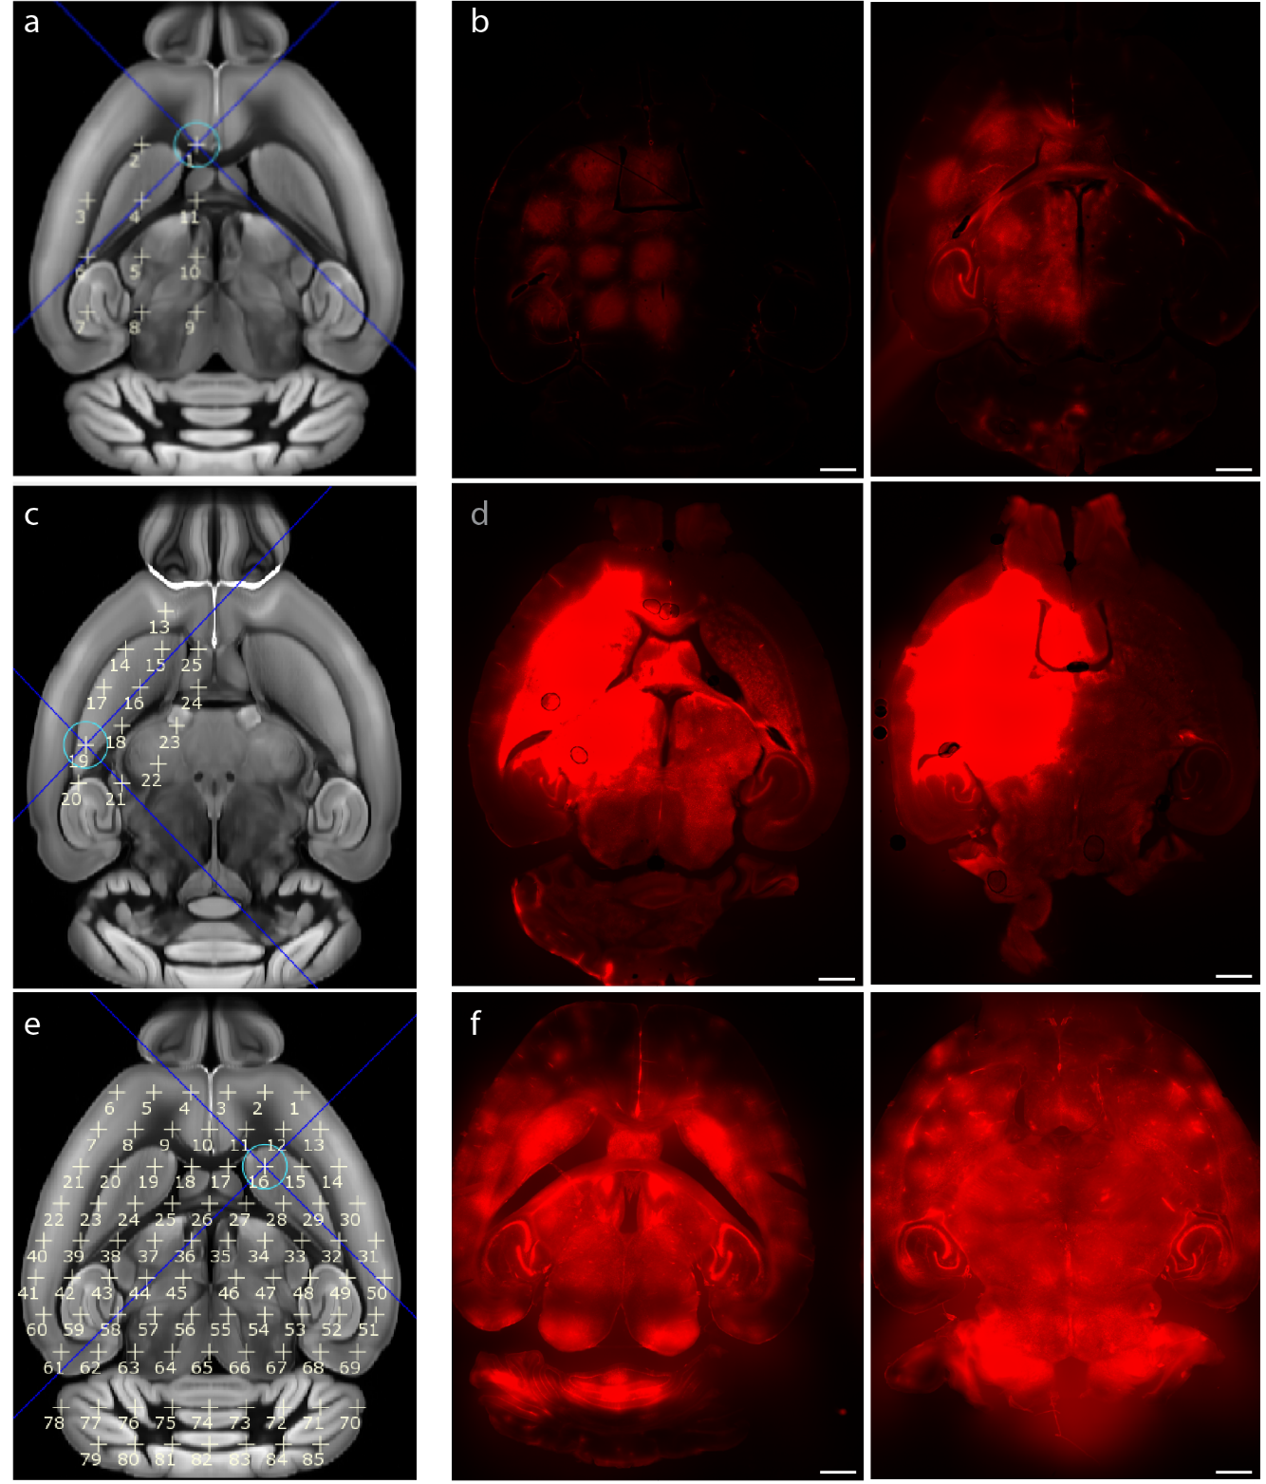
Supplementary Fig. 3: Delivery of Evans blue dye with FUS-BBBO. Two mice were tested for each group, with 11, 22, or 85 sites. a) Targeting plan showing the location of the 11 targeted sites. b) EBD fluorescence of tested mice. c) Targeting plan for the 22-site BBB opening, and d) EBD fluorescence for both tested mice. e) Targeting plan showing the location of 85 sites, and f) images of EBD fluorescence for both mice. We have observed no apparent tissue damage in either of the groups. Scale bars are 1000 microns.

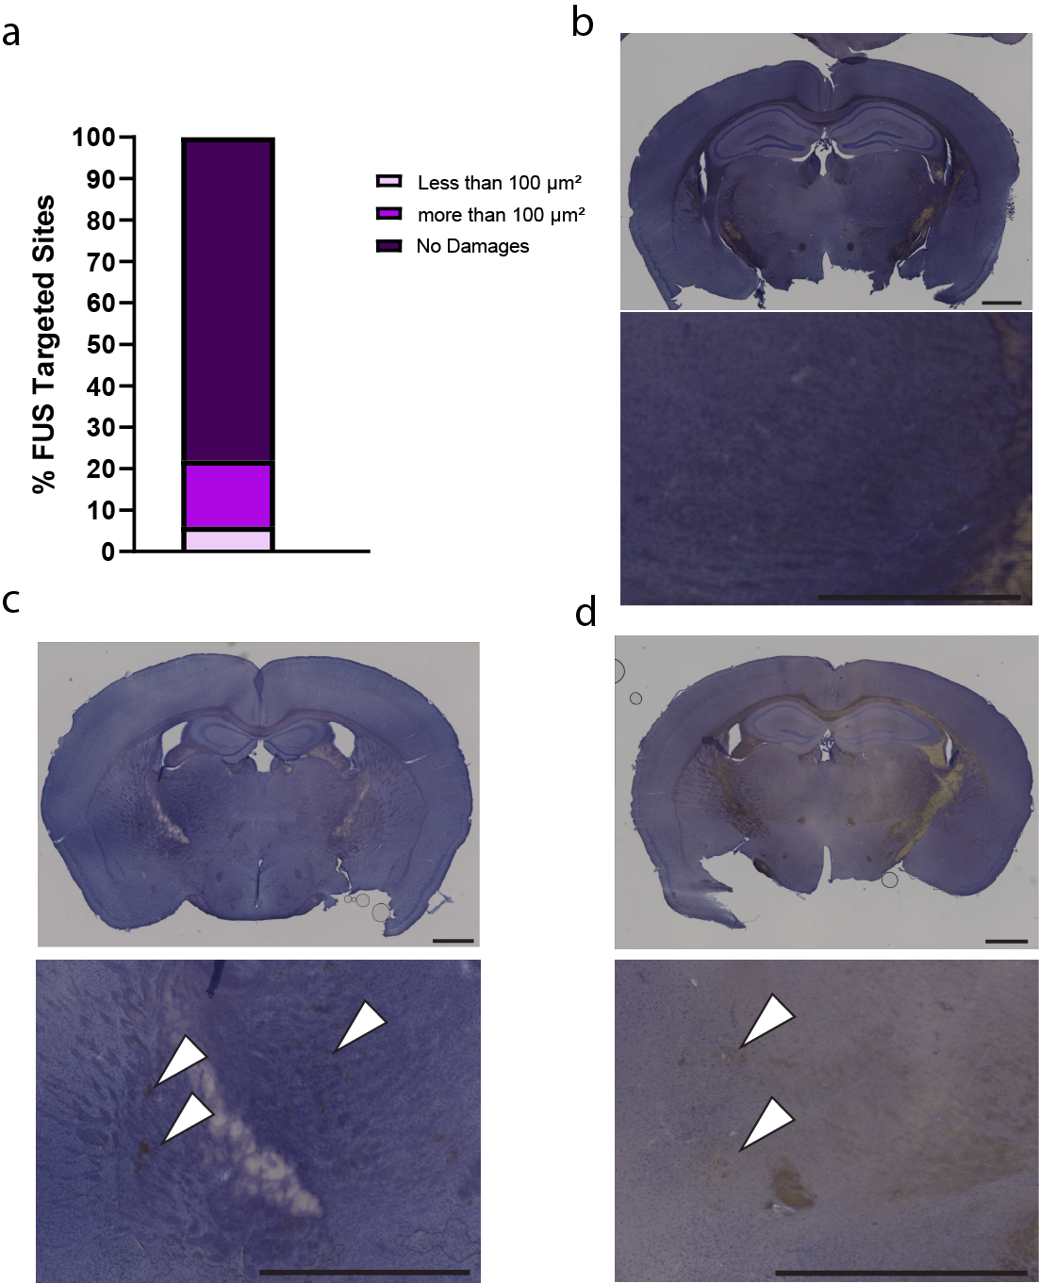
Supplementary Fig. 4: Short term safety assement. a) measuring the hemorrhage size for 132 sites in 6 mice. b) representative images of the brain sections with no hemmorhages and c) with hemorrhages below 100 μm² and d) with more than 100 μm². Scale bars are 1000 microns.

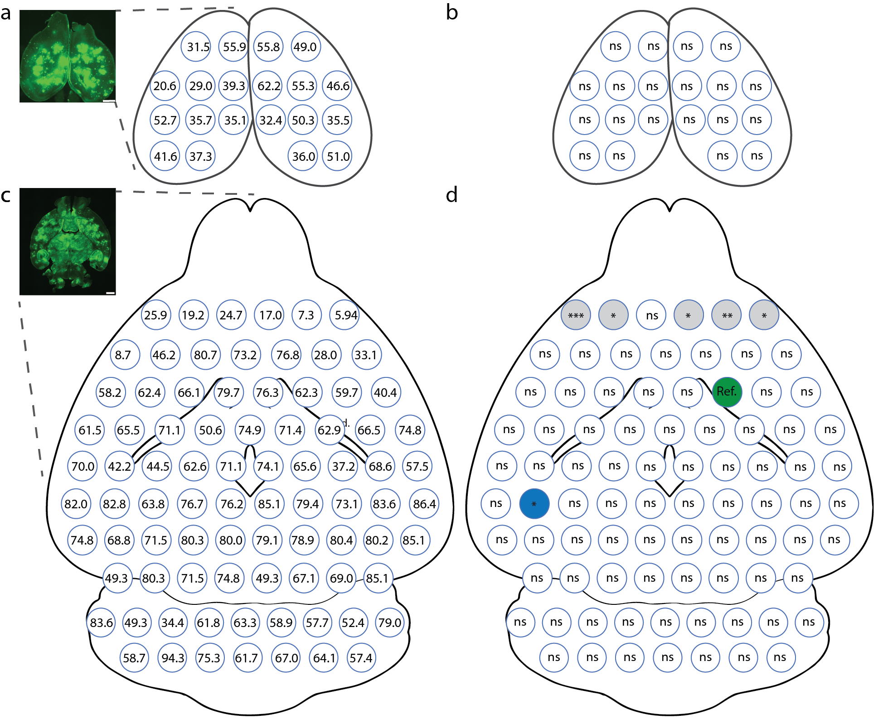
Supplementary Fig. 5: Transduction efficiency in each of the 105 FUS-BBBO-targeted sites. a) Representative image of the gene expression in the cortex overlaying hippocampus in group C mice (20 sites), along with the mean transduction efficiency (n=6 mice). Each circle represents a targeted site, and the number inside represents mean transduction efficiency. b) All sites in the cortex are not significantly different than a site transduced in caudate putamen (Cpu), a commonly targeted region in FUS-BBBO studies. Each circle represents a targeted site, and the ‘ns’ refers to a p-value above 0.05. c) Representative image and the mean transduction efficiency in each targeted site. Each circle represents a targeted site, and the number inside represents mean transduction efficiency. d) Several sites were significantly different than the reference ("Ref.”, green) site in Cpu). Most of the sites were at the top targeted row and had lower transduction than Cpu (grey color). However, one site in hippocampus showed higher transduction (blue). ns = p>0.05, * = p<0.05, ** = p<0.01, *** = p<0.001. Scale bars are 1000 microns

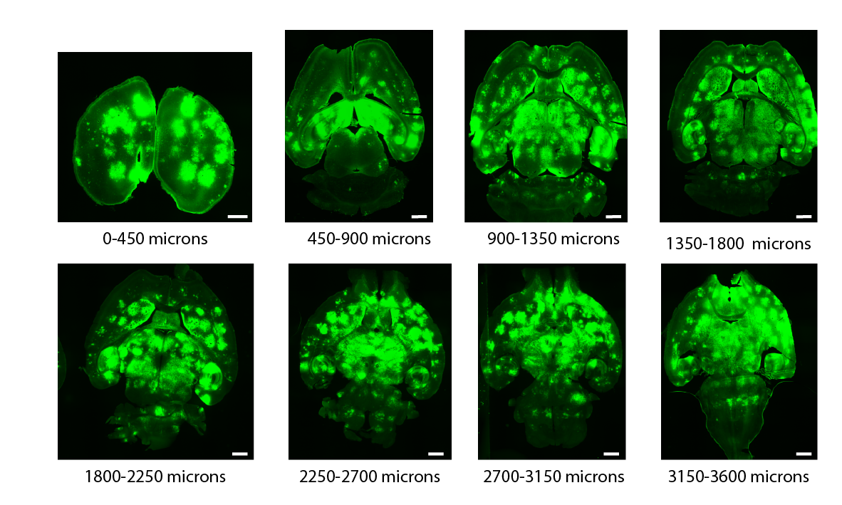
Supplementary Figure 6. Distribution of gene expression at different depths of targeting. First image on the left shows the approximate depth of the section from the top of the brain. The 50-micron sections were taken randomly from bins of 450 microns to evaluate how FUS-BBBO enhanced AAV expression changes in 3-dimensions. We observe gene expression at all tested depths, throughout the brain.

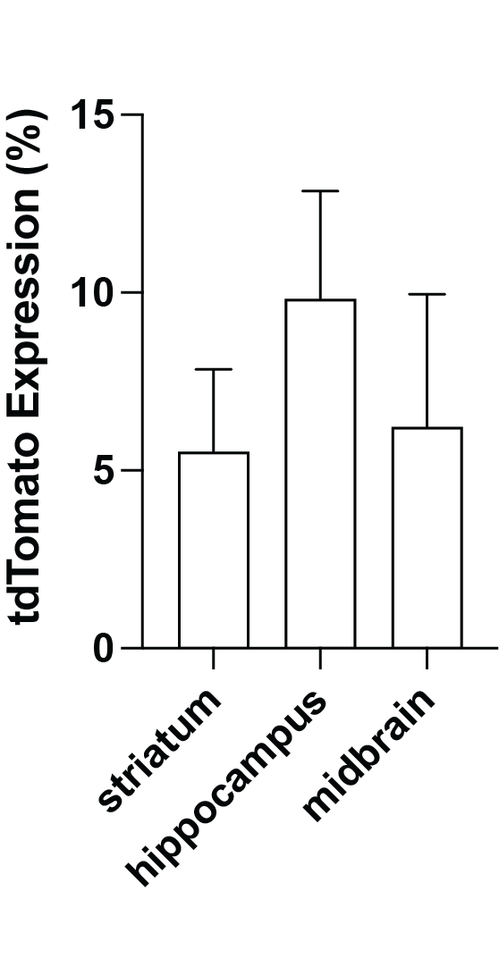
Supplementary Figure 7. Gene editing efficiency does not vary between the regions after FUS-BBBO delivery to Ai9 nice. AAV9 carrying SpCas9 under the neuron-specific Mecp2 promoter, and the guide RNA (gRNA) under the U6 promoter targeting the STOP cassette and a GFP under synapsin was injected intravenously and FUS-BBBO applied in the same parameters as in the group B throughout the study (22 sites). We allowed 3 weeks of expression and observed no significant differences in the genome editing efficiency, as evidenced by tdTomato expression among the tested brain regions [one-way ANOVA, with Tukey’s post-hoc test, F(2, 62)= 0.2331].

