 |  |  | Dose Group
Test | Normal cats in colony (n=26) |  | 5.0 x 10¹³ vg/kg |  |  | 7.5 x 10¹³ vg/kg |  |  | 1.0 x 10¹⁴ vg/kg
Liver Function | Range | Mean | 1 | 2 | 3 | 1 | 2 | 3 | 1 | 2 | 3
ALT | 27-99 | 52.4 | 27 | 29 | ND | 75 | 52 | 118 | 67 | 67 | 76
AST | 11-84 | 22 | 22 | 30 | ND | 40 | 40 | 94 | 44 | 42 | 48
Alk. Phos. | 23-197 | 93.9 | 24 | 22 | ND | 55 | 50 | 104 | 28 | 77 | 72
Kidney Function
BUN | 12-35 | 23.7 | 30 | 33 | ND | 30 | 32 | 28 | 32 | 31 | 34
Creatinine | 0.4-1.4 | 0.9 | 1.2 | 0.9 | ND | 1.0 | 0.6 | 1.0 | 1.3 | 0.8 | 1.2
Age |  |  | 51 | 51 | ND | 42 | 18 | 38 | 51 | 22 | 18
Table S1 Serum chemistry of cats used in study

Blood was collected from treated cats when the animal reached the humane endpoint and analyzed for several markers of liver and kidney function. Columns contain values for each animal in a treatment group. ND - no bloodwork done one individual in 5.0 x 10¹³ vg/kg dose group due to COVID-19 pandemic.

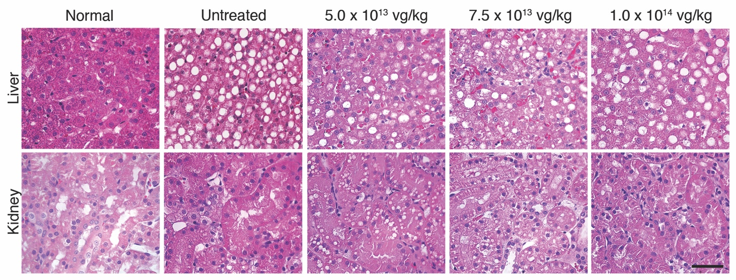
Figure S1. Treatment does not correct storage in liver or kidney of treated cats. Representative hematoxylin and eosin-stained liver sections of normal, untreated, and AAVhu.32-fMANB-treated cats. Little to no improvement of storage is seen in treated cats when compared to untreated AMD cats. Scale bar = 50 μm.

