Figure S1. Patients with a mutation in the NOTCH3 ligand binding domain have a relatively high white matter hyperintensity lesion load. Scatterplot showing the correlation between normalized white matter hyperintensity volume (nWMHV) and age, for patients with a mutation in the NOTCH3 ligand binding domain compared to all other mutations.

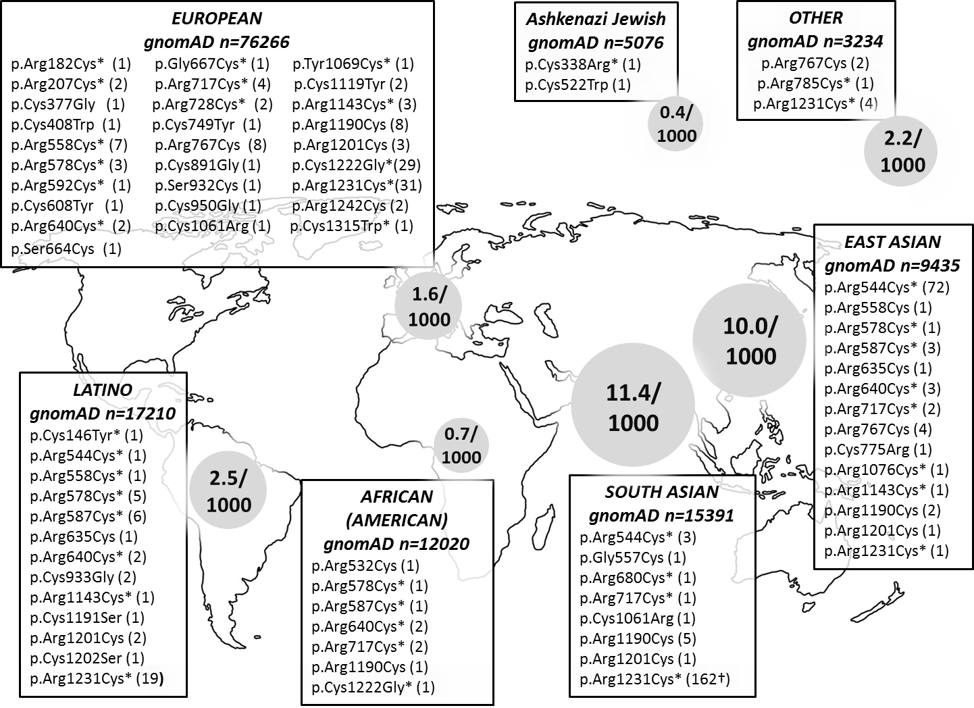
Figure S2. NOTCH3 mutations in the gnomAD database, according to ethnicity. Frequencies range from 0.4/1000 individuals in the Ashkenazi Jewish population to 1.6/1000 in the European population and 11.4/1000 in the South Asian population, with an overall frequency of 3.2/1000. NOTCH3 mutation frequencies in gnomAD are largely similar to those previously found in the ExAC database. Figure adapted and updated from Rutten et al. ACTN 2016.¹

1. Rutten JW, Dauwerse HG, Gravesteijn G, et al. Archetypal NOTCH3 mutations frequent in public exome: implications for CADASIL. Annals of clinical and translational neurology. 2016;3(11):844-853.

