Supplementary Methods
Model design. The schematic overview of the Xrare model is shown in Supplementary Figure 2. We firstly collected pathogenic variants from ClinVar and divided them into three parts by publishing years: a set of database variants for implementing ACMG guideline features, a set of variants for model training, and a set of variants for model evaluation. We then synthesized each patient genome by inserting a pathogenic variant into a background healthy genome, and extracted features for model training, such as evidence features based on the implemented ACMG evidences; the preexisting in silico computation scores of variants; population-level scores; phenotypic features based on a new phenotype-similarity measurement. We used a gradient boosting algorithm to combine all these genotypic and phenotypic features to predict the pathogenicity of a variant. We evaluated the model performance using simulated and real clinical data sets.
Variant annotation. We used Variant Effect Predictor¹ (VEP version 84) to predict the consequence of a variant. A VEP plugin, Loss-Of-Function Transcript Effect Estimator (LOFTEE, https://github.com/konradjk/loftee), was used to assess the quality of LoF variants.
Pathogenic variants. Pathogenic variants were downloaded from ClinVar (ftp://ftp.ncbi.nlm.nih.gov/pub/clinvar/xml/archive/2017/ClinVarFullRelease_2017-04.xml.gz). Human Genome Mutation Database (HGMD) was not used here, because of the much higher false positive rates for the disease-associated variants listed in that dataset ². We obtained 49,021 pathogenic or likely pathogenic (collectively called as pathogenic in this study) variants from 3,267 genes after further excluding potentially false ones with population allele frequency > 0.05 or a homozygous allele count > 10 in ExAC database.
Year determination of ClinVar variants and genes. We used the literature references (pubmed IDs, PMIDs) given by ClinVar to determine the publication time of a variant and determine when the gene was found to be associated with rare diseases. Publication years were retrieved by an R package, rentrez. If there are multiple PMIDs for a variant, the earliest time is chosen as the publication time of the variant. Similarly, the earliest time is used when a gene has multiple variants or PMIDs. Although only about 43% (21052/49021) of the ClinVar variant has PMIDs, we found 92% of the genes have at least one variants with PMIDs (i.e., 92% genes have publication year identified being causative to rare diseases). The publication years of variants without PMIDs are set as the publication time of the gene. The remaining 8% genes without publication year information are considered as known genes, and all variants in these genes are used in database. In this way, we are conservative in defining novel genes and get a relatively reliable list of novel genes.
Three independent sources of background variants. To prevent data leakage in model training and performance evaluation, we isolated sets of background or negative variants for different purposes: feature calculation (1000 genomes, ESP and ExAC), training (UK10K), and evaluation (independent 400 whole genomes). One rationale for using different genomic background is that, if the negative variants in training were also sampled from the variant set for feature calculation, their allele frequencies must be more than zero. However, we found ~80% positive variants from ClinVar are not present in the 1000 genomes, ESP or ExAC, which will exaggerate the role of features related to allele frequencies in model training.
ACMG/AMP guideline implementation and scoring. We implemented 14 ACMG/AMP guideline based evidences and provided automatic clinical interpretation of genetic variants. See Supplementary Table S2 for details of the implementation. We also developed ACMG score, a weighted sum score based on the 14 implemented evidences with the following weights (PVS1:6, PS1:4, PM1:2, PM2:2, PM4:2, PM5:2, PP2:1, PP3:1, BA1:-9, BS1:-3, BS2:-3, BP3:-1, BP4:-1, BP7:-2) to represent its overall pathogenic/benign strength.
Our basic scoring principles are: BA=-9, PVS=6, PS=4, PM=2, PP=1, BS=-3, BP=-1. And one exception is BP7=-2. The basic principles are derived from the ACMG/AMP rules for combining criteria to classify sequence variants, attempting to capture the experience of clinical experts behind these rules. For example, since 1 PVS1 + 1 PS and 1PVS1 + 2 PM are both pathogenic, thus 2PM is equal to 1PS. And since 1PS1+2PM and 1PS+3PM+2PP are pathogenic, we can set 1PM to be ~2PP. Because 1PVS1+1PS and 2PS are pathogenic, PVS1 is slightly higher than PS. In summary, if PP is set to 1, then PM=2, PS=4, PVS1=6. Furthermore, PP3 indicates that a supporting evidence for pathogenicity, and BP4 indicates that a supporting evidence for benign, thus we set BP = -1. In the same way, we think that BS should be close to -PS, but considering the genotypes of population data sets such as ExAC and 1KG contain a certain part of false positives, so we set BS = -3, instead of -4. We think BA1 is a very strong evidence for benign variant, thus it is set to -9.
Other than serving as a feature in the model, the ACMG score is also used to filter apparently benign variants, leaving only the ACMG score > 0 for analysis. In order not to filter common pathogenic sites, we used a slightly higher threshold MAF≤0.001 for PM2. But in the actual analysis process, especially for whole genome data, we found this will retain a large number of benign non-coding sites (not conservative, not affecting splicing, without any other functional predictions or annotations). Therefore, we slightly modified the meaning of BP7 as synonymous variants or non-functional non-coding variants, and set BP7=-PM2=-2.

In silico scores. In silico pathogenic scores including SIFT³, Polyphen_2HDIV⁴, Polyphen2_HVAR⁴, LRT⁵, MutationTaster⁶, GERP++_RS⁷, and phyloP⁸ were download from dbNSFP database⁹. The dbscSNV¹⁰ SPIDEX, CADD¹¹, and DANN¹² were downloaded from ANNOVAR ¹³. These scores were used as features in the study (Supplementary Table S2).
Population level and gene level constraint scores. Allele frequencies from 1000 genomes, ESP, and ExAC dataset were used. We collected gene features from the ExAC paper¹⁴, including pDom, pRec, syn_z, mis_z, and pLI. Inspired by Phen-Gen¹⁵, we also calculated population level variant damage scores using CADD for each gene. For example, the caddphred_a1qt005 score of a gene is calculated as in the following two steps: first, the largest CADD phred score of all alleles of the gene for each sample from 1000 genome project was calculated; second, the 0.5% percentile score of step 1 was used as the score (Supplementary Table S2).
Similarity between phenotype sets. Best match sum¹⁶ (BMS) was used to calculate the similarity between two sets of phenotype terms: the query phenotype set $T_{1}$ and the annotation phenotype set $T_{2}$ :
$$sim\left(T_{1},T_{2}\right)=\sum_{t_{1}∈T_{1}}{\max_{t_{2}∈T_{2}}\left(Sim\left(t_{1},t_{2}\right)\right).}$$
In clinical practice, $T_{1}$ is the phenotypic collection of a patient, and $T_{2}$ is a set of all annotated phenotype terms associated with a target gene. Our main question here is how much the patient's phenotype set $T_{1}$ can be explained by the target gene corresponding to $T_{2}$. Therefore, the similarity score between sets was defined as the sum of the best match (max) from $T_{2}$ for each phenotype term in $T_{1}$.
ERIC-based normalized metrics. Because the ERIC similarity score increases with the number of phenotype terms in $T_{1}$, we defined two 0 to 1 scaled or normalized scores: ERIC_Norm and ERIC_RP in the machine learning model. ERIC_Norm is calculated as the ERIC score between phenotype sets divided by the sum of all ICs of set $T_{1}$. ERIC_RP is the rank percentage of a target gene, calculated as the numerical rank of the gene divided by the total number of all target genes. Even when an ERIC_Norm score is small when there are a large number of noise phenotypes, the ERIC_RP score of the disease gene can be a big value due to its top ranking compared to other genes. Therefore, the addition of ERIC_RP can make the model more robust.
Gene-phenotype associations predicted over interactomes
Since only a subset of genes (these are referred to as seed genes hereafter) have phenotype annotations from HPO or UPO, we must find a way to obtain phenotypic annotation for the remaining genes, otherwise a large set of variants will be excluded automatically from the prioritization. We will do this by transferring phenotypic annotations on seed genes to their non-seed neighbors based on interactomes that encode some type of gene-gene interactions. Formally, an interactome is a graph $G(V,W)$ where $V$ represent all genes and $W$ represent edge weights between gene pairs. Given G, define the weighted phenotype similarity score between phenotype $p$ and gene $g$ as:
$wSim(p,g,S_{g}, G)=\frac{\sum_{v∈S_{g}}{Sim\left(p,v\right)×w_{gv}}}{\sum_{v∈S_{g}}{w_{gv}}}$,
where $Sim(p,v)$ represents the ERIC-BWA phenotype similarity score between phenotype $p$and a set of phenotypes annotated to gene $v$. $S_{g}$ is a set of seed genes excluding gene $g.$ $w_{gv}$ is the weight between gene $g$ and gene $v$, which is the similarity between two genes in different similarity networks. In this work we used 10 interactomes to capture different types of gene-gene interactions (Supplementary Table 3). For example, the Reactome pathway interactome between genes (G1) can define a predictor variable $wSim(p,g,S_{g}, G1)$, while the shared Pfam domain information forming another interactome (G2) can define another predictor variable $wSim(p,g,S_{g}, G2)$. In total, we obtained 10 vectors of $wSim(p,g,S_{g}, G)$ as 10 predictors.
To train a model to predict gene-phenotype similarities, we considered genes found by 2005 as seed genes, and calculated the weighted phenotype similarity scores over the 10 interactome networks as 10 predictors in the phenotype prediction model. The predicted variable is the gene-phenotype ERIC-BWA scores, $Sim(p,g)$, of the 615 genes found between 2006 and 2011 and 1,289 phenotypes with IC < 5 and IC > 1. That is, $Sim\left(p,g\right) \sim wSim(p,g, S_{g},G)$. XGBoost was used to train the phenotype prediction model.
We recalculated the network-related features for all genes and the 1,289 phenotypes by considering the genes found by 2011 as seed genes. Using the recalculated features and the trained model, we obtained the predicted gene-phenotype similarity scores (Pred_phen score in Supplementary Table 2) for all genes and the 1,289 phenotypes.
We noted that Exomiser hiPHIVE¹¹ has also used interactomes to extend phenotype annotations to non-seed genes. However, our approach is based on machine learning (via gradient tree boosting approach), which is very different from the random walk approach used in that work.
Patient phenotype simulations. Given a pathogenic variant of a gene, we simulate an HPO phenotype set of a patient involving the pathogenic variant as following: 1) randomly sample $a$ phenotypes from all known annotated phenotypes; 2) sample $b$ phenotypes like step 1 and replace each of the $b$ phenotypes with one of its ancestral (imprecise) phenotypes; 3) randomly sample $c$ noisy phenotypes that are neither annotated phenotypes nor their ancestors. The 6 phenotype models used in the evaluation dataset for method comparisons had different completeness, imprecision and noise levels (1|2|0, 1|2|2, 2|2|0, 2|2|2, 3|2|0, 3|2|2), where x|y|z means x precise, y imprecise and z noisy phenotypes. The phenotype simulation model to be used for a synthesized genome is randomly chosen from the 6 models.
Model training using gradient boosting decision tree (GBDT¹⁷) algorithm.
GBDT, unlike the linear model, is robust to multicollinearity when features are redundant and highly correlated. The tree boosting model is a collection of classification and regression trees (CART). Each tree yields prediction scores in leaves. Suppose we have $K$ trees, the model is $\sum_{k=1}^{K}{f_{k}}$, which sums the predictions of multiple tress. The tree $f(x)$ is defined as:
$$f\left(x\right)=w_{q(x)},w∈R^{T},q:R^{d}→\left\{1,2, …, T\right\},$$
where $w$ is the vector of scores on leaves, function $q$ assigns each data point to the corresponding leaf, and $T$ is the number of leaves.
Our objective function contains two parts: $Obj=L+Ω,$ where the training loss function $L$ is the logistic loss for logistic regression:
$$L=\sum_{i=1}^{N}{l\left(y_{i},{\hat{y}}_{i}\right)=}\sum_{i=1}^{N}{\left(y_{i}ln(1+e^{-{\hat{y}}_{i}})+\left(1-y_{i}\right)ln(1+e^{{\hat{y}}_{i}})\right)},$$
The regularization term $Ω$ is:
$$Ω=γT+\frac{1}{2}λ\sum_{j=1}^{T}{w_{j}^{2}},$$
where $T$ is the number of leaves, and $w_{j}$ is the score on the $j^{th}$ leaf.
We use an additive strategy to train the model by fixing the learned trees, and add one new tree at a time. The objective at step $t$ becomes:
$$obj^{(t)}=\sum_{i=1}^{N}{l(y_{i}, {\hat{y}}_{i}^{t-1}+f_{t}(x_{i})})+\sum_{i=1}^{t}{Ω(f_{i})}.$$
Taking the first and the second order of Taylor expansion of loss function into consideration, the objective at time $t$ becomes:
$$obj^{\left(t\right)}≈\sum_{i}^{N}{\left[g_{i}f_{i}\left(x_{i}\right)+\frac{1}{2}h_{i}f_{i}^{2}\left(x_{i}\right)\right]+Ω\left(f_{t}\right)},$$
Here, $g_{i}=∂_{{\hat{y}}_{i}^{\left(t-1\right)}}l\left(y_{i},{\hat{y}}_{i}^{\left(t-1\right)}\right)$, $h_{i}=∂_{{\hat{y}}_{i}^{\left(t-1\right)}}^{2}l\left(y_{i},{\hat{y}}_{i}^{\left(t-1\right)}\right)$, which is further simplified as:
$$obj^{\left(t\right)}=\sum_{j=1}^{T}{[G_{j}w_{j}+\frac{1}{2}\left(H_{j}+λ\right)w_{j}^{2}]}+γT,$$
where $G_{j}=\sum_{i∈I_{j}}{g_{i}}$ , $H_{j}=\sum_{i∈I_{j}}{h_{i}}$, and $I_{j}=\{i|q\left(x_{i}\right)=j\}$ is the set of data point indices assigned to the $j^{th}$ leaf. By minimizing it, we obtain the best $w_{j}$ and the best objective reduction:
$$w_{j}^{*}=-\frac{G_{j}}{H_{j}+λ},$$
$$obj^{*}=-\frac{1}{2}\sum_{j}^{T}{\frac{G_{j}^{2}}{H_{j}+λ}+γT}.$$
Now that we have a way to score a tree, next we describe a strategy to create a tree with small objective reduction. Generating a tree is a process of iteratively splitting a leaf into two leaves. The following formula is used to determine if a leaf should be split:
$$Gain=\frac{1}{2}\left[\frac{G_{L}^{2}}{H_{L}+λ}+\frac{G_{R}^{2}}{H_{R}+λ}-\frac{{\left(G_{L}+G_{R}\right)}^{2}}{H_{L}+H_{R}+λ}\right]-γ.$$

Model training using XGBoost. We obtained 51 features (Supplementary Table S2) as $x$ and the label variable as $y$ indicating a variant being associated with a phenotype set. The GBDT algorithm implemented in XGBoost¹⁸ was used to train the predicting model. In addition to implementing the core GBDT algorithm effectively, XGBoost further introduces some improvements. One of the most attractive reason is that XGBoost has “built-in” support for missing values, i.e., XGBoost can automatically "learn" what is the best imputation value for missing values based on reduction on training loss. The support for missing values is important for our study, because some features contain a high percentage of missing values. For example, ~20% variants lack SIFT scores. In addition, XGBoost is fast and has a function to calculate the feature importance.
For training the model, we used the“max.depth” and “min_child_weight” to control model complexity and used the “subsample” and “lambda” functions to reduce overfitting. Finally, we performed a grid search to determine the parameters: the learning rate (constituting {0.05, 0.1}), the max tree depth (constituting {5, 6, 7}) and the subsample ratio of the training instance (constituting {0.7, 0.8, 0.9}). Fivefold cross-validation was also performed to prevent overfitting in grid search.
Comparison to Exomiser. The most recent version of Exomiser (Aug 2017) was downloaded from https://data.monarchinitiative.org/exomiser/8.0.0/. PhenIX and hiPHIVE models were performed with and without specifying inheritance models. Because we filtered non-pathogenic variants by ACMG_score > 0 for all models, the filter function of Exomiser was turned off by setting “max-freq” to 1.
Comparison to Phen-Gen. Phen-Gen (version 1.0) was downloaded from http://phen-gen.org/ and performed with corresponding inheritance models.
Comparison to eXtasy. eXtasy (version 0.1) was downloaded from http://extasy.esat.kuleuven.be/ and performed without specifying inheritance models.
Effect of random splitting training data. It is important that we split pathogenic variants by their publishing years. We found random splitting, as done in many cross-validation style model training, greatly reduce the performance in prioritizing novel genes. For example, for a gene that with several variants firstly being linked to rare disorders in recent years and would be considered as a novel gene by the year splitting. However in random splitting, when some variants of the gene are included in model training, some gene-level features of this gene (e.g., ACMG_PVS1 and other gene constraint scores) are early exposed in the training. Then it is not surprising that other test variants from the same gene would have good predictions. To demonstrate this, we compared the results of the two splitting strategies using 48,166 pathogenic ClinVar variants since year 2015 from 3,139 genes. For the year splitting, the 41,590 variants found by 2011 were used as the database for feature extraction, and the remaining 6,576 variants were randomly divided into two parts according to 3:1 ratio, used for model training and evaluation, respectively. For the random splitting, the 48,166 variants were randomly split into three parts with the numbers of variants matching those of the year splitting (Supplementary Table 6). Although the random splitting shows even better performance than the year splitting in known genes, we observed a dramatic decrease in novel genes (e.g., 57% v.s. 4% ranked at top 1,Supplementary Table 7). Furthermore, we noticed that 94% (3,053/3,139) genes were shown in the database in the random splitting. However, the number is 78% (2,449/3,139) in the year splitting (Supplementary Table 6), suggesting randomly choosing variants as the database greatly reduces the number of training cases for novel genes and results in a wrong perception of performance on known and novel genes.

URLs
ClinVar (Feb 2017): https://www.ncbi.nlm.nih.gov/ClinVar/
1000 Genomes Project: http://www.internationalgenome.org/
ESP: http://evs.gs.washington.edu/EVS/
ExAC (version 0.3.1): http://exac.broadinstitute.org/
HPO (Jan 2017): http://human-phenotype-ontology.github.io/
UberPheno (Nov 2015): http://compbio.charite.de/tl_files/HPO/uberpheno/
DDG2P (May 2017): https://decipher.sanger.ac.uk
dbNSFP (version 2.0b1): https://sites.google.com/site/jpopgen/dbNSFP
M-CAP (version 1.0): http://bejerano.stanford.edu/mcap/
REVEL: https://sites.google.com/site/revelgenomics/
CADD (version 1.3): http://cadd.gs.washington.edu/
DANN: https://cbcl.ics.uci.edu/public_data/DANN/
OMIM: https://www.omim.org
VEP (version 84): https://www.ensembl.org/vep
LOFTEE: https://github.com/konradjk/loftee
ANNOVAR (Feb 2016): http://annovar.openbioinformatics.org

Supplementary Tables
Supplementary Table S1. Precise, imprecise, noisy phenotype counts and the diagnosed causal gene symbols in two recent WES studies^{19,20} based on HPO phenotype-genotype association annotations. (SupplementaryTableS1.xlsx)

Supplementary Table S2. Features for Xrare model training.
Category | Features | Data type | Definition
Population | AF_POPMAX_KG | Float | Max population frequency (AFR, EAS, FIN, NFE, SAS) from 1000 genome project
Population | AF_POPMAX_ESP | Float | Max population frequency (AFR, EAS, FIN, NFE, SAS) from ESP project
Population | AF_POPMAX_ExAC | Float | Max population frequency (AFR, EAS, FIN, NFE, SAS) from ExAC project
Population | AF_POPMAX | Float | Max of AF_POPMAX_KG, AF_POPMAX_ESP, AF_POPMAX_ExAC
Population | AC_Hom_ExAC | Integer | Homozygous/Hemizygous Allele count from ExAC
Population | AC_Het_ExAC | Integer | Heterozygous Allele count from ExAC
In silico | dbscSNV_ADA | Float | Splicing prediction from dbscSNV
In silico | dbscSNV_RF | Float | Splicing prediction from dbscSNV
In silico | dpsi_max_tissue | Float | Splicing prediction from SPIDEX
In silico | SIFT | Float | Derived from amino acid conservation in closely related species
In silico | Polyphen2_HDIV | Float | HumDiv deleterious scores from Ployphen2
In silico | Polyphen2_HVAR | Float | HumVAR deleterious scores from PloyPhen2
In silico | LRT | Float | An evolutionary constrain score from dbscSNV
In silico | MutationTaster | Float | Support Vector Machine model combining 14 variant scoring metrics
In silico | GERP_RS | Float | An evolution constraint score (GERP)
In silico | phyloP | Float | An evolution constraint score (Phylop)
In silico | CADD_phred | Float | A deleteriousness score from CADD
In silico | DANN | Float | A deleteriousness score from DANN
Function | Consequence | Factor | Mutation consequence (e.g. missense, frameshift etc.) annotated by VEP
Function | LOFTEE | Factor | High/low confidence of Loss of Function annotated by LOFTEE
ACMG guideline evidence | ACMG_PVS1 | Boolean | Null mutations in genes that have at least one known null variants in the pathogenic database
ACMG guideline evidence | ACMG_PS1 | Boolean | Same amino acid change as a known pathogenic variant
ACMG guideline evidence | ACMG_PM1 | Boolean | Mutations occurred in critical domains or hotspots.  1) Critical domains. Fisher's_exact_test was used to determine if a domain is significantly enriched with the pathogenic variants from ClinVar database compared to the healthy sample ExAC database. If P < 0.05, the domain is considered as a critical domain. Domain annotations are from VEP.  2) Mutation hotspots are defined as the regions where the distances between two closest pathogenic database missense variants are less than 3 amino acids.
ACMG guideline evidence | ACMG_PM2 | Boolean | Low frequency mutations with allele frequency < 0.001 in any population from 1000 genomes or ExAC.
ACMG guideline evidence | ACMG_PM4 | Boolean | Protein length changes resulting from in-frame deletions/insertions in a non-repeat region; stop-loss variants; null mutations in genes where null variant has not been observed in the database; potential variants that may cause splicing alteration.
ACMG guideline evidence | ACMG_PM5 | Boolean | Novel amino acid change at an amino acid residue where a different missense change has been recorded in the pathogenic database.
ACMG guideline evidence | ACMG_PP2 | Boolean | Missense variant in a gene that has a low rate of benign missense variation and where missense variants are a common mechanism of disease.  Fisher's_exact_test was used to determine if a gene has excessive missense variants in the pathogenic database compared to ExAC. If P < 0.05, the gene is considered as a pathogenic missense gene.
ACMG guideline evidence | ACMG_PP3 | Boolean | Predicted to be pathogenic by at least 6/8 methods.
ACMG guideline evidence | ACMG_BA1 | Boolean | Frequency mutations with allele frequency > 0.05 in any population from 1000 genomes or ExAC.
ACMG guideline evidence | ACMG_BS1 | Boolean | Frequency mutations with allele frequency > 0.01 in any population from 1000 genomes or ExAC.
ACMG guideline evidence | ACMG_BS2 | Boolean | >2 homozygous counts were observed in ExAC database.
ACMG guideline evidence | ACMG_BP3 | Boolean | Non-frameshift mutations in repeat regions.
ACMG guideline evidence | ACMG_BP4 | Boolean | Predicted to be benign by at least 6/8 methods.
ACMG guideline evidence | ACMG_BP7 | Boolean | Synonymous or non-coding mutations without impacts on splicing.
ACMG guideline evidence | ACMG_score | Integer | Weighted sum of evidences with the following weight for each term (PVS1:6, PS1:4, PM1:2, PM2:2, PM4:2, PM5:2, PP2:1, PP3:1, BA1:-9, BS1:-3, BS2:-3, BP3:-1, BP4:-1, BP7:-2)
Database Genes | isdbgene | Boolean | Gene is known for rare disease or in the database for implementing ACMG guideline evidences
Database Genes | dbgene_rwr | Float | Random walk similarity score of database genes on STRING network
Gene Level Constraint | pDom | Float | Probability of dominant gene from ExAC
Gene Level Constraint | pRec | Float | Probability of recessive gene from ExAC
Gene Level Constraint | syn_z | Float | Z score of silent mutation from ExAC
Gene Level Constraint | mis_z | Float | Z score of missense mutation from ExAC
Gene Level Constraint | pLI | Float | Probability of LoF intolerant score from ExAC
Gene Level Constraint | CADD_a1qt005 | Float | The 0.5% percentile of the largest CADD phred score of all alleles of the gene for each sample from the 1000 genome project
Gene Level Constraint | CADD_a1qt01 | Float | The 1% percentile of the largest CADD phred score of all alleles of the gene for each sample from the 1000 genome project
Gene Level Constraint | CADD_a2qt005 | Float | The 0.5% percentile of the second largest CADD phred score of all alleles of the gene for each sample from the 1000 genome project
Gene Level Constraint | CADD _a2qt01 | Float | The 1% percentile of the second largest CADD phred score of all alleles of the gene for each sample from the 1000 genome project
Phenotype | ERIC | Float | ERIC-based phenotype similarity score
Phenotype | Pred_Phen | Float | Predicted phenotype similarity score
Phenotype | ERIC_RP | Float | Rank percentage of ERIC-based phenotype similarity score
Phenotype | Pred_Phen_RP | Float | Rank percentage of predicted phenotype similarity score
Phenotype | ERIC_Norm | Float | ERIC-based phenotype similarity score divided by the total IC of queried phenotypes

Supplementary Table S3. Gene-Gene network and interactome information used for extracting features of genotype-phenotype association prediction.
Name | Function | Edge description
GOBP | Biological process | ERIC-BMS
GOMF | Molecular function | ERIC-BMS
GOCC | Cell location | ERIC-BMS
STRING | Combined scores of several networks | Network from https://string-db.org
Reactome | Pathway | Number of pathways shared
Pfam | Protein Domain | Number of Domains shared
Interpro | Protein Domain | Number of Domains shared
Treefam | Gene family | Indication of the same family
Blast | Sequence | Pairwise Blast scores
GIANT | Tissue expression pattern | Expression similarity network from http://giant.princeton.edu/

Supplementary Table S4. Partition of ClinVar pathogenic variants. Variants by year 2011 were used as database for feature extraction as in the ACMG/AMP guideline related scores.
^{1.} Number of variants known/novel in model training or evaluation based on the genes in the database for feature extraction.
^{2.} Number of genes known/novel in model training or evaluation based on the genes in the database for feature extraction.

Date | #Variants¹ | #Genes² | Application
(, 2011] | 41,590 | 2,449 | Database for ACMG/AMP evidence feature extraction
[2012, 2015] | 3,933 known; 2,643 novel | 1,015 known; 690 novel | Training
[2016, Now) | 436 known; 419 novel | 244 known; 128 novel | Evaluation

Supplementary Table S5. Comparison of phenotype-driven methods on pathogenic variant prioritization.
Method | Type | Genotype | Phenotype | Combination
Xrare | SNV, INDEL | ACMG_score, in-silico scores, gene level features | New phenotype similarity measuring and prediction algorithm | Gradient tree boosting
Exomiser | SNV, INDEL | Meta of in-silico scores | Resnik-based P-value score and random walk. 2 algorithms:  PhenIX: human phenotypes only;  hiPHIVE: human and model organism phenotypes | Logistic linear regression with equal phenotype score and variant score weights
Phen-Gen | SNV, INDEL | Meta of in-silico scores, 95% population gene-level cutoffs | Resnik-based P-value score and random walk | Bayesian framework
eXtasy | Missense | Meta of in-silico scores | Phenomizer for known HPO genes, then Endeavour algorithm using shared annotations in gene ontology databases | Combined ranks from separate sources using Random Forest

Supplementary Table S6. Partition of ClinVar pathogenic variants found by year 2015 using random and year splitting, respectively. Two different splitting strategies were performed to demonstrate the influence of publishing years.
 | #Variants | #Genes (Year) | #Genes (Random)
All (, 2015] | 48166 | 3139 | 3139
Database | 41590 | 2449 | 3053
Train+Test | 6576 | 690 | 86

Supplementary Table S7. Performance comparison of two splitting strategies using variants in test sets from Supplementary Table S6.
Splitting | Gene | #Variants | Top1 | Top5 | Top10
Year | Known | 998 | 0.746 | 0.880 | 0.925
Year | Novel | 636 | 0.570 | 0.763 | 0.823
Random | Known | 1621 | 0.843 | 0.940 | 0.968
Random | Novel | 23 | 0.0436 | 0.087 | 0.261

Supplementary Figures
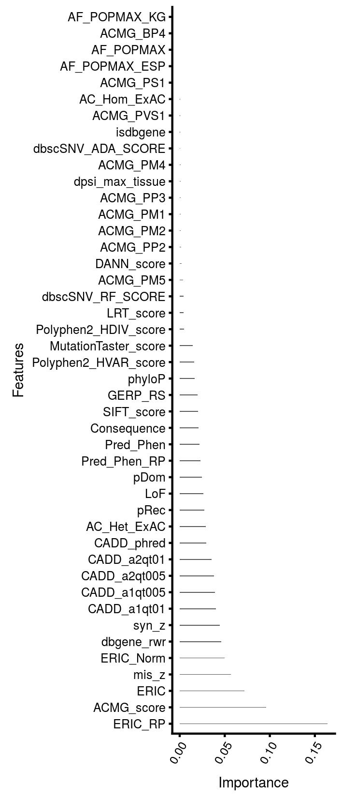
Supplementary Figure S1. Feature importance scores from XGBoost in Xrare model. Feature importance is defined as the average gain of the feature in trees.

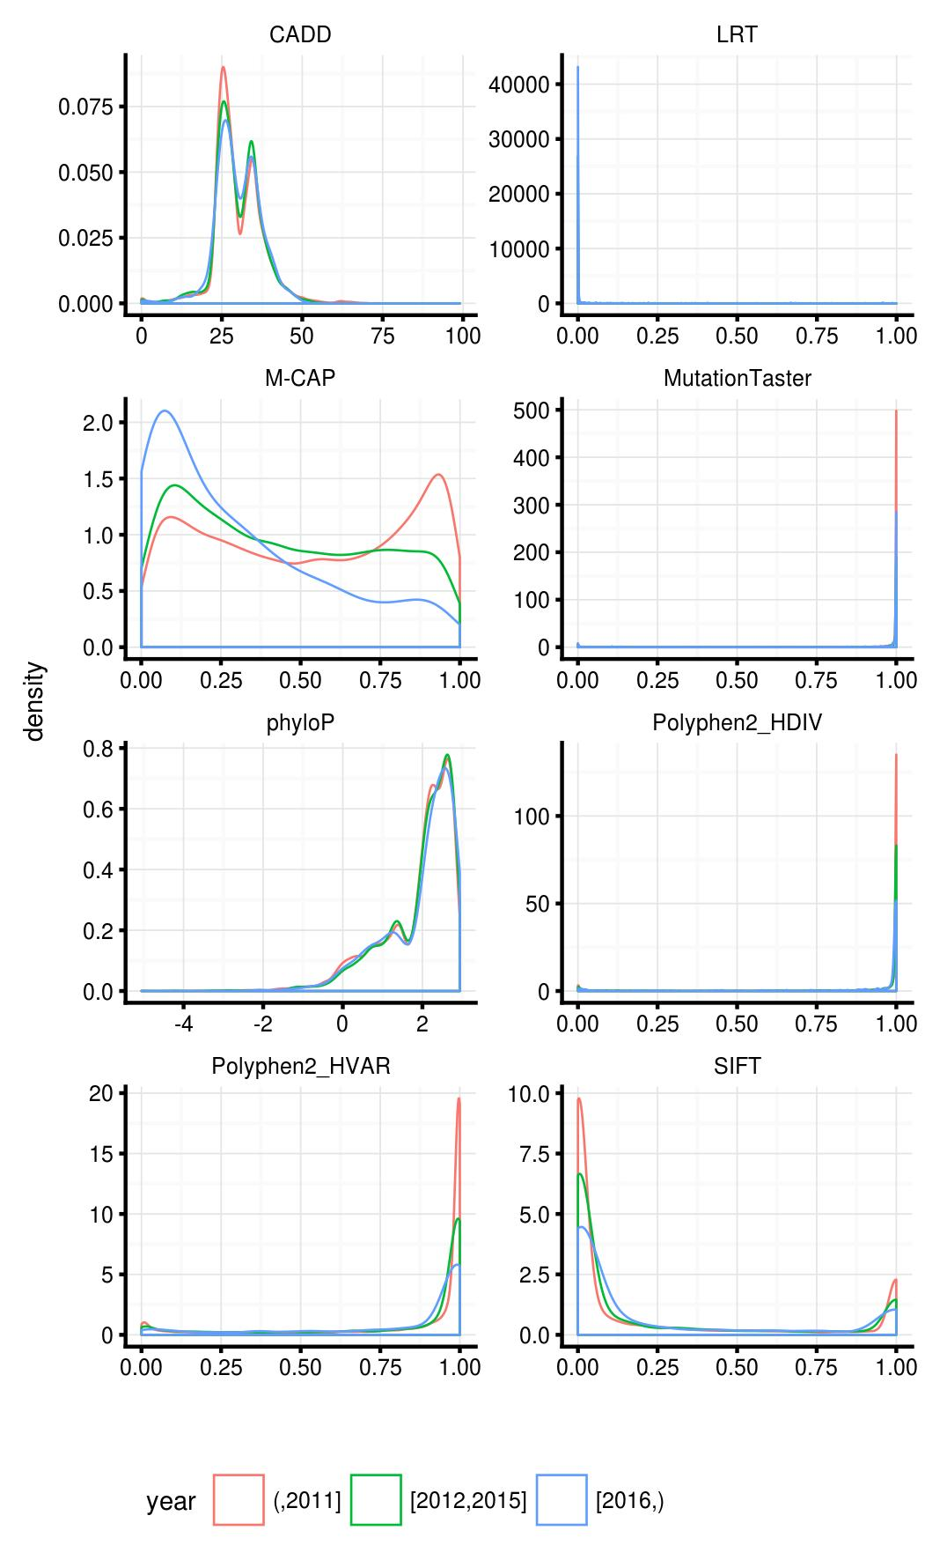
Supplementary Figure S2. Distributions of in silico prediction scores of ClinVar pathogenic variants across different years.

Supplementary Figure S3. Performance evaluation of phenotype similarity measures for prioritizing target diseases at different noise and imprecison levels. The simulation utilized 24743 HPO developmental disease phenotype associations curated in the decipher DDG2P database (accessed in May 2017). We extracted 50% of true HPO phenotypes associated with each disease in the dataset, and then added various levels of noise and imprecision. Simulations were run 10 times for each disease. The top panel represents phenotype sets simulated using 0.5×, 1×, and 1.5× noise, respectively. The middle panel represents phenotype sets simulated with 50%, 70%, and 90% imprecise phenotypes, respectively. The bottom panel represents phenotype sets simulated with no noise and no imprecision, 0.5× noise and 50% imprecision, 1× noise and 50% imprecision, respectively. X-axis is the rank of target diseases. Y-axis is the cumulative distribution function (CDF) of the rank. Resnik, JC, Lin, and ERIC scores were compared.

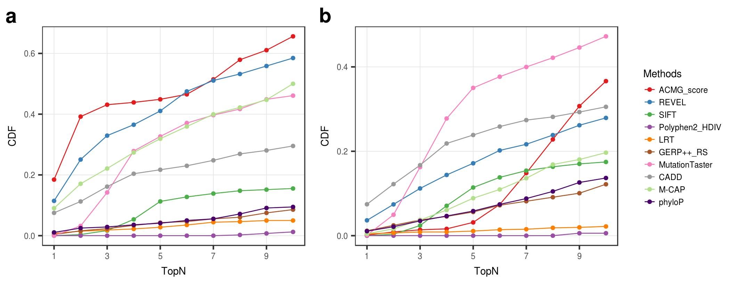
Supplementary Figure S4. A more comprehensive performance evaluation of genotype-only methods using 3420 synthetic genomes of patients. (a). performance comparison for known genes; (b). performance comparison for novel genes. Please be aware that the methods used here (e.g. M-CAP ) are not necessarily included as in silico prediction features in the Xrare model.

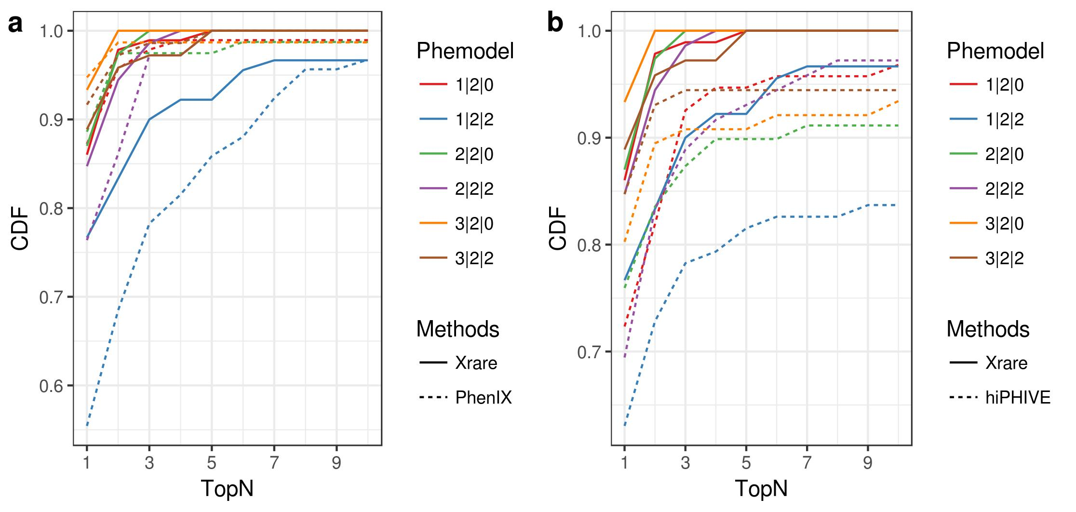
Supplementary Figure S5. Performance comparison of Xrare versus 2 Exomiser models in different phenotype conditions. Exomiser PhenIX (a) and hiPHIVE (b). Phemodel x|y|z means x precise, y imprecise and z noisy phenotypes. Although the release data of Exomiser used here is after our data-frozen date, to exclude the performance differences introduced by the gene-phenotype annotation differences between our data and Exomiser, we only considered simulated cases where the precise phenotypes are all included in the phenotype annotation file in Exomiser.

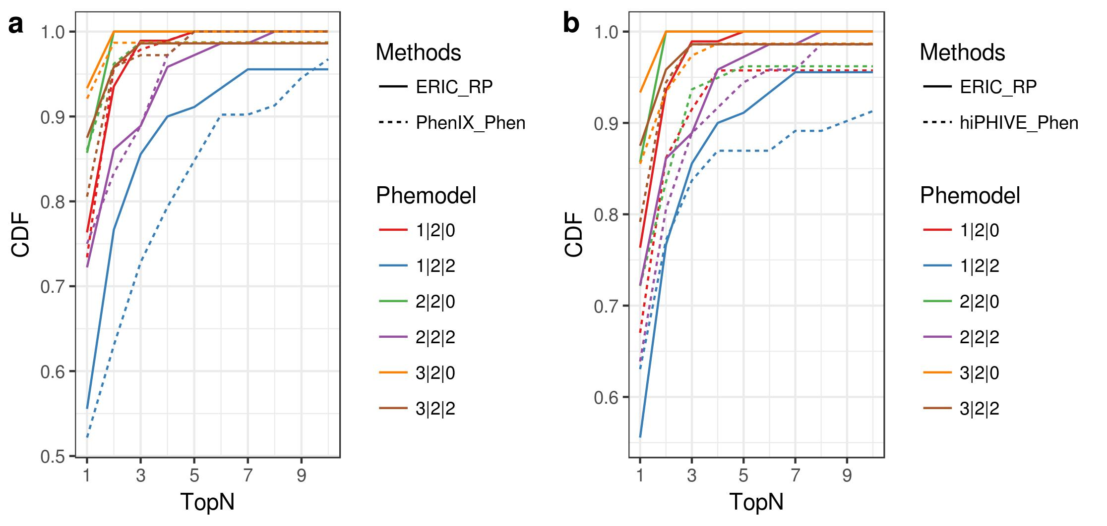
Supplementary Figure S6. Performance comparison of prioritizing target genes by phenotype scoring in different phenotype conditions. Exomiser PhenIX (a) and hiPHIVE (b). The data is the same as in Supplementary Figure 5, but both Xrare and Exomiser only used their phenotype scores. The most important phenotype feature ERIC_RP of Xrare is used here. PhenIX phenotype score implemented in Phenomizer software is a Resnik-similarity-based P value score, and hiPHIVE is a combination score of Phenomizer score and a prediction score by random walking on gene-gene similarity networks. This result suggests our ERIC-based score is better than Phenomizer score on measuring phenotype similarity.

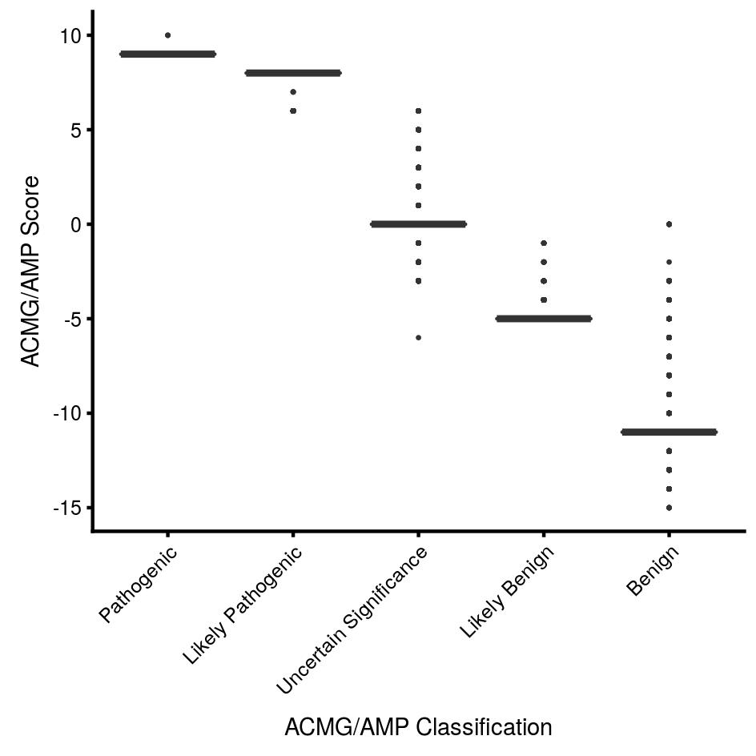
Supplementary Figure S7. Comparison between our ACMG score and the classification of ACMG/AMP guidelines. We analyzed approximately 1 million variants randomly sampled from UK10K dataset and found different ACMG/AMP classes have different score ranges, suggesting our scoring method is comparable to the classification rules of the ACMG/AMP guideline and has a clear separation of the 5 levels of pathogenicity.

References:
1. McLaren W, Gil L, Hunt SE, et al. The Ensembl Variant Effect Predictor. Genome Biol. 2016;17.
2. Dorschner MO, Amendola LM, Turner EH, et al. Actionable, pathogenic incidental findings in 1,000 participants’ exomes. Am J Hum Genet. 2013;93(4):631-640.
3. Ng PC, Henikoff S. Predicting deleterious amino acid substitutions. Genome Res. 2001;11(5):863-874.
4. Adzhubei IA, Schmidt S, Peshkin L, et al. A method and server for predicting damaging missense mutations. Nat Methods. 2010;7(4):248-249.
5. Chun S, Fay JC. Identification of deleterious mutations within three human genomes. Genome Res. 2009;19(9):1553-1561.
6. Schwarz JM, Rödelsperger C, Schuelke M, Seelow D. MutationTaster evaluates disease-causing potential of sequence alterations. Nat Methods. 2010;7(8):575-576.
7. Davydov EV, Goode DL, Sirota M, Cooper GM, Sidow A, Batzoglou S. Identifying a High Fraction of the Human Genome to be under Selective Constraint Using GERP++. PLOS Comput Biol. 2010;6(12):e1001025.
8. Pollard KS, Hubisz MJ, Rosenbloom KR, Siepel A. Detection of nonneutral substitution rates on mammalian phylogenies. Genome Res. 2010;20(1):110-121.
9. Liu X, Jian X, Boerwinkle E. dbNSFP: a lightweight database of human nonsynonymous SNPs and their functional predictions. Hum Mutat. 2011;32(8):894-899.
10. Jian X, Boerwinkle E, Liu X. In silico prediction of splice-altering single nucleotide variants in the human genome. Nucleic Acids Res. 2014;42(22):13534-13544.
11. Kircher M, Witten DM, Jain P, O’roak BJ, Cooper GM, Shendure J. A general framework for estimating the relative pathogenicity of human genetic variants. Nat Genet. 2014;46(3):310.
12. Quang D, Chen Y, Xie X. DANN: a deep learning approach for annotating the pathogenicity of genetic variants. Bioinformatics. 2014;31(5):761-763.
13. Wang K, Li M, Hakonarson H. ANNOVAR: functional annotation of genetic variants from high-throughput sequencing data. Nucleic Acids Res. 2010;38(16):e164.
14. Lek M, Karczewski KJ, Minikel EV, et al. Analysis of protein-coding genetic variation in 60,706 humans. Nature. 2016;536(7616):285-291.
15. Javed A, Agrawal S, Ng PC. Phen-Gen: combining phenotype and genotype to analyze rare disorders. Nat Methods. 2014;11(9):935-937.
16. Wang JZ, Du Z, Payattakool R, Yu PS, Chen C-F. A new method to measure the semantic similarity of GO terms. Bioinformatics. 2007;23(10):1274-1281.
17. Friedman JH. Greedy function approximation: a gradient boosting machine. Ann Stat. 2001:1189-1232.
18. Chen T, Guestrin C. XGBoost: A Scalable Tree Boosting System. In: Proceedings of the 22Nd ACM SIGKDD International Conference on Knowledge Discovery and Data Mining. KDD ’16. New York, NY, USA: ACM; 2016:785–794.
19. Eldomery MK, Coban-Akdemir Z, Harel T, et al. Lessons learned from additional research analyses of unsolved clinical exome cases. Genome Med. 2017;9(1):26.
20. Stark Z, Dashnow H, Lunke S, et al. A clinically driven variant prioritization framework outperforms purely computational approaches for the diagnostic analysis of singleton WES data. Eur J Hum Genet. 2017;25(11):1268-1272.

