Title: Psychological Outcomes Related to Exome and Genome Sequencing Result Disclosure: A Meta-Analysis of Seven Clinical Sequencing Exploratory Research (CSER) Consortium Studies
Supplemental Files

Authors:
Jill O. Robinson, MA^{1a}, Julia Wynn, MS^{2a}, Barbara Biesecker, PhD, MS³, Leslie Biesecker, MD⁴, Barbara Bernhardt, MS⁵, Kyle B Brothers, MD, PhD⁶, Wendy K. Chung, MD, PhD^{2,7}, Kurt D. Christensen, PhD⁸ Robert C. Green, MD, MPH^{8,9}, Amy L. McGuire, JD, PhD¹, M. Ragan Hart, MS, PhD¹⁰, Ida Griesemer, MSPH¹¹, Donald L Patrick, MSPH, PhD¹², Christine Rini, PhD^{13,14}, David Veenstra, ParmD, PhD^{15,16}, Angel M Cronin, MS¹⁷, Stacy W Gray, MD, AM^{18,19}

Affiliations:
- co-first authors

- Center for Medical Ethics and Health Policy, Baylor College of Medicine, Houston, TX, USA
- Department of Pediatrics, Columbia University Medical Center, New York, NY, USA
- RTI, International D.C. Office, Washington DC, USA
- Medical Genomics and Metabolic Genetics Branch, National Human Genome Research Institute, Bethesda, MD
- Division of Translational Medicine and Human Genetics, Perelman School of Medicine at the University of Pennsylvania, Philadelphia, PA, USA
- Department of Pediatrics, University of Louisville School of Medicine, Louisville, KY, USA
- Department of Medicine, Columbia University Medical Center, New York, NY, USA
- Department of Medicine, Brigham and Women's Hospital and Harvard Medical School, Boston, Massachusetts, USA
- Broad Institute of MIT, Cambridge, Massachusetts, USA
- Department of Biomedical Data Science, Stanford University, Stanford, CA, USA
- Department of Health Behavior, University of North Carolina, Chapel Hill, NC, USA
- Department of Health Services, University of Washington, Seattle, WA, USA
- John Theurer Cancer Center, Hackensack University Medical Center, Hackensack, NJ, USA
- Georgetown University School of Medicine, Washington, DC, USA
- Clinical Sequencing Exploratory Research Coordinating Center, University of Washington, Seattle, WA, USA
- Department of Pharmacy, University of Washington, Seattle, WA, USA
- Corrona, LLC, Waltham, MA, USA
- Department of Population Science, City of Hope, Duarte, CA, USA
- Department of Medical Oncology & Therapeutics Research, City of Hope, Duarte, CA, USA

Corresponding Author:
Stacy W. Gray, MD, AM
City of Hope
1500 East Duarte Rd.
Duarte, CA 91010
626-256-4673
stagray@coh.org

Supplemental Figures: Stratified by return of test results (no result returned vs. result returned)

Supplemental Figure 1. Box and whisker plots of GAD-7 and HADS anxiety scores stratified by receipt of genetic results. Scores are instrument-specific and have not been rescaled for comparability across scales. Frequency counts represent the number of patients without results returned followed by those with results returned.

Supplemental Figure 2. Box and whisker plots of PHQ-9 and HADS depression scores stratified by receipt of genetic results. Scores are instrument-specific and have not been rescaled for comparability across scales. Frequency counts represent the number of patients without results returned followed by those with results returned.

Supplemental Figure 3a and b. Random effects meta-analysis of standardized mean difference in anxiety stratified by receipt of genetic results. Negative values represent decreased anxiety post-disclosure. The effect size represents a one standard deviation change.

Supplemental Figure 3a. No test results returned. I²=71.3%

Supplemental Figure 3b. Test results returned. I²=71.8%

Supplemental Figure 4a and b. Random effects meta-analysis of standardized mean difference in depression stratified by receipt of genetic results. Negative values represent decreased anxiety post-disclosure. The effect size represents a one standard deviation change.

Supplemental Figure 4a. No test results returned. I²=64.8%

Supplemental Figure 4b. Test results returned. I²=61.1%

Supplemental Figure 5a. Box and whisker plots of FACToR negative emotions and MICRA distress subscales stratified by receipt of genetic results. Higher scores represent greater levels of negative emotions/distress. Scores are instrument-specific and have not been rescaled for comparability across subscales. Frequency counts represent the number of patients without results returned followed by those with results returned.
Supplemental Figure 5b. Box and whisker plots of FACToR and MICRA uncertainty subscales stratified by receipt of genetic results. Higher scores represent greater levels of uncertainty. Scores are instrument-specific and have not been rescaled for comparability across subscales. Frequency counts represent the number of patients without results returned followed by those with results returned. Uncertainty subscales are not shown for participants at DFCI, since they were not asked all of the items on the subscale.

Supplemental Figure 5c. Box and whisker plots of FACToR positive feelings and MICRA positive experience subscales stratified by receipt of genetic results. Higher scores represent fewer positive feelings/experience. Scores are instrument-specific and have not been rescaled for comparability across subscales. Frequency counts represent the number of patients without results returned followed by those with results returned.
Supplemental Figure 6a1 and 6a2. Random effects meta-analysis of multi-dimensional impact negative emotions/distress stratified by receipt of genetic results. Higher values represent worse outcomes. Subscale scores have been rescaled to a 0-100 point scale, where 0 represents “Not at all” or “Never”, and 100 represents “A great deal” or “Often”.

Supplemental Figure 6a1. No test results returned. I²=71.4%

Supplemental Figure 6b1.Test results returned. I²=93.5%

Supplemental Figure 6b1 and 6b2. Random effects meta-analysis of multi-dimensional impact uncertainty stratified by receipt of genetic results. Higher values represent worse outcomes. Subscale scores have been rescaled to a 0-100 point scale, where 0 represents “Not at all” or “Never”, and 100 represents “A great deal” or “Often”.

Supplemental Figure 6b1. No test results returned. I²=91.3%

Supplemental Figure 6b2. Test results returned. I²=97.3%

Supplemental Figure 6c1 and 6c2. Random effects meta-analysis of multi-dimensional positive feelings/experiences, stratified by receipt of genetic results. Higher values represent worse outcomes. Subscale scores have been rescaled to a 0-100 point scale, where 0 represents “Often” or “A great deal”, and 100 represents “Not at all” or “Never”.

Supplemental Figure 6c1. No test results returned. I²=67.7%

Supplemental Figure 6c2. Test results returned. I²=93.5%

Supplemental Figures: Stratified by return of primary test results (no result returned vs. result returned)

Supplemental Figure 7. Primary Results Box and whisker plots of GAD-7 and HADS anxiety scores stratified by receipt of primary genetic results. Scores are instrument-specific and have not been rescaled for comparability across scales. Frequency counts represent the number of patients without results returned followed by those with results returned.

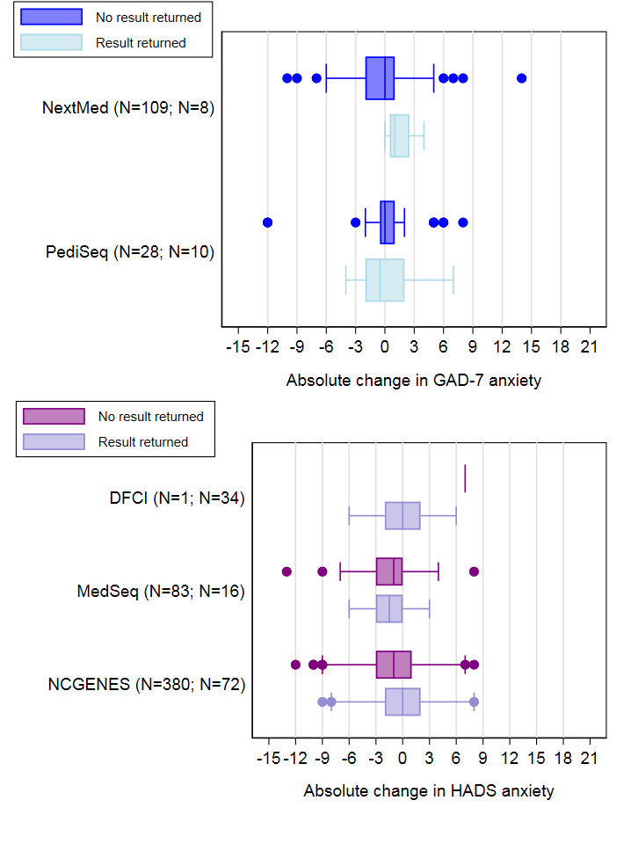
Supplemental Figure 8. Primary Results Box and whisker plots of PHQ-9 and HADS depression scores stratified by receipt of primary genetic results. Scores are instrument-specific and have not been rescaled for comparability across scales. Frequency counts represent the number of patients without results returned followed by those with results returned.

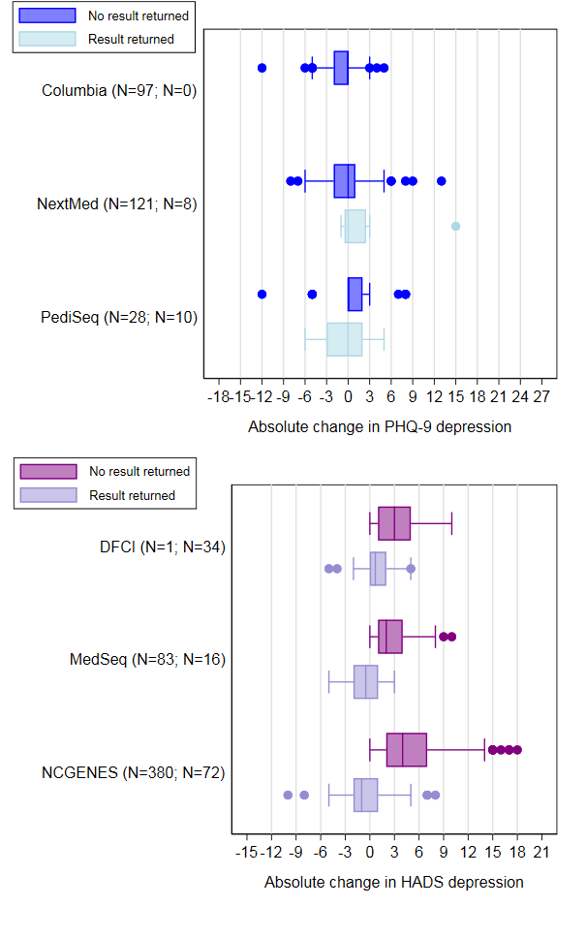
Supplemental Figure 9. Primary Results Box and whisker plots of FACToR negative emotions and MICRA distress subscales stratified by receipt of primary genetic results. Higher scores represent greater levels of negative emotions/distress. Scores are instrument-specific and have not been rescaled for comparability across subscales. Frequency counts represent the number of patients without results returned followed by those with results returned.
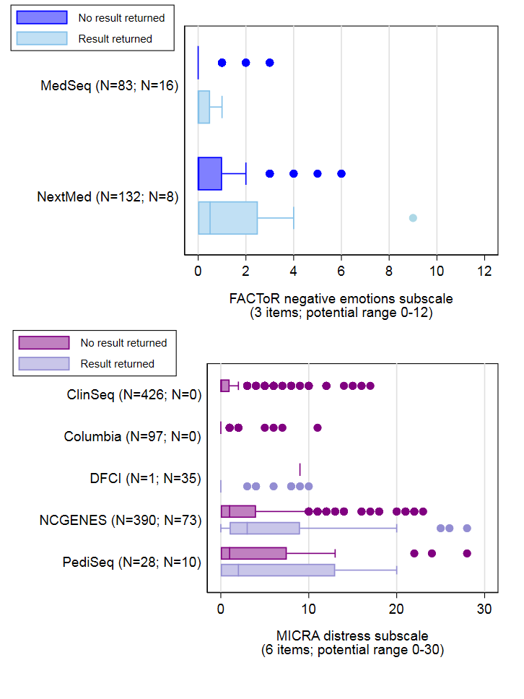

Supplemental Figure 10. Primary Results Box and whisker plots of FACToR positive feelings and MICRA positive experience subscales stratified by receipt of primary genetic results. Higher scores represent fewer positive feelings/experience. Scores are instrument-specific and have not been rescaled for comparability across subscales. Frequency counts represent the number of patients without results returned followed by those with results returned.
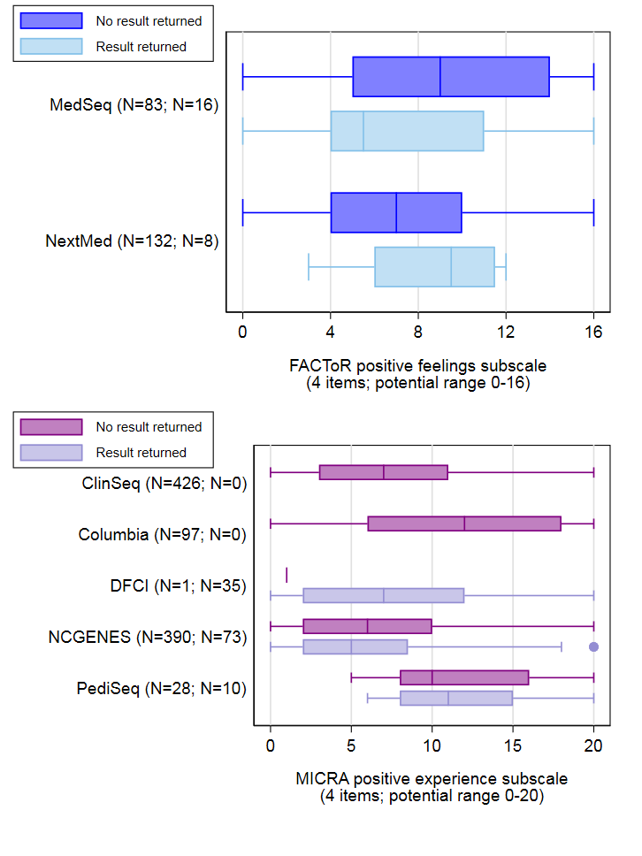

Supplemental Figure 11. Primary Results Box and whisker plots of FACToR and MICRA uncertainty subscales stratified by receipt of positive genetic results. Higher scores represent greater levels of uncertainty. Scores are instrument-specific and have not been rescaled for comparability across subscales. Frequency counts represent the number of patients without results returned followed by those with results returned. Uncertainty subscales are not shown for participants at Dana-Farber Cancer Institute, since they were not asked all of the items on the subscale.
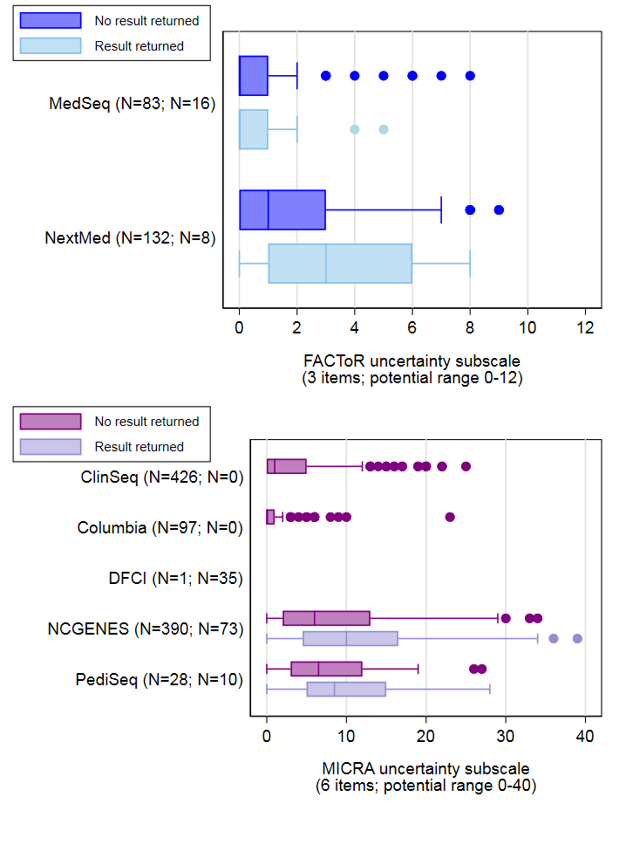
Supplemental Figure 12a and b. Random effects meta-analysis of standardized mean difference in HADS or GAD anxiety stratified by a) no receipt of primary results and b) receipt of primary genetic results. Negative values represent decreased anxiety post-disclosure. The effect size represents a one standard deviation change.
Supplemental Figure 12a. No Primary Results: Anxiety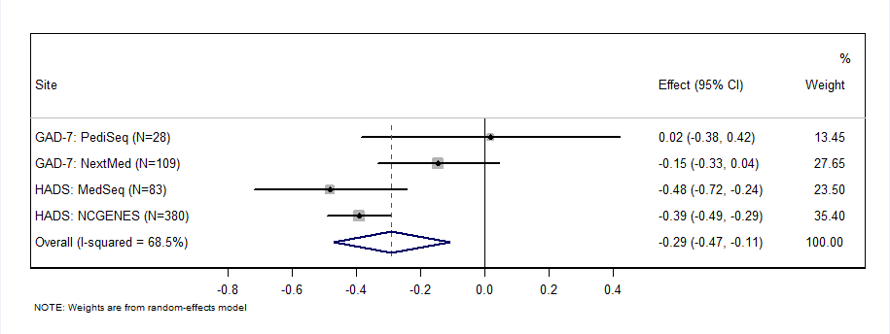
Supplemental Figure 12b. Received Primary Results: Anxiety
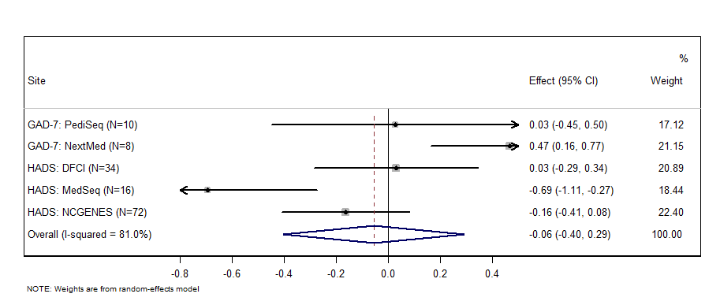

Supplemental Figure 13a and b. Random effects meta-analysis of standardized mean difference in HADS or PHQ-9 depression stratified by a) no receipt of primary genetic results and b) receipt of primary genetic results. Negative values represent decreased anxiety post-disclosure. The effect size represents a one standard deviation change.
Supplemental Figure 13a. No Primary Results: Depression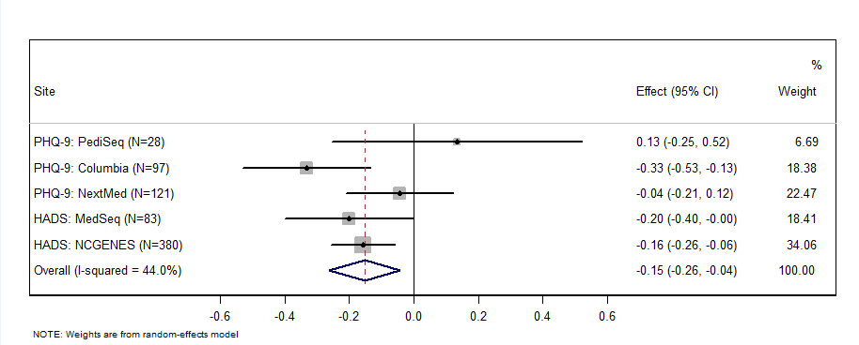
Supplemental Figure 13b. Received Primary Results: Depression
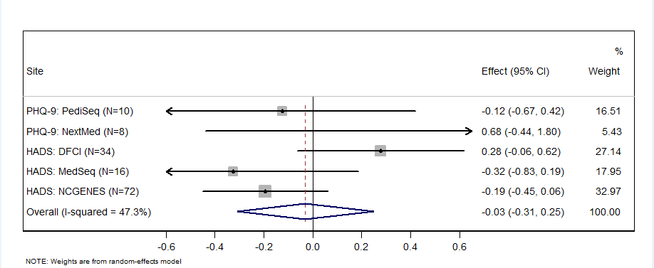

Supplemental Figure 14a and b. Random effects meta-analysis of multi-dimensional impact FACToR negative emotions/ MICRA distress stratified by a) no receipt of primary genetic results and b) receipt of primary genetic results. Higher values represent worse outcomes. Subscale scores have been rescaled to a 0-100 point scale, where 0 represents “Not at all” or “Never”, and 100 represents “A great deal” or “Often”.
Supplemental Figure 14a. No Primary Results: Distress
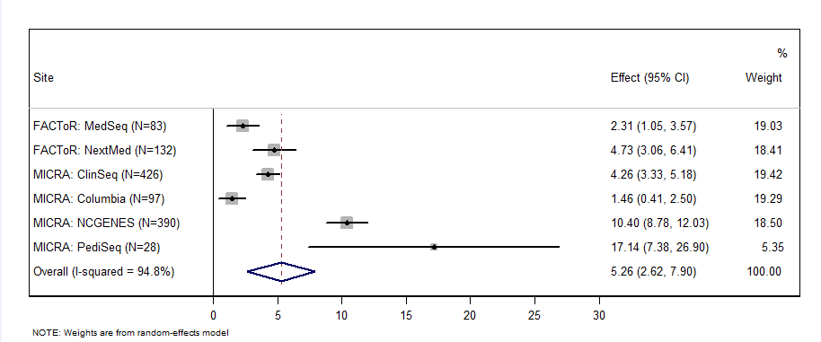
Supplemental Figure 14b. Received Primary Results: Distress
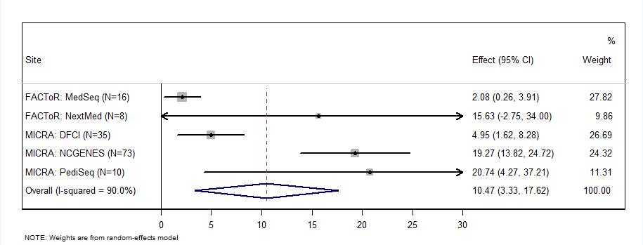

Supplemental Figure 15a and b. Random effects meta-analysis of multi-dimensional FACToR or MICRA positive feelings/experiences, stratified by a) no receipt of primary genetic results and b) receipt of primary genetic results. Higher values represent worse outcomes. Subscale scores have been rescaled to a 0-100 point scale, where 0 represents “Often” or “A great deal”, and 100 represents “Not at all” or “Never”.
Supplemental Figure 15a. No Primary Results: Positive Experiences
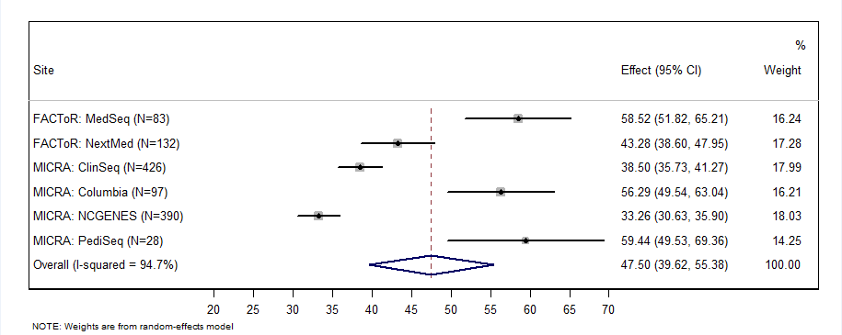
Supplemental Figure 15b. Received Primary Results: Positive Experiences
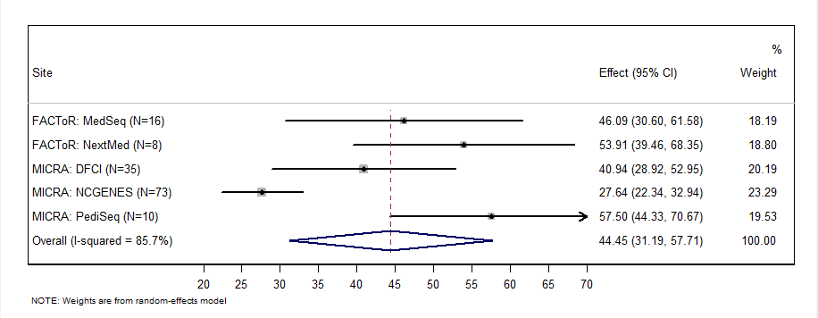

Supplemental Figure 16a and b. Random effects meta-analysis of multi-dimensional impact FACToR or MICRA uncertainty stratified by a) no receipt of primary results and b) receipt of primary genetic results. Higher values represent worse outcomes. Subscale scores have been rescaled to a 0-100 point scale, where 0 represents “Not at all” or “Never”, and 100 represents “A great deal” or “Often”.
Supplemental Figure 16a. No Primary Results: Uncertainty
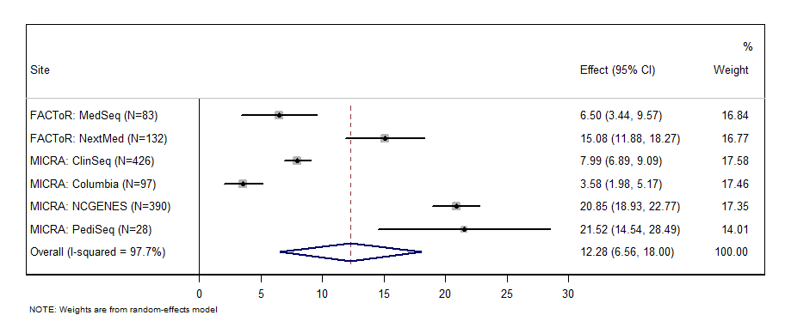
Supplemental Figure 16b. Received Primary Results: Uncertainty
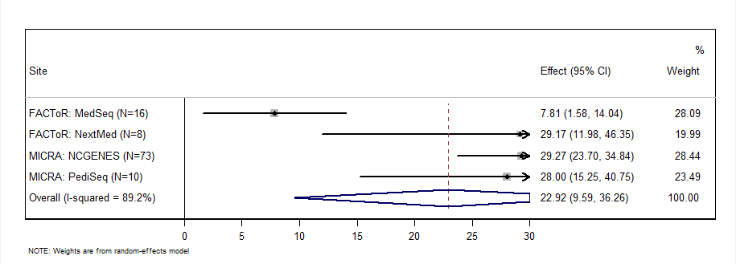

Supplemental Figures: Stratified by return of carrier/pharmacogenetic test results (no result returned vs. result returned)

Supplemental Figure 17. Carrier/Pharmacogenetic Results Box and whisker plots of GAD-7 and HADS anxiety scores stratified by receipt of carrier/pharmacogenetic genetic results. Scores are instrument-specific and have not been rescaled for comparability across scales. Frequency counts represent the number of patients without results returned followed by those with results returned.
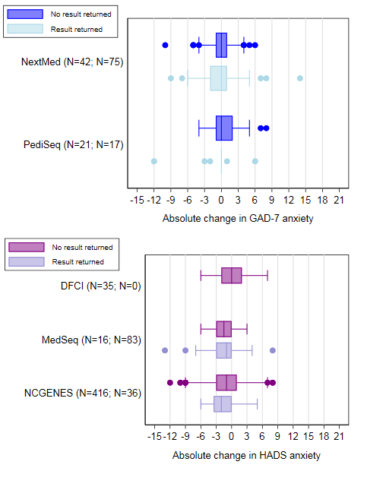

Supplemental Figure 18. Carrier/Pharmacogenetic Results Box and whisker plots of PHQ-9 and HADS depression scores stratified by receipt of carrier/pharmacogenetic results. Scores are instrument-specific and have not been rescaled for comparability across scales. Frequency counts represent the number of patients without results returned followed by those with results returned.
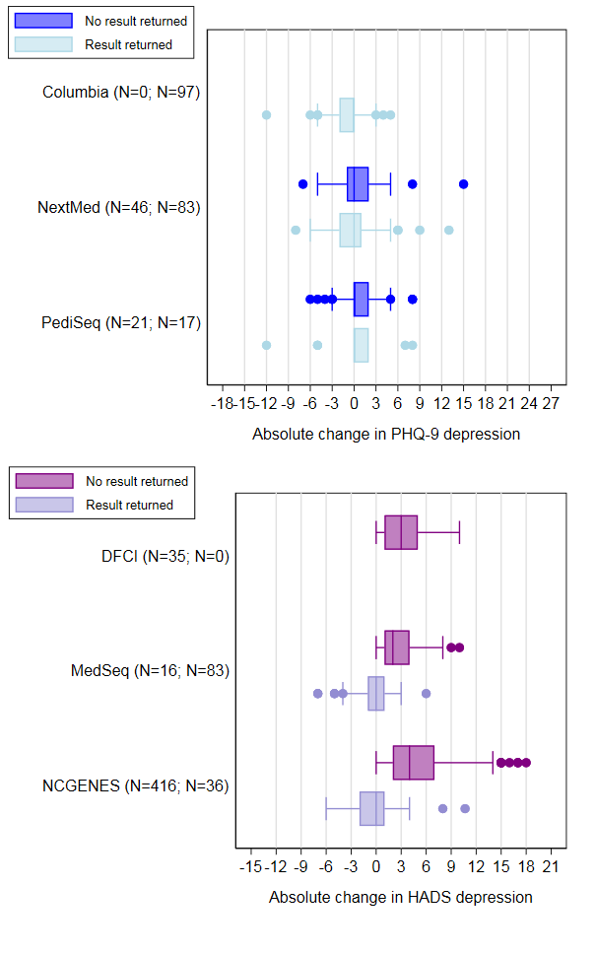

Supplemental Figure 19. Carrier/Pharmacogenetic Results Box and whisker plots of FACToR negative emotions and MICRA distress subscales stratified by receipt of carrier/pharmacogenetic results. Higher scores represent greater levels of negative emotions/distress. Scores are instrument-specific and have not been rescaled for comparability across subscales. Frequency counts represent the number of patients without results returned followed by those with results returned.
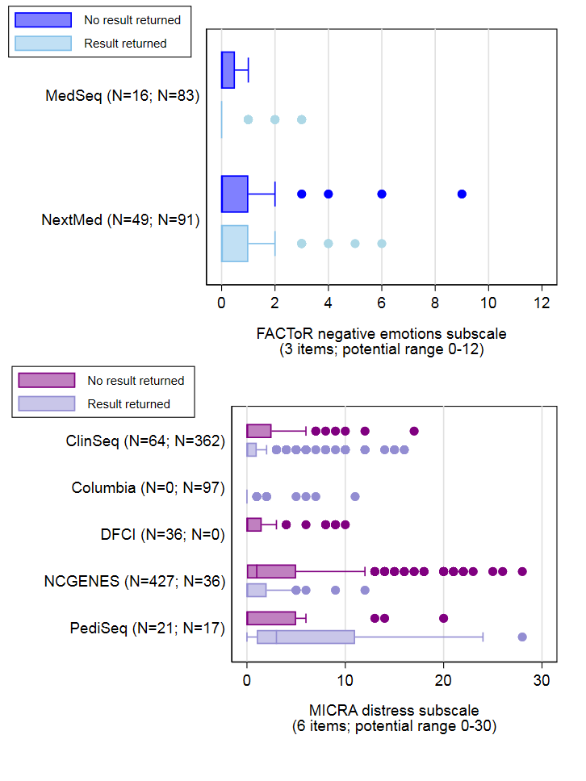
Supplemental Figure 20. Carrier/Pharmacogenetic Results Box and whisker plots of FACToR positive feelings and MICRA positive experience subscales stratified by receipt of carrier/pharmacogenetic results. Higher scores represent fewer positive feelings/experience. Scores are instrument-specific and have not been rescaled for comparability across subscales. Frequency counts represent the number of patients without results returned followed by those with results returned.
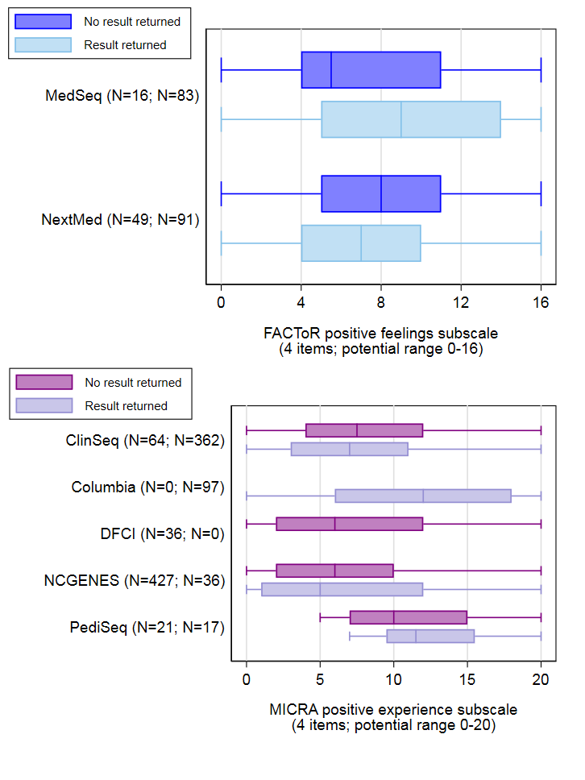
Supplemental Figure 21. Carrier/Pharmacogenetic Results Box and whisker plots of FACToR and MICRA uncertainty subscales stratified by receipt of carrier/pharmacogenetic results. Higher scores represent greater levels of uncertainty. Scores are instrument-specific and have not been rescaled for comparability across subscales. Frequency counts represent the number of patients without results returned followed by those with results returned. Uncertainty subscales are not shown for participants at Dana-Farber Cancer Institute, since they were not asked all of the items on the subscale.
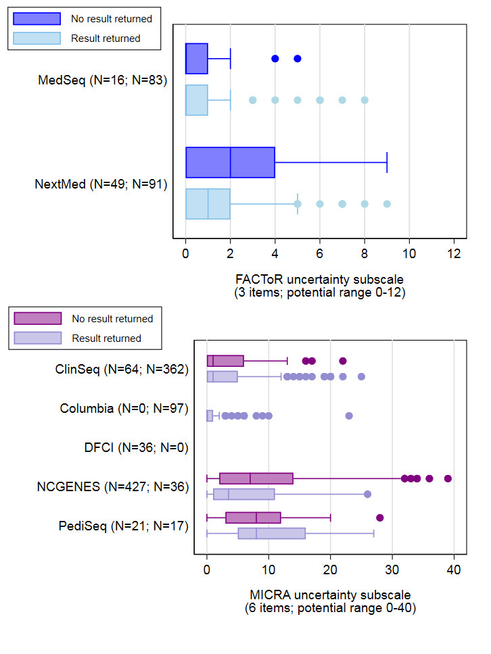
Supplemental Figure 22a and b. Random effects meta-analysis of standardized mean difference in HADS or GAD anxiety stratified by a) no receipt of carrier/pharmacogenetic results and b) receipt of carrier/pharmacogenetic results. Negative values represent decreased anxiety post-disclosure. The effect size represents a one standard deviation change.
Supplemental Figure 22a. No Carrier/Pharmacogenetic Results: Anxiety
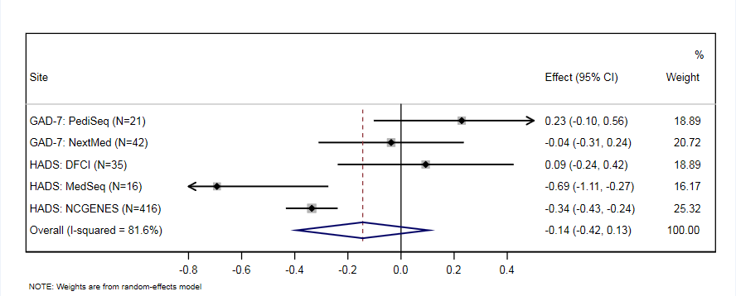

Supplemental Figure 22b. Recieved Carrier/Pharmacogenetic Results: Anxiety
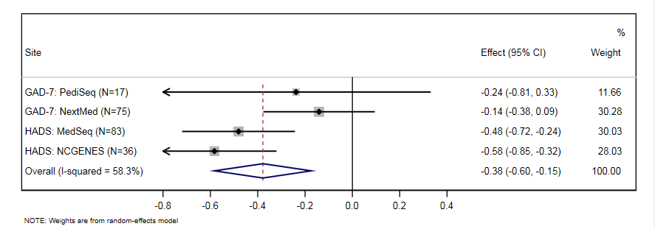

Supplemental Figure 23a and b. Random effects meta-analysis of standardized mean difference in HADS or PHQ-9 depression stratified by a) no receipt of carrier/pharmacogenetic results and b) receipt of carrier/pharmacogenetic results. Negative values represent decreased anxiety post-disclosure. The effect size represents a one standard deviation change.
Supplemental Figure 23a. No Carrier/Pharmacogenetic Results: Depression
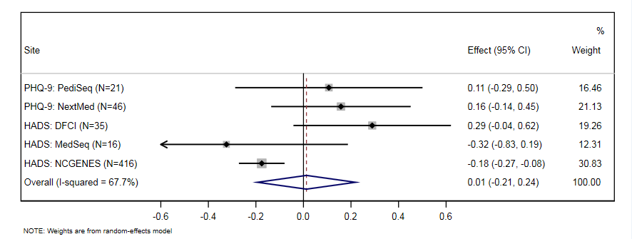

Supplemental Figure 23b. Received Carrier/Pharmacogenetic Results: Depression
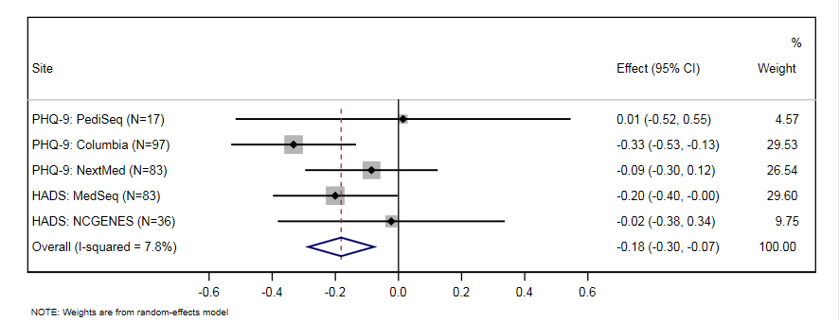

Supplemental Figure 24a and b. Random effects meta-analysis of multi-dimensional impact FACToR negative emotions/ MICRA distress stratified by by a) no receipt of carrier/pharmacogenetic results and b) receipt of carrier/pharmacogenetic results. Higher values represent worse outcomes. Subscale scores have been rescaled to a 0-100 point scale, where 0 represents “Not at all” or “Never”, and 100 represents “A great deal” or “Often”.
Supplemental Figure 24a. No Carrier/Pharmacogenetic Results: Distress
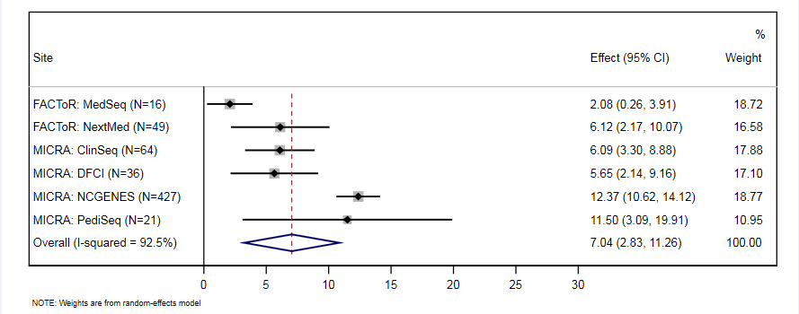

Supplemental Figure 24a. Recieved Carrier/Pharmacogenetic Results: Distress
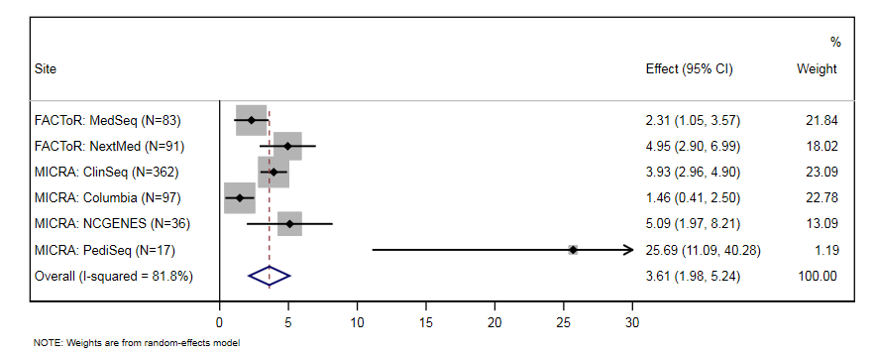

Supplemental Figure 25a and b. Random effects meta-analysis of multi-dimensional FACToR or MICRA positive feelings/experiences, by a) no receipt of carrier/pharmacogenetic results and b) receipt of carrier/pharmacogenetic results. Higher values represent worse outcomes. Subscale scores have been rescaled to a 0-100 point scale, where 0 represents “Often” or “A great deal”, and 100 represents “Not at all” or “Never”.
Supplemental Figure 25a. No Carrier/Pharmacogenetic Results: Positive Response
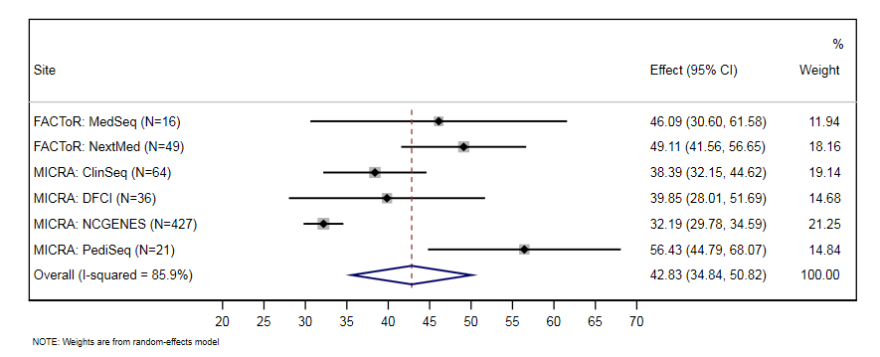

Supplemental Figure 25a. Recieved Carrier/Pharmacogenetic Results: Positive Response
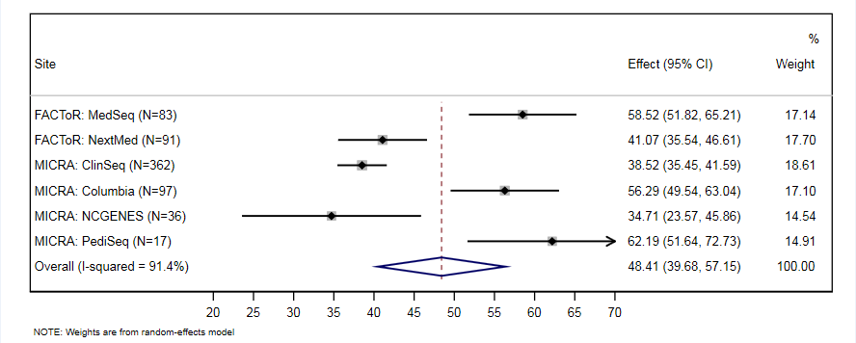

Supplemental Figure 26a and b. Random effects meta-analysis of multi-dimensional impact FACToR or MICRA uncertainty stratified by a) no receipt of carrier/pharmacogenetic results and b) receipt of carrier/pharmacogenetic results. Subscale scores have been rescaled to a 0-100 point scale, where 0 represents “Not at all” or “Never”, and 100 represents “A great deal” or “Often”.
Supplemental Figure 26a. No Carrier/Pharmacogenetic Results: Uncertainty
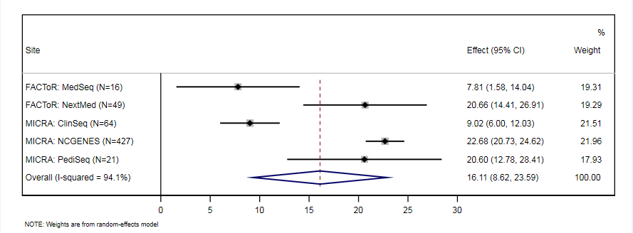

Supplemental Figure 26a. Received Carrier/Pharmacogenetic Results: Uncertainty
