IMMUNOPATHOLOGICAL MANIFESTATIONS IN KABUKI SYNDROME: A REGISTER STUDY OF 177 INDIVIDUALS

SUPPLEMENTARY DATA

Authors Block: Henri Margot MS¹, Guilaine Boursier PharmD-PhD^{2,3}, Claire Duflos MD⁴, Elodie Sanchez MD^{2,3}, Jeanne Amiel MD-PhD⁵, Jean-Christophe Andrau PhD⁶,Stéphanie Arpin MD⁷, Elise Boucher MD⁸, Odile Boute MD⁹, Lydie Burglen MD-PhD¹⁰, Charlotte Caille MS¹¹, Yline Capri MD¹², Patrick Collignon MD-PhD¹³, Solène Conrad MS¹⁴, Valérie Cormier-Daire MD-PhD⁵, Geoffroy Delplancq MS⁸, Klaus Dieterich MD-PhD¹⁵, Hélène Dollfus MD-PhD¹⁶, Mélanie Fradin MD¹⁷, Laurence Faivre MD-PhD¹⁸, Helder Fernandes PhD^{19,20} Christine Francannet MD²¹, Vincent Gatinois PharmD-PhD^{2,3}, Marion Gerard MD²², Alice Goldenberg MD-PhD²³, Jamal Ghoumid MD-PhD⁹, Sarah Grotto MD¹², Anne-Marie Guerrot MD²³, Agnes Guichet MD²⁴, Bertrand Isidor MD-PhD¹⁴, Marie-Line Jacquemont MD^{25,26}, Sophie Julia MD²⁷, Philippe Khau Van Kien MD-PhD²⁸, Marine Legendre MD-PhD^{1,26} , KH. Le Quan Sang PhD²⁹, Bruno Leheup MD-PhD³⁰, Stanislas Lyonnet MD-PhD⁵, Virginie Magry MS²¹, Sylvie Manouvrier MD-PhD⁹, Dominique Martin MD³¹, Godelieve Morel MS³², Arnold Munnich MD-PhD⁵, Sophie Naudion MD^{1,26}, Sylvie Odent MD-PhD¹⁷, Laurence Perrin MD¹², Florence Petit MD-PhD⁹, Nicole Philip MD-PhD³³, Marlène Rio MD-PhD⁵, Julie Robbe MS³³, Maximiliano Rossi MD-PhD³⁴, Elisabeth Sarrazin MD²⁶, Annick Toutain MD-PhD⁶, Julien Van Gils MD^{1,26,36}, Gabriella Vera MS-PhD²³, Alain Verloes MD-PhD¹², Sacha Weber MD²², Sandra Whalen MD³⁵, Damien Sanlaville MD-PhD³⁴, Didier Lacombe MD-PhD^{1,26,36}, Nathalie Aladjidi MD^{19,20*}, David Genevieve MD-PhD^{2,3*}

¹Service de génétique médicale, CHU de Bordeaux, Bordeaux, France ²Département de génétique médicale, Maladies rares et médecine personnalisée, CHU de Montpellier, Montpellier, France ³INSERM U1183, Université de Montpellier, Montpellier, France ⁴Département d'Information Médicale, CHU Montpellier, Montpellier, France ⁵Fédération de Génétique et Institut Imagine, Hôpital Necker-Enfants Malades, AP-HP et INSERM UMR1163, Paris Descartes-Sorbonne Paris Cité University, Paris, France ⁶Institut de Génétique Moléculaire de Montpellier (IGMM), Univ Montpellier, CNRS-UMR5535, Montpellier, France ⁷Service de génétique, CHU de Tours, UMR 1253, iBrain, Université de Tours, Inserm, Tours, France ⁸Centre de Génétique Humaine, Université de Franche-Comté, Besançon, France ⁹Centre de référence maladies rares pour les anomalies du développement Nord-Ouest, Clinique de Génétique médicale, CHU de Lille et EA7364, Université de Lille, Lille, France ¹⁰Centre de référence des malformations et maladies congénitales du cervelet, département de génétique et embryologie médicale, APHP, GHUEP, Hôpital Trousseau, Paris, France ¹¹Service de génétique médicale, CHU de Brest, Brest, France ¹²Service de génétique médicale, AP-HP Robert-Debré, Paris, France ¹³Service de génétique médicale, CHI de Toulon, Toulon, France ¹⁴Service de génétique médicale, CHU de Nantes, Nantes, France ¹⁵Service de génétique médicale, CHU de Grenoble, Grenoble, France ¹⁶Service de génétique médicale, CHU de Strasbourg, Strasbourg, France ¹⁷Service de génétique clinique, CHU de Rennes, Univ. Rennes, Institute of Genetics and Development of Rennes (IGDR) UMR6290 CNRS Rennes, France ¹⁸Service de génétique médicale et centre de référence Anomalies du Développement et Syndromes Malformatifs, CHU de Dijon, Dijon, France ¹⁹Service d'onco hématologie pédiatrique, CHU de Bordeaux, Bordeaux, France, ²⁰Centre de référence des cytopénies auto-immunes de l'enfant, CHU de Bordeaux, Bordeaux, France, CIC401, INSERM CICP, Université de Bordeaux, Bordeaux, France ²¹Service de génétique médicale, CHU de Clemont-Ferrand, Clermont-Ferrand, France ²²Service de génétique médicale, CHU de Caen, Caen, France ²³Normandie Univ, UNIROUEN, Inserm U1245 and Rouen University Hospital, Department of Genetics and Reference Center for Developmental Disorders , F 76000, Normandy Center for Genomic and Personalized Medicine, Rouen, France ²⁴ Service de génétique médicale, CHU d'Angers, Angers, France ²⁵Service de génétique médicale, CHU de la Reunion, Saint-Pierre, France ²⁶Centre de Référence Anomalies du développement et Syndromes malformatifs du Sud-Ouest Occitanie Réunion ²⁷Service de génétique médicale, CHU de Toulouse, Toulouse, France ²⁸Service de génétique médicale, CHU de Nîmes, Nîmes, France ²⁹Institut Imagine, Paris Descartes-Sorbonne Paris Cité University, INSERM U1163, Paris, France ³⁰Service de génétique médicale, CHU de Nancy, Nancy, France ³¹Service de génétique médicale, CH du Mans, Le Mans, France ³²Service de génétique médicale, CHU de Nice, Nice, France ³³Service de génétique médicale, CHU de Marseille, Marseille, France ³⁴Service de génétique médicale, CHU de Lyon, Lyon, France France ³⁵Service de génétique médicale, AP-HP Pitié Salpétrière, Paris, France ³⁶INSERM U1211, Université de Bordeaux, Bordeaux, France

Contact: Henri MARGOT, henri.margot@hotmail.fr, 0033(0)633844224
*Corresponding author
Pr Geneviève David
Département de Génétique Médicale, CHRU Arnaud de Villeneuve
371 avenue du doyen Gaston Giraud, 34000 Montpellier, France
Tel: +33 (0)4 67 33 65 64
Fax: +33 (0)4 67 33 60 52
Email: d-genevieve@chu-montpellier.fr

Age | Sex | Gene | Nucleotide position (c.) | Protein position | Mutation type | AID | ITP | AIHA | THY | VIT | OTH | N AID | IS | Hypo Ig | CVID | Additional information
1 | F | KDM6A | c.3270_3273del | p.(Ser1091Metfs*12) | F | N | N | N | N | N | N | 0 | Y | Y | Y
2 | F | KDM6A | c.3835C>T | p.(Arg1279*) | N | N | N | N | N | N | N | 0 | N
2 | M | KDM6A | c.875+1G>A | p.? | L | N | N | N | N | N | N | 0 | N
2 | M | KDM6A | c.3835C>T | (p.Arg1279*) | N | N | N | N | N | N | N | 0 | N |  |  | Died of hypovolemic choc (gastroenteritis)
3 | M | KDM6A | c.619+6T>C | p.? | L | N | N | N | N | N | N | 0 | N
4 | F | KDM6A | c.1924-1G>C | p.? | L | N | N | N | N | N | N | 0 | N
5 | M | KDM6A | c.3835C>T | p.(Arg1279*) | N | N | N | N | N | N | N | 0 | Y | Y | Y | Recurrent otitis
6 | F | KDM6A | c.443+5G>C | p.? | L | N | N | N | N | N | N | 0 | N
7 | F | KDM6A | c.2939-1G>T | p.? | L | N | N | N | N | N | N | 0 | Y |  |  | Cerebral abces (Tonsillitis)
8 | M | KDM6A | c.2074C>T | p.(Gln692*) | N | N | N | N | N | N | N | 0 | N
10 | M | KDM6A | c.620-2A>G | p.? | L | Y | N | N | N | Y | N | 1 | Y | N | U | Recurrent otitis
11 | M | KDM6A | c.514C>T | p.(Arg172*) | N | N | N | N | N | N | N | 0 | Y | N | U | Osteomyelitis
14 | M | KDM6A | c.3073A>G | p.(Ser1025Gly) | M | N | N | N | N | N | N | 0 | N
20 | F | KDM6A | Del Ex 1 |  | N | N | N | N | N | N | N | 0 | N
28 | F | KDM6A | c.564+1G>T | p.? | L | N | N | N | N | N | N | 0 | N
0 | M | KMT2D | c.11425del | p.(Val3809Cysfs*21) | F | N | N | N | N | N | N | 0 | Y | N | U | Died of a bacterial infection complicating bronchiolitis
1 | F | KMT2D | c.15330del | p.(Asn5111Metfs*36) | F | N | N | N | N | N | N | 0 | N
1 | M | KMT2D | c.8053C>T | p.(Arg2685*) | N | N | N | N | N | N | N | 0 | N
1 | M | KMT2D | c.15844C>T | p.(Arg5282*) | N | N | N | N | N | N | N | 0 | Y | Y | Y | Recurrent pyelonephritis
1 | F | KMT2D | c.15061C>T | p.(Arg5021*) | N | N | N | N | N | N | N | 0 | Y |  |  | Pulmonary infections
2 | M | KMT2D | c.2760_2782del | p.(Gly921Alafs*40) | F | N | N | N | N | N | N | 0 | N | N | N
2 | F | KMT2D | c.13606C>T | p.(Arg4536*) | N | N | N | N | N | N | N | 0 | Y | Y | Y | Recurrent otitis
2 | F | KMT2D | c.11827C>T | p.(Gln3943*) | N | N | N | N | N | N | N | 0 | N
2 | M | KMT2D | c.9971C>T | p.(Arg3321*) | N | N | N | N | N | N | N | 0 | N | N | N
2 | F | KMT2D | c.11263C>T | p.(Gln3755*) | N | N | N | N | N | N | N | 0 | N | N | N
2 | M | KMT2D | c.15461G>A | p.(Arg5154Gln) | M | N | N | N | N | N | N | 0 | N |  |  | Died of CA on tracheotomy
2 | F | KMT2D | c.15536G>A | p.(Arg5179His) | M | N | N | N | N | N | N | 0 | N | N | N
2 | M | KMT2D | c.16294C>T | p.(Arg5432Trp) | M | N | N | N | N | N | N | 0 | N
2 | F | KMT2D | c.6183G>A | p.? | L | N | N | N | N | N | N | 0 | N | N | N
3 | F | KMT2D | c.15142C>T | p.(Arg5048Cys) | M | N | N | N | N | N | N | 0 | N
3 | F | KMT2D | c.10357C>T | p.(Gln3453*) | N | N | N | N | N | N | N | 0 | Y | Y | Y | Severe digestive infections
4 | M | KMT2D | c.11977C>T | p.(Gln3993*) | N | N | N | N | N | N | N | 0 | Y |  |  | Recurrent pyelonephritis
4 | F | KMT2D | c.15784+5G>A | p.? | L | N | N | N | N | N | N | 0 | N | N | N
4 | F | KMT2D | c.14873C>G | p.(Ser4958*) | N | N | N | N | N | N | N | 0 | N
4 | M | KMT2D | c.166C>T | p.(Gln56*) | N | N | N | N | N | N | N | 0 | N
4 | M | KMT2D | c.2506dup | p.(Gln836Profs*3) | F | N | N | N | N | N | N | 0 | N
4 | F | KMT2D | c.13780del | p.(Ala4594Profs*23) | F | N | N | N | N | N | N | 0 | N
4 | M | KMT2D | c.7903C>T | p.(Arg2635*) | N | N | N | N | N | N | N | 0 | Y |  |  | Recurrent otitis
5 | M | KMT2D | c.15920C>G | p.(Ser5307*) | N | N | N | N | N | N | N | 0 | N | Y | U
5 | F | KMT2D | c.10694del | p.(Lys3565Serfs*93) | F | N | N | N | N | N | N | 0 | N
5 | F | KMT2D | c.15781C>T | p.(Gln5261*) | N | N | N | N | N | N | N | 0 | Y |  |  | Facial nerve paralysis (Herpes)
5 | F | KMT2D | c.269_272del | p.(Asp90Glyfs*39) | F | N | N | N | N | N | N | 0 | Y | Y | Y
5 | M | KMT2D | c.11524C>T | p.(Gln3842*) | N | N | N | N | N | N | N | 0 | N
5 | M | KMT2D | c.13450C>T | p.(Arg4484*) | N | N | N | N | N | N | N | 0 | Y |  |  | Recurrent otitis
5 | F | KMT2D | c.5764C>T | p.(Gln1922*) | N | N | N | N | N | N | N | 0 | Y | N | U | Recurrent otitis
5 | F | KMT2D | c.952A>T | p.(Lys318*) | N | Y | Y | Y | N | N | N | 3 | Y | N | U | Sepsis salmonella  Recurrent otitis  Chronic ITP/ Evans
5 | F | KMT2D | c.11728C>T | p.(Gln3910*) | N | N | N | N | N | N | N | 0 | Y | N | U
5 | M | KMT2D | c.15461G>A | p.(Arg5154Gln) | M | N | N | N | N | N | N | 0 | Y | Y | Y | Recurrent otitis
6 | F | KMT2D | c.13014del | p.(Thr4339Profs*45) | F | N | N | N | N | N | N | 0 | Y |  |  | Recurrent otitis
6 | M | KMT2D | c.7199dup | p.(Arg2401Serfs*33) | F | N | N | N | N | N | N | 0 | Y | Y | Y | Recurrent otitis
6 | F | KMT2D | c.13297dup | p.(Arg4433Lysfs*54) | F | N | N | N | N | N | N | 0 | N | Y | U
6 | M | KMT2D | c.12469C>T | p.(Gln4157*) | N | N | N | N | N | N | N | 0 | N
6 | M | KMT2D | c.14710C>T | p.(Arg4904*) | N | N | N | N | N | N | N | 0 | Y | Y | Y | Recurrent otitis
6 | M | KMT2D | c.12183del | p.(Glu4061Aspfs*5) | F | N | N | N | N | N | N | 0 | N
6 | M | KMT2D | c.6622C>T | p.(Gln2208*) | N | Y | N | N | N | N | Y | 1 | N |  |  | Diabetes type 1
6 | M | KMT2D | c.11597dup | p.(Gln3867Alafs*145) | F | N | N | N | N | N | N | 0 | N
6 | M | KMT2D | c.6962T>G | p.(Leu2321*) | N | N | N | N | N | N | N | 0 | Y | N | U | Recurrent otitis
7 | F | KMT2D | c.12301C>T | p.(Gln4101*) | N | Y | N | N | N | Y | N | 1 | Y |  |  | Recurrent otitis
7 | F | KMT2D | c.15842del | p.(Leu5281Argfs*8) | F | N | N | N | N | N | N | 0 | Y |  |  | Recurrent otitis
7 | F | KMT2D | c.8200C>T | p.(Arg2734*) | N | N | N | N | N | N | N | 0 | N
7 | M | KMT2D | c.12598C>T | p.(Gln4200*) | N | N | N | N | N | N | N | 0 | N
7 | M | KMT2D | c.12592C>T | p.(Arg4198*) | N | N | N | N | N | N | N | 0 | N
7 | F | KMT2D | c.9829C>T | p.(Gln3277*) | N | N | N | N | N | N | N | 0 | N |  |  | Died of a renal failure
7 | F | KMT2D | c.15536G>A | p.(Arg5179His) | M | Y | N | N | N | Y | N | 1 | N | N | N
7 | M | KMT2D | c.15536G>A | p.(Arg5179His) | M | N | N | N | N | N | N | 0 | Y |  |  | Urinary infections
7 | M | KMT2D | c.16019G>A | p.(Arg5340Gln) | M | N | N | N | N | N | N | 0 | N | N | N
8 | F | KMT2D | c.3540del | p.(Pro1181Hisfs*31) | F | N | N | N | N | N | N | 0 | N
8 | M | KMT2D | c.12700_12701del | p.(Gln4235Glyfs*98) | F | N | N | N | N | N | N | 0 | N
8 | M | KMT2D | c.11770dup | p.(Gln3924Profs*88) | F | N | N | N | N | N | N | 0 | N | N | N
8 | F | KMT2D | c.11515dup | p.(Gln3839Profs*173) | F | N | N | N | N | N | N | 0 | N
8 | M | KMT2D | c.16052G>A | p.(Arg5351Gln) | M | N | N | N | N | N | N | 0 | N
9 | F | KMT2D | c.15142C>T | p.(Arg5048Cys) | M | N | N | N | N | N | N | 0 | N | Y | U
9 | M | KMT2D | c.2164del | p.(Glu722Serfs*208) | F | N | N | N | N | N | N | 0 | Y |  |  | Recurrent otitis
9 | M | KMT2D | c.4171G>A | p.(Glu1391Lys) | M | N | N | N | N | N | N | 0 | Y | Y | Y | Recurrent otitis
10 | M | KMT2D | c.15142C>T | p.(Arg5048Cys) | M | N | N | N | N | N | N | 0 | N
10 | F | KMT2D | c.10841C>G | p.(Ser3614*) | N | N | N | N | N | N | N | 0 | Y |  |  | Recurrent otitis
10 | M | KMT2D | c.12986_13010dup | p.(Pro4338Alafs*4) | F | N | N | N | N | N | N | 0 | Y | Y | Y | Recurrent otitis
10 | F | KMT2D | c.13660C>T | p.(Gln4554*) | N | N | N | N | N | N | N | 0 | N
10 | M | KMT2D | c.12688C>T | p.(Gln4230*) | N | N | N | N | N | N | N | 0 | Y |  |  | Recurrent otitis
10 | F | KMT2D | c.12442_12455del | p.(Met4148Serfs*15) | F | N | N | N | N | N | N | 0 | N
10 | F | KMT2D | c.6987_6988ins | p.(Pro2330Serfs*47) | F | N | N | N | N | N | N | 0 | Y |  |  | Recurrent otitis
10 | M | KMT2D | c.3626_3627del | p.(Ser1209*) | N | N | N | N | N | N | N | 0 | N
11 | F | KMT2D | c.15143G>A | p.(Arg5048His) | M | N | N | N | N | N | N | 0 | Y | Y | Y | Recurrent otitis
11 | F | KMT2D | c.14803G>T | p.(Glu4935*) | N | N | N | N | N | N | N | 0 | N
11 | M | KMT2D | c.13040_13041del | p.(Gln4347Argfs*24) | F | N | N | N | N | N | N | 0 | Y |  |  | Recurrent otitis
11 | M | KMT2D | c.14516-1G>C | p.? | L | N | N | N | N | N | N | 0 | N
11 | F | KMT2D | c.1363del | p.(Glu455Asnfs*475) | F | N | N | N | N | N | N | 0 | Y | Y | Y | Reccurent digestive infection
11 | M | KMT2D | c.15079C>T | p.(Arg5027*) | N | N | N | N | N | N | N | 0 | N
11 | F | KMT2D | c.6629del | p.(Pro2210Argfs*54) | F | N | N | N | N | N | N | 0 | N
11 | F | KMT2D | c.15673C>T | p.(Arg5225Cys) | M | N | N | N | N | N | N | 0 | N
12 | M | KMT2D | c.13450C>T | p.(Arg4484*) | N | N | N | N | N | N | N | 0 | Y | N | U | Recurrent infections (ENT, Dig, Pulm)
12 | F | KMT2D | c.14076-1G>A | p.? | L | N | N | N | N | N | N | 0 | N
12 | M | KMT2D | c.4135_4136del | p.(Met1379Valfs*52) | F | N | N | N | N | N | N | 0 | Y | N | U | Recurrent otitis
12 | F | KMT2D | c.11645C>G | p.(Ser3882*) | N | N | N | N | N | N | N | 0 | Y | Y | Y | Recurrent otitis
12 | M | KMT2D | c.4267C>G | p.(Arg1423Gly) | M | N | N | N | N | N | N | 0 | Y | Y | Y | Recurrent otitis
13 | F | KMT2D | c.15142C>T | p.(Arg5048Cys) | M | N | N | N | N | N | N | 0 | N
13 | F | KMT2D | c.5627_5630del | p.(Asp1876Glyfs*38) | F | N | N | N | N | N | N | 0 | Y |  |  | Recurrent otitis
13 | F | KMT2D | c.400+2T>C | p.? | L | N | N | N | N | N | N | 0 | N
13 | F | KMT2D | c.6325C>T | p.(Gln2109*) | N | N | N | N | N | N | N | 0 | Y | Y | Y | Recurrent Infections (otitis, cystitis, gastroenteritis)
13 | F | KMT2D | c.8410del | p.(Tyr2804Ilefs*47) | F | N | N | N | N | N | N | 0 | N | Y | U
13 | F | KMT2D | c.15337dup | p.(Tyr5113Leufs*25) | F | N | N | N | N | N | N | 0 | N
13 | F | KMT2D | c.16489_16491del | p.(Ile5497del) | M | N | N | N | N | N | N | 0 | Y |  |  | Recurrent otitis
13 | M | KMT2D | c.3527C>T | p.(Ala1176Val) | M | N | N | N | N | N | N | 0 | Y | N | U
14 | F | KMT2D | c.15206T>A | p.(Val5069Glu) | M | N | N | N | N | N | N | 0 | N | N | N
14 | M | KMT2D | c.6295C>T | p.(Arg2099*) | N | N | N | N | N | N | N | 0 | N | N | N
14 | F | KMT2D | c.8709dup | p.(Pro2904Thrfs*8) | F | N | N | N | N | N | N | 0 | Y | Y | Y | Recurrent otitis
14 | M | KMT2D | c.16315C>G | p.(Arg5439Gly) | M | N | N | N | N | N | N | 0 | Y | Y | Y | Recurrent otitis
14 | F | KMT2D | c.9022G>T | p.(Ser5307*) | N | N | N | N | N | N | N | 0 | N | N | N
14 | M | KMT2D | c.3906+2T>C | p.? | L | N | N | N | N | N | N | 0 | N
14 | M | KMT2D | c.5983G>T | p.(Gly1995*) | N | N | N | N | N | N | N | 0 | N
14 | F | KMT2D | c.15079C>T | p.(Arg5027*) | N | N | N | N | N | N | N | 0 | Y |  |  | Recurrent otitis
14 | F | KMT2D | c.2345del | p.(Val782Glyfs*148) | F | N | N | N | N | N | N | 0 | N
15 | F | KMT2D | c.15397T>C | p.(Cys5133Arg) | M | N | N | N | N | N | N | 0 | N | N | N
15 | F | KMT2D | c.14515+1del | p.? | L | Y | Y | Y | N | N | N | 2 | Y | Y | Y | GLILD  Chronic ITP/Evans
15 | F | KMT2D | c.15349T>G | p.(Cys5117Gly) | M | Y | Y | N | N | N | N | 1 | Y | Y | Y | Chronic ITP
15 | M | KMT2D | c.11899C>T | p.(Gln3967*) | N | N | N | N | N | N | N | 0 | Y | Y | Y
15 | F | KMT2D | c.15546_15547ins | p.(Leu5183Alafs*16) | F | N | N | N | N | N | N | 0 | Y | N | U | Recurrent otitis
16 | M | KMT2D | c.15142C>T | p.(Arg5048Cys) | M | N | N | N | N | N | N | 0 | Y | Y | Y | Recurrent otitis
16 | M | KMT2D | c.15640C>T | p.(Arg5214Cys) | M | N | N | N | N | N | N | 0 | N
16 | F | KMT2D | c.3669dup | p.(Glu1224Argfs*26) | F | N | N | N | N | N | N | 0 | N
16 | M | KMT2D | c.11203C>T | p.(Gln3735*) | N | N | N | N | N | N | N | 0 | N | N | N
16 | F | KMT2D | c.15079C>T | p.(Arg5027*) | N | N | N | N | N | N | N | 0 | N
16 | M | KMT2D | c.12116_12117del | p.(Glu4039Glyfs*17) | F | Y | N | N | N | Y | N | 1 | N
16 | M | KMT2D | c.15596_15597del | p.(Phe5199Serfs*2) | F | N | N | N | N | N | N | 0 | N | Y | U
16 | M | KMT2D | c.751dup | p.(Tyr251Leufs*22) | F | N | N | N | N | N | N | 0 | N | N | N
16 | M | KMT2D | c.12592C>T | p.(Arg4198*) | N | N | N | N | N | N | N | 0 | Y | Y | Y
16 | F | KMT2D | c.16501C>T | p.(Arg5501*) | N | Y | N | Y | N | N | Y | 2 | Y | Y | Y | Antinuclear antibody
16 | F | KMT2D | c.4413C>G | p.(Cys1471Trp) | M | N | N | N | N | N | N | 0 | Y |  |  | Recurrent otitis
17 | M | KMT2D | c.15143G>A | p.(Arg5048His) | M | N | N | N | N | N | N | 0 | Y | Y | Y
17 | M | KMT2D | c.4093G>T | p.(Val1365Phe) | M | N | N | N | N | N | N | 0 | N
17 | M | KMT2D | c.6295C>T | p.(Arg2099*) | N | N | N | N | N | N | N | 0 | N
17 | M | KMT2D | c.16489_16491del | p.(Ile5497del) | M | Y | Y | N | N | N | N | 1 | N |  |  | Chronic ITP
17 | M | KMT2D | c.11679del | p.(Met3894Trpfs*85) | F | N | N | N | N | N | N | 0 | N | N | N
17 | M | KMT2D | c.4267C>T | p.(Arg1423Cys) | M | Y | Y | N | N | N | N | 1 | Y | Y | Y | Recurrent otitis
17 | M | KMT2D | c.14710C>T | p.(Arg4904*) | N | N | N | N | N | N | N | 0 | N
17 | M | KMT2D | c.13285C>T | p.(Gln4429*) | N | Y | Y | Y | N | Y | N | 3 | Y |  |  | Chronic ITP/Evans
17 | M | KMT2D | c.14879_14889del | p.(Arg4960Profs*6) | F | Y | N | N | N | Y | Y | 2 | Y |  |  | Oligoarthitis  SAPL, TVP
18 | M | KMT2D | c.14249del | p.(Pro4750Glnfs*47) | F | N | N | N | N | N | N | 0 | N | N | N | Haemophilia A
18 | F | KMT2D | c.1966dup | p.(Leu656Profs*12) | F | N | N | N | N | N | N | 0 | Y |  |  | Urinary infections
18 | F | KMT2D | c.6595del | p.(Tyr2199Ilefs*65) | F | N | N | N | N | N | N | 0 | Y |  |  | Recurrent otitis
18 | F | KMT2D | c.16342C>T | p.(Arg5448*) | N | N | N | N | N | N | N | 1 | Y | Y | Y | Recurrent otitis
18 | M | KMT2D | c.16412+5G>C | p.? | L | N | N | N | N | N | N | 0 | N
19 | M | KMT2D | c.15730A>T | p.(Lys5244*) | N | N | N | N | N | N | N | 0 | N
19 | F | KMT2D | c.858dup | p.(Lys287*) | N | N | N | N | N | N | N | 0 | N
19 | M | KMT2D | c.3326_3336del | p.(Ala1109Glyfs*2) | F | N | N | N | N | N | N | 0 | N
19 | M | KMT2D | c.1576_1577del | p.(Ser526Thrfs*7) | F | Y | Y | Y | N | N | N | 2 | Y | Y | Y | Respiratory tract recurrent infections  Chronic ITP/Evans
19 | F | KMT2D | c.8200C>T | p.(Arg2734*) | N | N | N | N | N | N | N | 0 | Y |  |  | Sepsis
20 | M | KMT2D | c.13531-2A>C | p.? | L | Y | Y | N | N | Y | N | 2 | Y | Y | Y
20 | F | KMT2D | c.741T>A | p.(Cys247*) | N | N | N | N | N | N | N | 0 | Y |  |  | Osteomyelitis
20 | M | KMT2D | c.9164del | p.(Pro3055Leufs*16) | F | N | N | N | N | N | N | 0 | N | N | N
20 | F | KMT2D | c.14946G>A | p.(Trp4982*) | N | N | N | N | N | N | N | 0 | N | N | N
20 | M | KMT2D | c.11851C>T | p.(Gln3951*) | N | N | N | N | N | N | N | 0 | N
21 | M | KMT2D | c.4799del | p.(Leu1600Argfs*4) | F | N | N | N | N | N | N | 0 | Y | Y | Y | Recurrent otitis
21 | M | KMT2D | c.12667C>T | p.(Gln4223*) | N | N | N | N | N | N | N | 0 | Y |  |  | Recurrent otitis
22 | M | KMT2D | c.12943C>T | p.(Gln4315*) | N | N | N | N | N | N | N | 0 | N | Y | U
24 | F | KMT2D | c.4267C>T | p.(Arg1423Cys) | M | N | N | N | N | N | N | 0 | N | N | N
24 | F | KMT2D | c.6114G>A | p.(Trp2038*) | N | Y | N | N | N | Y | N | 1 | N
24 | M | KMT2D | c.14945G>A | p.(Trp4982*) | N | Y | N | N | N | Y | N | 1 | Y | Y | Y | Recurrent otitis
24 | F | KMT2D | c.4214A>T | p.(His1405Leu) | M | Y | Y | Y | N | N | N | 2 | Y | Y | Y | Died of acute heamolysis  Evans
26 | F | KMT2D | c.2819C>G | p.(Ser940*) | N | N | N | N | N | N | N | 0 | Y |  |  | Recurrent otitis
26 | F | KMT2D | c.4359C>A | p.(His1453Gln) | M | Y | Y | Y | N | N | Y | 3 | Y | Y | Y | Antinuclear antibody  Chronic diarrhea  GLILD  Chronic ITP/Evans
27 | M | KMT2D | c.15536G>T | p.(Arg5179Leu) | M | Y | Y | N | N | N | N | 1 | Y | Y | Y | Chronic ITP
27 | M | KMT2D | c.9145C>G | p.(Leu3049Val) | M | N | N | N | N | N | N | 0 | N
28 | F | KMT2D | c.1425del | p.(Ala476Hisfs*454) | F | N | N | N | N | N | N | 0 | N
28 | F | KMT2D | c.177-2A>G | p.? | L | N | N | N | N | N | N | 0 | Y | Y | Y | Recurrent Infections (otitis, cystitis, blepharitis, impetigo)
28 | M | KMT2D | c.14189G>A | p.(Trp4730*) | N | N | N | N | N | N | N | 0 | Y | Y | Y | Recurrent otitis
29 | F | KMT2D | Exon 11 stop |  | N | N | N | N | N | N | N | 0 | Y | Y | Y | Recurrent otitis
29 | F | KMT2D | c.8903dup | p.(Ser2969Valfs*4) | F | N | N | N | N | N | N | 0 | Y | Y | Y | Recurrent otitis
30 | F | KMT2D | c.16501C>T | p.(Arg5501*) | N | N | N | N | N | N | N | 0 | Y | Y | Y | Recurrent otitis
31 | M | KMT2D | c.12413_12414del | p.(Ser4138Cysfs*29) | F | N | N | N | N | N | N | 0 | N
35 | M | KMT2D | c.166C>T | p.(Gln56*) | N | N | N | N | N | N | N | 0 | N
35 | F | KMT2D | c.14975del | p.(Leu4992Argfs*3) | F | Y | Y | N | N | N | N | 1 | N | Y | U | Chronic ITP
36 | F | KMT2D | c.16116dup | p.(Asn5373Glnfs*86) | F | Y | N | N | Y | N | N | 1 | N
38 | M | KMT2D | c.5090del | p.(Gly1697Valfs*25) | F | N | N | N | N | N | N | 0 | N | N | N
40 | F | KMT2D | E31 stop |  | N | Y | Y | N | Y | N | N | 2 | N | N | N | Chronic ITP
46 | F | KMT2D | c.12955A>T | p.(Arg4319*) | N | N | N | N | N | N | N | 0 | N
66 | F | KMT2D | c.8366+2T>C | p.? | L | N | N | N | N | N | N | 0 | Y |  |  | Recurrent otitis

Supplementary Table 2: Clinical and molecular data from the register of 177 individuals with KS. M, Male; F, Female. Pathogenic variant type: F, frameshift; M, missense; N, nonsense; L, splice. AID, autoimmune disease; ITP, immune thrombocytopenic purpura; AIHA, autoimmune hemolytic anemia; N. AID, number of autoimmune diseases cooccurring in an individual; IS, infection susceptibility; Y, Yes; N, No; GLILD, granulomatous lymphocytic interstitial lung disease; CA, Cardiac arrest. RefSeq: NM_003482.3. Mutation nomenclature according to HGVS.

Age | Sex | Gene | Nucleotide position (c.) | Protein position | Functionnal domain | Exon | Mutation type | ITP | ACMG Classification | Published record
24 | F | KMT2D | c.4214A>T | p.(His1405Leu) | PHD4 | 14 | M | Y | Likely Pathogenic | Bögershausen et al. 2016¹⁹
17 | M | KMT2D | c.4267C>T | p.(Arg1423Cys) | PHD4 | 15 | M | Y | Likely Pathogenic | Miyake et al. 2013⁵
26 | F | KMT2D | c.4359C>A | p.(His1453Gln) | PHD5 | 15 | M | Y | Likely Pathogenic | Bögershausen et al. 2016¹⁹
15 | F | KMT2D | c.15349T>G | p.(Cys5117Gly) | PHD7 | 48 | M | Y | Likely Pathogenic | Bögershausen et al. 2016¹⁹
27 | M | KMT2D | c.15536G>T | p.(Arg5179Leu) | FRY-N | 48 | M | Y | Pathogenic | Bögershausen et al. 2016¹⁹
17 | M | KMT2D | c.16489_16491del | p.(Ile5497del) | SET | 53 | M | Y | Likely Pathogenic | Hannibal et al. 2011³⁷  Micale et al. 2011⁴⁰
13 | M | KMT2D | c.3527C>T | p.(Ala1176Val) |  | 11 | M | N | Likely Pathogenic | Novel – de novo
17 | M | KMT2D | c.4093G>T | p.(Val1365Phe) |  | 13 | M | N | Likely Pathogenic | Bögershausen et al. 2016¹⁹
9 | M | KMT2D | c.4171G>A | p.(Glu1391Lys) | PHD4 | 14 | M | N | Likely Pathogenic | Micale et al. 2011⁴⁰
12 | M | KMT2D | c.4267C>G | p.(Arg1423Gly) | PHD4 | 15 | M | N | Likely Pathogenic | Bögershausen et al. 2016¹⁹
24 | F | KMT2D | c.4267C>T | p.(Arg1423Cys) | PHD4 | 15 | M | N | Likely Pathogenic | Bögershausen et al. 2016¹⁹
16 | F | KMT2D | c.4413C>G | p.(Cys1471Trp) | PHD5 | 15 | M | N | Likely Pathogenic | Bögershausen et al. 2016¹⁹
27 | M | KMT2D | c.9145C>G | p.(Leu3045Val) |  | 34 | M | N | Likely Pathogenic | Bögershausen et al. 2016¹⁹
3 | F | KMT2D | c.15142C>T | p.(Arg5048Cys) | PHD7 | 48 | M | N | Likely Pathogenic | Bögershausen et al. 2016¹⁹  Miyake et al. 2013⁵
9 | F | KMT2D | c.15142C>T | p.(Arg5048Cys) | PHD7 | 48 | M | N | Likely Pathogenic | Bögershausen et al. 2016¹⁹  Miyake et al. 2013⁵
10 | M | KMT2D | c.15142C>T | p.(Arg5048Cys) | PHD7 | 48 | M | N | Likely Pathogenic | Bögershausen et al. 2016¹⁹  Miyake et al. 2013⁵
13 | F | KMT2D | c.15142C>T | p.(Arg5048Cys) | PHD7 | 48 | M | N | Likely Pathogenic | Bögershausen et al. 2016¹⁹  Miyake et al. 2013⁵
16 | M | KMT2D | c.15142C>T | p.(Arg5048Cys) | PHD7 | 48 | M | N | Likely Pathogenic | Bögershausen et al. 2016¹⁹  Miyake et al. 2013⁵
11 | F | KMT2D | c.15143G>A | p.(Arg5048His) | PHD7 | 48 | M | N | Likely Pathogenic | Makrythanasis et al. 2013³⁹  Miyake et al. 2013⁵
17 | M | KMT2D | c.15143G>A | p.(Arg5048His) | PHD7 | 48 | M | N | Likely Pathogenic | Makrythanasis et al. 2013³⁹  Miyake et al. 2013⁵
14 | F | KMT2D | c.15206T>A | p.(Val5069Glu) | PHD7 | 48 | M | N | Likely Pathogenic | Bögershausen et al. 2016¹⁹
15 | F | KMT2D | c.15397T>C | p.(Cys5133Arg) | PHD7 | 48 | M | N | Likely Pathogenic | Bögershausen et al. 2016¹⁹
2 | M | KMT2D | c.15461G>A | p.(Arg5154Gln) |  | 48 | M | N | Likely Pathogenic | Miyake et al. 2013⁵  Li et al 2011³⁸
5 | M | KMT2D | c.15461G>A | p.(Arg5154Gln) |  | 48 | M | N | Likely Pathogenic | Miyake et al. 2013⁵  Li et al 2011³⁸
2 | F | KMT2D | c.15536G>A | p.(Arg5179His) | FRY-N | 48 | M | N | Pathogenic | Miyake et al. 2013⁵  Ng et al. 2010²
7 | F | KMT2D | c.15536G>A | p.(Arg5179His) | FRY-N | 48 | M | N | Pathogenic | Miyake et al. 2013⁵  Ng et al. 2010²
7 | M | KMT2D | c.15536G>A | p.(Arg5179His) | FRY-N | 48 | M | N | Pathogenic | Miyake et al. 2013⁵  Ng et al. 2010²
16 | M | KMT2D | c.15640C>T | p.(Arg5214Cys) | FRY-N | 48 | M | N | Pathogenic | Makrythanasis et al. 2013³⁹  Hannibal et al. 2011³⁷
11 | F | KMT2D | c.15673C>T | p.(Arg5225Cys) | FRY-N | 48 | M | N | Likely Pathogenic | Bögershausen et al. 2016¹⁹
7 | M | KMT2D | c.16019G>A | p.(Arg5340Gln) |  | 50 | M | N | Likely Pathogenic | Micale et al. 2011⁴⁰
8 | M | KMT2D | c.16052G>A | p.(Arg5351Gln) |  | 50 | M | N | Likely Pathogenic | Miyake et al. 2013⁵
2 | M | KMT2D | c.16294C>T | p.(Arg5432Trp) | SET | 51 | M | N | Likely Pathogenic | Makrythanasis et al. 2013³⁹
14 | M | KMT2D | c.16315C>G | p.(Arg5439Gly) | SET | 51 | M | N | Likely Pathogenic | Bögershausen et al. 2016¹⁹
13 | F | KMT2D | c.16489_16491del | p.(Ile5497del) | SET | 53 | M | N | Likely Pathogenic | Hannibal et al. 2011³⁷  Micale et al. 2011⁴⁰

Supplementary Table 3: Molecular data from the 34 missense patients with information regarding, the classification of the variant, exon location, proteic domain involved and association or not with ITP. RefSeq: NM_003482.3. Pathogenic variant nomenclature according to HGVS. Function domains positions are determined from UniProt.org.

Age | Sex | Gene | Nucleotide position (c.) | Protein position | Variant type | IS | Hypo Ig | CVID | Immune phénotype | Anti-diphteria titer | Anti-tetanus titer | Age at the test
4 | F | KMT2D | c.13606C>T | p.(Arg4536*) | N | Y | Y | Y | Recurrent otitis | <0.1 | 0.06 | 4
6 | M | KMT2D | c.7199dup | p.(Arg2401Serfs*33) | F | Y | Y | Y | Recurrent otitis | N | <0.1 | 2
12 | M | KMT2D | c.13450C>T | p.(Arg4484*) | N | Y | N |  | Recurrent infections (ENT, Dig, Pulm) |  | <0.1 | 10
13 | F | KMT2D | c.6325C>T | p.(Gln2109*) | N | Y | Y | Y | Recurrent Infections (otitis, cystitis, gastroenteritis) |  | <0.1 | 12
15 | F | KMT2D | c.14515+1del | p.? | L | Y | Y | Y | GLILD  Chronic ITP/Evans |  | 0.02 | 15
17 | M | KMT2D | c.15143G>A | p.(Arg5048His) | M | Y | Y | Y | Antinuclear antibodies | <0.1 | 0.35 | 16

Supplementary table 4: Description of immune phenotype in 6 KS patients with non-adequate postimmunization antibodies. Antibodies levels are in UI/mL. All patients receive an adequate immunization schedule. ENT: Ear, Nose or Throat recurrent infection, Dig: Digestive infections, Pulm : Pulmonary infections. GLILD, granulomatous lymphocytic interstitial lung disease, ITP ITP, immune thrombocytopenic purpura.

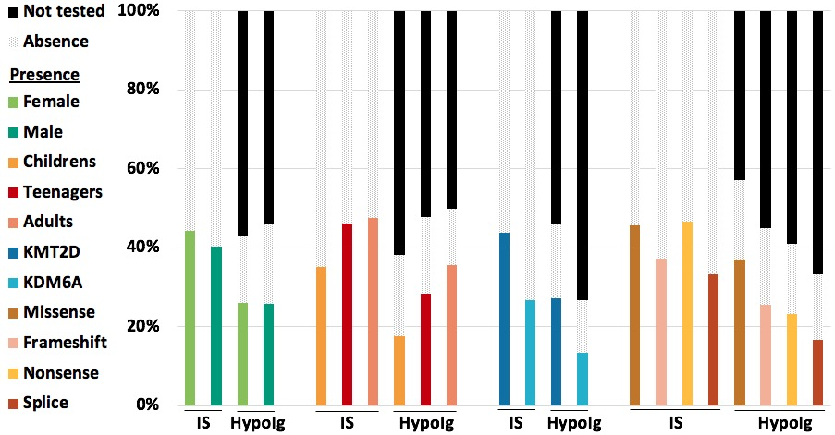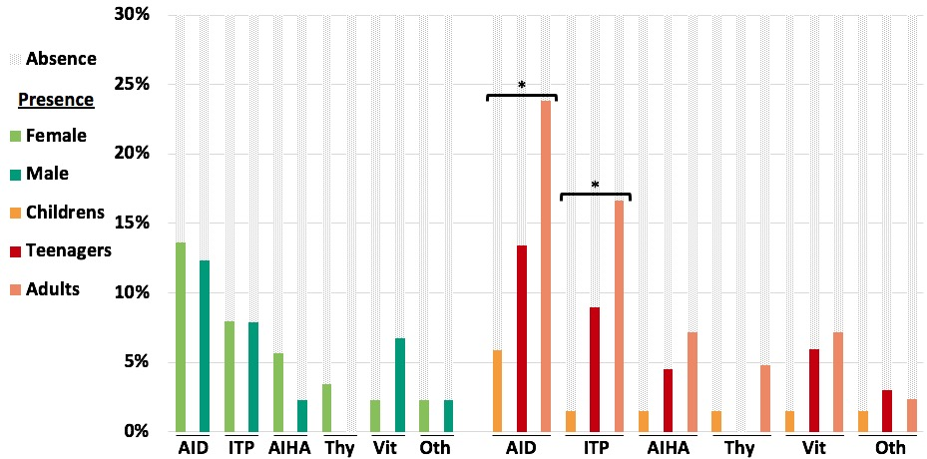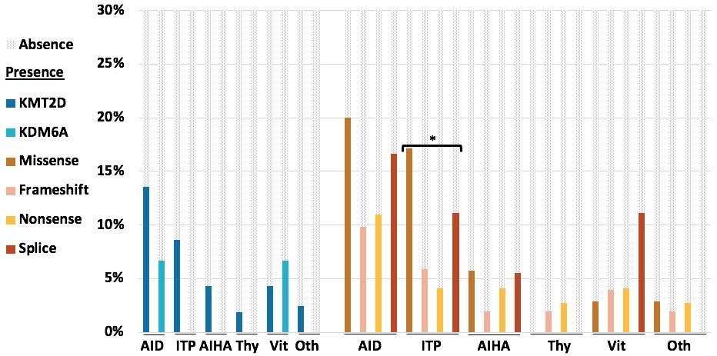
Supplementary Figure 2: Immune features by sex, age, gene and pathogenic variant type.
* P <0.05. Absence : Absence of the phenotype, Presence : Presence of the phenotype described in the legend. IS: infection susceptibility, HypoIg: hypogammaglobulinemia. AID: autoimmune disease, ITP: immune thrombocytopenic purpura, AIHA: autoimmune hemolytic anemia, Thy: thyroiditis, Vit: vitiligo, Oth: other autoimmune manifestations.
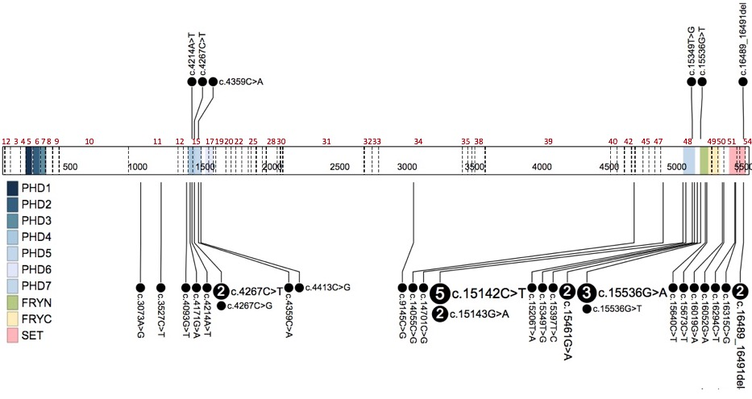
Supplementary Figure 3: Location of missense variant on exon and protein domains of KMT2D. Repartition of missense variant on KMT2D c.DNA sequence. KMT2D missense variants found in patient with ITP are above the sequence. All KMT2D missense variants are listed under the sequence. Functional domains are in Blue: PHDs domain; Red: Set domain; Green: FRYN; Yellow: FTYC. Dash line are exonic borders, exon numbers are in red. Figure realized with ProteinPaint a tool provided by St. Jude Children's Research Hospital.

