Table S1. Spearman Correlation Coefficients Between Lyso-Gb₃ and LVMi, eGFR, and Pain at Baseline. This table presents Spearman correlation coefficients between lyso-Gb₃ and LVMi, eGFR, and pain at baseline to assess the relationship between baseline values of lyso-Gb₃ and LVMi, eGFR, and pain in patients with Fabry disease.
 |  | Overall  (N = 97) |  |  | ERT-naive  (n = 48) |  |  | ERT-experienced  (n = 49) |  |  | Males  (n = 37) |  |  | Females  (n = 60) |  |  | Age ≤40 years  (n = 31) |  |  | Age >40 years  (n = 66)
Parameter | nª |  | P value^{b} | nª |  | P value^{b} | nª |  | P value^{b} | nª |  | P value^{b} | nª |  | P value^{b} | nª |  | P value^{b} | nª |  | P  value^{b}
LVMi | 76 |  | 0.0001 | 30 |  | 0.0002 | 46 |  | 0.0016 | 28 |  | 0.1605 | 48 |  | 0.0905 | 24 |  | 0.0007 | 52 |  | 0.0003
eGFR | 78 |  | 0.4371 | 31 |  | 0.9245 | 47 |  | 0.5554 | 30 |  | 0.1751 | 48 |  | 0.9160 | 24 |  | 0.9005 | 54 |  | 0.8359
Pain | 78 |  | 0.0204 | 31 |  | 0.1115 | 47 |  | 0.2172 | 30 |  | 0.0038 | 48 |  | 0.2510 | 24 |  | 0.3854 | 54 |  | 0.0555

eGFR estimated glomerular filtration rate, ERT enzyme replacement therapy, LVMi left ventricular mass index, lyso-Gb₃ globotriaosylsphingosine.
ªn indicates number of patients with values for both lyso-Gb₃ and the other assessment at baseline.
^{b}P values represent Spearman correlations.
Supplemental Figure 1. Study Design. This figure presents the study designs of the phase 3 FACETS and ATTRACT studies that assessed the efficacy and safety of migalastat in ERT-naive and ERT-experienced patients, respectively. Patients completing each study had the option of enrolling in an open-label extension study for up to 5 years.
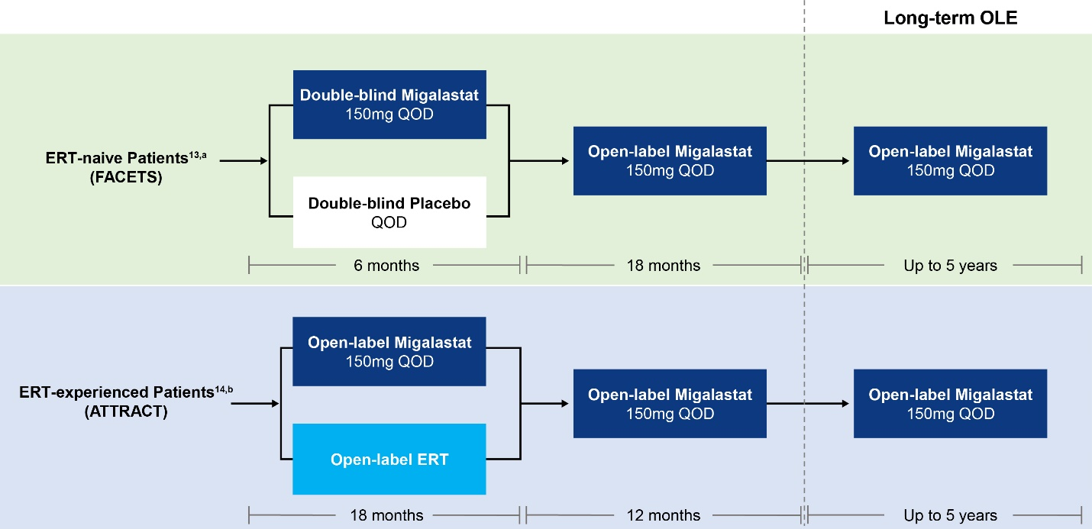
ERT enzyme replacement therapy, OLE open-label extension, QOD every other day.
ªPatients were ERT naive or had not received ERT for ≥6 months prescreening.
^{b}Patients had received ERT for ≥12 months prescreening.

