Supplemental material
A Six-attribute Classification of Genetic Mosaicism
Víctor Martínez-Glez, Jair Tenorio, Julián Nevado, Gema Gordo, Lara Rodríguez-Laguna, Marta Feito, Raúl de Lucas, Luis A. Pérez-Jurado, Víctor L. Ruiz Pérez, Antonio Torrelo, Nancy B. Spinner, Rudolf Happle, Leslie G. Biesecker, Pablo Lapunzina.

Historical notes
At the end of the 19th century, Blaschko hypothesized that a “disturbing factor” could interfere during the months when embryonal differentiation takes place; thus, “only particular territories are involved, whereas intervening regions are healthy” Blaschko, 1895, cited by Happle, 2014) ^{1,2}. This foundational work was neglected for many years and later independently re-discovered in the 1970s by Happle and Jackson ^{3,4}. In 1929, Sturtevant studied chromosomal mosaicism in Drosophila melanogaster 22 and in the 1930s, Stern demonstrated that genetic recombination, normal in meiosis, can also take place in mitosis and results in somatic mosaics ^{5,6}. In the early 1950s, Barbara McClintock demonstrated the phenotypic importance of somatic transposition in maize, and later Sir Macfarlane Burnet proposed a role for somatic mutation in disease ^{7,8}. The term "somatic mosaicism" was used by Cotterman in 1956 in his seminal paper on antigenic variation ⁹

Cases as examples.
Patient 1. A 25-year-old pregnant woman presented for genetic consultation due to a skin disorder with a complex pattern (Figure 3, A and B). She presented with widespread linear lesions following the lines of Blaschko, located in the anterior and posterior portions of the legs, with affected axillary folds, elbows, and hands, affecting about 20% of her body. Histopathology showed epidermolytic hyperkeratosis. In her first pregnancy she gave birth to a boy with diffuse epidermolytic ichthyosis (Figure 3C). The child’s genetic study by next generation based sequencing (NGS) panel of more than 450 genes involved in skin diseases detected a heterozygous (VAF 50%) c.563A>G: p.(Asn188Ser) variant in KRT1, both in blood and affected skin of the child, and was not detected in blood or in healthy skin of his mother (not done at that moment in affected skin). The mosaicism in the mother can be designated as: A3B4C1D1E2bF2: presumed to be gonadosomatic (A3), with a Blaschko pattern in narrow bands (B4), with a benign to pathogenic mutational direction of the variant (C1), type 1 postzygotic mechanism (heterozygous state) (D1), due to a genetic etiology (SNV in a gene (KRT1) (E2b) and between 10-30% of the tissue (skin) involved (F2) (Figure 3). The presence of gonadosomatic mosaicism (A), the mechanism by which it was produced (C), the direction of the change (D), as well as knowing the specific point variant (E) have important implications in terms of diagnosis and recurrence risks for current and future pregnancies of the affected mosaic mother. The distribution pattern (B) can also give an idea of the developmental stage at which the variant arose, and the affected tissue fraction may be informative regarding the prognosis (F) for the affected mosaic mother. Similarly, the direction of the change (D) and the etiology (E) might be useful for a personalized treatment.
Patient 2. A 17 year-old man presented for genetic consultation because of hyperpigmented, linear skin lesions following the Blaschko lines in thorax, upper and lower limbs (Figure 3, D-E). The hyperpigmented skin was calculated as affecting about 8% of the body. There were no other remarkable clinical findings. A karyotype in peripheral blood lymphocytes and a CGH array were reported as normal. A cytogenetic analysis in normal skin was also normal but the affected, hyperpigmented skin carried a trisomy 20 mosaicism (46, XY [24]/47, XY+20 [14]). The mosaicism in this young man can be designated as: A1B4C1D1E1F1: a somatic mosaicism (A1), with a narrow lines of Blaschko pattern (B4), with a benign to pathogenic mutational direction of the variant (C1), type 1 postzygotic mechanism (heterozygous state) (D1), due to a genomic etiology (mosaic of chromosomes) (E1) and with mild involvement (<10%) of the tissue (skin) involved (F1).
Patient 3. A 9 month-old child presented with macroglossia and asymmetric regional body overgrowth (on the right leg) (Figure 3). He had a history of neonatal hypoglycemia and increased birth weight (4,235 g.; >97th centile). A clinical diagnosis of Beckwith-Wiedemann syndrome was established and consequently a methylation-sensitive MLPA and a SNP array was requested. The MLPA showed mild hypomethylation of the proximal chromosome 11p imprinting center together with a hypermethylation of the telomeric 11p imprinting center, both suggestive of mosaic paternal 11p UPD. The SNParray confirmed the diagnosis of UPD and permitted the location of the mitotic recombination breakpoint (45 Mb from the telomere) and the calculation of the percentage of mosaicism for paternal 11pUPD (22%). The mosaicism in this child can be designated as: A1B8C1D1E1fF3: a somatic mosaicism (A1), with a lateralization pattern (B8), with a healthy to pathogenic mutational direction of the variant (C1), a postzygotic mechanism (heterozygous state) (D1), due to an genomic etiology (mosaic of UPD of about 45 Mb) (E1f) and with moderate involvement (about 13%) of the tissue (the entire left leg) involved (F3).
Patient 4. A 22 year-old male with prenatal onset growth retardation, bilateral radial hypoplasia, mild intellectual disability, hearing loss and some dysmorphic features who developed bone marrow failure at 9 years of age. A clinical diagnosis of Fanconi anemia was suspected and confirmed by genetic analysis (NGS gene panel) that detected compound heterozygous SNVs (nonsense and missense) in the FANCD2 gene. The SNP array was consistent with mosaic uniparental UPD of 53 Mb in 3p (30%) (Figure 3), leading to homozygosis of the missense allele in the cells with UPD ¹⁰. Mosaicism in this child with an autosomal recessive disorder and a rescue mosaic UPD can be designated as: A1B0C2D1E1fF3: somatic mosaicism (A1), no pattern (B0), pathogenic to healthier (less pathogenic) mutational direction of the variant (C2), a postzygotic reversal mechanism (compound heterozygous to homozygous state) (D2), genomic etiology (UPD of 53 Mb) (E1f), involvement of about 33% (blood and buccal cells) (F3).
Suppl. Table 1. Size of the variations and different mechanisms.
Genomic
E1a | >100 Mb. Loss or gain of chromosomes or ploidy. Microscope visible changes. Ex: Down syndrome.
E1b | 4 Mb - 100 Mb. Loss or gain of part of chromosomes. Deletions and duplications visible at light microscope. E.g., Wolf-Hirschhorn syndrome.
E1c | 0.1 Mb - 4 Mb. Loss or gain of small parts of a chromosome. Not visible with light microscope but only with cyto-molecular techniques. E.g., Smith-Magenis syndrome.
E1d | 1 Kb – 100 Kb. E.g., LINE (L1) retrotransposition. Interrogated with molecular techniques (L1 reporter assays and high-throughput sequencing). E.g., some cases of colonic cancer due to APC gene variants.
E1e | 100 bp - 1000 bp. SINE (Alu) retrotransposition. Interrogated with molecular techniques. E.g., Congenital cataracts due to a fraction of patients with GCNT2 variants.
E1f | Copy neutral changes of any size. Segmental or whole chromosome uniparental disomies, gene conversions

Genetic
E2a | 10 bp – 10000 bp DNA polymerase slippage and trinucleotide repeat expansions. E.g., Huntington disease
E2b | 1 bp – 10 bp. DNA damage, replication errors, and erroneous DNA repair mechanisms. E.g., thousands of disorders caused by SNVs.

Epigenetic-epigenomic
E3a | Methylation defects affecting gene expression. E.g., Beckwith-Wiedemann syndrome.
E3b | Acetylation defects. E.g., syndromic intellectual disability due to a pathogenic acetylation of BRPF1.

Positional effect
E4a | Translocations or inversions without any losses or gains. E.g., many translocations disrupting genes or gene expression.
E4b | Topologically associated domains (TADs). E.g., limb malformations caused by deletions, inversions, or duplications altering the structure of the TAD-spanning WNT6/IHH/EPHA4/PAX3 locus.
Legends for Figures
Suppl. Figure 1
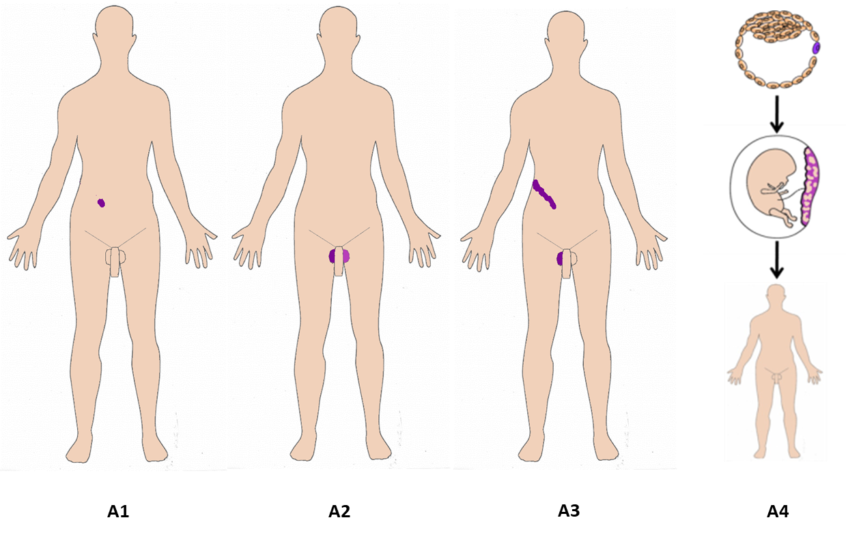
Suppl. Figure 1. Affected tissues. A1: somatic mosaicism. A2: Germinal (gonadal) mosaicism. A3: Gonadosomatic mosaicism. A4: Confined placental mosaicism. Note the mutant cell (top panel, violet arrow), the mosaic placenta (middle panel, violet arrow), and the normal individual. Based on the placental membrane localization of the genetic or chromosomal abnormality/variant, CPM can be classified into three subtypes (types 1, 2 and 3). In type 1 CPM (CPM1), the variant is found exclusively in the cytotrophoblast (i.e., observed only after cytogenetic or genetic/genomic testing of short-term cultured villi, which derive from the cytotrophoblast). For type 2 CPM (CPM2), the variant is limited to the mesenchymal core of the chorionic villi (i.e., observed only after cytogenetic or genetic/genomic testing of long-term culture villi). Type 3 CPM (CPM3) is defined as the presence of a variant in both the cytotrophoblast and the mesenchymal core of the chorionic villi (i.e., observed after both short- and long-term culture villi analysis) ¹¹ (Figure 1, Suppl. Figure 1).

Suppl. Figure 2

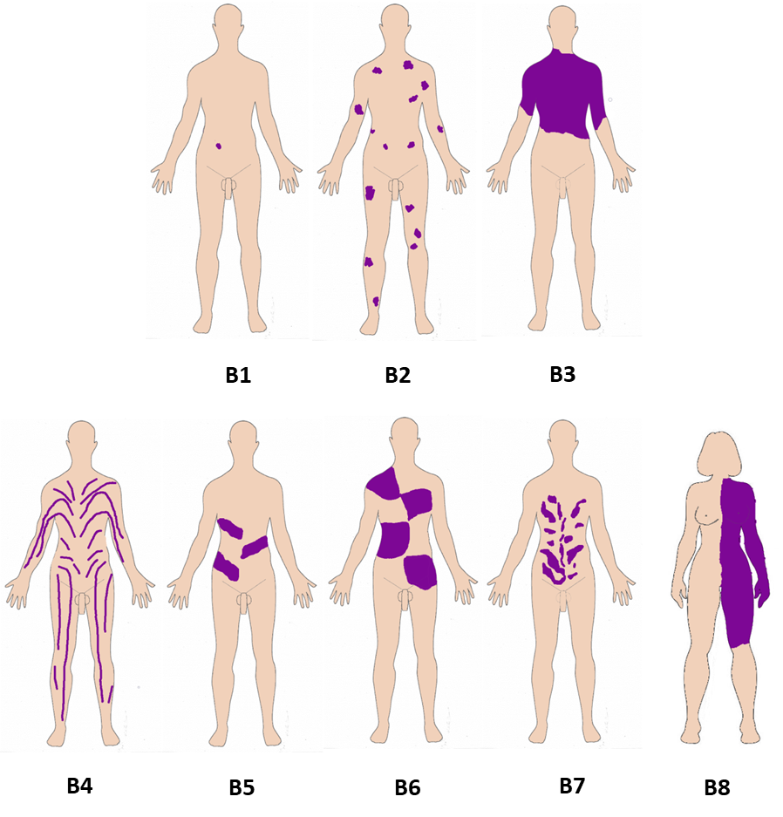
Suppl. Figure 2. Body patterns. Upper panel (B1-B3): Non-segmented mosaicism. B1: single point mosaicism; B2: disseminated mosaicism; B3: patchy mosaicism without midline separation; Lower panel (B4-B8): Segmental mosaicism. B4. Blaschko lines in narrow bands; B5. Blaschko lines in broad bands; B6. Checkerboard; B7. Phylloid; B8. Lateralization/half body.

Suppl. Figure 3

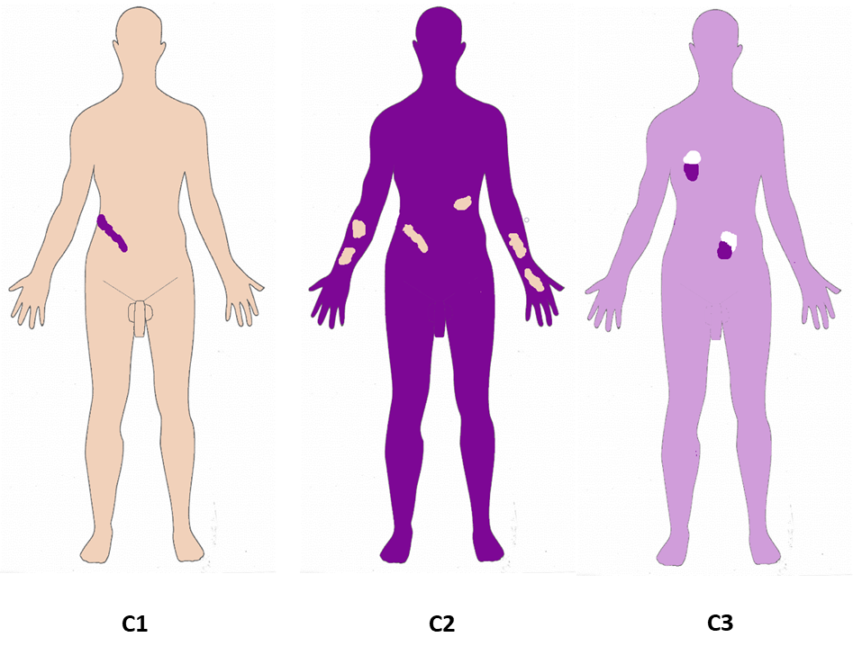
Suppl. Figure 3. Change’s Direction C1: From benign (wild type) to pathogenic; C2: From pathogenic to benign (wild type): revertant mosaicism; Noticeably, in revertant mosaicism the same affected individual could have multiple cell lineages involved or it may be limited to a particular cell clone ¹². In the skin, molecular studies on revertant mosaicism have demonstrated that affected individuals may harbor multiple distinct variants in their patches of normalized tissue ^{13,14}. C3: Didymosis: paired patches of mutant tissues that differ genetically from each other and from unaffected (wild type) tissue.

Suppl. Figure 4

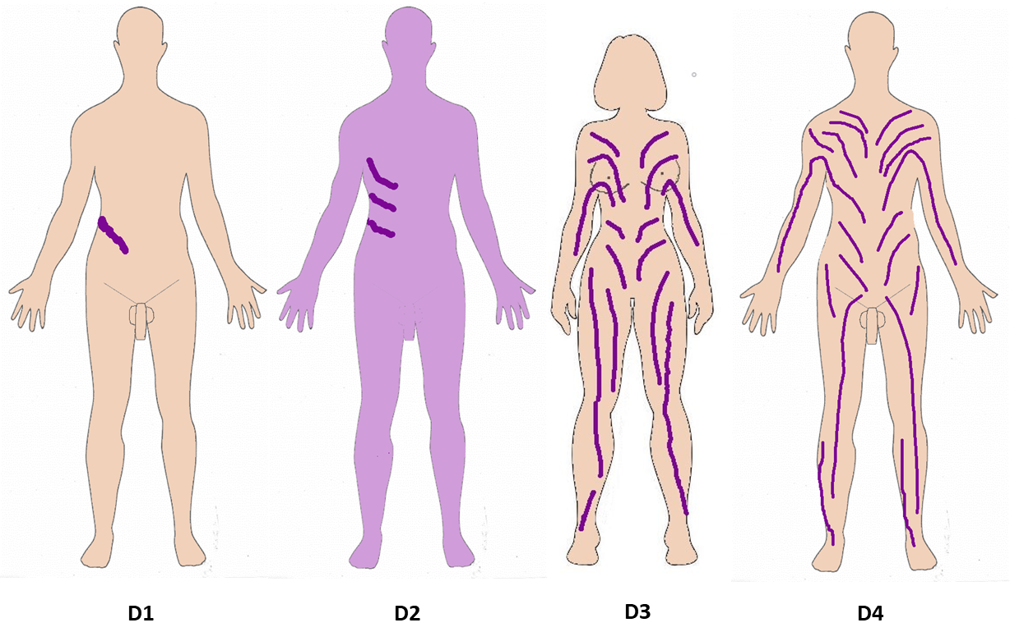
Suppl. Figure 4. Developmental mechanism. D1: Type 1 segmental, heterozygous state; D2: Type 2 segmental reflecting loss of the corresponding wild-type allele: a second mutation occurs on the wild-type allele in a previously heterozygous patient, leading to absence of the wild-type allele; D3: functional X-chromosome mosaicism with or without lethality for males; D4: Disorders due to autosomal lethal mutations that manifest only as mosaics.
Suppl. Figure 5

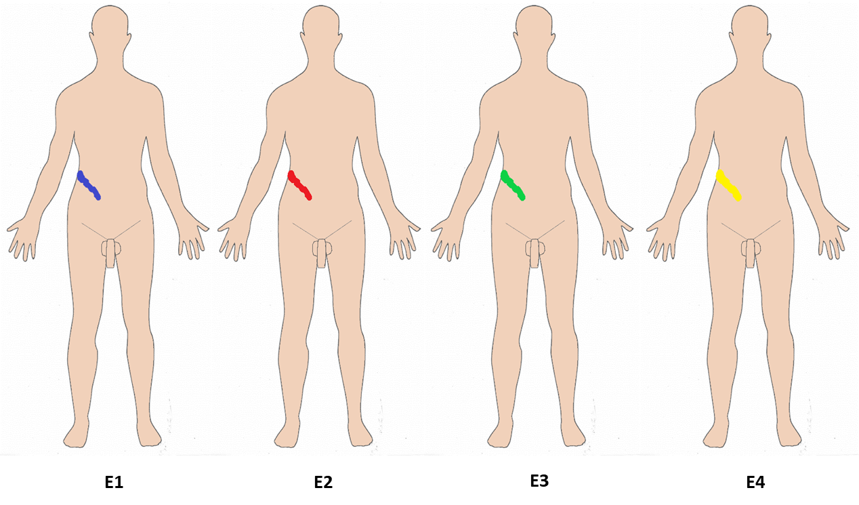

Suppl. Figure 5. Etiology. E1: genomic changes; E2: genetic changes; E3: epigenetic changes; E4: positional effects. In mosaic genome-wide uniparental disomy (UPD) there is a coexistence of diploid cells and cells with UPD of all chromosomes; patients display overlapping features of syndromes associated with UPD for other chromosomes, notably UPD14, UPD15, UPD6, and UPD20. Due to mosaicism, a phenotypic spectrum is to be expected, and patients may have clinical features of many disorders such as Beckwith-Wiedemann syndrome, Angelman/Prader Willi syndromes, Temple/Kagami-Ogata syndrome, and transient neonatal diabetes mellitus ¹⁵.

Suppl. Figure 6

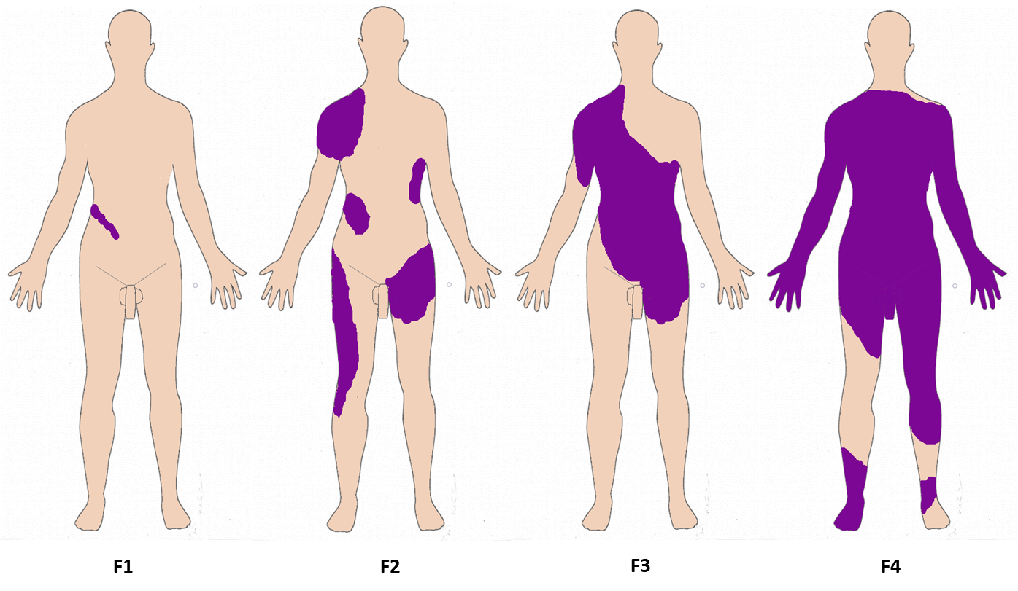
Suppl. Figure 6. Fraction of the affected tissue. F1: Mild involvement; F2: Moderate involvement; F3: Severe involvement F4: Very severe (extreme) involvement.
Suppl. Figure 7

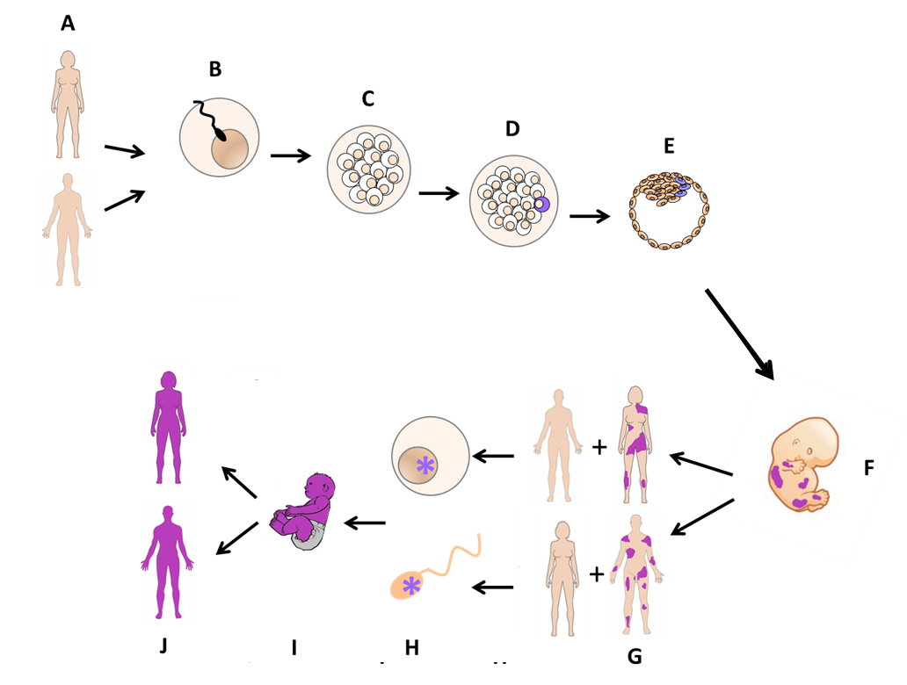
Suppl. Figure 7: Mechanisms of gonadosomatic mosaicism to full heterozygous state. A: Normal, unaffected woman and man; B: Fertilization of a normal egg and normal sperm; C: First divisions during early development; D: A postzygotic mutational event gives rise to a single cell with a pathogenic variant; E: The cell with the variant divides into more cells within the inner cell mass of the blastocyst; F: A mosaic embryo develops with wild type cells (orange) and variant-containing cells (violet) G: Either a man or a woman with gonadosomatic mosaicism + an unaffected, “wild-type” partner; H: Sperm or egg with the variant may fertilize or be fertilized, the risks of having such an offspring varies due to the variant allele fraction (VAF) of the gonadal cells; I: An offspring with a constitutive variant (non-mosaic) result; J: Either a man or a woman with a constitutive variant may transmit the variant allele to 50% of his/her offspring (in the case of diseases inherited in an autosomal dominant pattern).

Supplemental references
1. Happle R. Mosaicism in Human Skin. 1 ed: Springer-Verlag Berlin Heidelberg; 2014.
2. Happle R, Franco-Guio MF, Santacoloma-Osorio G. Phylloid Hypermelanosis: A Cutaneous Marker of Several Different Disorders? Pediatr Dermatol. 2014;31(4):504-506.
3. Happle R. Genetic Mechanisms Giving Rise to Linear Skin Lesions. Paper presented at: Joint meeting of the Vereinigung Südwestdeutscher Dermatologen and the Vereinigung Rheinisch-Westfälischer Dermatologen; 8-10 October, 1976, 1976; Heidelberg.
4. Jackson R. The Lines of Blaschko: A Review and Reconsideration: Observations of the Cause of Certain Unusual Linear Conditions of the Skin. The British journal of dermatology. 1976;95(4):349-360.
5. Stern C. Somatic Crossing over and Segregation in Drosophila Melanogaster. Genetics. 1936;21(6):625-730.
6. Stern CS, K. Analyse Eines Mosaikindividuums Bei Drosophila Melanogaster. Bio Zentr. 1931;51:194-199.
7. Burnet FMS. The Clonal Selection Theory of Acquired Immunity. Nashville: Vanderbilt University Press; 1959.
8. Mc Clintock B. Chromosome Organization and Genic Expression. Cold Spring Harb Symp Quant Biol. 1951;16:13-47.
9. De S. Somatic Mosaicism in Healthy Human Tissues. Trends in genetics : TIG. 2011;27(6):217-223.
10. Reina-Castillon J, Pujol R, Lopez-Sanchez M, et al. Detectable Clonal Mosaicism in Blood as a Biomarker of Cancer Risk in Fanconi Anemia. Blood Adv. 2017;1(5):319-329.
11. Toutain J, Goutte-Gattat D, Horovitz J, Saura R. Confined Placental Mosaicism Revisited: Impact on Pregnancy Characteristics and Outcome. PloS one. 2018;13(4):e0195905.
12. Lai-Cheong JE, Moss C, Parsons M, Almaani N, McGrath JA. Revertant Mosaicism in Kindler Syndrome. J Invest Dermatol. 2012;132(3 Pt 1):730-732.
13. Pasmooij AM, Pas HH, Deviaene FC, Nijenhuis M, Jonkman MF. Multiple Correcting Col17a1 Mutations in Patients with Revertant Mosaicism of Epidermolysis Bullosa. American journal of human genetics. 2005;77(5):727-740.
14. Happle R. The Categories of Cutaneous Mosaicism: A Proposed Classification. American journal of medical genetics Part A. 2016;170A(2):452-459.
15. Romanelli V, Meneses HN, Fernandez L, et al. Beckwith-Wiedemann Syndrome and Uniparental Disomy 11p: Fine Mapping of the Recombination Breakpoints and Evaluation of Several Techniques. European journal of human genetics : EJHG. 2011;19(4):416-421.

