Figure S3. Q- and ∆K-plots for STRUCTURE analyses
Below is a summary of the results from multiple structure runs. After initial comparisons of the 8 locus and 11 locus results, we decided to move forward with the 11 locus since results were broadly similar. We took the approach of running an initial analysis with all populations, and using the best and smallest value of K, evaluating for substructure within those clusters. In the end, this hierarchical approach results in final conclusions that are similar to the K=4 result from the all populations analysis, with the exception of additional division between the two BC populations. These analyses did not resolve any substructure within WI and NEB, which I believe was found in previous analyses, although perhaps with a different compliment of loci.

All runs were done using the straight admixture model with no location information.

Population numbers in the bar plots are as follows:
1 | 2 | 3 | 4 | 5 | 6 | 7 | 8 | 9 | 10
AMNH | FK | LP | WIe | WIw | WIe | IND | NEB | BCs | BCw

8 loci, all pops
K1-10, 10 iterations, 500,000 burn-in, 1 million after
Best value is K=2.
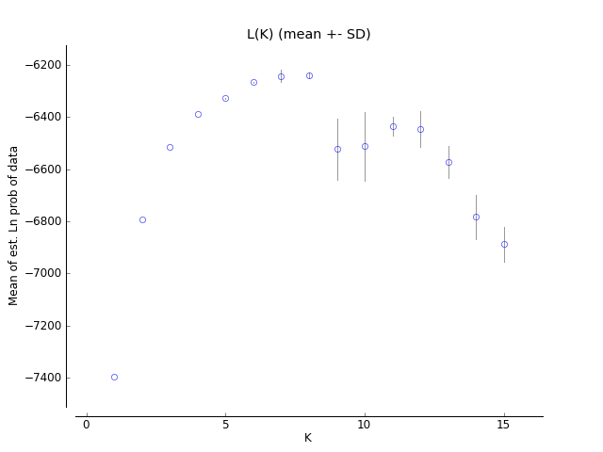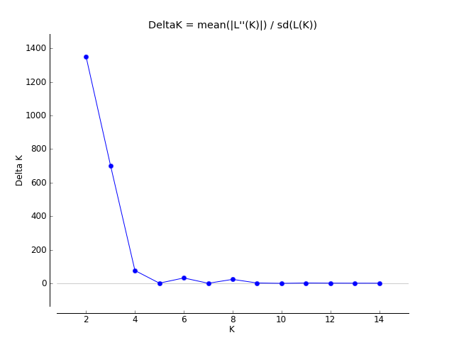

11 loci, all pops
K1-10, 10 iterations, 500,000 burn-in, 1 million after
Best value is K=2, but K=4 is also relevant in light of “sub-structure” results.
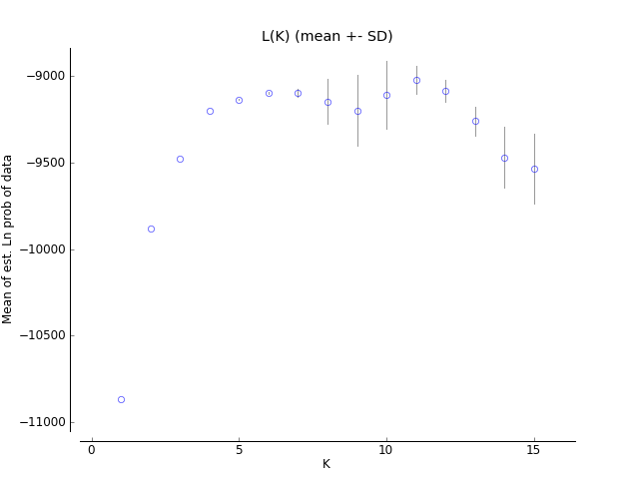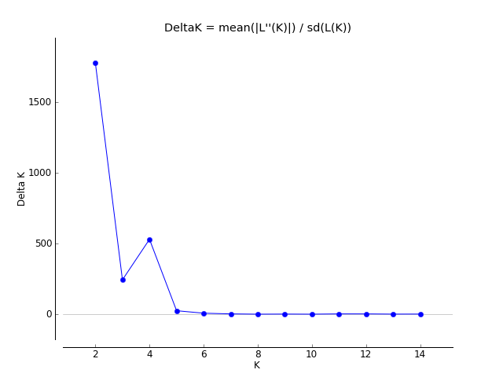
K=2 barplot
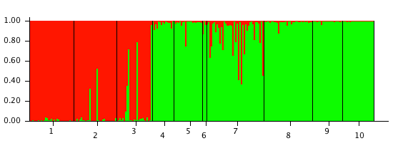

K=4 barplot
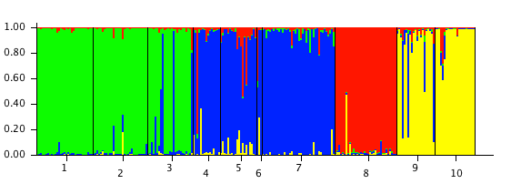

11 loci, Pops 1-3
K1-5, 10 iterations, 500,000 burn-in, 1 million after
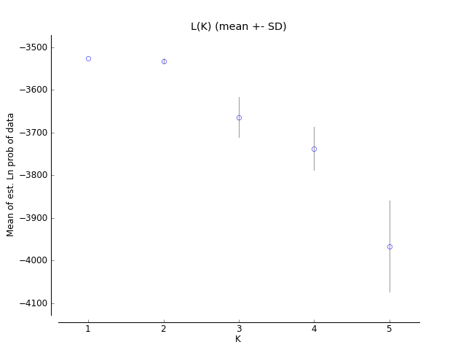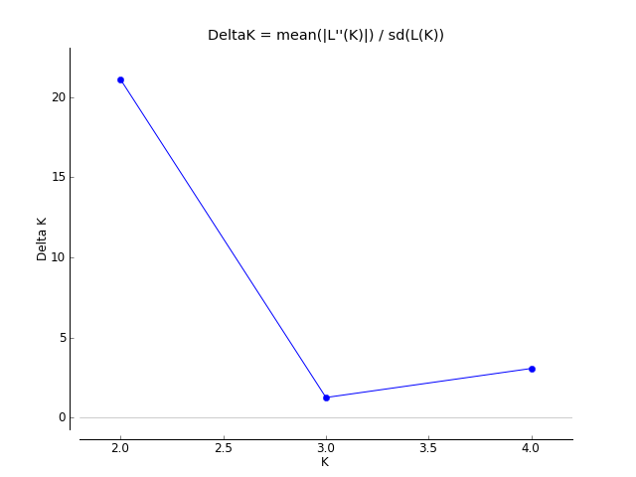
K=2 bar plot, for illustrative purposes only. Best value of K is 1.
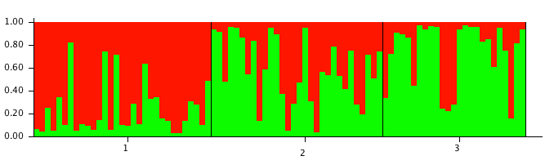

11 loci, Pops 4-10
K1-7, 10 iterations, 500,000 burn-in, 1 million after

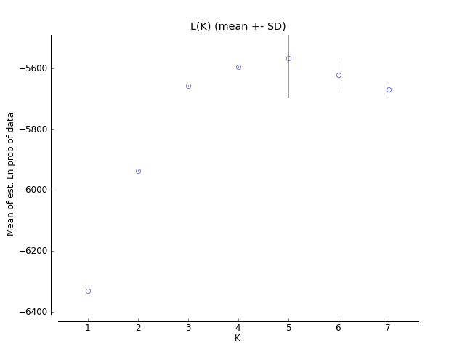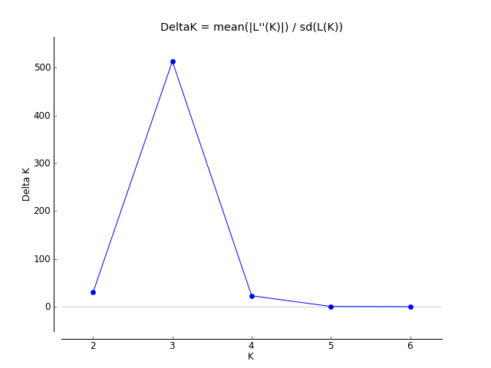
K=3 bar plot. Best value is K=3.
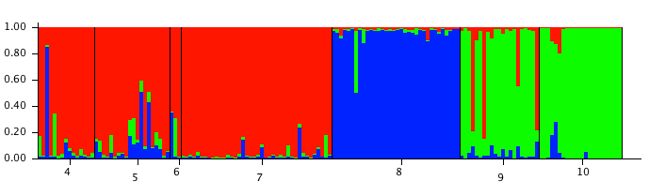
WI IND NEB BC
11 loci, Pops 5,7,8-10 (ie same as above with WI East removed)
K1-6, 10 iterations, 500,000 burn-in, 1 million after

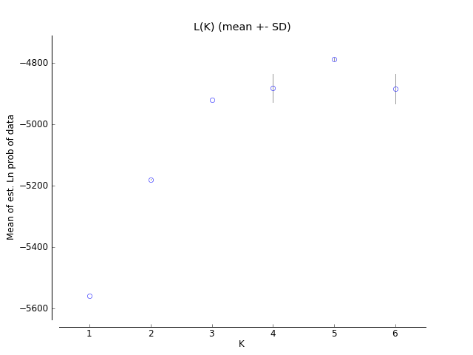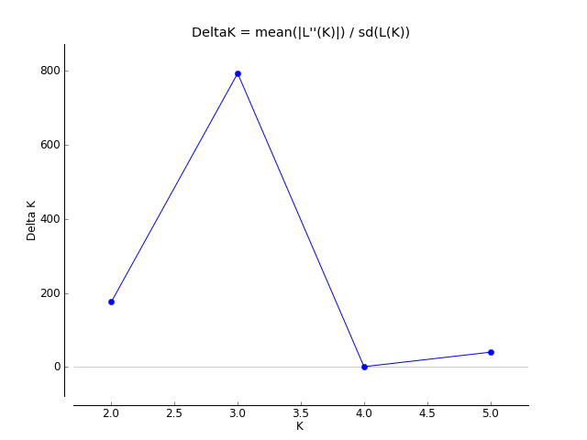
Bar Plot K=3. Best value is K=3
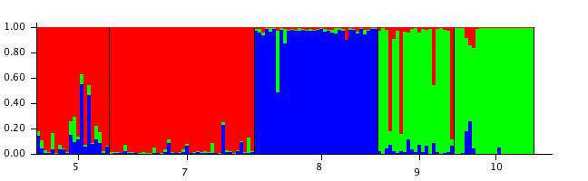

11 loci, Pops 4-7
K1-5, 10 iterations, 500,000 burn-in, 1 million after
Best value is K=1
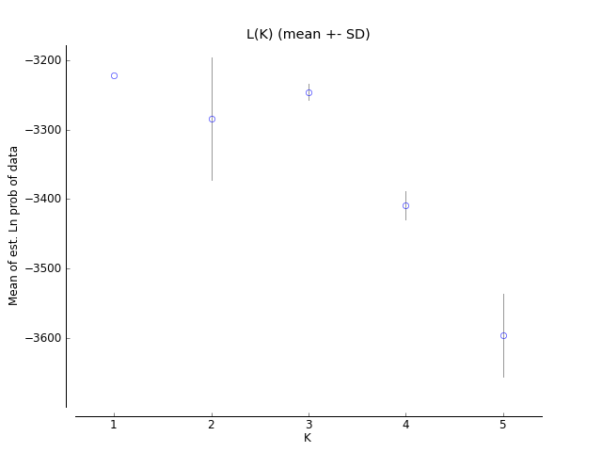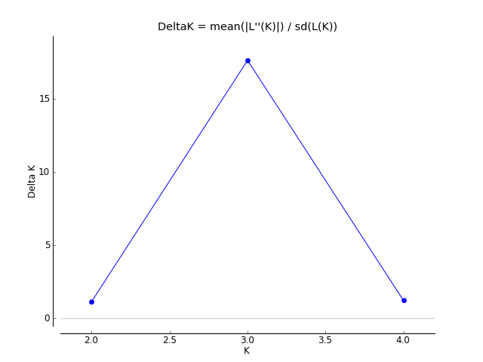

11 loci, Pops 9-10
K1-3, 10 iterations, 500,000 burn-in, 1 million after
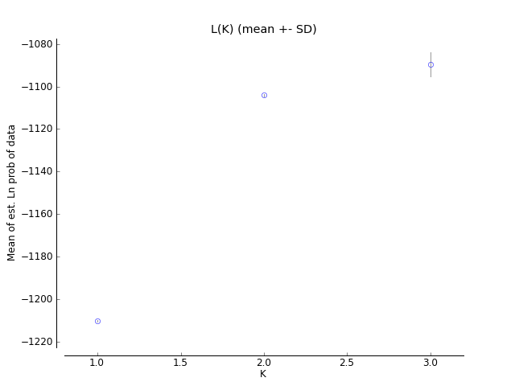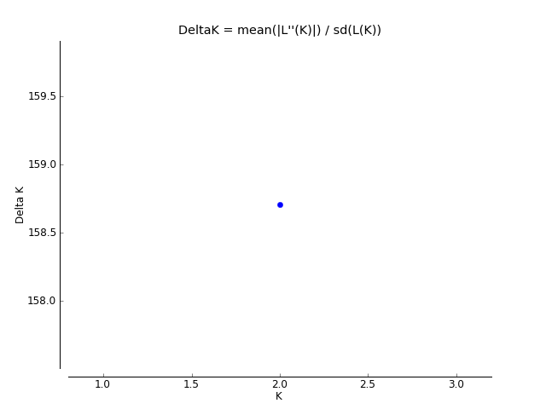
Bar plot K=2. Best value is K=2.
