S1 Table. Description of the behaviour traits used as phenotypes. Behaviour traits were generated using a principal component analysis (PCA) on questions from the C-BARQ questionnaire and additional questions about playfulness.
Behaviour trait | Description
Stranger-directed aggression (SDA) | Positive loadings of aggressive behaviour towards strangers
Dog-directed aggression (DDA) | Positive loadings of aggressive behaviour and negative loadings of playfulness towards unfamiliar dogs
Stranger-directed fear (SDF) | Positive loadings of fearful behaviour towards strangers
Playfulness (Play) | Positive loadings of playful interaction with humans
Resource guarding (RG) | Positive loadings of owner-directed aggression in regard to food or toys
Excitability (EX) | Positive loadings of excited behaviour in response to different situations
Separation anxiety (SA) | Positive loadings of stress-related behaviour when left alone
Lack of obedience (LO) | Negative loadings of obedience-related behaviours
Stranger-directed interest (SDI) | Positive loadings of friendly interaction with strangers
Attention seeking (AS) | Positive loadings of attention-seeking behaviour towards owner
Chasing (CH) | Positive loadings of chasing-related behaviours
Non-social fear (NSF) | Positive loadings of fear response to loud noise or unfamiliar objects
Dog-directed fear (DDF) | Positive loadings of fearful behaviour towards unfamiliar dogs
Aversion of being stepped over (AvSO) | Positive loadings of fearful or aggressive response when stepped over
Touch sensitivity (TS) | Positive loadings of fearful behaviour when touched for various treatments

S2 Table. Lifestyle variables that were fitted as fixed factors in the statistical analyses of behaviour traits. Description of lifestyle variables that were assessed using the lifestyle survey ( “Variables”) and individual models for every behaviour trait where variables fitted as fixed effects in the models are indicated by “x” (“Models”).
Variables
Name | Description | Type | Levels
Cohort | Origin of the dog | Categorical | UK
 |  |  | Sweden
People_hh | Number of people in household | Numerical | n.a.
Children_hh | Number of children < 15 years in household | Numerical | n.a.
Dogs_hh | Are there other dogs living in the household? | Binary | Yes
 |  |  | No
Animals_hh | Are there other animals living with the dog (e.g. cats, rodents, livestock)? | Binary | Yes
 |  |  | No
Living place | Where does the dog live? | Categorical | 1: Inside
 |  |  | 2: Primarily outside
 |  |  | 3: Indoors and outside
 |  |  | 4: Place of work
Age | Age of the dog in years | Numerical | n.a.
Gender | Gender of the dog | Binary | Female
 |  |  | Male
Neuter status | Has the dog been neutered? | Binary | Intact
 |  |  | Neutered
Gender*Neuter status | Interaction of gender and neuter status | Categorical | 1: Female*intact
 |  |  | 2: Female*neutered
 |  |  | 3: Male*intact
 |  |  | 4: Male*neutered
Coat colour | Coat colour of the dog | Categorical | 1: Typical GSD coloured^{C}
 |  |  | 2: Sable
 |  |  | 3: Black
 |  |  | 4: Other
Age.acquisition | How old was the dog when acquired? | Ordinal | Birth
 |  |  | < 9 weeks
 |  |  | 9 - 12 weeks
 |  |  | 12 - 16 weeks
 |  |  | 4 - 6 months
 |  |  | 6 - 12 months
 |  |  | 1 - 2 years
 |  |  | 2 - 4 years
 |  |  | > 4 years
Bred | Has dog been used for breeding? | Binary | Yes
 |  |  | No
Shape | Shape of the dog with increasing body weight | Ordinal | A
 |  |  | B
 |  |  | C
 |  |  | D
Role_PC1 | How do you see your dog? | PCA score^{P} | Pet (0.77)
 |  |  | Playmate (0.78)
 |  |  | Guard (0.60)
Role_PC2 |  |  | Coworker (0.58)
 |  |  | Show dog (-0.68)
Comp_PC1 | Has your dog participated in competitions? | PCA score^{P} | Showing (0.73)
 |  |  | None (-0.60)
Comp_PC2 |  |  | Competitive obedience (0.73)
 |  |  | Working trials (0.81)
Commands | Number of commands the dog was trained for (Maximum = 10) | Numerical | n.a.
Train_PC1 | Which training method do you use to train your dog? | PCA score^{P} | No training (-0.85)
 |  |  | Motivation, positive (0.65)
 |  |  | Relationship based (0.61)
Train_PC2 |  |  | Clicker (0.67)
 |  |  | Counterconditioning (0.63)
Train_PC3 |  |  | Dominance (0.84)
 |  |  | Aversion (0.68)
F_walking | How often do you walk your dog? | Ordinal | Never
 |  |  | Few times a month
 |  |  | Few times a week
 |  |  | Daily
 |  |  | Multiple times a day
F_interaction_humans | How often does your dog interact with humans? | Ordinal | Never
 |  |  | Few times a month
 |  |  | Few times a week
 |  |  | Daily
 |  |  | Multiple times a day
F_interaction_dogs | How often does your dog interact with other dogs not living in the same household? | Ordinal | Never
 |  |  | Few times a month
 |  |  | Few times a week
 |  |  | Daily
 |  |  | Multiple times a day
F_training | How often do you train your dog? | Ordinal | Never
 |  |  | Few times a month
 |  |  | Few times a week
 |  |  | Daily
 |  |  | Multiple times a day
F_exercise | What is the amount of daily exercise your dog gets? | Ordinal | < 1h
 |  |  | 1 - 2h
 |  |  | 2 - 4h
 |  |  | > 4h
F_offlead | How often is your dog off lead? | Ordinal | Never
 |  |  | Few times a month
 |  |  | Few times a week
 |  |  | Daily
 |  |  | Multiple times a day
n.a. = not applicable
^{C}Black and tan, black and red, black and silver
^{P}For multiple choice questions, a PCA was applied to condense the answers. Loadings of answer choices that contributed most to the PC are given in parentheses

Models
 | Stranger-directed aggression | Dog-directed aggression | Stranger-directed fear | Human-directed playfulness | Excitability | Separation anxiety | Lack of obedience | Stranger-directed interest | Attachment/ Attention seeking | Chasing | Non-social fear | Dog-directed fear | Touch-sensitivity
Population (UK or Sweden) | x | x |  | x |  |  | x | x | x | x |  | x
Number of people living in the household |  |  |  |  |  |  | x
Number of children ( < 15 years) living in the household |  |  |  |  |  |  |  |  |  |  |  |  | x
Number of dogs living in the household |  | x |  |  |  | x | x |  | x |  |  | x | x
Do other animals live in the household (yes/ no) |  |  | x |  |  |  |  | x |  | x
Living place |  |  |  | x | x
Age | x | x | x | x |  |  |  | x |  | x | x | x
Gender
Neuter status
Gender*Neuter status |  |  | x | x |  | x |  |  | x |  | x | x
Coat colour |  |  |  |  |  |  |  |  |  | x
Age.acquisation |  |  |  | x |  |  |  | x |  |  |  | x | x
Bred |  |  | x |  |  |  |  |  |  | x
Shape | x |  |  |  |  |  |  |  |  | x |  | x
Role_PC1 | x |  |  |  |  | x
Role_PC2 |  |  |  | x |  |  |  |  |  |  | x
Comp_PC1 | x |  |  |  |  |  |  |  |  |  |  |  | x
Comp_PC2 | x |  |  | x |  |  | x |  |  |  | x
Commands |  | x |  | x |  |  | x |  | x | x | x |  | x
Train_PC1 |  |  |  |  |  |  |  |  |  |  |  |  | x
Train_PC2 |  |  |  |  |  |  |  |  |  |  |  |  | x
Train_PC3 |  | x | x |  |  |  |  | x
F_walking | x |  | x |  |  | x |  |  |  | x
F_interaction_humans | x |  |  |  |  |  |  | x
F_interaction_dogs |  | x |  | x |  |  |  |  |  |  |  | x | x
F_training |  |  |  |  |  |  | x | x |  | x
F_exercise |  |  |  |  |  | x |  |  | x
F_offlead | x |  |  |  | x | x | x |  | x | x

S3 Figure. Principal component analysis of the genomic data. Eigenvalues for the first two principal components are plotted and individuals are coloured according to their cohort (blue=UK or pink=Sweden).

S4 Figure. Q-Q plots and lambda values in parentheses for the genome-wide association study of the 13 behaviour traits.
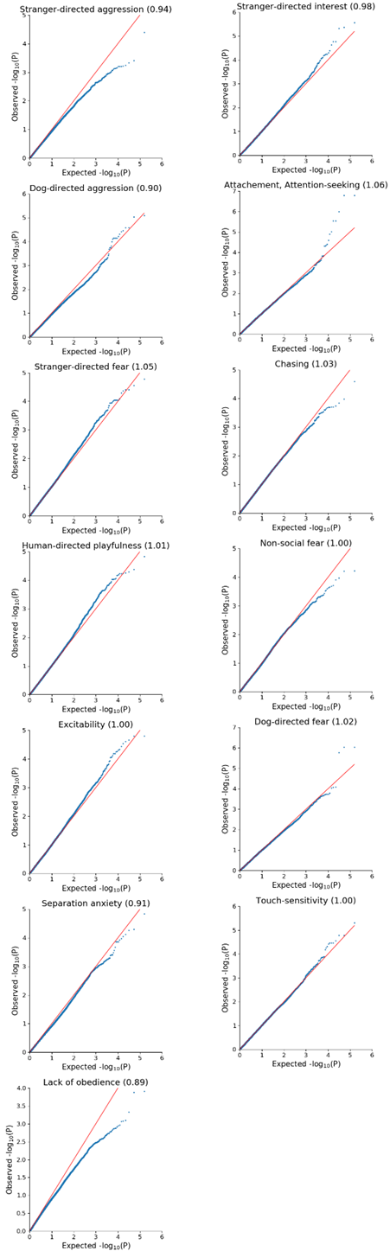
S5 Figure. Regional association plot. The -log(P) values calculated in the GWAS, gene annotations and local linkage disequilibrium patterns are plotted for regions identified by the regional heritability mapping that harbour genes. Neighbouring and overlapping regions (due to the sliding-window approach) were plotted together. The SNP with highest -log(P) from the GWAS is coloured in blue and all others are coloured according to their r² to this SNP with white for no LD (r²≤0.2), yellow for weak LD (0.2≤r²<0.5), orange for moderate LD (0.5≤r²<0.8) and red for strong LD (r²≥0.8).

