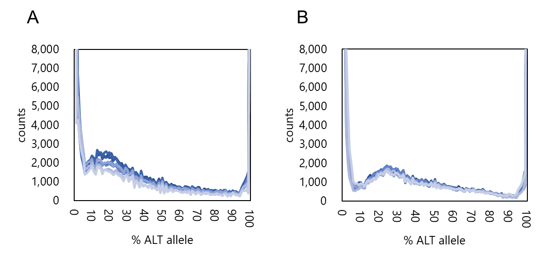

Supplementary Fig. S1. Distribution of the alternative allele frequencies of (A) rabbiteye blueberry and (B) highbush blueberry. Sites were counted based on their alternative allele frequency in 1% bins. Lines represent different cultivars. Eight representative cultivars are presented in each figure.

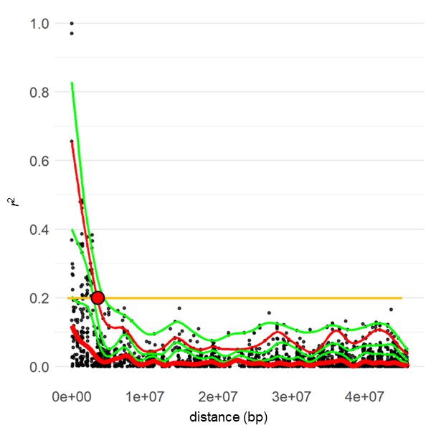

Supplementary Fig. S2. Representative patterns of the detection of the maximum association distance. The r² value was plotted for all SNPs on the same chromosome. Curves represent cubic splines fitted for the 99th, 95th, 90th, 75th, and 50th percentiles (top to bottom). The point where the fitted curve of the 95th percentile first decayed to r² = 0.2 was recorded for all SNPs.

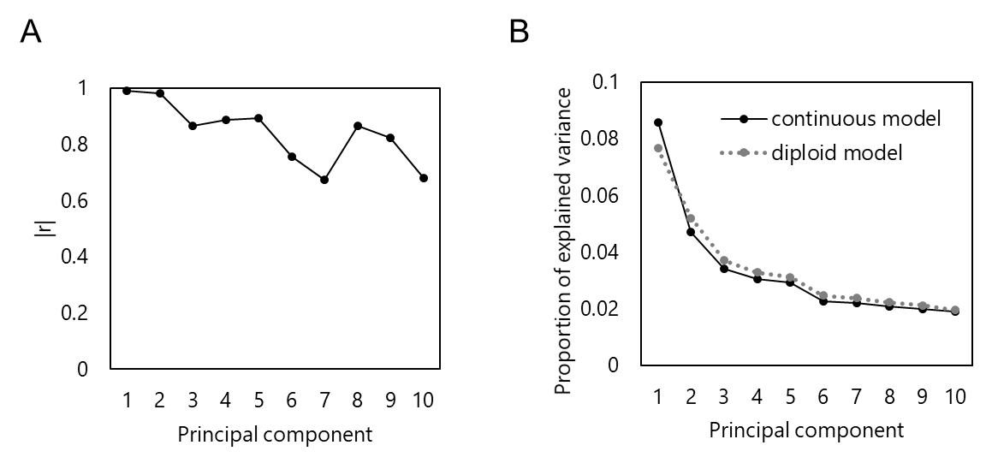

Supplementary Fig. S3. Comparison of the genotyping models used in this study. (A) Plot of the absolute Pearson correlation coefficients for the principal component scores based on the continuous and diploid models. The principal component analysis (PCA) involved the genotype matrices of 47,424 SNPs for the population with RE, NHB, and SHB. The principal component scores were calculated based on the probabilistic PCA. (B) Scree plot of the explained variance in the probabilistic PCA.

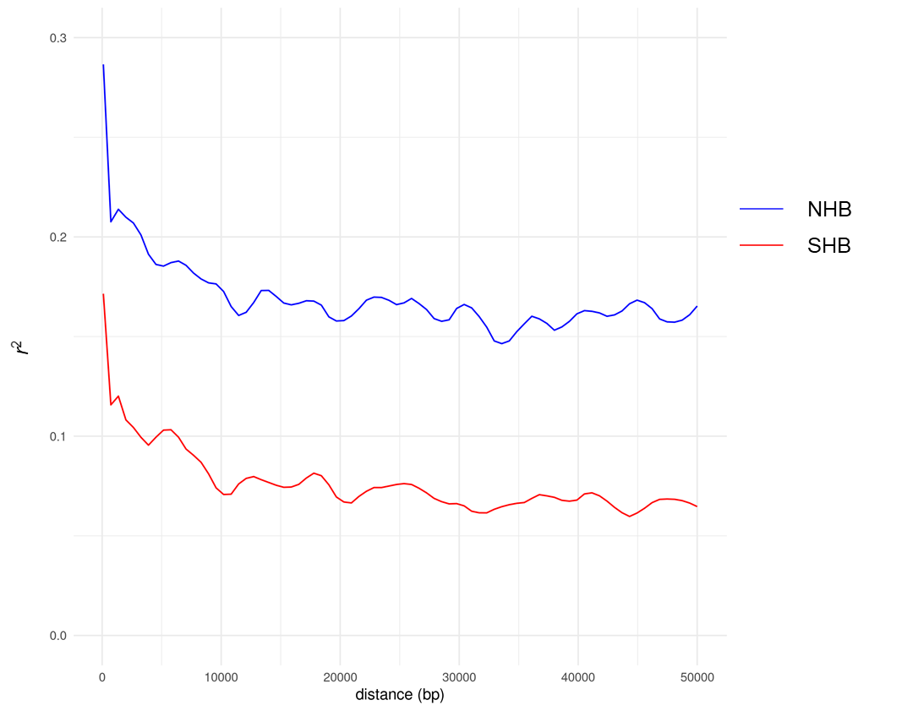

Supplementary Fig. S4. Patterns of LD decay in the highbush population. The r² value was plotted against the physical distance and regressed via loess smoothing, with span = 0.1.

